Review and meta-analysis of the evidence for choosing between specific pyrethroids for programmatic purposes.
N. Lissenden¹, M. Kont², J. Essandoh¹, H. M. Ismail¹, T. S. Churcher², B. Lambert², A. Lenhart³, P. J. McCall¹, C. L. Moyes⁴, M. J. I. Paine¹, G. Praulins¹, D. Weetman¹ & R. S. Lees¹*
¹ Department of Vector Biology, Liverpool School of Tropical Medicine, UK
² MRC Centre for Global Infectious Disease Analysis, School of Public Health, Imperial College London, UK
³ Entomology Branch, Division of Parasitic Diseases and Malaria, U.S. Centers for Disease Control and Prevention, Atlanta, USA
⁴ Big Data Institute, University of Oxford, OX3 7LF, UK
* Correspondence: Rosemary.Lees@lstmed.ac.uk; Tel.: +44 (0) 151 705 3344

Deltamethrin dose response curves
- CDC An. albimanus Teco  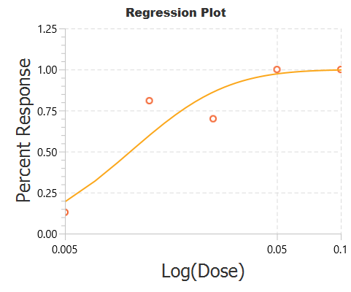 | - Cardiff An. gambiae G3  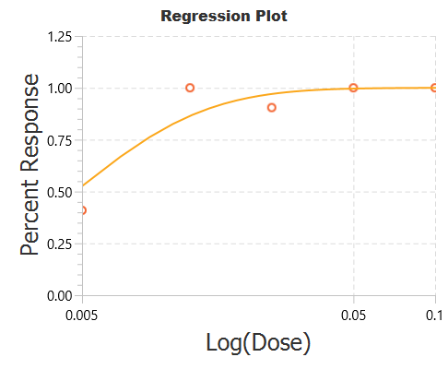
- LIN An. gambiae G3  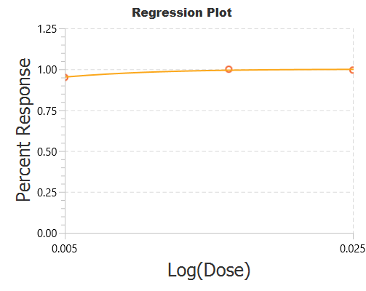 | - Mali An. gambiae Mopti  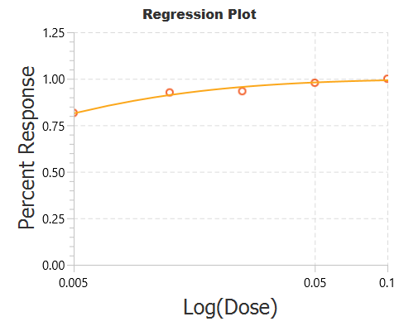
- CDC An. stephensi Delhi  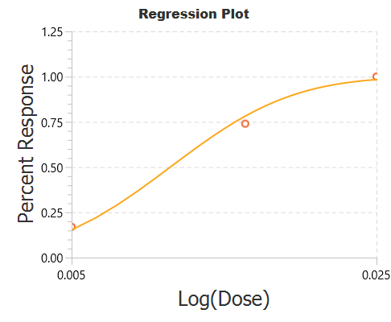 | - Cardiff An. stephensi St  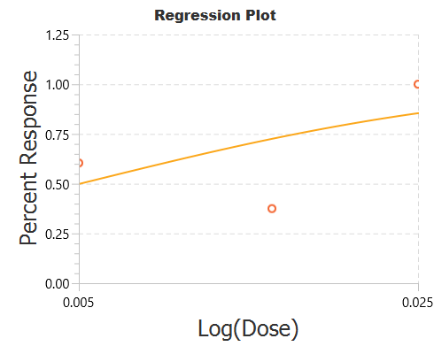
- Cardiff An. stephensi Beech  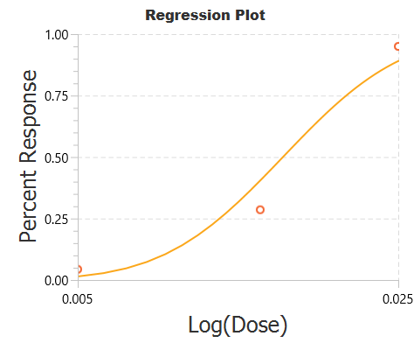 | - LSHTM An. stephensi Beech  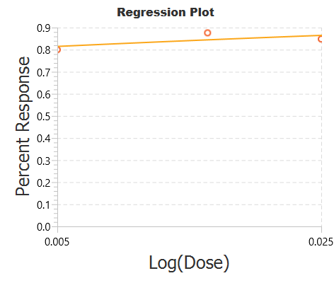
- Iran An. stephensi Beech  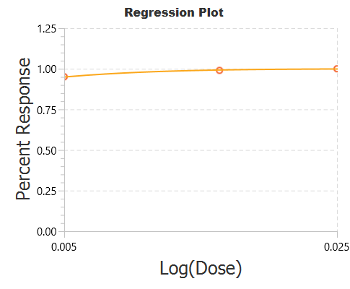 | - Pooled An. albimanus
- Pooled An. gambiae  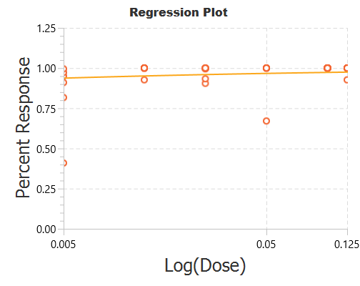 | - Pooled An. stephensi  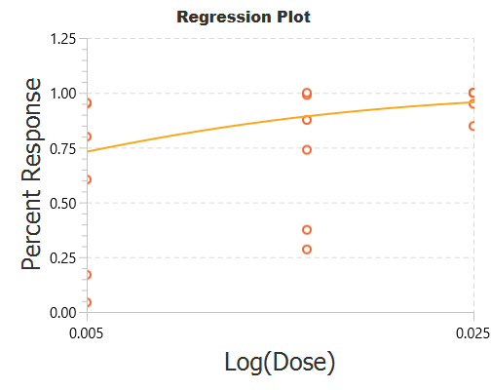
- Deltamethrin pooled all data
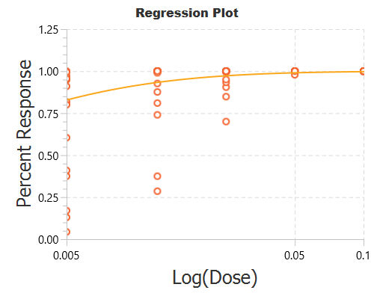
Permethrin dose response curves
- CDC An. albimanus Teco  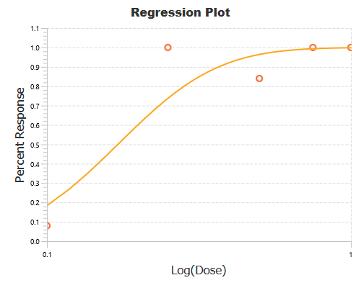 | - CDC An. gambiae G3  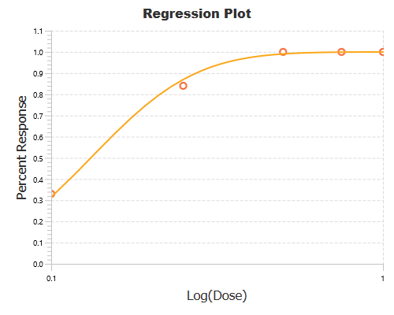
- LIN An. gambiae G3  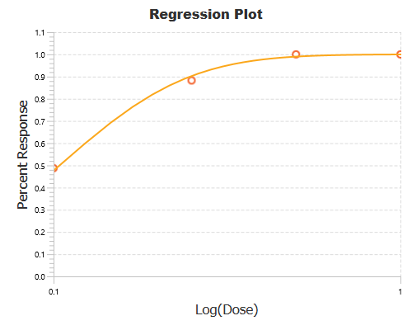 | - LSHTM An. gambiae Kwa  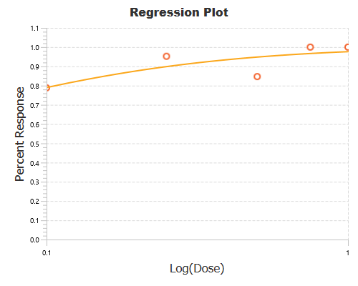
- Mali An. gambiae Mopti  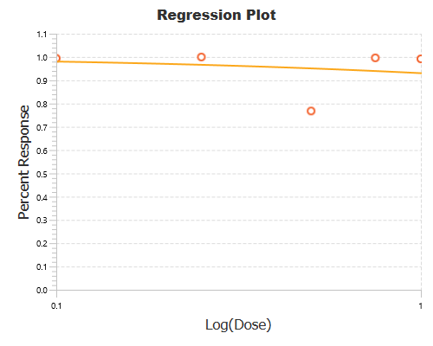 | - CDC An. stephensi Delhi  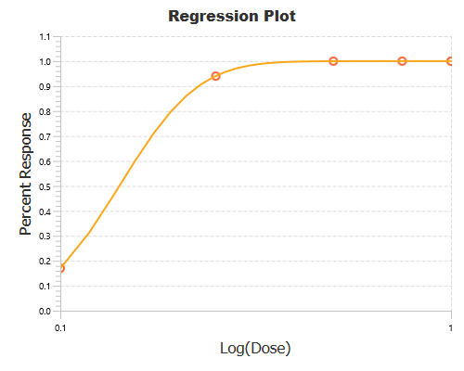
- Cardiff An. stephensi Beech  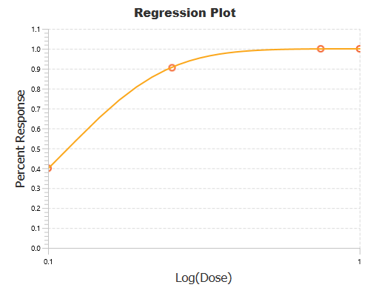 | - LSHTM An. stephensi Beech  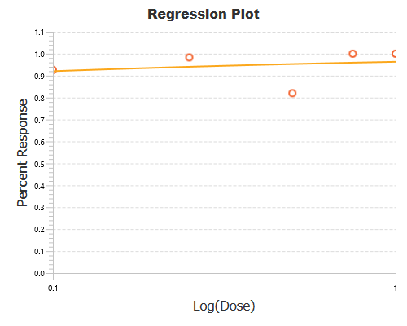
- Pooled An. albimanus  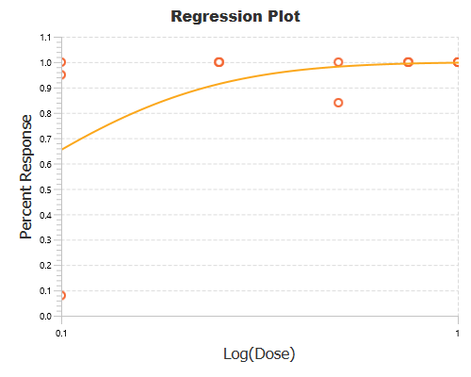 | - Pooled An. gambiae  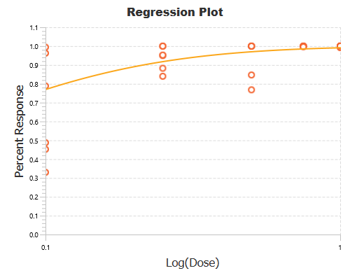
- Pooled An. stephensi  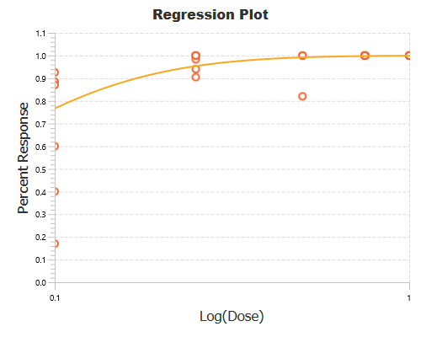 | - Permethrin pooled all data  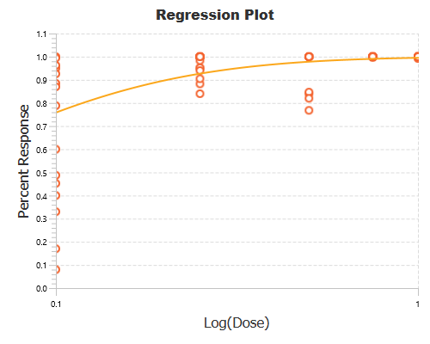
Figure S1. Dose response curves for deltamethrin (A – M) and permethrin (N – Y) using original raw data from the 1998 WHO multicentre study [1]

Table S1. Probit analysis of deltamethrin and permethrin using original raw data from the 1998 WHO multicentre study [1]. Analysis was conducted using PoloJR program within PoloSuite (Ver 2.1). The discriminating dose is twice the LD₉₉. Abbreviations: LD = Lethal dose, DD = Discriminating dose.
Institute | Species | Strain | Insecticide | No. concentrations  test | Total  Mosquitoes exposed | LD₉₅ | LD₉₅  95% CI | LD₉₉ | LD₉₉  95% CI | DD
Deltamethrin
CDC | An. albimanus | Teco | Deltamethrin | 5 | 500 | 0.04 | 0.017 - 0 | 0.07 | 0.025 - 0 | 0.14
Cardiff | An. albimanus | Panama | Deltamethrin | 4 | 160 | LD matrix not calculated | - | - | - | -
LSHTM | An. albimanus | Mexico | Deltamethrin | 5 | 562 | LD matrix not calculated | - | - | - | -
CDC | An. gambiae | G3 | Deltamethrin | 5 | 500 | LD matrix not calculated | - | - | - | -
Cardiff | An. gambiae | G3 | Deltamethrin | 5 | 184 | 0.02 | ? | 0.04 | 0.013 - 0.001 | 0.08
LIN | An. gambiae | G3 | Deltamethrin | 3 | 900 | 0 | ? | 0.01 | ? | 0.2
LSHTM | An. gambiae | Kwa | Deltamethrin | 5 | 533 | LD matrix not calculated | - | - | - | -
Mali | An. gambiae | Mopti | Deltamethrin | 5 | 1525 | 0.02 | 0.013 - 0.061 | 0.08 | 0.038 -1.042 | 0.16
LIN | An. gambiae | Kisumu | Deltamethrin | 4 | 1400 | LD matrix not calculated | - | - | - | -
CDC | An. stephensi | Delhi | Deltamethrin | 3 | 300 | 0.02 | ? | 0.03 | ? | 0.06
Cardiff | An. stephensi | St | Deltamethrin | 3 | 120 | 0.06 | ? | 0.17 | ? | 0.34
Cardiff | An. stephensi | Beech | Deltamethrin | 3 | 128 | 0.03 | ? | 0.04 | ? | 0.08
LSHTM | An. stephensi | Beech | Deltamethrin | 3 | 317 | 1.72 | ? | 347.81 | 0.015 - 0.008 | 695.62
Iran | An. stephensi | Beech | Deltamethrin | 3 | 604 | 0.01 | ? | 0.01 | ? | 0.02
India | An. stephensi | Delhi | Deltamethrin | 2 | 525 | Excluded < 3 concentrations | - | - | - | -
Species pooled
Pooled | An. albimanus | Pooled | Deltamethrin | - | - | 0.03 | 0.013 -22.116 | 0.06 | 0.022 - 10109.5039 | 0.12
Pooled | An. gambiae | Pooled | Deltamethrin | - | - | 0.01 | 0.001 - 0.015 | 0.03 | 0.016 - 7.617 | 0.06
Pooled | An. stephensi | Pooled | Deltamethrin | - | - | 0.02 | 0.01 - 0.001 | 0.06 | 0.018 - 0 | 0.12
All pooled
Pooled | Pooled | Pooled | Deltamethrin | - | - | 0.02 | 0.01 - 0.055 | 0.05 | 0.023 - 1.166 | 0.1
Permethrin
CDC | An. albimanus | Teco | Permethrin | 5 | 500 | 0.46 | 0.167 - 0.059 | 0.69 | 0.265 - 0.015 | 1.38
Cardiff | An. albimanus | Panama | Permethrin | 4 | 160 | LD matrix not calculated | - | - | - | -
LSHTM | An. albimanus | Mexico | Permethrin | 5 | 504 | LD matrix not calculated | - | - | - | -
CDC | An. gambiae | G3 | Permethrin | 5 | 500 | 0.34 | 0.275 - 0.457 | 0.5 | 0.38 - 0.76 | 1
Cardiff | An. gambiae | G3 | Permethrin | 4 | 162 | 0.25 | 0.242 - 0.258 | 0.36 | 0.34 - 0.372 | 0.72
LIN | An. gambiae | G3 | Permethrin | 4 | 1500 | 0.32 | 0.233 - 0.624 | 0.5 | 0.328 - 1.393 | 1
LSHTM | An. gambiae | Kwa | Permethrin | 5 | 524 | 0.52 | ? | 1.96 | 0.333 - 0.06 | 3.92
Mali | An. gambiae | Mopti | Permethrin | 5 | 1425 | 0.52 | ? | 0.04 | ? | 0.08
LIN | An. gambiae | Kisumu | Permethrin | 4 | 1400 | LD matrix not calculated | - | - | - | -
CDC | An. stephensi | Delhi | Permethrin | 5 | 500 | 0.26 | 0.252 - 0.264 | 0.33 | 0.321 - 0.34 | 0.66
Cardiff | An. stephensi | St | Permethrin | 4 | 160 | LD matrix not calculated | - | - | - | -
Cardiff | An. stephensi | Beech | Permethrin | 4 | 162 | 0.3 | 0.275 - 0.335 | 0.45 | 0.393 - 0.52 | 0.9
LSHTM | An. stephensi | Beech | Permethrin | 5 | 522 | 0.42 | ? | 26.16 | ? | 52.32
Iran | An. stephensi | Beech | Permethrin | 5 | 1063 | LD matrix not calculated | - | - | - | -
India | An. stephensi | Delhi | Permethrin | 2 | 500 | Excluded < 3 concentrations | - | - | - | -
Species pooled
Pooled | An. albimanus | Pooled | Permethrin | - | - | 0.33 | 0.161 - 0 | 0.62 | 0.271 - 0 | 1.24
Pooled | An. gambiae | Pooled | Permethrin | - | - | 0.36 | 0.218 - 1.518 | 0.93 | 0.445 - 21.446 | 1.86
Pooled | An. stephensi | Pooled | Permethrin | - | - | 0.24 | 0.155 - 1.478 | 0.47 | 0.255 - 21.446 | 0.94
All pooled
Pooled | Pooled | Pooled | Permethrin | - | - | 0.32 | 0.233 - 0.544 | 0.73 | 0.452 - 2.067 | 1.46

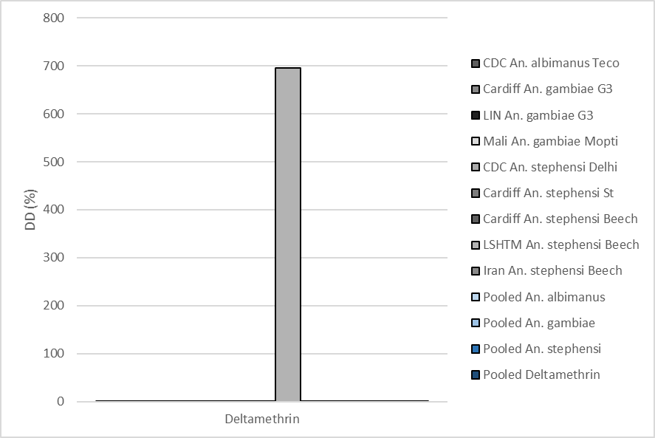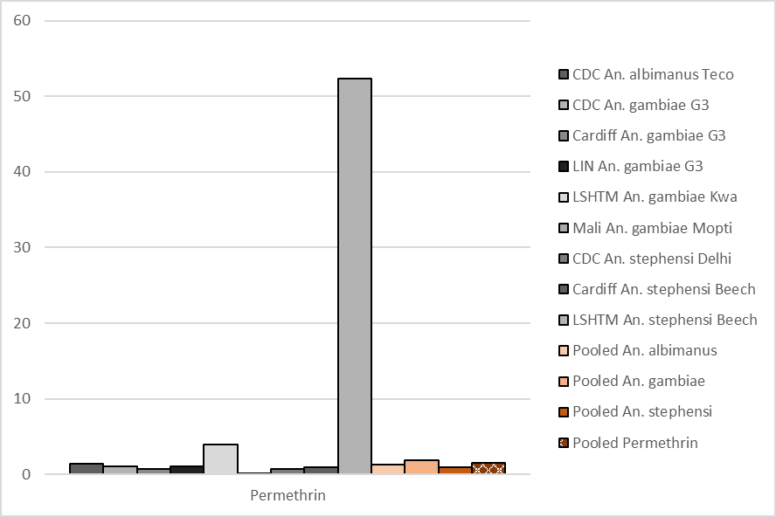
Figure S2. Calculated discriminating doses (%) for (A) deltamethrin and (B) permethrin. Points show individual sites/strain combinations, and data pooled by species or overall, by insecticide. Site/strain testing <3 concentrations of an insecticide and datasets not robust enough to calculate lethal dose matrixes are excluded. Discriminating doses are set at 2 x the calculated lethal dose at which 99% (LD99) of test mosquitoes were killed. LSHTM An. stephensi Beech data included.

A
B
C
Figure S3. Mosquito mortality (%) following exposure to deltamethrin in WHO tube bioassays of site/strain combinations for (A) An. albimanus, (B) An. gambiae, and (C) An. stephensi. Numbers above bars show number of exposed mosquitoes.

A

B

C

Figure S4. Mosquito mortality (%) following exposure to permethrin in WHO tube bioassays of site/strain combinations for (A) An. albimanus, (B) An. gambiae, and (C) An. stephensi. Numbers above bars show number of exposed mosquitoes.

Table S2. Summary statistics of variability in mosquito mortality following exposure to pyrethroids in standard WHO tube or CDC bottle bioassays. Mosquitoes were exposed to insecticides following the recommended methods for each test and mortality in each replicate tube or bottle was recorded 24-hours post-exposure. The strains detailed here are those maintained by the Ranson Group or LITE at LSTM, UK. Abbreviations: R = Insecticide resistant mosquito strain, S = Insecticide susceptible mosquito strain, IKR = inter-quartile range.
Rearing group | Assay | Insecticide | Strain | R/S | Data points (replicate) | Lower range | Upper range | IKR | Mean | Median | Variance | Standard Deviation
Ranson | Tube | α-cypermethrin | Kisumu  An. gambiae | S | 4 | 95.00 | 100.00 | 5.00 | 97.50 | 97.50 | 8.33 | 2.89
Ranson | Tube | Deltamethrin | Kisumu  An. gambiae | S | 4 | 100.00 | 100.00 | 0.00 | 100.00 | 100.00 | 0.00 | 0.00
Ranson | Tube | Permethrin | Kisumu  An. gambiae | S | 3 | 95.00 | 100.00 | 2.50 | 98.33 | 100.00 | 8.33 | 2.89
Ranson | Tube | α-cypermethrin | N’gousso  An. coluzzii | S | 8 | 90.00 | 100.00 | 5.00 | 97.50 | 100.00 | 14.29 | 3.78
Ranson | Tube | Deltamethrin | N’gousso  An. coluzzii | S | 4 | 100.00 | 100.00 | 0.00 | 100.00 | 100.00 | 0.00 | 0.00
Ranson | Tube | Permethrin | N’gousso  An. coluzzii | S | 8 | 84.21 | 100.00 | 0.00 | 98.03 | 100.00 | 31.16 | 5.58
Ranson | Tube | α-cypermethrin | Banfora-Sus  An. coluzzii | S | 4 | 92.00 | 100.00 | 5.00 | 95.00 | 94.00 | 14.67 | 3.83
Ranson | Tube | Deltamethrin | Banfora-Sus  An. coluzzii | S | 4 | 80.00 | 88.00 | 7.63 | 83.88 | 83.75 | 20.06 | 4.48
Ranson | Tube | Permethrin | Banfora-Sus  An. coluzzii | S | 4 | 68.00 | 92.31 | 13.14 | 79.39 | 78.62 | 114.05 | 10.68
Ranson | Tube | α-cypermethrin | Banfora M  An. coluzzii | R | 3 | 0.00 | 30.00 | 15.00 | 13.33 | 10.00 | 233.33 | 15.28
Ranson | Tube | Deltamethrin | Banfora M  An. coluzzii | R | 8 | 0.00 | 10.00 | 0.00 | 1.25 | 0.00 | 12.50 | 3.54
Ranson | Tube | Permethrin | Banfora M  An. coluzzii | R | 12 | 0.00 | 24.00 | 9.00 | 6.74 | 4.08 | 57.33 | 7.57
Ranson | Tube | α-cypermethrin | Bakaridjan  An. gambiae | R | 4 | 0.00 | 8.00 | 2.00 | 2.00 | 0.00 | 16.00 | 4.00
Ranson | Tube | Deltamethrin | Bakaridjan  An. gambiae | R | 8 | 0.00 | 7.69 | 4.81 | 2.40 | 0.00 | 12.42 | 3.52
Ranson | Tube | Permethrin | Bakaridjan  An. gambiae | R | 4 | 0.00 | 4.35 | 1.09 | 1.09 | 0.00 | 4.73 | 2.17
Ranson | Tube | α-cypermethrin | Gaoura  An. arabiensis | R | 4 | 0.00 | 8.00 | 2.00 | 2.00 | 0.00 | 16.00 | 4.00
Ranson | Tube | Deltamethrin | Gaoura  An. arabiensis | R | 8 | 0.00 | 4.00 | 4.00 | 2.00 | 2.00 | 4.57 | 2.14
Ranson | Tube | Permethrin | Gaoura  An. arabiensis | R | 8 | 0.00 | 12.00 | 2.00 | 2.50 | 0.00 | 22.57 | 4.75
Ranson | Tube | Deltamethrin | Tiefora  An. coluzzii | R | 8 | 0.00 | 7.69 | 4.00 | 2.46 | 2.00 | 8.39 | 2.90
Ranson | Tube | Permethrin | Tiefora  An. coluzzii | R | 8 | 0.00 | 7.69 | 4.38 | 3.09 | 3.92 | 8.00 | 2.83
Ranson | Tube | Deltamethrin | VK7 2014  An. coluzzii | R | 4 | 4.17 | 13.04 | 3.72 | 8.80 | 9.00 | 13.85 | 3.72
Ranson | Tube | Permethrin | VK7 2014  An. coluzzii | R | 4 | 0.00 | 8.33 | 5.65 | 5.06 | 5.95 | 16.42 | 4.05
Ranson | Tube | α-cypermethrin | Tiassale 13  An. gambiae | R | 7 | 0.00 | 30.00 | 2.50 | 8.00 | 5.00 | 99.67 | 9.98
Ranson | Tube | Deltamethrin | Tiassale 13  An. gambiae | R | 3 | 45.00 | 55.00 | 5.00 | 48.33 | 45.00 | 33.33 | 5.77
Ranson | Tube | Permethrin | Tiassale 13  An. gambiae | R | 3 | 10.00 | 15.00 | 2.50 | 11.67 | 10.00 | 8.33 | 2.89
Ranson | Tube | α-cypermethrin | Fumoz  An. funestus | R | 4 | 0.00 | 4.00 | 1.00 | 3.00 | 4.00 | 4.00 | 2.00
Ranson | Tube | Deltamethrin | Fumoz  An. funestus | R | 24 | 0.00 | 16.67 | 8.08 | 4.68 | 4.00 | 22.06 | 4.70
Ranson | Tube | Permethrin | Fumoz  An. funestus | R | 6 | 0.00 | 28.00 | 3.07 | 6.62 | 3.85 | 113.40 | 10.65
LITE | Tube | α-cypermethrin | Fumoz  An. funestus | R | 4 | 0.00 | 10.00 | 3.10 | 5.08 | 5.16 | 16.78 | 4.10
LITE | Tube | Deltamethrin | Fumoz  An. funestus | R | 20 | 0.00 | 83.33 | 19.01 | 21.82 | 11.52 | 590.30 | 24.30
LITE | Tube | Permethrin | Fumoz  An. funestus | R | 23 | 0.00 | 86.21 | 42.67 | 25.24 | 9.52 | 847.92 | 29.12
LITE | Tube | α-cypermethrin | Kisumu  An. gambiae | S | 4 | 100.00 | 100.00 | 0.00 | 100.00 | 100.00 | 0.00 | 0.00
LITE | Tube | Deltamethrin | Kisumu  An. gambiae | S | 12 | 95.24 | 100.00 | 1.04 | 98.89 | 100.00 | 4.02 | 2.01
LITE | Tube | Permethrin | Kisumu  An. gambiae | S | 12 | 96.14 | 100.00 | 0.00 | 99.68 | 100.00 | 1.24 | 1.11
LITE | Tube | α-cypermethrin | Moz  An. arabiensis | S | 4 | 88.00 | 100.00 | 6.26 | 95.91 | 97.83 | 32.03 | 5.66
LITE | Tube | Deltamethrin | Moz  An. arabiensis | S | 12 | 83.33 | 100.00 | 13.00 | 93.19 | 96.00 | 46.13 | 6.79
LITE | Tube | Permethrin | Moz  An. arabiensis | S | 12 | 92.00 | 100.00 | 4.00 | 97.67 | 100.00 | 10.06 | 3.17
LITE | Tube | α-cypermethrin | Tiassale 13  An. gambiae | R | 8 | 4.00 | 12.50 | 5.13 | 8.13 | 7.42 | 10.61 | 3.26
LITE | Tube | Deltamethrin | Tiassale 13  An. gambiae | R | 24 | 0.00 | 41.67 | 12.51 | 15.35 | 12.25 | 121.23 | 11.01
LITE | Tube | Permethrin | Tiassale 13  An. gambiae | R | 25 | 0.00 | 62.50 | 25.00 | 15.97 | 12.00 | 256.38 | 16.01
LITE | Tube | α-cypermethrin | VK7 2014  An. coluzzii | R | 4 | 0.00 | 8.00 | 2.11 | 3.89 | 3.78 | 10.69 | 3.27
LITE | Tube | Deltamethrin | VK7 2014  An. coluzzii | R | 16 | 0.00 | 13.04 | 5.13 | 3.49 | 0.00 | 23.06 | 4.80
LITE | Tube | Permethrin | VK7 2014  An. coluzzii | R | 27 | 0.00 | 8.33 | 0.00 | 1.38 | 0.00 | 7.98 | 2.83
LITE | Bottle | Permethrin | Fumoz  An. funestus | R | 20 | 0.00 | 100.00 | 50.44 | 46.92 | 42.24 | 1121.92 | 33.50
LITE | Bottle | Permethrin + PBO | Fumoz  An. funestus | R | 18 | 69.57 | 100.00 | 0.00 | 96.62 | 100.00 | 96.87 | 9.84
LITE | Bottle | Permethrin | Kisumu  An. gambiae | S | 20 | 4.00 | 100.00 | 1.67 | 93.58 | 100.00 | 456.84 | 21.37
LITE | Bottle | Permethrin + PBO | Kisumu  An. gambiae | S | 17 | 8.00 | 100.00 | 0.00 | 94.59 | 100.00 | 497.88 | 22.31
LITE | Bottle | Permethrin | Tiassale 13  An. gambiae | R | 18 | 0.00 | 73.91 | 44.53 | 33.27 | 30.93 | 513.42 | 22.66
LITE | Bottle | Permethrin + PBO | Tiassale 13  An. gambiae | R | 21 | 4.17 | 100.00 | 16.67 | 88.62 | 100.00 | 454.27 | 21.31
LITE | Bottle | Permethrin | VK7 2014  An. coluzzii | R | 20 | 0.00 | 21.43 | 8.54 | 8.91 | 9.56 | 59.31 | 7.70
LITE | Bottle | Permethrin + PBO | VK7 2014  An. coluzzii | R | 20 | 25.00 | 100.00 | 7.73 | 87.06 | 100.00 | 630.80 | 25.12

Table S3 P-values (Welch’s t-test) comparing mean mosquito mortality following exposure to α-cypermethrin 0.05%, deltamethrin 0.05%, or permethrin 0.75% in a standard WHO tube bioassay. Values significant at the 5% level (p = < 0.05) are highlighted in blue. Abbreviations; Delta = deltamethrin, Perm = permethrin, Alpha = α-cypermethrin.
Group | Strain | Delta v Perm | Delta v Alpha | Perm v Alpha | Delta v Perm + PBO | Perm v Perm + PBO | Alpha v Perm + PBO
Ranson | Banfora-Susceptible | 0.482 | 0.010 | 0.055 | - | - | -
 | Kisumu | 0.423 | 0.182 | 0.723 | - | - | -
 | N'gousso | 0.351 | 0.104 | 0.829 | - | - | -
 | Banfora M | 0.044 | 0.303 | 0.536 | - | - | -
 | Bakaridjan | 0.446 | 0.870 | 0.706 | - | - | -
 | FUMOZ-R | 0.680 | 0.254 | 0.451 | - | - | -
 | Gaoura | 0.792 | 1.000 | 0.854 | - | - | -
 | Tiassalé 13 | 0.002 | 0.000 | 0.401 | - | - | -
 | Tiefora | 0.668 | - | - | - | - | -
 | VK7 2014 | 0.223 | - | - | - | - | -
LITE | Kisumu | 0.251 | 0.082 | 0.339 | - | - | -
 | Moz | 0.055 | 0.458 | 0.590 | - | - | -
 | FUMOZ-R | 0.678 | 0.009 | 0.004 | 0.000 | 0.000 | 0.000
 | Tiassalé 13 | 0.874 | 0.008 | 0.029 | 0.002 | 0.001 | 0.002
 | VK7 2014 | 0.124 | 0.851 | 0.225 | 0.738 | 0.506 | 0.652

- Banfora susceptible (Ranson group)
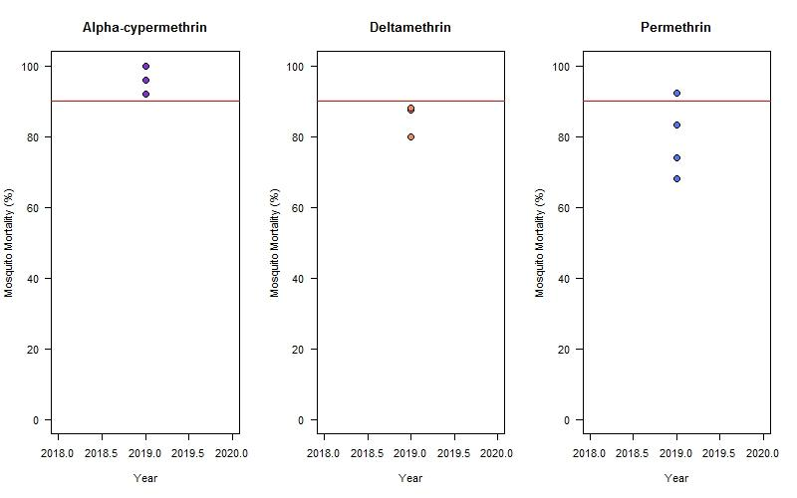
- Kisumu (Ranson group)
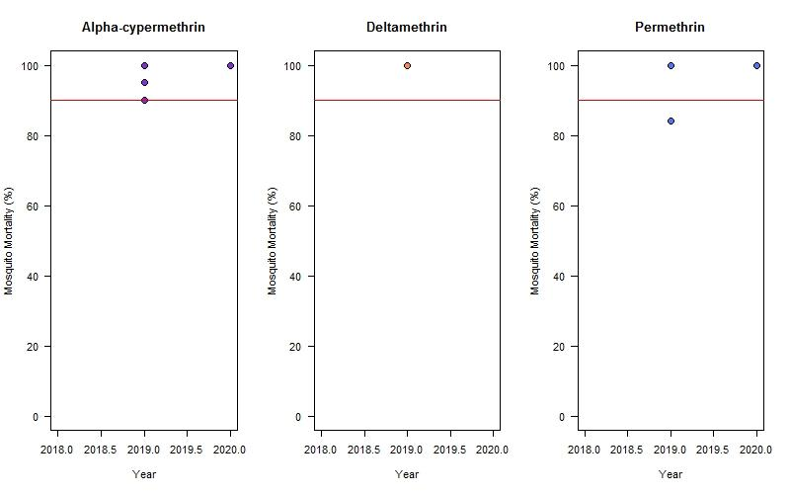

- N’gousso (Ranson group)
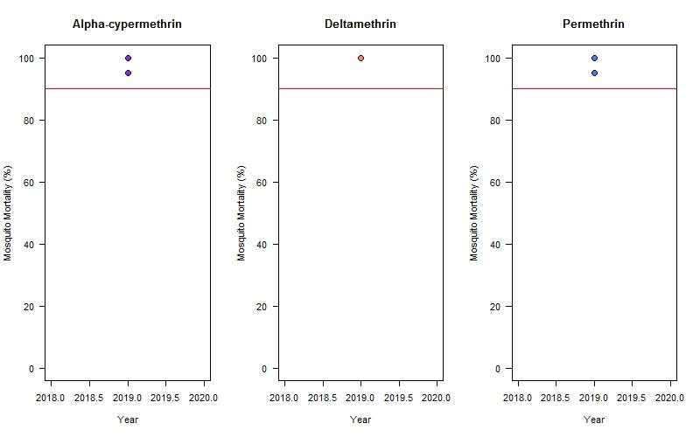
- Banfora M (Ranson group)
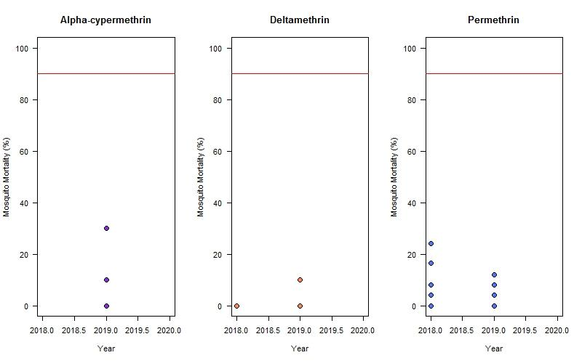

- Bakaridjan (Ranson group)
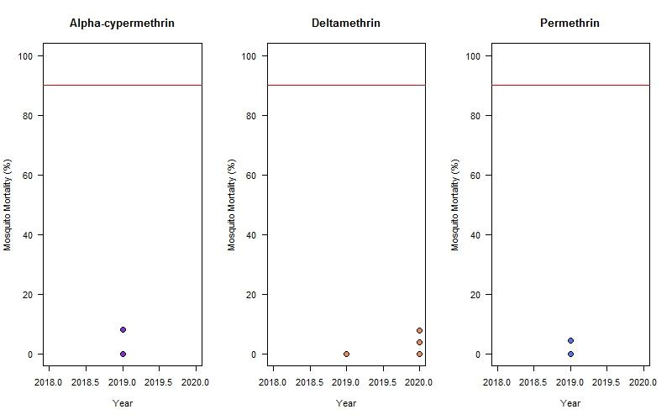
- FUMOZ-R (Ranson group)
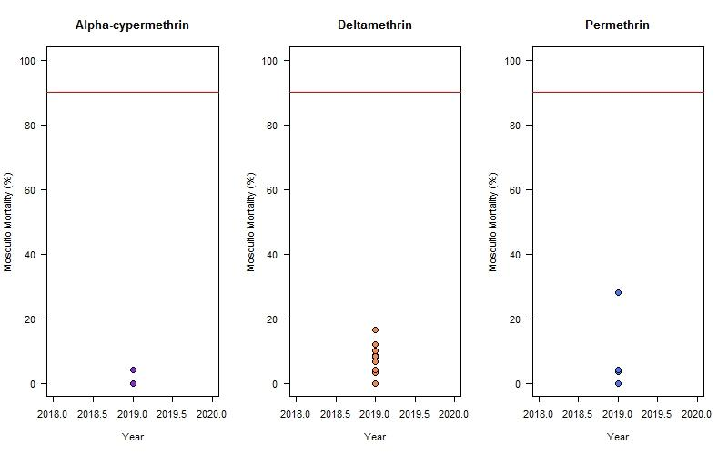

- Gaoura (Ranson group)
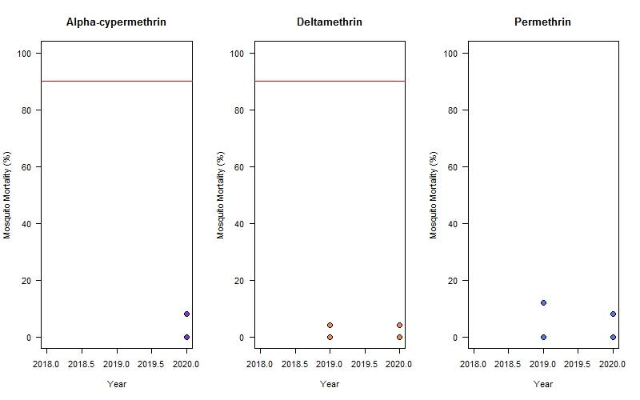
- Tiassalé 14 (Ranson group)
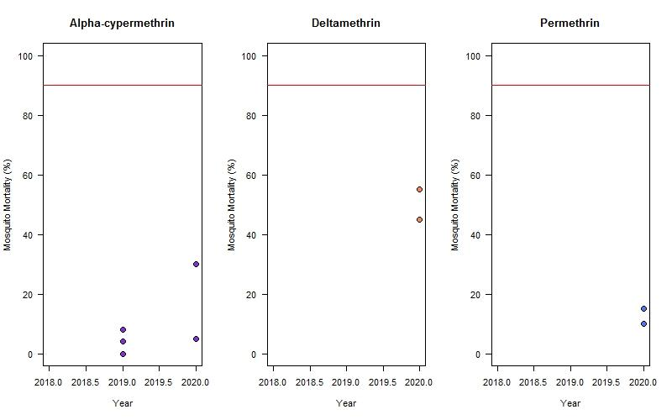

- Tiefora (Ranson group)
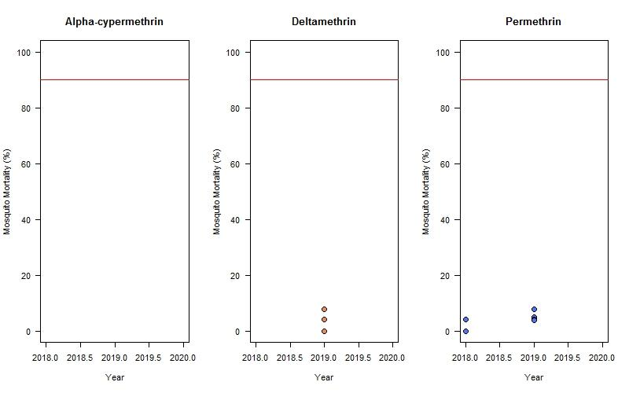
- VK7 2014 (Ranson group)
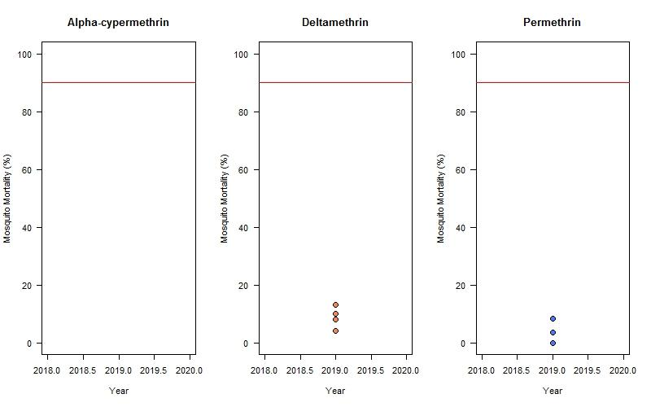

- Kisumu (LITE)
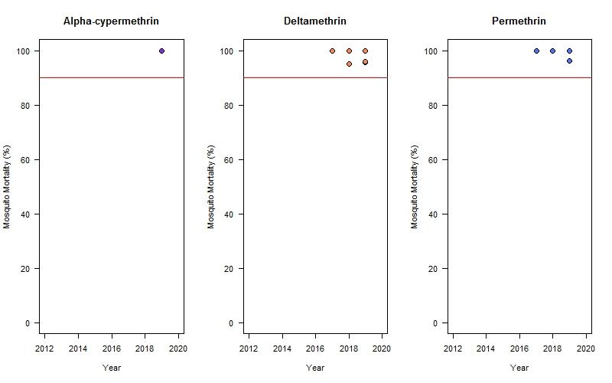
- Moz (LITE)
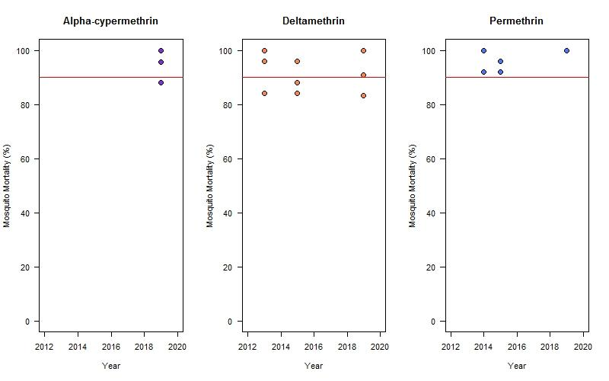

- FUMOZ-R (LITE)
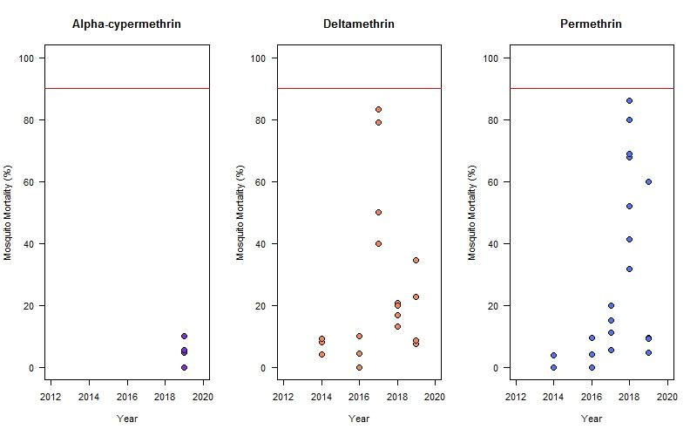
- Tiassalé 13 (LITE)
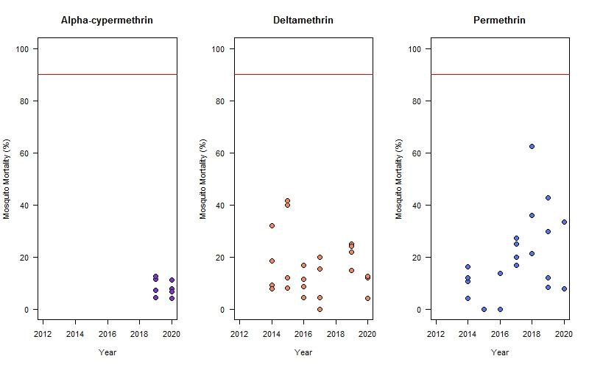

- VK7 2014 (LITE)
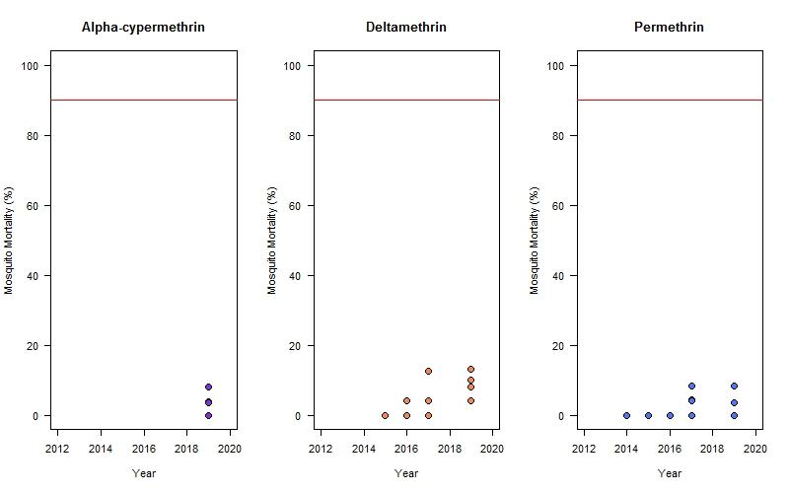
Figure S5. Mosquito mortality over time following exposure to pyrethroids in a standard WHO tube bioassay. Ranson group (A- J) and LITE (K – O) mosquito strains were exposed to deltamethrin 0.05%, permethrin 0.75% and α-cypermethrin 0.05% in a standard 1-hour WHO tube bioassay, and their 24-hour mortality was recorded. Coloured circles indicate each individual replicate tube.

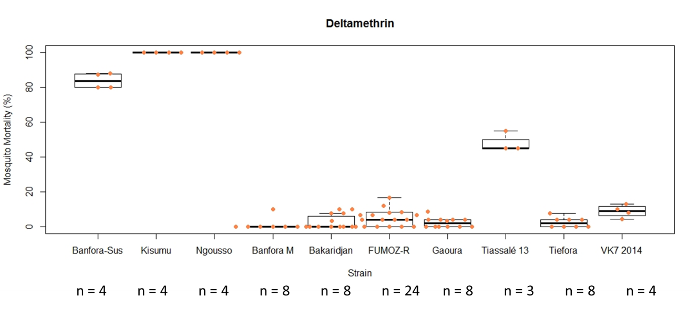
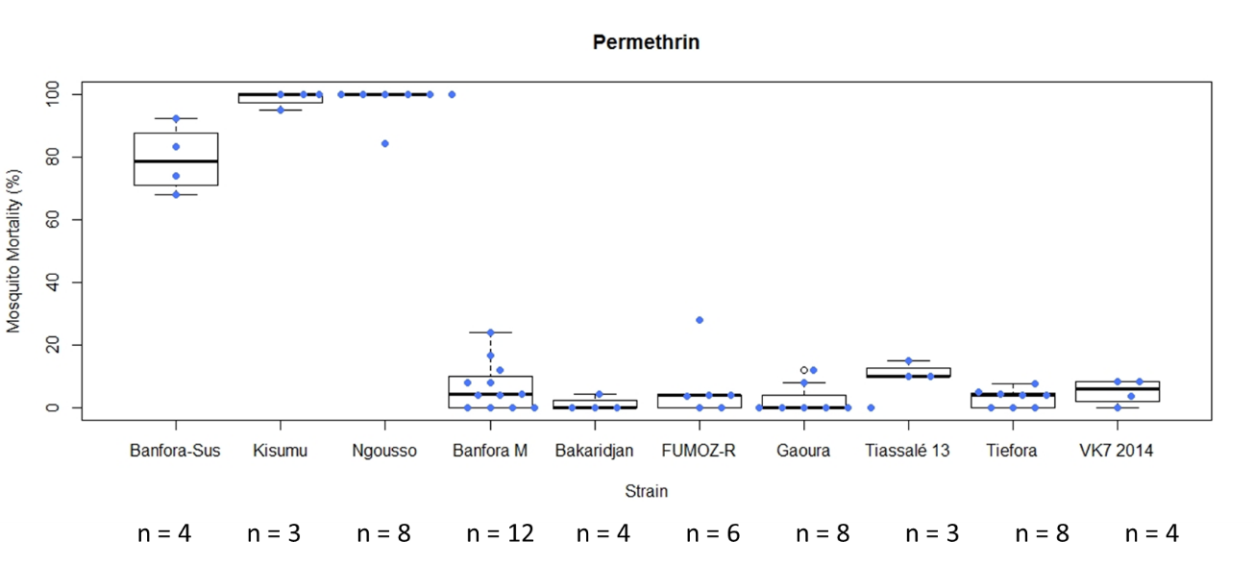
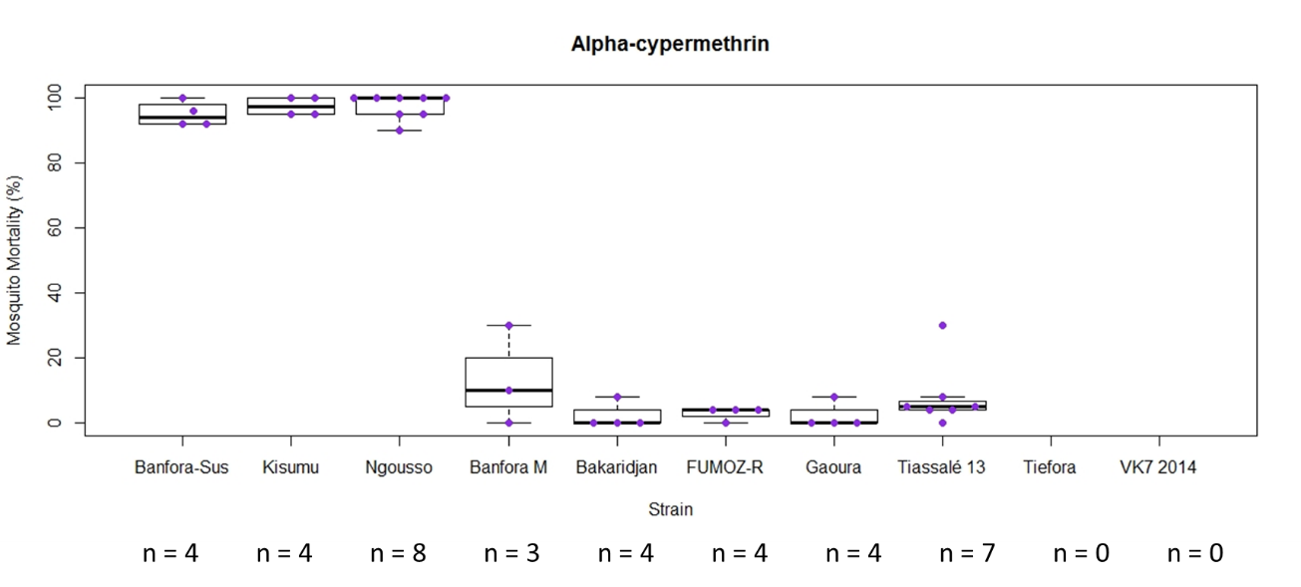
Figure S6. Box plot summarising mosquito mortality following exposure to deltamethrin 0.05% (top), permethrin 0.75% (middle), or α-cypermethrin 0.05% (bottom) in a standard WHO tube bioassay in Ranson group strains. Each box represents a different mosquito strain. Coloured circles and n-numbers indicate each individual tube replicate.

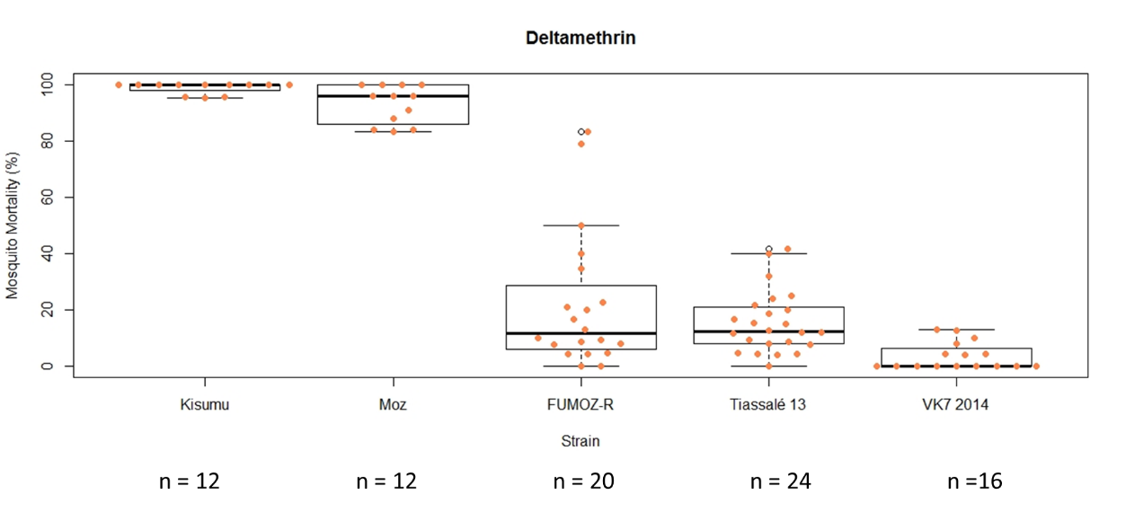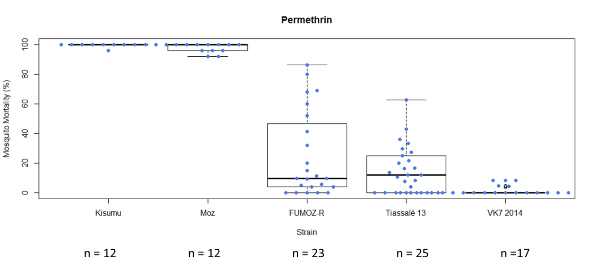
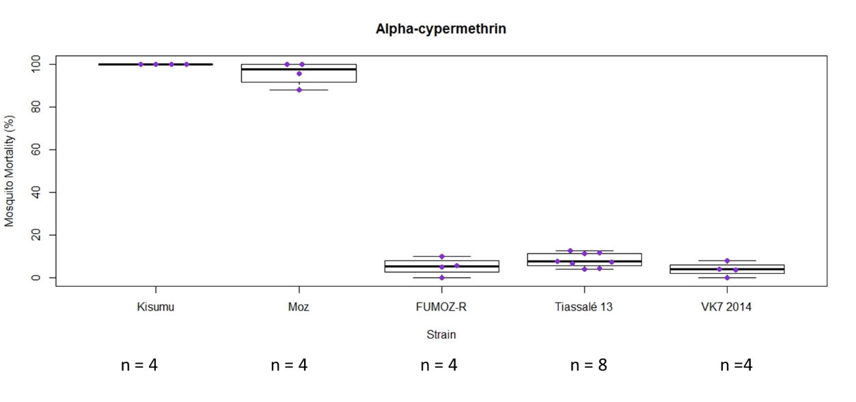
Figure S7. Box plot summarising mosquito mortality following exposure to deltamethrin 0.05% (top), permethrin 0.75% (middle), or α-cypermethrin 0.05% (bottom) in a standard WHO tube bioassay in LITE strains. Each box represents a different mosquito strain. Coloured circles and n-numbers indicate each individual tube replicate.

B
A
A

Figure S8. Distribution of larval relatedness of (A) An. gambiae and (B) An. Coluzzii within breeding sites sampled across multiple locations in 2016 from southern Ghana. Individuals (median N=7 per site) were genotyped by reduced coverage whole genome sequencing and pairwise relatedness categories estimated from chromosome 3 data (2229 SNP markers) as siblings or unrelated using ML-Relate (Kalinowski 2006). The percentage of sibling relationships is shown. Sample site numbers are nominal and are not equivalent between plots.

