Supporting Figures
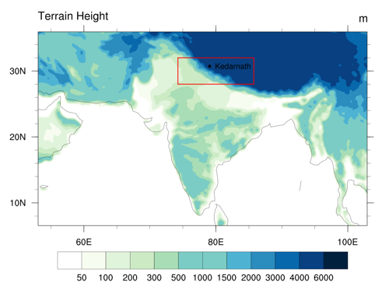
Figure S1. Domain of simulation at 25 km resolution, domain of simulation at 4 km resolution (red box) and Kedarnath (black dot).

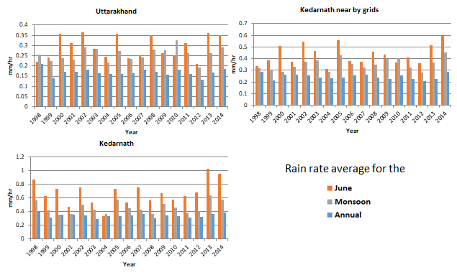
Figure S2. Rain rate over Uttarakhand, nearby Kedarnath and over Kedarnath average for annual, monsoon and June month.

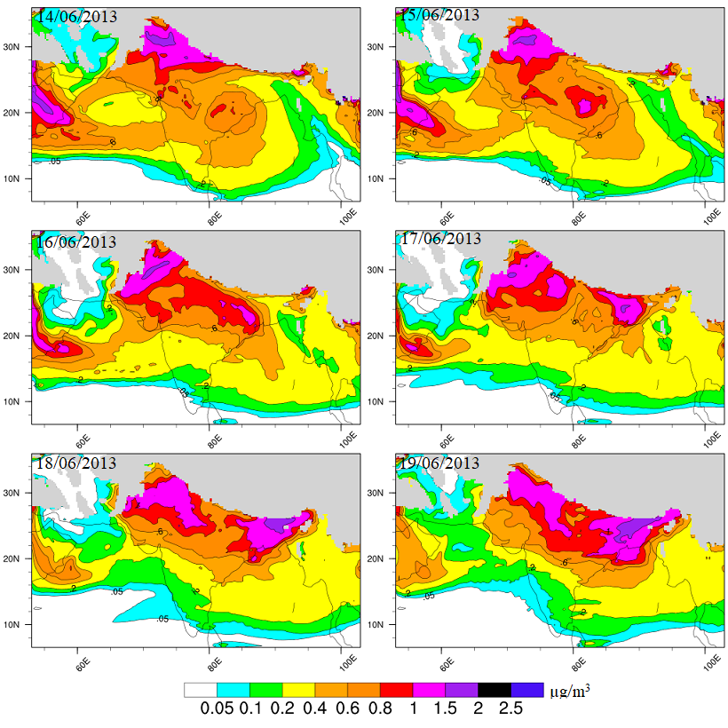
Figure S3a: BC1 concentration at 850 hPa from 14th - 19th June 2013.

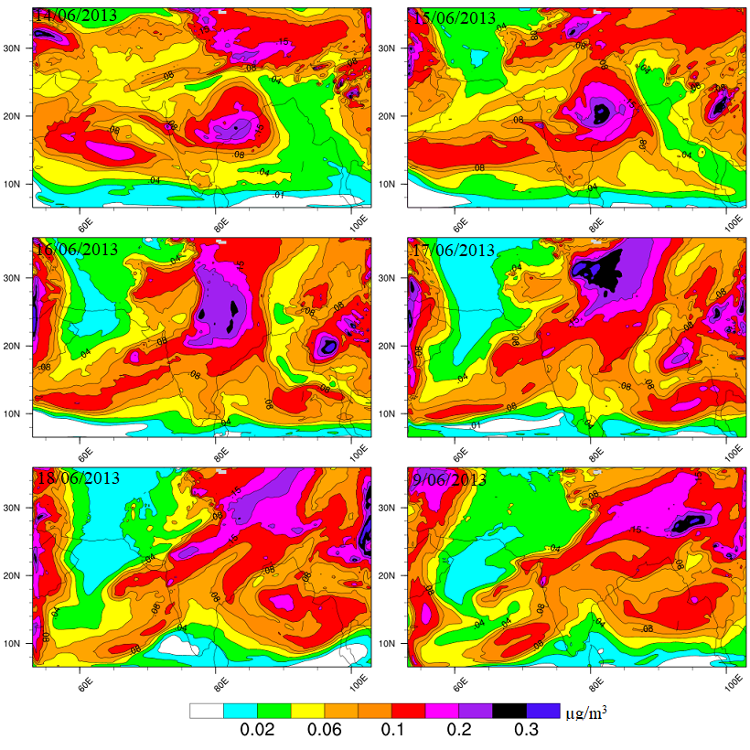
Figure S3b: BC1 concentration at 500 hPa from 14th - 19th June 2013.

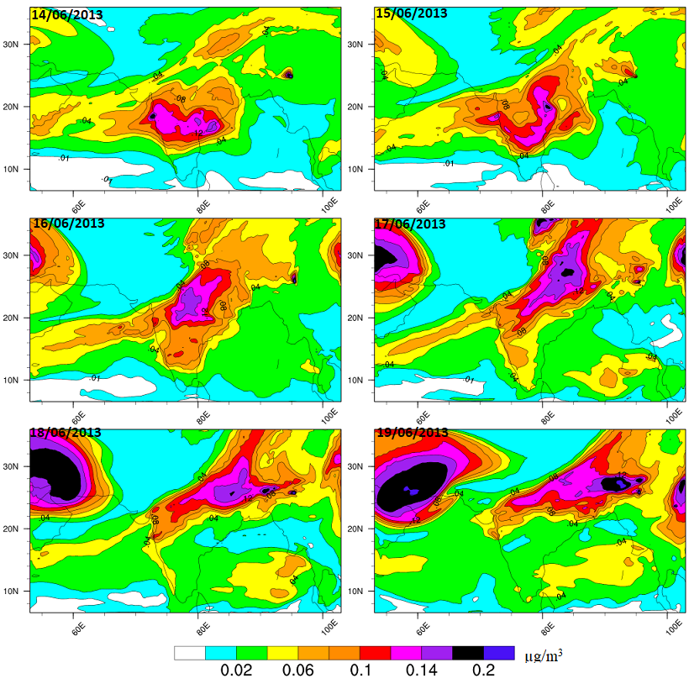
Figure S3c: BC1 concentration at 300 hPa from 14th - 19th June 2013.

Figure S4a: BC1 volume flow on 17th June 2013, 25 km resolution.

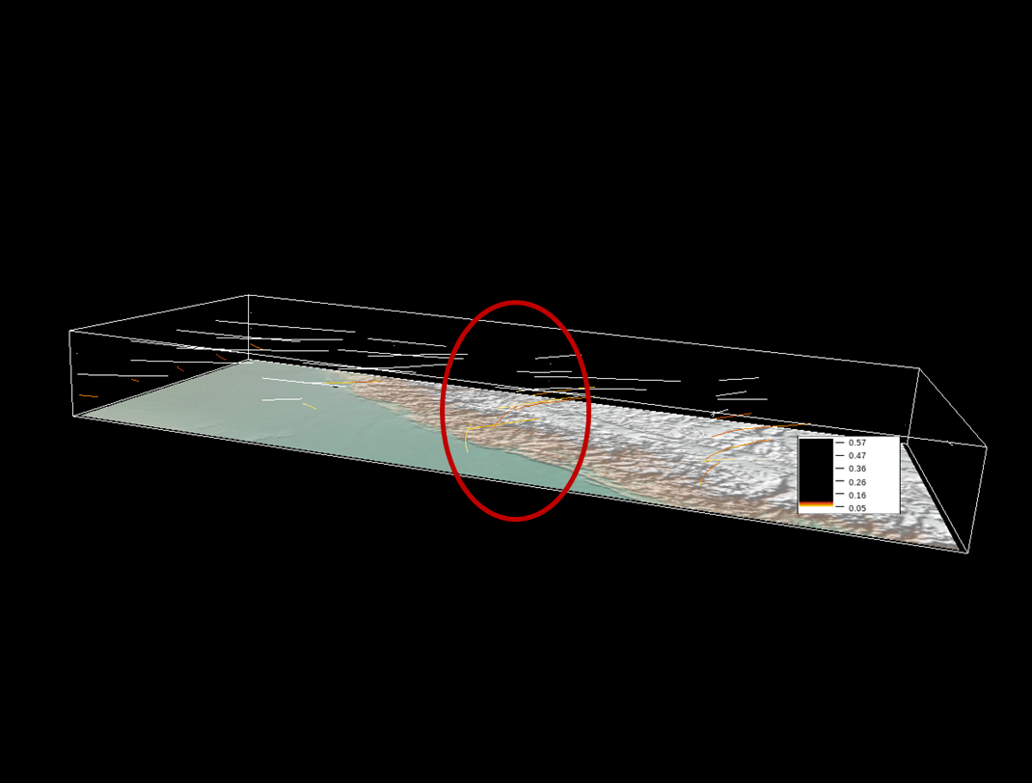
Figure 4b: BC1 volume flow on 17th June 2013, 4 km resolution

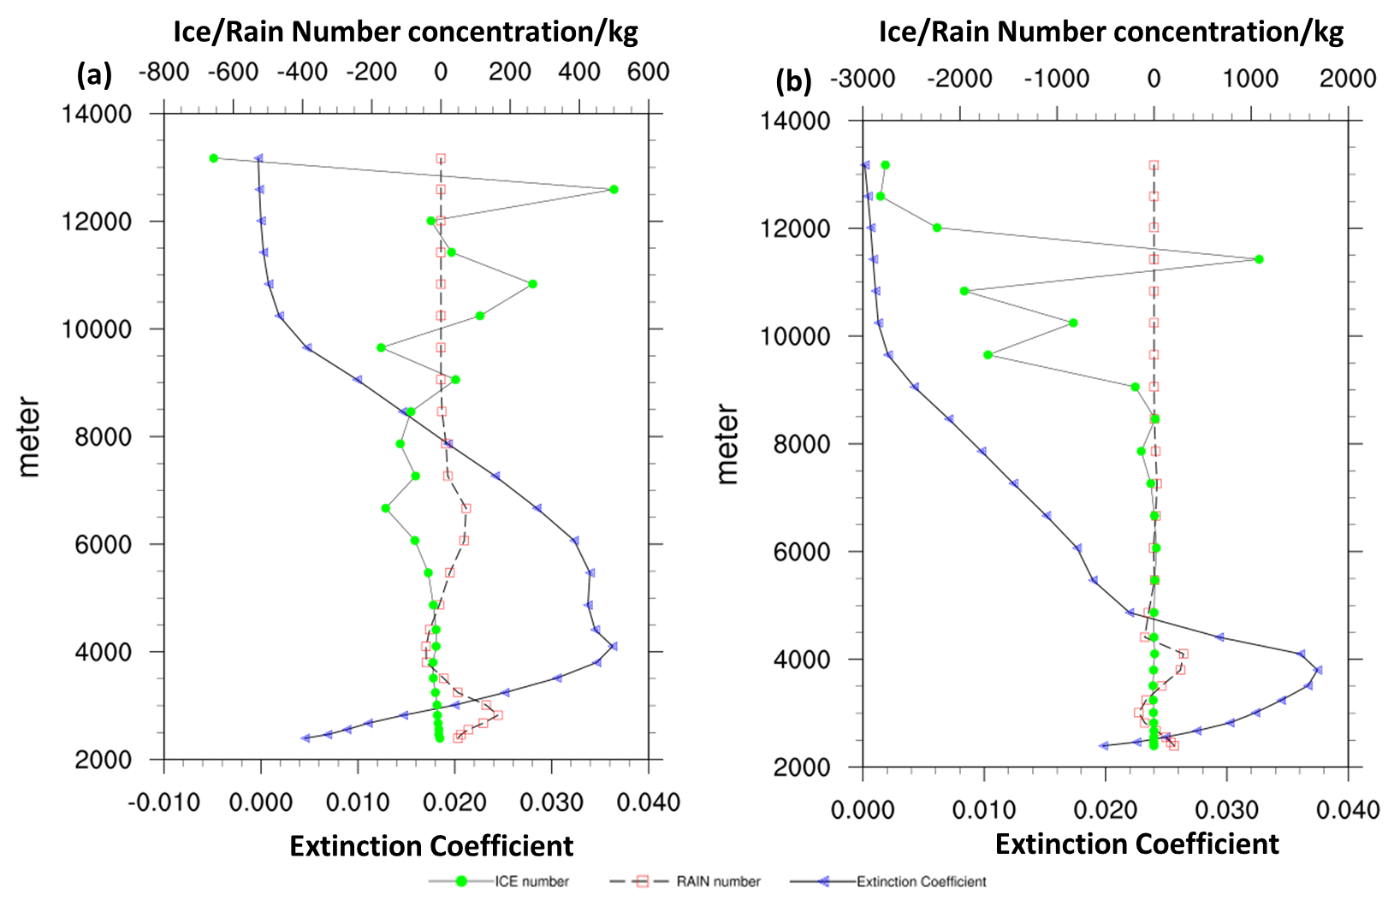
Figure S5. Difference of Extinction Coefficient, rain and ice concentration profile over Kedarnath during a) 16th June and b) 17th June from WC25, WRF25 simulations.
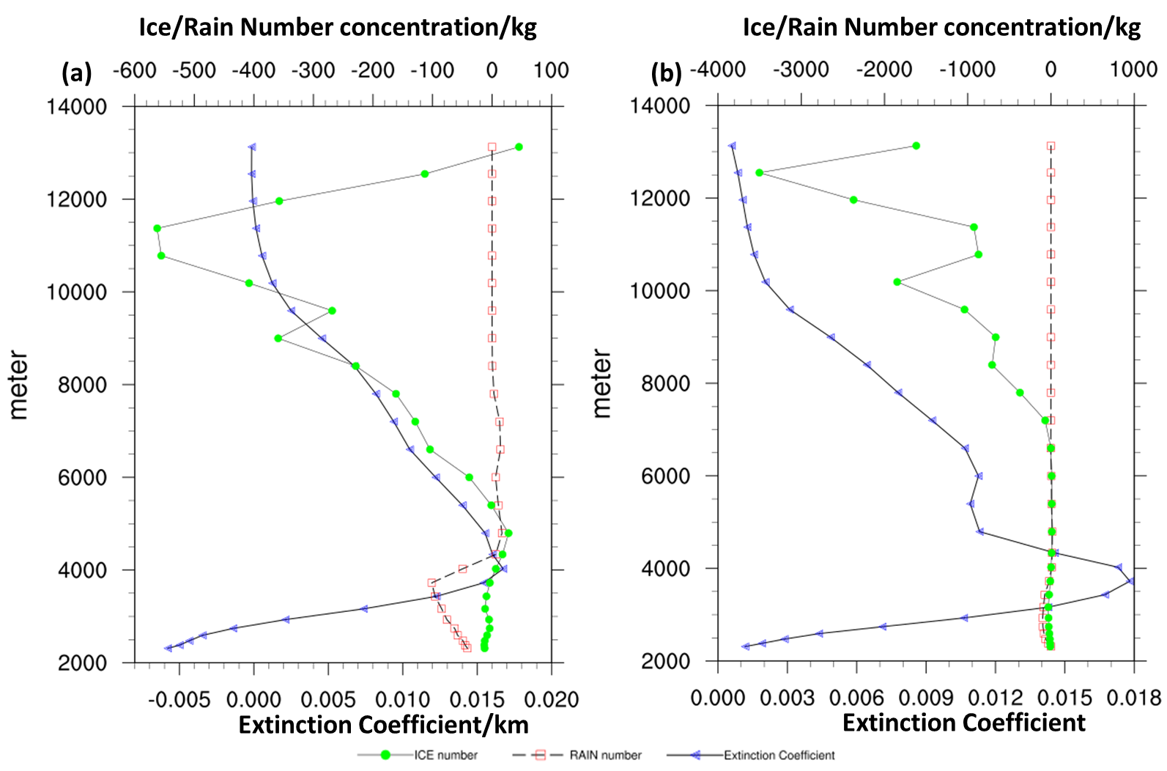
Figure S6. Difference of Extinction Coefficient, rain and ice concentration profiles over Kedarnath during a) 16th June and b) 17th June from WC4, WRF4 simulations (WC4-WRF4).

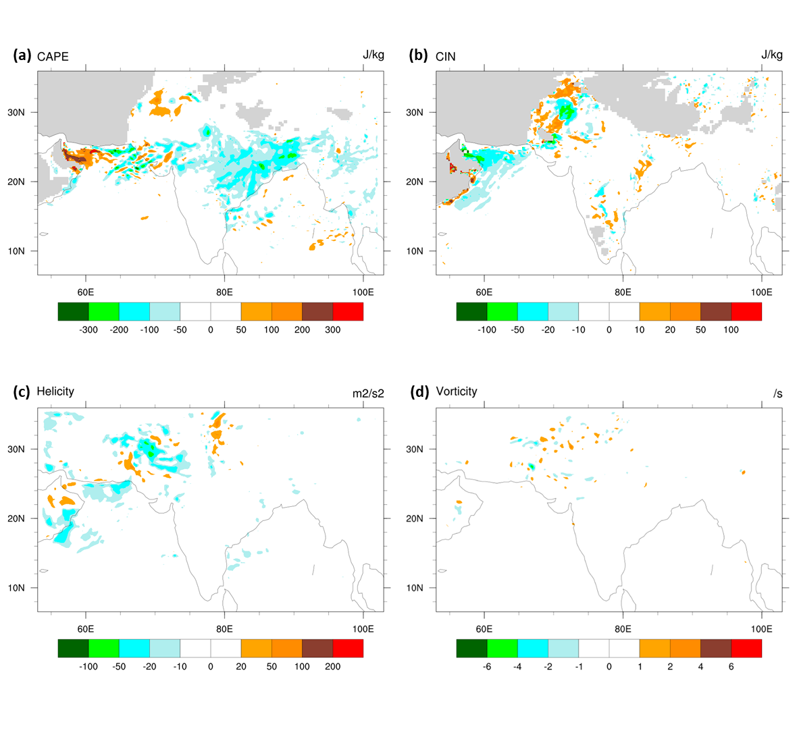
Figure S7. Effect of aerosols on a) CAPE, b) CIN, c) helicity and d) vorticity at 25 km resolution (WC25-WRF25) during 17th June.

Table S1: Average rain rate (mm/hr) over Uttarakhand, Kedarnath and nearby area for the period of 1998-2014 from TRMM.
Year | Uttarakhand |  |  | Kedarnath nearby area |  |  | Kedarnath
 | June | Monsoon | Annual | June | Monsoon | Annual | June | Monsoon | Annual
1998 | 0.22 | 0.26 | 0.21 | 0.34 | 0.32 | 0.28 | 0.87 | 0.57 | 0.39
1999 | 0.24 | 0.22 | 0.14 | 0.39 | 0.31 | 0.21 | 0.63 | 0.42 | 0.31
2000 | 0.36 | 0.24 | 0.17 | 0.51 | 0.29 | 0.26 | 0.73 | 0.36 | 0.35
2001 | 0.31 | 0.23 | 0.17 | 0.37 | 0.33 | 0.26 | 0.48 | 0.36 | 0.35
2002 | 0.36 | 0.29 | 0.18 | 0.55 | 0.38 | 0.26 | 0.76 | 0.50 | 0.35
2003 | 0.28 | 0.28 | 0.17 | 0.46 | 0.38 | 0.24 | 0.54 | 0.43 | 0.29
2004 | 0.24 | 0.22 | 0.16 | 0.31 | 0.29 | 0.23 | 0.34 | 0.37 | 0.34
2005 | 0.36 | 0.27 | 0.16 | 0.56 | 0.43 | 0.24 | 0.73 | 0.58 | 0.34
2006 | 0.24 | 0.23 | 0.16 | 0.38 | 0.36 | 0.26 | 0.54 | 0.45 | 0.35
2007 | 0.25 | 0.24 | 0.18 | 0.37 | 0.33 | 0.27 | 0.75 | 0.43 | 0.37
2008 | 0.35 | 0.28 | 0.17 | 0.46 | 0.35 | 0.24 | 0.57 | 0.36 | 0.30
2009 | 0.26 | 0.28 | 0.16 | 0.44 | 0.40 | 0.23 | 0.67 | 0.52 | 0.34
2010 | 0.25 | 0.33 | 0.18 | 0.37 | 0.40 | 0.26 | 0.58 | 0.46 | 0.34
2011 | 0.31 | 0.26 | 0.16 | 0.41 | 0.32 | 0.23 | 0.63 | 0.38 | 0.31
2012 | 0.21 | 0.19 | 0.13 | 0.36 | 0.28 | 0.21 | 0.68 | 0.41 | 0.33
2013 | 0.36 | 0.26 | 0.17 | 0.51 | 0.37 | 0.23 | 1.03 | 0.64 | 0.36
2014 | 0.35 | 0.29 | 0.19 | 0.59 | 0.45 | 0.28 | 0.96 | 0.57 | 0.39

Table S2. R² of precipitation from different simulation with observed precipitation from in situ and satellite observation.
Simulation | TRMM | WC25 |  | WRF25 |  | WC4 |  | WRF4
Stations | Obs. | Obs. | Sat. | Obs. | Sat. | Obs. | Sat. | Obs. | Sat.
Kedarnath | NA | NA | 0.36 | NA | 0.36 | NA | 0.40 | NA | 0.41
Champawat | 0.52 | 0.40 | 0.95 | 0.63 | 0.70 | 0.60 | 0.74 | 0.60 | 0.74
Nainital | 0.56 | 0.53 | 0.41 | 0.93 | 0.45 | 0.78 | 0.62 | 0.76 | 0.60
Jolly grant | 0.60 | 0.31 | 0.32 | 0.02 | 0.01 | 0.28 | 0.06 | 0.21 | 0.04
Dehradun | 0.32 | 0.28 | 0.27 | 0.14 | 0.02 | 0.41 | 0.06 | 0.36 | 0.03
Lambagrh | 0.58 | 0.63 | 0.74 | 0.66 | 0.56 | 0.65 | 0.54 | 0.39 | 0.54
Pandukeshwar | 0.49 | 0.23 | 0.74 | 0.41 | 0.56 | 0.36 | 0.56 | 0.36 | 0.56
Pipalkoti | 0.40 | 0.23 | 0.57 | 0.67 | 0.45 | 0.42 | 0.44 | 0.40 | 0.43

Table S3: ∆concentration for different aerosols and ∆ in absolute percentage in model column and at 850 hPa, 500 hPa, 300 hPa for 16th and 17th June 2013 over Kedarnath at 4km resolution.

Aerosols | 16th June 2013
 | Δ Column |  | Δ 850 hPa |  | Δ 500 hPa |  | Δ 300 hPa
 | ug/m3 | % | ug/m³ | % | ug/m3 | % | ug/m3 | %
BC | 0.069 | 62.69 | 0.318 | 71.64 | 0.056 | 69.01 | 0.019 | 123.85
OC | 0.267 | 49.22 | 1.321 | 58.75 | 0.173 | 51.07 | 0.059 | 119.12
DUST1 | 4.135 | 106 | 15.66 | 103.9 | 4.911 | 119 | 0.842 | 163.13
DUST2 | 9.283 | 107.1 | 35.49 | 104.3 | 10.94 | 123.1 | 1.831 | 168.1
DUST3 | 6.174 | 110.1 | 23.76 | 105.8 | 7.243 | 132.1 | 1.161 | 178.9
DUST4 | 1.829 | 124.1 | 7.276 | 112.3 | 2.063 | 169.8 | 0.307 | 204.4
DUST5 | 0.842 | 179.1 | 3.613 | 142.5 | 0.861 | 263.9 | 0.121 | 245.8
SEA SALT1 | 0.002 | 113.5 | 0.004 | 326.1 | 0.003 | 79.99 | 0.004 | 72.56
SEA SALT2 | 0.015 | 320.5 | 0.039 | 412.5 | 0.029 | 219.4 | 0.005 | 245.5
SEA SALT3 | 0.021 | 345.2 | 0.06 | 359.4 | 0.038 | 268.6 | 0.004 | 1001
SEA SALT4 | 0.0002 | 139.7 | 0.001 | 147.7 | 9E-05 | 188.6 | 5E-06 | 4185
sulf | -0.012 | -1.28 | -1.49 | -30.99 | 0.321 | 64.39 | 0.161 | 69.71
 | 17th June 2013
 | Δ Column |  | Δ 850 hPa |  | Δ 500 hPa |  | Δ 300 hPa
 | ug/m3 | % | ug/m3 | % | ug/m3 | % | ug/m3 | %
BC | 0.068 | 62.25 | 0.287 | 64.70 | 0.065 | 79.78 | 0.024 | 154.91
OC | 0.242 | 44.57 | 1.082 | 48.12 | 0.203 | 59.73 | 0.072 | 146.51
DUST1 | 4.449 | 114 | 16.99 | 112.8 | 6.059 | 146.8 | 0.947 | 183.51
DUST2 | 9.998 | 115.4 | 38.55 | 113.3 | 13.52 | 152.2 | 2.078 | 190.90
DUST3 | 6.687 | 119.3 | 26.04 | 115.9 | 9.0213 | 164.6 | 1.339 | 206.4
DUST4 | 2.003 | 135.9 | 8.062 | 124.1 | 2.614 | 215.2 | 0.371 | 246.2
DUST5 | 0.923 | 196.9 | 3.857 | 152.1 | 1.119 | 343.1 | 0.155 | 315.1
SEA SALT1 | 0.002 | 97.29 | 0.004 | 353.4 | 0.002 | 51.76 | 0.003 | 58.84
SEA SALT2 | 0.011 | 234.4 | 0.042 | 436.6 | 0.01 | 79.35 | 0.004 | 198.68
SEA SALT3 | 0.012 | 204.2 | 0.053 | 315.7 | 0.01 | 76.25 | 0.002 | 595.5
SEA SALT4 | 2E-05 | 13.39 | 1E-04 | 9.75 | 1E-05 | 188.7 | 1E-06 | 1533
sulf | -0.026 | -2.61 | -1.157 | -23.57 | 0.205 | 27.56 | 0.023 | 21.25

