Supplement

Table 1. The NGS analysis of the quality control.

Sample | Raw Read | Raw Base | Clean Read | Clean base | Q20 (%) | Q30 (%) | GC content (%)
Control | 52507748 | 7.9 G | 47230360 | 6.9 G | 98.75 | 95.22 | 51.875
C_10ug | 50871132 | 7.6 G | 45522748 | 6.7 G | 98.65 | 94.935 | 51.68
C_20ug | 58785584 | 8.8 G | 52546180 | 7.7 G | 98.71 | 95.1 | 52.015
C_30ug | 51634468 | 7.7 G | 45635416 | 6.7 G | 98.67 | 94.975 | 51.125

Table 2. The NGS analysis of the DEGseq Processlog
Set.Name | Trt | Ctrl | Raw.  Gene  Count | Prefilter.  Gene  Count | DEGseq.  outlier | DEGseq.  Outlier.  remove.  Gene  Count | Filter.  Gene  Count | Filter.  Gene  Count.  Up | Filter.  Gene  Count.  Down | Filter. Criteria
group 10ug vs Control | C_10ug | Control | 55536 | 11187 | 5 | 11182 | 279 | 177 | 102 | fc.threshold = 2 ; l2fc.threshold = 1 ; p.threshold = 0.005 ; ptype = adjust
group 20ug vs Control | C_20ug | Control | 55536 | 11187 | 5 | 11182 | 176 | 83 | 93 | fc.threshold = 2 ; l2fc.threshold = 1 ; p.threshold = 0.005 ; ptype = adjust
group 30ug vs Control | C_30ug | Control | 55536 | 11187 | 7 | 11180 | 360 | 228 | 132 | fc.threshold = 2 ; l2fc.threshold = 1 ; p.threshold = 0.005 ; ptype = adjust

Table 3. DEG seq prediction demonstrating S. suieae acetyl-xylogalactan facilitated the regulation of the apoptotic relative factors. Predicted expressed genes included Nfkbia, Hyou1, Ddit3, Gadd45a, Akt3, and Cflar.

Ensembl_gene_id | Symbol | Treatment | log2 FoldChange | P value | padj
ENSMUSG00000021025 | Nfkbia | 10ug | - | - | -
 |  | 20ug | 1.347814544 | 7.4173E-18 | 8.3778E-16
 |  | 30ug | 1.380527451 | 3.36846E-19 | 3.6211E-17
ENSMUSG00000032115 | Hyou1 | 10ug | 0.962404421 | 2.51659E-39 | 5.51776E-37
 |  | 20ug | 1.190381588 | 1.27077E-67 | 5.68391E-65
 |  | 30ug | 1.045345064 | 3.17948E-52 | 9.11451E-50
ENSMUSG00000025408 | Ddit3 | 10ug | 2.425985578 | 6.59176E-15 | 4.23615E-13
 |  | 20ug | 2.831432378 | 4.85266E-23 | 7.4332E-21
 |  | 30ug | 2.497456474 | 9.87924E-17 | 9.28151E-15
ENSMUSG00000036390 | Gadd45a | 10ug | 2.191850959 | 3.91206E-05 | 0.00068458
 |  | 20ug | 2.747488401 | 9.0039E-09 | 4.55573E-07
 |  | 30ug | 2.727069935 | 1.06739E-08 | 3.8998E-07

Ensembl_gene_id | Symbol | Treatment | Log2 FoldChange | P value | padj
ENSMUSG00000019699 | Akt3 | 10ug | - | - | -
 |  | 20ug | - | - | -
 |  | 30ug | 1.006068089 | 2.29643E-05 | 0.000423665
ENSMUSG00000026031 | Cflar | 10ug | 1.16575601 | 1.65751E-08 | 5.43527E-07
 |  | 20ug | 0.663139925 | 0.001510975 | 0.022348842
 |  | 30ug | 1.244150052 | 1.81719E-10 | 8.87169E-09

Control
30 μg
20 μg
10 μg
Figure 1. The NGS analysis of the FPKM Log Normalized Counts Sample 3D PCA

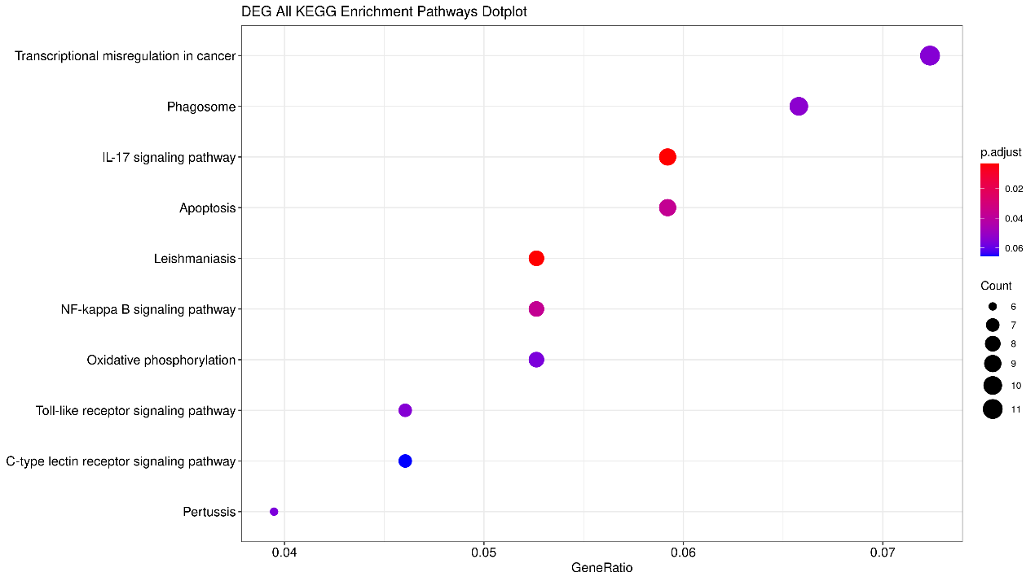
Figure 2. The NGS analysis of the KEGG pathway.

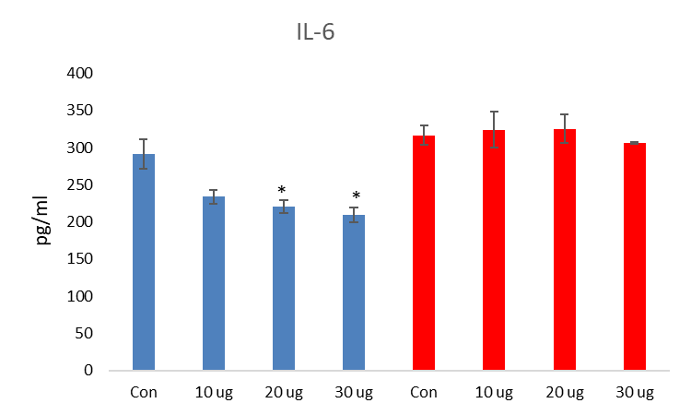
A.

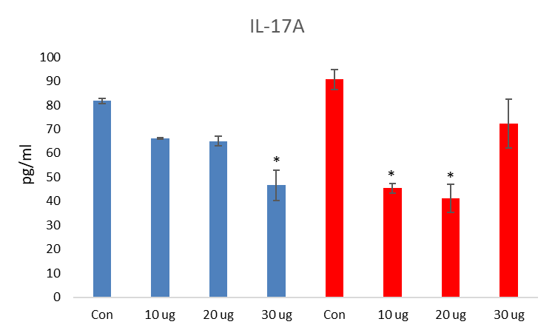
B.

Figure 3. Effect of the RAW 264.7 macrophage cytokine IL-6 (A) and IL-17A (B) production

