8. Supplementary material
Tables.2S. Complete data from the association analyses.
AIS & Hypertension (OR) |  |  |  | AIS & T2DM (OR) |  |  | AIS & Smoking (OR)
miRNA | OR  (95% CI) | P-val | Z statistic | OR  (95% CI) | P-val | Z statistic | OR  (95% CI) | P-val | Z statistic | Ref
miR-484 | 0.71  (0.22, 2.29) | 0.5626 | 0.579 | 2.13  (0.49, 9.10) | 0.3062 | 1.023 | 0.58  (0.18, 1.81) | 0.3520 | 0.931 | (41)
miR-107 | 0.71  (0.22, 2.29) | 0.5626 | 0.579 | 2.13  (0.49, 9.10) | 0.3062 | 1.023 | 0.58  (0.18, 1.81) | 0.3520 | 0.931 | (41)
miR-107_2 | 22.77  (9.74, 53.24) | <0.0001 | 7.211 | 6.48  (2.18, 19.26) | 0.0008 | 3.366 | 1.81  (0.92, 3.57) | 0.0831 | 1.733 | (42)
miR-16 | 2.12  (1.26, 3.56) | 0.0046 | 2.836 | 0.66  (0.38, 1.12) | 0.1287 | 1.519 | 1.95  (1.07, 3.54) | 0.0277 | 2.202 | (43)
miR-15a | 2.12  (1.26, 3.56) | 0.0046 | 2.836 | 0.66  (0.38, 1.12) | 0.1287 | 1.519 | 1.95  (1.07, 3.54) | 0.0277 | 2.202 | (43)
miR-4454 | 0.71  (0.22, 0.29) | 0.5626 | 0.579 | 2.13  (0.49, 9.10) | 0.3062 | 1.023 | 0.58  (0.18, 1.81) | 0.3520 | 0.931 | (41)
miR-125b-5p | 4  (0.98, 16.27) | 0.0528 | 1.936 | 11.18  (0.56, 222.99) | 0.1139 | 1.581 | 0.81  (0.23, 2.85) | 0.7492 | 0.32 | (30)
miR-124-3p | ND * | --- | --- | ND * | --- | --- | ND * | --- | --- | ---
miR-320b | ND * | --- | --- | ND * | --- | --- | ND * | --- | --- | ---
(ND= no determined, * Clinical data were not available for analysis)

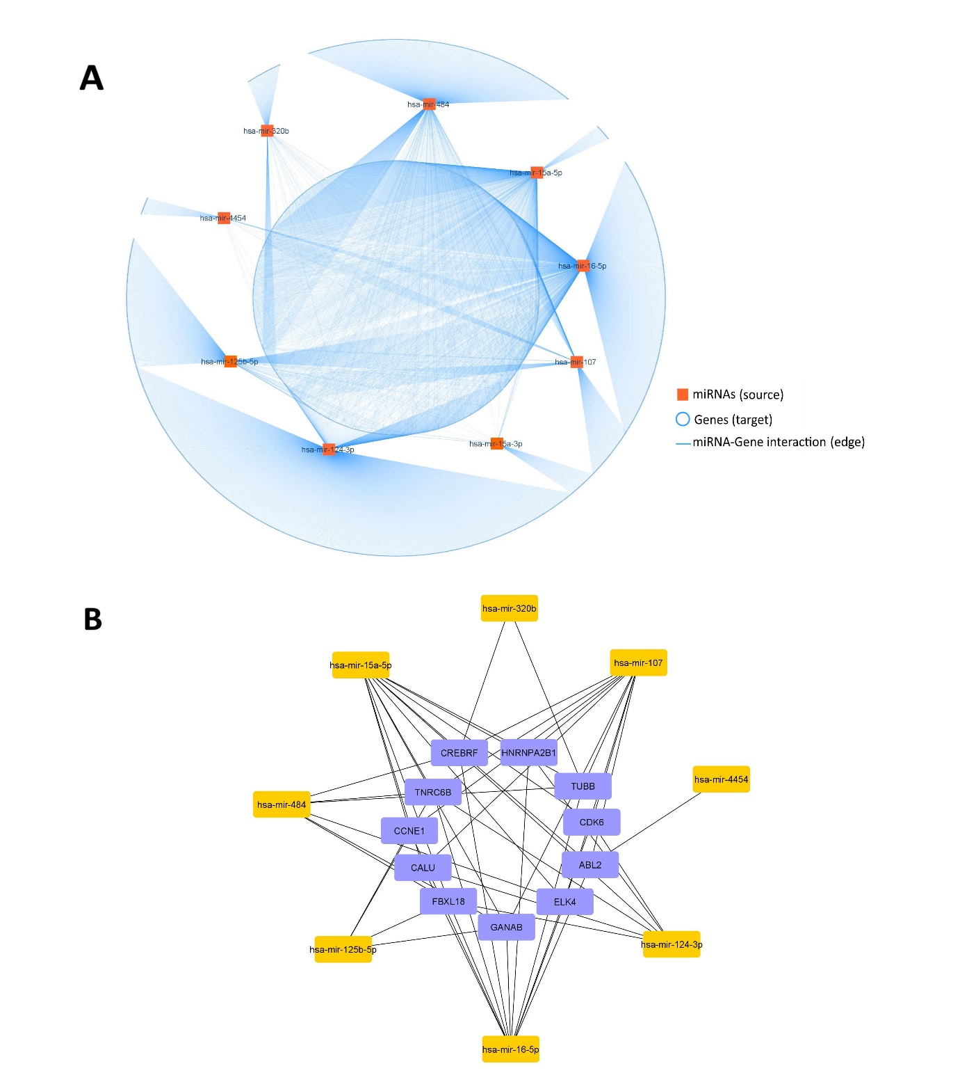
Figure 1S. Gene enrichment analyses from the set of miRNAs shared among AIS patients. (A) The structural network that represents miRNA-gene interaction, this network was built with the eight miRNAs miR-484, miR-320b, miR-125b-5p, miR-107, miR-124-3p, miR-4454, miR-16, miR-15a, identified in Figures 2 and 3. (B) Structural network that represents the top 20 most connected nodes (15 interactions) among the miRNA-gene interaction, miRNAs are in yellow and the genes that they altered are in purple.

Figure 2S. Pathway enrichment analyses from the set of miRNAs shared among AIS patients. (A) Each box represents a zoom-in of the significant signaling process altered by miR-484, miR-320b, miR-125b-5p, miR-107, miR-124-3p, miR-4454, miR-16, and miR-15a. The size of the node is directly proportional to the number of the genes that are altered in the signaling pathways; color scale (bottom right corner) represents the significance value from the lowest (highlighted in yellow, P value 0.05) to the higher value (colored in orange, P value <0.0000005). Statistical significance is adjusted by Bejamin-Hochberg), (B-D) Results from the enrichment analyses performed in KEGG (B), GO:BP (C) and Reactome (P value >0.05) adjusted by the Wilcoxon rank-sum test.

Figure 3S. Forest plots analyzed by tissue. (A) Studies performed in blood (Q=1823.75, p-value <0.0001). (B) Studies performed in plasma (Q=111.92, p-value<0.0001). (C) Studies performed in serum (Q=207.91, p-value<0.0001). (D) Studies performed in CSF (Q=0.00, p-value=1). (E) Studies performed in other tissues (immune cells and exosomes) (Q=1.67, p-value=0.64). The squares correspond to the miRNA-OR, and the size reflects its weight. Horizontal lines correspond to the 95% CIs. The diamond represents the pooled ORs of the overall population. The vertical solid line shows the Log OR of 0.

Figure 4S. Funnel plots analyzed by tissue samples. (A) Studies performed in blood. (B) Studies performed in plasma. (C) Studies performed in serum. (D) Studies performed in CSF. (E) Studies performed in other samples (immune cells or exosomes). The vertical solid line represents the summary effect estimate, and the 95% CI zone is shown in white.

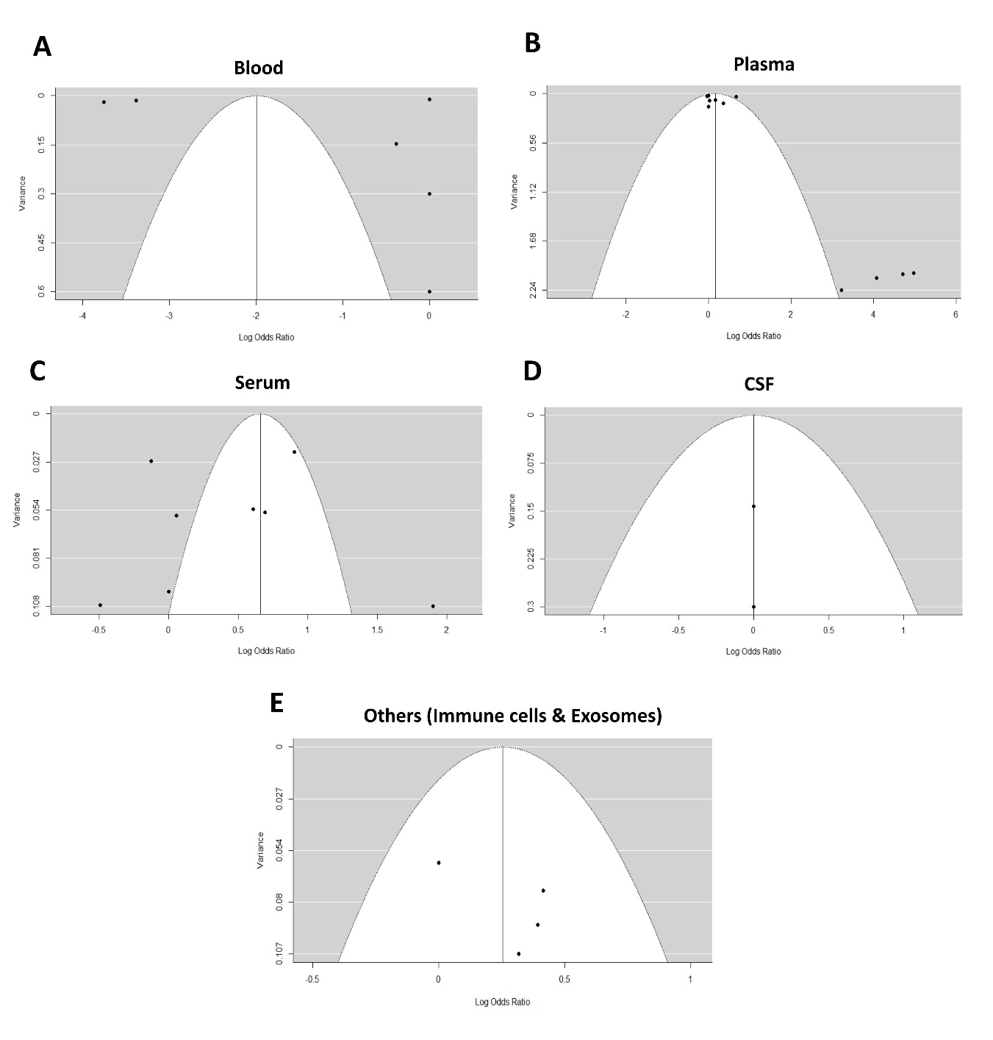
Figure 5S. Sampling Variance by tissue origin

Figure 6S. Forest plots by geographical region. (A) Studies performed in China (Q=420.08, p-value <0.0001). (B) Studies performed in Europe (Q=2.02, p-value=1). (C) Studies performed in the USA (Q=42.31, p-value <0.0001). The squares correspond to the miRNA-OR, and the size reflects its weight. Horizontal lines correspond to the 95% CIs. The diamond represents the pooled ORs of the overall population. The vertical solid line shows the Log OR of 0.

Figure 7S. Funnel plots by geographical region. (A) Studies performed in China. (B) Studies performed in Europe. (C) Studies performed in the USA. The vertical solid line represents the summary effect estimate, and the 95% CI zone is shown in white.
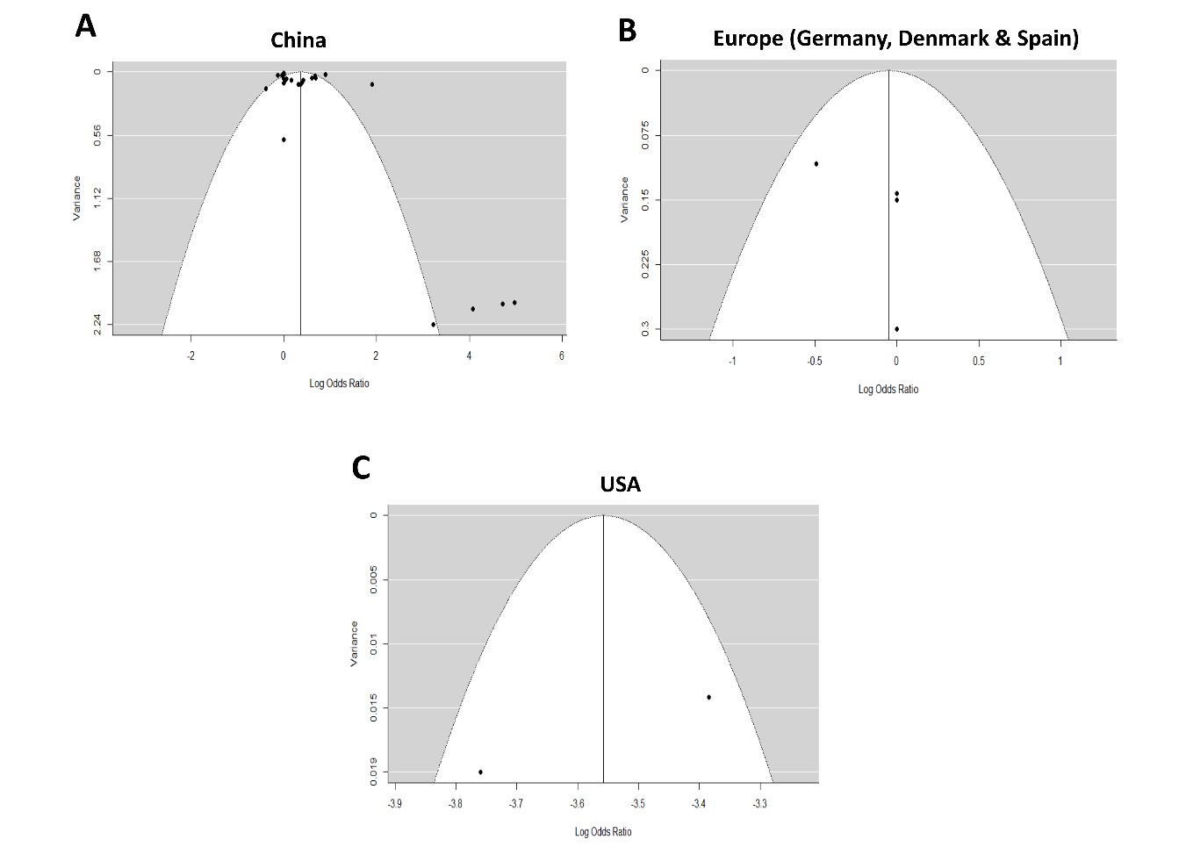
Figure 8S. Sampling Variance by geographical region

Figure 9S. Forest plots analyzed by platform. (A) Studies performed in microarrays (Q=86.35, p-value=0.007). (B) RNA-seq (Q=0.00, p-value=1). (C) qPCR (Q=32.9, p-value=0.03). (A) Blood (Q=6675.5, p-value <0.0001). The squares correspond to the miRNA-OR, and the size reflects its weight. Horizontal lines correspond to the 95% CIs. The diamond represents the pooled ORs of the overall population. The vertical solid line shows the Log OR of 0.

Figure 10S. Representative funnel plots analyzed by platform. (A) Studies performed in microarrays. (B) Studies performed in RNA-seq. (C) Studies performed in qPCR. (D) Studies performed in qRT-PCR. The vertical solid line represents the summary effect estimate, and the 95% CI zone is shown in white.

Figure 11S. Sampling Variance by Platform

