Supplementary Figures
Figure S1
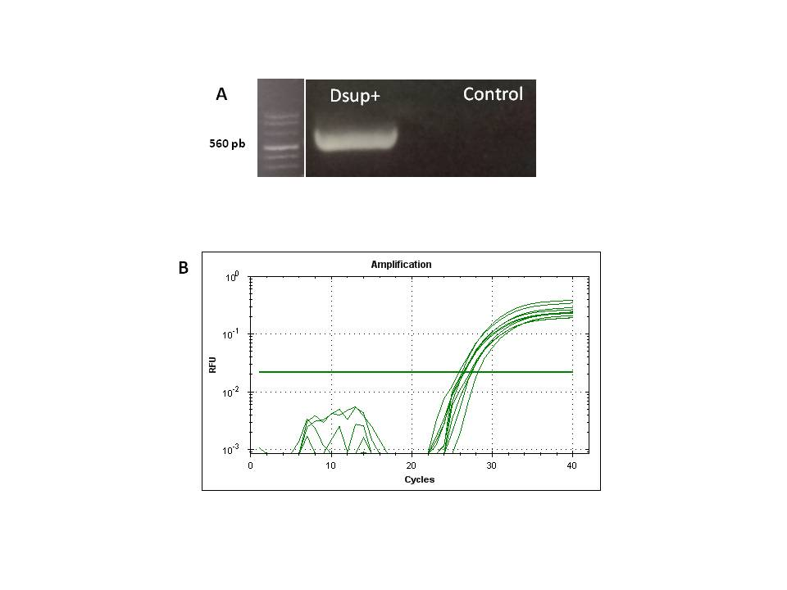
Supplementary Figure 1. A) Agarose gel showing Dsup expression in transfected cells compared to untransfected HEK293. B) Real time RT-PCR at 2, 5, 7 and 9 days after stabilization of the transfection.

Figure S2
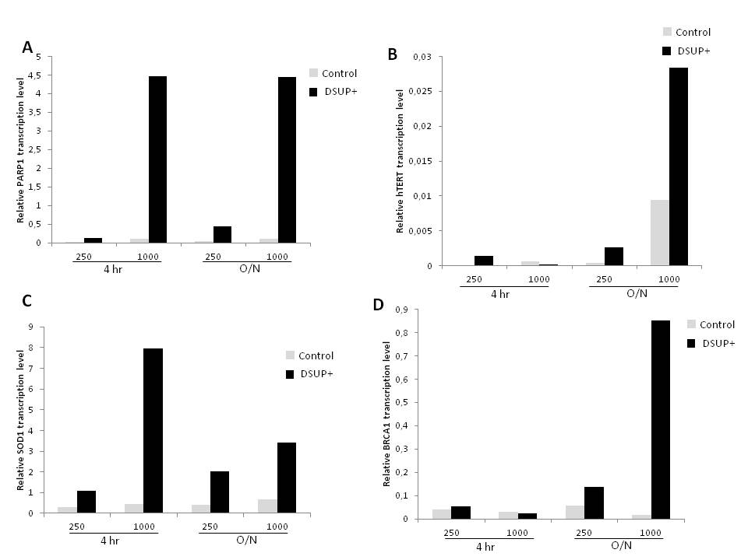
Supplementary Figure 2. Graphic showing relative expression of selected genes after H2O2 (250 and 1000 µM) treatment. Both 4 hr and O/N results are presented for A) PARP1, B) hTERT, C) SOD1, and D) BRCA1 genes.

Figure S3
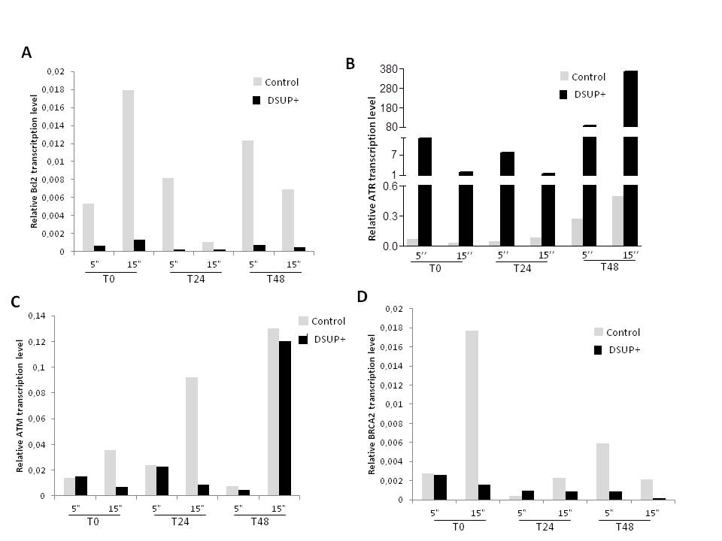
Supplementary Figure 3. Graphic showing relative expression of selected genes after 5'' or 15'' of UV-C exposure. Results are presented immediately after irradiation (T0) and after 24 or 48 hr of recovery for A) Bcl2, B) ATR, C) ATM, and D) BRCA2 genes.

