Expanding the myxochelin natural product family by nicotinic acid containing congeners

Nicolas A. Frank ^{1,2,†}, Márió Széles ^{1,2,†}, Sergi H. Akone ^{1,2,3}, Sari Rasheed ^{1,2}, Stephan Hüttel ^{1,2}, Simon Frewert ^{1,2}, Mostafa M. Hamed ^{1,2}, Jennifer Herrmann ^{1,2}, Sören M. M. Schuler ⁴, Anna K. H. Hirsch ^{1,2} and Rolf Müller ^{1,2,}*

¹ Helmholtz-Institute for Pharmaceutical Research Saarland (HIPS), Helmholtz Centre for Infection Research (HZI) and Department of Pharmacy, Saarland University, Campus E8 1, 66123 Saarbrücken, Germany
² German Center for Infection Research (DZIF), Partner Site Hannover-Braunschweig, 38124 Braunschweig, Germany
³ Department of Chemistry, Faculty of Science, University of Douala, P.O.Box 24157 Douala, Cameroon
⁴ Evotec International GmbH, 37079 Göttingen, Germany
† These authors contributed equally

Supplementary Information

Table of Contents
1 Characterization of Myxochelin derivatives 3
1.1 UV spectra of the myxochelins 3
1.1.1 UV spectra of naturally occurring myxochelins 3
1.1.2 UV spectra of synthetic myxochelins 4
1.2 Tandem MS spectra 7
1.2.1 Tandem MS spectra of naturally occurring myxochelins 7
1.2.1 Tandem MS spectra of synthetic myxochelins 8
1.3 Circular dichroism spectra 10
1.4 HPLC-MS chromatograms of crude extracts 12
1.5 HPLC-MS chromatograms of the synthetic compounds 15
1.6 Synthesis of aryl substituents with an Fmoc-protected amino group 23
1.7 NMR-based structure elucidation 25
1.7.1 ¹H and ¹³C-spectra of compounds 1 and 3 25
1.7.2 ¹H and ¹³C spectra of the synthetic compounds 30
2 In-silico analysis of the myxochelin N1–N3 biosynthesis 49
2.1 Metabolome database search of 1–3 49
2.2 Analysis of the myxochelin BGC 50
3 Assessment of biological activities 52
4 References 53

Characterization of Myxochelin derivatives

UV spectra of the myxochelins

UV spectra of naturally occurring myxochelins
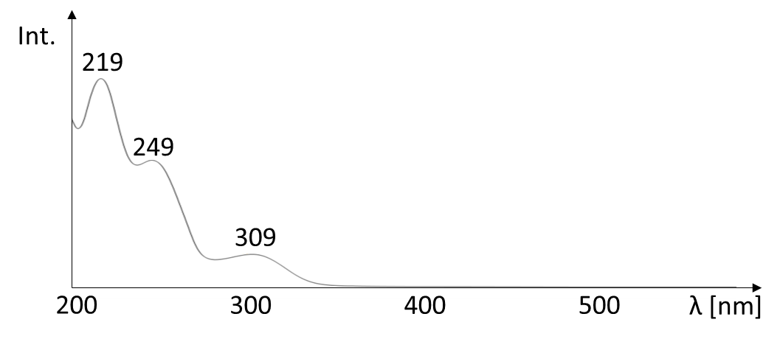
Figure S1. UV spectrum of 1(natural product) in water/acetonitrile mixture with 0.1% formic acid
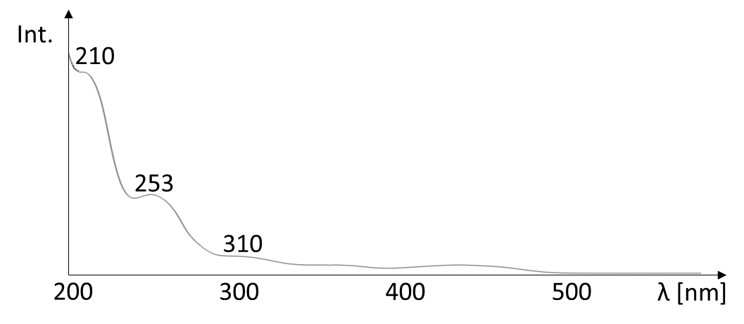
Figure S2. UV spectrum of 2 (natural product) in water/acetonitrile mixture with 0.1% formic acid
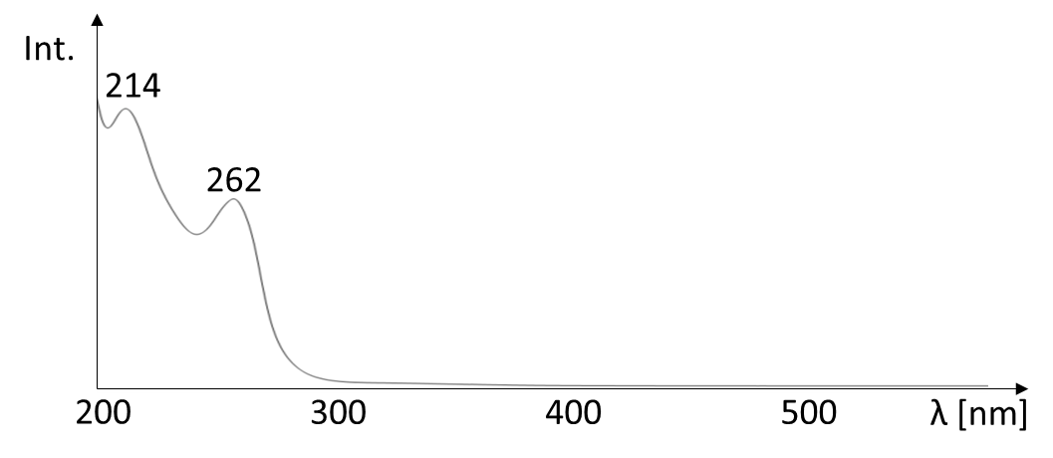
Figure S3. UV spectrum of 3 (natural product) in water/acetonitrile mixture with 0.1% formic acid

UV spectra of synthetic myxochelins
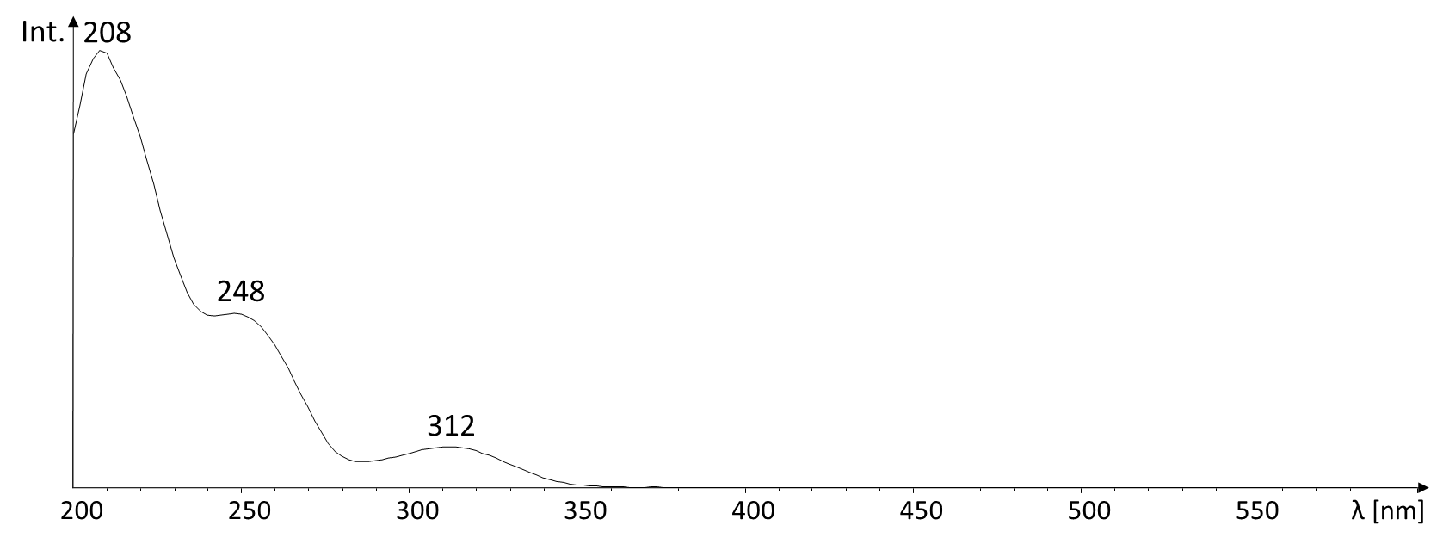
Figure S4. UV spectrum of 9a = 1 (synthetic compound) in water/acetonitrile mixture with 0.1% formic acid

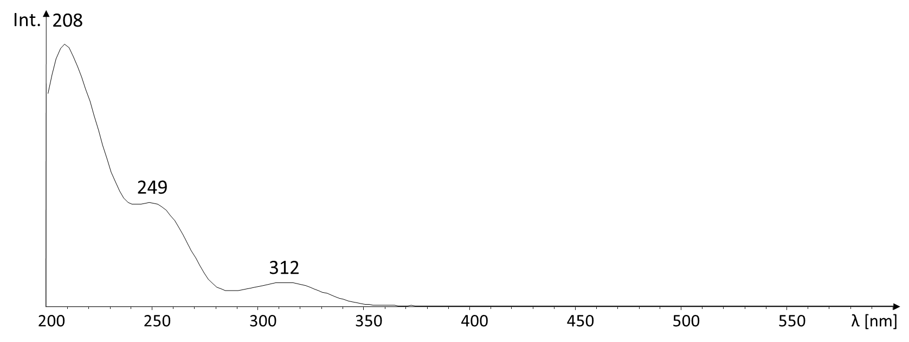
Figure S5. UV spectrum of 9b = 2 (synthetic compound) in water/acetonitrile mixture with 0.1% formic acid

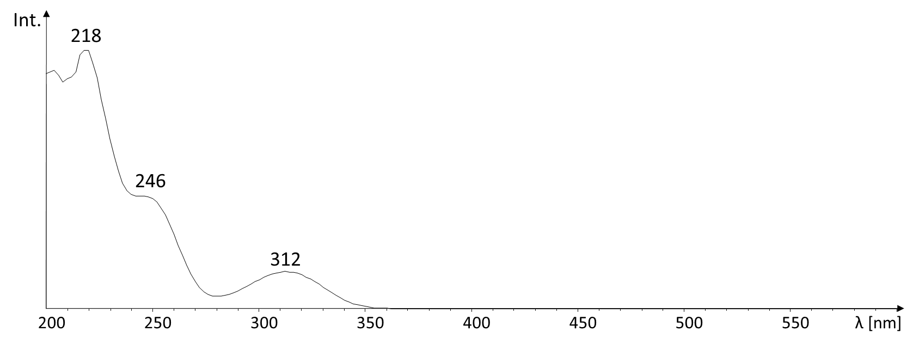
Figure S6. UV spectrum of 9c in water/acetonitrile mixture with 0.1% formic acid

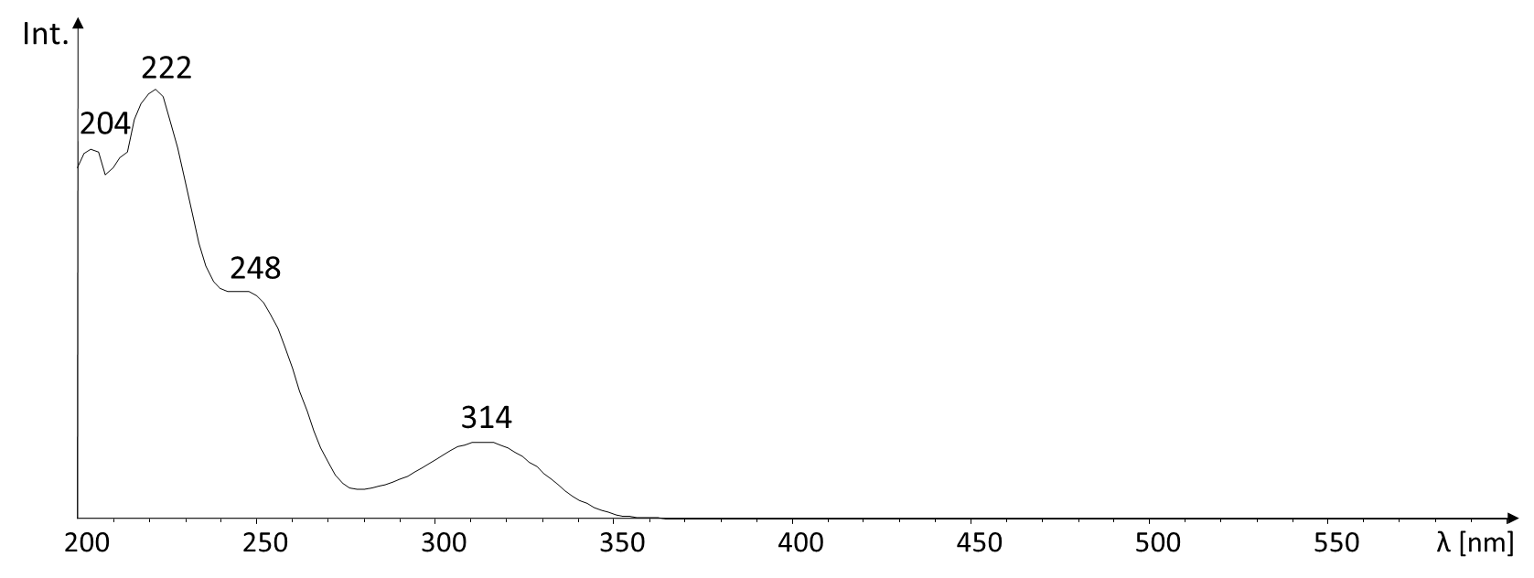
Figure S7. UV spectrum of 9d in water/acetonitrile mixture with 0.1% formic acid

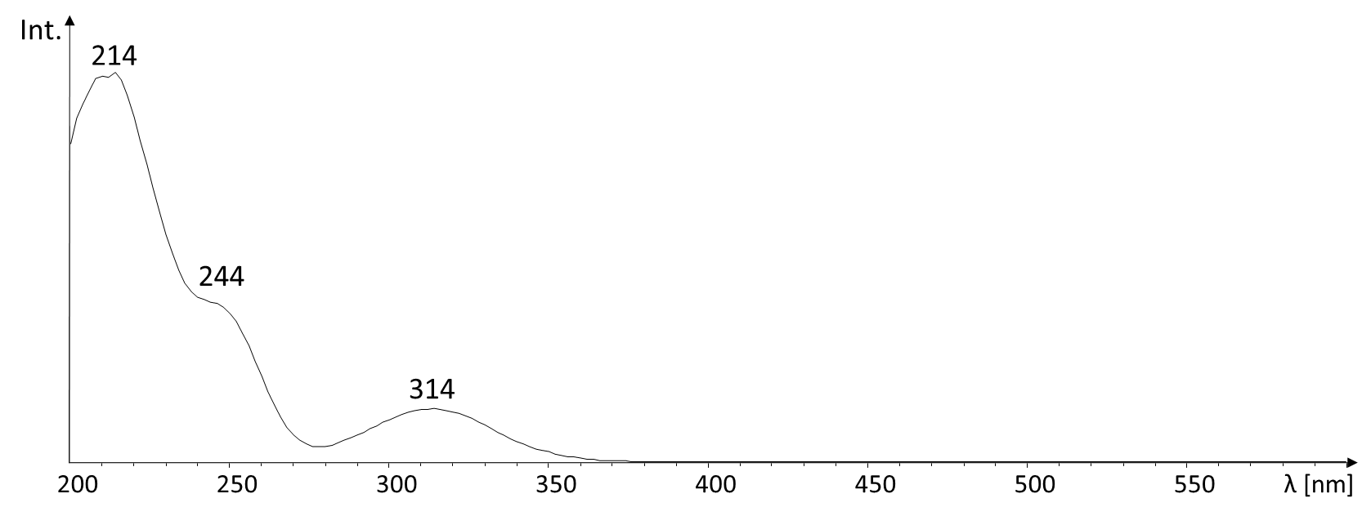
Figure S8. UV spectrum of 9e in water/acetonitrile mixture with 0.1% formic acid

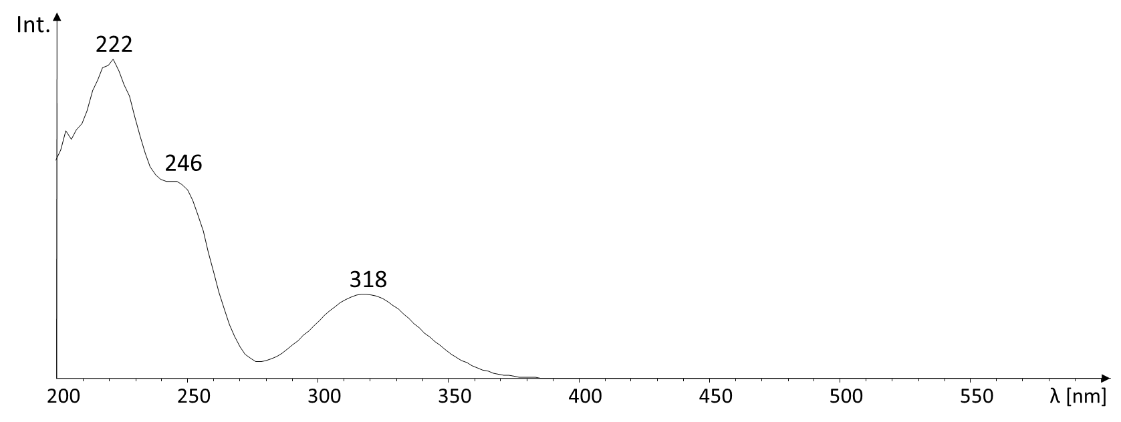
Figure S9. UV spectrum of 9f in water/acetonitrile mixture with 0.1% formic acid

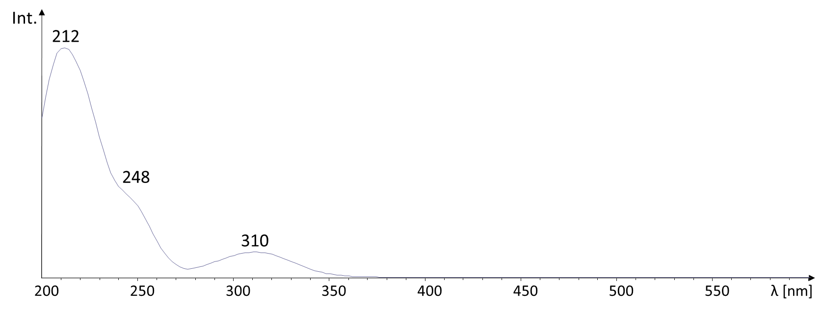
Figure S10. UV spectrum of 9g in water/acetonitrile mixture with 0.1% formic acid

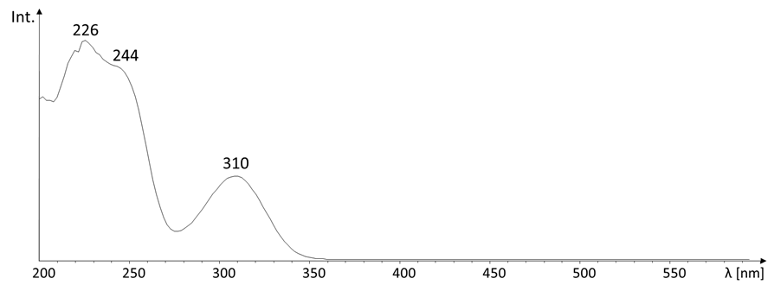
Figure S11. UV spectrum of 9h in water/acetonitrile mixture with 0.1% formic acid

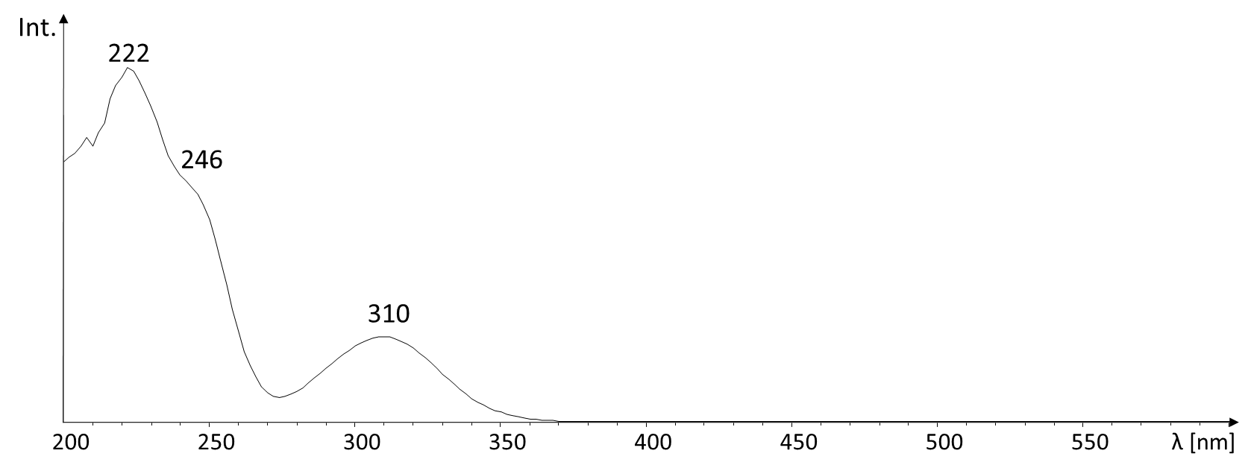
Figure S12. UV spectrum of 9i in water/acetonitrile mixture with 0.1% formic acid

Tandem MS spectra

Tandem MS spectra of naturally occurring myxochelins
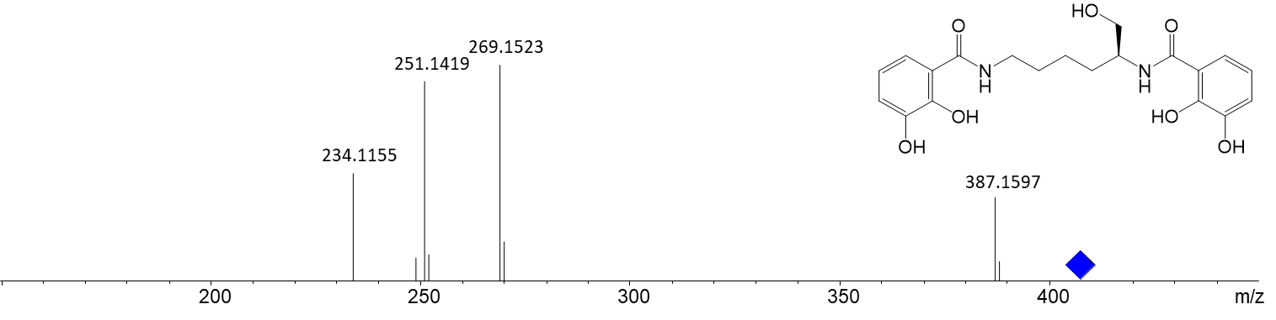
Figure S13. Tandem MS spectrum of myxochelin A
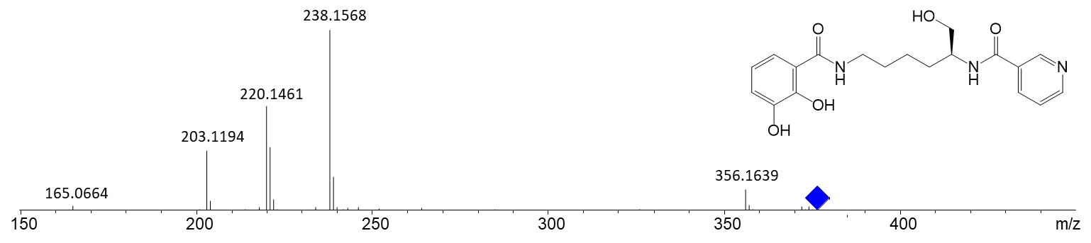
Figure S14. Tandem MS spectrum of 1
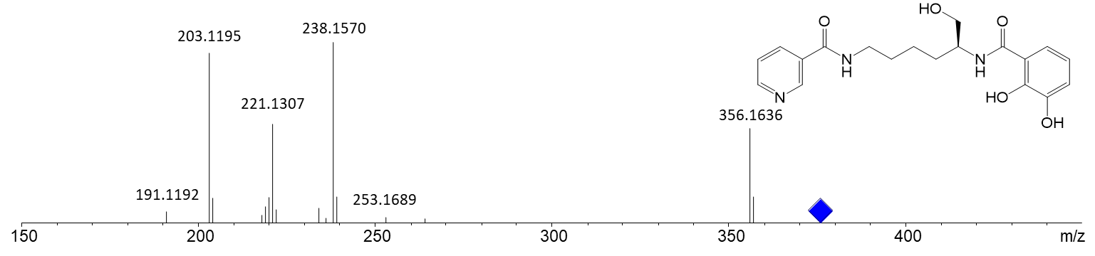
Figure S15. Tandem MS spectrum of 2
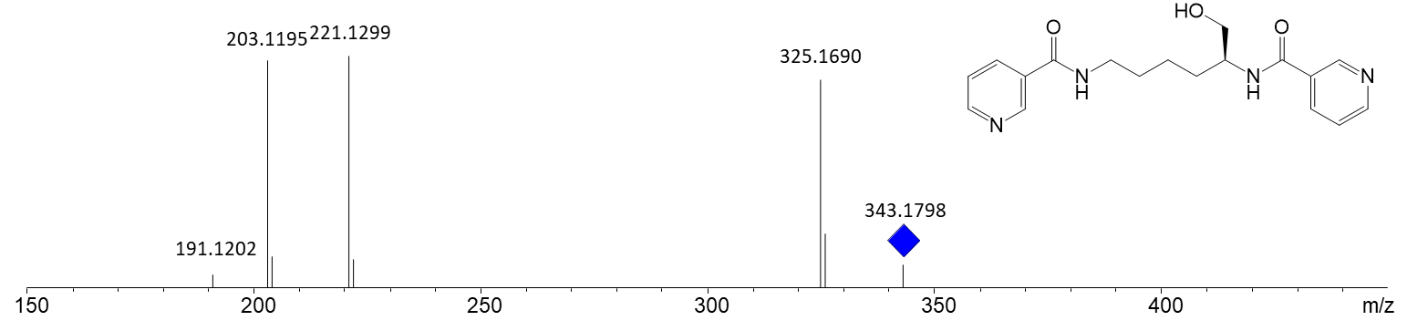
Figure S16. Tandem MS spectrum of 3

Tandem MS spectra of synthetic myxochelins
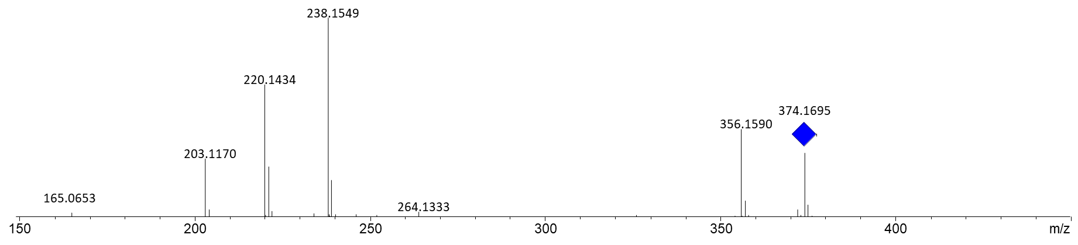
Figure S17. Tandem MS spectrum of 9a = 1
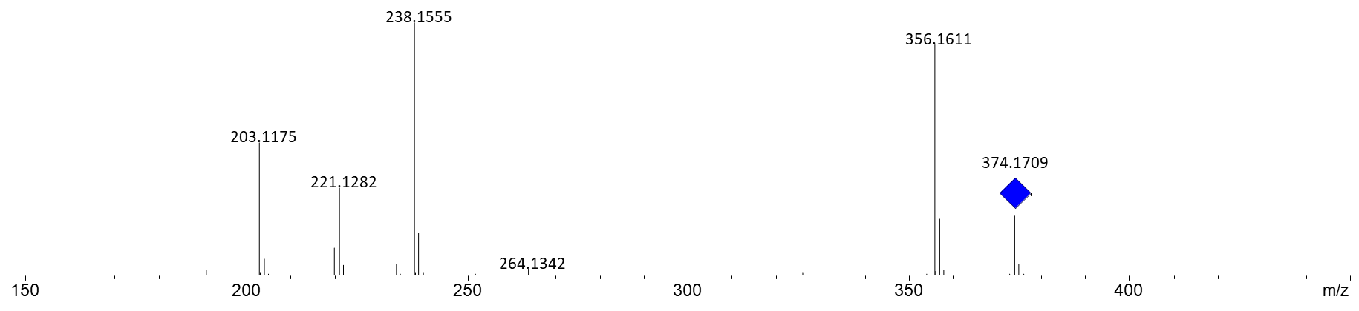
Figure S18. Tandem MS spectrum of 9b = 2
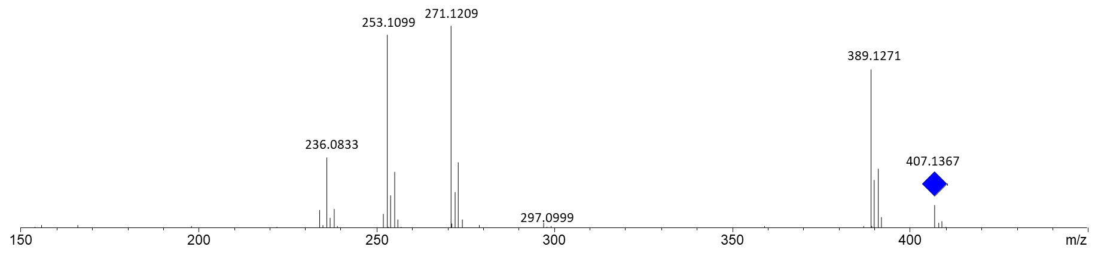
Figure S19. Tandem MS spectrum of 9c
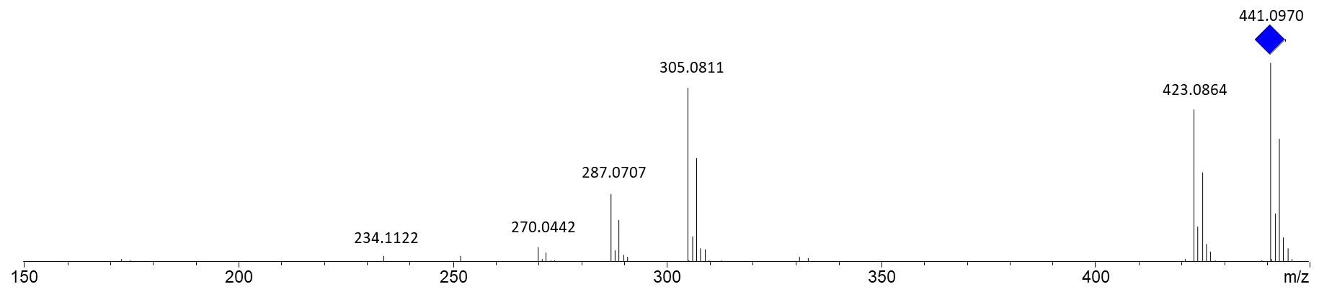
Figure S20. Tandem MS spectrum of 9d
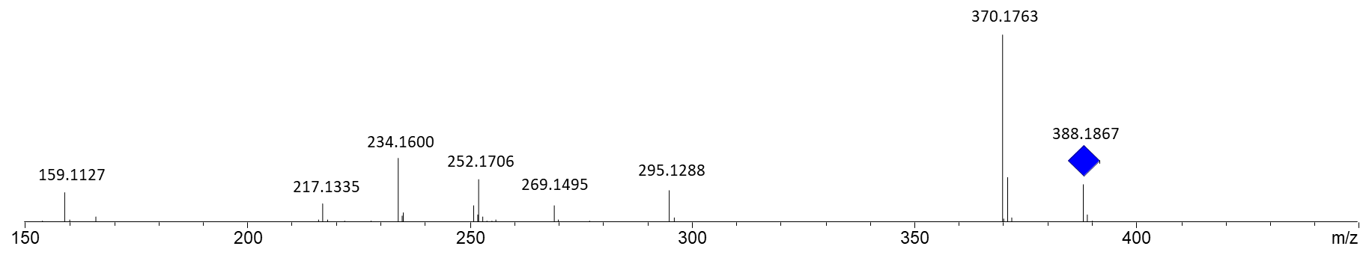
Figure S21. Tandem MS spectrum of 9e

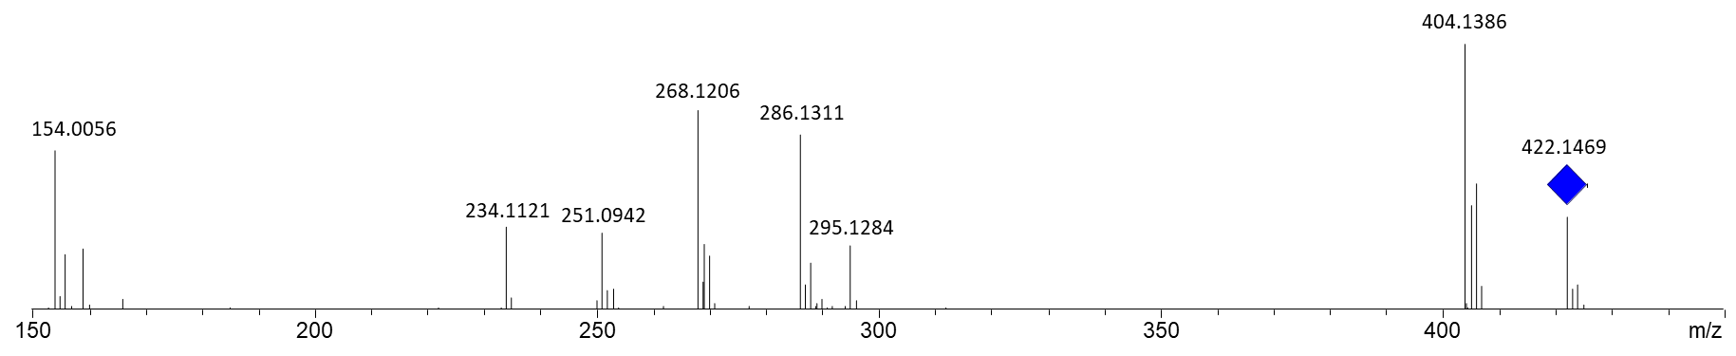
Figure S22. Tandem MS spectrum of 9f
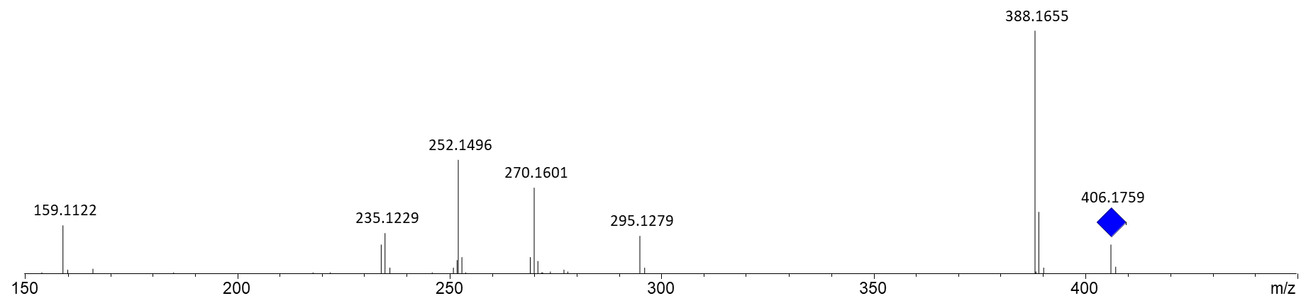
Figure S23. Tandem MS spectrum of 9g
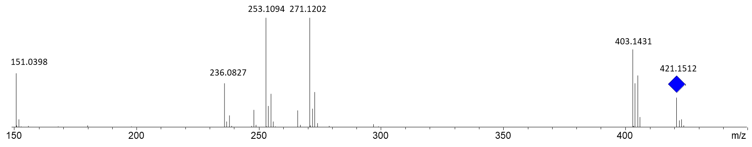
Figure S24. Tandem MS spectrum of 9h

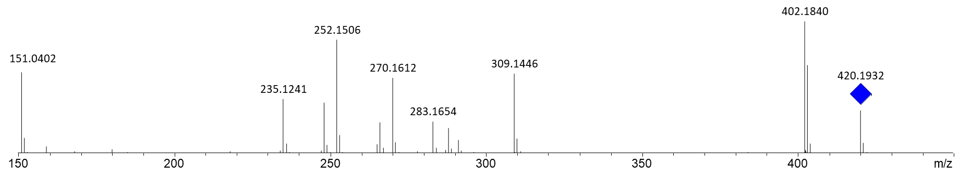
Figure S25. Tandem MS spectrum of 9i

Circular dichroism spectra
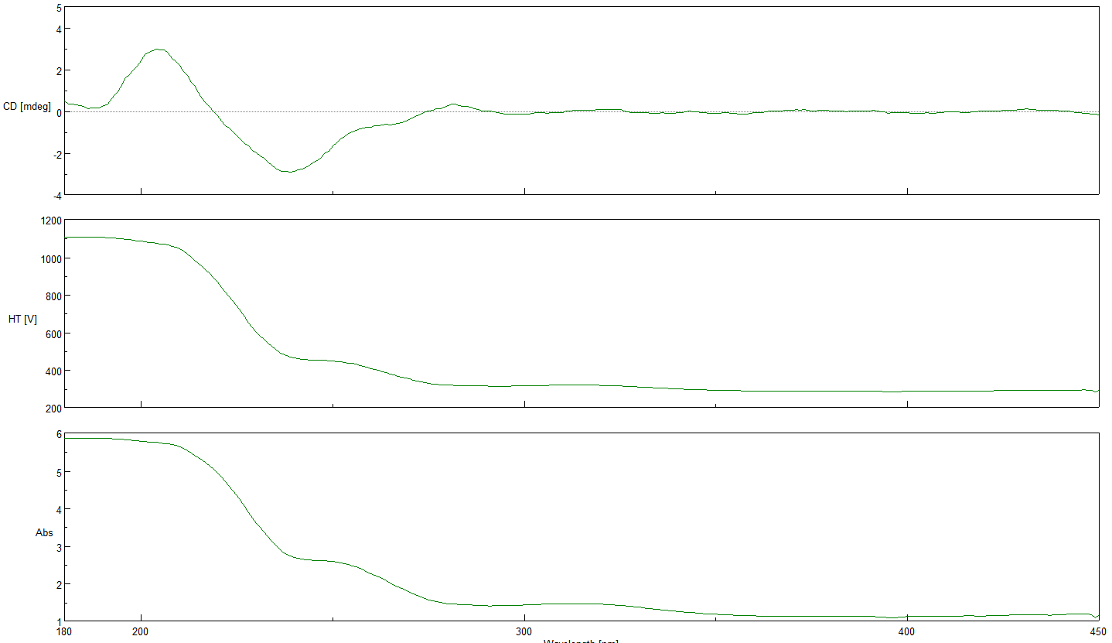
Figure S26. CD spectrum of 1mg/mL 1 (isolated) in methanol in the area 180–450 nm
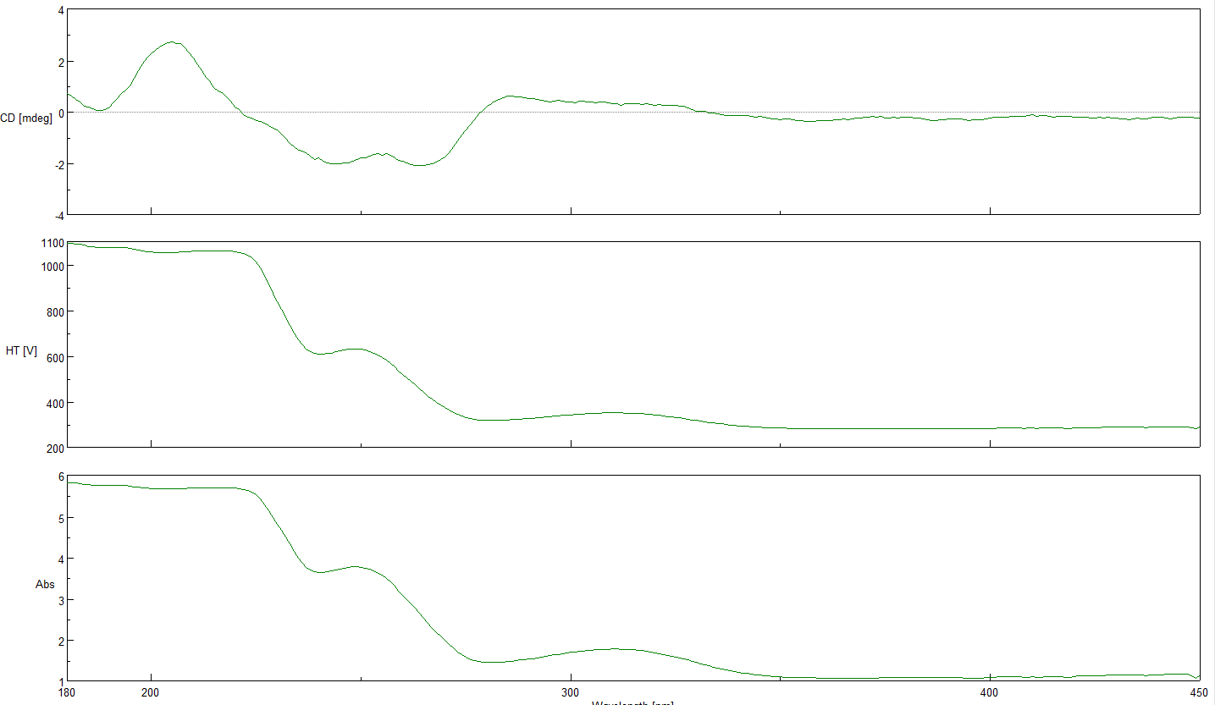
Figure S27. CD spectrum of 1mg/mL 9a = 1 (synthetic) in methanol in the area 180–450 nm
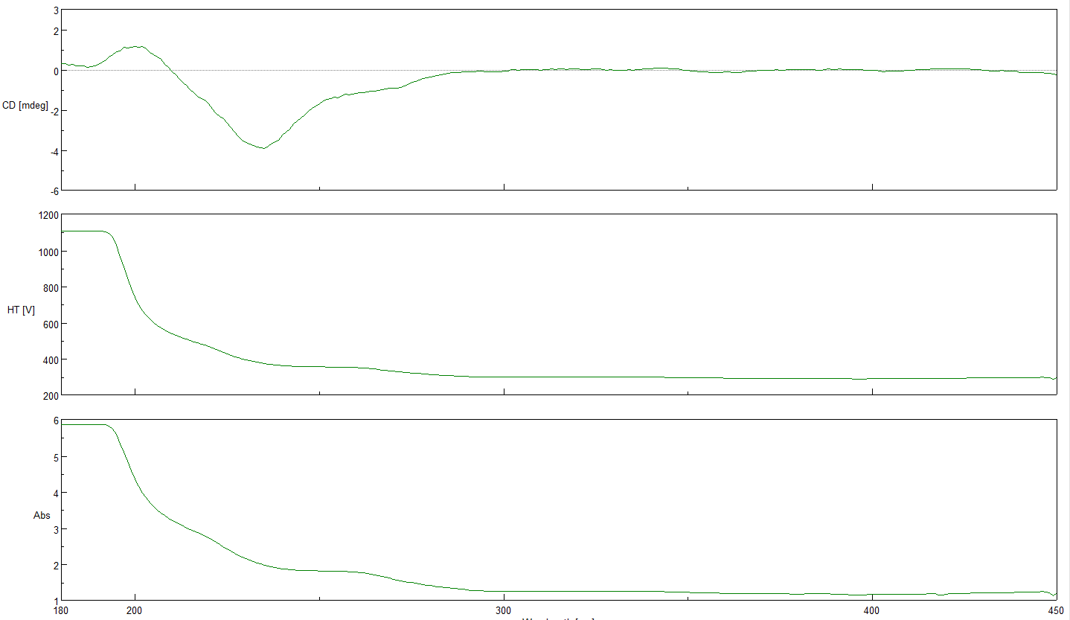
Figure S28. CD spectrum of 1mg/mL 2 (isolated) in methanol in the area 180–450 nm
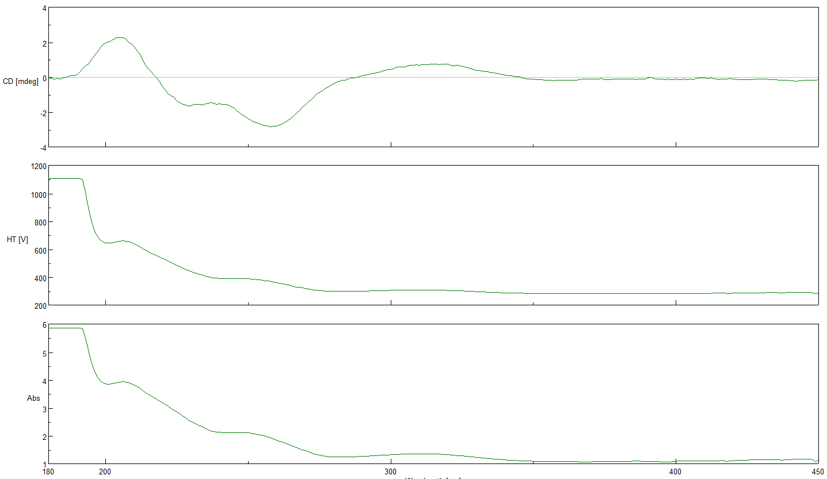
Figure S29. CD spectrum of 1mg/mL 9b = 2 (synthetic) in methanol in the area 180–450 nm

HPLC-MS chromatograms of crude extracts
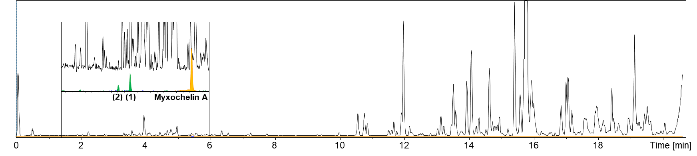
Figure S30. HPLC-MS base peak chromatogram (BPC) of Corallococcus sp. MCy9049 in VY/2S medium with highlighted extracted ion chromatograms (EICs) of 374.17105 m/z (green: 1, 2), 343.17647 m/z (blue, 3) and 405.16565 (orange: myxochelin A), with a width of 0.005 m/z.
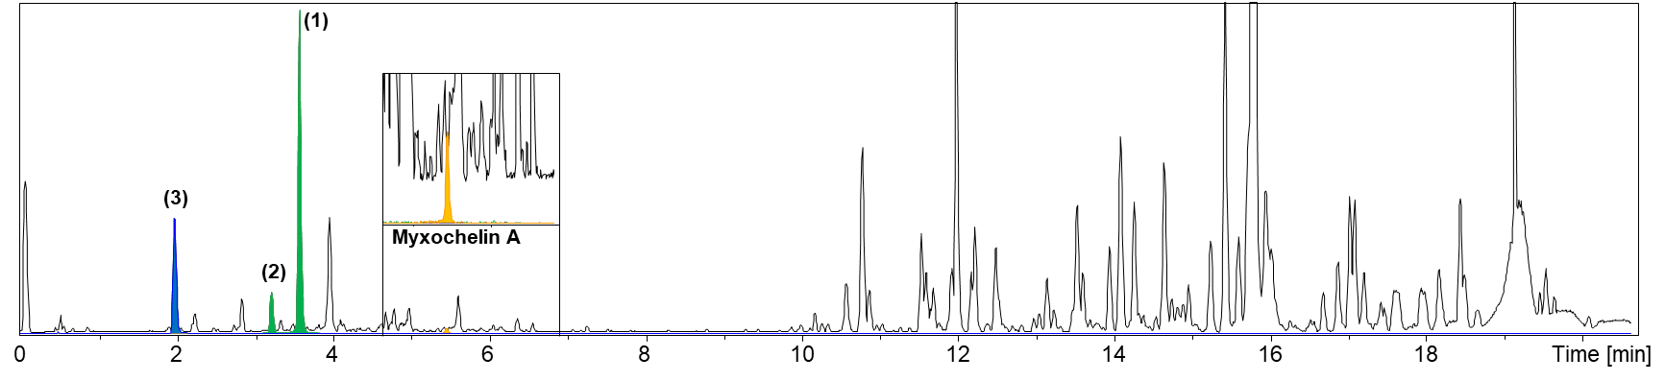
Figure S31. HPLC-MS base peak chromatogram (BPC) of Corallococcus sp. MCy9049 in VY/2S medium with supplementation of 1 mM nicotinamide with highlighted extracted ion chromatograms (EICs) of 374.17105 m/z (green: 1, 2), 343.17647 m/z (blue, 3) and 405.16565 (orange: myxochelin A), with a width of 0.005 m/z.
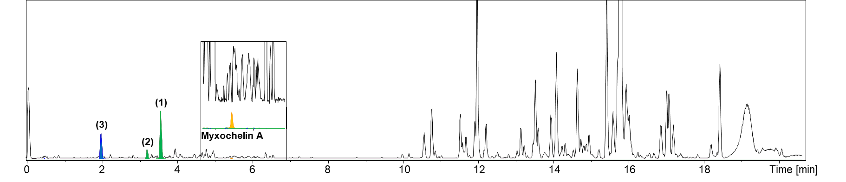
Figure S32. HPLC-MS base peak chromatogram (BPC) of Corallococcus sp. MCy9049 in VY/2S medium with supplementation of 1 mM nicotinic acid with highlighted extracted ion chromatograms (EICs) of 374.17105 m/z (green: 1, 2), 343.17647 m/z (blue, 3) and 405.16565 (orange: myxochelin A), with a width of 0.005 m/z.
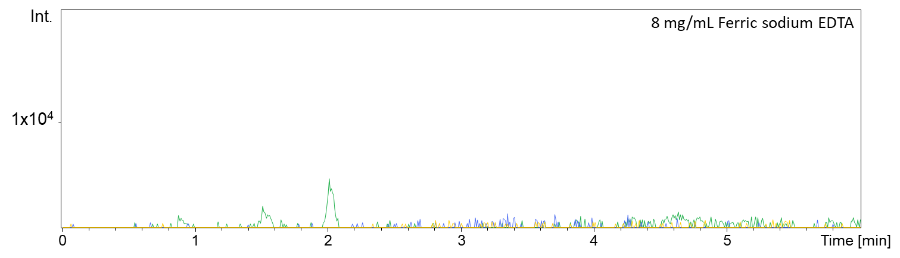
Figure S33. HPLC-MS extracted ion chromatograms (EICs) of 374.17105 m/z (green: 1, 2), 343.17647 m/z (blue, 3) and 405.16565 (orange: myxochelin A), with a width of 0.005 m/z from crude extracts of Corallococcus sp. MCy9049 in VY/2S medium with supplementation of ferric sodium EDTA.

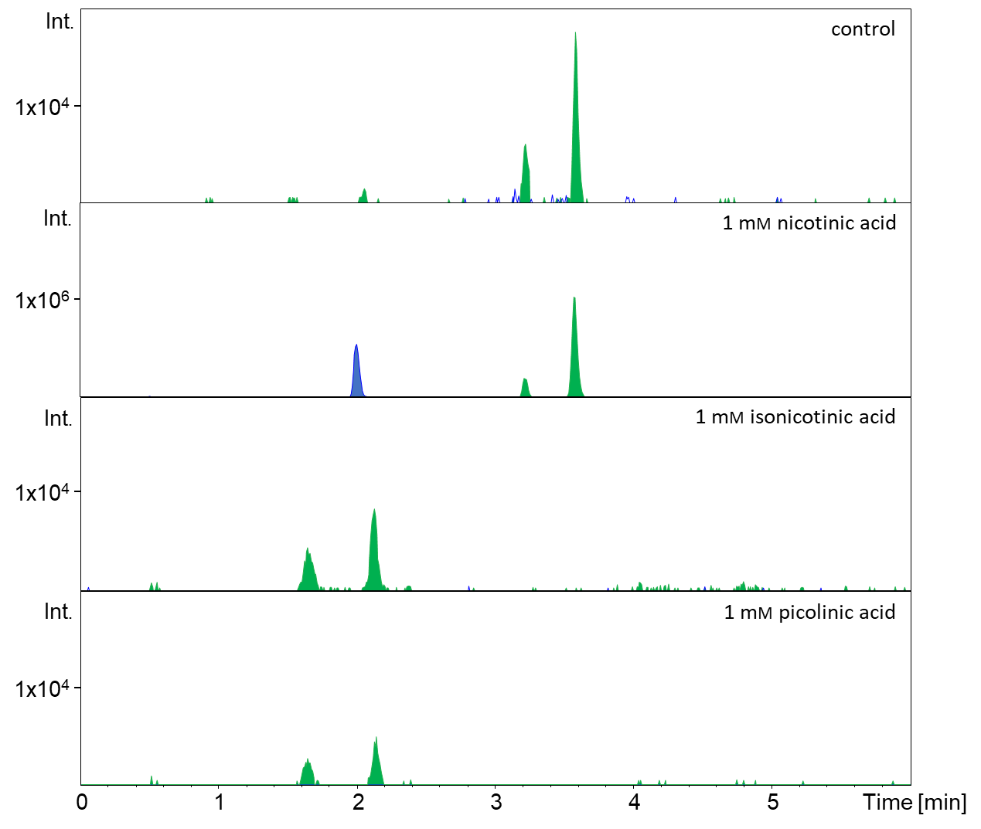
Figure S34. HPLC-MS extracted ion chromatograms (EICs) of 374.17105 m/z (green: 1, 2) and 343.17647 m/z (blue, 3), with a width of 0.005 m/z from crude extracts of Corallococcus sp. MCy9049 in VY/2S medium with supplementation of different pyridinecarboxylic acids.

HPLC-MS chromatograms of the synthetic compounds
Figure S35. HPLC-MS UV chromatogram and positive ESI-MS of 9a.
Figure S36. HPLC-MS UV chromatogram and positive ESI-MS of 9b.
Figure S37. HPLC-MS UV chromatogram and positive ESI-MS of 9c.
Figure S38. HPLC-MS UV chromatogram and positive ESI-MS of 9d.
Figure S39. HPLC-MS UV chromatogram and positive ESI-MS of 9e.
Figure S40. HPLC-MS UV chromatogram and positive ESI-MS of 9f.
Figure S41. HPLC-MS UV chromatogram and positive ESI-MS of 9g.
Figure S42. HPLC-MS UV chromatogram and positive ESI-MS of 9h.
Figure S43. HPLC-MS UV chromatogram and positive-ESI MS of 9i.

Synthesis of aryl substituents with an Fmoc-protected amino group
N-Fmoc-2-aminobenzoic acid (SI-1). To 2-aminobenzoic acid (274 mg, 2.0 mmol), Fmoc-Cl (517 mg, 2.0 mmol) was added, and the mixture was dissolved in dioxane (5 mL). Then, saturated aqueous sodium bicarbonate solution (0.1 mL) was added to the solution, and stirred overnight. The solution was extracted with saturated aqueous ammonium chloride solution and ethyl acetate (3 x 50 mL). The organic layers were combined dried over sulfate and filtered. Then, the solvent was removed under reduced pressure. The compound was obtained as white solid and it was used without further purification (650 mg, 90%). ¹H NMR (500 MHz, DMSO-d₆): δ 11.21 (s, 1H), 8.14 (d, J = 8.6 Hz, 1H), 7.97 (dd, J = 7.9, 1.7 Hz, 1H), 7.92 (d, J = 7.5 Hz, 2H), 7.69 (d, J = 7.5 Hz, 2H), 7.53 (t, J = 7.8 Hz, 1H), 7.46–7.39 (m, 2H), 7.35 (td, J = 7.5, 1.2 Hz, 2H), 7.08 (t, J = 7.6 Hz, 1H), 4.48 (d, J = 6.8 Hz, 2H), 4.35 (t, J = 6.8 Hz, 1H); ESI-MS (m/z): calcd for C₂₂H₁₆NO₄ 358.11, found 358.24 [M - H]–.

N-Fmoc-2-amino-3-chlorobenzoic acid (SI-2). To 2-amino-3-chlorobenzoic acid (348 mg, 2.0 mmol) Fmoc-Cl (517 mg, 2.0 mmol) was added and the mixture was dissolved in dioxane (5 mL). Then, saturated aqueous sodium bicarbonate solution (0.1 mL) was added to the solution, and stirred overnight. The solution was extracted with saturated aqueous ammonium chloride solution and ethyl acetate (3 x 50 mL). The organic layers were combined and dried over sodium sulfate and filtered. Then, the solvent was removed under reduced pressure. The compound was obtained as white solid and it was used without further purification (660 mg, 84%). ¹H NMR (500 MHz, DMSO-d₆): δ 13.04 (s, 1H), 7.96–7.80 (m, 2H), 7.83–7.70 (m, 2H), 7.71–7.53 (m, 1H), 7.51–7.14 (m, 6H), 4.36–4.29 (m, 2H), 4.29–4.23 (m, 1H); ESI-MS (m/z): calcd for C₂₂H₁₇ClNO₄ 394.08, found 394.02 [M + H]⁺.

N-Fmoc-2-amino-6-fluorobenzoic acid (SI-3). To 2-amino-6-fluorobenzoic acid (310 mg, 2.0 mmol) Fmoc-Cl (517 mg, 2.0 mmol) was added and the mixture was dissolved in dioxane (5 mL). Then, saturated aqueous sodium bicarbonate solution (0.1 mL) was added to the solution, and stirred overnight. The solution was extracted with saturated aqueous ammonium chloride solution and ethyl acetate (3 x 50 mL). The organic layers were combined and dried over sodium sulfate and filtered. Then, the solvent was removed under reduced pressure. The compound was obtained as white solid and it was used without further purification (671 mg, 89%). No ¹H NMR spectrum was recorded; ESI-MS (m/z): calcd for C₂₂H₁₅FNO₄ 376.11, found 376.24 [M - H]–.

NMR-based structure elucidation

¹H and ¹³C-spectra of compounds 1 and 3
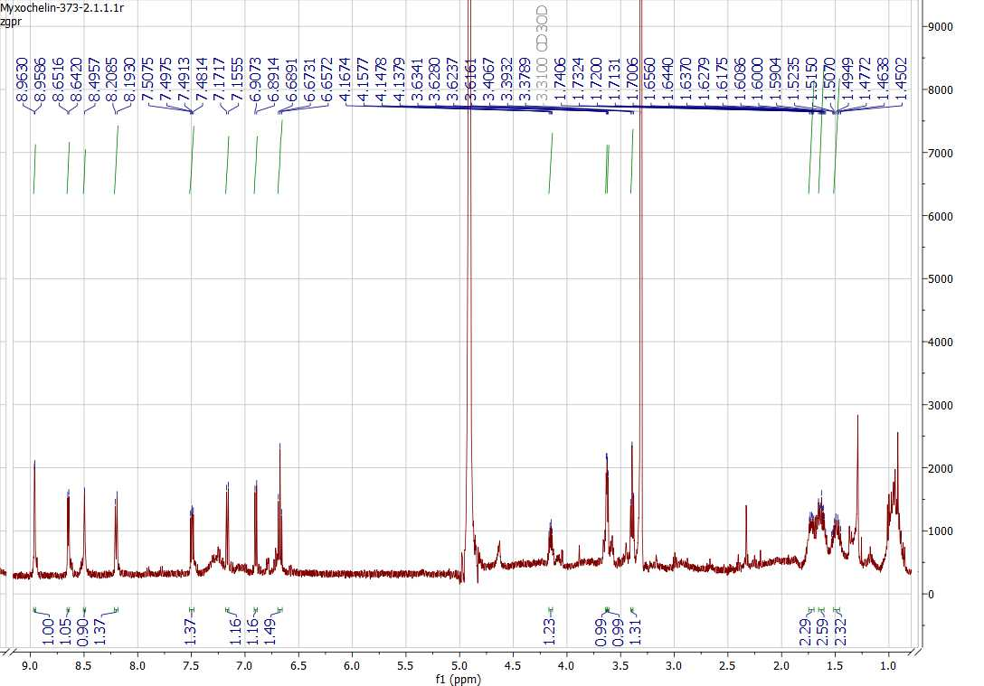
Figure S44. ¹H NMR spectrum of 1 in methanol-d₄.
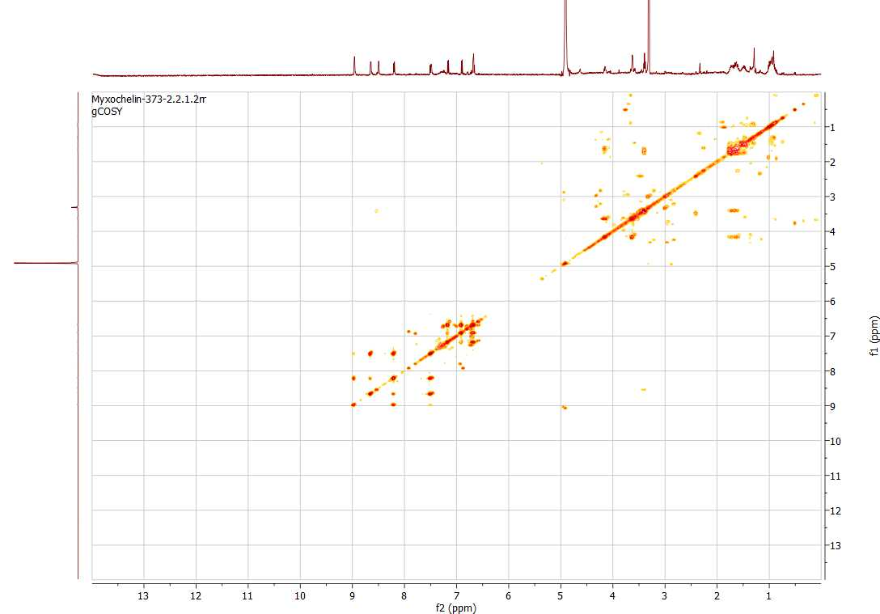
Figure S45. ¹H-¹H COSY spectrum of 1 in methanol-d₄.

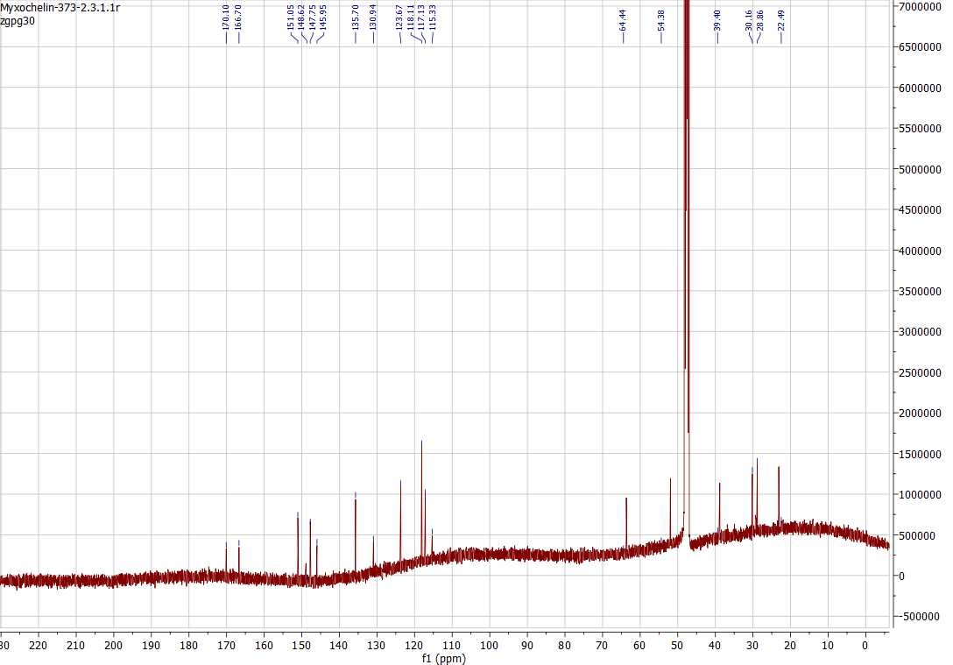
Figure S46. ¹³C NMR spectrum of 1 in methanol-d₄.

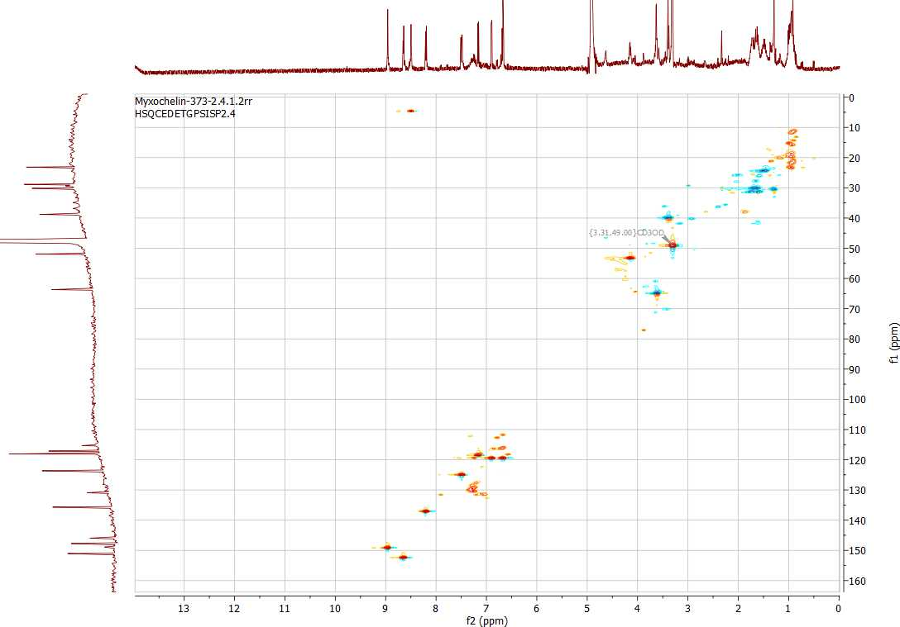
Figure S47. HSQC spectrum of 1 in methanol-d₄.

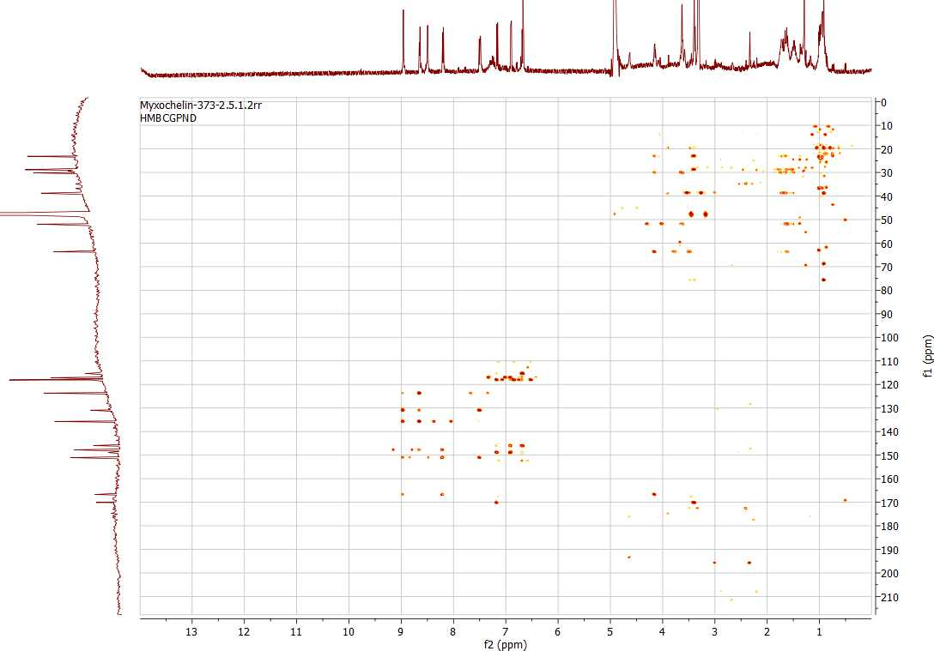
Figure S48. HMBC spectrum of 1 in methanol-d₄.
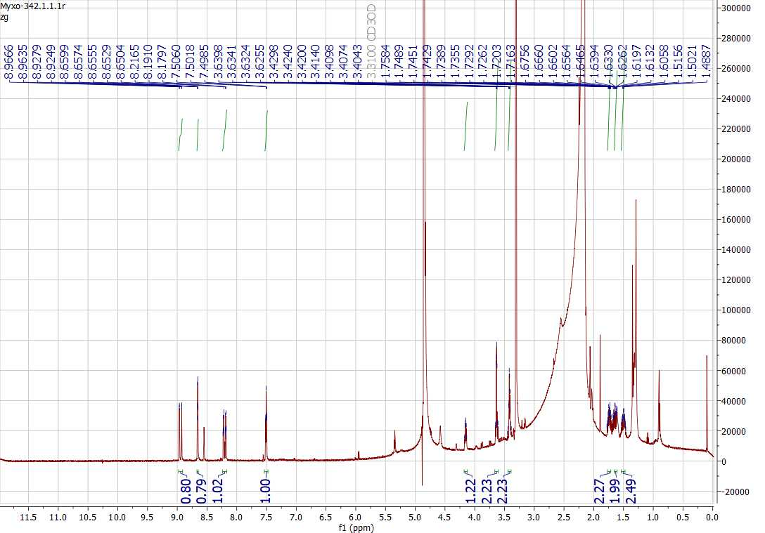

Figure S49. ¹H NMR spectrum of 3 in methanol-d₄.

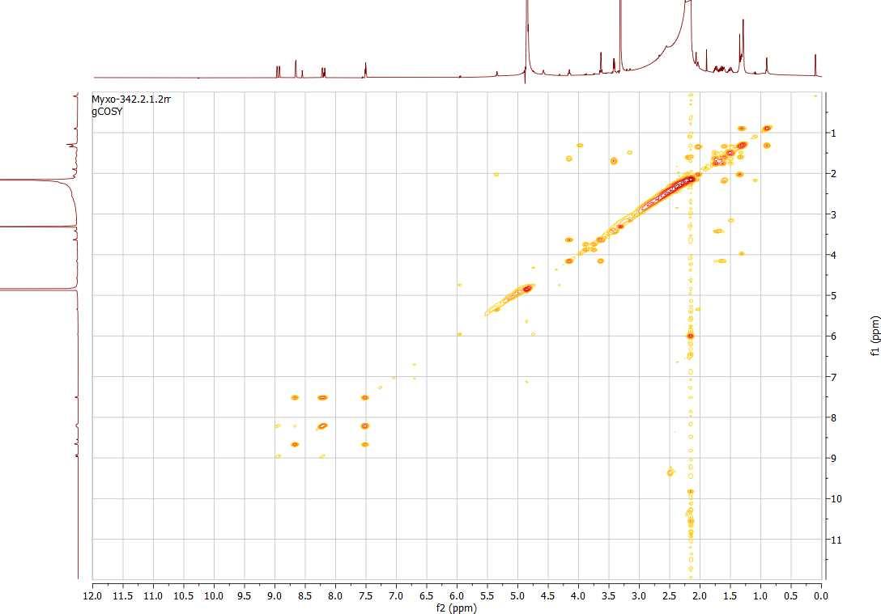
Figure S50. ¹H-¹H COSY spectrum of 3 in methanol-d₄.

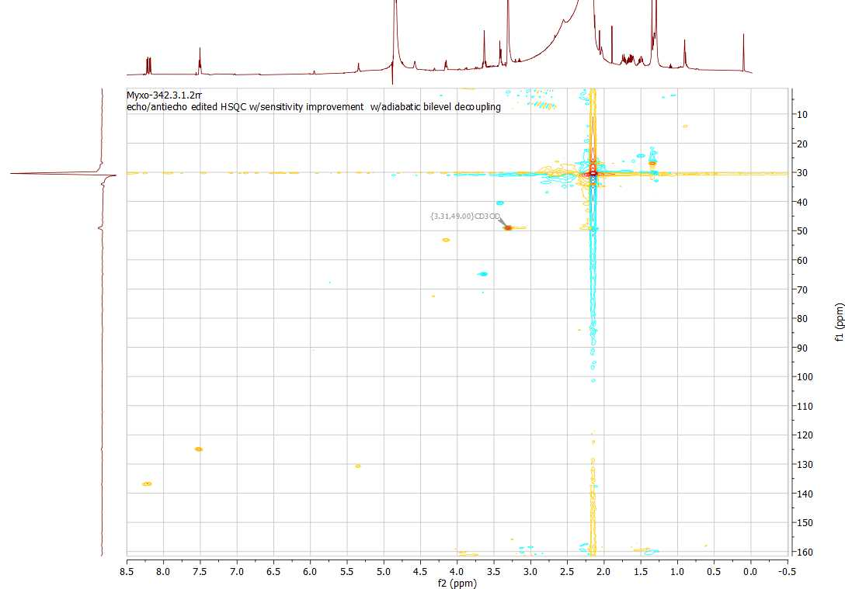
Figure S51. HSQC spectrum of 3 in methanol-d₄.
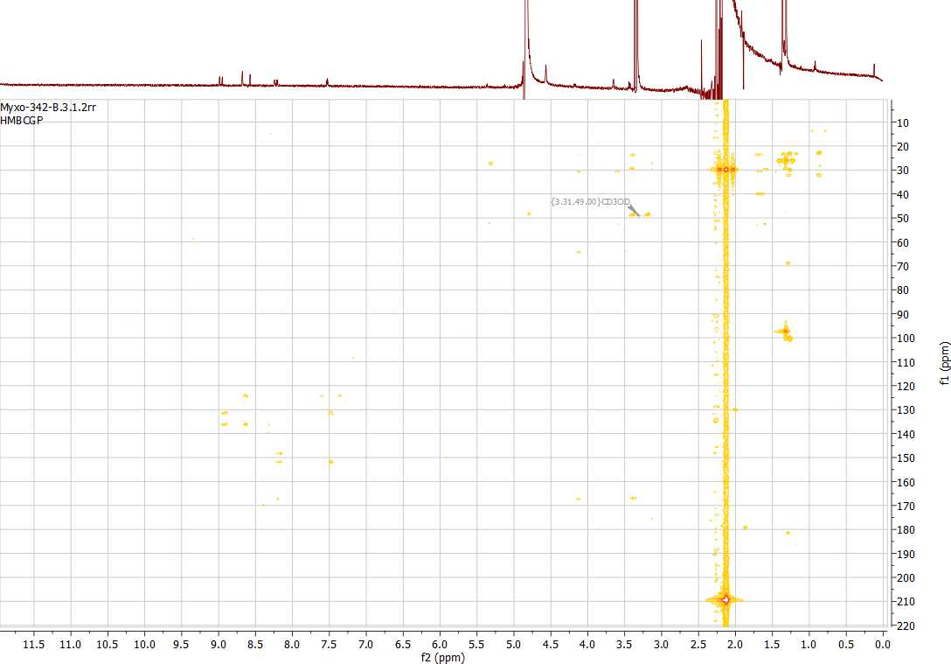
Figure S52. HMBC spectrum of 3 in methanol-d₄.

¹H and ¹³C spectra of the synthetic compounds
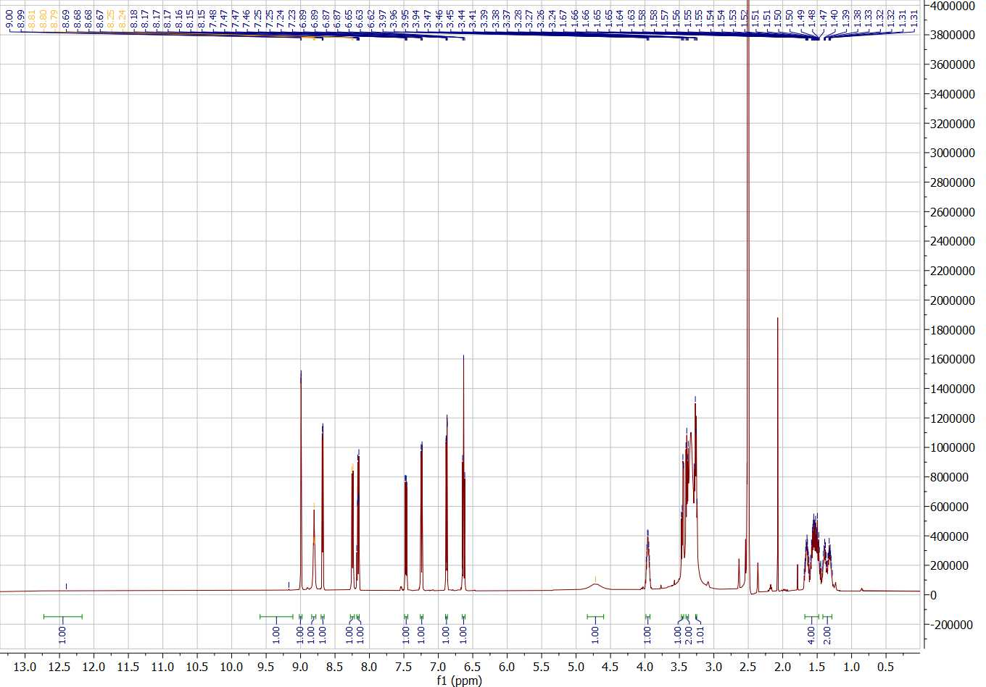
Figure S53. ¹H NMR spectrum of 9a in DMSO-d₆.
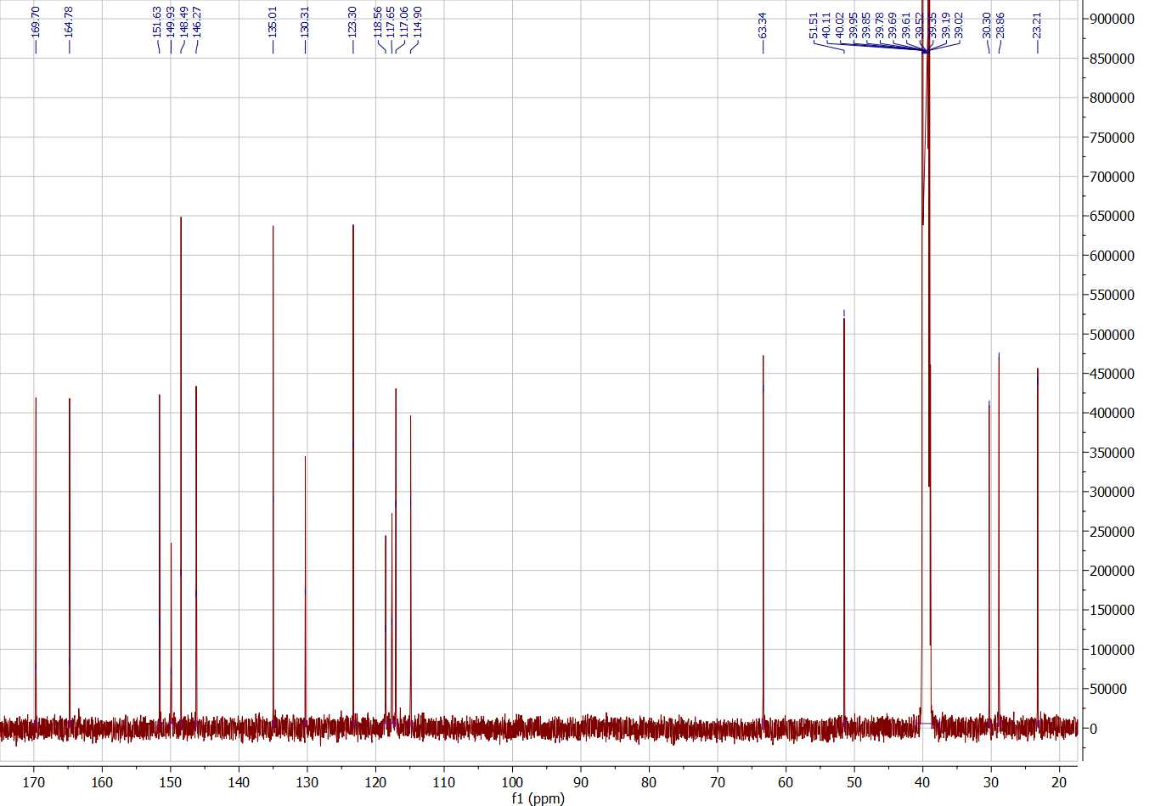
Figure S54. 13C NMR spectrum of 9a in DMSO-d6.
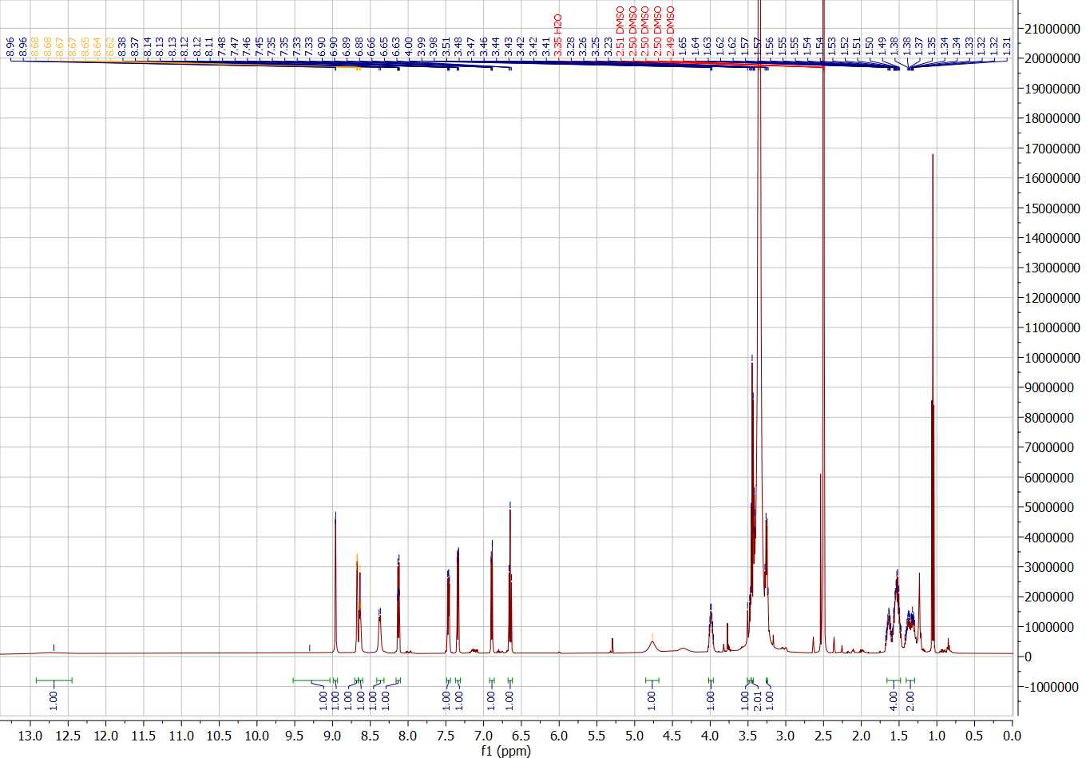
Figure S55. ¹H NMR spectrum of 9b in DMSO-d₆.
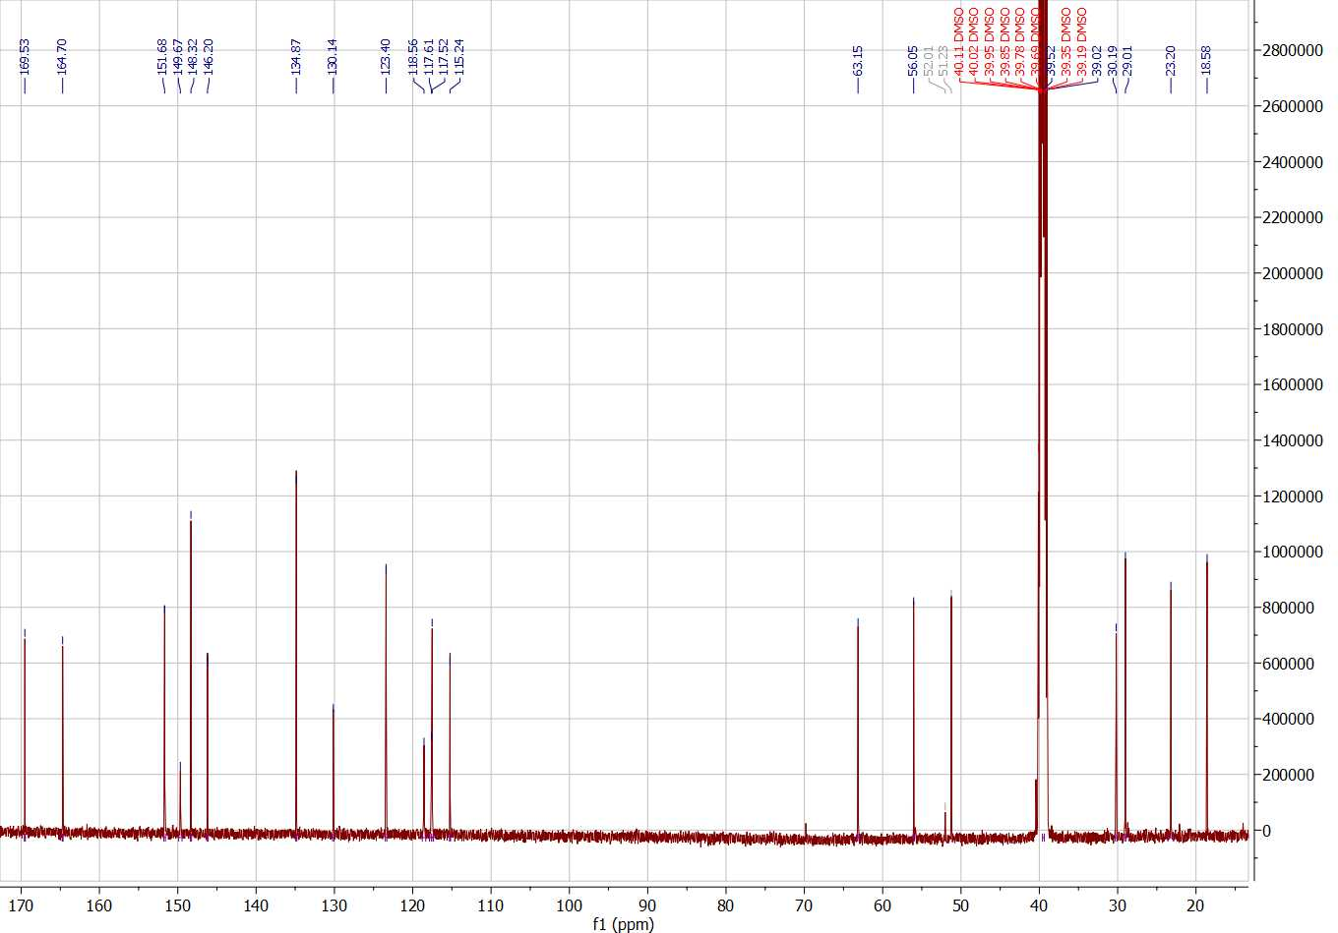
Figure S56. ¹³C NMR spectrum of 9b in DMSO-d₆.
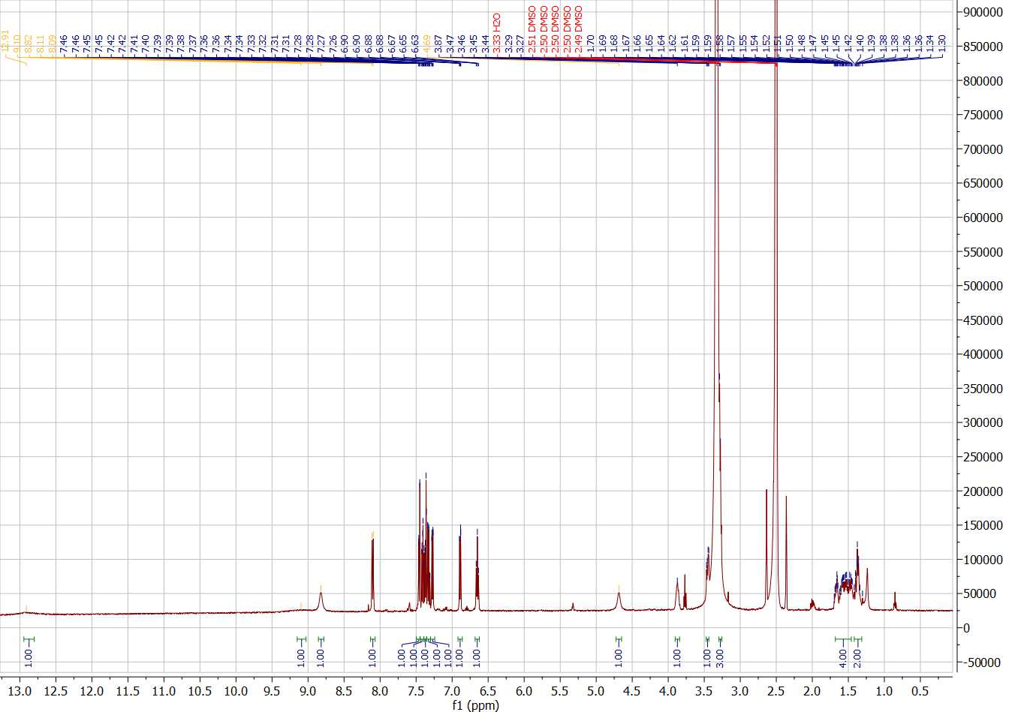
Figure S57. ¹H NMR spectrum of 9c in DMSO-d₆.
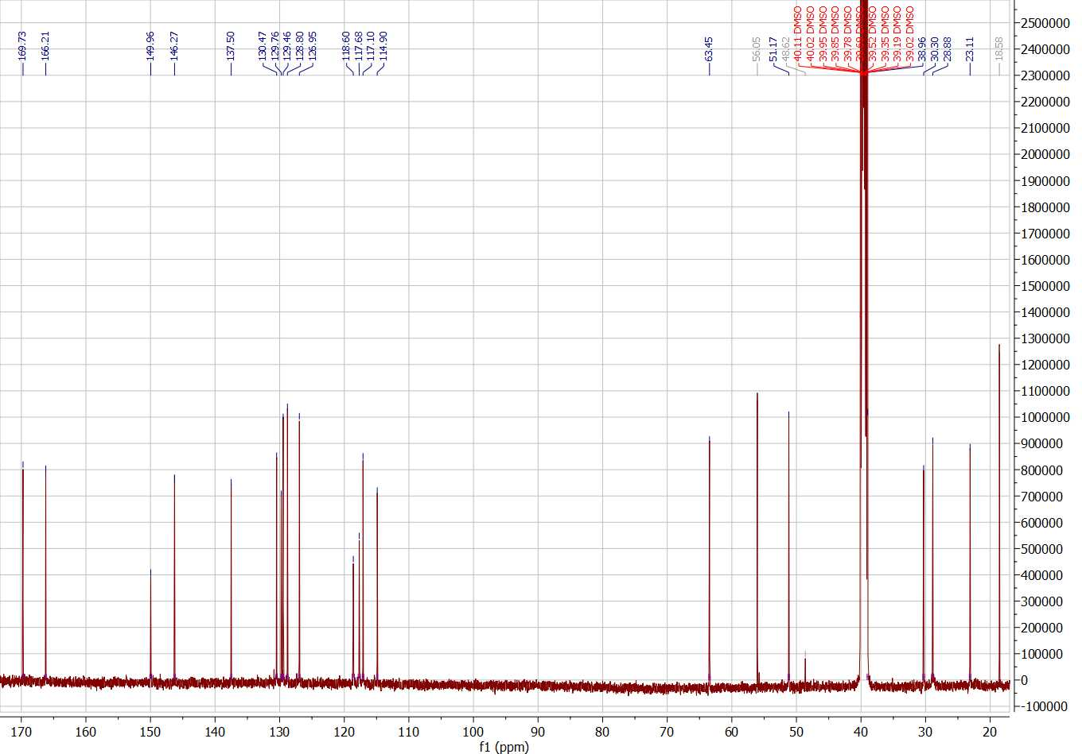
Figure S58. ¹³C NMR spectrum of 9c in DMSO-d₆.
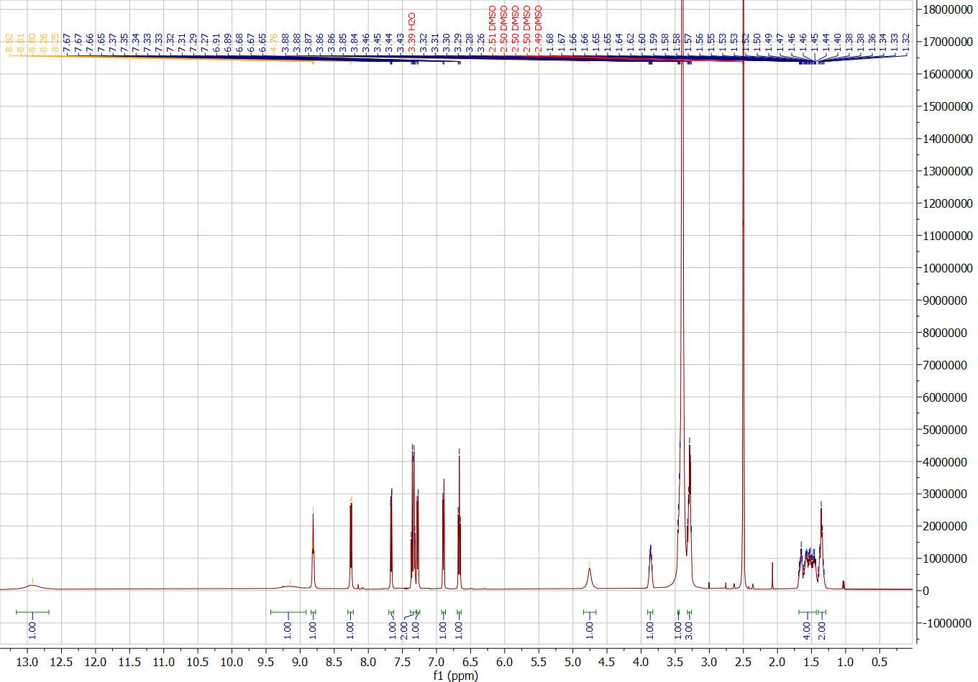
Figure S59. ¹H NMR spectrum of 9d in DMSO-d₆.
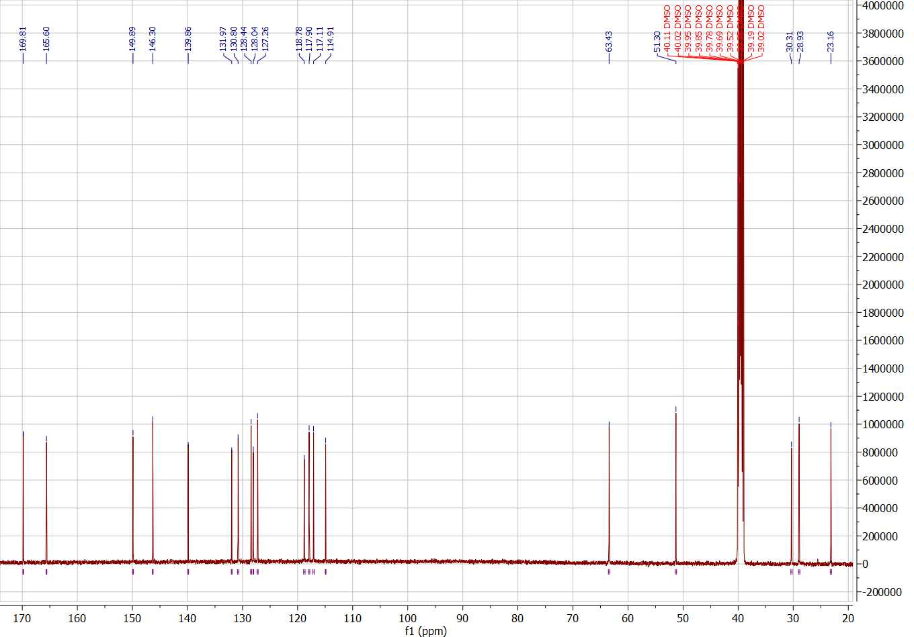
Figure S60. ¹³C NMR spectrum of 9d in DMSO-d₆.
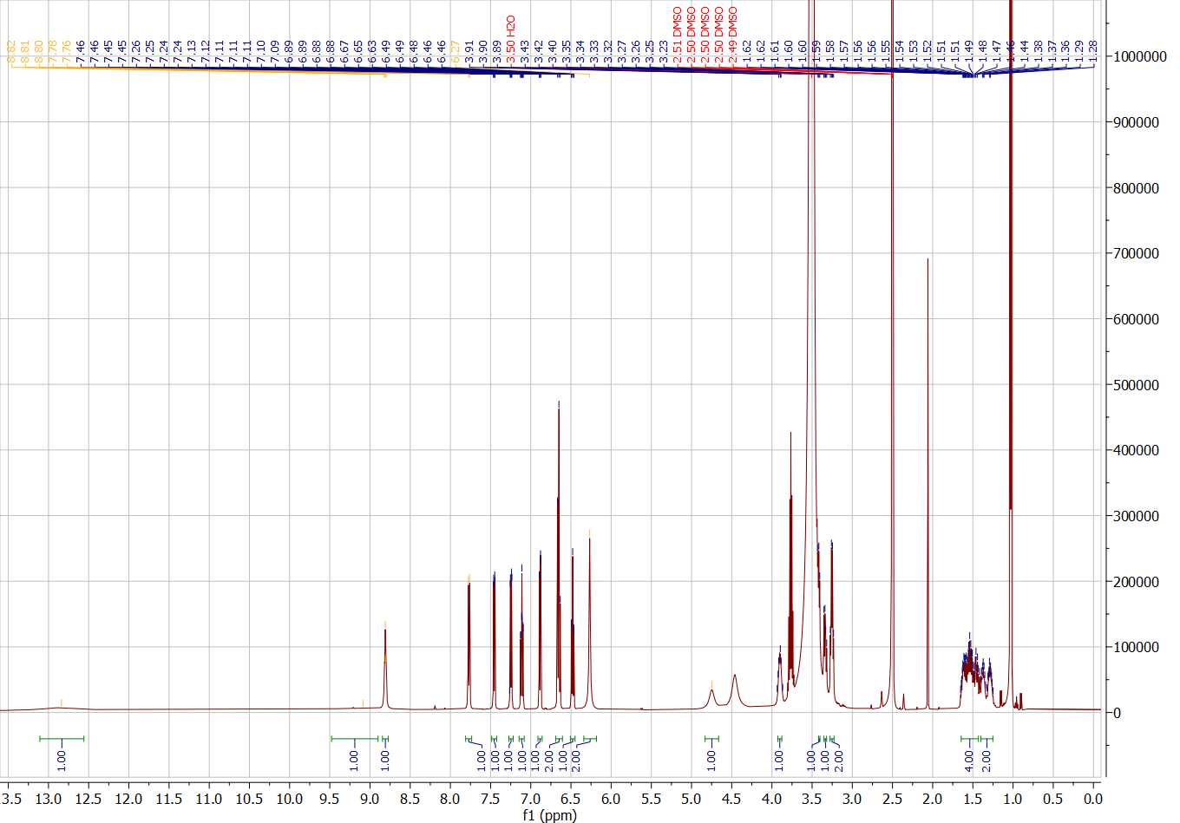
Figure S61. ¹H NMR spectrum of 9e in DMSO-d₆.
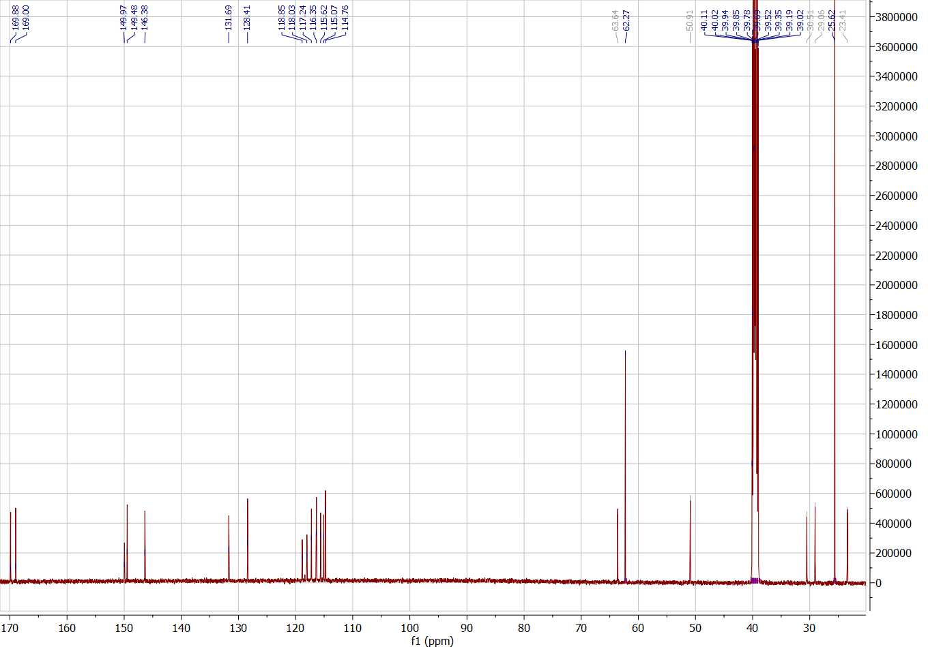
Figure S62. ¹³C NMR spectrum of 9e in DMSO-d₆.
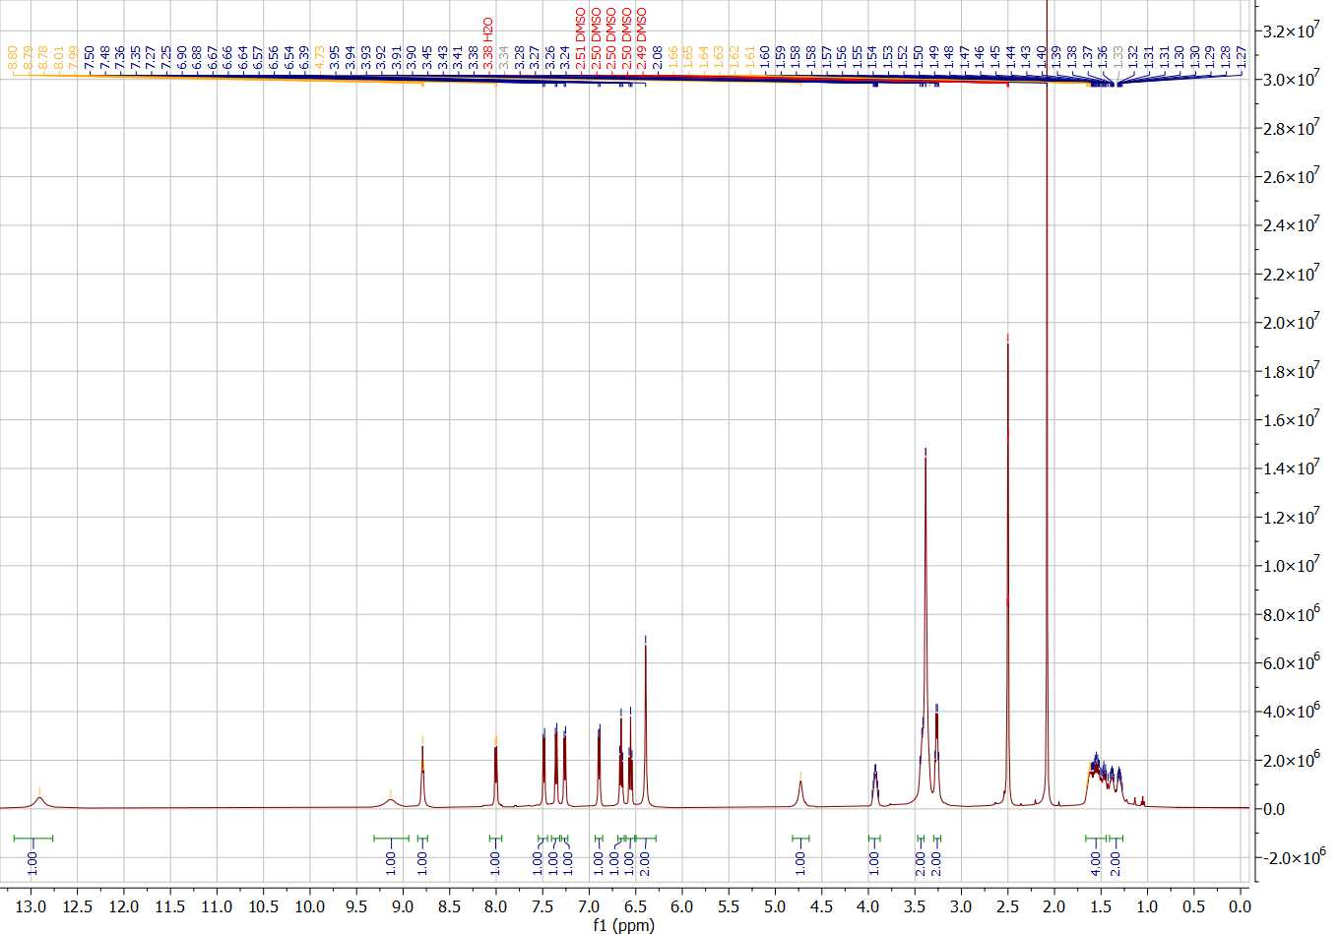
Figure S63. ¹H NMR spectrum of 9f in DMSO-d₆.
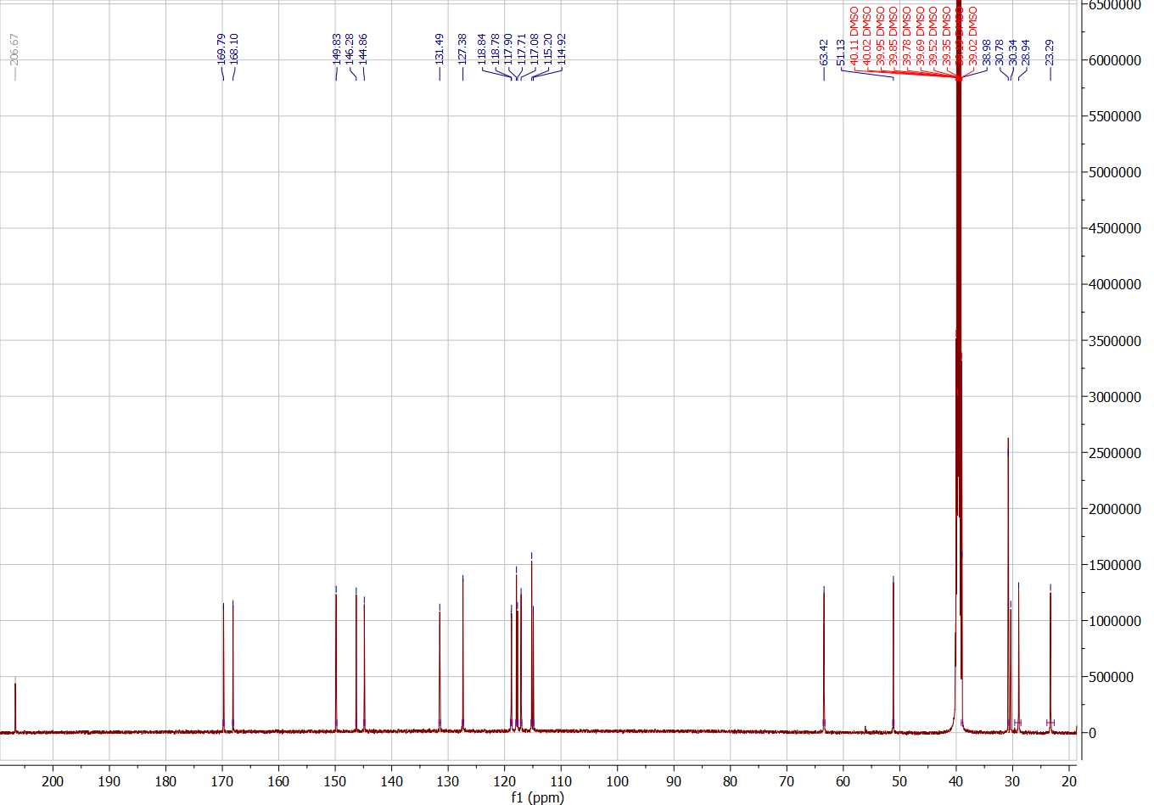
Figure S64. ¹³C NMR spectrum of 9f in DMSO-d₆.

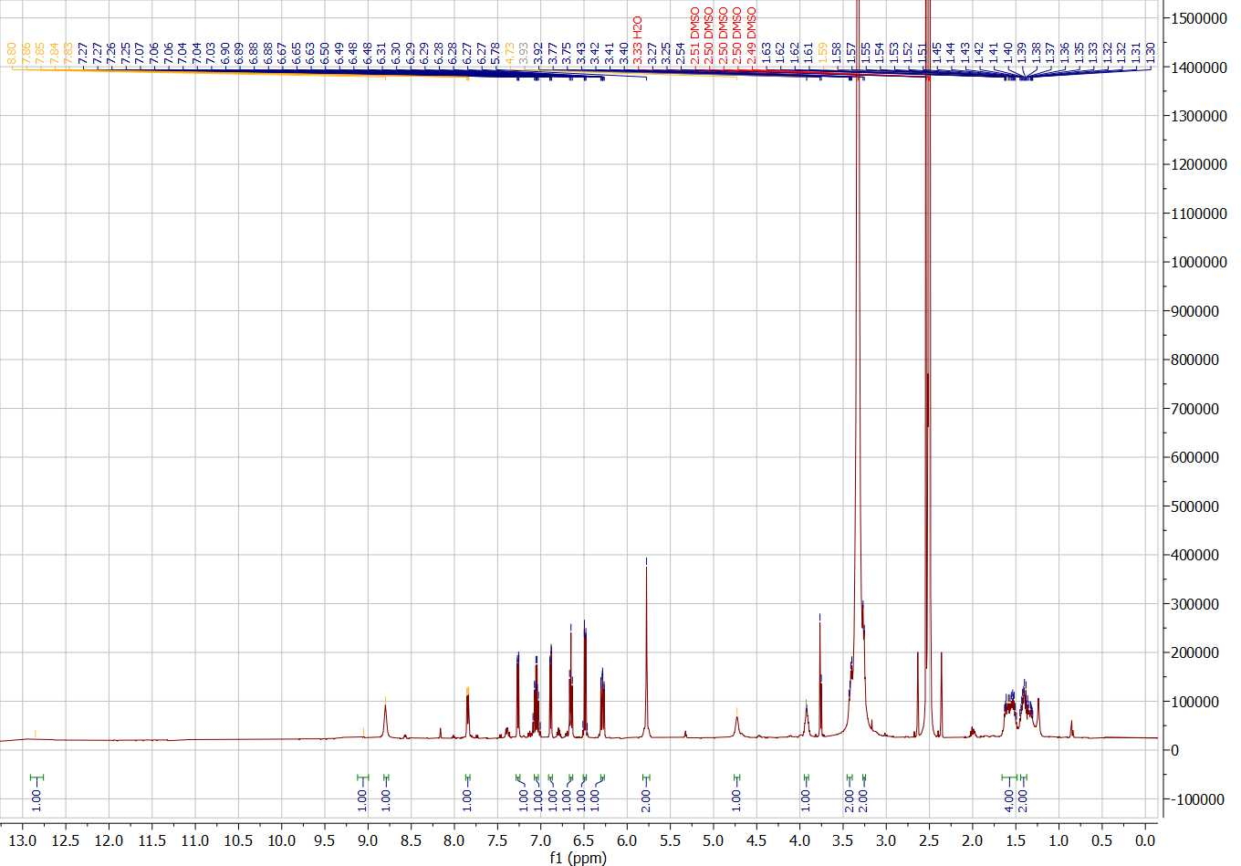
Figure S65. ¹H NMR spectrum of 9g in DMSO-d₆.

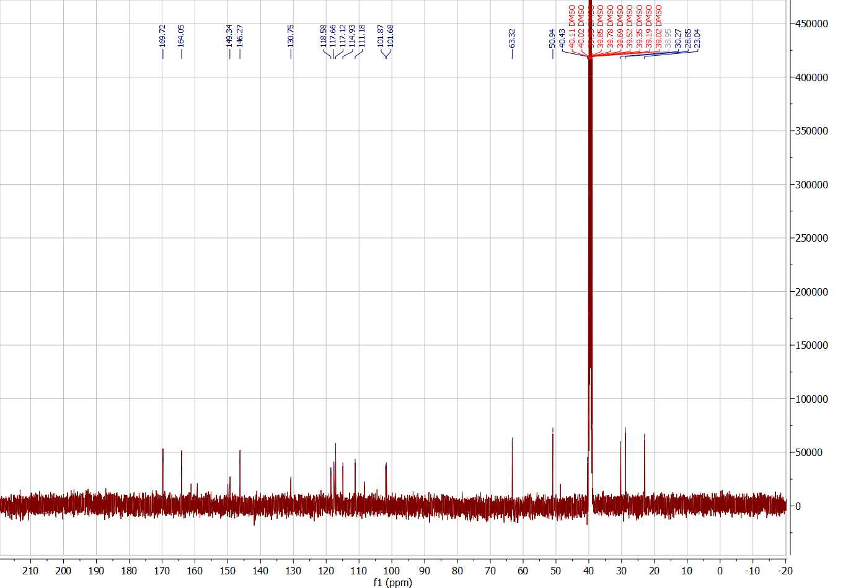
Figure S66. ¹³C NMR spectrum of 9g in DMSO-d₆.

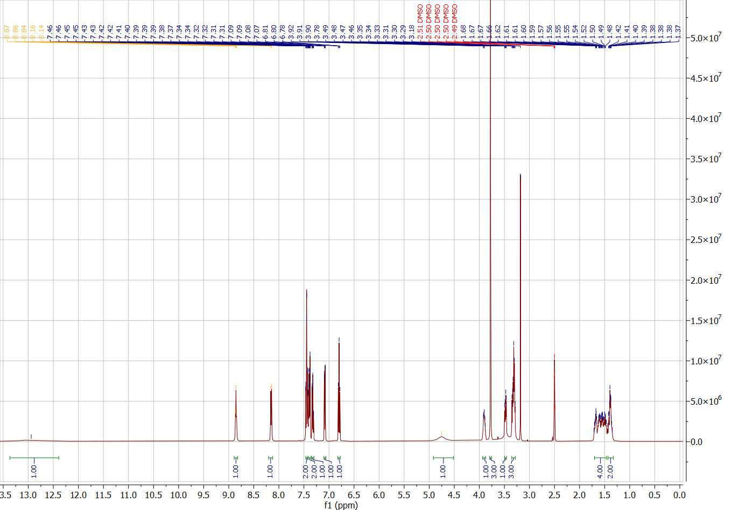
Figure S67. ¹H NMR spectrum of 9h in DMSO-d₆.
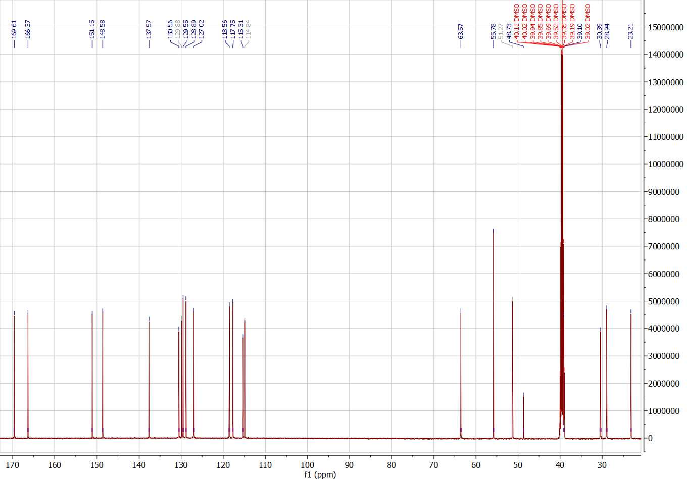
Figure S68. ¹³C NMR spectrum of 9h in DMSO-d₆.

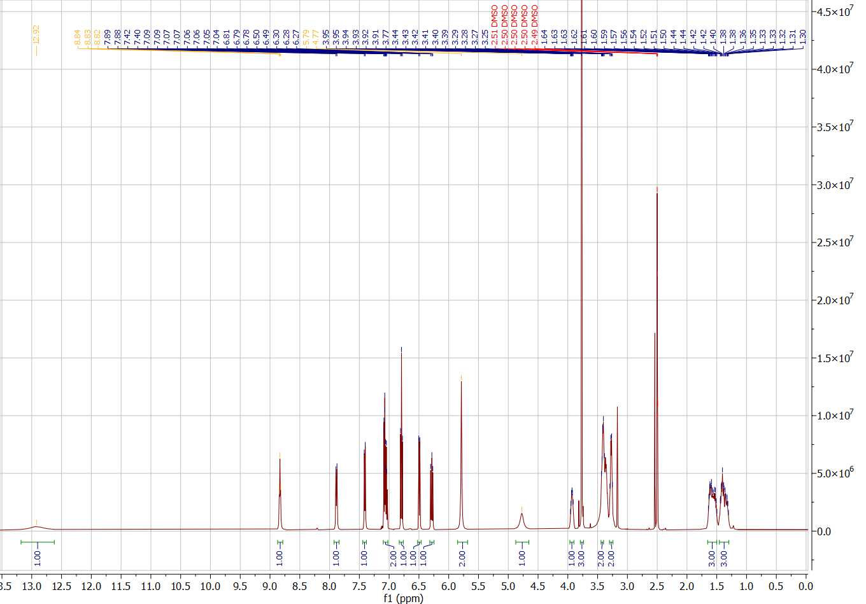
Figure S69. ¹H NMR spectrum of 9i in DMSO-d₆.

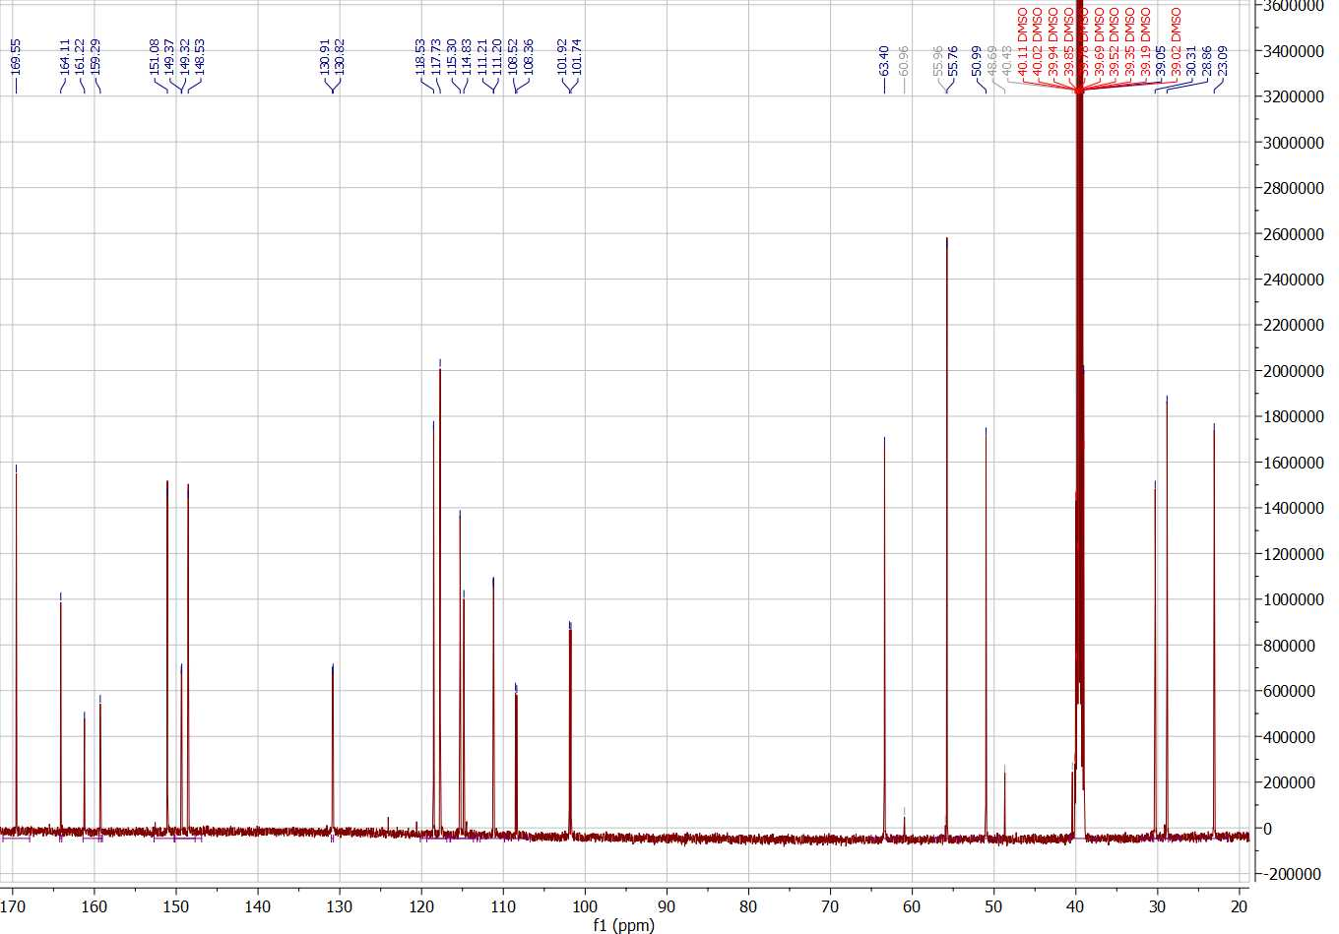
Figure S70. ¹³C NMR spectrum of 9i in DMSO-d₆.

In-silico analysis of the myxochelin N1–N3 biosynthesis

Metabolome database search of 1–3
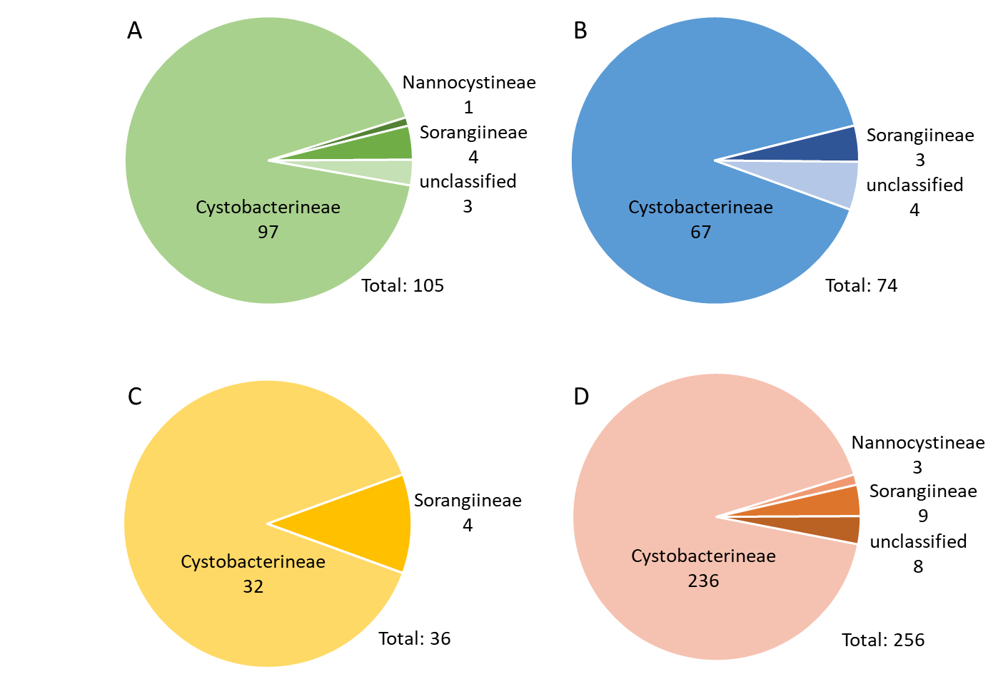
Figure S71. Alternative producers of 1–3 (A–C) and myxochelin A (D) from our in-house metabolome database sorted by suborder. Search parameters: exact mass deviation <5ppm, retention time deviation <0.3min, area threshold 3*10⁴. The decreasing number of hits from 1 to 3 is most likely due to the threshold of the peak finding algorithm.
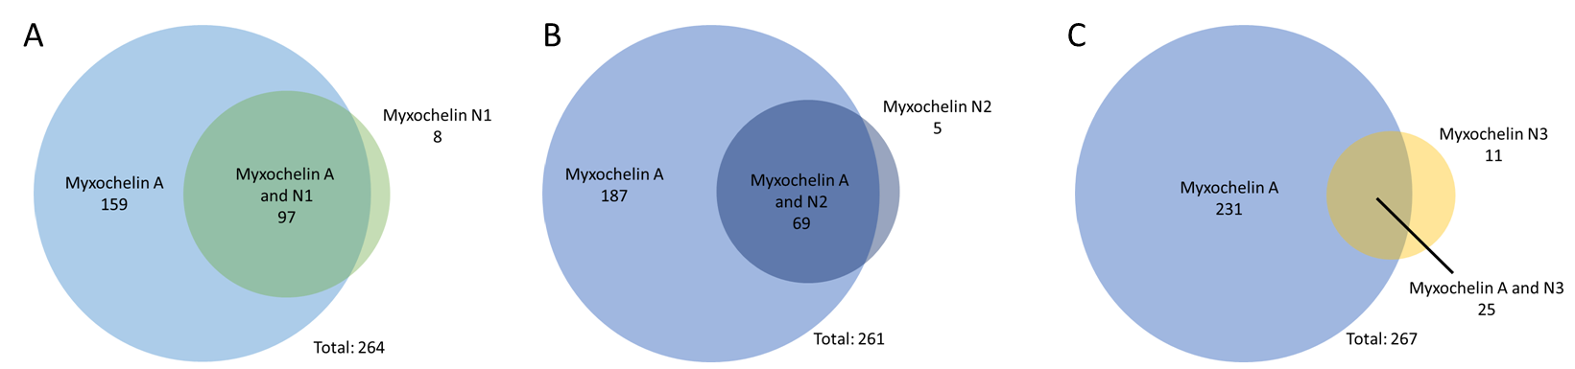
Figure S72. Venn Diagrams of alternative producers of 1–3 (A–C) and of Myxochelin A from our in-house metabolome database. Search parameters: exact mass deviation <5ppm, retention time deviation <0.3min, area threshold 3*10⁴.
The strains that were found to produce 1, 2, and/or 3, but not myxochelin A were manually screened for presence of 1–3 and myxochelin A. The 24 hits refer to 22 myxobacterial metabolomes in total. Out of these, 10 hits were found to produce myxochelin A and 1, 2, and/or 3 and 12 hits were found to produce neither 1–3 nor myxochelin A. No strain was observed to produce 1, 2, and/or 3 in absence of myxochelin A.

Analysis of the myxochelin BGC
Every coding sequence in the myxochelin biosynthesis gene cluster of MCy9049 was extracted translated and searched with the blastp algorithm against the NCBI RefSeq non-redundant protein sequence database.[1] MxcA (NADP-dependent alcohol oxidoreductase) and MxcB (removal of iron from siderophore complex) are found outside the myxochelin regulon.
Table S1. Tabulated blastP results for the CDS regions present in the MCy9049 myxochelin biosynthetic gene cluster
CDS  Name | Length [AA] | Closest homologue  [Organism of origin] | Identity [%] and alignment length [AA] | Proposed function | Accession Nr.
mxcC | 280 | 2,3-dihydro-2,3-dihydroxybenzoate dehydrogenase [Corallococcus] | 97.3 / 257 |  | WP_120546994
mxcD | 429 | isochorismate synthase DhbC [Corallococcus sp. NCSPR001] | 95.6 / 429 |  | WP_206795025
mxcE | 544 | (2,3-dihydroxybenzoyl)adenylate synthase [Corallococcus interemptor] | 98.3 / 544 |  | WP_121769586
mxcF | 301 | isochorismatase family protein [Corallococcus sp. AB049A] | 98.0 / 301 | aryl carrier protein | WP_121723307
mxcG | 1576 | myxochelin non-ribosomal peptide synthetase MxcG [Corallococcus sp. AB049A] | 92.6 / 913 |  | WP_121723308
aroAA5 | 426 | 3-deoxy-7-phosphoheptulonate synthase [Corallococcus sp. AB049A] | 99.3 / 426 | DAHP synthase | WP_121723309
mxcH | 856 | TonB-dependent siderophore myxochelin receptor MxcH [Corallococcus interemptor] | 97.0 / 856 |  | WP_121769582
mxcI | 422 | hypothetical protein [Corallococcus interemptor] | 92.9 / 422 | unknown | WP_121769581
mxcK | 405 | myxochelin export MFS transporter MxcK [Corallococcus sp. AB049A] | 96.3 / 405 |  | WP_121725177
mxcL | 427 | myxochelin B biosynthesis transaminase MxcL [Corallococcus interemptor] | 98.1 / 427 |  | WP_121769587

Table S2. A-domain specificity codes for mxcE homologs from NRPSpredictor2[2]. Prediction for all hits: dihydroxybenzoic acid or salicylic acid
CDS  Name | Organism of origin | 8 angstrom signature code | Stachelhaus code
entE | Escherichia coli  K12 | SRSIYAMSSPGGALQVGGAQQVFGMAEGLVNYTR | AMPAQGVVNK
dhbE | Bacillus subtilis  subsp. 168 | SRSLYPLSSPGGALQVGGAQQVFGMAEGLVNYTR | PLPAQGVVNK
mxcE | Corallococcus sp.  MCy9049 | SASLFPLSSPGGALQVGGAQQVFGMAEGLVNYTR | PLPAQGVVNK
mxcE | Archangium gephyra  DSM 2261 | SASLFPLSSPGGALQVGGAQQVFGMAEGLVNYTR | PLPAQGVVNK
mxcE | Archangium sp.  Cb G35 | SGSLFPLSSPGGALQVGGAQQVFGMAEGLVNYTR | PLPAQGVVNK
mxcE | Corallococcus coralloides  DSM 2259 | SASLFPMSSPGGALQVGGAQQVFGMAEGLVNYTR | PMPAQGVVNK
mxcE | Corallococcus sp.  H22C18031201 | SASLFPLSSPGGALQVGGAQQVFGMAEGLVNYTR | PLPAQGVVNK
mxcE | Cystobacter fuscus  DSM 2262 | SGSLFPLSSPGGALQVGGAQQVFGMAEGLVNYTR | PLPAQGVVNK
mxcE | Cystobacter violaceus  Cb vi76 | SGSLFPLSSPGGALQVGGAQQVFGMAEGLVNYTR | PLPAQGVVNK
mxcE | Haliangium ochraceum DSM 14365 | SASLFTLSSPGGALQVGGAQQVFGMAEGLVNYTR | TLPAQGVVNK
mxcE | Hyalangium minutum DSM 14724 | SASLFPMSSPGGALQVGGAQQVYGMAEGLVNYTR | PMPAQGVVNK
mxcE | Myxococcus fulvus  124B02 | SASLFPMSSPGGALQVGGAQQVFGMAEGLVNYTR | PMPAQGVVNK
mxcE | Myxococcus fulvus  HW-1 | SGSLFPLSSPGGAVQVGGAQQVFGMAEGLVNYTR | PLPAQGVVNK
mxcE | Myxococcus stipitatus  DSM 14675 | SASLFPMSSPGGALQVGGAQQVFGMAEGLVNYTR | PMPAQGVVNK
mxcE | Myxococcus xanthus  DK 1622 | SGSLFPLSSPGGAVQVGGAQQVFGMAEGLVNYTR | PLPAQGVVNK
mxcE | Polyangium fumosum  DSM 14668 | SASLFTLSSPGGSVQVGGSQQVFGMAEGLVNYTR | TLPSQGVVNK
mxcE | Polyangium sorediatum  DSM 14670 | SASLFTLSSPGGSVQVGGSQQVFGMAEGLVNYTR | TLPSQGVVNK
mxcE | Polyangium sp.  SDU3-1 | SASLFTLSSPGGAVQVGGAQQVFGMAEGLVNYTR | TLPAQGVVNK
mxcE | Sandaracinus amylolyticus  DSM 53668 | SASLFPLSSPGGALQVGGAQQVFGMAEGLVCYTR | PLPAQGVVCK
mxcE | Stigmatella aurantiaca  DW4/3-1 | SGSLFPLSSPGGALQVGGAQQVYGMAEGLVNYTR | PLPAQGVVNK
mxcE | Stigmatella aurantiaca  S15 | SGSLFPLSSPGGALQVGGAQQVYGMAEGLVNYTR | PLPAQGVVNK
mxcE | Vitiosangium sp.  GDMCC 1.1324 | SASLFPMSSPGGALQVGGAQQVFGMAEGLVNYTR | PMPAQGVVNK


Figure S73. Consensus sequences for 8 angstrom signature code (upper) and Stachelhaus code (lower) of myxobacterial mxcE translations.

Assessment of biological activities
Table S3. Minimum inhibitory concentrations (MICs) for the synthetic myxochelins against a panel of microorganisms and MICs of reference drugs in combination with 9a (128 µg/mL). -: not determined.
compound | MIC [µg/mL]
compound | S. aureus  str. Newman | E. coli  BW25113 | E. coli  K12 ΔtolC | C. albicans  DSM 1665 | M. hiemalis  DSM 2656
9a | > 128 | > 128 | > 128 | > 128 | > 128
9b | > 128 | > 128 | > 128 | > 128 | > 128
9c | > 128 | > 128 | > 128 | > 128 | > 128
9d | > 128 | > 128 | > 128 | > 128 | > 128
9e | > 128 | > 128 | > 128 | > 128 | > 128
9f | > 128 | > 128 | > 128 | > 128 | > 128
9g | > 128 | > 128 | > 128 | > 128 | > 128
9h | > 128 | > 128 | > 128 | > 128 | > 128
9i | > 128 | > 128 | > 128 | > 128 | > 128
Ciprofloxacin | 0.125 | - | - | - | -
Linezolid | 2 | - | - | - | -
Gentamicin | 0.5 | - | - | - | -
Daptomycin | 1 | - | - | - | -
Ciprofloxacin + 9a | 0.125 | - | - | - | -
Linezolid + 9a | 2 | - | - | - | -
Gentamicin + 9a | 0.5 | - | - | - | -
Daptomycin + 9a | 1 | - | - | - | -

References
1. O'Leary, N.A.; Wright, M.W.; Brister, J.R.; Ciufo, S.; Haddad, D.; McVeigh, R.; Rajput, B.; Robbertse, B.; Smith-White, B.; Ako-Adjei, D.; et al. Reference sequence (RefSeq) database at NCBI: current status, taxonomic expansion, and functional annotation. Nucleic Acids Res. 2016, 44, D733-45, doi:10.1093/nar/gkv1189.
2. Röttig, M.; Medema, M.H.; Blin, K.; Weber, T.; Rausch, C.; Kohlbacher, O. NRPSpredictor2—a web server for predicting NRPS adenylation domain specificity. Nucleic Acids Res. 2011, 39, W362-W367, doi:10.1093/nar/gkr323.

