Supplementary Table 1. The formula of four comorbidity indexes
Index | Number of conditions | Formula
Dartmouth-Manitoba's CCI (range 0–33) | 17 | 6 × (metastatic solid tumor + acquired immune deficiency syndrome)  +3 × (severe or moderate liver disease)  +2 × (hemiplegia + renal disease + diabetes with chronic complications + any malignancy, including leukemia and lymphoma)  +1 × (myocardial infarction + congestive heart failure + peripheral vascular disease + cerebrovascular disease + dementia + chronic obstructive pulmonary disease + connective tissue disease + ulcer + mild liver disease + diabetes, mild to moderate)
Elixhauser point system  (range -19 to 89) | 30 | 12 × metastatic cancer  +11 × liver disease  +9 × lymphoma  +7 × (congestive heart failure + paralysis)  +6 × (weight loss + other neurological disorder)  +5 × (cardiac arrhythmias + renal failure + fluid or electrolyte disorder)  +4 × (pulmonary circulation disorder + solid tumor without metastasis)  +3 × (chronic pulmonary disease + coagulopathy)  +2 × peripheral vascular disease  +0 × (acquired immune deficiency syndrome + alcohol abuse + diabetes, complicated + diabetes, uncomplicated + hypertension + hypothyroidism + peptic ulcer disease + psychoses + RA/collagen vascular disease)  - 1 × valvular disease  - 2 × (blood loss anemia + deficiency anemia)  - 3 × depression  - 4 × obesity  - 7 × drug abuse
Counted MMI  (range 1–12) | 12 | 1 × (hypertension + obesity + depression + cancer + diabetes mellitus + asthma + coronary heart disease + viral hepatitis + chronic obstructive pulmonary disease + chronic kidney disease + diverticulitis + stroke)
RDCI (range 0–9) | 11 | 2 × lung disease + [2 × (heart attack, other cardiovascular disease, or stroke) or 1 × hypertension] + fracture + depression + diabetes + cancer + (ulcer or stomach problem)

Supplementary Table 2. Comparison of the different comorbidity indexes
 | CDI | ECI | MMI | RDCI
Number of diseases | 19 | 30 | 40 | 11
Original outcome | One-year mortality | Hospital stay, cost, and mortality | Quality of life | Mortality, hospitalization, disability, and costs
Unique disease | Dementia | Alcohol related disease, obesity, and thyroid disorders | Blindness, dementia, alcohol related disease, obesity, and thyroid disorders | Fracture
Common disease | Lung disease, stroke, cancer, heart failure, diabetes, coronary heart disease
Number of papers about rheumatoid arthritis before 2018 | Numerous | 2 | 1 | 2
Dementia | O | X | O | X
Epilepsy | X | O | O | X
Liver disease | O | O | O | X
Lung disease | O | O | O | O
Blindness | X | X | O | X
Renal disease | O | O | O | X
Substance/alcohol use | X | O | O | X
Depression | X | O | O | O
Heart failure | O | O | O | O
Obesity | X | O | O | X
Thyroid disorder | X | O | O | X
Stroke | O | O | O | O
Cancer | O | O | O | O
Diabetes | O | O | O | O
Connective tissue disease | O | O | X | X
O Comorbidity which is included in the comorbidity index
X Comorbidity which is not included in the comorbidity index

Supplementary Table 3. Comparison of comorbidity indexes in patients with rheumatoid arthritis
Author, year of publication (Ref) | Country | Study design | No. of RA patients | Comorbidity index | Summary of the study
England et al., 2015 (20) | US  Veterans Affairs Rheumatoid  Arthritis (VARA) registry and the Rheumatology and  Arthritis Investigator’s Network Database (RAIN-DB) | Cohort | 4765 | RDCI,  CDI, FCI, ETS, EPS, and COUNT | ETS and RDCI best predicted death. The FCI best predicted function
Radner et al., 2015 (18) | US  Brigham and Women’s Rheu- matoid Arthritis Sequential Study(BRASS) and COMOrbidities in Rheumatoid Arthritis Study(COMORA) | Cohort | 876 | MMI.count, MMI.weight, MMI.weight using beta-coefficients, CCI, and FCI | MMI based on EQ-5D performed better than CCI. Not much improvement was obtained by weighting.
Putrik et al., 2018 (25) | Norway  Norwegian Register-  DMARD study (patients with inflammatory joint diseases treated with DMARDs) | Cohort | 4126 | RDCI, CDI, FCI | Three indexes performed comparably well. CDI performing slightly worse when predicting functioning and health.
Nikiphorou et al., 2019 (26) | UK  The Royal College of General Practitioners (RCGP) Research and Surveillance Centre (RSC) database | Cohort | 6591 | CCI, RDCI | In early RA, both the RDCI and CCI were associated with an increased risk of all-cause mortality. RDCI predicts all-cause mortality better than CCI.
England et al., 2021(27) | US  Commercial insurance database(MarketScan) | Cohort | 138891 | CCI, RDCI | CCI and RDCI showed a higher burden of multimorbidity in RA. Similar findings were obtained when requiring ≥1 year of follow-up after RA diagnosis.
Abbreviations: Rheumatic Disease Comorbidity Index (RDCI) with the Charlson-Deyo Index (CDI), functional comorbidity index (FCI), Elixhauser Total Score (ETS), Elixhauser Point System (EPS), simple comorbidity count (COUNT), counted multimorbidity index (MMI.count), weighted multimorbidity index (MMI.weight), MMI.weight using beta-coefficients (weighted multimorbidity index using beta-coefficients), Charlson comorbidity index (CCI)

Supplementary Figure 1. The impact of comorbidity on disease-specific survival showed in weighted Kaplan-Meire curve. (a) Charlson Comorbidity Index. (b) Elixhauser Comorbidity Index. (c) Multimorbidity Index. (d) Rheumatic Disease Comorbidity Index. (All log-rank test’s p-values <0.001)
a
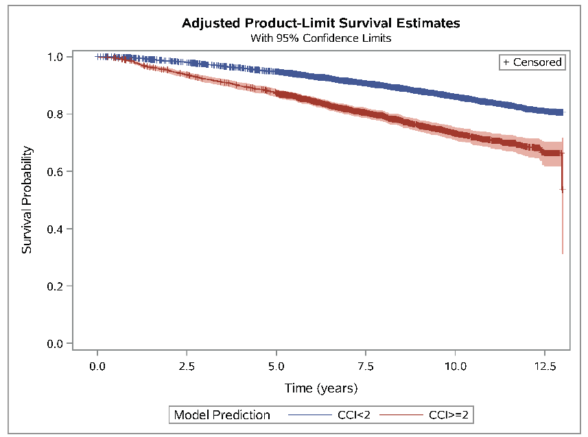
b
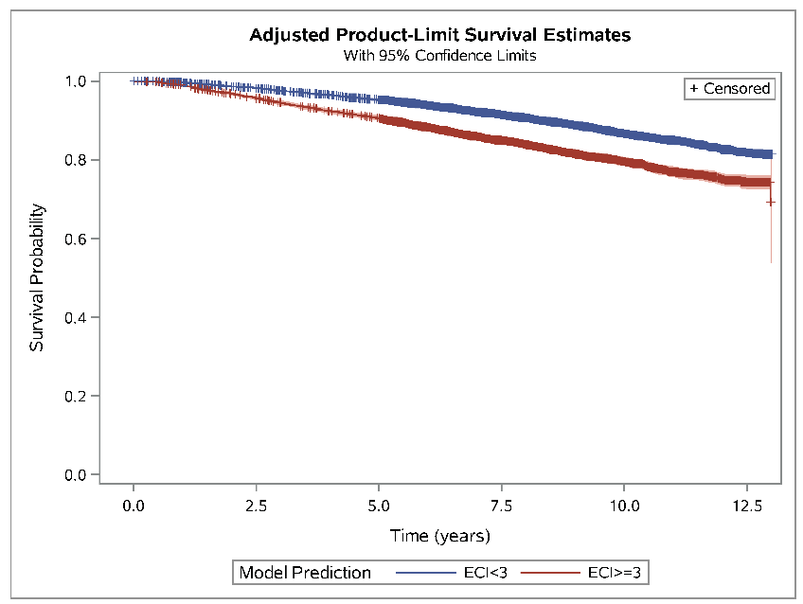
c
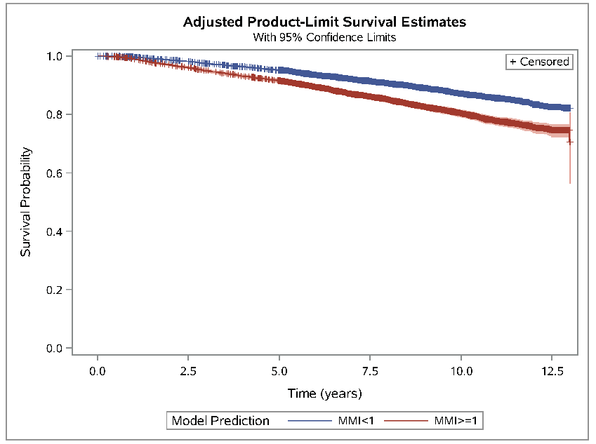
d
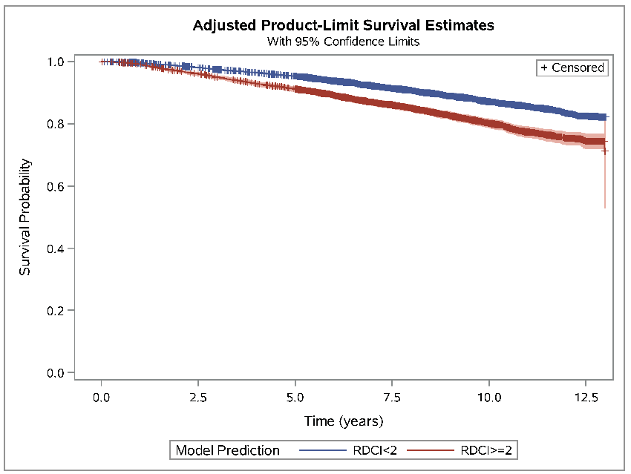
*The comorbidity indexes are calculated during the diagnostic period (the period of 4 months before and after the initial diagnosis)

Supplementary Figure 2. Receiver Operating Characteristic (ROC) Curve for Prediction of (a) 1-year Mortality and (b) 5-year Mortality by Four Comorbidity Indexes.
a
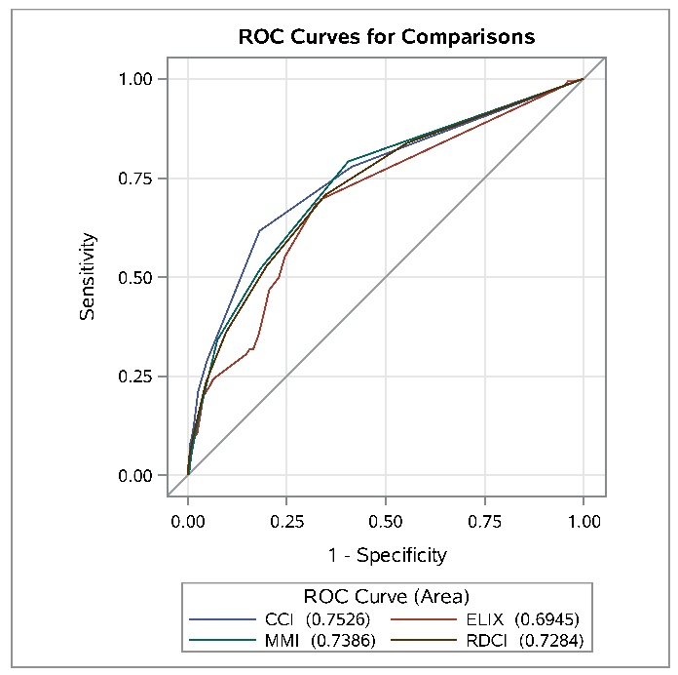
b


