Supplementary data
Table S1. SARS-CoV-2 ELISA (enzyme-linked immunoassay) and MNT (microneutralisation test) result in different age groups among dogs living in COVID-19 positive households.
Age (years) | Number of tested samples | Number of ELISA positive | ORª  (95% CI^{b}) | p | Number of MNT^{c} positive | OR  (95% CI) | p
<1 | 7 | 1 | 0.17 (0.01 – 0.98) | - | 1 | 0.17 (0,01 – 0.98) | -
1 – 4 | 22 | 14 | 10.5 (1.44 – 27.82) | 0.04* | 7 | 2.80 (0.37 – 58.21) | 0.38
5+ | 46 | 18 | 3.86 (0.59 – 76.05) | 0.23 | 11 | 1.89 (0.28 – 37.65) | 0.58
Note: Logistic regression was used to calculate OR with dogs under one year of age used as the reference category. ªOR - odds ratio, ^{b}CI - confidence interval, * - statistically significant

Table S2. Breed predisposition to SARS-CoV-2 infection.
Clades of breeds | Number of tested samples | Number of ELISAª positive samples (%) | Seroprevalence  95% CI^{b} (%) | OR^{c} | OR 95%CI | p
Mix breed | 312 | 50 (16.03) | 12.13 – 20.58 | 0.19 | 0.14 - 0.26 | -
Alpine | 8 | 1 (12,5) | 0,32 – 52,65 | 1.04 | 0.11 – 4.91 | 0.97
American Toy | 11 | 0 | NA | 0.23 | 0 – 1.78 | 0.2
Asian Spitz | 36 | 5 (13,89) | 4,67 – 29,5 | 0.91 | 0.31 – 2.2 | 0.84
Asian Toy | 60 | 9 (15) | 7,1 – 26,57 | 0.96 | 0.43 – 1.96 | 0.91
Continental Herder | 23 | 9 (39,13) | 19,71 – 61,46 | 3.40 | 1.38 – 8.06 | 0.01*
Drover | 12 | 3 (25) | 5,49 – 57,19 | 1.92 | 0.47 – 6.28 | 0.34
European Mastiff | 114 | 11 (9,65) | 4,92 – 16,61 | 0.58 | 0.28 – 1.1 | 0.1
New World | 33 | 5 (15,15) | 5,11 – 31,9 | 1 | 0.35 – 2.45 | 0.99
Pointer Setter | 30 | 6 (20) | 7,71 – 38,57 | 1.38 | 0.51 – 3.27 | 0.5
Poodle | 100 | 11 (11) | 5,62 – 18,83 | 0.67 | 0.32 – 1.28 | 0.23
Retriever | 66 | 8 (12,12) | 5,38 – 22,49 | 0.76 | 0.33 – 1.57 | 0.47
Samoyed | 8 | 0 | NA | 0.31 | 0 – 2.52 | 0.33
Scent Hound | 13 | 1 (7,69) | 0,19 – 36,03 | 0.62 | 0.07 – 2.67 | 0.57
Schnauzer | 19 | 4 (21,05) | 6,05 – 45,57 | 1.51 | 0.45 – 4.19 | 0.48
Small Spitz | 22 | 2 (9,09) | 1,12 – 29,16 | 0.63 | 0.12 – 2.07 | 0.48
Spaniel | 37 | 3 (8,11) | 1,7 – 21,91 | 0.53 | 0.14 – 1.46 | 0.24
Terrier | 78 | 10 (12, 82) | 6,32 – 22,32 | 0.8 | 0.37 – 1.57 | 0.53
Tibetan terrier | 2 | 0 | NA | 1.04 | 0 – 13.03 | 0.98
Toy Spitz | 13 | 3 (23,08) | 5,04 – 53,81 | 1.73 | 0.43 – 5.56 | 0.41
UK rural | 22 | 2 (9,09) | 1,12 – 19,16 | 0.63 | 0.12 – 2.07 | 0.48

Note: Breeds were grouped in phylogenetic clades [11]. For 72 samples, there was no breed data, and they were excluded from the analysis (n=997). Logistics regression was used to calculate odds ratio values with ˝Mix breed˝ as reference. ªELISA – enzyme-linked immunoassay, ^{b}CI – confidence interval, ^{c}OR – odds ratio, * - statistically significant
Table S3. The interaction between age and CNS symptoms in the logistic regression model.
Age | CNSª symptoms |  |  |  | OR^{c} | OR 95%CI^{d} | p (Fisher’s exact test)
 | Present |  | Absent
 | No of samples | No of ELISA^{b} positive | No of samples | No of ELISA^{b} positive
<1 | 1 | 0 | 46 | 3 | 4.14 | 0.14 – 121.78 | 1
1 | 7 | 1 | 67 | 12 | 0.76 | 0.08 – 6.94 | 1
2 | 4 | 0 | 57 | 9 | 0.46 | 0.02 – 9.11 | 0.58
3 | 6 | 1 | 56 | 9 | 1.04 | 0.11 – 10.03 | 1
4 | 0 | 0 | 51 | 8 | 5.12 | 0.09 – 276.15 | 1
5 | 4 | 0 | 45 | 11 | 0.33 | 0.02 – 6.68 | 0.56
6 | 7 | 4 | 47 | 8 | 6.5 | 1.21 – 34.85 | 0.04*
7 | 7 | 1 | 80 | 9 | 1.31 | 0.14 – 12.2 | 0.59
8 | 5 | 0 | 47 | 4 | 0.88 | 0.04 – 18.62 | 1
9 | 4 | 1 | 64 | 7 | 2.71 | 0.25 – 29.78 | 0.4
10 | 1 | 1 | 72 | 11 | 16.04 | 0.61 – 418.75 | 0.1
11 | 2 | 2 | 81 | 5 | 69.55 | 2.96 – 1634.71 | 0.01*
12 | 2 | 1 | 63 | 9 | 6 | 0.34 – 104,79 | 0.29
13 | 3 | 1 | 37 | 5 | 6.4 | 0.34 – 119.58 | 0.29
14 | 1 | 0 | 39 | 1 | 8.56 | 0.24 – 310.72 | 1
15+ | 5 | 2 | 34 | 6 | 3.11 | 0.42 – 22.87 | 0.27
Note: ªCNS – central nervous system, ^{b}ELISA – enzyme-linked immunoassay, ^{c}OR- odds ratio, ^{d}CI - confidence interval.

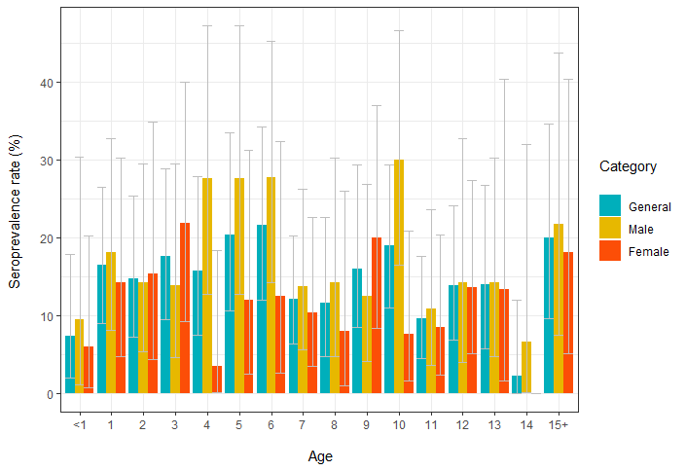
Figure S1. Age and sex distribution of SARS-CoV-2 ELISA positive dogs. Error bars represent a 95% confidence interval.

