Supplementary figures
Supplementary figure 1. LOPAC¹²⁸⁰ screening plate layout: the LOPAC¹²⁸⁰ collection was arrayed across sixteen 96-well plates. Each plate contained three positive (no-inhibitor) controls (green), three blank wells (pink) and 80 wells containing compounds from the library (blue). The remaining wells were unused.

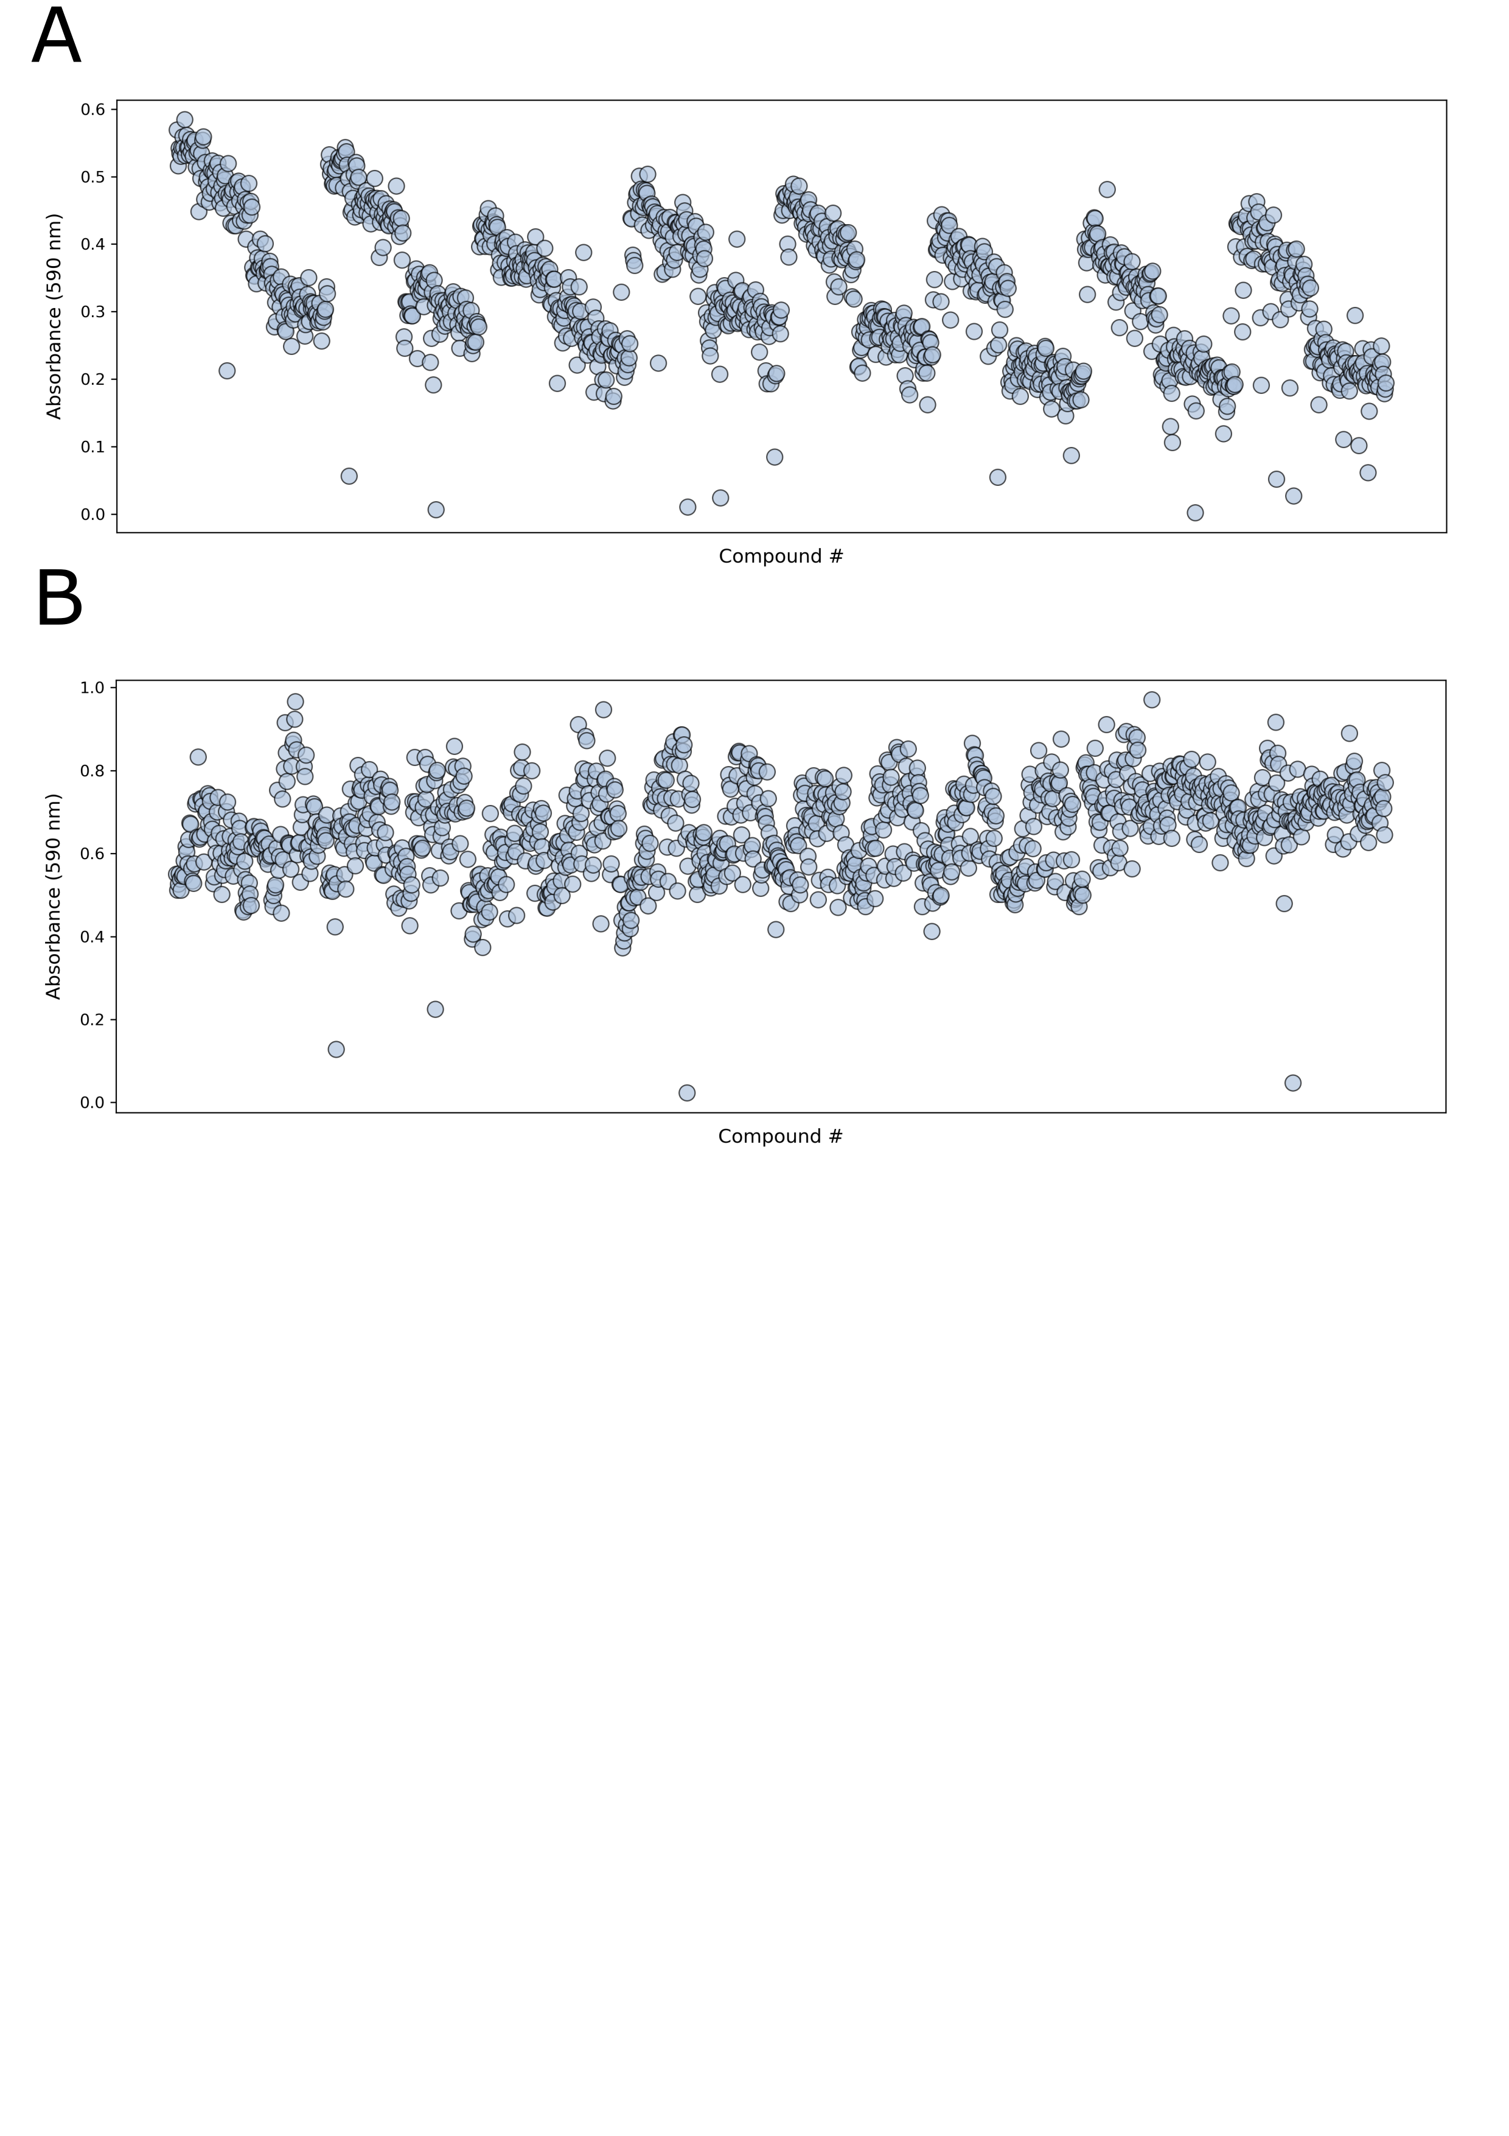Supplementary figure 2. Raw values absorbance values of the LOPAC¹²⁸⁰ collection: A) A₅₉₀ values derived post indigoidine synthesis by PptT-activated BpsA for 16 96-well plates, screened in pairs to identify candidate PptT inhibitors from the LOPAC¹²⁸⁰ collection. Clearly evident is the wave-like pattern arising due to the instability of PptT in aqueous media. B) A₅₉₀ values derived post indigoidine synthesis for an equivalent set of 96-well plates to those presented in Panel A, only using pre-activated BpsA. These reactions did not contain PptT and correspondingly no wave-like pattern is discernible.

Supplementary Figure 3. EC₅₀ values for top compounds: A two-fold serial dilution from 40 µM to 0.625 µM for each compound was established across individual rows of a 96 well plate. Graphpad Prism was then used to fit a four parameter dose-response curve to determine EC₅₀ values. In each case, data was derived from the mean of three independent replicates and error bars represent the standard deviation.

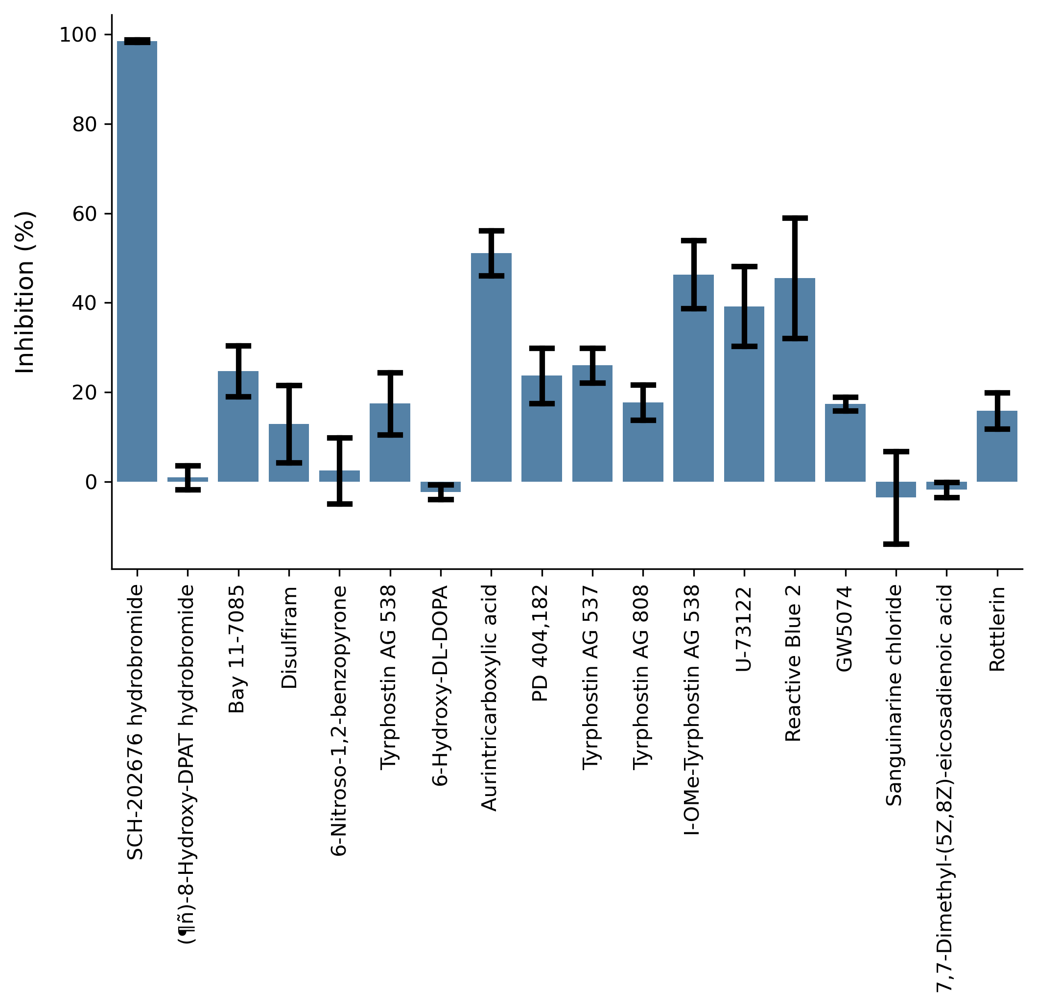

Supplementary Figure 4. Inhibition of holo-BpsA at a candidate -inhibitor concentration of 40 µM: The inhibition of holo-BpsA by compounds identified as candidate PptT inhibitors at 20 µM was determined by re-screening at 40 µM. In each case, data was derived from the mean of three independent replicates and error bars represent the standard deviation.

Supplementary Figure 5. Kinetic determination of EC₅₀ values: A) The rate of BpsA activation by PptT diminishes with increasing levels of 6-NOBP. Data were recorded every 20 s and are the average of three replicates. The lighter shaded boundaries around each set of A₅₉₀ data (left panel) represent one standard deviation. The right panel shows the graph used to derive EC₅₀ values from the mean A₅₉₀ data. Data was derived from the mean of three replicates, and the error bars in the right panel represent one standard deviation. B) The rate of BpsA activation by PptT diminishes with increasing levels of Sanguinarine chloride. Data were recorded every 20 s and are the average of three replicates. The lighter shaded boundaries around each set of A₅₉₀ data (left panel) represent one standard deviation. The right panel shows the graph used to derive EC₅₀ values from the mean A₅₉₀ data. Data was derived from the mean of three replicates, and the error bars in the right panel represent one standard deviation.

