Supplementary Material

Determination of the Open-Bundle Structure of Cytochrome c’ as a Folding/Unfolding Intermediate by Small-Angle Neutron Scattering

Takahide Yamaguchi,^{1,2} Kouhei Akao,¹ Alexandros Koutsioubas,³ Henrich Frielinghaus,³ and Takamitsu Kohzuma*^{1,2}

¹Institute of Quantum Beam Science, Graduate School of Science and Engineering, Ibaraki University, 2-1-1 Bunkyo, Mito, Ibaraki 310-8512, Japan
²Frontier Research Center of Applied Atomic Sciences, Ibaraki University, 162-1 Shirakata, Tokai, Ibaraki 319-1106, Japan
³Jülich Centre for Neutron Science at Heinz Maier-Leibnitz Zentrum, Forschungszentrum Jülich GmbH, Lichtenbergstrasse 1, Garching D-85747, German

Table of Contents
Figure S1. SDS-PAGE of purified Cyt c’ on a 12.5% gel…………….……… page 2
Figure S2. Electronic absorption spectra of Cyt c’ at pD 1.7, 6.4, 9.6, and ~13. The spectral patterns are annotated by charge-transfer 3 (CT3), Soret, CT2, Q, and CT 1 at short wavelengths. The samples were prepared by diluting the samples following SANS experiments…………………………………………………………………… page 2
Figure S3. Curves obtained by ab initio analyses (red lines) and data points used for each condition (squares: pD 6.4, circles: pD 9.6, triangles: pD ~13)…...………… page 3
Figure S4. The estimation of I(0) values by extrapolation of the I(Q) SANS curves (top panels) and Guinier plots (bottom panels) at pD 1.7 (A, red), 6.4 (B, orange), 9.6 (C, green), and ~13 (D, blue). The black solid lines in the top panels are fitted I(Q) SANS curves by Fourier transformation of P(r) at each pD value, and the black dashed lines in the bottom panels were obtained from linear Guinier fitting. The I(0) point at each pD value is marked by a diamond on the vertical axis.…...……………………… page 3

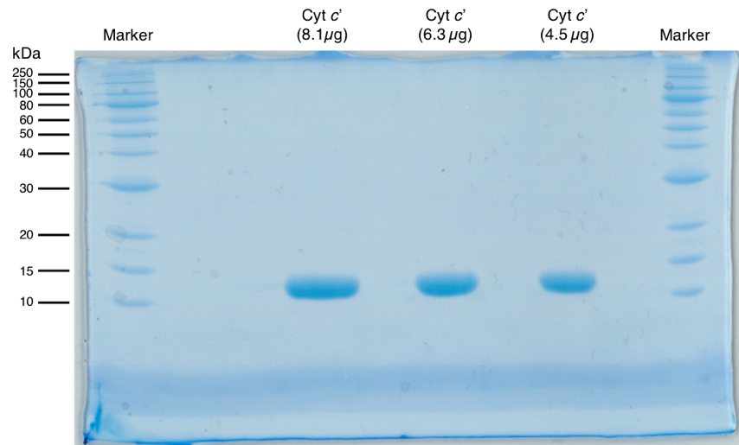
Figure S1. SDS-PAGE of purified Cyt c’ on a 12.5% gel.

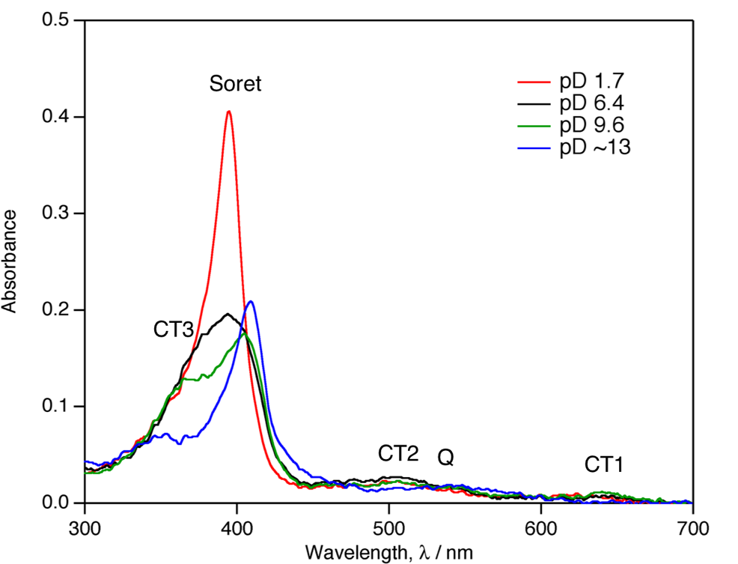
Figure S2. Electronic absorption spectra of Cyt c’ at pD 1.7, 6.4, 9.6, and ~13. The spectral patterns are annotated by charge-transfer 3 (CT3), Soret, CT2, Q and CT 1 at short wavelengths. The samples were prepared by diluting the samples following SANS experiments.

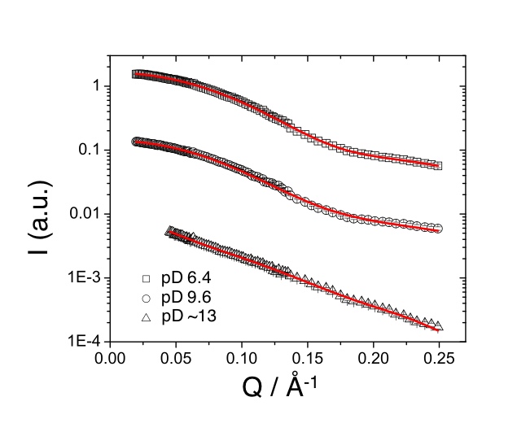
Figure S3. Curves obtained by ab initio analyses (red lines) and data points used for each condition (squares: pD 6.4, circles: pD 9.6, triangles: pD ~13).

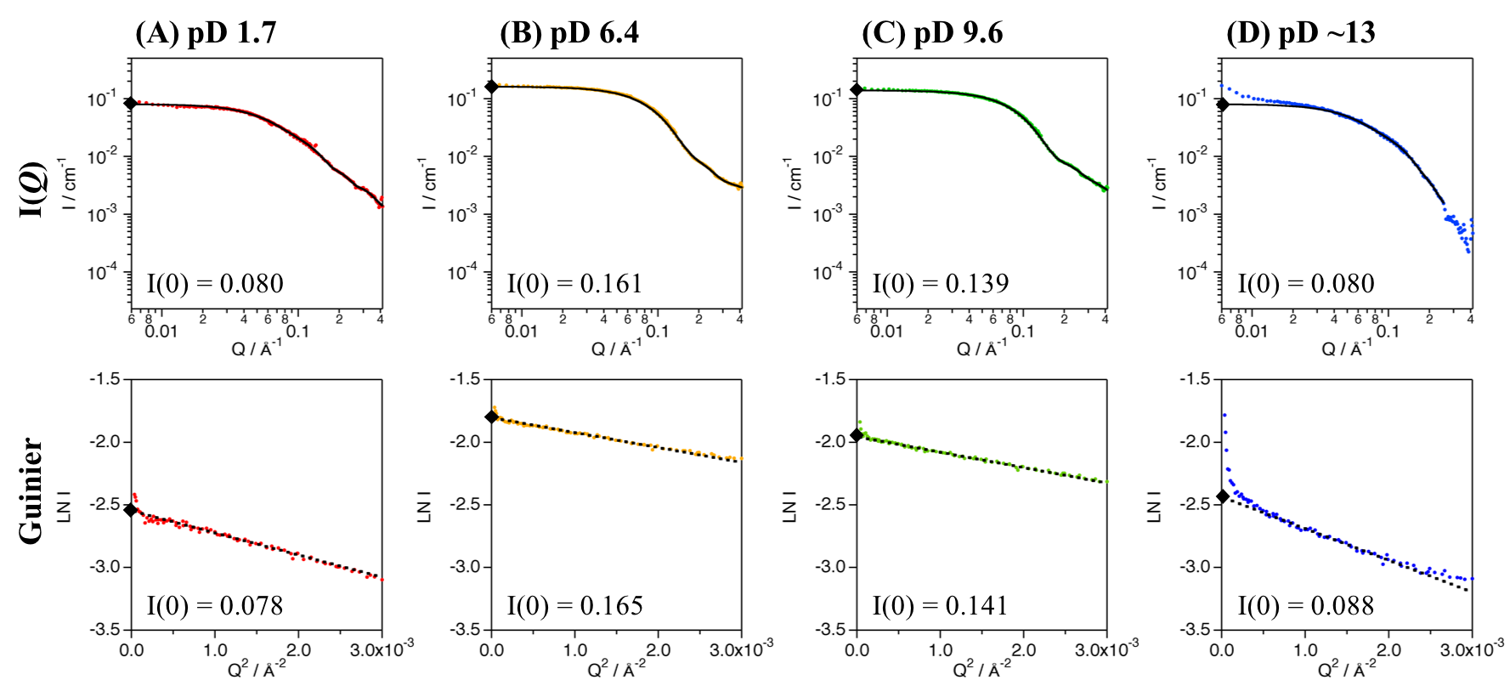
Figure S4. The estimation of I(0) values by extrapolation of the I(Q) SANS curves (top panels) and Guinier plots (bottom panels) at pD 1.7 (A, red), 6.4 (B, orange), 9.6 (C, green), and ~13 (D, blue). The black solid lines in the top panels are fitted I(Q) SANS curves by Fourier transformation of P(r) at each pD value, and the black dashed lines in the bottom panels were obtained from linear Guinier fitting. The I(0) point at each pD value is marked by a diamond on the vertical axis.

