Data diagnoses through error bar and scatter plots
As described below (Figure 2), the two error bars do not overlap by horizontal imaginary line. This is a clue that the mean value of vitC for normal individuals is different as compared with individuals who already developed kidney disease. There was also high variability of vitC level among individuals who have developed kidney disease compared with normal individuals. However, we cannot be sure and it is a must to perform a statistical test to draw a conclusion.
- 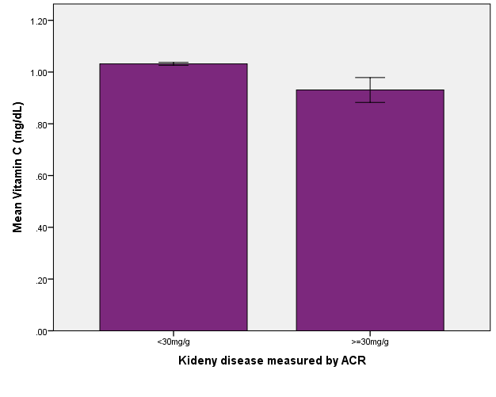
Figure 2: An error bar which indicates the relationship between ACR and VitC among the US population; data from NHANES, 2007-2008.
Moreover, about the relationship among albumin creatinine ratio (ACR), vitC and MetS was described briefly below in Figure 3. The mean value of ACR and vitC was different for both normal and individuals with MetS. From the graph, we observe that there was huge variability with higher mean value of ACR among MetS individuals compared with normal individuals. The mean value of vitC among normal individuals was a little bit higher compared to individuals who developed MetS. Beyond this, there was no any error bar that overlaps with any of the bars through horizontal imaginary line. These supports that there may be statistically significant difference mean value of VitC and ACR for both normal and individuals who developed MetS.

- 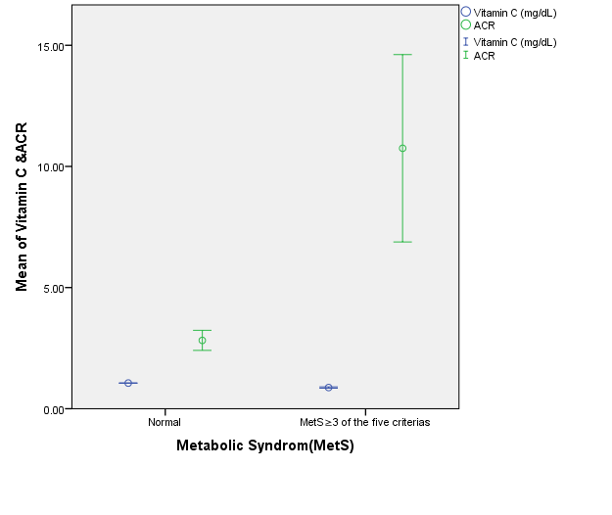Figure 3: An error bar which indicates the relationship of MetS, ACR and VitC among the US population; data from NHANES, 2007-2008.
The scatter plot also indicates that there is a negative linear relationship between ACR and vitC serum concentration though there are some extreme data (Figure 4). For a unit an increase in serum vitamin C concentration, the value of ACR is decreased by 1.9 (ACR=6.04-1.9*vitamin C in mg/dl).
- 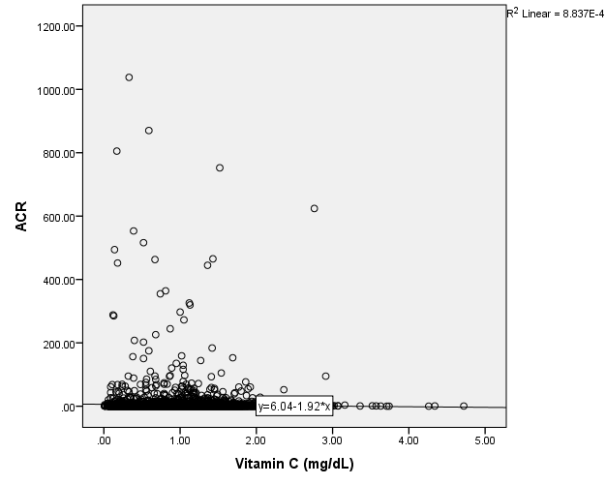Figure 4: The scatter plot which indicates the relationship between ACR and vitC among the US population; data from NHANES, 2007-2008.
Independent T test, one way ANOVA and its mean plots
There was statististical difference in the means of vitC concentration of indviduals whose ACR was less than 30 mg/g and greater than or equal to 30 mg/g ( P =0.05; t=2.01).
One way ANOVA also indicated that both the mean difference of vitC concentration and ACR was statistically significant between normal individuals and who developed MetS. The mean plot also indicated that individuals who developed MetS had low mean of vitC concentration but high mean value of ACR compared with normal individuals (Figure 5 and 6).

- 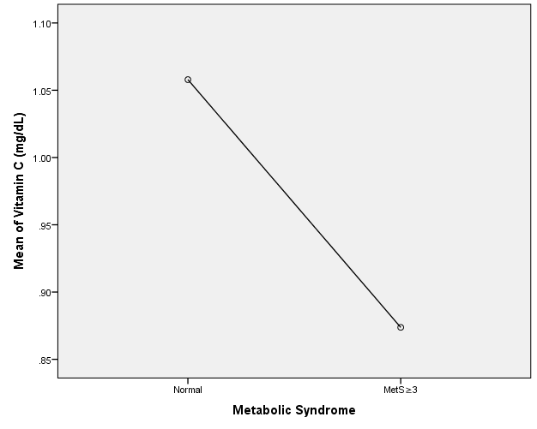
- Figure 5: Means plot indicating the relationship between vitC and Metabolic syndrome among the US population in the year from 2007-2008.
- 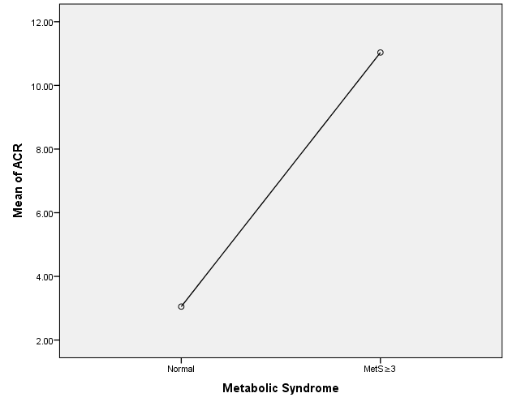Figure 6: Means plot indicating the relationship between ACR and Metabolic syndrome among the US population in the year from 2007-2008.
Chi-square test results and its interpretation
To do Chi-square tests and its corresponding odds ratio and Pearson chi-square statistical test was considered. Individuals who developed metabolic syndrome had increased odds of kidney disease by 2.55 folds (COR=2.55; 95% CI: 1.78, 3.66) compared with their counter parts. Whereas, vitC deficiency also increases the odds of developing kidney disease by 2.38 folds (COR=2.38; 95% CI: 1.35, 4.20).
Regression analysis and R² value interpretation
Collinearity diagnosis was tested using variance inflation factor (VIF) and the tolerance value, which was found to be acceptable to fit for continuous variables. From the output the following equation was established as: ACR=6.037-1.92* vitamin C+ 0.76. This implies that for a unit decrease in serum vitamin C, the risk of developing kidney disease can be increased nearly by two folds (COR=-1.92; 95% CI:-3.41,-0.43) though it explained only 0.1 percent compared with the other un-explained variables (R²=0.001 and p value<0.01).

