Supplementary

Mining Indonesian microbial biodiversity for novel natural compounds by a combinatory genome mining and molecular networking approach
Ira Handayani ^{1,2,a}, Hamada Saad ^{3,8,a} , Shanti Ratnakomala ², Puspita Lisdiyanti ², Wien Kusharyoto ², Janina Krause¹, Wolfgang Wohlleben¹, Andreas Kulik¹, Saefuddin Aziz ³, Harald Gross ³, Athina Gavriilidou ⁴, Nadine Ziemert ^{4,5} , and Yvonne Mast^{1,5,6,7,}*
¹ Department of Microbiology/Biotechnology, Interfaculty Institute of Microbiology and Infection Medicine, Tübingen (IMIT), Cluster of Excellence ‘Controlling Microbes to Fight Infections’, University of Tübingen, Auf der Morgenstelle 28, 72076 Tübingen, Germany; e-mail@e-mail.com
² Research Center for Biotechnology, Indonesian Institute of Sciences (LIPI), Jl. Raya Jakarta-Bogor KM.46, Cibinong, West Java 16911, Indonesia; p2biotek@bioteknologi.lipi.go.id.
³ Department of Pharmaceutical Biology, Institute of Pharmaceutical Sciences, University of Tübingen, Auf der Morgenstelle 8, 72076 Tübingen, Germany; e-mail@e-mail.com
⁴ Applied Natural Products Genome Mining, Interfaculty Institute of Microbiology and Infection Medicine Tübingen (IMIT), Cluster of Excellence ‘Controlling Microbes to Fight Infections’, University of Tübingen, Auf der Morgenstelle 28, 72076 Tübingen, Germany.; e-mail@e-mail.com
⁵ German Center for Infection Research (DZIF), Partner Site Tübingen, Tübingen, Germany
⁶ Department of Bioresources for Bioeconomy and Health Research, Leibniz Institute DSMZ – German Collection of Microorganisms and Cell Cultures, Inhoffenstraße 7B, 38124 Braunschweig, Germany; e-mail@e-mail.com
⁷ Department of Microbiology, Technical University of Braunschweig, Braunschweig, Germany; e-mail@e-mail.com
⁸ Department of Phytochemistry and Plant Systematics, Division of Pharmaceutical Industries, National Research Centre, Dokki, Cairo (Egypt)
ª Ira Handayani and Hamada Saad contributed equally to this work
* Correspondence: yvonne.mast@dsmz.de; Tel.: +49-531-2616-358

Preparation of test plates for agar diffusion tests

- Preparation of Bacillus subtilis test plates

B. subtilis is grown for 4 to 7 days at a temperature of 29°C in sporulation medium (FeCl₃ x 6H₂O 1 mg, MnCl₂ x 2xH₂O 14.5 mg, NH₄Cl 540 mg, Na₂SO₄ 105 mg, KH₂PO₄ 87 mg, CaCl₂ 194.7 mg, NH₄NO₃, MgCl₂ x 6H₂O 8.3 mg, glucose 2 g, Na-L-glutamate x H₂O 1.9 g, pH7.1). The B. subtilis culture was harvested (10 min, 5000 rpm, 4 ° C) and twice washed with 20 mL of H₂O_{deion.}. The washed pellets were dissolved with 15 mL H₂O_{deion}. and heated for 30 minutes at 70 °C to kill remaining vegetative cells. The spore suspension can be stored for a long time at a temperature not exceeding 4 ° C. For B. subtilis test plates, 10 mL/L of the spore suspension were poured into B. subtilis test agar (KH₂PO₄ 3g, K₂HPO₄ 7g, tri-Na citrate.2H2O 0.5 g, MgSO4 x 7H2O 0.1 g, (NH4)2SO4 1g). Plates were incubated overnight at 37 °C

- Preparation of M. luteus and P. fluorescens test plates

Bioassays test plates for M. luteus and P. fluorescens were prepared by spread M. luteus or P. fluorescens cells evenly over YM agar plates surface. The plates were used directly for inhibition zone tests. Plates were incubated overnight at 28°C.

- Preparation of E. coli and S. carnosus test plates

In liquid LB agar, cells of an overnight culture of E. coli of S. carnosus were poured in a ratio of 1: 100 and pipetted into petri dishes. For bioassays, the plates were incubated overnight at 37°C.

Figures and Tables

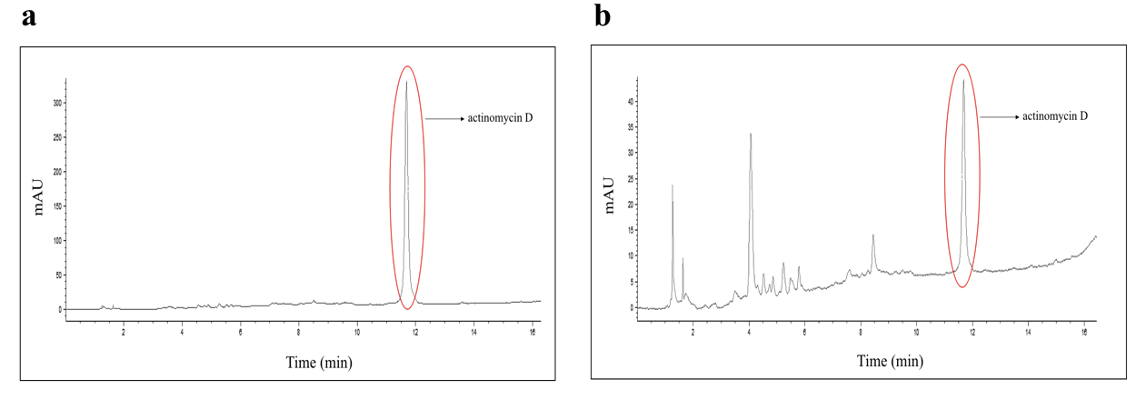

c
Figure S1. Actinomycin D production in DHE 6-7 (a) and DHE 5-1 (b). Peaks in HPLC representing actinomycin are marked with red colour. Mass spectra of actinomycin D detected in DHE 6-7 (c).

Figure S2. Positive extracted ion chromatograms (EICs), ions cluster and predicted molecular formula of antimycins.

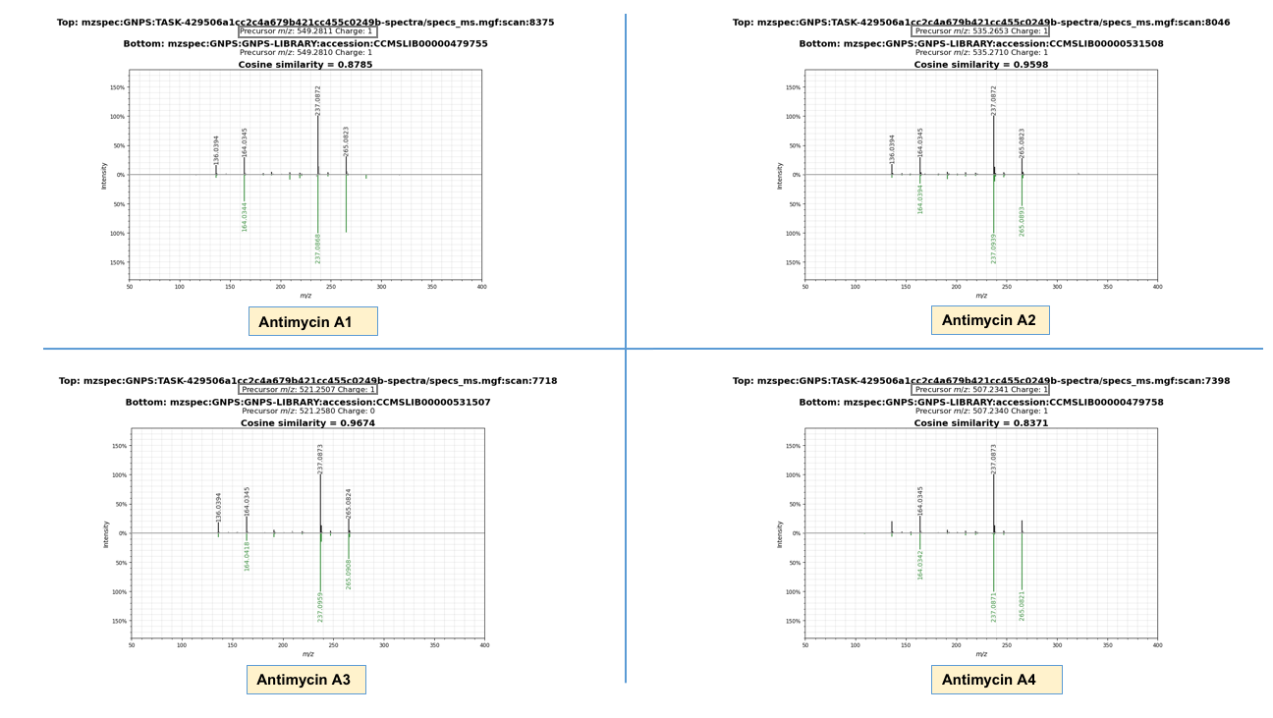
Figure S3. GNPS spectral libraries hits of antimycins.

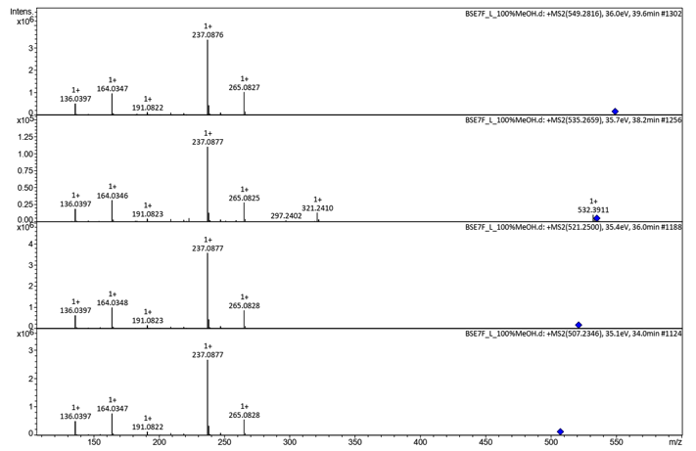
Figure S4. Positive MS2 spectra of the detected antimycins from isolate BSE7F.

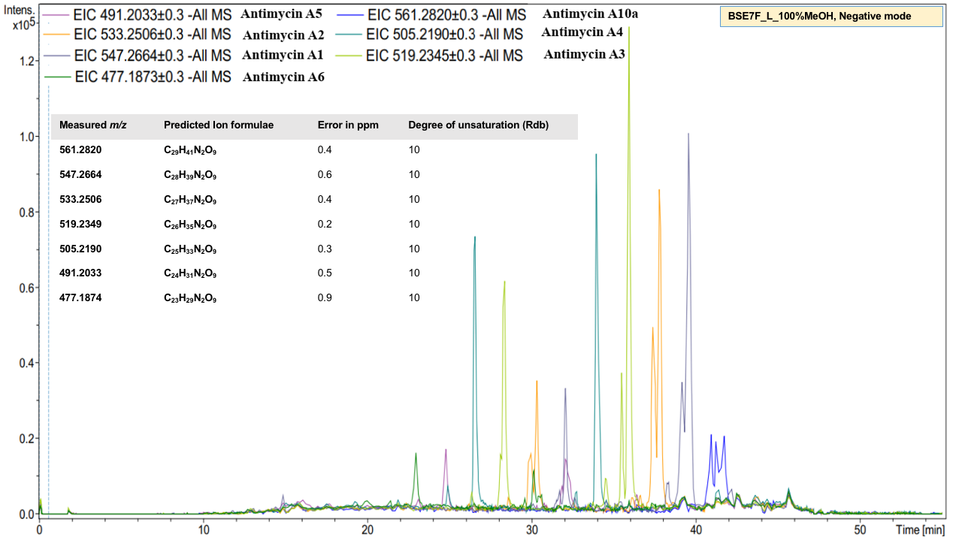
Figure S5. Negative EICs and predicted molecular formulae of antimycins.

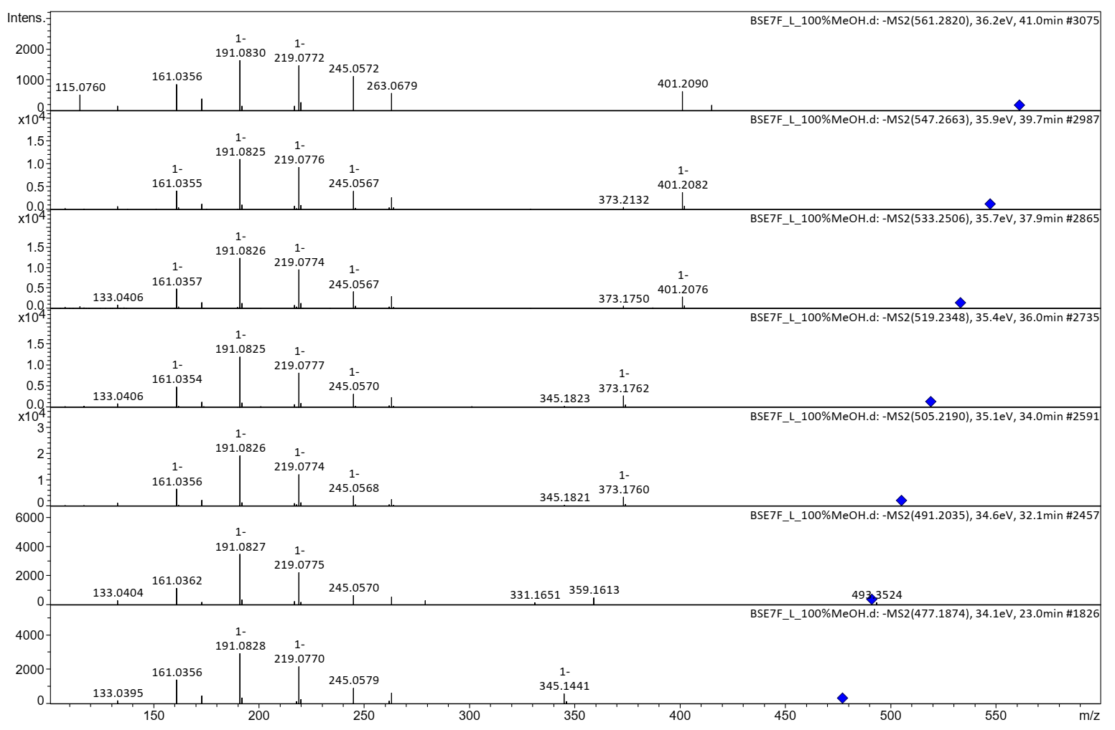
Figure S6. Negative MS2 spectra of the detected antimycins from isolate BSE7F.

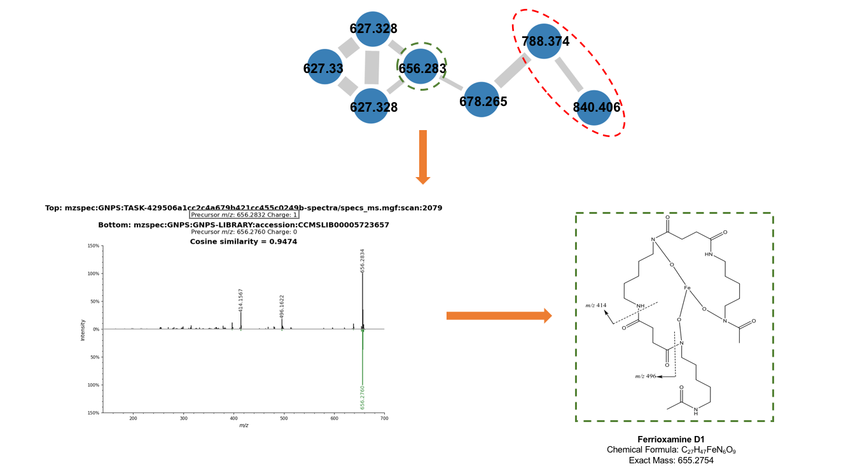
Figure S7. Ions cluster of ferrioxamines and GNPS spectral libraries hit of ferrioxamine D1.

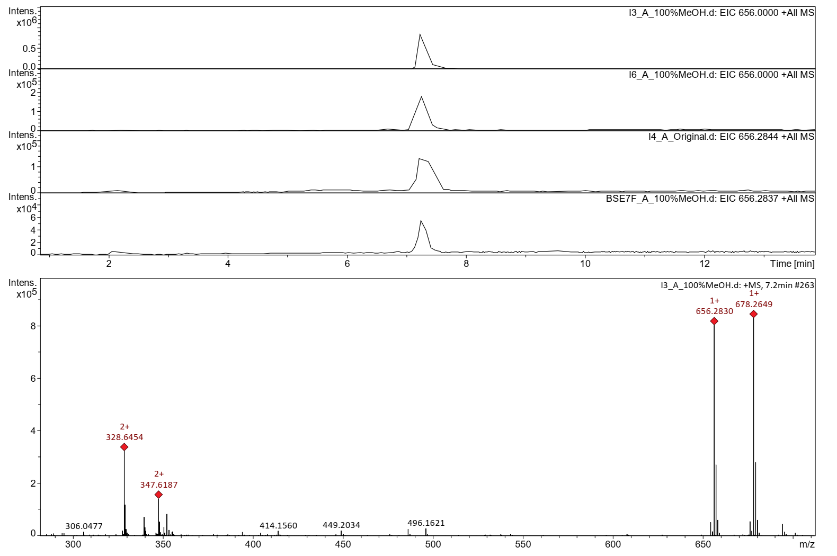
Figure S8. Positive EICs and molecular formula prediction of ferrioxamine D1.

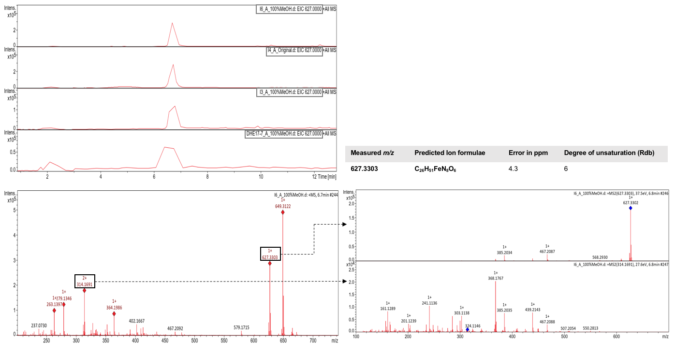
Figure S9. Positive EICs, molecular formula prediction and MS2 of an unknown ferrioxamine.

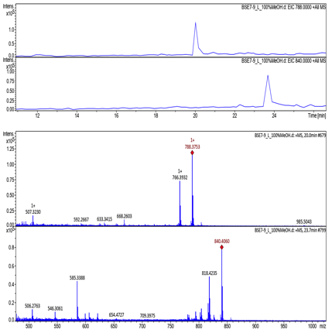
Figure S10. Positive EICs and MS1 of unknown amphiphilic ferrioxamines.
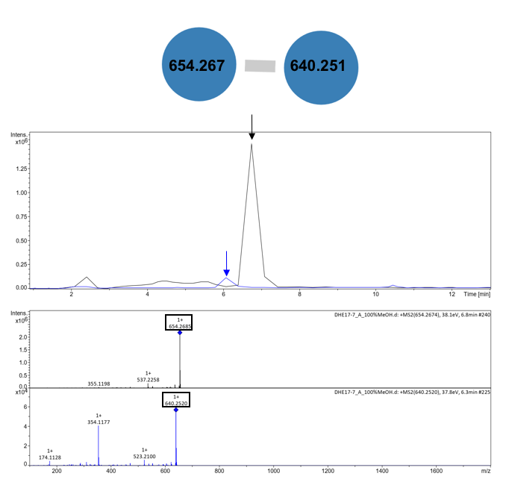
Figure S11. Positive EICs and MS2 of DHE 17-7 ferrioxamines.

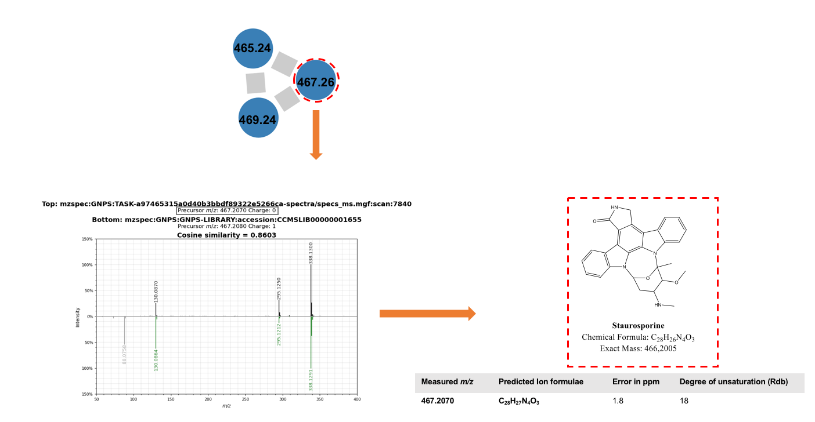
Figure S12. Ions cluster of staurosporines and GNPS spectral libraries hit of staurosporine.

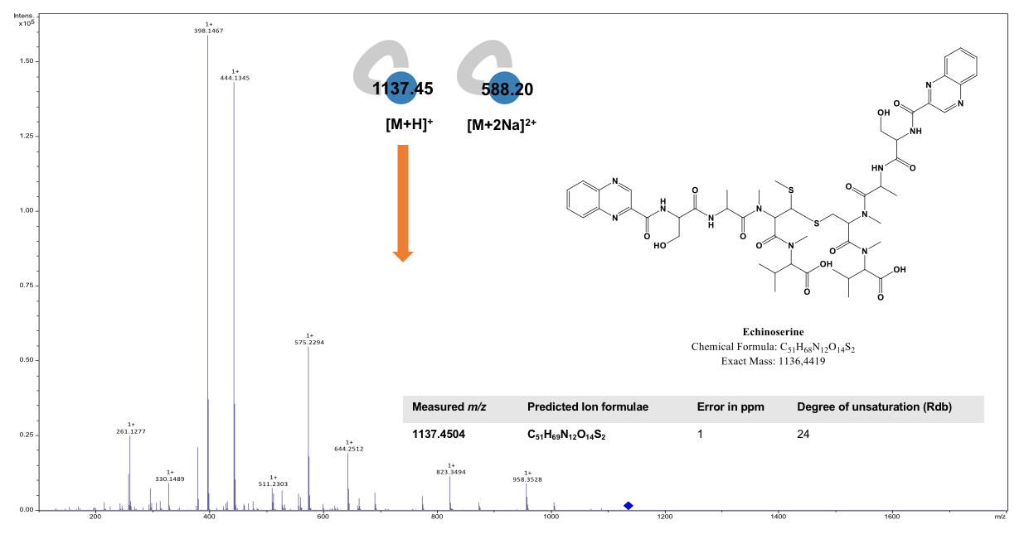
Figure S13. Ions clusters of echinoserine.

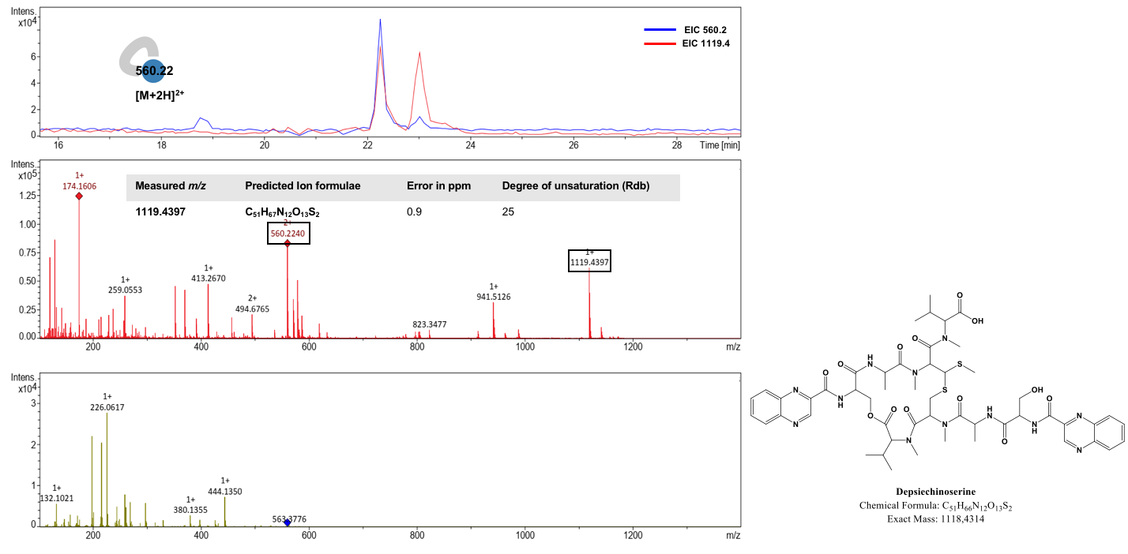
Figure S14. Ion singleton of depsiechinoserine, positive EICs and MS2 of depsiechinoserine.

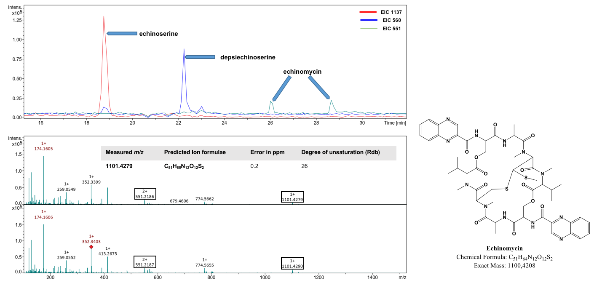
Figure S15. Positive EICs and MS1 of echinomycin.

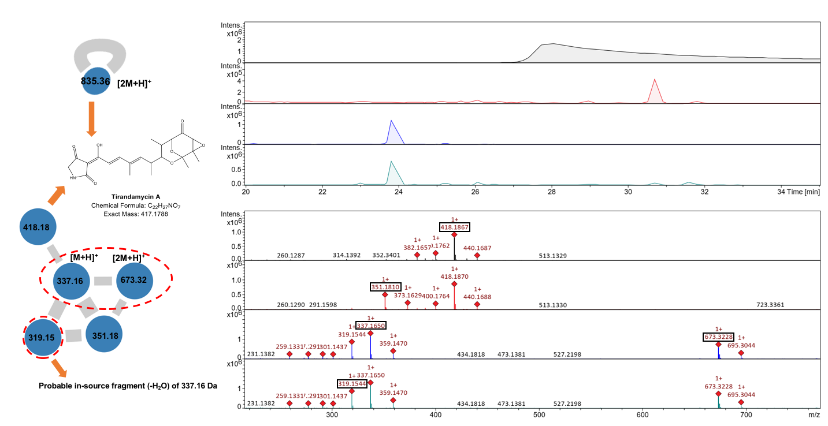
Figure S16. Ions cluster, Positive EICs and MS1 of tirandamycin A in addition to its congeners.

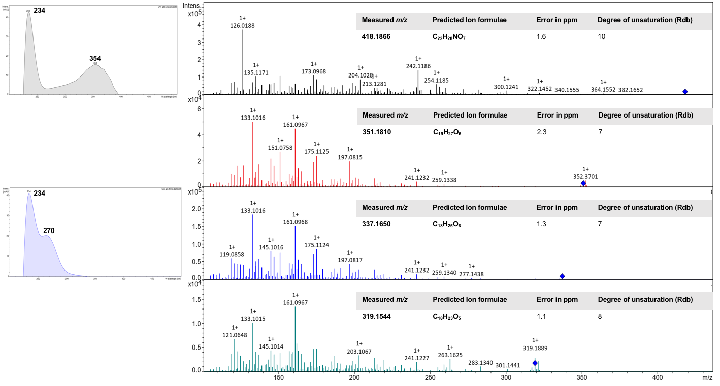
Figure S17. UV absorbance, and MS2 of tirandamycin A in addition to its congeners.

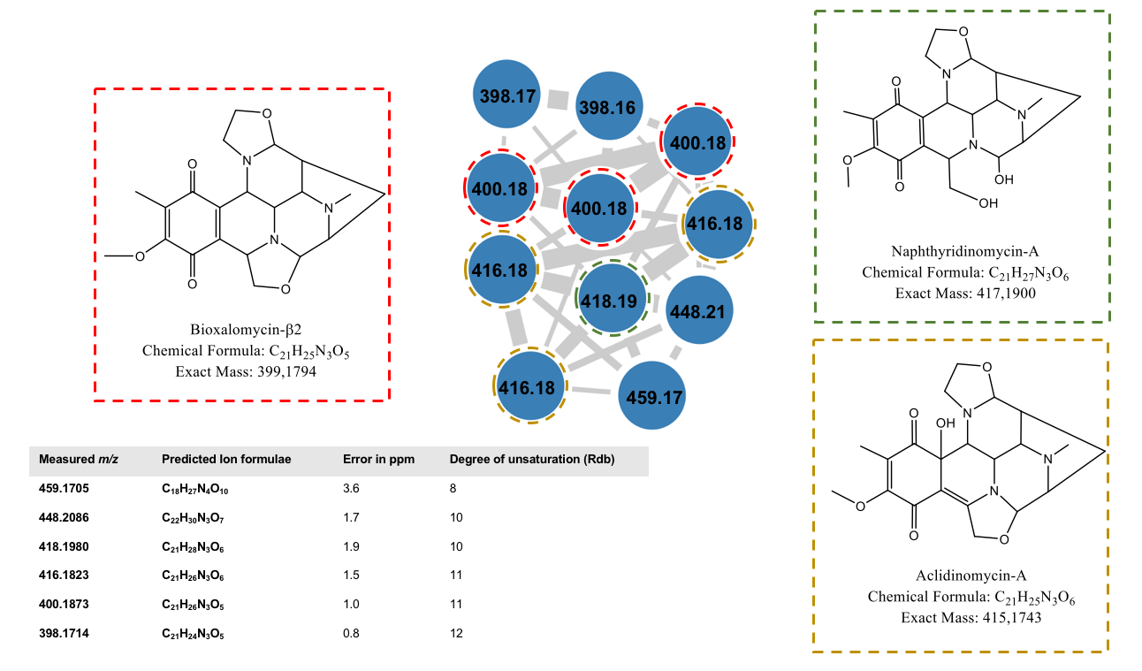
Figure S18. Ion cluster of naphthyridinomycins and their predicted molecular formula (MF).

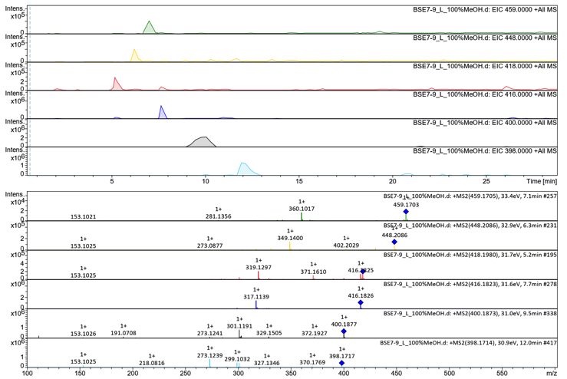
Figure S19. Positive EICs and MS2 of naphthyridinomycin and their related entities from isolate BSE7-9.

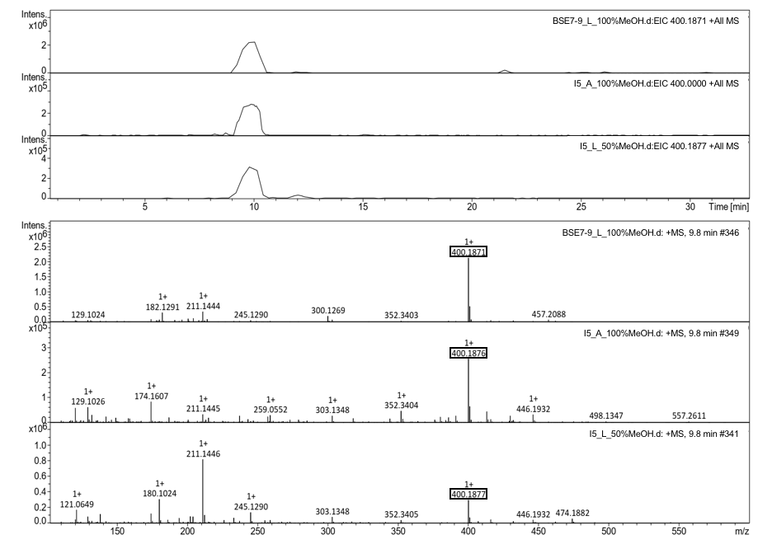
Figure S20. Positive EICs and MS1 of naphthyridinomycin from isolates BSE7-9 and I5.
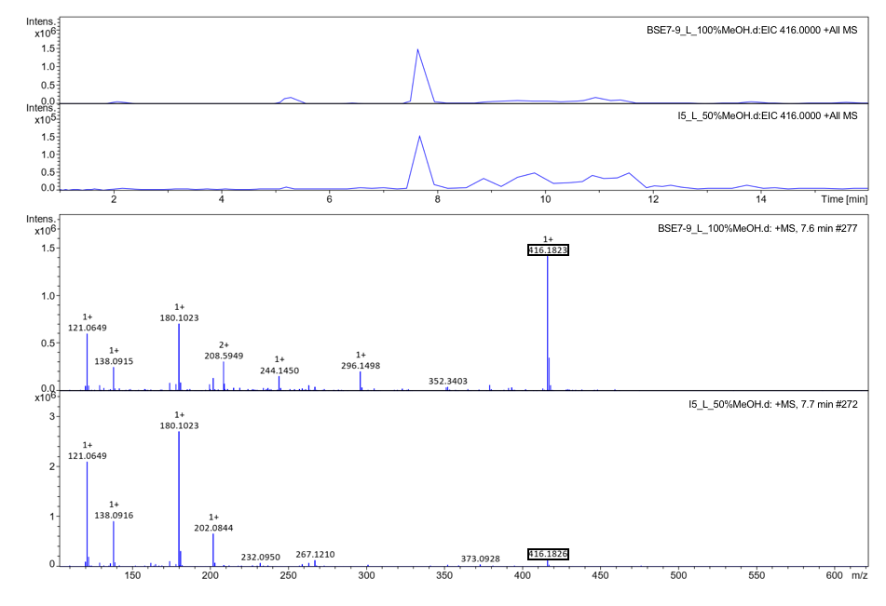
Figure S21. Positive EICs and MS1 of aclidinomycin A from isolates BSE7-9 and I5.
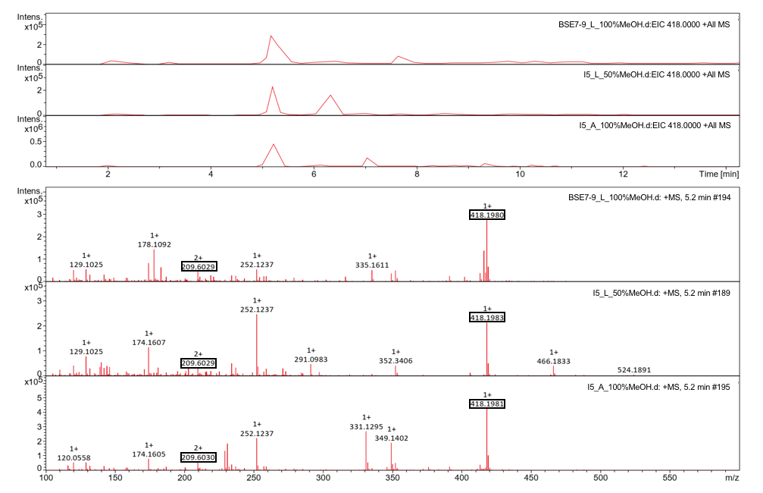
Figure S22. Positive EICs and MS1 of bioxalomycin-β2 from isolates BSE7-9 and I5.

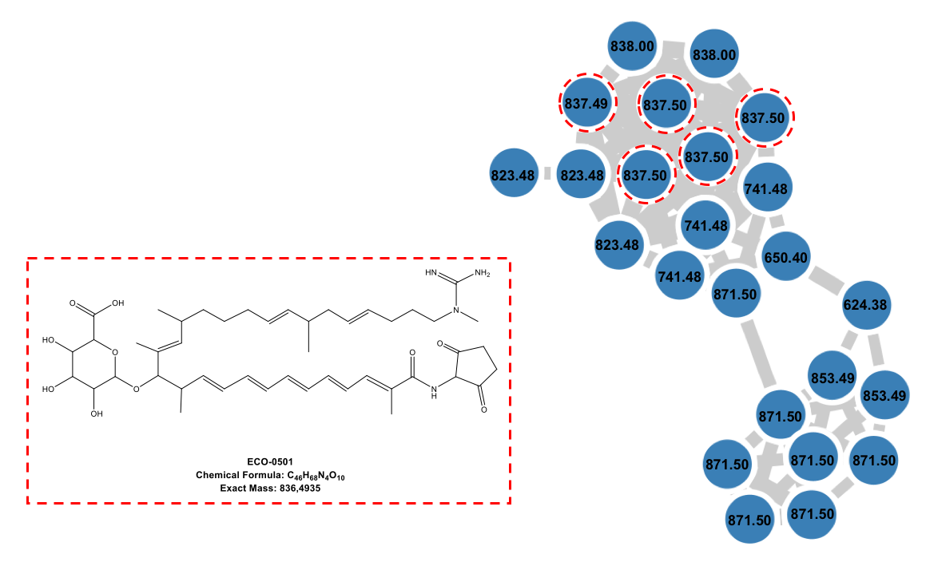
Figure S23. Ions cluster of ECO-0501 and its related congeners from isolate DHE 17-7.

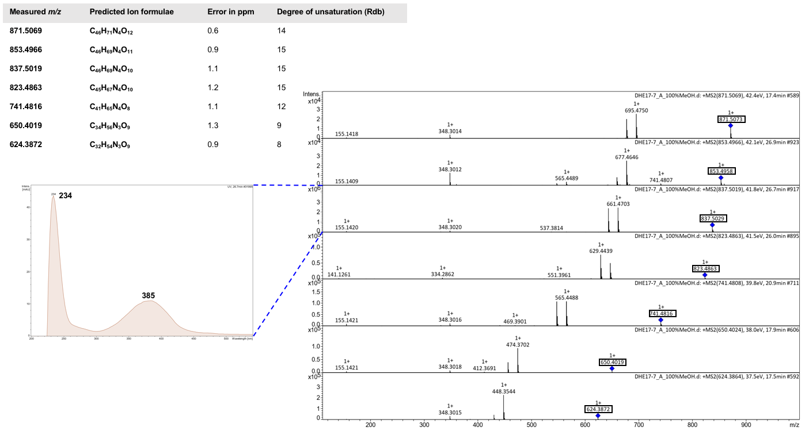
Figure S24. UV absorbance, MS2 of ECO-0501 and its related congeners from isolate DHE 17-7.

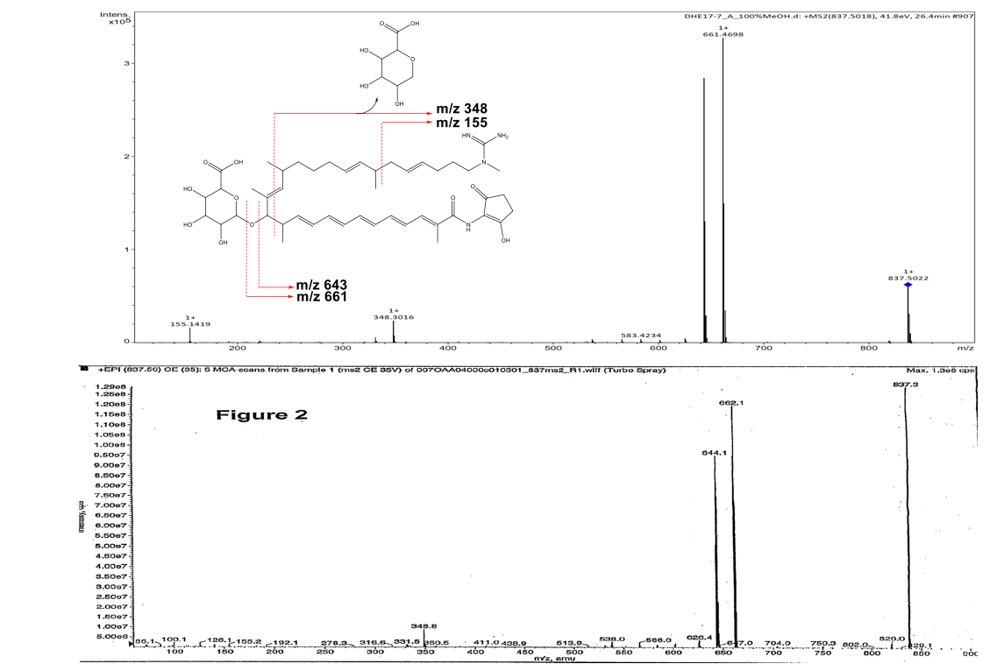
Figure S25. Comparative positive MS2 of ECO-0501 from isolate DHE 17-7 and its reported version from Amycolatopsis orientalis.

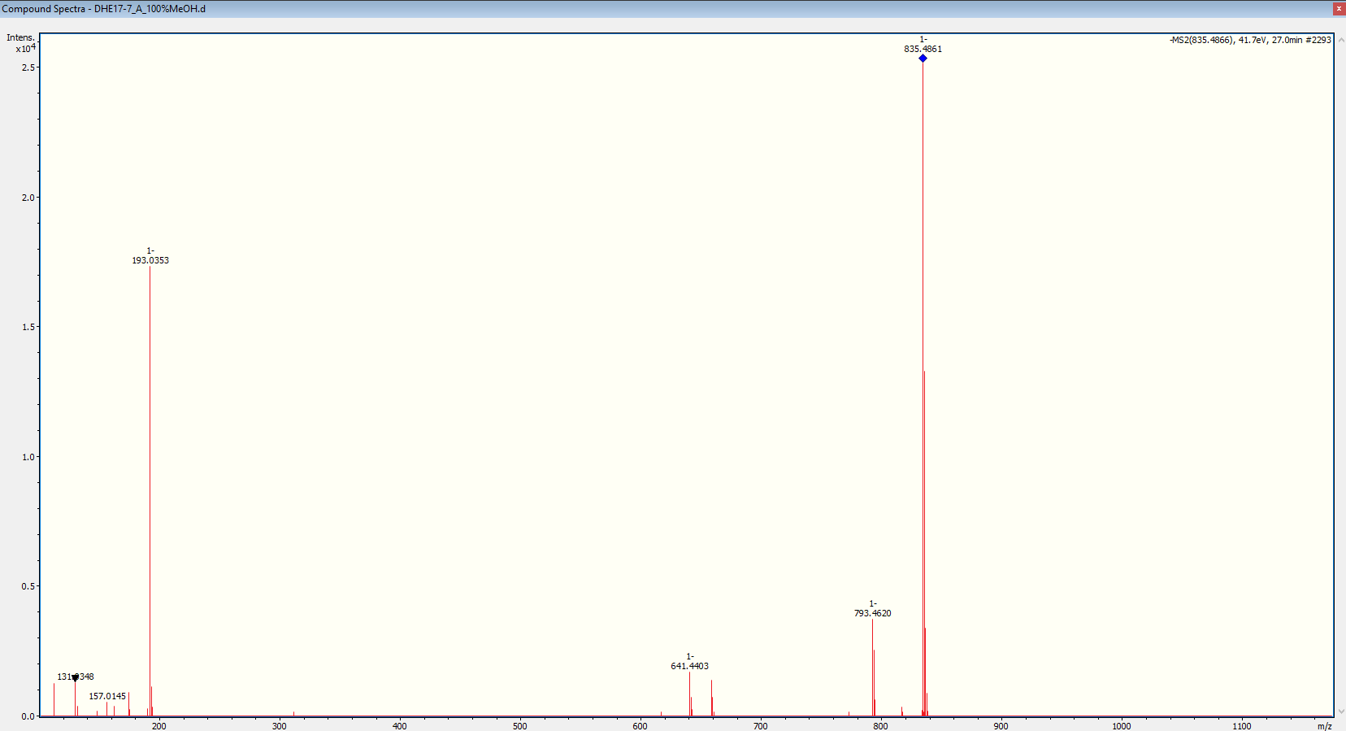
Figure S26. Negative MS2 of ECO-0501 from isolate DHE 17-7 and its proposed fragmentation scheme.

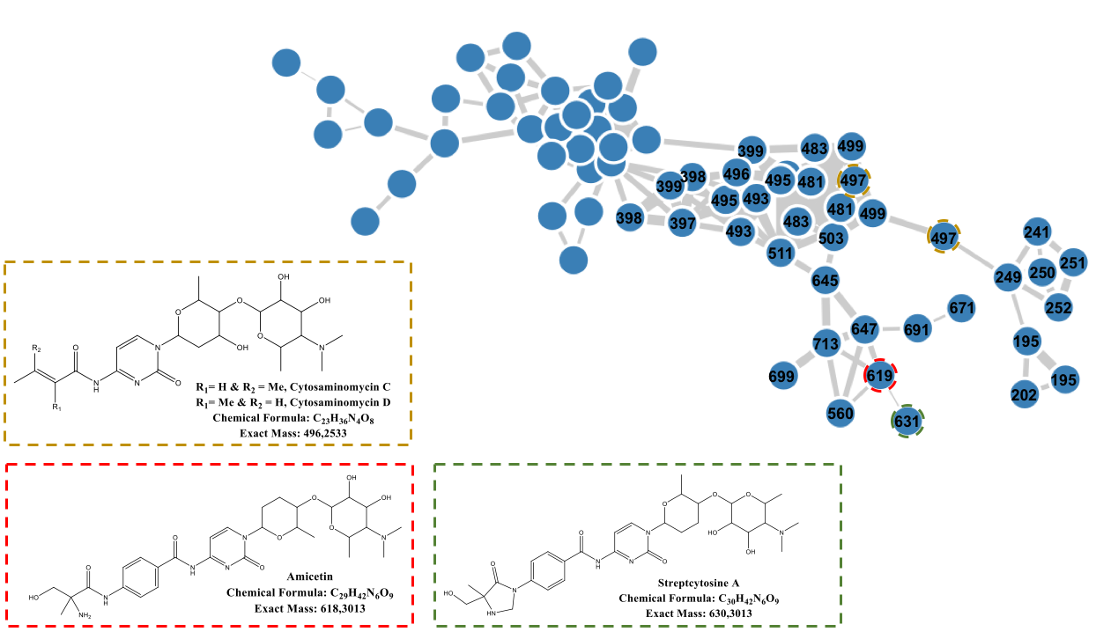
Figure S27. Ions cluster of amicetins and its related congeners from isolate SHP 22-7.

Figure S30. Comparative positive MS2 of some unknown members of amicetin molecular family.

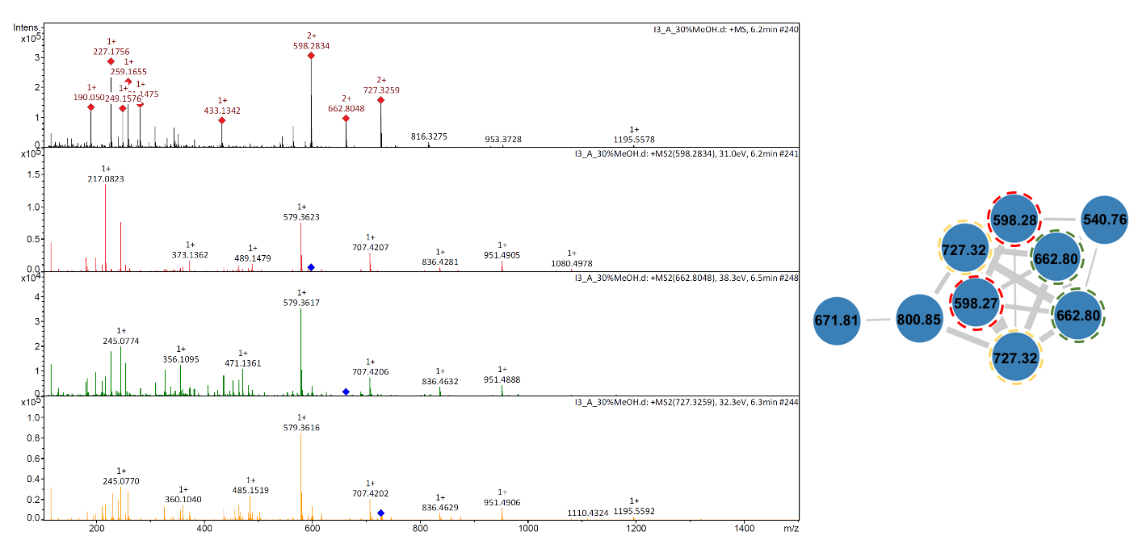
Figure S31. Comparative positive MS2 of some unknowns of likely peptides.

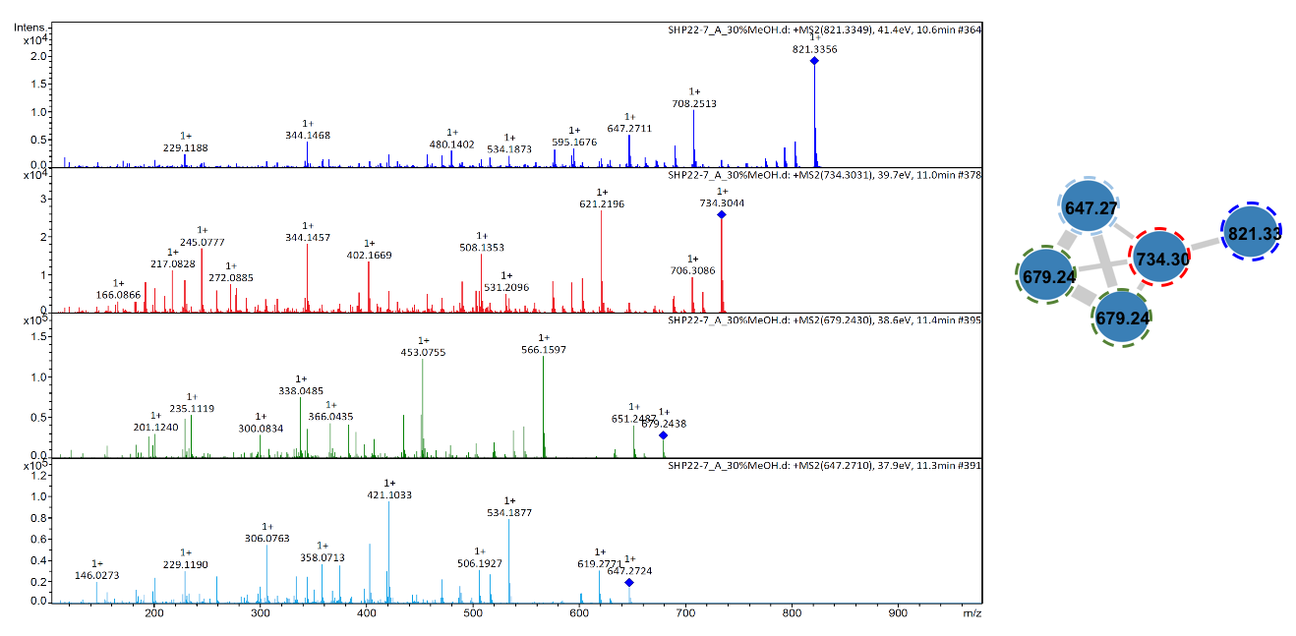
Figure S32. Comparative positive MS2 of some unknowns from isolate SHP 22-7.

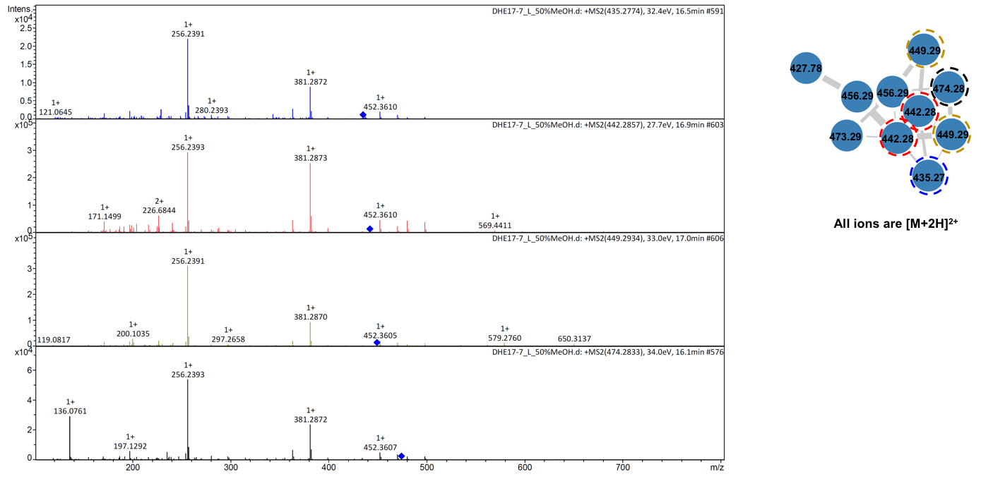
Figure S33. Comparative positive MS2 of some unknowns from isolate DHE 17-7

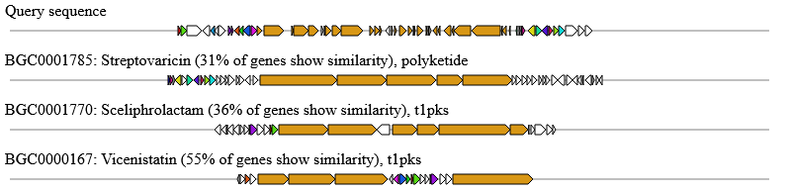
Figure S34. Cluster similarity between the DHE 17-7 gene region 24 (query sequence) and the streptovaricin, sceliphrolactam and vicenistatin cluster.

Table S1. Genome characteristics from nine Indonesian actinomycetes strain isolates.
Strain | Genome size (bp) | Contigs | GC content (%) | Coding sequence (CDS) | Transfer RNA (tRNA) | Ribosomal RNA (rRNA)
DHE 17-7 | 8,364,241 | 5 | 72.11 | 7,895 | 83 | 15
DHE 7-1 | 8,144,351 | 3 | 72.08 | 8,168 | 90 | 18
SHP 22-7 | 7,899,734 | 146 | 72.20 | 4,602 | 63 | 18
14 | 7,712,674 | 7 | 72.26 | 6,877 | 84 | 18
I3 | 7,638,058 | 7 | 72.26 | 7,394 | 83 | 18
I5 | 7,611,235 | 4 | 72.27 | 6,842 | 80 | 18
BSE 7F | 7,510,161 | 5 | 72.30 | 6,880 | 79 | 21
BSE 7-9 | 7,435,252 | 5 | 72.29 | 6,562 | 82 | 18
I6 | 7,054,598 | 2 | 72.47 | 6,005 | 79 | 18

Table S2. media tested for antibiotic production in agar and liquid culture. All data refer to 1 l H₂O_{deion.}. For solid media 16 g/l agar is added, except for R5 medium 18 g/l agar is added.

medium | Ingrediens | pH
NL410 (preculture medium) | 10 glucose  10 g glycerol  5 g oat meal  10 g soy flour  5 g yeast extract  5 g bacto casamino acids  1 g CaCO₃ | pH 7.0
NL19 (main culture medium) | 20 g mannitol  20 g soy flour | pH 7.5
SGG | 10 g soluble starch  10 g glucose  10 g glycerol  2.5 g corn steep powder  5 g bacto peptone  2 g yeast extract  1 g NaCl  3 g CaCO₃ | pH 7.3
MS | 20 g mannitol  20 g soya flour, full fat | -
R5 medium | 103 g saccharose  10 g glucose  0,25 g K₂SO₄  10,12 g MgCl₂  0,1 g casamino acids  5 g yeast extract  5,73 g TES  2 ml trace element solution  in 955 ml H₂O_{deion.} to solve | adjust pH before autoclaving with NaOH to 7.2;  after autoclaving separate addition of:  20 ml 1 M CaCl₂,  10 ml 0,54% KH₂PO₄,  15 ml 20 % L-proline
Yeast Malt (YM) | 10 g malt extract  5 g yeast extract  4 g glucose | pH 7.3
Oat meal medium (OM) | 20 g oat meal  5 ml trace element solution | pH 7.3
TSG | 17 g bacto tryptone  3 g bacto soytone  2.5 g glucose  5 g NaCl  2.5 g K₂HPO₄ | set pH to 7.3 before autoclaving
NL300 | 20 g mannitol  20 g cotton seed | pH 7.5
NL333 | 5 g glucose  10 g soluble starch  10 g malt extract  3 g yeast extract  3 g bacto peptone  3 g NH₄NO₃  2 g CaCO₃ | pH 7.2
NL500 | 10 g soluble starch  10 g glucose  10 g glycerol  15 g fish flour  10 g sea salt | Adjust pH to 8.0, retitrate to pH 8.0 after 1 hour = pH 6.6 after autoclaving
NL550 | 10 g soluble starch  10 g glucose  5 g peptone from casein  2.5 g corn starch powder  2 g CaCO₃  10 g sea salt | Adjust pH to 8.0, retitrate to pH 8.0 after 1 hour = pH 6.6 after autoclaving
NL800 | 5 g glucose  10 g glycerol  10 g soluble starch  5 g soy flour, full fat  2 g yeast extract  1 g NaCl  1 g CaCO₃ | pH 7.2

Table S3. List of optimal culture conditions (media, time point) and bioactivity profile of nine Indonesian strain isolates.
Strain | Optimal production in liquid medium | Optimal production in solid medium | Optimal incubation time (h) in liquid | Antimicrobial activity  against Gram (+)/(-) test bacteria
I6 | R5 | MS | 48 | (+), (-)
DHE 7-1 | OM | OM | 48 | (+)
DHE 17-7 | SGG | SGG | 48 | (+)
I3 | NL550 | MS | 72 | (+), (-)
14 | NL550 | MS | 72 | (+), (-)
I5 | MS | MS | 96 | (+), (-)
SHP 22-7 | NL300 | NL300 | 96 | (+), (-)
BSE 7-9 | NL19 | NL19 | 96 | (+), (-)
BSE 7F | NL500 | NL500 | 168 | (+), (-)

Table S4. List of predicted BGCs of strain DHE 17-7 derived from antiSMASH analysis. The minus sign (-) indicates the BGC did not have any similarity with any BGCs in the antiSMASH database.
Region | Type | Most similar known region | Similarity
Region 1 | NRPS | streptothricin | 87%
Region 2 | NRPS, T1PKS, NRPS-like, hglE-KS | levorin A3 /C06690 / FR-008-III / candicidin A /UNIIAP5PEF5W7U | 95%
Region 3 | terpene | lysolipin I | 4%
Region 4 | indole | 5-isoprenylindole-3-carboxylate β-Dglycosyl ester | 33%
Region 5 | terpene | carotenoid | 54%
Region 6 | T3PKS | herboxidiene | 8%
Region 7 | ectoine | ectoine | 100%
Region 8 | melanin | melanin | 60%
Region 9 | siderophore | desferrioxamine B/desferrioxamine E | 83%
Region 10 | NRPS-like | - | -
Region 11 | PKS-like, furan | methylenomycin A | 9%
Region 12 | lanthipeptide | catenulipeptin | 60%
Region 13 | NRPS | phosphonoglycans | 5%
Region 14 | terpene | albaflavenone | 100%
Region 15 | T2PKS | spore pigment | 66%
Region 16 | siderophore | - | -
Region 17 | bacteriocin | - | -
Region 18 | terpene | geosmin | 100%
Region 19 | siderophore | paulomycin | 7%
Region 20 | NRPS | CDA1b / CDA2a /CDA2b/ CDA3a/ CDA3b / CDA4a /CDA4b | 70%
Region 21 | NRPS-like | amicetin | 79%
Region 22 | lanthipeptide | - | -
Region 23 | terpene | hopene | 100%
Region 24 | T1PKS | streptovaricin | 31%
Region 25 | terpene | versipelostatin | 5%
Region 26 | bacteriocin | informatipeptin | 42%
Region 27 | NRPS | coelichelin | 100%
Region 28 | lanthipeptide | - | -
Region 29 | lanthipeptide | SapB | 100%
Region 30 | T2PKS , butyrolactone | fluostatins M-Q | 62%

Table S5. List of predicted BGCs of strain SHP22-7 derived from antiSMASH analysis. The minus sign (-) indicates the BGC did not have any similarity with any BGCs in the antiSMASH database.
Region | Type | Most similar known region | Similarity
Region 1 | terpene | albaflavenone | 100%
Region 2 | T2PKS | spore pigment | 66%
Region 3 | furan | methylenomycin | 9%
Region 4 | NRPS-like | granaticin | 5%
Region 5 | melanin | istamycin | 4%
Region 6 | ectoine | ectoine | 100%
Region 7 | NRPS | phosphonoglycans | 5%
Region 8 | bacteriocin | - | -
Region 9 | terpene | geosmin | 100%
Region 10 | NRPS-like | amicetin | 70%
Region 11 | NRPS | CDA1a/CDA2a/CDA2b/CDA3a/CDA3b/CDA4a/CDA4b | 45%
Region 12 | T3PKS | herboxidiene | 8%
Region 13 | siderophore | desferrioxamine B/desferrioxamine E | 100%
Region 14 | indole | 5-isoprenylindole-3-carboxylate β-D-glycosyl ester | 23%
Region 15 | terpene | carotenoid | 36%
Region 16 | T2PKS butyrolactone NRPS | fluostatins | 62%
Region 17 | terpene | hopene | 76%
Region 18 | lanthipeptide | - | -
Region 19 | T1PKS NRPS | candicidin | 90%
Region 20 | NRPS arylpolyene | lipopeptide 8D1-1/lipopeptide 8D-2 | 29%
Region 21 | siderophore | grincamycin | 8%
Region 22 | T1PKS | streptovaricin | 26%
Region 23 | hglE-KS | sanglifehrin | 13%
Region 24 | bacteriocin | informatipeptin | 57%
Region 25 | NRPS | coelichelin | 27%

Table S6. List of predicted BGCs of strain I3 derived from antiSMASH analysis. The minus sign (-) indicates the BGC did not have any similarity with any BGCs in the antiSMASH database.
Region | Type | Most similar known region | Similarity
Region 1 | siderophore | grincamycin | 8%
Region 2 | terpene | geosmin | 100%
Region 3 | bacteriocin | - | -
Region 4 | terpene | albaflavenone | 100%
Region 5 | lassopeptide | aborycin | 85%
Region 6 | siderophore | desferrioxamine B/desferrioxamine E | 83%
Region 7 | ectoine | ectoine | 100%
Region 8 | T2PKS | spore pigment | 83%
Region 9 | terpene | carotenoid | 45%
Region 10 | T3PKS | alkylresorcinol | 100%
Region 11 | NRPS, T1PKS, PKS-like | naphthyridinomycin | 100%
Region 12 | terpene | hopene | 84%
Region 13 | PKS-like, T1PKS, hglE-KS | nataxazole | 55%
Region 14 | bacteriocin | informatipeptin | 57%
Region 15 | ectoine, NRPS, butyrolactone, other, T1PKS | polyoxypeptin | 48%
Region 16 | amglyccycl | cetoniacytone A | 12%
Region 17 | TfuA-related | - | -
Region 18 | NRPS-like | rhizomide A/rhizomide B/rhizomide C | 100%

Table S7. List of predicted BGCs of strain I4 derived from antiSMASH analysis. The minus sign (-) indicates the BGC did not have any similarity with any BGCs in the antiSMASH database.
Region | Type | Most similar known region | Similarity
Region 1 | terpene | hopene | 92%
Region 2 | siderophore | grincamycin | 8%
Region 3 | terpene | geosmin | 100%
Region 4 | bacteriocin | - | -
Region 5 | terpene | albaflavenone | 100%
Region 6 | lassopeptide | aborycin | 100%
Region 7 | lanthipeptide | venezuelin | 100%
Region 8 | siderophore | desferrioxamine B/desferrioxamine E | 83%
Region 9 | T2PKS | spore pigment | 83%
Region 10 | ectoine | ectoine | 100%
Region 11 | NRPS | SCO-2138 | 64%
Region 12 | TfuA-related | - | -
Region 13 | lanthipeptide | SapB | 100%
Region 14 | amglyccycl | - | -
Region 15 | NRPS, T1PKS, other, butyrolactone, ectoine, lanthipeptide, PKS-like | naphthyridinomycin | 100%
Region 16 | T3PKS | alkylresorcinol | 100%
Region 17 | terpene | carotenoid | 54%
Region 18 | hglE-KS, T1PKS,  PKS-like | nataxazole | 48%
Region 19 | bacteriocin | informatipeptin | 57%
Region 20 | ectoine | ectoine | 100%

Table S8. List of predicted BGCs of strain I5 derived from antiSMASH analysis. The minus sign (-) indicates the BGC did not have any similarity with any BGCs in the antiSMASH database.
Region | Type | Most similar known region | Similarity
Region 1 | T3PKS | alkylresorcinol | 100%
Region 2 | terpene | carotenoid | 54%
Region 3 | T2PKS | spore pigment | 83%
Region 4 | ectoine | ectoine | 100%
Region 5 | NRPS | SCO-2138 | 64%
Region 6 | siderophore | desferrioxamine B/desferrioxamine E | 83%
Region 7 | lanthipeptide | venezuelin | 100%
Region 8 | lassopeptide | aborycin | 100%
Region 9 | terpene | albaflavenone | 100%
Region 10 | bacteriocin | - | -
Region 11 | terpene | geosmin | 100%
Region 12 | siderophore | grincamycin | 11%
Region 13 | T2PKS | resistomycin / resistoflavine | 88%
Region 14 | terpene | hopene | 92%
Region 15 | bacteriocin | informatipeptin | 42%
Region 16 | NRPS, ectoine, butyrolactone, other, T1PKS | aurantimycin A | 51%
Region 17 | NRPS, T1PKS, PKS-like | naphthyridinomycin | 57%
Region 18 | NRPS | naphthyridinomycin | 39%
Region 19 | ectoine | ectoine | 100%

Table S9. List of predicted BGCs of strain BSE 7F derived from antiSMASH analysis. The minus sign (-) indicates the BGC did not have any similarity with any BGCs in the antiSMASH database
Region | Type | Most similar known region | Similarity
Region 1 | ectoine | ectoine | 100%
Region 2 | NRPS | SCO-2138 | 64%
Region 3 | siderophore | desferrioxamine B/desferrioxamine E | 83%
Region 4 | lanthipeptide | venezuelin | 100%
Region 5 | lassopeptide | aborycin | 100%
Region 6 | phenazine | - | -
Region 7 | terpene | albaflavenone | 100%
Region 8 | bacteriocin | - | -
Region 9 | terpene | geosmin | 100%
Region 10 | siderophore | grincamycin | 11%
Region 11 | T2PKS | resistomycin /resistoflavine | 88%
Region 12 | terpene | hopene | 92%
Region 13 | transAT-PKS | weishanmycin | 54%
Region 14 | NRPS | weishanmycin | 41%
Region 15 | bacteriocin | informatipeptin | 57%
Region 16 | NRPS, ectoine, butyrolactone, other, T1PKS | aurantimycin A | 51%
Region 17 | terpene, amglyccycl | cetoniacytone A | 12%
Region 18 | T2PKS | spore pigment | 83%
Region 19 | terpene | carotenoid | 45%
Region 20 | T3PKS | alkylresorcinol | 100%
Region 21 | NRPS, T1PKS | antimycin | 25%
Region 22 | butyrolactone, ectoine | ectoine | 100%
Region 23 | NRPS, PKS-like | naphthyridinomycin | 100%

Table S10. List of predicted BGCs of strain BSE 7-9 derived from antiSMASH analysis. The minus sign (-) indicates the BGC did not have any similarity with any BGCs in the antiSMASH database
Region | Type | Most similar known region | Similarity
Region 1 | butyrolactone, ectoine | ectoine | 100%
Region 2 | bacteriocin | informatipeptin | 57%
Region 3 | NRPS | weishanmycin | 38%
Region 4 | transAT-PKS | weishanmycin | 58%
Region 5 | terpene | hopene | 92%
Region 6 | T2PKS | resistomycin/resistoflavine | 88%
Region 7 | siderophore | grincamycin | 11%
Region 8 | terpene | geosmin | 100%
Region 9 | bacteriocin | - | -
Region 10 | terpene | albaflavenone | 100%
Region 11 | phenazine | - | -
Region 12 | lassopeptide | aborycin | 100%
Region 13 | lanthipeptide | venezuelin | 100%
Region 14 | siderophore | desferrioxamine B/desferrioxamine E | 83%
Region 15 | NRPS | SCO-2138 | 64%
Region 16 | ectoine | ectoine | 100%
Region 17 | T2PKS | spore pigment | 83%
Region 18 | terpene | carotenoid | 54%
Region 19 | T3PKS | alkylresorcinol | 100%
Region 20 | NRPS, T1PKS,  PKS-like | naphthyridinomycin | 100%
Region 21 | ectoine, butyrolactone | ectoine | 100%
Region 22 | NRPS, T1PKS | polyoxypeptin | 32%

Table S11. List of predicted BGCs of strain DHE 7-1 derived from antiSMASH analysis. The minus sign (-) indicates the BGC did not have any similarity with any BGCs in the antiSMASH database.
Region | Type | Most similar known region | Similarity
Region 1 | lanthipeptide | actinorhodin | 9%
Region 2 | terpene | pentalenolactone | 58%
Region 3 | NRPS, lanthipeptide | vioprolide A | 33%
Region 4 | melanin | melanin | 57%
Region 5 | T1PKS | foxicins A-D | 12%
Region 6 | lassopeptide, terpene | isorenieratene | 63%
Region 7 | T3PKS | herboxidiene | 7%
Region 8 | PKS-like, butyrolactone | - | -
Region 9 | ectoine | ectoine | 100%
Region 10 | melanin | istamycin | 4%
Region 11 | siderophore | desferrioxamine | 66%
Region 12 | T2PKS, bacteriocin | spore pigment | 83%
Region 13 | NRPS | pepticinnamin E | 20%
Region 14 | terpene | julichrome Q3-3 /julichrome Q3-5 | 14%
Region 15 | siderophore | - | -
Region 16 | transAT-PKS-like, NRPS, transATPKS, bacteriocin | phthoxazolin | 20%
Region 17 | other, T1PKS, PKS-like | meilingmycin | 6%
Region 18 | bacteriocin | - | -
Region 19 | terpene | geosmin | 100%
Region 20 | siderophore | - | -
Region 21 | NRPS, T1PKS | polyoxypeptin | 21%
Region 22 | terpene | hopene | 84%
Region 23 | NRPS, T1PKS | conglobatin | 26%
Region 24 | NRPS, bacteriocin | surugamide A/ surugamide D | 19%
Region 25 | NRPS | stenothricin | 18%
Region 26 | other, T3PKS | A-503083 A / A-503083 B /  A-503083 E / A-503083 F | 9%
Region 27 | NRPS | lipopeptide 8D1-1 / lipopeptide 8D1-2 | 13%

Table S12. List of predicted BGCs of strain I6 derived from antiSMASH analysis. The minus sign (-) indicates the BGC did not have any similarity with any BGCs in the antiSMASH database.
Region | Type | Most similar known region | Similarity
Region 1 | indole | staurosporine | 100%
Region 2 | NRPS | scabichelin | 100%
Region 3 | NRPS-like, terpene | stenothricin | 13%
Region 4 | T2PKS, siderophore | spore pigment | 75%
Region 5 | siderophore | desferrioxamine B/desferrioxamine E | 83%
Region 6 | thiopeptide, LAP | - | -
Region 7 | phosphonate, NRPS | phosphonoacetic | 15%
Region 8 | NRPS-like | phosphonoglycans | 3%
Region 9 | NRPS-like | stenothricin | 13%
Region 10 | siderophore | ficellomycin | 3%
Region 11 | NRPS | echinomycin | 88%
Region 12 | bacteriocin | - | -
Region 13 | T3PKS | flaviolin | 75%
Region 14 | terpene | isorenieratene | 100%
Region 15 | linaridin | nogalamycin | 30%
Region 16 | bacteriocin | - | -
Region 17 | terpene | hopene | 61%
Region 18 | NRPS, T1PKS | tirandamycin | 100%
Region 19 | melanin | melanin | 28%
Region 20 | thiopeptide, LAP | - | -
Region 21 | T1PKS, hglE-KS, lanthipeptide | SapB | 100%
Region 22 | T3PKS, fused | pheganomycin | 52%
Region 23 | NRPS-like | streptonigrin | 5%
Region 24 | NRPS, T1PKS, butyrolactone | neocarzinostatin | 50%

Table S13. Parameters used in MetaboScape analysis.
Parameter name | Value
Intensity threshold [counts] | 1000.0
Minimum peak length [spectra] | 3
Minimum peak length (recursive) [spectra] | 1
Minimum # Features for Extraction | 1
Presence of features in minimum # of analyses | 1
Lock mass calibration | false
Mass calibration | false
Excl. mass list | [666.019887, 413.0, 352.0]
Excl. mass tolerance | 5.0
Excl. mass tolerance unit | mDa
Primary Ion | [M+H]⁺
Seed Ions | [M+Na]⁺, [M+K]⁺, [2M+H]⁺, [2M+Na]⁺, [M+2H]²⁺, [M+H+Na]²⁺
Common Ions | [M-H₂O+H]⁺, [M+H₂O+H]⁺, [2M+H₂O+H]⁺, [2M-H₂O+H]⁺
EIC correlation | 0.8
Mass range: Start [m/z] | 150.0
Mass range: End [m/z] | 1800.0
Retention time range: Start [min] | 1.0
Retention time range: End [min] | 48.0
Perform MS/MS import | true
Group by collision energy | true
MS/MS import method | average

