Effects of amino acid side chain length and chemical structure on anionic poly glutamic and poly aspartic acid cellulose-based polyelectrolyte brushes.

Dmitry Tolmachev^{1,*}, George Mamistvalov², Natalia Lukasheva¹, Sergey Larin^{1,2}, and Mikko Karttunen^{1,3,4,5,*}
1 Institute of Macromolecular Compounds, Russian Academy of Sciences, Bolshoy pr. 31, 199004 St. Petersburg, Russia; luk@imc.macro.ru
2 Faculty of Physics, St. Petersburg State University, Petrodvorets, 198504 St. Petersburg, Russia; mamistvalov.georgii@gmail.com
3 Department of Chemistry, the University of Western Ontario, 1151 Richmond Street, London, ON N6A 5B7, Canada
4 Department of Applied Mathematics, the University of Western Ontario, 1151 Richmond Street, London, ON N6A 5B7, Canada
5 The Centre of Advanced Materials and Biomaterials Research, the University of Western Ontario, 1151 Richmond Street, London, ON N6A 5B7, Canada
* Correspondence: dm.tolmahev@yandex.ru (D.T.); mkarttu@uwo.ca (M.K.)

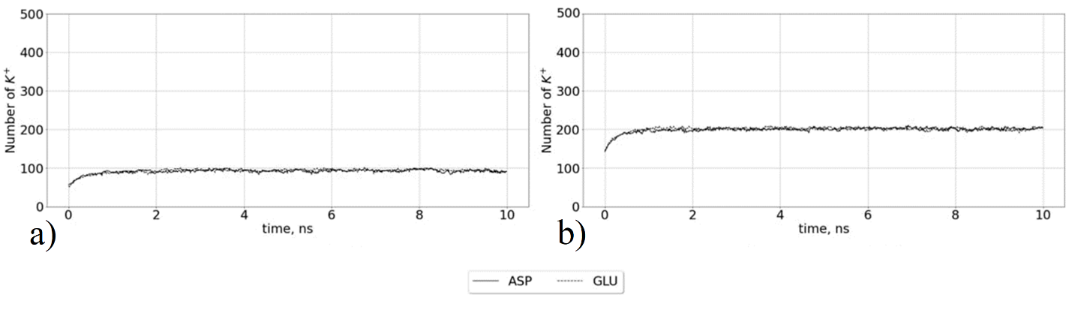
Figure S1. The number of K⁺ ions in the brush during the first 10 ns in the simulations without CaCl₂ salt. a) systems with 12% degree surface modification, b) systems with 25% degree surface modification

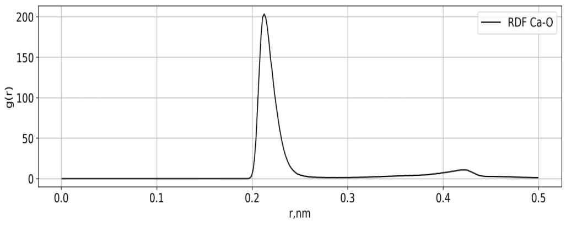
Figure S2. Radial distribution function of Ca²⁺ ions around oxygens of amino acid carboxyl groups.

Radial distribution function was calculated as:
$g_{AB}\left(r\right)=\frac{1}{N_{A}ρ_{B}}\sum_{i⊂A}^{N_{A}}{\sum_{j⊂A}^{N_{B}}{\frac{δ(r_{ij}-r)}{4πr^{2}}}}$, (1)
where ρ_{B} is the average density of type B atoms around atoms A, N_{A} and N_{B} are the number of A and B atoms, respectively, r_{ij} is the distance between two atoms A and B, and δ is the Kronecker delta function.
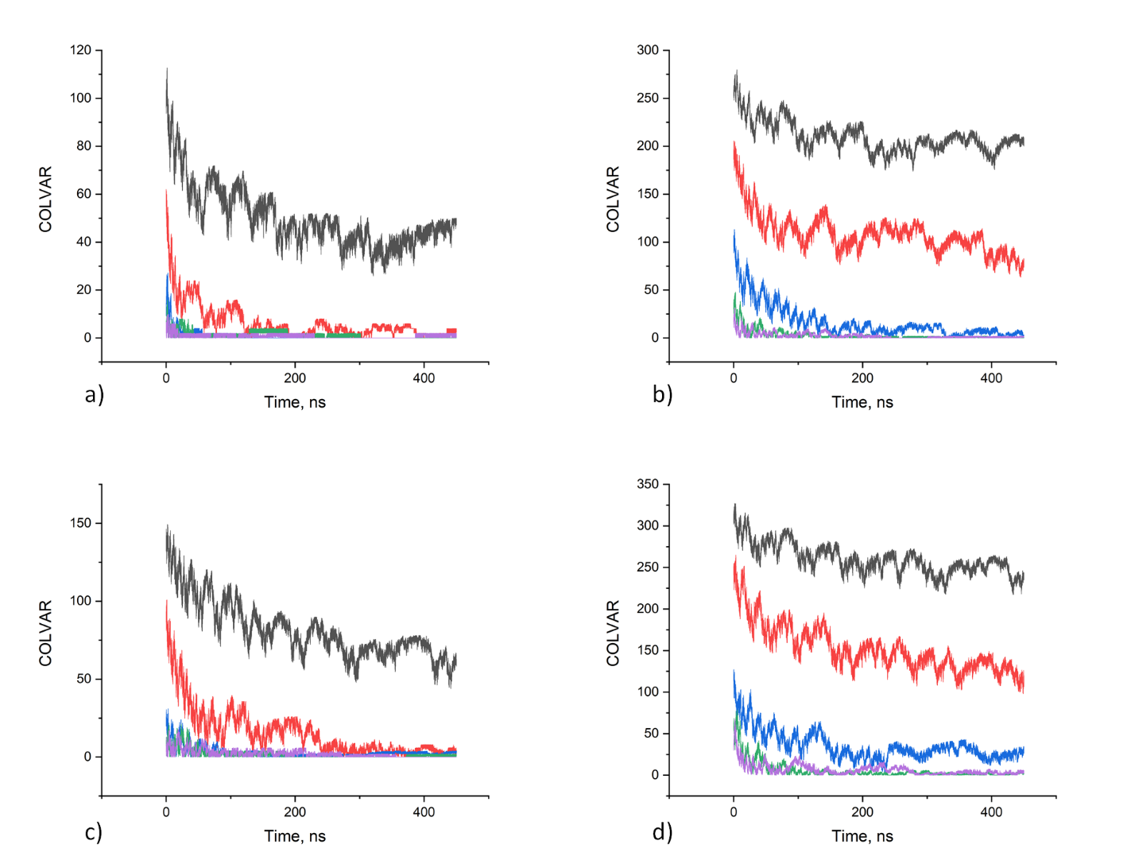
Figure S3. Time dependence of the collective variables (carboxyl group free from adsorbed calcium ions). The collective variable was calculated using differentiable switching function (1) in the text. The results of the simulation in different CaCl₂ concentration 0.07 mol/kg, 0.15 mol/kg, 0.30 mol/kg, 0.62 mol/kg, 0.94 mol/kg are presented by black, red, blue, green and purple colors correspondingly. a) Aspartic acid brush with 12% surface modification, b) aspartic acid brush with 25% degree surface modification, c) glutamic acid brush with 12% degree surface modification d) glutamic acid brush with 25% degree surface modification.
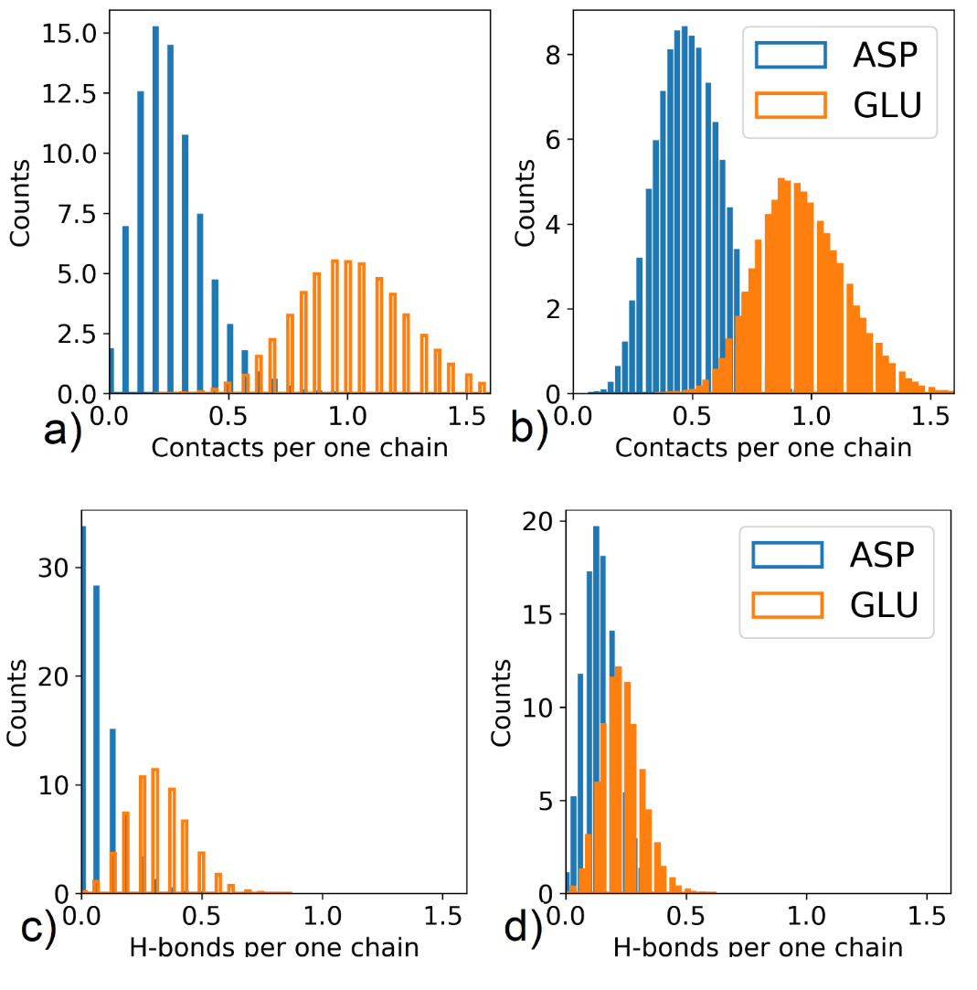
Figure S4. Distributions of the number of a, b) close contacts between hydrogens of surface hydroxyl groups and oxygens of amide groups and (the distance between atoms less then 0.35 nm) c,d) H-bonds between them (the distance between atoms less then 0.35 nm and the angle formed by acceptor, hydrogen and donor less than 35°). a,c) systems with 12% degree surface modification, b,d) systems with 25% degree surface modification
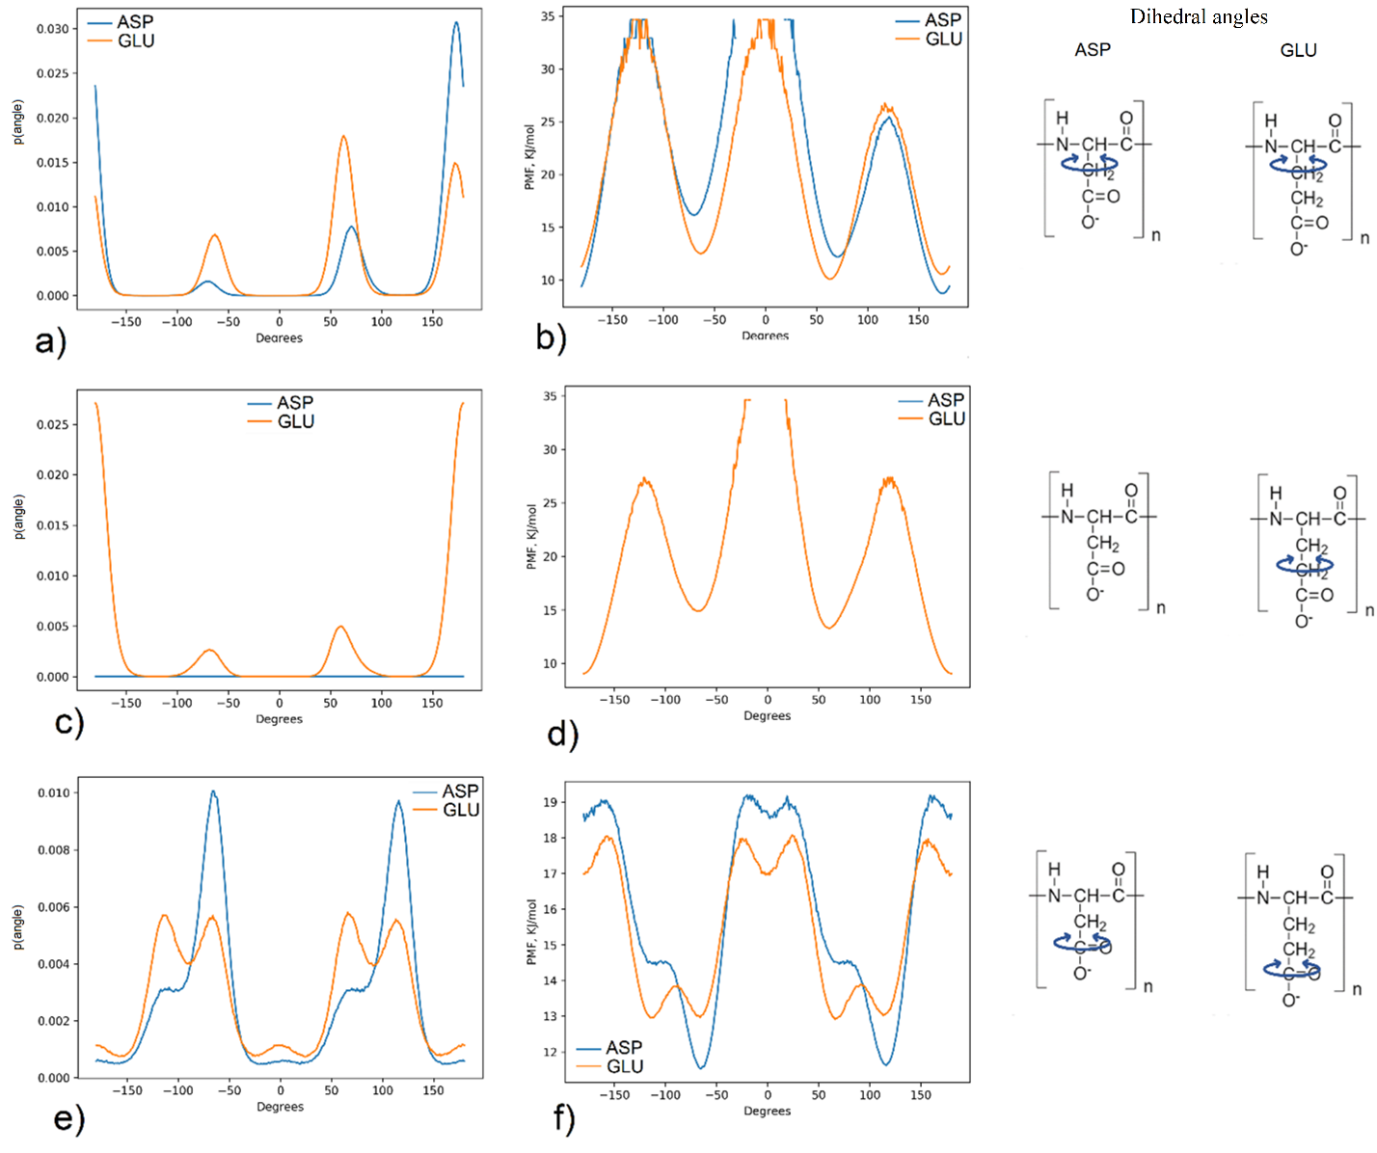Figure S5. Dihedral angle distributions of the side chain (a,c,e) and potential mean force (b,d,f) obtained from the distributions with the schemes illustrating considering angles.
The distributions was obtained using 1 μs trajectory of the poly(amino acids) in water with degree polymerization 32. The potential mean force was obtained from the distributions using the following dependence:
$PMF\left(α\right)=-kT\ln{g(α)}$ (2)
where α – is dihedral angle, g(α) – distribution of α, k- the Boltzmann constant, T- temperature,

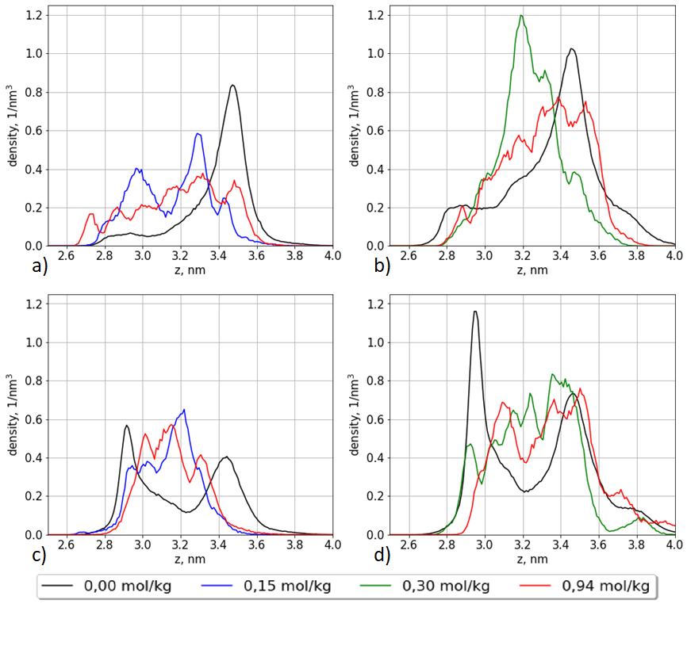
Figure S6. Density profiles of the ends of the grafted oligomers of aspartic and glutamic acids in at different CaCl₂ concentrations. a) Aspartic acid brush with 12% surface modification, b) aspartic acid brush with 25% degree surface modification, c) glutamic acid brush with 12% degree surface modification d) glutamic acid brush with 25% degree surface modification.

