SUPPLEMENTARY FIGURES
Supplemental Figure 1. Kaplan-Meier curve of overall survival for all dnMBC patients
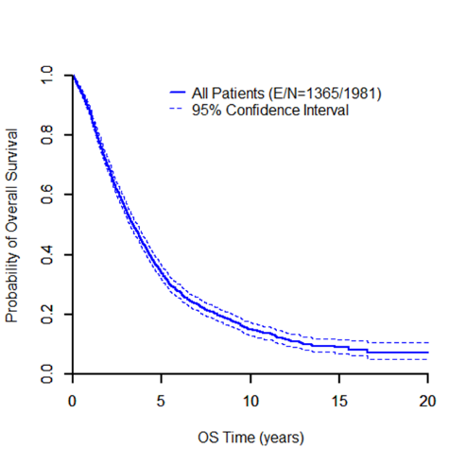
Supplemental Figure 2.
A. Kaplan-Meier curve of overall survival stratified by IBC
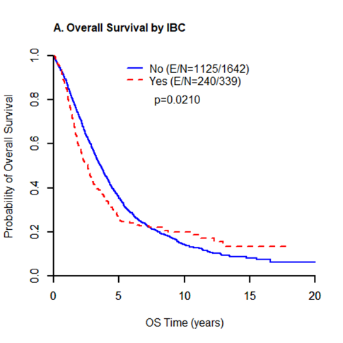
B. Kaplan-Meier curve of overall survival stratified by ER
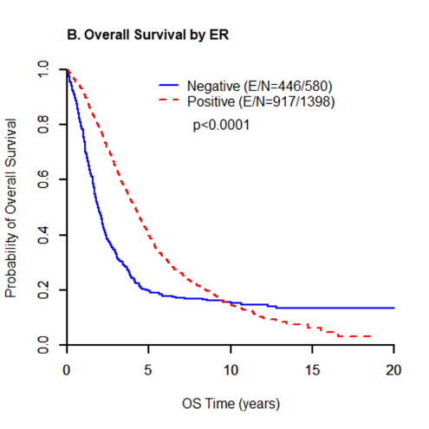
C. Kaplan-Meier curve of overall survival stratified by PR
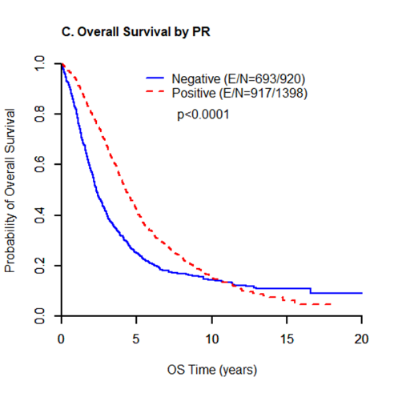
D. Kaplan-Meier curve of overall survival stratified by HER2
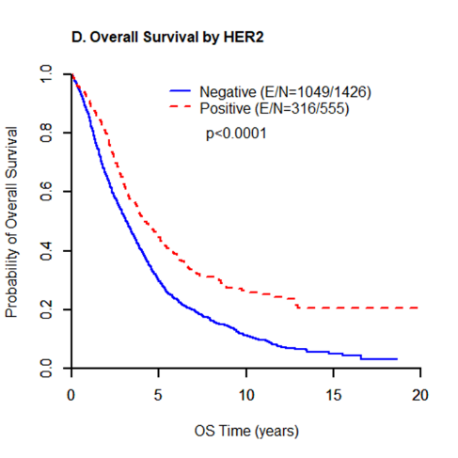
E. Kaplan-Meier curve of overall survival stratified by subtypes
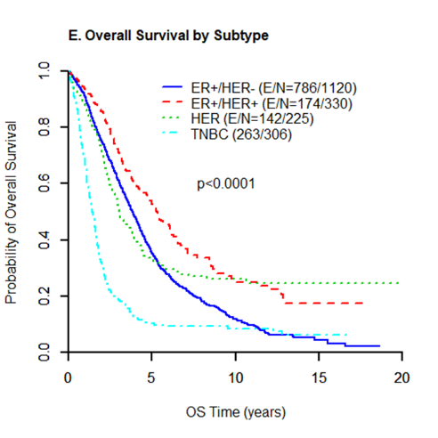
F. Kaplan-Meier curve of overall survival stratified by grade
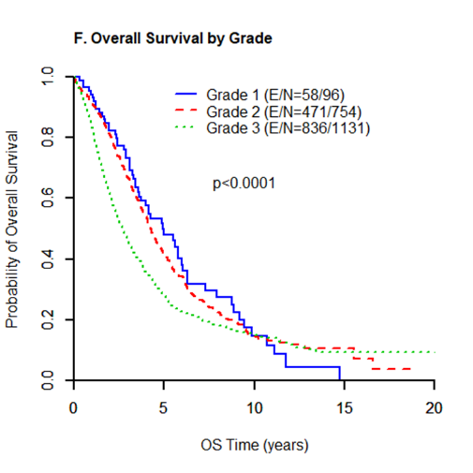
G. Kaplan-Meier curve of overall survival stratified by the locoregional therapy
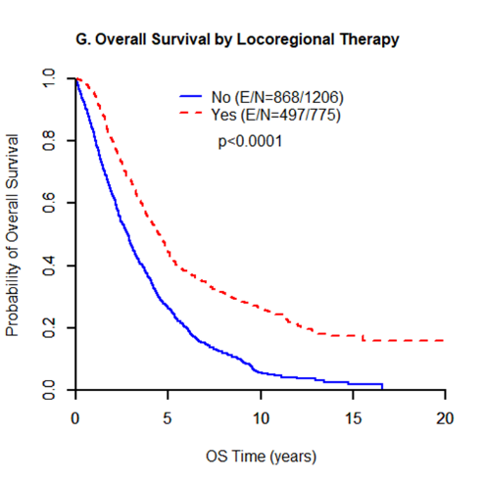
H. Kaplan-Meier curve of overall survival stratified by single or multiple organ metastasis
