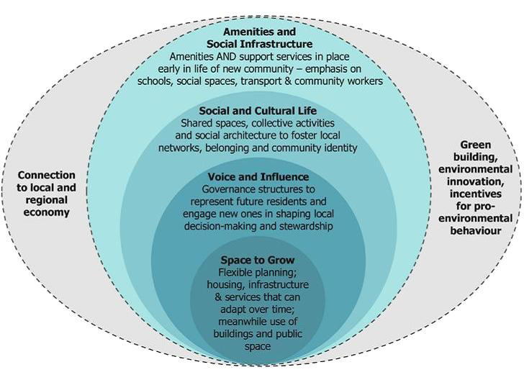

Figure 1: Graphic Interpretation of the Young Sustainable Social Design Framework (Woodcraft, 2011)

