Supplementary material

Partners of the Sudoang project
Table S1. List of available partners. Partners in italics are associated partners while others are main partners. Some partners have several roles (e.g. Office Français de la Biodiversité has missions of knowledge creation, scientific expertise, water policing and management of certain environment) ; in that case, the main role in the context of the project is indicated without parentheses, while secondary missions in the context of the project are indicated between brackets.
role | Spain | France | Portugal
scientists | Azti  Fundación Lonxanet  Universidad de Cordobo  Universitat de Girona | Inrae  Office Français de la Biodiversité  Université de Perpignan | Ciimar  Faculdade de Ciências da Universidade de Lisboa
 | Sociedad Ibérica de Ictiología | CNRS Délegation Languedoc Rousillon
managers |  | (Office Français de la Biodiversité)
 | Dirección General de Pesca y Alimentación - Gobierno de Cantabria  Dirección General del Agua - Ministerio de Agricultura y Pesca, Alimentación y Medio Ambiente  Agència Catalana de l’Aigua  Gobierno del Principado de Asturias - Dirección General de Pesca Marítima del Principado de Asturias, Gobierno Vasco - Dirección de Pesca y Acuicultura  Secretaría da Dirección Xeral de Conservación da Natureza - Xunta de Galicia  Consejería de Medio Ambiente y Ordenación del Territorio - Junta de Andalucía  Consorci del Ter  DG Recursos Pesqueros y Acuicultura (Secretaría General de Pesca – MAPA)  Diputación Foral de Gipuzkoa | DREAL Nouvellel Aquitaine  DREAL Auvergne-Rhône-Alpes  délégation de bassin Rhône-Méditerranée  DREAL Occitanie | Agência Portuguesa do Ambiente  Autoridad de Segurança Alimentar e Economica (ASAE)  Direção-Geral de Recursos Naturais  Segurança e Serviços Marítimos  Instituto da Conservação da Natureza e das Florestas
fishers representatives | Federación de Cofradías de Pescadores del Principado de Asturias | Comité regional des pêches marines et des élevages marins d’Occitanie, Association du Grand Littoral Atlantique | Associação de Profissionais de Pesca do Rio Minho e do Mar (APRMM)
NGOs | Asociación para el Estudio y Mejora de los Salmónidos – Ríos con Vida, Autoridad Administrativa CITES |  | Câmara Municipal de Vila Nova de Cerveira (Aquamuseu do Rio Minho)
control forces |  | (Office Français de la Biodiversité)
 | Servicio de Protección de la Naturaleza de la Guardia Civil | Office central de lutte contre les atteintes à l’environnement et à la santé publique | Guarda Nacional Republicana

Zone definition

Example of map drawn by an expert
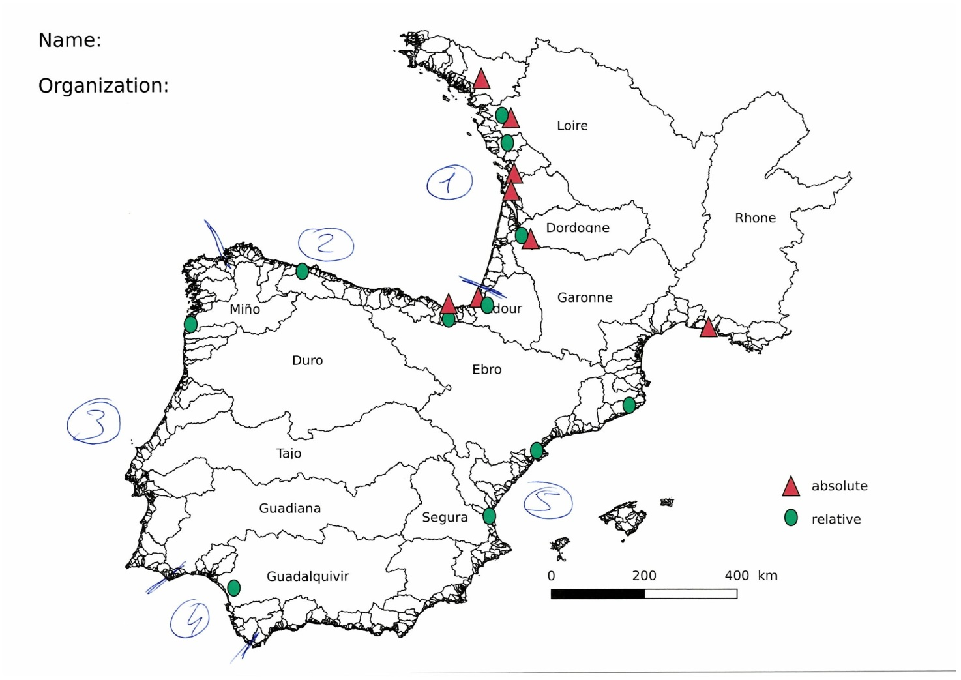
Figure S1 – Example of map drawn by an expert during the kick-off meeting in Lisbon.

Environmental conditions in the study area

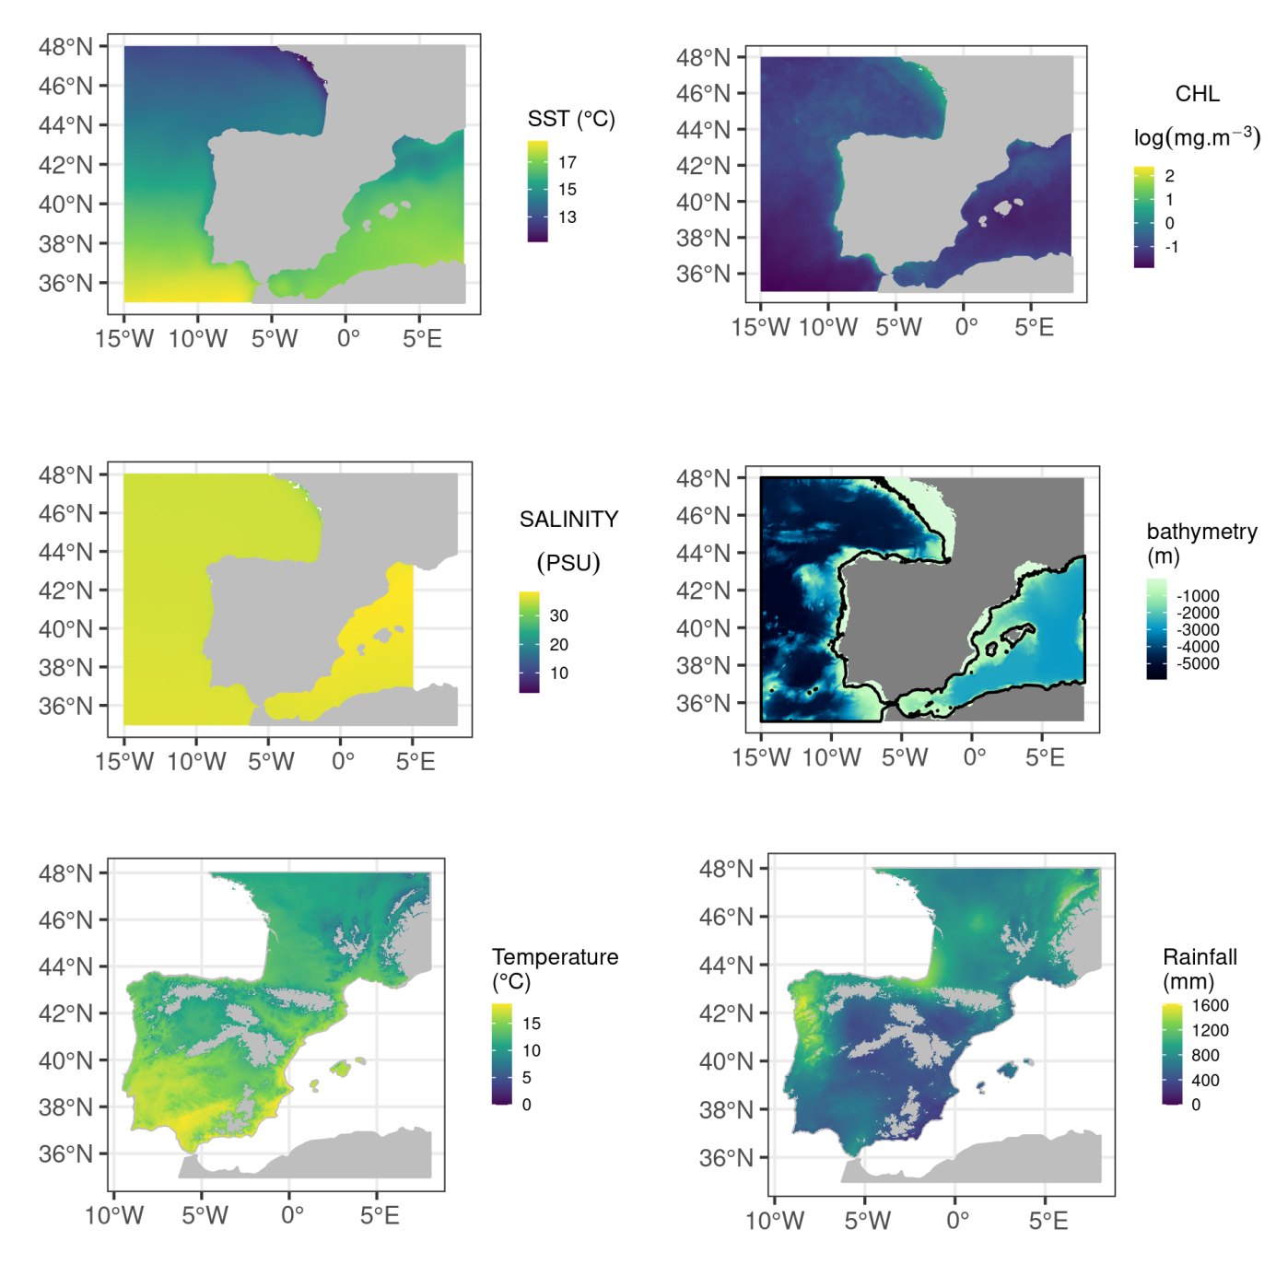
Figure S2 - Environmental conditions over the study area. The black line represents isobath 150-m.

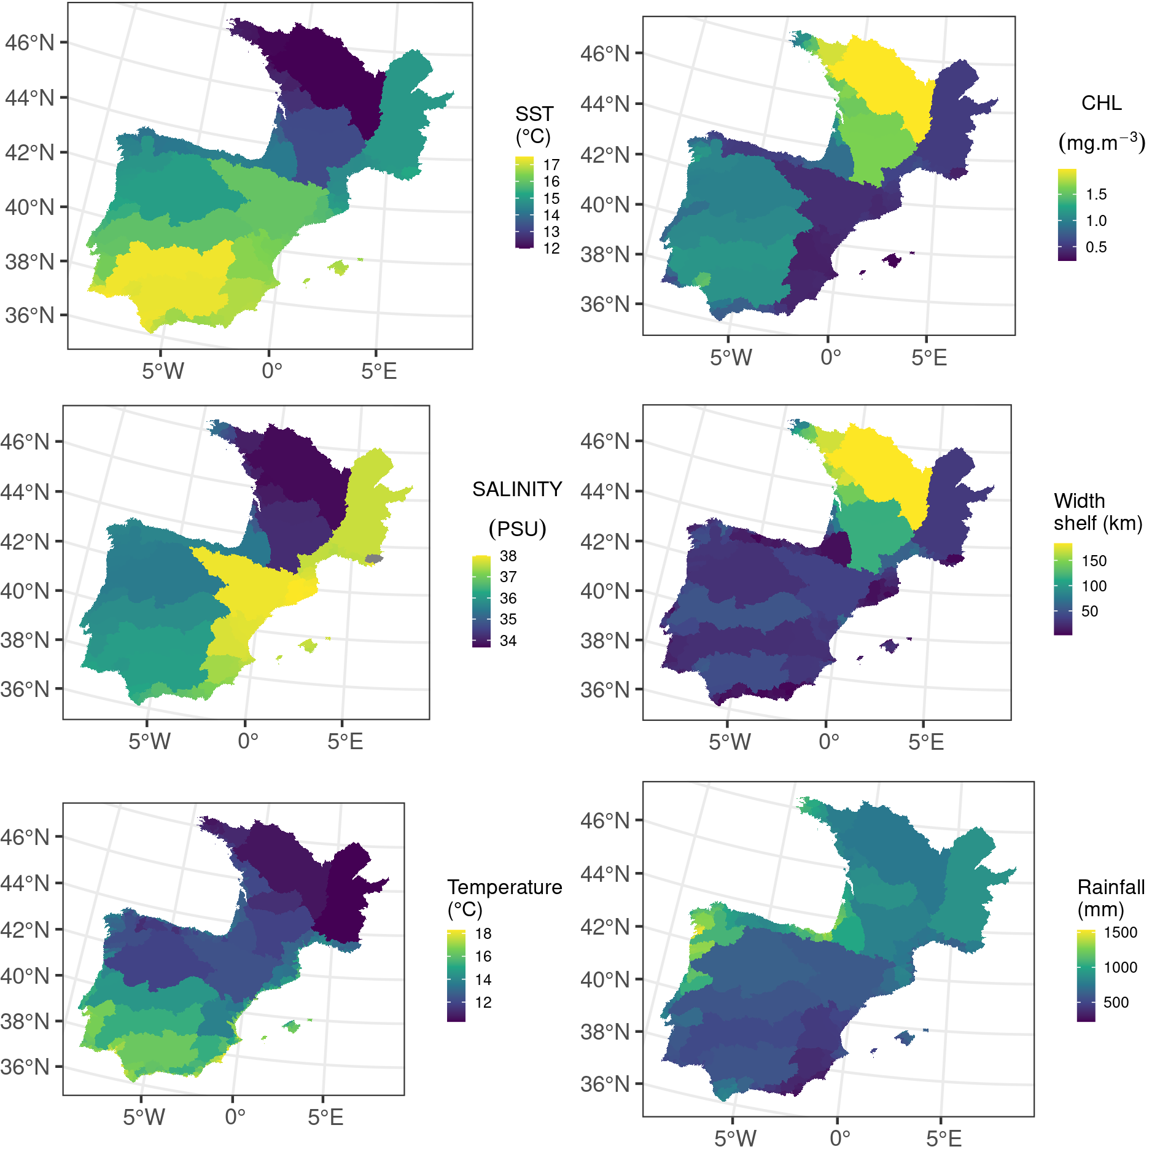
Figure S3- Environmental conditions characterizing river basins. Salinity, CHL a and SST are averaged in a 100-km buffer around river basin outlets. The width of the continental shelf is measured as the distance from the outlet to the 150-m isobath (Figure 1). Air temperature and precipitation are the annual averages in the basin for areas below 1000 m elevation (Figure 1).

Different zone definitions based on expert data
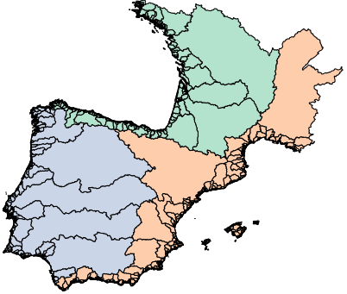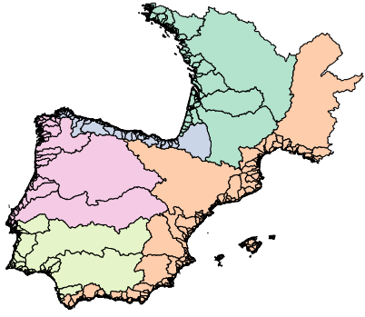
Figure S4 – The Distatis analysis of maps produced by experts, followed by a hierarchical clustering suggested the creation from 3 (left) to 5 (right) zones. Finally, the 4 zones configuration (middle) was kept in the exercise.

Example of questionnaire on exploitation rate

Introduction text (originally provided in French, Portuguese and Spanish):
“In A Coruña, a questionnaire on glass eel exploitation rates was proposed to the participants. You have received a summary of the results by e-mail. Knowing the answers responses made by the other participants, we would like you to answer the questionnaire again. This will allow us to see if the compromises are modified. Only the answers to this online survey will be taken into account for the final results! The survey can remain anonymous, you just need to provide a pseudonym that will allow you to change your answers later.”

Exemple of questionnaire for the Nalon River (originally provided in French, Portuguese and Spanish):
Nalón :
- Description:
  - Length - 217,2 km
  - Surface - 4 892 km2
  - Estuary length – 12 km
  - Estuary width ~ 200m
- Fishery
  - Only commerical fishery
  - Fishing gear : sieve from boat (36 in 2017/2018) from the shore (48 in 2017/2018)
- Questions :
  - I think the exploitation rate can be less than (% - a figure between 0 and 100, 0 if you don’t know, answer compulsory):
  - I would say exploitation rate is about: nombre entre 0 et 100 - mettez 0 si vous ne savez pas) :B2. Je dirais que le taux d'exploitation est d'environ than (% - a figure between 0 and 100, 0 if you don’t know, answer not compulsory) :
  - I think the exploitation rate can’t be greater than
  - Je pense que que le taux d'exploitation ne peut être supérieur à (% - a figure between 0 and 100, 100 if you don’t know, answer compulsory):

