Supplementary information for “Considerations for droplet digital PCR for environmental samples”

Table S1. Web of Science (Clarivate Analytics 2018) search for environmental studies using ddPCR. For each study, the type of sample used, and the threshold determination method is reported.

Source | Type of sample | Threshold strategy
Kokkoris et al., 2021 | Fungal spores | Manual Quantasoft – Based on controls
Fu et al. 2020 | Seeds/grains | Auto Quantasoft (1.6.6)
Grudlewska et al. 2020 | Sewage/wastewater | Manual Quantasoft – 7000-8000 RFU depending on assay
Suttner et al. 2020 | Watershed sediment | Auto Quantasoft (1.7.4)
Rosa et al., 2020 | Roots | Manual Quantasoft – Based on controls
Maldonado-González et al., 2020 | Soil | Auto Quantasoft - Unspecified
Liu et al., 2020 | Soil | Define the rain algorithm
Wen et al., 2020 | Soil | Define the rain algorithm
Martínez-Diz et al., 2020 | Soil | Auto Quantasoft - Unspecified
Manzari et al., 2020 | Bacteria | Manual QuantaSoft - Unspecified
Hansen et al., 2019 | Soil | Unspecified
Kokkoris et al., 2019 | Soil/plant tissue | Manual Quantasoft – Based on controls
Köppel et al. 2019 | Meat tissue | Auto Quantasoft – Unspecified
Cao et al. 2019 | Fish muscle tissue | Auto Quantasoft (1.7)
Shehata et al. 2019 | Meat | Auto Quantasoft – Unspecified
Cottenet et al. 2019 | Plant tissue | Auto Quantasoft (1.7.4)
Deng et al. 2019 | Seeds | Manual Quantasoft – Unspecified
Mauvisseau et al. 2019 | Water | Manual Quantasoft – 3500 RFU
Giraldo et al. 2019 | Plant tissue | Auto Quantasoft – Unspecified
Bahar et al. 2018 | Plant tissue | Manual QuantaSoft - High
Cooley et al. 2018 | Surface water | Manual – BioRad Rare Mutation Detection guidelines
Gao et al. 2018 | Compost | Auto QuantaSoft
Gobert et al. 2018 | Faecal | Manual QuantaSoft- Low
Gradoville et al. 2018 | Seawater | Three standard deviations above average NTC RFU
Grelewska-Nowotko et al. 2018 | Plant tissue | Manual QuantaSoft - Unspecified
Hamaguchi et al. 2018 | Coastal sediment | Auto QuantaSoft
Köppel et al. 2018 | Plant and animal tissue | Auto QuantaSoft
Naaum et al. 2018 | Meat products | Auto QuantaSoft
Paternò et al. 2018 | Wheat | Manual QuantaSoft - Unspecified
Paquette et al. 2018 | Faecal | Auto QuantaSoft
Steele et al. 2018 | Water | Manual QuantaSoft - Low
Selvaraj et al. 2018 | Plant tissue | Auto QuantaSoft
Wang et al. 2018 | Meat products | Auto QuantaSoft
Zhong et al. 2018 | Plant tissue | Auto QuantaSoft
Boynton et al. 2017 | Leaf tissue | Manual QuantaSoft - Unspecified
van Dorssen et al. 2017 | Faecal | Auto QuantaSoft
Hunter et al. 2017 | Pond water | Manual QuantaSoft - Unspecified
King et al. 2017 | Insect tissue | Manual - Low
Košir et al. 2017 | Plant tissue | Manual QuantaSoft – 1600-18500 RFU depending on assay
Lee et al. 2017 | Seawater | Auto QuantaSoft
Maheshwari et al. 2017 | Plant tissue | Auto QuantaSoft
McMahon et al. 2017 | Beef, pork, plant tissue | Auto QuantaSoft
Perez-Lopez et al. 2017 | Plant tissue | Auto QuantaSoft
Perry and Lee 2017 | Wheat | RainDrop Sense
Ren et al. 2017 | Meat | Auto QuantaSoft
Shehata et al. 2017 | Meat | Auto QuantaSoft
Singh et al. 2017 | River sediment | Auto QuantaSoft
Yang et al. 2017b | Wastewater | Auto QuantaSoft
Yang et al. 2017c | Faecal | Auto QuantaSoft
Zink et al. 2017 | Insect tissue | definetherain
Bucher and Köppel 2016 | Rice | Auto QuantaSoft
Cavé et al. 2016 | Soils and organic residues | Auto QuantaSoft
Cremonesi et al. 2016 | Cheese | Auto QuantaSoft
Demeke et al. 2016 | Plant tissue | RainDrop
Dobnik et al. 2016 | Corn | Manual - Mid
Gao et al. 2016 | Potato | Auto QuantaSoft
Iwobi et al. 2016 | Plant tissue | Auto QuantaSoft
Jerde et al. 2016 | Water | Unspecified
Lievens et al. 2016 | Plant tissue | Auto QuantaSoft
Palumbo et al. 2016a | Soils | Unspecified
Palumbo et al. 2016b | Grapes | Auto QuantaSoft
Porcellato et al. 2016 | Milk | Manual QuantaSoft - 2000-2200 RFU
Simmons et al. 2016 | Water | Auto QuantaSoft
Zhao et al. 2016 | Plant tissue | Manual - Unspecified
Cao et al. 2015 | Water and Faecal | Auto QuantaSoft
Doi et al. 2015a | Water | Manual QuantaSoft - Unspecified
Doi et al. 2015b | Water | Manual QuantaSoft – 1100 RFU
Te et al. 2015 | Water | Manual QuantaSoft - 9000 or 5400 RFU depending on assay
Kim et al. 2014 | Soil | Auto QuantaSoft
Nathan et al. 2014 | Water | Manual QuantaSoft - Unspecified
Rački et al. 201 | Plant tissue | Auto QuantaSoft or manual at 7000 RFU
Yang et al. 2014 | Faecal | Auto QuantaSoft
Kelley et al. 2013 | Nostril swab | Auto QuantaSoft
Morisset et al. 2013 | Corn | Manual QuantaSoft- Unclear
Roberts et al. 2013 | Eye swabs | Custom Perl and R scripts

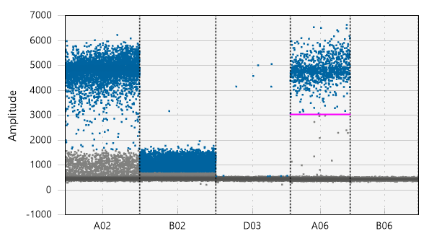
1
3
5
6
7
8
9
10
2
4
Figure S1. A key to interpreting ddPCR output figures. 1) Y axis represents the number of droplets amplified as a reflection of their fluorescence. Higher amplitude levels can be achieved with optimized cycling PCR protocol and optimized PCR reaction protocol. Higher amplitude levels result in improved cloud separation 2) X axis represents individual samples, in this example five individual samples are presented (A02, B02, D03, A06 and B06) and are named based on their location on the 96 well plate. 3) The cluster of high amplitude droplets (amplitude 4000 – 6000) is called “positive cloud” and represents positive to the target DNA droplets. 4 & 5) droplets between the “negative cloud” (see 10) and the “positive cloud” are called “rain” and may be negative or positive droplets. 6) Blue droplets are recognized as positive droplets from the automatic threshold determination system of the QuantaSoft software. While sample A02 and B02 are from a single ddPCR run, the automatic threshold treats each sample distinctly placing the “rain” as negative or “positive” respectively. 7) Low number of positive to the target DNA droplets. 8) Clean “negative cloud” 9) The pink line represents the manually set threshold. Above the line all droplets are considered as positive while bellow the line all droplets are considered as negative. 10) This sample represents a non-template control sample where there is no rain and no positive droplets. The negative cloud droplets cluster closely together creating a thick line at low amplitude. In theory, droplets that appear above this cloud in samples other that non-template controls can be potentially positive.

Negative environmental
Positive control
Unknown environmental
NTC control
NTC control
NTC control

Figure S2. Manual threshold determination. In order to determine the quantity of target DNA in an unknown environmental sample (well D06) we used three NTCs (wells B07, C07, D07), an organismal positive control (well A07) and a negative environmental sample (well A05). The threshold (purple line) was set manually at amplitude of 2386 to include the positive droplet cloud produced by the organismal positive control but to exclude the droplets produced by the negative environmental samples. Blue droplets represent positive droplets while grey droplets represent negative droplets. Separation of negative from positive cloud was achieved by setting the threshold manually at “2386” amplitude.

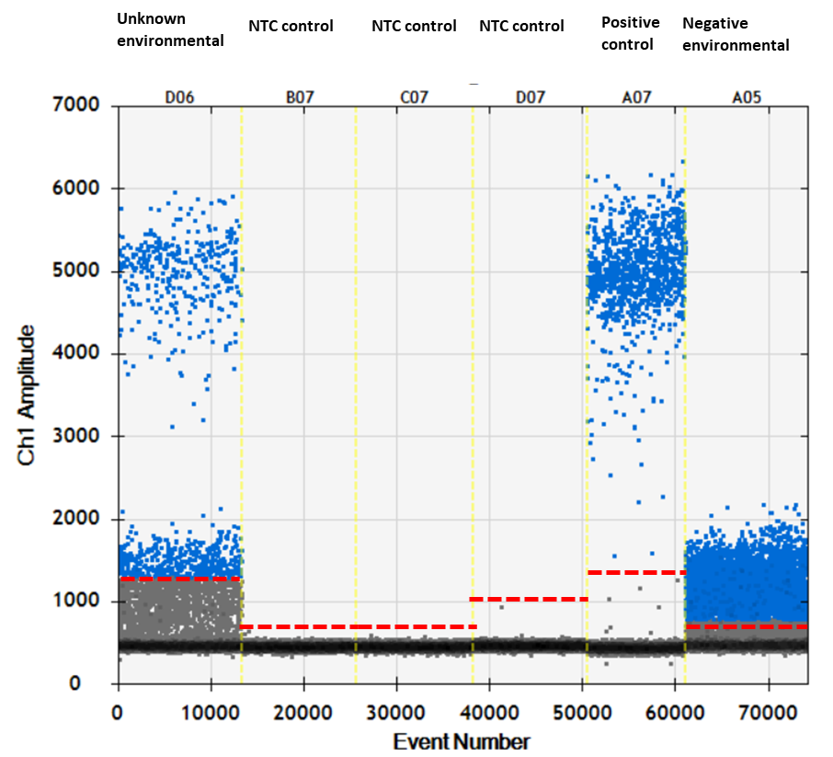

Figure S3. Automatically determined threshold using the QuantaSoft® software. Threshold was variable for each sample. The QuantaSoft® software algorithm failed to discriminate between true positive and negative droplets. Blue droplets represent positive droplets while grey droplets represent negative droplets.

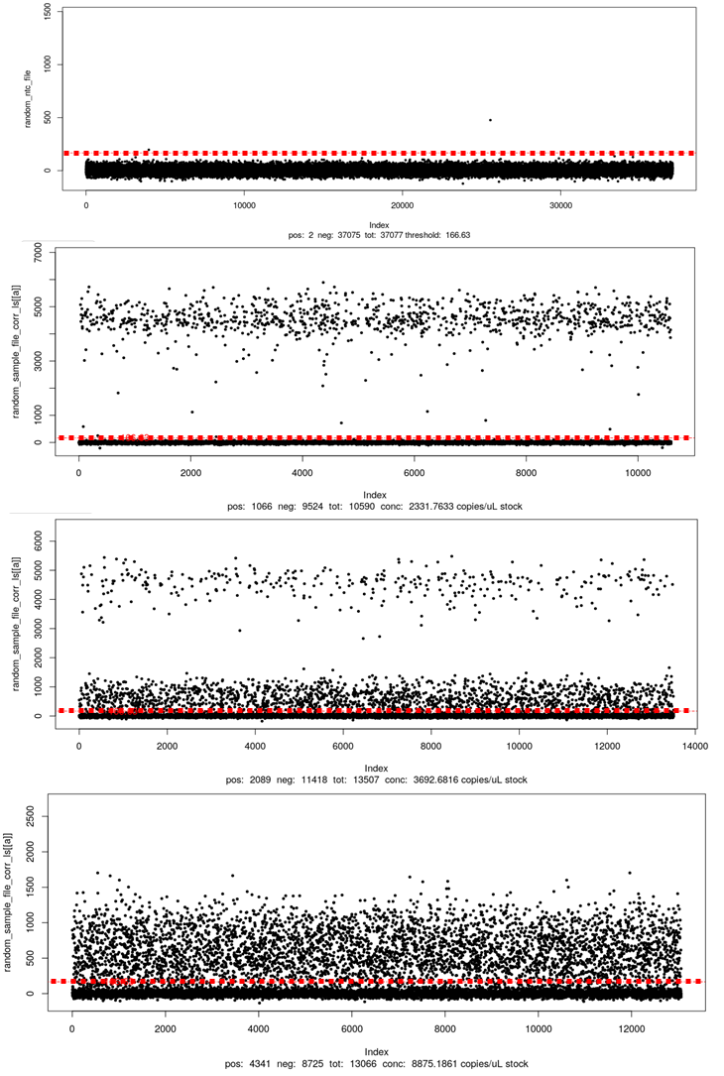
NTC control
Positive control
Unknown environmental
Negative environmental
Figure S4. Automatically determined threshold using the ‘ddPCRquant’ algorithm. The ‘ddPCRquant’ algorithm merges the three NTC samples and calculates the threshold based on the dense negative droplet cloud. The threshold was set automatically at “166.63” amplitude (red line in each sample). All samples above this value were considered erroneously as positive, including the negative environmental sample.

Supplementary References:

Bahar, M.H., Wist, T.J., Bekkaoui, D.R., Hegedus, D.D., Olivier, C.Y., 2018. Aster leafhopper survival and reproduction, and Aster yellows transmission under static and fluctuating temperatures, using ddPCR for phytoplasma quantification. Sci. Rep. 8, 227. https://doi.org/10.1038/s41598-017-18437-0
Boynton, P.J., Stelkens, R., Kowallik, V., Greig, D., 2017. Measuring microbial fitness in a field reciprocal transplant experiment. Mol. Ecol. Resour. 17, 370–380. https://doi.org/10.1111/1755-0998.12562
Bucher, T.B., Köppel, R., 2016. Duplex digital droplet PCR for the determination of non-Basmati rice in Basmati rice (Oryza sativa) on the base of a deletion in the fragrant gene. Eur. Food Res. Technol. 242, 927–934. https://doi.org/10.1007/s00217-015-2599-3
Cao, Y., Raith, M.R., Griffith, J.F., 2015. Droplet digital PCR for simultaneous quantification of general and human-associated fecal indicators for water quality assessment. Water Res. 70, 337–349. https://doi.org/10.1016/j.watres.2014.12.008
Cao, W., Li, Y., Chen, X., Chang, Y., Li, L., Shi, L., Bai, W., Ye, L., 2020. Species identification and quantification of silver pomfret using the droplet digital PCR assay. Food Chem. 302, 125331. https://doi.org/10.1016/j.foodchem.2019.125331
Cavé, L., Brothier, E., Abrouk, D., Bouda, P.S., Hien, E., Nazaret, S., 2016. Efficiency and sensitivity of the digital droplet PCR for the quantification of antibiotic resistance genes in soils and organic residues. Appl. Microbiol. Biotechnol. 100, 10597–10608. https://doi.org/10.1007/s00253-016-7950-5
Cooley, M.B., Carychao, D., Gorski, L., 2018. Optimized Co-extraction and Quantification of DNA From Enteric Pathogens in Surface Water Samples Near Produce Fields in California. Front. Microbiol. 9, 448. https://doi.org/10.3389/fmicb.2018.00448
Cottenet, G., Blancpain, C., Chuah, P.F., 2019. Performance assessment of digital PCR for the quantification of GM-maize and GM-soya events. Anal. Bioanal. Chem. 411, 2461–2469. https://doi.org/10.1007/s00216-019-01692-7
Cremonesi, P., Cortimiglia, C., Picozzi, C., Minozzi, G., Malvisi, M., Luini, M., Castiglioni, B., 2016. Development of a Droplet Digital Polymerase Chain Reaction for Rapid and Simultaneous Identification of Common Foodborne Pathogens in Soft Cheese. Front. Microbiol. 7, 1725. https://doi.org/10.3389/fmicb.2016.01725
Demeke, T., Holigroski, M., Eng, M., Xing, J., 2016. Absolute quantification of genetically engineered traits with droplet digital PCR: Effect of DNA treatments and spiking with non-target DNA. Food Control 68, 105–111. https://doi.org/10.1016/j.foodcont.2016.03.007
Deng, T., Huang, W., Ren, J., Ma, X., Ge, Y., Chen, Y., 2019. Verification and applicability of endogenous reference genes for quantifying GM rice by digital PCR. Anal. Biochem. 587, 113442. https://doi.org/10.1016/j.ab.2019.113442
Dobnik, D., Štebih, D., Blejec, A., Morisset, D., Žel, J., 2016. Multiplex quantification of four DNA targets in one reaction with Bio-Rad droplet digital PCR system for GMO detection. Sci. Rep. 6, 1–9. https://doi.org/10.1038/srep35451
Doi, H., Takahara, T., Minamoto, T., Matsuhashi, S., Uchii, K., Yamanaka, H., 2015a. Droplet digital polymerase chain reaction (PCR) outperforms real-time PCR in the detection of environmental DNA from an invasive fish species. Environ. Sci. Technol. 49, 5601–5608. https://doi.org/10.1021/acs.est.5b00253
Doi, H., Uchii, K., Takahara, T., Matsuhashi, S., Yamanaka, H., Minamoto, T., 2015b. Use of droplet digital PCR for estimation of fish abundance and biomass in environmental DNA surveys. PLoS One 10. https://doi.org/10.1371/journal.pone.0122763
Fu, W., Wang, C., Zhu, P., Xu, W., Li, X., Zhu, S., 2020. A universal analytical approach for screening and monitoring of authorized and unauthorized GMOs. LWT 125. https://doi.org/10.1016/j.lwt.2020.109176
Gao, H., Yu, X., Deng, T., Sun, M., Xiao, X., Huang, X., Chen, Y., Li, R., 2016. Event-specific detection of transgenic potato AV43-6-G7 using real-time and digital PCR methods. BMC Biotechnol. 16, 74. https://doi.org/10.1186/s12896-016-0303-8
Gao, M., Qiu, T., Sun, Y., Wang, X., 2018. The abundance and diversity of antibiotic resistance genes in the atmospheric environment of composting plants. Environ. Int. 116, 229–238. https://doi.org/10.1016/j.envint.2018.04.028
Giraldo, P.A., Cogan, N.O.I., Spangenberg, G.C., Smith, K.F., Shinozuka, H., 2019. Development and application of droplet digital PCR tools for the detection of transgenes in pastures and pasture-based products. Front. Plant Sci. 9. https://doi.org/10.3389/fpls.2018.01923
Gobert, G., Cotillard, A., Fourmestraux, C., Pruvost, L., Miguet, J., Boyer, M., 2018. Droplet digital PCR improves absolute quantification of viable lactic acid bacteria in faecal samples. J. Microbiol. Methods 148, 64–73. https://doi.org/10.1016/j.mimet.2018.03.004
Gradoville, M.R., Crump, B.C., Häse, C.C., White, A.E., 2018. Environmental Controls of Oyster-Pathogenic Vibrio spp. in Oregon Estuaries and a Shellfish Hatchery. Appl. Environ. Microbiol. 84, e02156-17. https://doi.org/10.1128/aem.02156-17
Grelewska-Nowotko, K., Żurawska-Zajfert, M., Żmijewska, E., Sowa, S., 2018. Optimization and Verification of Droplet Digital PCR Even-Specific Methods for the Quantification of GM Maize DAS1507 and NK603. Appl. Biochem. Biotechnol. 185, 207–220. https://doi.org/10.1007/s12010-017-2634-x
Grudlewska-Buda, K., Skowron, K., Gospodarek-Komkowska, E., 2020. Comparison of the intensity of biofilm formation by Listeria monocytogenes using classical culture-based method and digital droplet PCR. AMB Express 10. https://doi.org/10.1186/s13568-020-01007-5
Hamaguchi, M., Shimabukuro, H., Hori, M., Yoshida, G., Terada, T., Miyajima, T., 2018. Quantitative real-time polymerase chain reaction (PCR) and droplet digital PCR duplex assays for detecting Zostera marina DNA in coastal sediments. Limnol. Oceanogr. Methods 16, 253–264. https://doi.org/10.1002/lom3.10242
Hunter, M.E., Dorazio, R.M., Butterfield, J.S.S., Meigs-Friend, G., Nico, L.G., Ferrante, J.A., 2017. Detection limits of quantitative and digital PCR assays and their influence in presence–absence surveys of environmental DNA. Mol. Ecol. Resour. 17, 221–229. https://doi.org/10.1111/1755-0998.12619
Iwobi, A., Gerdes, L., Busch, U., Pecoraro, S., 2016. Droplet digital PCR for routine analysis of genetically modified foods (GMO) - A comparison with real-time quantitative PCR. Food Control 69, 205–213. https://doi.org/10.1016/j.foodcont.2016.04.048
Jerde, C.L., Olds, B.P., Shogren, A.J., Andruszkiewicz, E.A., Mahon, A.R., Bolster, D., Tank, J.L., 2016. Influence of Stream Bottom Substrate on Retention and Transport of Vertebrate Environmental DNA. Environ. Sci. Technol. 50, 8770–8779. https://doi.org/10.1021/acs.est.6b01761
Kelley, K.S., Cosman, A., Belgrader, P., Chapman, B., Sullivan, D.C., 2013. Detection of methicillin-resistant Staphylococcus aureus by a duplex droplet digital PCR assay. J. Clin. Microbiol. 51, 2033–2039. https://doi.org/10.1128/JCM.00196-13
Kim, T.G., Jeong, S.Y., Cho, K.S., 2014. Comparison of droplet digital PCR and quantitative real-time PCR for examining population dynamics of bacteria in soil. Appl. Microbiol. Biotechnol. 98, 6105–6113. https://doi.org/10.1007/s00253-014-5794-4
King, J.L., Smith, A.D., Mitchell, E.A., Allen, M.S., 2017. Validation of droplet digital PCR for the detection and absolute quantification of Borrelia DNA in Ixodes scapularis ticks. Parasitology 144, 359–367. https://doi.org/10.1017/S0031182016001864
Köppel, R., Thomas Bucher, ·, Bär, D., Franziska Van Velsen, ·, Ganeshan, A., 2018. Validation of 13 duplex droplet digital PCR systems for quantitative GMO analysis of most prevalent GMO traits 244, 313–321. https://doi.org/10.1007/s00217-017-2957-4
Köppel, R., Ganeshan, A., Weber, S., Pietsch, K., Graf, C., Hochegger, R., Griffiths, K., Burkhardt, S., 2019. Duplex digital PCR for the determination of meat proportions of sausages containing meat from chicken, turkey, horse, cow, pig and sheep. Eur. Food Res. Technol. 245, 853–862. https://doi.org/10.1007/s00217-018-3220-3
Košir, A.B., Spilsberg, B., Holst-Jensen, A., Žel, J., Dobnik, D., 2017. Development and inter-laboratory assessment of droplet digital PCR assays for multiplex quantification of 15 genetically modified soybean lines. Sci. Rep. 7. https://doi.org/10.1038/s41598-017-09377-w
Lee, H.G., Kim, H.M., Min, J., Kim, K., Park, M.G., Jeong, H.J., Kim, K.Y., 2017. An advanced tool, droplet digital PCR (DdPCR), for absolute quantification of the red-tide dinoflagellate, Cochlodinium polykrikoides Margalef (Dinophyceae). Algae 32, 189–197. https://doi.org/10.4490/algae.2017.32.9.10
Lievens, A., Jacchia, S., Kagkli, D., Savini, C., Querci, M., 2016. Measuring Digital PCR Quality: Performance Parameters and Their Optimization. https://doi.org/10.1371/journal.pone.0153317
Maheshwari, Y., Selvaraj, V., Hajeri, S., Yokomi, R., 2017. Application of droplet digital PCR for quantitative detection of Spiroplasma citri in comparison with real time PCR. PLoS One 12. https://doi.org/10.1371/journal.pone.0184751
Mauvisseau, Q., Davy-Bowker, J., Bulling, M., Brys, R., Neyrinck, S., Troth, C., Sweet, M., 2019. Combining ddPCR and environmental DNA to improve detection capabilities of a critically endangered freshwater invertebrate. Sci. Rep. 9. https://doi.org/10.1038/s41598-019-50571-9
McMahon, T.C., Blais, B.W., Wong, A., Carrillo, C.D., 2017. Multiplexed single intact cell droplet digital PCR (MuSIC ddPCR) method for specific detection of enterohemorrhagic E. coli (EHEC) in food enrichment cultures. Front. Microbiol. 8. https://doi.org/10.3389/fmicb.2017.00332
Morisset, D., Štebih, D., Milavec, M., Gruden, K., Žel, J., 2013. Quantitative Analysis of Food and Feed Samples with Droplet Digital PCR. PLoS One 8. https://doi.org/10.1371/journal.pone.0062583
Naaum, A.M., Shehata, H.R., Chen, S., Li, J., Tabujara, N., Awmack, D., Lutze-Wallace, C., Hanner, R., 2018. Complementary molecular methods detect undeclared species in sausage products at retail markets in Canada. Food Control 84, 339–344. https://doi.org/10.1016/j.foodcont.2017.07.040
Nathan, L.M., Simmons, M., Wegleitner, B.J., Jerde, C.L., Mahon, A.R., 2014. Quantifying environmental DNA signals for aquatic invasive species across multiple detection platforms. Environ. Sci. Technol. 48, 12800–12806. https://doi.org/10.1021/es5034052
Palumbo, J.D., O’Keeffe, T.L., Fidelibus, M.W., 2016. Characterization of Aspergillus section Nigri species populations in vineyard soil using droplet digital PCR. Lett. Appl. Microbiol. 63, 458–465. https://doi.org/10.1111/lam.12667
Palumbo, Jeffrey D., O’keeffe, T.L., Ho, Y.S., Fidelibus, M.W., 2016. Population dynamics of aspergillus section Nigri species on vineyard samples of grapes and raisins. J. Food Prot. 79, 448–453. https://doi.org/10.4315/0362-028X.JFP-15-437
Paquette, S.J., Stanford, K., Thomas, J., Reuter, T., 2018. Quantitative surveillance of Shiga toxins 1 and 2, Escherichia coli O178 and O157 in feces of western-Canadian slaughter cattle enumerated by droplet digital PCR with a focus on seasonality and slaughterhouse location. PLoS One 13. https://doi.org/10.1371/journal.pone.0195880
Paternò, A., Verginelli, D., Bonini, P., Misto, M., Quarchioni, C., Dainese, E., Peddis, S., Fusco, C., Vinciguerra, D., Marchesi, U., 2018. In-House Validation and Comparison of Two Wheat (Triticum aestivum) Taxon-Specific Real-Time PCR Methods for GMO Quantification Supported by Droplet Digital PCR. Food Anal. Methods 11, 1281–1290. https://doi.org/10.1007/s12161-017-1097-6
Pérez-López, E., Rodríguez-Martínez, D., Olivier, C.Y., Luna-Rodríguez, M., Dumonceaux, T.J., 2017. Molecular diagnostic assays based on cpn60 UT sequences reveal the geographic distribution of subgroup 16SrXIII-(A/I)I phytoplasma in Mexico. Sci. Rep. 7. https://doi.org/10.1038/s41598-017-00895-1
Perry, D.J., Lee, S.J., 2017. Droplet digital PCR for verification of interspersed refuge in midge tolerant wheat varietal blends. Can. J. Plant Sci. 97, 257–265. https://doi.org/10.1139/cjps-2016-0223
Porcellato, D., Narvhus, J., Skeie, S.B., 2016. Detection and quantification of Bacillus cereus group in milk by droplet digital PCR. J. Microbiol. Methods 127, 1–6. https://doi.org/10.1016/j.mimet.2016.05.012
Rački, N., Dreo, T., Gutierrez-Aguirre, I., Blejec, A., Ravnikar, M., 2014. Reverse transcriptase droplet digital PCR shows high resilience to PCR inhibitors from plant, soil and water samples. Plant Methods 10, 42. https://doi.org/10.1186/s13007-014-0042-6
Ren, J., Deng, T., Huang, W., Chen, Y., Ge, Y., 2017. A digital PCR method for identifying and quantifying adulteration of meat species in raw and processed food. PLoS One 12. https://doi.org/10.1371/journal.pone.0173567
Roberts, C.H., Last, A., Molina-Gonzalez, S., Cassama, E., Butcher, R., Nabicassa, M., McCarthy, E., Burr, S.E., Mabey, D.C., Bailey, R.L., Holland, M.J., 2013. Development and evaluation of a next-generation digital PCR diagnostic assay for ocular Chlamydia trachomatis infections. J. Clin. Microbiol. 51, 2195–2203. https://doi.org/10.1128/JCM.00622-13
Selvaraj, V., Maheshwari, Y., Hajeri, S., Chen, J., McCollum, T.G., Yokomi, R., 2018. Development of a duplex droplet digital PCR assay for absolute quantitative detection of “candidatus liberibacter asiaticus.” PLoS One 13. https://doi.org/10.1371/journal.pone.0197184
Shehata, H.R., Li, J., Chen, S., Redda, H., Cheng, S., Tabujara, N., Li, H., Warriner, K., Hanner, R., 2017. Droplet digital polymerase chain reaction (ddPCR) assays integrated with an internal control for quantification of bovine, porcine, chicken and turkey species in food and feed. PLoS One 12. https://doi.org/10.1371/journal.pone.0182872
Shehata, H.R., Naaum, A.M., Chen, S., Murphy, T., Li, J., Shannon, K., Awmack, D., Locas, A., Hanner, R.H., 2019. Re-visiting the occurrence of undeclared species in sausage products sold in Canada. Food Res. Int. 122, 593–598. https://doi.org/10.1016/j.foodres.2019.01.030
Simmons, M., Tucker, A., Chadderton, W.L., Jerde, C.L., Mahon, A.R., 2016. Active and passive environmental DNA surveillance of aquatic invasive species. Can. J. Fish. Aquat. Sci. 73, 76–83. https://doi.org/10.1139/cjfas-2015-0262
Singh, G., Sithebe, A., Enitan, A.M., Kumari, S., Bux, F., Stenström, T.A., 2017. Comparison of droplet digital PCR and quantitative PCR for the detection of Salmonella and its application for river sediments. J. Water Health 15, 505–508. https://doi.org/10.2166/wh.2017.259
Steele, J.A., Blackwood, A.D., Griffith, J.F., Noble, R.T., Schiff, K.C., 2018. Quantification of pathogens and markers of fecal contamination during storm events along popular surfing beaches in San Diego, California. Water Res. 136, 137–149. https://doi.org/10.1016/j.watres.2018.01.056
Suttner, B., Johnston, E.R., Orellana, L.H., Rodriguez-R, L.M., Hatt, J.K., Carychao, D., Carter, M.Q., Cooley, M.B., Konstantinidis, K.T., 2020. Metagenomics as a public health risk assessment tool in a study of natural creek sediments influenced by agricultural and livestock runoff: Potential and limitations. Appl. Environ. Microbiol. 86, 2525–2544. https://doi.org/10.1128/AEM.02525-19
Te, S.H., Chen, E.Y., Gin, K.Y.-H., 2015. Comparison of Quantitative PCR and Droplet Digital PCR Multiplex Assays for Two Genera of Bloom-Forming Cyanobacteria, Cylindrospermopsis and Microcystis. Appl. Environ. Microbiol. 81, 5203–5211. https://doi.org/10.1128/aem.00931-15
Wang, Q., Cai, Y., He, Y., Yang, L., Li, J., Pan, L., 2018. Droplet digital PCR (ddPCR) method for the detection and quantification of goat and sheep derivatives in commercial meat products. Eur. Food Res. Technol. 244, 767–774. https://doi.org/10.1007/s00217-017-3000-5
Yang, R., Abraham, S., Gardner, G., Ryan, U., Jacobson, C., 2017. Prevalence and pathogen load of Campylobacter spp., Salmonella enterica and Escherichia coli O157/O145 serogroup in sheep faeces collected at sale yards and in abattoir effluent in Western Australia. Aust. Vet. J. 95, 143–148. https://doi.org/10.1111/avj.12572
Yang, R., Paparini, A., Monis, P., Ryan, U., 2014. Comparison of next-generation droplet digital PCR (ddPCR) with quantitative PCR (qPCR) for enumeration of Cryptosporidium oocysts in faecal samples. Int. J. Parasitol. 44, 1105–1113. https://doi.org/10.1016/j.ijpara.2014.08.004
Yang, Y., Cheng, D., Li, Y., Yu, L., Gin, K.Y.H., Chen, J.P., Reinhard, M., 2017. Effects of monochloramine and hydrogen peroxide on the bacterial community shifts in biologically treated wastewater. Chemosphere 189, 399–406. https://doi.org/10.1016/j.chemosphere.2017.09.087
Zhao, Y., Xia, Q., Yin, Y., Wang, Z., 2016. Comparison of Droplet Digital PCR and Quantitative PCR Assays for Quantitative Detection of Xanthomonas citri Subsp. citri. PLoS One 11, e0159004. https://doi.org/10.1371/journal.pone.0159004
ZHONG, X., LIU, X. lu, LOU, B. hai, ZHOU, C. yong, WANG, X. feng, 2018. Development of a sensitive and reliable droplet digital PCR assay for the detection of ‘Candidatus Liberibacter asiaticus.’ J. Integr. Agric. 17, 483–487. https://doi.org/10.1016/S2095-3119(17)61815-X
Zink, F.A., Tembrock, L.R., Timm, A.E., Farris, R.E., Perera, O.P., Gilligan, T.M., 2017. A droplet digital PCR (ddPCR) assay to detect Helicoverpa armigera (Lepidoptera: Noctuidae) in bulk trap samples. PLoS One 12, e0178704. https://doi.org/10.1371/journal.pone.0178704

