In vitro and In vivo Activity of 14-O-[(4,6-Diamino-pyrimidine-2-yl) thioacetyl] mutilin Against Methicillin-Resistant Staphylococcus aureus
Yunxing Fu^{1, 2}, Chunqing Leng³, Yuan Fan⁴, Xia Ma¹, Xianghui Li¹, Xuefei Wang¹, Zhenghuan Guo¹,
Xiujun Wang^{1*}, Ruofeng Shang^{4*}
¹Zhengzhou Key Laboratory of Immunopharmacology of effective components of Chinese Veterinary Medicine, College of Veterinary Medicine, Henan University of Animal Husbandry and Economy, 450046 Zhengzhou, PR China
²Henan Provincial Research Center for the inheritance and innovation of Chinese veterinary medicine classic prescriptions, College of Veterinary Medicine, Henan University of Animal Husbandry and Economy, 450046 Zhengzhou, PR China
³Department of Animal Production, Jinhua Polytechnic, 321000, Jinhua, PR China.
⁴Key Laboratory of Veterinary Pharmaceutical Development, Ministry of Agriculture and Rural Affairs, Lanzhou Institute of Husbandry and Pharmaceutical Sciences of CAAS, 730050 Lanzhou, PR China
*1 Address correspondence to Xiujun Wang: wxjfly@126.com. Address: Henan University of Animal Husbandry and Economy, No. 6, Longzi North Road, Zhengdong New District, Zhengzhou, 450046, P.R. China.
*2 Address correspondence to Ruofeng Shang: shangrf1974@163.com. Address: Lanzhou Institute of Husbandry and Pharmaceutical Sciences of CAAS, No. 335, Qilihe District, Lanzhou, 730050, P.R. China.

Supplemental Data

Table of Contents
Figure S1. IR, ¹H-NMR and ¹³C-NMR Spectra of DPTM…………………………………………………………1-3
Table S1. MIC values of DPTM and Tiamulin fumarate against clinical isolates of MRSA…………………………4

Figure S1. IR, ¹H-NMR and ¹³C-NMR Spectra of DPTM
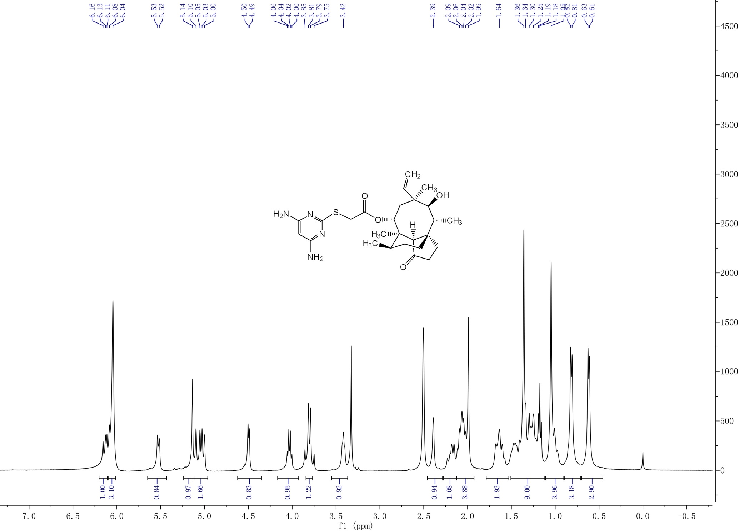
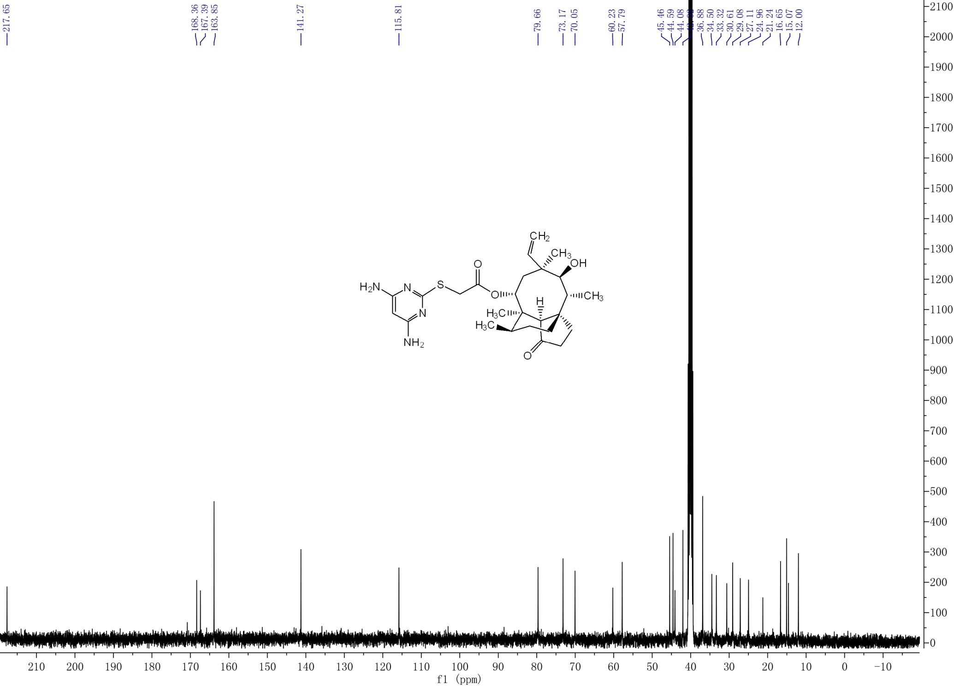

Table S1. MIC values of DPTM and Tiamulin fumarate against MRSA strains.
Stainª | SCCmec^{b} | MIC (μg/mL) |  | Stainª | SCCmec^{b} | MIC (μg/mL)
 |  | DPTM | Tiamulin |  |  | DPTM | Tiamulin
MRSA-21  MRSA-23  MRSA-24  MRSA-32  MRSA-33  MRSA-38  MRSA-39  MRSA-40  MRSA-44  MRSA-45  MRSA-47  MRSA-48  MRSA-51  MRSA-53  MRSA-54  MRSA-55  MRSA-57  MRSA-59  MRSA-60  MRSA-61  MRSA-64  MRSA-67  MRSA-68  MRSA-70  MRSA-71  MRSA-72  MRSA-73 | III  III  IV  IV  IV  I  II  I  I  II  III  II  II  II  IV  IV  IV  III  III  I  IV  III  III  IV  III  III  II | 0.0625  0.0625  0.125  0.125  0.0625  0.0625  0.25  0.0625  0.0625  0.313  0.125  0.125  0.25  0.0625  0.0625  0.125  0.0625  0.0625  0.0313  0.0625  0.0625  0.0625  0.125  0.25  0.0625  0.0625  0.125 | 0.25  0.125  0. 5  0.25  0.125  0.125  1  0.125  0.25  0.125  0.5  0.25  1  0.25  0.5  0.25  0.125  0.25  0.125  0.5  0.125  0.25  0.25  0.5  0.125  0.25  0.125 | MRSA-75  MRSA-79  MRSA-85  MRSA-90  MRSA-94  MRSA-99  MRSA-108  MRSA-122  MRSA-128  MRSA-133  MRSA-135  MRSA-141  MRSA-147  MRSA-149  MRSA-153  MRSA-155  MRSA-157  MRSA-159  MRSA-160  MRSA-166  MRSA-173  MRSA-177  MRSA-180  MRSA-185  MRSA-188  MRSA-194  MRSA-197 | II  II  II  IV  III  III  II  I  IV  IV  III  III  II  III  III  III  IV  II  IV  IV  II  III  III  II  IV  IV  III | 0.25  0.0625  0.0625  0.125  0.0313  0.0625  0.0625  0.0625  0.0313  0.125  0.25  0.125  0.0625  0.125  0.0625  0.0625  0.0625  0.0625  0.0625  0.0625  0.125  0.125  0.25  0.0625  0.125  0.0625  0.125 | 0.5  0.125  0.25  0.25  0.125  0.125  0.25  0.25  0.125  0.25  0.5  0.25  0.125  0.5  0.5  0.25  0.25  0.5  0.5  0.25  0.25  0.5  1  0.125  0.125  0.125  0.5
ªStrains were collected from dairy farms located in Gansu province, China.
^{b}Staphylococcal cassette chromosome mec types.

