Drone-based hyperspectral and thermal imagery for quantifying upland rice growth and water use efficiency after biochar application

Supplementary Material

- Estimation of canopy gap fraction and hemispherical transmittance
The directional gap fraction $b\left(θ\right)$ is the directional upward transmittance through the canopy to the camera in field measurement, writing as
$b\left(θ\right)=e^{-\frac{G}{cosθ}LAI}$, (S1)
in which G is a geometric function of leaf angular distribution, being estimated from an ellipsoidal leaf angular distribution model [1]:
$G=\frac{\sqrt{{}^{2}\cos^{2}θ+\sin^{2}θ}}{+1.77{(+1.182)}^{-0.733}}$, (S2)
where χ is the ratio of semi-axes of the ellipsoidal distribution model, estimated as χ = 0.409 using relation in Wang, et al. [2] and discrete measurement of rice leaf angle distribution (${\overline{θ}}_{L}={73.1}^{°}$) from Zhang, et al. [3]:
$χ=-3+{(\frac{{\overline{θ}}_{L}}{9.65})}^{-0.6061}$. (S3)
$σ_{f}$ is called shading factor and $1-σ_{f}$ is the hemispherical transmittance, estimated from $b\left(θ\right):$
$1-σ_{f}=\frac{1}{π}\int_{-\frac{π}{2}}^{\frac{π}{2}}{e^{-\frac{G}{cosθ}∙LAI}dθ}$. (S4)
The estimated G = 0.245 for nadir direction and a χ of 0.409. The integral of Eq. (S4) has no analytical expression, instead, it can be approximated by $1-σ_{f}=e^{-0.423∙LAI}$ using Matlab numerical integration and curve fitting toolbox (Matlab R2015b, MathWorks, USA).

- Variation propagation for estimating variations in GPP and water use efficiency
The Gross primary productivity (GPP) can be modeled using a simple light use efficiency concept [4] and considering the proportion of APAR absorbed by chlorophyll instead of whole canopy [5]:
$GPP=ε∙fAPAR∙CCC∙PAR$, (S5)
where ε is light use efficiency, fAPAR is the fraction of photosynthetically active radiation (PAR) absorbed by canopy. APAR, and PAR is the incoming PAR radiation in the spectrum range of 400nm to 700nm. CCC is the canopy chlorophyll content.
Since fAPAR has a linear relationship to normalized difference vegetation index NDVI [6]:
$fAPAR=k∙NDVI$, (S6),
where k is a constant slope in the linear relationship between fAPAR and NDVI. It is assumed that zero fAPAR for NDVI = 0.
From Eq. (S1) and (S2), GPP is then written as:
$GPP=ε∙k∙PAR∙CCC∙NDVI$. (S7)
Using variation propagation [7], the GPP change changes induced by NDVI and CCC variations is obtained using first-order difference and ignoring other minimal effects on light use efficiency parameters:
$ΔGPP=ε∙k∙PAR∙(CCC∙ΔNDVI+NDVI∙ΔCCC)$. (S8)
And the relative GPP variation is obtained by dividing GPP from both sides of Eq. (S8):
$\frac{ΔGPP}{GPP}=\frac{ΔNDVI}{NDVI}+\frac{ΔCCC}{CCC}$. (S9)
The standard error of the relative variation ($ΔGPP/GPP$) is:
${SE}_{ΔGPP/GPP}=\sqrt{{({SE}_{ΔNDVI/NDVI})}^{2}+{({SE}_{ΔCCC/CCC})}^{2}}$. (S10)
The relative NDVI variation between biochar group NDVI (${NDVI}_{BC}$) and the control group NDVI (${NDVI}_{C}$) is:
$\frac{ΔNDVI}{NDVI}=\frac{{NDVI}_{BC}-{NDVI}_{C}}{{NDVI}_{C}}$. (S11)
The standard error (SE) of the variation is estimated from the SE of ${NDVI}_{BC}$ and ${NDVI}_{C}$:
${SE}_{ΔNDVI/NDVI}=\sqrt{{{SE}_{{NDVI}_{BC}}}^{2}+{{SE}_{{NDVI}_{C}}}^{2}}/{NDVI}_{C}$. (S12)
And similarly the relative changes in CCC and the SE are written as:
$\frac{ΔCCC}{CCC}=\frac{{CCC}_{BC}-{CCC}_{C}}{{CCC}_{C}}$. (S13)
${SE}_{ΔCCC/CCC}=\sqrt{{{SE}_{{CCC}_{BC}}}^{2}+{{SE}_{{CCC}_{C}}}^{2}}/{CCC}_{C}$. (S14)
The significance level of the variation can be given from the Student's t distribution. The variations and the SE of other variables were estimated similarly.
The water use efficiency (WUE) can be simply defined as the ratio of GPP to evapotranspiration (ET) water loss:
$WUE=\frac{GPP}{ET}$. (S15)
The variation in WUE in deuced from both GPP and ET variations is obtained using first-order difference:
$ΔWUE=\frac{1}{ET}ΔGPP-\frac{GPP}{{ET}^{2}}ΔET$. (S16)
The relative WUE variation is obtained by dividing WUE from both sides of Eq. (S16):
$\frac{ΔWUE}{WUE}=\frac{1}{ET∙WUE}ΔGPP-\frac{GPP}{{ET}^{2}∙WUE}ΔET=\frac{ΔGPP}{GPP}-\frac{ΔET}{ET}$. (S17)
The standard error of the relative variation is:
${SE}_{ΔWUE/WUE}=\sqrt{{({SE}_{ΔGPP/GPP})}^{2}+{({SE}_{ΔET/ET})}^{2}}$. (S18)

Table S1. Statistics for variables of the biochar experiment
Variables |  | C | BC1 | Δ_{BC1−C} / C |  | BC2 | Δ_{BC2−C} / C |  | Standard error (SE) | SE / C
 |  | Mean | Mean | % | p-value | Mean | % | p-value | Standard error (SE) | %
Soil properties | θ_UAS (m³/m³) | 0.203 | 0.239 | 17.7 | <0.001 | 0.225 | 10.8 | <0.001 | 0.0001 | 0.1
Soil properties | θ_in situ (m³/m³) | 0.193 | 0.210 | 8.8 | 0.396 | 0.208 | 7.8 | 0.522 | 0.007 | 5.1
Soil properties | ψ_UAS (MPa) | -0.172 | -0.095 | 44.8 | <0.001 | -0.289 | − 66.9 | <0.001 | 0.001 | 0.7
Soil properties | ψ_in situ (MPa) | -0.401 | -0.500 | − 24.7 | 0.672 | -0.871 | − 117.2 | 0.233 | 0.156 | 55.0
Soil properties | Soil N content (%) | 0.153 | 0.147 | − 3.9 | 0.392 | 0.157 | 2.6 | 0.786 | 0.003 | 2..8
Soil properties | Soil albedo (-) | 0.216 | 0.217 | 0.5 | 0.003 | 0.219 | 1.4 | <0.001 | 0.000 | 0.1
Soil properties | Soil LST (°C) | 36.59 | 36.34 | − 0.7 | 0.004 | 36.09 | − 1.4 | <0.001 | 0.047 | 0.2
Leaf properties | Leaf water content (g/g) | 0.567 | 0.623 | 9.9 | 0.143 | 0.552 | − 2.6 | 0.866 | 0.020 | 5.0
Leaf properties | Leaf N content (%) | 0.593 | 0.788 | 32.9 | 0.035 | 0.554 | − 6.6 | 0.857 | 0.052 | 12.4
Leaf properties | Leaf P content (%) | 0.218 | 0.228 | 4.6 | 0.607 | 0.218 | 0.0 | 1.000 | 0.007 | 4.5
Leaf properties | Leaf K content (%) | 0.092 | 0.143 | 55.4 | 0.027 | 0.159 | 72.8 | 0.003 | 0.013 | 20.0
Canopy properties | CCC (g/m² ground) | 0.604 | 0.797 | 32.0 | <0.001 | 0.665 | 10.1 | 0.012 | 0.013 | 3.0
Canopy properties | NDVI (-) | 0.502 | 0.552 | 9.96 | <0.001 | 0.539 | 7.4 | <0.001 | 0.005 | 1.4
Canopy properties | GPP (gC/m²/day) | - | - | 41.9 | 0.003 | - | 17.5 | 0.018 | - | 3.4
Canopy properties | WUE (gC/kg H₂O) | - | - | 40.8 | 0.004 | - | 13.4 | 0.031 | - | 3.5
Canopy properties | f_{c} (-) | 0.288 | 0.303 | 5.2 | <0.001 | 0.277 | − 3.8 | 0.007 | 0.002 | 1.0
Canopy properties | LAI (m²/m²) | 1.462 | 1.550 | 6.0 | <0.001 | 1.391 | − 4.9 | 0.004 | 0.013 | 1.3
Canopy properties | Canopy albedo (-) | 0.292 | 0.294 | 0.7 | 0.523 | 0.283 | − 3.1 | <0.001 | 0.001 | 0.5
Canopy properties | Canopy LST (°C) | 32.33 | 32.14 | − 0.6 | 0.004 | 32.53 | 0.6 | 0.003 | 0.035 | 0.2
Land surface energy components | Rn (W/m²) | 205.7 | 205.3 | − 0.2 | 0.838 | 210.3 | 2.3 | <0.001 | 0.460 | 0.3
Land surface energy components | AE (W/m²) | 156.4 | 156.9 | 0.3 | 0.445 | 159.3 | 1.9 | <0.001 | 0.304 | 0.3
Land surface energy components | EF (-) | 0.434 | 0.450 | 3.7 | 0.002 | 0.433 | − 0.2 | 0.951 | 0.003 | 1.0
Land surface energy components | λET (W/m²) | 79.61 | 80.47 | 1.1 | 0.544 | 82.83 | 4.0 | 0.002 | 0.567 | 1.0
Land surface energy components | H (W/m²) | 76.82 | 76.50 | − 0.4 | 0.812 | 76.48 | − 0.4 | 0.832 | 0.387 | 0.7
Land surface energy components | G (W/m²) | 49.33 | 48.42 | − 1.8 | 0.011 | 51.05 | 3.5 | <0.001 | 0.195 | 0.6
Note: Standard error (SE) of the marginal mean is the same for all three groups. Red numbers show negative changes and green numbers positive changes in biochar groups compared with the control. Bold font indicates significant changes at p <0.05.
BC1: local bamboo biochar group, BC2: Taiwan sugarcane biochar group; C: control group

AE: available energy, Rn-G, or λET+H
CCC: canopy chlorophyll content
ET: evapotranspiration
EF: evaporative fraction, λET/AE
f_{c}: fractional vegetation cover
G: ground heat flux
GPP: gross primary productionH: sensible heat flux
H: sensible heat flux
LAI: leaf area index
LST: land surface temperature
NDVI: normalized difference vegetation index
N, P, and K: nitrogen, phosphorous, and potassium
Rn: net radiation
SMP: soil matric potential
WUE: water use efficiency
θ: soil moisture content
λET: latent heat flux (energy form for ET)

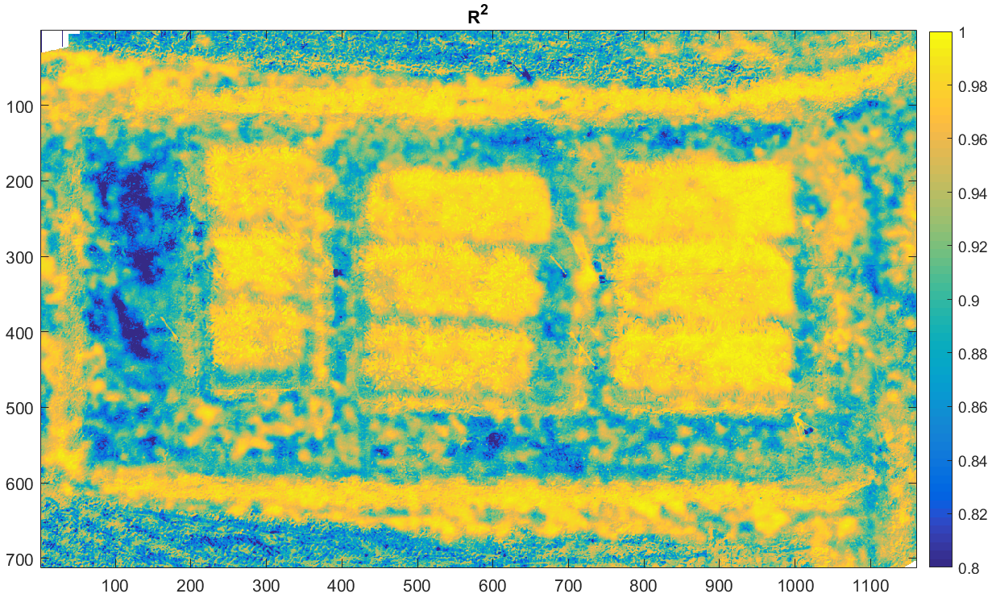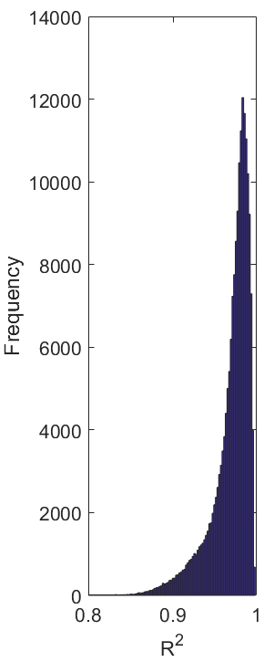
(a)
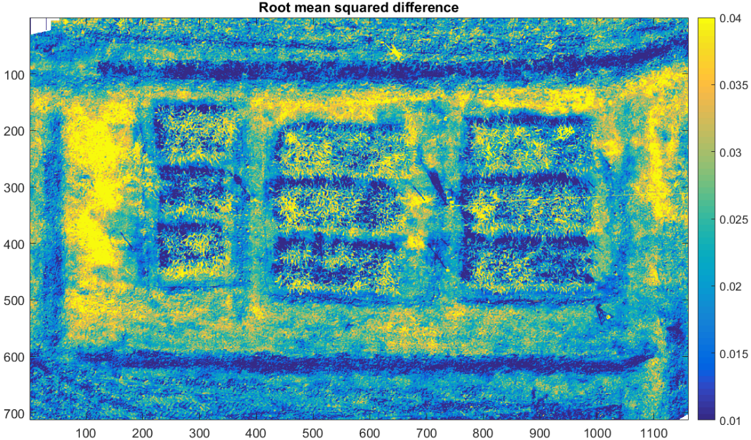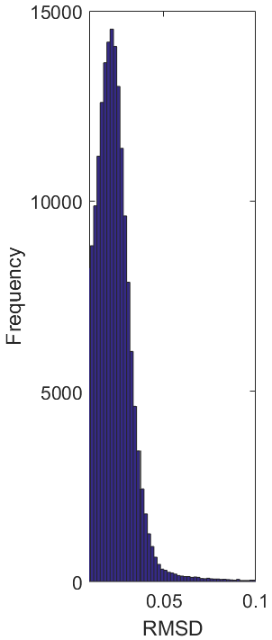
(b)
Figure S1. (a) R² and (b) root mean squared difference (RMSD) between the UAS-measured and the Pro4SAIL-modeled hyperspectral reflectance using the parameters from the model inversion outputs. Histograms show the frequencies of these values over three groups of rice canopy.

Figure S2. (a) The comparison of plot-averaged soil moisture content (θ) in three groups BC1, BC2, and C from UAS over the period Nov 14 to 21, 2018 and during the four UAS campaigns. Whiskers denote 95 % confidence interval of each group on each day. Violin plots of θ from UAS in each plot and each treatment on (b) Nov16, (c) Nov 19, and (d) Nov-21. The shaded areas of the violin plot denote distribution of the day’s measurement, the white dots denote the median values, and the bottom and top edges of the black bars denote the 25th and 75th percentiles respectively. The red circle ‘○’ denotes sensor measurements during flight

Figure S3. (a) The comparison of plot-averaged soil matric potential (ψ) in three groups BC1, BC2, and C from UAS over the period Nov 14 to 21, 2018 and during the four UAS campaigns. Whiskers denote 95 % confidence interval of each group on each day. Violin plots of ψ from UAS in each plot and each treatment on (b) Nov16, (c) Nov 19, and (d) Nov-21. The shaded areas of the violin plot denote distribution of the day’s measurement, the white dots denote the median values, and the bottom and top edges of the black bars denote the 25th and 75th percentiles respectively. The red circle ‘○’ denotes sensor measurements during flight

(a)
(b)
Figure S4. (a) Water retention curves estimated from field measured soil matric potential (ψ) and soil moisture content using Van Genuchten model. (b) Comparison of evaporative fraction (EF) and soil matric potential (ψ). The solid lines are exponential fitting of EF-ψ relationships in three groups. Dash lines indicating the extrapolation of the fitting lines to EF = EF_{max}, using sigmoidal curves. Dot-dash line denotes field capacity (FC) at -0.05MPa. The wilting point (-1.5 MPa) is out of the x-axis range.

(a)
(b)
(c)
Figure S5. Overall relationships of (a) canopy chlorophyll content (CCC), (b) NDVI, and (c) LAI to soil moisture content in three groups BC1, BC2 and C.

References

1. Campbell, G.S.; Norman, J.M. An Introduction to Environmental Biophysics; Springer-Verlag New York, Inc. : 1998.
2. Wang, W.M.; Li, Z.L.; Su, H.B. Comparison of leaf angle distribution functions: Effects on extinction coefficient and fraction of sunlit foliage. Agricultural and Forest Meteorology 2007, 143, 106-122, doi:https://doi.org/10.1016/j.agrformet.2006.12.003.
3. Zhang, X.-c.; Lu, C.-g.; Hu, N.; Yao, K.-m.; Zhang, Q.-j.; Dai, Q.-g. Simulation of Canopy Leaf Inclination Angle in Rice. Rice Science 2013, 20, 434-441, doi:https://doi.org/10.1016/S1672-6308(13)60161-4.
4. Monteith, J.L. Solar radiation and productivity in tropical ecosystems. The Journal of Applied Ecology 1972, 9, 747-766.
5. Zhang, F.; Zhou, G. Deriving a light use efficiency estimation algorithm using in situ hyperspectral and eddy covariance measurements for a maize canopy in Northeast China. Ecology and Evolution 2017, 7, 4735-4744, doi:doi:10.1002/ece3.3051.
6. Sellers, P.J. Canopy reflectance, photosynthesis and transpiration. International Journal of Remote Sensing 1985, 6, 1335-1372, doi:10.1080/01431168508948283.
7. Jin, H.; Eklundh, L. In Situ Calibration of Light Sensors for Long-Term Monitoring of Vegetation. Geoscience and Remote Sensing, IEEE Transactions on 2015, 53, 3405-3416, doi:10.1109/tgrs.2014.2375381.

