**Supplementary Materials:**

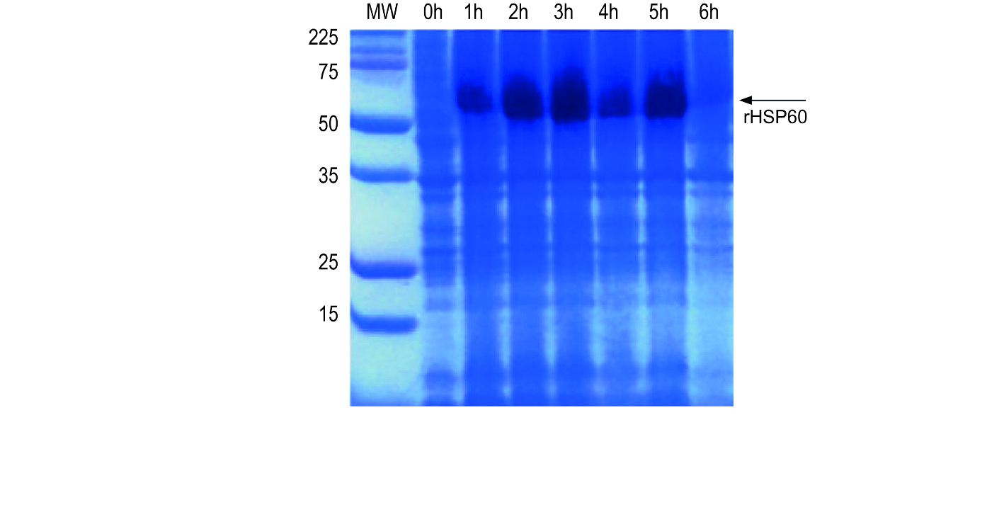**Figure S1. – Recombinant HSP60 production in E. coli BL21 DE3.** Whole-cell protein extract from E. coli culture producing recombinant HSP60 from H. capsulatum at different times after induction. **MW:** Broad Range Protein Molecular Weight Marker Prestained Promega.

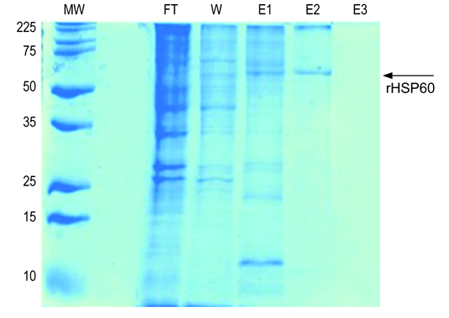**Figure S2. – Recombinant HSP60 protein purification steps SDS-PAGE.** Electrophoresis of affinity-purified recombinant H. capsulatum HSP60 samples eluted in different buffers. **FT:** Flow Through; **W:** Washing Buffer 10 mM Imidazole; **E1:** Elution buffer 100 mM Imidazole; **E2:** Elution buffer 250 mM Imidazole; **E3:** Elution buffer 500 mM Imidazole. **MW:** Broad Range Protein Molecular Weight Marker Prestained Promega.

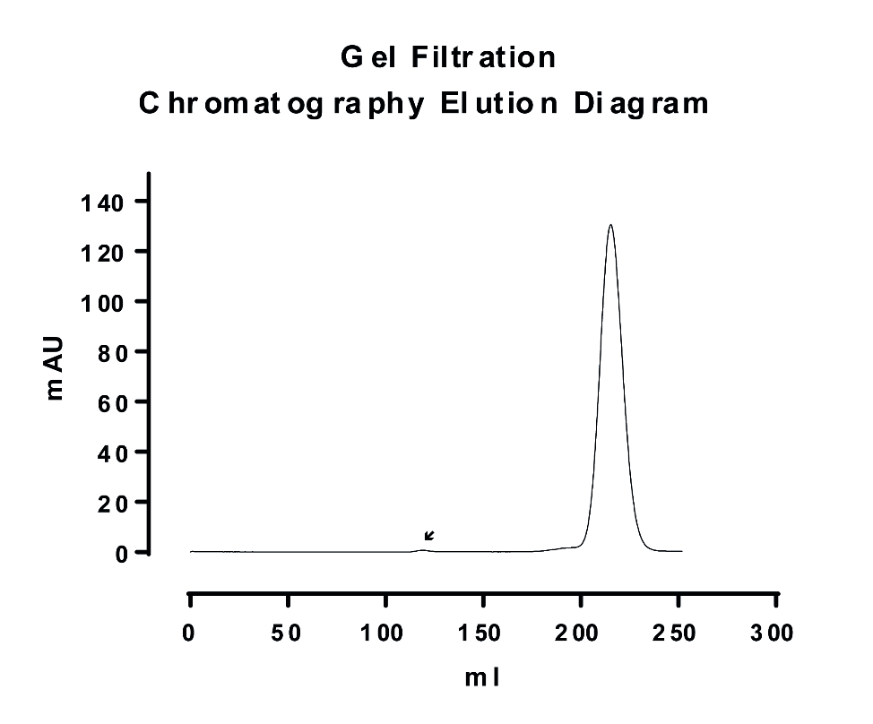

**Figure S3. Elution profile of ch-MAb 4E12 on gel filtration chromatography.** A very small proportion of aggregate antibody was well separated from the collected fractions (201.79 - 231.32 ml) that were pooled and concentrated. The aggregate peak (black arrow) can be seen on the GF trace at about 120ml.

**Figure S4. Phagocytosis assay with** *H. capsulatum* **yeast cells using human polyclonal serum as a control. A.** Effectiveness comparison between ch-MAb 4E12 and serum from patients with Histoplasmosis.The phagocytosis percentage was similar for yeasts opsonized with serum against *H. capsulatum* or with ch-MAb at 5 and 10 µg. **B.** Effectiveness comparison between ch-MAb and serum from patients with Paracoccidioidomycosis.All chimeric antibody concentrations increased phagocytosis significantly compared to serum against *P. lutzii*. **(**)** P <0.01; **(***)** P <0.001; **(****)** P <0.0001; **(ns)** Not significant; **Y Axis:** Phagocytic capacity (Phagocytes number with internalized yeasts/100 macrophages) in linear scale.

**Figure S5. Phagocytosis assay with** *P. lutzii* **yeast cells using human polyclonal serum as a control. A.** Effectiveness comparison between ch-MAb 4E12 and serum from patients with Histoplasmosis.The phagocytosis percentage was similar for yeasts opsonized with serum against *H. capsulatum* or with ch-MAb at 5 and 10 µg. **B.** Effectiveness comparison between ch-MAb and serum from patients with Paracoccidioidomycosis.All chimeric antibody concentrations increased phagocytosis significantly compared to serum against *P. lutzii*. **(**)** P <0.01; **(***)** P <0.001; **(****)** P <0.0001; **(ns)** Not significant; **Y Axis:** Phagocytic capacity (Phagocytes number with internalized yeasts/100 macrophages) in linear scale.

**Table S1. – PCR primers set used for hybridoma cDNA screening to identify the variable region.** For light chain identification, each Forward Primer VL was used individually in partnership with the Reverse Primer CL UNI. For heavy chain identification, each Forward Primer VH was used individually in partnership with the Reverse Primer CH UNI. Standard abbreviations have been used to mixed sites: **(M)** A or C; **(R)** A or G; **(W)** A or T; **(S)** C or G; **(Y)** C or T; **(K)** G or T.

|  |  |  |
| --- | --- | --- |
| **Variable Region** | **Primer** | **Sequence (5’-3’)** |
| Light chain | F-VL I/III | aatgacatccactttgcctttctctccacaggcgcgcactccGACATTGTGATGACYCARTCT |
| F-VL IV/VI | aatgacatccactttgcctttctctccacaggcgcgcactccCAAAWTGTKCTCACCCAGTCT |
| F-VL Ila | aatgacatccactttgcctttctctccacaggcgcgcactccGATGTTKTGATGACCCAAACT |
| F-VL IIb | aatgacatccactttgcctttctctccacaggcgcgcactccGAYATTGTGATAACCCAGGMT |
| F-VL Va | aatgacatccactttgcctttctctccacaggcgcgcactccGACATCSAGATGACYCAGTCT |
| F-VL Vb | aatgacatccactttgcctttctctccacaggcgcgcactccGAYATTGTGMTGACMCAGTCT |
| R-CL UNI | gggaagatgaagacagatggtgcagccaccgtacgTTTTATCTCCAGCTTKGTSCC |
| Heavy chain | F-VH I | aatgacatccactttgcctttctctccacaggcgcgcactccCAGGTGCAGCTKMAGGAGTCA |
| F-VH II | aatgacatccactttgcctttctctccacaggcgcgcactccCAGGTCCARCTGCAGCAGYCT |
| F-VH III | aatgacatccactttgcctttctctccacaggcgcgcactccGARGTGAAGCTGGTGGARTCT |
| F-VH V | aatgacatccactttgcctttctctccacaggcgcgcactccGAGGTTCAGCTTCAGCAGTCT |
| CH UNI | ccagggggaagaccgatgggcccttggtgctagcTGAGGAGACTGTGAGAGTGGTGCCTTGRCCCCA |