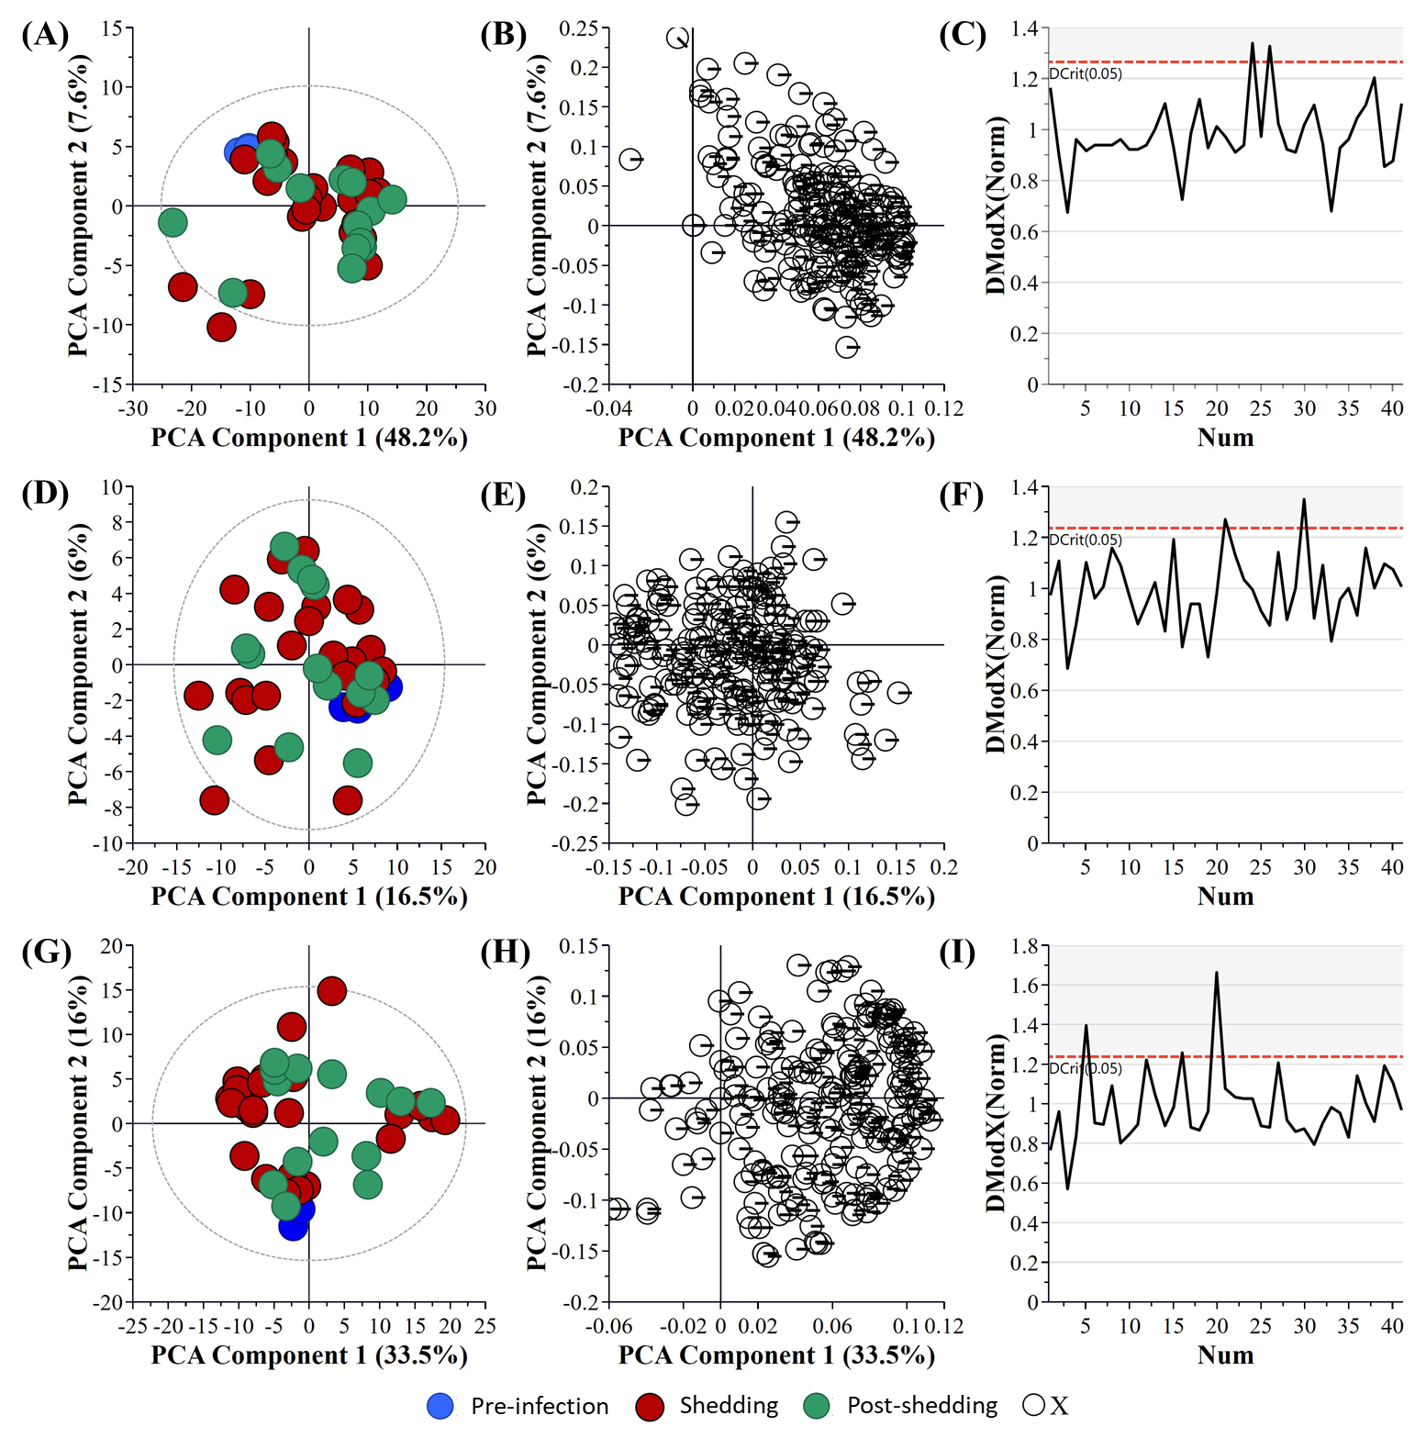
Supplementary Figure S1. PCA overview of the central carbon metabolite data analyzed in the nasal wash (A-C, R₂X = 0.656, and Q₂ = 0.476, DCrit value = 1.2648), oral swab (D-F, R₂X = 0.276, and Q₂ = 0.092, DCrit value = 1.2365), and rectal swab (G-I, R₂X = 0.595, and Q₂ = 0.459, DCrit value = 1.2365) samples pre-infection, during viral shedding, and post-viral shedding. (A, D, G) PLS-DA Score Scatter plot of metabolite data. (B, E, H) PLS-DA Loading Scatter plot of metabolite data. (C, F, I) DModX plot of metabolite data. The ellipse on the loadings scatter plots represents the 95% Hoteling’s threshold. Note, the ellipse presented in Figures S2A, S2D, and S2G represents Hotelling's T2 confidence limit (95%). Note: The colored circles in panel “A”, “D”, and “G” represent each analyzed sample, with the white circles representing the distribution of metabolite features between these groups.
Supplementary Table S1. Identified significant metabolite clusters (p ≤ 0.1) during viral shedding and post-shedding using the central carbon metabolism metabolite dataset.
Sample Type | Cluster name | Cluster size | P-value | FDR | Key compound | HMDB | KEGG ID | Altered metabolites
Nasal Wash | Indoles | 4 | 0.0075 | 0.00005 | Indoline-2-carboxylate | HMDB0002285 | NA | 1
 | Adenine Nucleotides | 5 | 0.0346 | 0.0066 | Adenosine 5-monophosphate | HMDB0000045 | C00020 | 1
 | Succinates | 5 | 0.0681 | 0.0066 | Succinic semialdehyde | HMDB0001259 | C00232 | 2
 | Deoxycytosine Nucleotides | 3 | 0.0939 | 0.007 | 2-Deoxycytidine 5-diphosphate | HMDB0001245 | C00705 | 2
 | Dicarboxylic Acids | 5 | 0.0190 | 0.0095 | Citramalic acid | HMDB0000426 | C00815 | 0
 | Glutarates |  | 0.0848 | 0.013 | 3-Methylglutaric acid | HMDB0000752 | NA | 0
 | Guanine Nucleotides | 6 | 0.0647 | 0.024 | Deoxyguanosine 5-triphosphate | HMDB0001440 | C00286 | 3
 | Hydroxy Acids | 4 | 0.0190 | 0.024 | Mevalonic acid | HMDB0000227 | C00418 | 1
 | Hydroxybenzoates | 6 | 0.0886 | 0.028 | m-Hydroxybenzoic acid | HMDB0002466 | C00587 | 3
 | Pentoses | 3 | 0.0086 | 0.061 | L-Arabinose | HMDB0000646 | C11476 | 2
 | Pentanols | 2 | 0.0716 | 0.061 | Isopentyl acetate | HMDB0031528 | C12296 | 1
 | Pentose phosphates | 5 | 0.0650 | 0.061 | 2-Deoxyribose 5-phosphate | HMDB0001031 | C00673 | 1
 | Sialic Acids | 1 | 0.0778 | 0.065 | N-Acetylneuraminic acid | HMDB0000230 | C19910 | 1
 | Tricarboxylic Acids | 5 | 0.0157 | 0.12 | trans-Aconitic acid | HMDB0000958 | C02341 | 2
Oral Swab | Succinates | 5 | 0.039 | 1 | Argininosuccinic acid | HMDB0000052 | C03406 | 2
Rectal Swab | Hexose phosphates | 4 | 0.0076 | 0.33 | D-Galactosamine | NA | C02262 | 2
 | Hydroxy acids | 4 | 0.027 | 0.59 | Lactic acid | HMDB0144295 | C01432 | 2
FDR: False Discovery Rate; HMDB: Human Metabolome Database; KEGG: Kyoto Encyclopedia of Genes and Genomes

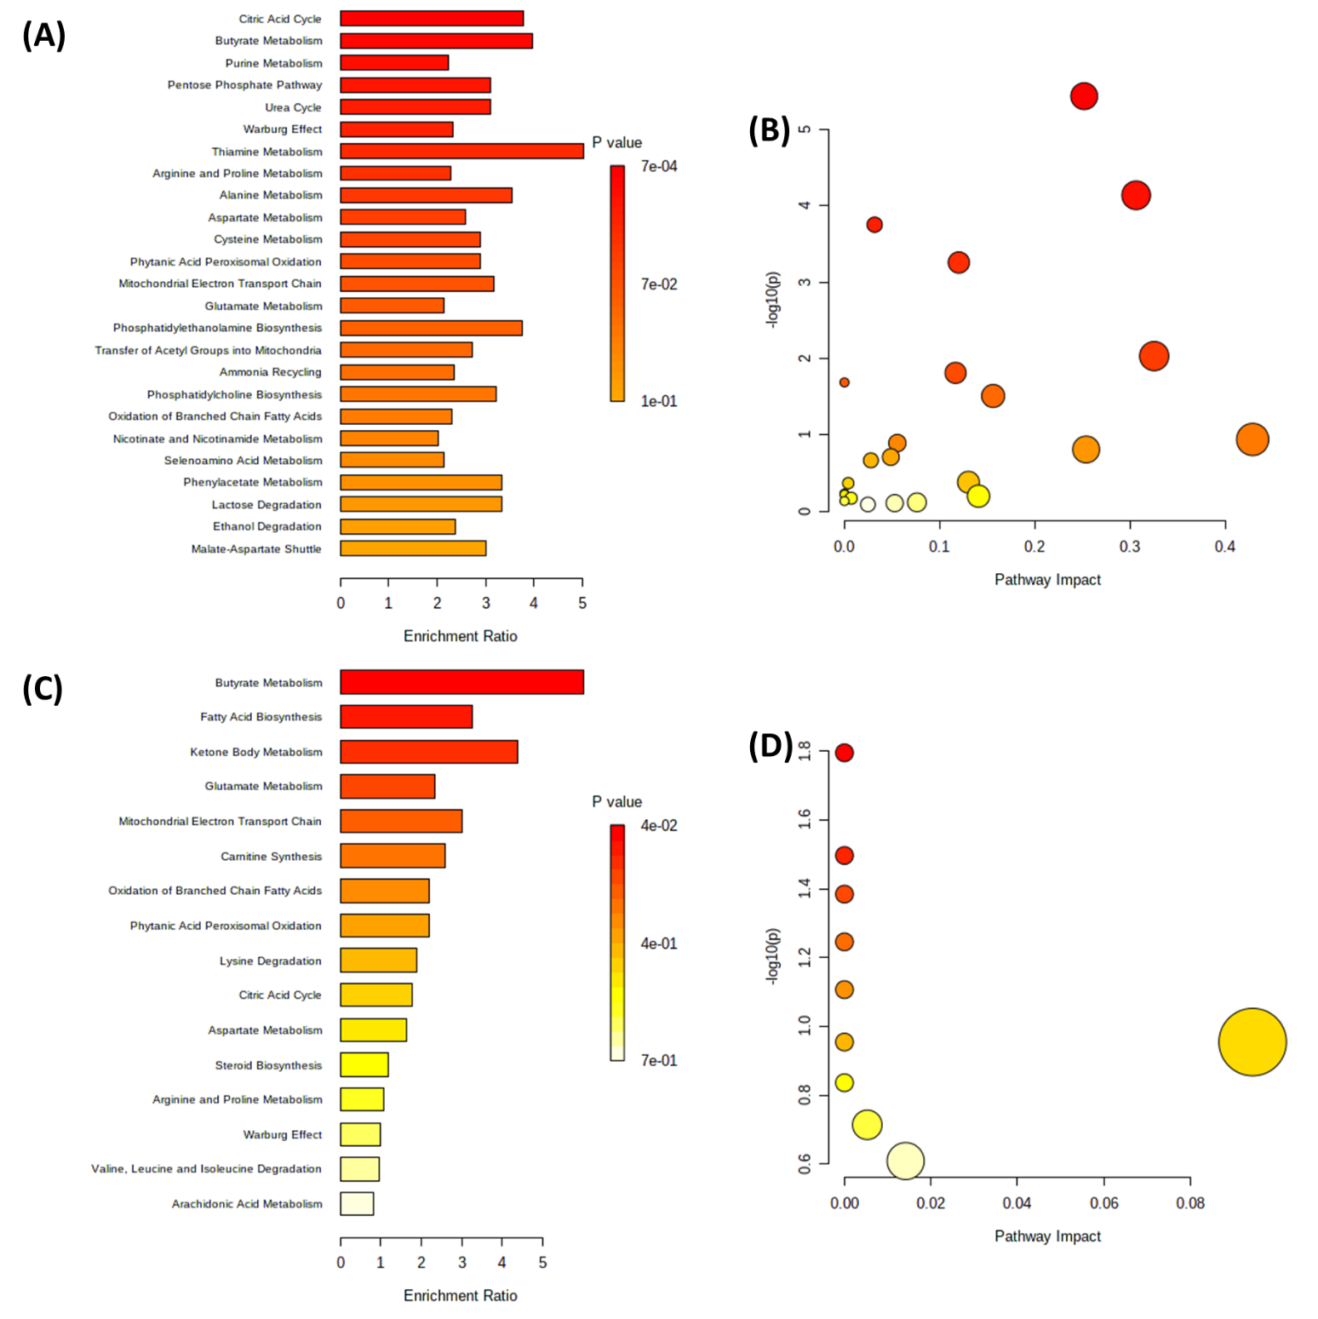
Supplementary Figure S2. Enrichment analysis of the identified metabolites of importance from nasal wash samples. (A) Metabolite enrichment analysis. (B) Metabolite pathway impact analysis. (C) Lipid enrichment analysis. (D) Lipid pathway impact analysis.

Supplementary Figure S3: Boxplot representing the data of individual significant metabolites from the key metabolism changes in a SARS-CoV-2 ferret model during viral shedding and post-shedding events. Normalized metabolite expression is determined as the mean ± the standard error.
Supplementary Table S2. Significant metabolites identified from central carbon metabolism metabolite dataset.
Metabolite | log2 (FC) | -log10 (p-value) | KEGG ID | HMDB ID | Elevated in
L-Cystine | 2.7682 | 2.1375 | C01420 | HMDB0000192 | SA01
L-Methionine | 2.5291 | 1.5963 | C01733 | HMDB0033951
L-Histidine | 2.0048 | 3.2117 | C00135 | HMDB0000177
Pyridoxal hydrochloride | 1.8407 | 2.4058 | C00250 | HMDB0001545
Cytidine 5-diphosphate | 1.1293 | 1.481 | C00112 | HMDB0001546
L-Glutamine | 0.76587 | 9.3871 | C00064 | HMDB0000641
L-Threonine | 0.74125 | 3.3936 | C00188 | HMDB0000167
L-Homoserine | 0.64845 | 2.9521 | C00263 | HMDB0000719
L-Dihydroorotic acid | 0.62133 | 2.0999 | C00337 | HMDB0003349
2-Deoxyribose 5-phosphate | 0.58836 | 5.2058 | C00673 | HMDB0001031
Itaconic acid | -0.62578 | 2.5257 | C00490 | HMDB0002092 | VIC01
D-Gluconic acid | -0.69118 | 1.9507 | C00257 | HMDB0000625
N-Formyl-L-Tyrosine | -0.77537 | 2.0569 | No result | No result
Shikimic acid | -0.78933 | 2.5124 | C00493 | HMDB0003070
N-Acetyl-alpha-D-glucosamine 1-phosphate | -0.8396 | 3.2117 | C04256 | HMDB0001367
N-Acetyl-D-glucosamine 6-phosphate | -0.8396 | 3.2117 | C00357 | HMDB0001062
N-Acetyl D-galactosamine | -0.8726 | 1.5963 | C01132 | HMDB0000853
Ketovaleric acid | -0.94453 | 2.477 | C06255 | HMDB0001865
L-Malic acid | -1.0265 | 2.1663 | C00711 | HMDB0000744
3-Methylglutaric acid | -1.0438 | 3.2427 | No result | HMDB0000752
Cellobiose | -1.053 | 1.3492 | C06422 | HMDB0000055
4-Guanidobutyric acid | -1.0534 | 2.1375 | C01035 | HMDB0003464
L-Hydroxyglutaric acid | -1.1278 | 1.912 | C02630 | HMDB0059655
Mevalonic acid | -1.1278 | 1.912 | C00418 | HMDB0000227
Dihydroxyacetone phosphate | -1.2088 | 1.5963 | C00111 | HMDB0001473
2-3-Dihydroxyisovalerate | -1.3219 | 1.3492 | C04039 | No result
alpha-D-Glucose-1-phosphate | -1.4665 | 1.3535 | C00103 | HMDB0001586 | VIC01
Oxamic acid | -1.4678 | 5.0099 | C01444 | No result
Homocitrate | -1.4685 | 1.3492 | C01251 | HMDB0003518
D-Fructose 6-phosphate | -1.6229 | 1.5051 | C00085 | HMDB0000124
2-Deoxyinosine | -1.6479 | 1.4177 | C05512 | HMDB0000071
L-Glutamic acid | -1.7373 | 2.1375 | C00025 | HMDB0000148
4-Methyl-2-oxovaleric acid | -1.8268 | 2.6782 | C00233 | HMDB0000695
2-3-Dihydroxybenzoic acid | -1.8476 | 2.6638 | C00196 | HMDB0000397
Uridine 5-monophosphate | -1.9414 | 2.4376 | C00105 | HMDB0000288
D-Ribulose 1,5-biphosphate | -1.9674 | 2.4058 | C01182 | No result
beta-Nicotinamide mononucleotide | -1.9977 | 1.6314 | C00455 | HMDB0000229
5-Hydroxy-3-indoleacetic acid | -2.0265 | 2.1426 | C05635 | HMDB0000763
Salicylic acid | -2.0703 | 2.4058 | C00805 | HMDB0001895
2-Deoxyadenosine | -2.1486 | 1.8156 | C00559 | HMDB0000101
Orotic acid | -2.3856 | 2.5257 | C00295 | HMDB0000226
Glyceric acid | -2.4357 | 6.9069 | C00258 | HMDB0000139
4-Hydroxybenzoic acid | -2.4671 | 2.5257 | C00156 | HMDB0000500
Xanthosine | -2.5255 | 2.5257 | C01762 | HMDB0000299
m-Hydroxybenzoic acid | -2.8056 | 2.5257 | C00587 | HMDB0002466
DL-2-Aminoadipic acid | -3.1699 | 3.2117 | C00956 | HMDB0000510
3-Hydroxyphenylacetic acid | -3.1823 | 2.8092 | C05593 | HMDB0000440
Arabinose-5-phosphate | -3.3687 | 4.5317 | C01112 | HMDB0011734

Supplementary Table S3. Significant metabolites identified from untargeted metabolomics using LC-QToF-MS.
Putatively Identified Metabolites | Mass Error (ppm) | log2 (FC) | -log10 (p-value) | KEGG ID | HMDB ID | Elevated in
L-Serine | -7.61 | 4.1948 | 4.3568 | C00065 | HMDB0000187 | SA01
L-Leucine | 1.52 | 3.8207 | 1.3328 | C00123 | HMDB0000687
L-Isoleucine | 1.52 | 3.8207 | 1.3328 | C00407 | HMDB0000172
Arachidonic Acid | -10.83 | 3.8104 | 1.4151 | #N/A | #N/A
L-Alanine | 4.48 | 3.7569 | 1.976 | C00041 | HMDB0000161
leukotriene-C4 | -3.19 | 3.1122 | 2.09 | C02166 | #N/A
N10-Formyltetrahydrofolic acid | -7.39 | 3.0032 | 3.2109 | #N/A | HMDB0000972
4-Hydroxybutanoic acid | 6.72 | 2.0549 | 2.6513 | C00989 | #N/A
4-Hydroxyphenylpyruvic acid | -0.55 | 1.963 | 2.6513 | C01179 | #N/A
L-Dopa | -5.07 | 1.743 | 1.6468 | C00355 | HMDB0000181
Thiophene | 3.56 | 1.4386 | 1.6468 | #N/A | HMDB0029718
5,10-Methylenetetrahydrofolate | -0.87 | 1.3491 | 1.7646 | C00143 | #N/A
L-Formylkynurenine | 16.90 | 1.2267 | 2.7231 | C02700 | HMDB0060485
L-Tryptophan | 3.43 | 1.2154 | 1.361 | C00078 | HMDB0000929
Nicotinamide adenine dinucleotide | 1.06 | 1.1301 | 1.3328 | C00003 | #N/A
D-Glutamine | 5.47 | 0.68765 | 2.6513 | C00819 | HMDB0003423
L-threo-7,8-Dihydrobiopterin | 0.418 | 0.66428 | 1.3666 | C20263 | #N/A
2,5-Dihydroxypyridine | 0.90 | -0.6266 | 2.6513 | C01059 | #N/A | VIC01
N2-Acetyl-L-ornithine | 2.30 | -1.2455 | 2.6513 | C00437 | #N/A
Niacinamide | 1.53 | -1.5095 | 1.3666 | C00153 | HMDB0001406
Nicotine imine | 7.61 | -1.5764 | 1.7116 | #N/A | HMDB0001010
2-Hydroxyphenylacetic acid | -0.29 | -1.6213 | 1.4151 | C05852 | HMDB0000669
2,3,6-Trihydroxypyridine | 2.36 | -1.6277 | 2.3912 | C03458 | #N/A
Quinic acid | -0.52 | -2.0971 | 2.0255 | C00296 | #N/A
2-Oxoarginine | -24.51 | -2.2389 | 1.7726 | C03771 | HMDB0004225
Tryptamine | 1.57 | -2.2553 | 1.5488 | C00398 | HMDB0000303
2-amino-tetradecanoic acid | 4.40 | -2.4455 | 3.4059 | #N/A | #N/A
enalaprilat (anhydrous) | 0.51 | -2.5619 | 1.6438 | C11720 | HMDB0041886
trans-3-Hydroxycotinine glucuronide | 2.81 | -2.642 | 1.5187 | #N/A | HMDB0001204
Putatively Identified Metabolites | Mass Error (ppm) | log2 (FC) | -log10 (p-value) | KEGG ID | HMDB ID | Elevated in
2-amino tridecanoic acid | 3.58 | -2.7872 | 2.9742 | #N/A | #N/A | VIC01
(Z)-5-Oxohex-2-enedioate | 0.00 | -3.3279 | 2.0398 | C03453 | #N/A
2'-Deoxyuridine | 2.63 | -3.3498 | 2.0204 | C00526 | #N/A
Maleamic acid | -0.87 | -3.4589 | 3.1193 | C01596 | #N/A
5-Hydroxy-L-tryptophan | 0.49 | -3.4709 | 3.1564 | C00643 | HMDB0000472
N-Acetyl-L-glutamic acid | 1.59 | -3.5539 | 4.9153 | C00624 | #N/A
5'-Butyrylphosphoinosine | -2.87 | -3.6568 | 4.2144 | C06435 | #N/A
2-Keto-6-acetamidocaproate | 2.36 | -3.9522 | 3.2715 | C05548 | HMDB0012150
5-Hydroxyindoleacetylglycine | -0.03 | -4.0211 | 1.9645 | C05832 | HMDB0004185
4-(2-Aminophenyl)-2,4-dioxobutanoic acid | -0.97 | -4.0493 | 3.2687 | C01252 | #N/A
Thymidine | 0.94 | -4.3172 | 1.4488 | C00214 | HMDB0000273
L-Erythrulose | 11.17 | -6.2344 | 2.1279 | C02045 | HMDB0006293

Supplementary Table S4. Significant lipids identified from untargeted lipidomics using LC-QToF-MS
Putatively Identified Lipids | Mass Error (ppm) | log2 (FC) | -log10 (p-value) | Elevated in
PE(13:0/18:3(6Z,9Z,12Z)) | -5.23 | 1.9716 | 3.3921 | SA01
PE(14:0/22:2(13Z,16Z)) | -0.28 | 0.92763 | 1.4637
PE(15:1(9Z)/22:4(7Z,10Z,13Z,16Z)) | -2.41 | 0.92124 | 1.35
PE(12:0/18:2(9Z,12Z)) | -4.11 | 0.90112 | 1.35
PE(12:0/17:0) | -6.41 | 0.76407 | 1.35
PE(16:1(9Z)/22:6(4Z,7Z,10Z,13Z,16Z,19Z)) | 1.63 | -1.1496 | 1.35 | VIC01
PE(12:0/20:4(5Z,8Z,11Z,14Z)) | -1.33 | -1.2432 | 1.35
PE(18:4(6Z,9Z,12Z,15Z)/22:6(4Z,7Z,10Z,13Z,16Z,19Z)) | -0.65 | -1.3902 | 1.4541
PE(14:0/20:5(5Z,8Z,11Z,14Z,17Z)) | 1.18 | -1.4124 | 1.4183
PE(15:1(9Z)/22:6(4Z,7Z,10Z,13Z,16Z,19Z)) | 1.19 | -2.0691 | 1.7454

Supplementary Figure S4 Boxplot representing the data of individual significant metabolites from the key metabolism changes in a SARS-CoV-2 ferret model infected with the SA01 isolate and VIC01 isolate during virus shedding. Normalized metabolite expression is determined as the mean ± the standard error.
Supplementary Table S5: Mutations (>20% Frequency) in VIC01 and SA01 isolates relative to Wuhan-Hu-1 (NC_045512)
Isolate | Mutation | Effect | Frequency (%)
VIC01 | T19065C | Silent | 99.81
 | T22303G | S247R in Spike | 99.94
 | G26144T | G251V in ORF3a | 99.83
 | 29750Del (10nt) | 10nt Deletion in 3’ UTR | 76.51
SA01 | C3037T | Silent | 99.41
 | C17074T | L5604F in orf1ab | 99.94
 | 26284Del | Loss of V14 in Envelope | 87.16
 | C27213T | Silent | 97.88
 | T27384C | Silent | 99.82

