Supplementary Figure
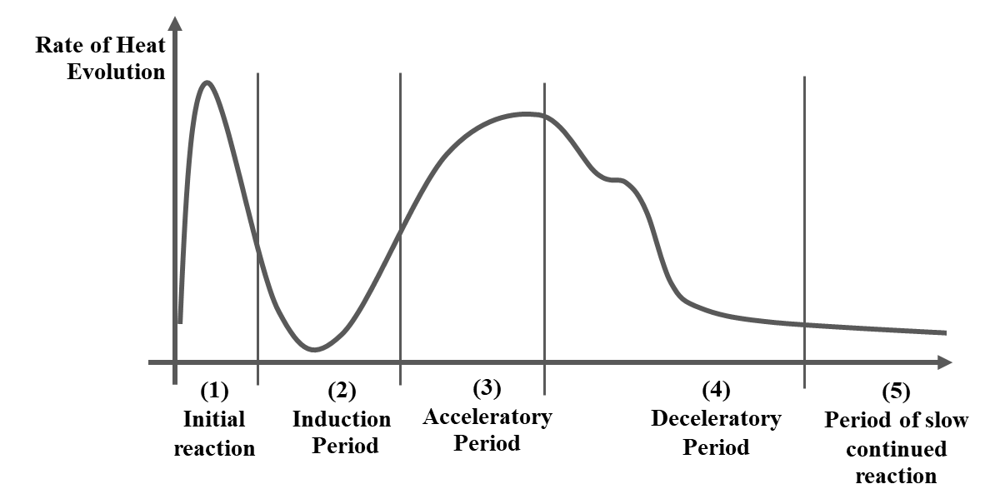

Supplementary Figure 1. Heat of hydration curve

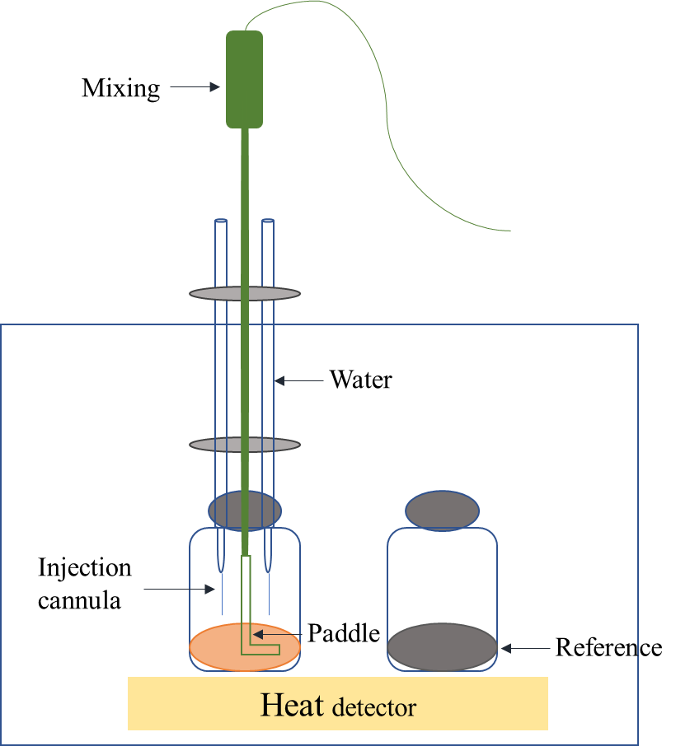

Supplementary figure 2. Syringe to fill water to the binder for hydration observation by TAM air calorimeter

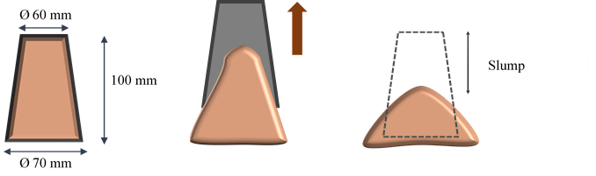

Supplementary figure 3. Mini-slump test operation

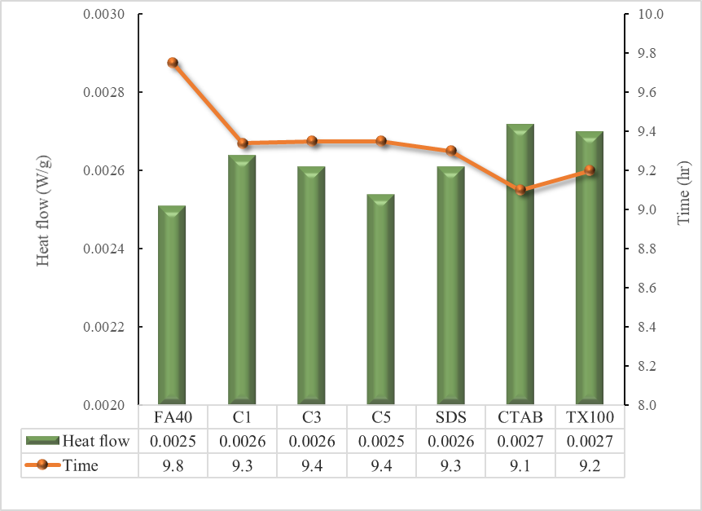

Supplementary figure 4 Comparisons the heat flow and time of the hydration peak maximum for FA blended cement with commercial α-Fe₂O₃ and synthesized α-Fe₂O₃

