SUPPLEMENTARY DATA
Table S1. The AHEI-2010 scoring method and mean scores at baseline among pregnant women in the NELA cohort Study.
Component | Criteria for minimum score (0) | Criteria for maximum score (10)
Vegetables, servings/d | 0 | ≥5
Fruit, servings/d | 0 | ≥4
Whole grains, g/d | 0 | 75
Sugar-sweetened beverages and fruit juice, servings/d | ≥1 | 0
Nuts and Legumes, servings/d | 0 | ≥1
Red and processed meat, servings/d | ≥1.5 | 0
Trans Fat, % of energy | ≥4 | ≤0.5
Long-chain (n-3) fats (EPA* + DHA**), mg/d | 0 | 250
PUFA†, % of energy | ≤2 | ≥10
Sodium, mg/d | Highest decile | Lowest decile
EPA: Eicosapentanoic acid. DHA: Docosahexaenoic acid. PUFA: Polyunsaturated fatty acid.

SUPPLEMENTARY DATA
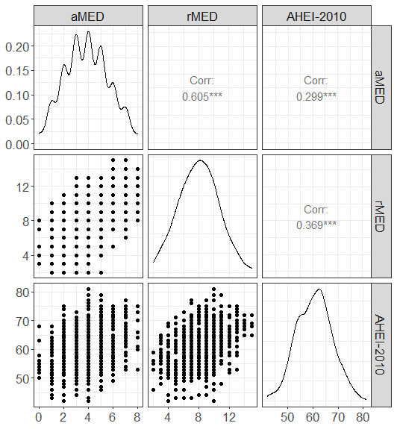
Figure S1. Correlation study between the 3 indices used to evaluate the pattern of adherence to the Mediterranean diet (aMED and rMED) and adherence to a healthy diet pattern (AHEI-2010) in the NELA cohort. *** (p-value<0.001); Corr: degree of correlation among indices.

