Table S1: Sequence logo of different motifs identified through MEME.

Logo | E-value | Sites | Width
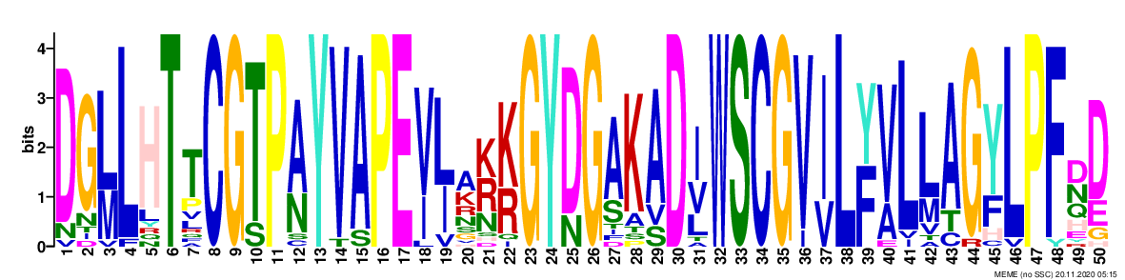 | 1.1e-797 | 22 | 50
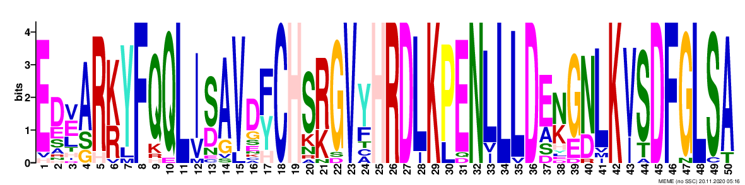 | 5.1e-768 | 22 | 50
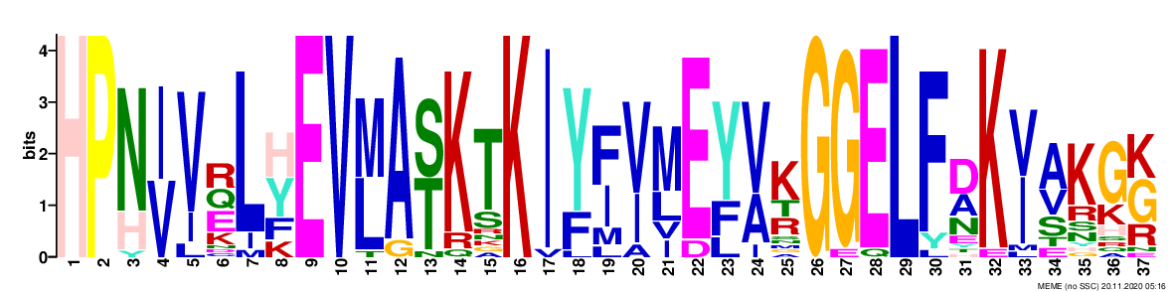 | 2.0e-441 | 22 | 37
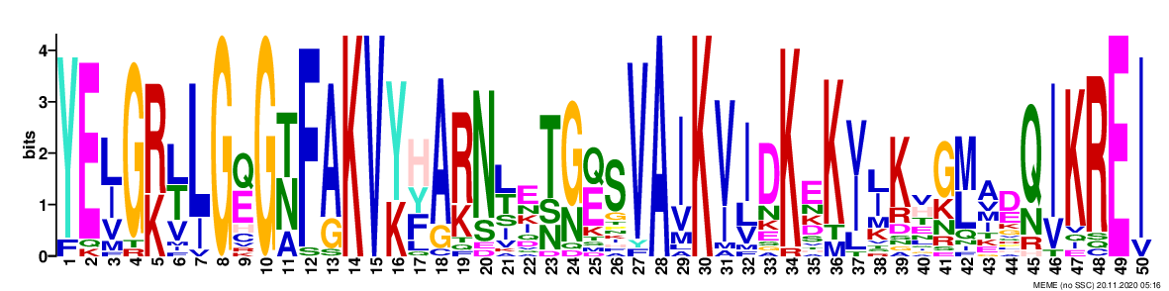 | 3.1e-502 | 22 | 50
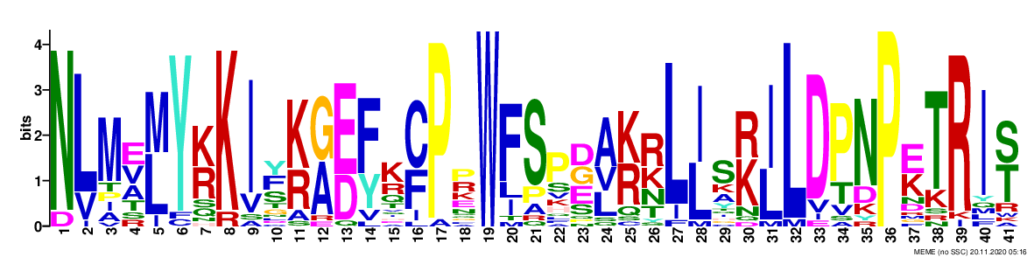 | 5.7e-409 | 22 | 41
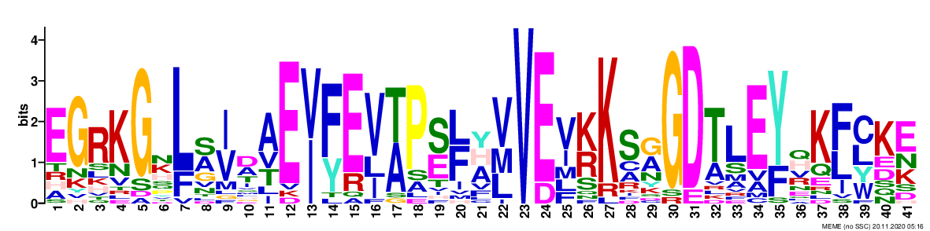 | 2.7e-254 | 21 | 41
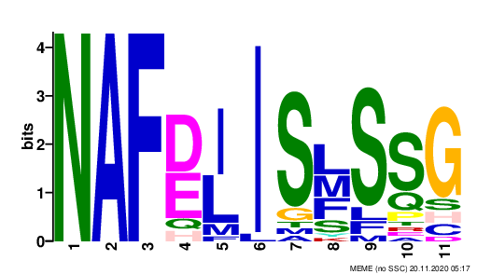 | 4.4e-097 | 22 | 11
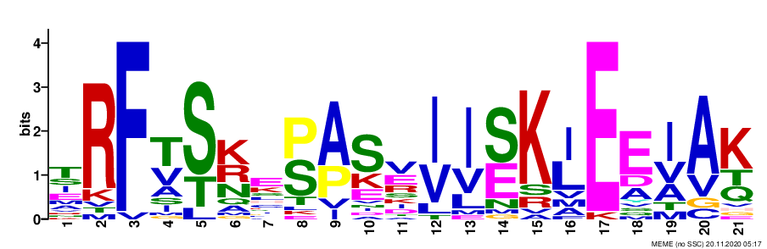 | 2.7e-092 | 22 | 21
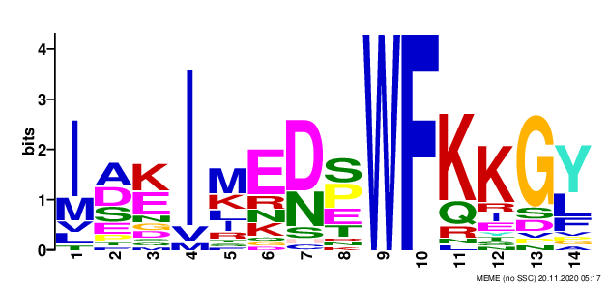 | 7.1e-084 | 22 | 14
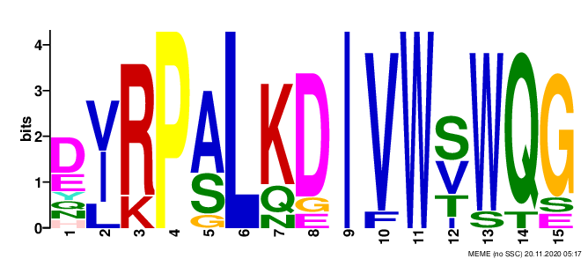 | 3.1e-065 | 10 | 15

Table S2: List of segmentally duplicated gene pairs.

Collinear gene pair
Gene name | Gene name | Ka | Ks | Ka/Ks
CaCIPK7 | CaCIPK5 | 0.1373 | 1.7532 | 0.0783
CaCIPK1 | CaCIPK17 | 0.1356 | 0.8096 | 0.1675
CaCIPK2 | CaCIPK18 | 0.2566 | 5.4846 | 0.0468
CaCIPK14 | CaCIPK22 | 0.3502 | 2.2212 | 0.1577
CaCIPK2 | CaCIPK10 | 0.1562 | 1.1211 | 0.1394
CaCIPK14 | CaCIPK11 | 0.1903 | 2.101 | 0.0906
CaCIPK18 | CaCIPK10 | 0.2768 | 2.8293 | 0.0978
CaCIPK22 | CaCIPK11 | 0.3208 | 47.4983 | 0.0068
CaCIPK18 | CaCIPK15 | 0.1194 | 0.9769 | 0.1222

Table S3: List of cis-regulatory elements identified in the promoter regions of CaCIPK genes.

 | CaCIPK1 | CaCIPK2 | CaCIPK3 | CaCIPK4 | CaCIPK5 | CaCIPK6 | CaCIPK7 | CaCIPK8 | CaCIPK9 | CaCIPK10 | CaCIPK11 | CaCIPK12 | CaCIPK13 | CaCIPK14 | CaCIPK15 | CaCIPK16 | CaCIPK17 | CaCIPK18 | CaCIPK19 | CaCIPK20 | CaCIPK21 | CaCIPK22
LTR |  | 1 |  |  |  |  |  |  |  | 1 |  |  |  |  |  |  |  |  | 1 |  | 1
ABRE | 1 | 10 | 1 | 3 | 2 | 2 | 1 | 3 |  | 3 | 1 |  |  | 2 |  |  | 1 | 1 | 1 |  |  | 1
ERE | 5 | 3 | 4 | 2 | 2 | 2 | 3 | 1 | 2 | 1 | 3 | 4 | 6 | 3 | 1 | 4 | 3 | 3 | 1 | 2 | 3 | 6
W box | 1 | 1 | 1 |  | 1 | 1 |  |  |  | 1 |  | 1 |  |  |  |  |  |  |  | 1 | 1 | 1
WUN-motif | 2 | 1 |  |  | 1 | 3 | 5 |  |  |  | 2 | 1 |  | 2 |  |  | 1 |  | 2 | 1 | 1 | 3
ARE | 2 | 4 | 1 | 2 |  | 2 | 1 | 2 |  | 3 | 3 | 3 | 2 | 4 | 1 | 2 | 2 | 2 | 1 | 1 | 1 | 2
LAMP-element | 1 |  |  |  |  |  |  |  |  |  |  |  |  |  | 1 |  |  |  |  |  | 1
Box 4 | 8 | 1 | 9 | 7 | 4 |  | 8 | 2 | 1 | 12 | 1 | 3 | 3 | 4 | 5 | 5 | 9 | 5 | 6 |  | 8 | 5
MYB | 2 | 3 | 6 | 3 | 1 | 5 | 6 |  | 2 | 6 | 3 | 6 | 3 | 5 | 1 | 3 | 1 | 4 | 2 | 5 | 6 | 1
GT1-motif | 4 | 5 | 1 |  | 1 | 1 | 2 |  |  | 1 |  | 1 |  | 1 |  |  |  | 2 | 2 |  | 2
AE-box | 1 |  |  | 1 |  |  |  |  |  | 1 | 1 | 1 |  |  | 1 | 1
MYB recognition site |  | 1 |  |  |  |  |  |  |  |  |  | 1 | 1 |  |  |  |  |  |  |  | 1
O2-site |  | 1 |  |  | 3 |  |  |  |  |  |  |  | 1 |  |  | 1 |  |  | 1 | 1
AuxRR-core |  |  | 1 |  |  |  |  |  |  |  |  | 1 |  |  |  | 1 |  | 1
TCA-element |  | 1 |  | 1 |  |  | 1 |  |  | 1 |  |  | 1 | 1 |  | 1 | 2 | 1 | 1 |  | 1
TC-rich repeats |  | 1 | 1 |  | 1 |  | 2 |  |  |  | 2 |  |  | 1 | 1 |  | 1 | 1 | 1 | 1 |  | 1

Table S4: The confidence, coverage and sequence identities of the homologous relationship of the CaCIPKs.

 |  |  | Model based on the template
Protein | Percentage confidence | Percentage coverage | Template id | Percentage identity with template | Percentage identity with c4czuC_
CaCIPK1 | 100 | 92 | c6c9dB_ | 30 | 61
CaCIPK2 | 100 | 91 | c6c9dB_ | 29 | 59
CaCIPK3 | 100 | 93 | c6c9dB_ | 33 | 75
CaCIPK4 | 100 | 59 | c5ebzF_ | 25 | 54
CaCIPK5 | 100 | 93 | c6c9dB_ | 31 | 56
CaCIPK6 | 100 | 57 | c5ebzF_ | 27 | 65
CaCIPK7 | 100 | 92 | c6c9dB_ | 29 | 57
CaCIPK8 | 100 | 54 | c5ebzF_ | 29 | 66
CaCIPK9 | 100 | 90 | c6c9dB_ | 29 | 85
CaCIPK10 | 100 | 54 | c5ebzF_ | 29 | 60
CaCIPK11 | 100 | 57 | c5ebzF_ | 28 | 58
CaCIPK12 | 100 | 50 | c5ebzF_ | 31 | 66
CaCIPK13 | 100 | 91 | c6c9dB_ | 31 | 59
CaCIPK14 | 100 | 58 | c5ebzF_ | 26 | 59
CaCIPK15 | 100 | 54 | c5ebzF_ | 27 | 65
CaCIPK16 | 100 | 95 | c6c9dB_ | 30 | 61
CaCIPK17 | 100 | 93 | c6c9dB_ | 29 | 59
CaCIPK18 | 100 | 54 | c5ebzF_ | 28 | 63
CaCIPK19 | 100 | 93 | c6c9dB_ | 31 | 63
CaCIPK20 | 100 | 56 | c5ebzF_ | 27 | 62
CaCIPK21 | 100 | 57 | c5ebzF_ | 28 | 61
CaCIPK22 | 100 | 58 | c5ebzF_ | 23 | 52

Table S5: Type and strength of interactions between CBL and CIPK proteins in chickpea.

Node1 | Node2 | Node1_string_id | Node2_string_id | Coexpression | Experimentally_determined_interaction | Automated_textmining | Combined_score
CaCBL1 | CaCIPK9 | 3702.AT4G17615.1 | 3702.AT1G30270.1 | 0 | 0.725 | 0.97 | 0.991
CaCBL1 | CaCIPK3 | 3702.AT4G17615.1 | 3702.AT2G26980.4 | 0 | 0.579 | 0.716 | 0.875
CaCBL1 | CaCIPK14 | 3702.AT4G17615.1 | 3702.AT2G30360.1 | 0.157 | 0.54 | 0.529 | 0.802
CaCBL1 | CaCIPK17 | 3702.AT4G17615.1 | 3702.AT3G17510.1 | 0 | 0.76 | 0.837 | 0.959
CaCBL1 | CaCIPK4 | 3702.AT4G17615.1 | 3702.AT4G14580.1 | 0 | 0.575 | 0.431 | 0.748
CaCBL1 | CaCIPK20 | 3702.AT4G17615.1 | 3702.AT5G45820.1 | 0 | 0.075 | 0.392 | 0.413
CaCBL1 | CaCIPK18 | 3702.AT4G17615.1 | 3702.AT5G58380.1 | 0 | 0.075 | 0.602 | 0.616
CaCBL1 | CaCIPK16 | 3702.AT4G17615.1 | 3702.AT5G25110.1 | 0 | 0.075 | 0.767 | 0.776
CaCBL1 | CaCIPK12 | 3702.AT4G17615.1 | 3702.AT4G18700.1 | 0 | 0.517 | 0.559 | 0.778
CaCBL1 | CaCIPK22 | 3702.AT4G17615.1 | 3702.AT5G01820.1 | 0 | 0.54 | 0.623 | 0.819
CaCBL1 | CaCIPK2 | 3702.AT4G17615.1 | 3702.AT5G07070.1 | 0.106 | 0.579 | 0.622 | 0.845
CaCBL1 | CaCIPK8 | 3702.AT4G17615.1 | 3702.AT4G24400.1 | 0.058 | 0.496 | 0.874 | 0.935
CaCBL1 | CaCIPK6 | 3702.AT4G17615.1 | 3702.AT4G30960.1 | 0 | 0.579 | 0.909 | 0.96
CaCBL1 | CaCIPK19 | 3702.AT4G17615.1 | 3702.AT5G35410.1 | 0 | 0.76 | 0.874 | 0.968
CaCBL10 | CaCIPK9 | 3702.AT4G33000.1 | 3702.AT1G30270.1 | 0 | 0.075 | 0.963 | 0.965
CaCBL10 | CaCIPK3 | 3702.AT4G33000.1 | 3702.AT2G26980.4 | 0 | 0.075 | 0.517 | 0.534
CaCBL10 | CaCIPK14 | 3702.AT4G33000.1 | 3702.AT2G30360.1 | 0 | 0.576 | 0.375 | 0.724
CaCBL10 | CaCIPK17 | 3702.AT4G33000.1 | 3702.AT3G17510.1 | 0 | 0.075 | 0.537 | 0.553
CaCBL10 | CaCIPK12 | 3702.AT4G33000.1 | 3702.AT4G18700.1 | 0 | 0.075 | 0.504 | 0.522
CaCBL10 | CaCIPK8 | 3702.AT4G33000.1 | 3702.AT4G24400.1 | 0 | 0.075 | 0.773 | 0.781
CaCBL10 | CaCIPK6 | 3702.AT4G33000.1 | 3702.AT4G30960.1 | 0 | 0.075 | 0.924 | 0.927
CaCBL10 | CaCIPK16 | 3702.AT4G33000.1 | 3702.AT5G25110.1 | 0 | 0.075 | 0.515 | 0.532
CaCBL10 | CaCIPK2 | 3702.AT4G33000.1 | 3702.AT5G07070.1 | 0 | 0.075 | 0.545 | 0.561
CaCBL10 | CaCIPK22 | 3702.AT4G33000.1 | 3702.AT5G01820.1 | 0 | 0.075 | 0.625 | 0.638
CaCBL10 | CaCIPK19 | 3702.AT4G33000.1 | 3702.AT5G35410.1 | 0 | 0.773 | 0.978 | 0.995
CaCBL5 | CaCIPK9 | 3702.AT5G24270.2 | 3702.AT1G30270.1 | 0 | 0.075 | 0.879 | 0.883
CaCBL5 | CaCIPK3 | 3702.AT5G24270.2 | 3702.AT2G26980.4 | 0 | 0.075 | 0.536 | 0.552
CaCBL5 | CaCIPK14 | 3702.AT5G24270.2 | 3702.AT2G30360.1 | 0 | 0.573 | 0.471 | 0.765
CaCBL5 | CaCIPK17 | 3702.AT5G24270.2 | 3702.AT3G17510.1 | 0 | 0.579 | 0.579 | 0.815
CaCBL5 | CaCIPK4 | 3702.AT5G24270.2 | 3702.AT4G14580.1 | 0 | 0.075 | 0.438 | 0.457
CaCBL5 | CaCIPK12 | 3702.AT5G24270.2 | 3702.AT4G18700.1 | 0 | 0.578 | 0.308 | 0.695
CaCBL5 | CaCIPK8 | 3702.AT5G24270.2 | 3702.AT4G24400.1 | 0 | 0.578 | 0.76 | 0.894
CaCBL5 | CaCIPK6 | 3702.AT5G24270.2 | 3702.AT4G30960.1 | 0 | 0.579 | 0.942 | 0.975
CaCBL5 | CaCIPK22 | 3702.AT5G24270.2 | 3702.AT5G01820.1 | 0 | 0.54 | 0.766 | 0.888
CaCBL5 | CaCIPK2 | 3702.AT5G24270.2 | 3702.AT5G07070.1 | 0 | 0.579 | 0.478 | 0.771
CaCBL5 | CaCIPK18 | 3702.AT5G24270.2 | 3702.AT5G58380.1 | 0 | 0.573 | 0.207 | 0.647
CaCBL5 | CaCIPK16 | 3702.AT5G24270.2 | 3702.AT5G25110.1 | 0 | 0.578 | 0.357 | 0.717
CaCBL5 | CaCIPK19 | 3702.AT5G24270.2 | 3702.AT5G35410.1 | 0 | 0.951 | 0.986 | 0.999
CaCBL6 | CaCIPK9 | 3702.AT5G55990.1 | 3702.AT1G30270.1 | 0 | 0.576 | 0.853 | 0.935
CaCBL6 | CaCIPK3 | 3702.AT5G55990.1 | 3702.AT2G26980.4 | 0 | 0.576 | 0.558 | 0.804
CaCBL6 | CaCIPK14 | 3702.AT5G55990.1 | 3702.AT2G30360.1 | 0 | 0.725 | 0.839 | 0.954
CaCBL6 | CaCIPK17 | 3702.AT5G55990.1 | 3702.AT3G17510.1 | 0 | 0.575 | 0.567 | 0.808
CaCBL6 | CaCIPK4 | 3702.AT5G55990.1 | 3702.AT4G14580.1 | 0 | 0.54 | 0.565 | 0.791
CaCBL6 | CaCIPK12 | 3702.AT5G55990.1 | 3702.AT4G18700.1 | 0 | 0.576 | 0.699 | 0.867
CaCBL6 | CaCIPK8 | 3702.AT5G55990.1 | 3702.AT4G24400.1 | 0 | 0.075 | 0.763 | 0.771
CaCBL6 | CaCIPK6 | 3702.AT5G55990.1 | 3702.AT4G30960.1 | 0 | 0.546 | 0.758 | 0.886
CaCBL6 | CaCIPK22 | 3702.AT5G55990.1 | 3702.AT5G01820.1 | 0 | 0.951 | 0.88 | 0.994
CaCBL6 | CaCIPK2 | 3702.AT5G55990.1 | 3702.AT5G07070.1 | 0 | 0.54 | 0.589 | 0.803
CaCBL6 | CaCIPK16 | 3702.AT5G55990.1 | 3702.AT5G25110.1 | 0 | 0.075 | 0.464 | 0.483
CaCBL6 | CaCIPK19 | 3702.AT5G55990.1 | 3702.AT5G35410.1 | 0 | 0.576 | 0.82 | 0.92
CaCBL6 | CaCIPK18 | 3702.AT5G55990.1 | 3702.AT5G58380.1 | 0 | 0.372 | 0.407 | 0.611
CaCBL6 | CaCIPK21 | 3702.AT5G55990.1 | 3702.AT5G57630.1 | 0 | 0.667 | 0.568 | 0.85
CaCBL8 | CaCIPK9 | 3702.AT1G64480.1 | 3702.AT1G30270.1 | 0 | 0.575 | 0.696 | 0.865
CaCBL8 | CaCIPK8 | 3702.AT1G64480.1 | 3702.AT4G24400.1 | 0 | 0.075 | 0.391 | 0.412
CaCBL8 | CaCIPK6 | 3702.AT1G64480.1 | 3702.AT4G30960.1 | 0 | 0.075 | 0.463 | 0.482
CaCBL8 | CaCIPK21 | 3702.AT1G64480.1 | 3702.AT5G57630.1 | 0 | 0.075 | 0.509 | 0.526
CaCBL8 | CaCIPK3 | 3702.AT1G64480.1 | 3702.AT2G26980.4 | 0 | 0.075 | 0.526 | 0.542
CaCBL8 | CaCIPK12 | 3702.AT1G64480.1 | 3702.AT4G18700.1 | 0 | 0.075 | 0.565 | 0.58
CaCBL8 | CaCIPK19 | 3702.AT1G64480.1 | 3702.AT5G35410.1 | 0 | 0.577 | 0.101 | 0.603
CaCBL8 | CaCIPK22 | 3702.AT1G64480.1 | 3702.AT5G01820.1 | 0 | 0.575 | 0.593 | 0.819

Table S6: Log2FPKM values of different tissues belonging to different developmental stages.

 | Germination |  |  | Seedling |  | Vegetative |  |  |  | Reproductive |  |  |  |  |  |  |  | Senescence
Gene | Radicle | Plumule | Embryo | Epicotyl | Primary Root | Root | Petiole | Stem | Leaf | Petiole | Stem | Nodules | Root | Flowers | Buds | Pods | Immature Seeds | Leaf | Leaf | Leaf Yellow | Immature Seeds | Mature Seeds | Seed Coat | Stem | Petiole | Root | Nodules
CaCIPK1 | 1.774 | -1.490 | 0.852 | 1.826 | 2.665 | 2.642 | 0.458 | 1.110 | 0.090 | 1.444 | 1.674 | 2.572 | 4.090 | 2.789 | 2.340 | 0.853 | 1.103 | 0.338 | 1.022 | -0.157 | 0.425 | 0.014 | 0.589 | 2.106 | 0.139 | 2.882 | 1.927
CaCIPK2 | -2.335 | -1.788 | -1.297 | 1.637 | -3.686 | -0.624 | -3.235 | -2.493 | -2.310 | -1.002 | -1.040 | -4.632 | 0.096 | 0.929 | -0.319 | -0.205 | -0.017 | 1.240 | -0.835 | -1.627 | -0.685 | 2.475 | -0.104 | -0.733 | -2.896 | -1.232 | -2.833
CaCIPK3 | 5.066 | 4.230 | 4.853 | 4.678 | 4.042 | 5.303 | 4.862 | 4.639 | 5.373 | 4.149 | 2.681 | 3.724 | 4.355 | 4.392 | 4.841 | 3.804 | 3.546 | 5.432 | 4.359 | 4.343 | 2.738 | 3.179 | 2.693 | 3.258 | 3.561 | 3.667 | 3.621
CaCIPK4 | 3.878 | 3.817 | 3.366 | 5.266 | 5.292 | 7.585 | 5.762 | 5.757 | 3.698 | 5.065 | 6.681 | 5.816 | 6.526 | 3.988 | 3.839 | 4.355 | 4.065 | 3.022 | 5.198 | 5.201 | 2.021 | 2.061 | 2.156 | 6.164 | 5.549 | 5.946 | 5.839
CaCIPK5 | 3.947 | 2.683 | 3.606 | 2.036 | 4.170 | 2.892 | 4.007 | 1.972 | 2.677 | 1.950 | 2.105 | 3.274 | 3.830 | 2.404 | 1.382 | 1.216 | 2.131 | -0.202 | 2.239 | 2.351 | 0.733 | -0.597 | 1.271 | 3.206 | 1.870 | 1.806 | 3.732
CaCIPK6 | 6.992 | 7.575 | 7.778 | 7.239 | 6.096 | 5.563 | 6.453 | 5.318 | 6.826 | 5.864 | 5.730 | 5.475 | 5.982 | 7.195 | 7.204 | 7.056 | 7.044 | 7.828 | 5.808 | 5.787 | 4.633 | 3.447 | 4.923 | 6.176 | 6.625 | 6.308 | 5.919
CaCIPK7 | 7.897 | 7.191 | 8.194 | 6.904 | 7.135 | 7.136 | 7.270 | 7.992 | 6.297 | 8.493 | 8.565 | 7.882 | 8.223 | 6.821 | 6.805 | 6.428 | 6.081 | 6.044 | 6.608 | 6.630 | 2.815 | 4.524 | 3.266 | 6.721 | 7.380 | 7.280 | 7.242
CaCIPK8 | 0.000 | 0.000 | 0.000 | 0.000 | -7.760 | 0.000 | 0.000 | 0.000 | -5.032 | 0.000 | 0.000 | -1.516 | -5.053 | -5.963 | 0.000 | 0.000 | -4.978 | 0.000 | 0.000 | 0.000 | 0.000 | 0.000 | -5.855 | -9.172 | -5.371 | -5.668 | -2.107
CaCIPK9 | 3.695 | 2.336 | 3.123 | 2.115 | 2.890 | 2.337 | 0.972 | 1.869 | 1.050 | 2.189 | 2.120 | 1.399 | 3.522 | 0.618 | 1.949 | 2.579 | 0.754 | 2.418 | 1.675 | 1.844 | -0.383 | 0.049 | 0.895 | 3.618 | 1.219 | 3.336 | 2.669
CaCIPK10 | 3.074 | 2.092 | 1.367 | 2.590 | 2.212 | 1.805 | 1.641 | 1.644 | 1.347 | 1.578 | 2.287 | 1.485 | 0.000 | 2.724 | 1.925 | 0.881 | 0.243 | 1.784 | 2.210 | 1.808 | 0.690 | 1.479 | 0.422 | 2.664 | 2.421 | 2.011 | 1.838
CaCIPK11 | 2.616 | 2.863 | 1.614 | 1.846 | -0.604 | 0.212 | 1.076 | 2.492 | 0.952 | 2.829 | 2.002 | 0.388 | -0.280 | 6.064 | 4.213 | 3.750 | 4.218 | 0.489 | 0.985 | 0.923 | 0.786 | 1.800 | 0.366 | 1.471 | 2.277 | 0.451 | 0.353
CaCIPK12 | 4.745 | 3.602 | 3.287 | 3.506 | 2.476 | 3.304 | 3.456 | 3.393 | 2.619 | 3.215 | 4.568 | 2.867 | 3.969 | 3.556 | 3.287 | 1.981 | 0.794 | 2.891 | 3.381 | 3.281 | -0.179 | -2.243 | -0.855 | 4.654 | 3.597 | 4.968 | 3.051
CaCIPK13 | -0.416 | -0.716 | 0.996 | 0.320 | -0.739 | -1.337 | -0.445 | -0.251 | -2.449 | -2.659 | -1.244 | -1.698 | -0.167 | -3.610 | -0.054 | -0.704 | 1.391 | -1.517 | -1.425 | -1.232 | -1.325 | 0.000 | -1.814 | -1.056 | -1.167 | 3.210 | -2.099
CaCIPK14 | 5.413 | 5.324 | 4.661 | 5.514 | 5.938 | 6.673 | 4.796 | 5.683 | 4.133 | 5.803 | 6.506 | 4.154 | 5.783 | 5.244 | 5.374 | 6.350 | 5.396 | 4.589 | 5.093 | 5.206 | 3.457 | 3.172 | 3.627 | 5.603 | 5.906 | 5.449 | 4.166
CaCIPK15 | 7.382 | 6.870 | 5.273 | 5.529 | 4.491 | 4.562 | 4.436 | 5.931 | 3.869 | 6.520 | 5.885 | 4.737 | 5.327 | 5.967 | 3.613 | 4.501 | 2.938 | 4.007 | 6.307 | 6.306 | 1.031 | 2.172 | 1.437 | 4.752 | 6.273 | 4.608 | 3.958
CaCIPK16 | 5.289 | 4.346 | 4.780 | 5.416 | 5.144 | 4.500 | 5.139 | 3.562 | 4.569 | 5.182 | 4.287 | 3.795 | 5.407 | 5.836 | 4.084 | 5.719 | 6.278 | 5.257 | 5.803 | 5.845 | 3.336 | -0.243 | 3.519 | 6.175 | 5.487 | 6.619 | 4.760
CaCIPK17 | 0.832 | 0.864 | -1.258 | 1.670 | 0.458 | 2.579 | 2.053 | 1.149 | 1.411 | 1.758 | 3.129 | 0.000 | 2.207 | 0.753 | 0.955 | 0.425 | -1.657 | 1.751 | 2.593 | 2.859 | -3.925 | -2.926 | -3.351 | 1.842 | 1.506 | 2.342 | -1.153
CaCIPK18 | 4.530 | 4.333 | 4.410 | 5.983 | 4.135 | 5.339 | 4.101 | 5.169 | 4.734 | 5.991 | 5.375 | 4.704 | 5.418 | 5.887 | 5.219 | 6.185 | 5.403 | 6.119 | 4.643 | 4.706 | 2.470 | 1.072 | 2.721 | 5.149 | 5.234 | 4.311 | 4.649
CaCIPK19 | 0.000 | -0.465 | 0.000 | 0.000 | 0.000 | 0.000 | 0.000 | 0.000 | 0.000 | 0.000 | 0.000 | 0.000 | 0.000 | -1.733 | 0.000 | -0.490 | 0.000 | 0.000 | 0.000 | 0.000 | -2.036 | 0.992 | 0.000 | 0.000 | 0.000 | 0.000 | 0.000
CaCIPK20 | -3.837 | 0.000 | 0.000 | 0.000 | 0.000 | 0.000 | -5.020 | -5.280 | 0.000 | 0.000 | 0.000 | 0.000 | -4.056 | 8.005 | 1.921 | -3.367 | -2.552 | -1.044 | -5.223 | -4.399 | 0.000 | 0.000 | -4.313 | 0.000 | 0.000 | -1.773 | 0.000
CaCIPK21 | 0.000 | -1.251 | 0.000 | -9.715 | 0.000 | 0.000 | -3.111 | -1.751 | -1.289 | -1.537 | -2.977 | 0.000 | 0.000 | -0.274 | -5.108 | 0.000 | -0.852 | -3.550 | -2.263 | 0.000 | -1.476 | 0.000 | -2.271 | -7.441 | 0.000 | -2.465 | -5.051
CaCIPK22 | 2.839 | 2.961 | 3.032 | 5.030 | 3.207 | 4.748 | 5.426 | 4.591 | 4.765 | 5.717 | 5.567 | 3.912 | 4.373 | 5.461 | 4.919 | 4.950 | 4.802 | 5.179 | 5.659 | 5.549 | 0.159 | 1.438 | 0.130 | 5.140 | 5.325 | 3.857 | 4.665

Table S7: Log2 Fold Change values of CaCIPKs in response to abiotic stress.

 | Root |  |  | Shoot
 | Desiccation stress | Salinity stress | Cold stress | Desiccation stress | Salinity stress | Cold stress
CaCIPK1 | 0.454 | 0.495 | 0.291 | 0.677 | -3.876 | -0.777
CaCIPK2 | 3.846 | 3.445 | 3.774 | 4.553 | 3.788 | 1.789
CaCIPK3 | -1.451 | -0.439 | -1.762 | 0.320 | 0.790 | 0.521
CaCIPK4 | 0.182 | -0.542 | 0.768 | 0.058 | -0.387 | 0.579
CaCIPK5 | -2.389 | -1.248 | -2.381 | -1.157 | -1.367 | -1.262
CaCIPK6 | -0.173 | 0.646 | 0.675 | 0.507 | -0.983 | -0.229
CaCIPK7 | -0.323 | 0.098 | 0.323 | -1.363 | -0.455 | 0.722
CaCIPK8 | -2.253 | -3.487 | 0.000 | 0.000 | 0.000 | 0.000
CaCIPK9 | -2.823 | -1.742 | -1.130 | -1.618 | -4.537 | 1.127
CaCIPK10 | -0.574 | -0.722 | -0.532 | 1.360 | 0.283 | -0.127
CaCIPK11 | 0.545 | 0.825 | 0.151 | 2.774 | 2.693 | 0.974
CaCIPK12 | 0.366 | 1.803 | 0.206 | 1.293 | 1.491 | 0.526
CaCIPK13 | 0.755 | 1.367 | 1.421 | 0.196 | 0.029 | -0.638
CaCIPK14 | 0.528 | 0.000 | 0.256 | 0.816 | 0.472 | 0.179
CaCIPK15 | -0.989 | -1.199 | -0.120 | 0.164 | -1.814 | -0.618
CaCIPK16 | -2.341 | -1.173 | -1.730 | 2.950 | 0.857 | -0.038
CaCIPK17 | 3.018 | 4.462 | 1.414 | 0.000 | 0.204 | -0.004
CaCIPK18 | 0.042 | 2.149 | 0.316 | 0.632 | 0.643 | 0.618
CaCIPK19 | 0.000 | 0.000 | 0.000 | 1.471 | 1.340 | 0.693
CaCIPK21 | -2.154 | -1.016 | -1.490 | 0.000 | 0.761 | 1.416
CaCIPK22 | -0.222 | -2.173 | 1.038 | 0.954 | 0.366 | 0.516

Table S8: Log2 Fold Change values of CaCIPKs in various stages of seed development.

 | SEED STAGE 1 |  | SEED STAGE 2 |  | SEED STAGE 3 |  | SEED STAGE 4 |  | SEED STAGE 5 |  | SEED STAGE 6 |  | SEED STAGE 7
GENE | JGK3 | HIMCHANA1 | JGK3 | HIMCHANA1 | JGK3 | HIMCHANA1 | JGK3 | HIMCHANA1 | JGK3 | HIMCHANA1 | JGK3 | HIMCHANA1 | JGK3 | HIMCHANA1
CaCIPK1 | -2.648 | -1.964 | -0.522 | -0.097 | -0.817 | 0.398 | -0.086 | 0.464 | -0.213 | -1.114 | -3.006 | -2.411 | -2.977 | -2.135
CaCIPK2 | 2.360 | 2.453 | 1.789 | 1.847 | 1.637 | 1.372 | 2.677 | 3.548 | 3.234 | 1.404 | 5.204 | 3.481 | 5.040 | 1.961
CaCIPK3 | -0.625 | -0.196 | -0.051 | 0.329 | -0.289 | -1.064 | -1.041 | -0.555 | -0.163 | -0.496 | -0.924 | -0.660 | -0.225 | -0.257
CaCIPK4 | 0.101 | 0.961 | 0.743 | 1.292 | -0.785 | 1.087 | 0.085 | 1.810 | -1.383 | -0.479 | -2.655 | -0.403 | -2.410 | -0.036
CaCIPK5 | -1.347 | -1.082 | -0.855 | -0.633 | -1.069 | -0.397 | -0.271 | -0.786 | -2.796 | -3.618 | -0.502 | 0.094 | -0.542 | 1.113
CaCIPK6 | -0.515 | -0.297 | 0.768 | 0.809 | -0.732 | -0.208 | -0.605 | -0.246 | -2.152 | -3.680 | -3.514 | -3.354 | -3.779 | -3.545
CaCIPK7 | -0.281 | -0.860 | 0.467 | -0.265 | -1.211 | -1.376 | -0.475 | -0.716 | -1.827 | -0.864 | -1.171 | -0.778 | -2.002 | -0.297
CaCIPK9 | -0.274 | -0.433 | -0.127 | -0.698 | -0.546 | -2.460 | -0.794 | -0.550 | -0.502 | -4.233 | -4.151 | -2.852 | -2.044 | -2.064
CaCIPK10 | -2.533 | -2.511 | -1.263 | -1.931 | -2.458 | -2.577 | -0.035 | -0.033 | 0.516 | 0.154 | -0.610 | -2.098 | -1.306 | -2.892
CaCIPK11 | 6.421 | 5.647 | 7.195 | 6.910 | 5.883 | 6.104 | 6.508 | 6.238 | 4.177 | 4.020 | 4.010 | 2.766 | 5.752 | 2.005
CaCIPK12 | -3.112 | -3.016 | -2.559 | -2.069 | -2.309 | -2.183 | -2.347 | -2.564 | -2.915 | -4.507 | -3.905 | -4.191 | -3.134 | -4.191
CaCIPK13 | 5.183 | 4.290 | 5.909 | 4.723 | 5.497 | 4.100 | 4.719 | 3.202 | 4.819 | 3.722 | 0.131 | -0.446 | 0.000 | -1.257
CaCIPK14 | 0.671 | 0.601 | 1.410 | 1.169 | 0.543 | 0.853 | 0.720 | 0.696 | -0.702 | -0.963 | -1.623 | -0.202 | -0.947 | 0.421
CaCIPK15 | -0.962 | -1.278 | -0.466 | -0.094 | -1.383 | -2.016 | -0.839 | -1.005 | -2.734 | -1.112 | -1.081 | -1.078 | -1.682 | 0.124
CaCIPK16 | -1.114 | -0.284 | 0.340 | 0.804 | -0.677 | -0.127 | -0.888 | -0.099 | -2.347 | -3.791 | -4.804 | -4.249 | -5.235 | -4.463
CaCIPK17 | -6.550 | -5.754 | -4.590 | -3.573 | -7.096 | -5.911 | -5.892 | -6.034 | -5.460 | -6.153 | -6.638 | -7.327 | -6.587 | -8.327
CaCIPK18 | 1.553 | 1.106 | 2.255 | 1.330 | 1.223 | 1.353 | 2.119 | 2.093 | 1.086 | -0.174 | -1.920 | -2.629 | -1.749 | -2.466
CaCIPK21 | 0.000 | 3.769 | 0.000 | 3.007 | 0.000 | 3.470 | 0.000 | 1.018 | 0.000 | 2.108 | 0.000 | 0.000 | 0.000 | -1.327
CaCIPK22 | -1.973 | -1.904 | -1.989 | -1.329 | -3.666 | -2.125 | -2.863 | -2.272 | -6.082 | -5.465 | -6.213 | -5.952 | -6.288 | -6.648

Figure S1: Percentage of identity and similarity between CaCIPKs.

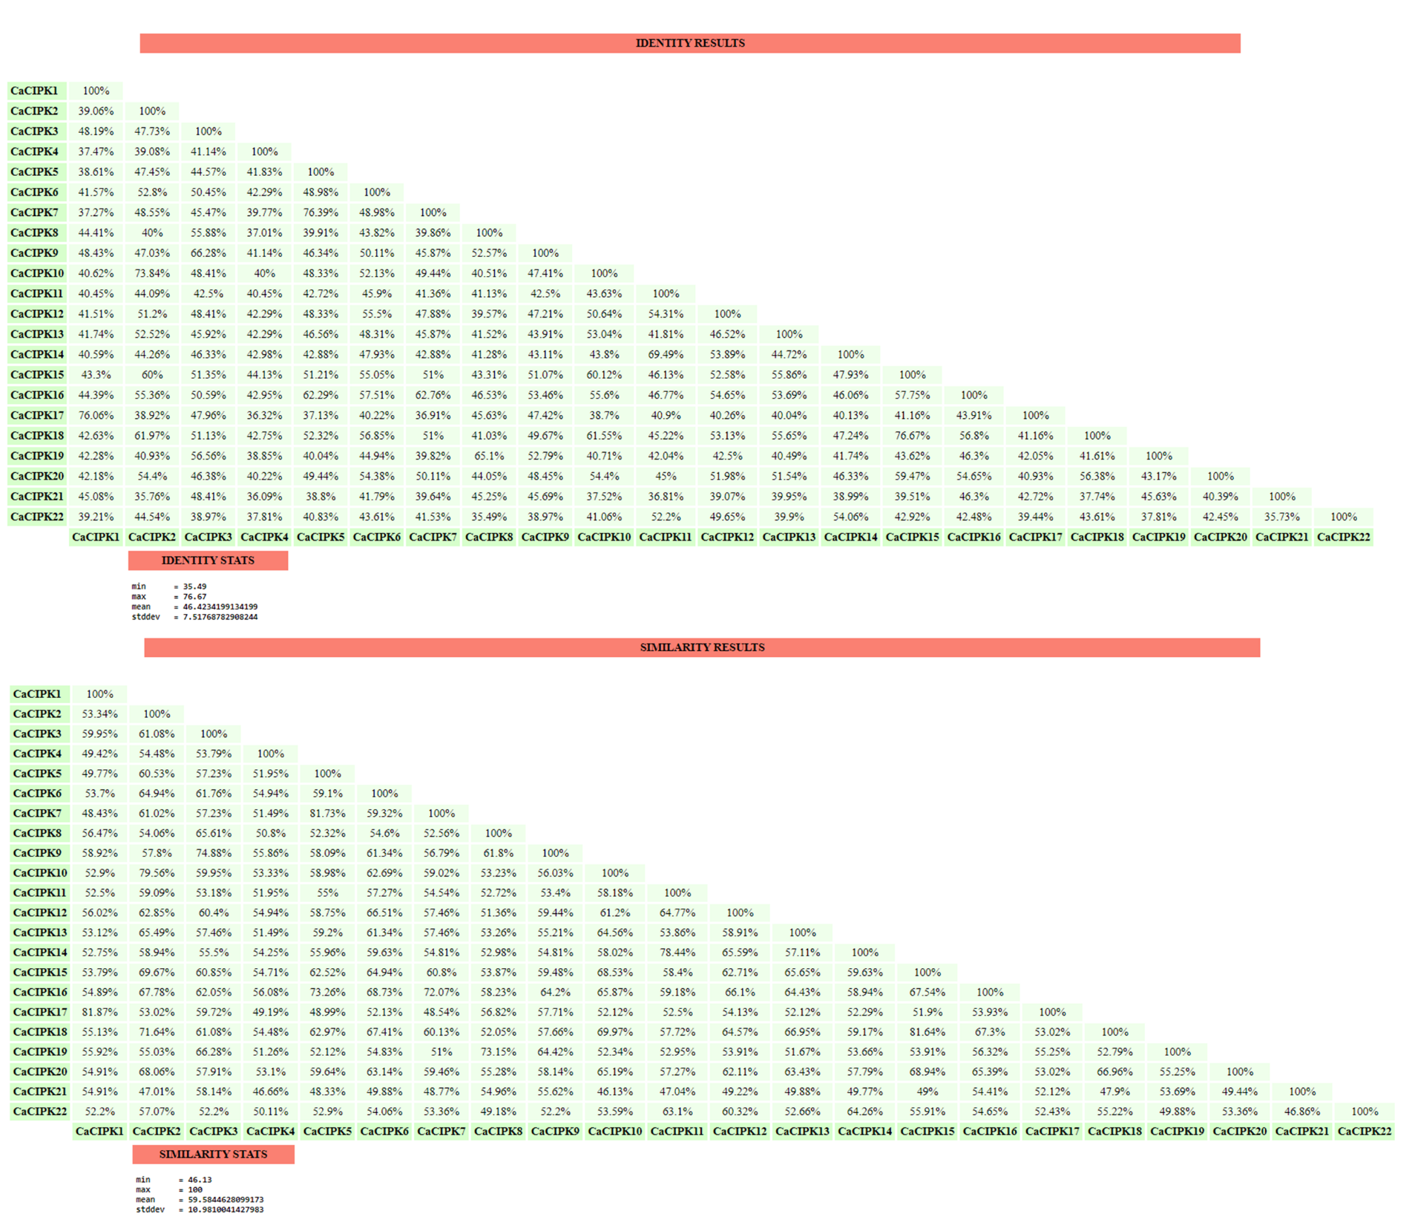

Figure S2: Alignment of 22 CaCIPKs for domain identification.

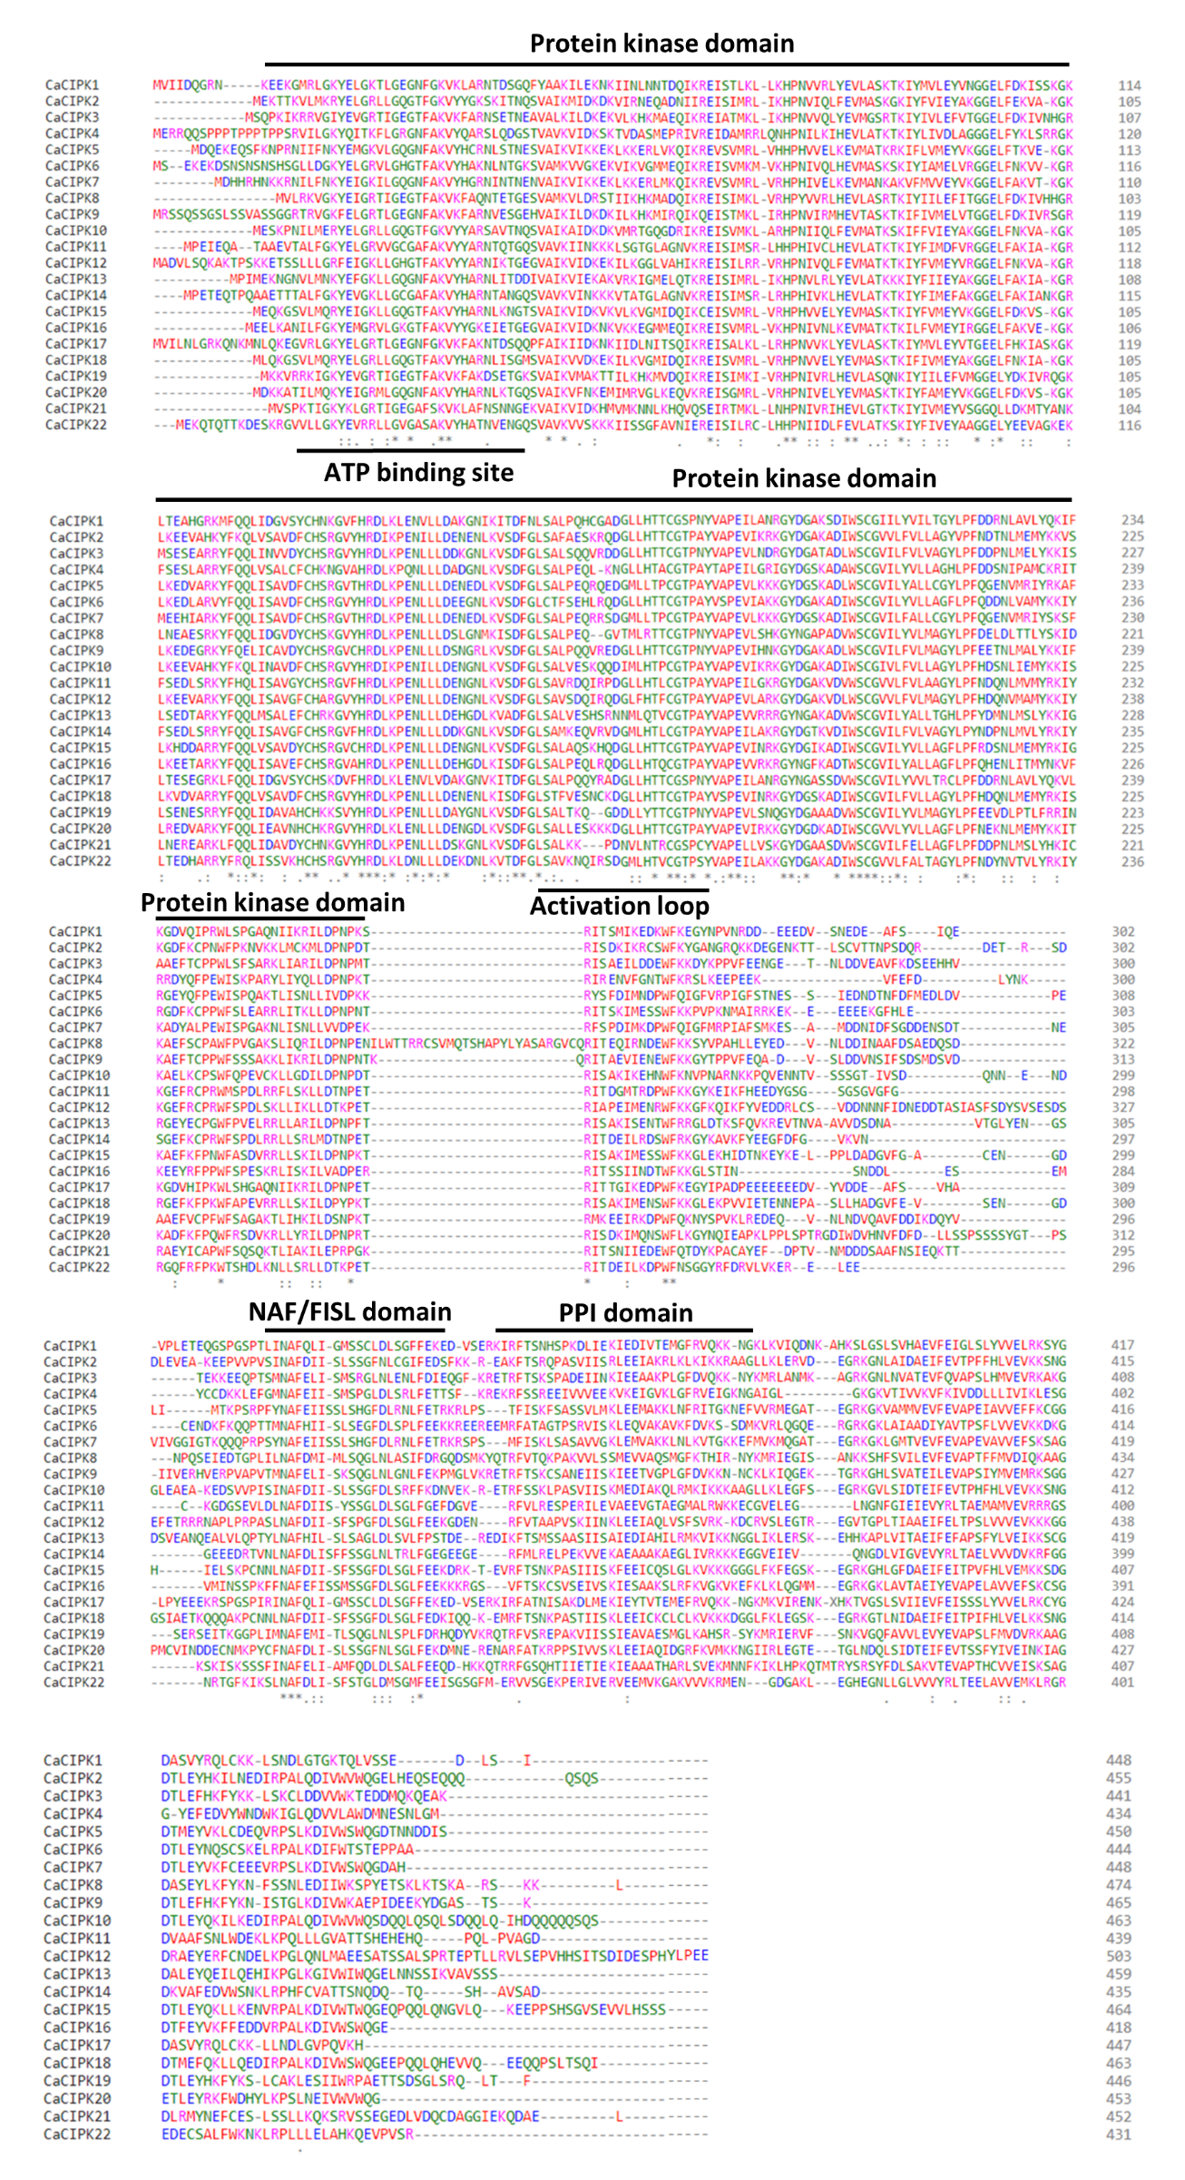
Figure S3: Identification of motifs through MEME.

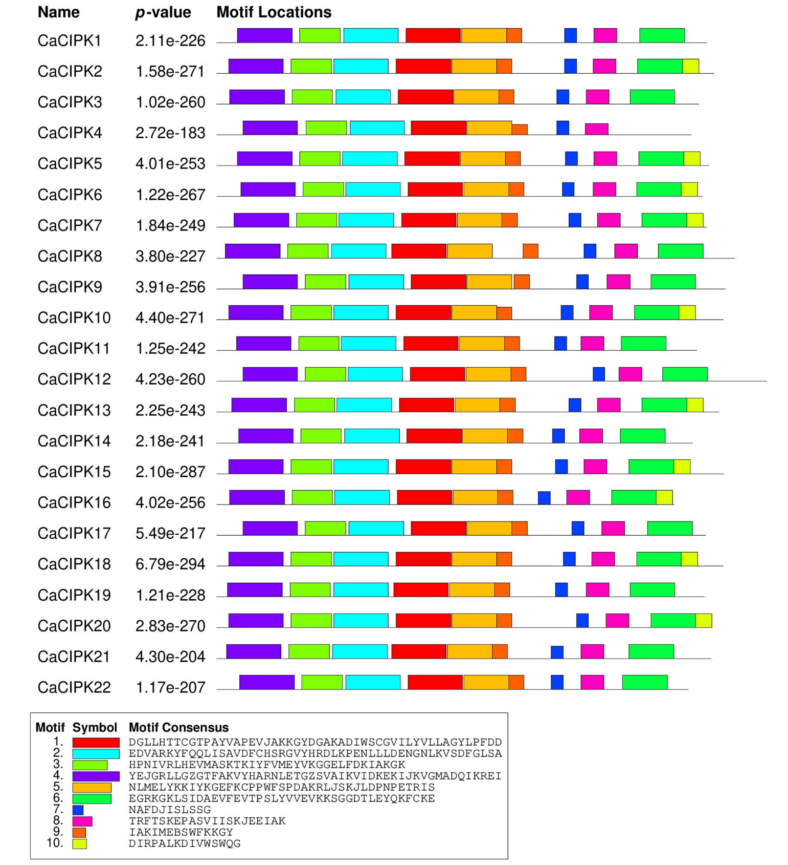

Figure S4: Duplication of chickpea CIPK genes performed by MCScanX is shown via Circos plot.
