Supplementary File
molecules-1119989

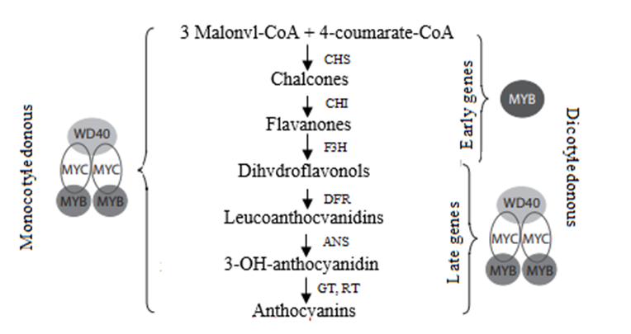
Figure 1. Biosynthesis of plant glycosides and its regulation in monocotyledonous and dicotyledonous plants [54]

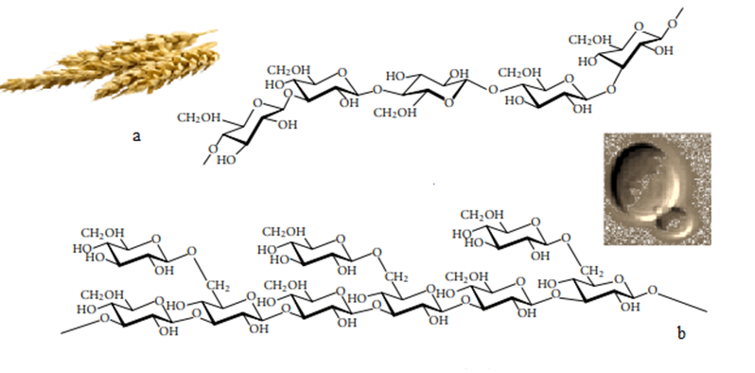
Figure 2. β-Glucans extracted a) from barley (β-(1,3-1,4)-d-glucan) and b) from yeast (β-(1,3-1,6)- d-glucan)

Table 1. Oil (percent of dry weight seed) and lipid content (percent of total lipid) in wild and cultivated oats samplesª

Wild / Cultivated | Oil content | Pl | 1,2-DAG | 1,3-DAG | FFA | Unknown lipids | TAG1 | TAG2 | TAG
Wild | 7.8±0.2 | 15.4±0.6 | 1.3±0.1 | 1.9±0.1 | 1.5±0.2 | 1.0±0.1 | 1.1±0.1 | 0.9±0.1 | 77.1±0.9
Cultivated | 5.9±0.2 | 16.0±0.7 | 1.1±0.1 | 2.3±0.1 | 2.5±0.1 | 1.4±0.1 | 1.4±0.1 | 1.1±0.0 | 74.2±1.0
F value | 47.5*** | 0.4 NS | 1.3 NS | 10.6** | 10.2** | 4.2* | 13.2*** | 11.0** | 4.3*
ªAbbreviations: PL, polar lipids; 1,2-DAG, 1,2-diacylglycerol; 1,3-DAG, 1,3-diacylglycerol; FFA, free FAs. F values are from one-way ANOVA. ***Significant at p < 0.001; **significant at p < 0.01; and *significant at p < 0.05

Table 2. Content of avenanthramides in oat cultivars [94]
№ VIR catalogue | Name of cultivars | Origin | Content of avenanthramides, mg/kg
 |  |  | I | II | III | Average
14787 | Privet | RF, Moscow reg. | 23,46 | 36,92 | 30,39 | 30,26
15277 | Bulanyi | RF, Moscow reg. | 8,28 | 13,06 | 7,31 | 9,55
15187 | Eklips | RF, Kirov reg. | 92,60 | 121,67 | 144,32 | 119,53
14648 | Argamak | RF, Kirov reg. | 5,38 | 6,60 | 6,11 | 6,03
14857 | Krechet | RF, Kirov reg. | 20,27 | 19,91 | 29,90 | 23,36
15068 | Konkur | RF, Ul’yanovsk reg. | 54,32 | 53,76 | 50,49 | 52,86
14960 | Vyatskii* | RF, Kirov reg. | 214,10 | 169,50 | 261,20 | 214,93
15275 | Persheron* | RF, Kirov reg. | 62,35 | 68,82 | 54,41 | 61,86
15067 | Golets* | RF, Krasnoyask reg. | 77,62 | 82,14 | 79,24 | 79,67
15067 | Levsha* | RF, Kemerovo reg. | 59,81 | 72,77 | 67,65 | 66,74
15115 | Aldan* | RF, Kemerovo reg. | 60,54 | 83,74 | 56,44 | 66,91
15116 | Murom* | RF, Kemerovo reg. | 138,98 | 170,54 | 200,71 | 170,08
15117 | Pomor* | RF, Kemerovo reg. | 43,40 | 46,82 | 46,00 | 45,40
15183 | Taidon* | RF, Kemerovo reg. | 140,20 | 165,76 | 122,96 | 142,97
14851 | Numbat* | Australia | 358,87 | 460,00 | 403,78 | 407,55
* - naked cultivars

Table 3. Content of tocopherols and sterols in oat accessions
№ VIR catalogue | Name of cultivars | Origin | Content of tocopherols, мg% | Content of sterols, %
5184 | Local | Spain | 283 | 1,18
11840 | Borrus | Germany | 184 | 1,00
14648 | Argamak | RF, Kirov reg. | 189 | 0,64
13780 | Skakun | RF, Moscow reg. | 180 | 0,64
13918 | Kirovets | RF, Kirov reg. | 227 | 0,72
13957 | Gunter | RF, Kirov reg. | 236 | 0,67
14373 | Fakir | RF, Kirov reg. | 235 | 0,81
14781 | Faust | RF, Kirov reg. | 195 | 0,77
14857 | Krechet | RF, Kirov reg. | 149 | 0,61
15177 | Derbi | RF, Ulaynovsk reg. | 169 | 0,62
15180 | Piruet | RF, Ulaynovsk reg. | 167 | 0,64
1931 | Local* | China | 223 | 0,74
2472 | Local* | Mongolia | 415 | 0,97
8317 | Local* | China | 106 | 0,85
* - naked cultivars

Table 4. The biochemical characteristics of caryopsis of wild and cultivated oats with different levels of ploidy (mg / 100 g) [97].
Name | Wild oats |  |  | Cultivated oats
 | Diploids | Tetraploids | Hexaploids | Hexaploids
Amino acids | 65,41 ± 0,03 | 37,96 ± 0,02 | 27,67 ± 0,01 | 75,80 ± 0,04
Fatty acid | 755,30 ± 0,08 | 787,30 ± 0,08 | 950,77 ± 0,10 | 494,00 ± 0,10
Sterols | 11,49 ± 0,00 | 22,29 ± 0,00 | 23,20 ± 0,00 | 16,40 ± 0,01
Organic acids | 117,56 ± 0,06 | 121,92 ± 0,06 | 101,35 ± 0,05 | 49,90 ± 0,02
Polyhydric alcohols | 352,26 ± 0,11 | 236,93 ± 0,07 | 295,76 ± 0,09 | 189,90 ± 0,09
Monosaccharides | 1170,91 ± 0,05 | 886,79 ± 0,04 | 1058,88 ± 0,04 | 901,50 ± 0,09
Disaccharide | 3651,68 ± 0,11 | 3894,83 ± 0,12 | 1280,41 ± 0,04 | 2361,40 ± 0,09
Total sugars | 4980,89 ± 0,10 | 4781,62 ± 0,10 | 2339,28 ± 0,05 | 3262,90 ± 0,09

