APPENDIX: Hospital admissions from care homes in England during the COVID-19 pandemic: a retrospective, cross-sectional analysis using linked administrative data
Appendix Table S1. ICD-10 chapters, diagnosis code ranges and chapter descriptions. ICD-10, International Statistical Classification of Diseases and Related Health Problems, 10th revision.
Chapter | Code range | Description | Short description
1 | A00-B99 | Certain infectious and parasitic diseases | Infectious, parasitic
2 | C00-D49 | Neoplasms | Neoplasms
3 | D50-D89 | Diseases of the blood and blood-forming organs and certain disorders involving the immune mechanism | Blood, blood-forming organs
4 | E00-E89 | Endocrine, nutritional and metabolic diseases | Endocrine, nutritional, metabolic
5 | F01-F99 | Mental, Behavioral and Neurodevelopmental disorders | Mental, behavioral
6 | G00-G99 | Diseases of the nervous system | Nervous system
7 | H00-H59 | Diseases of the eye and adnexa | Eye, adnexa
8 | H60-H95 | Diseases of the ear and mastoid process | Ear, mastoid
9 | I00-I99 | Diseases of the circulatory system | Circulatory system
10 | J00-J99 | Diseases of the respiratory system | Respiratory system
11 | K00-K95 | Diseases of the digestive system | Digestive system
12 | L00-L99 | Diseases of the skin and subcutaneous tissue | Skin, subcutaneous tissue
13 | M00-M99 | Diseases of the musculoskeletal system and connective tissue | Musculoskeletal, connective
14 | N00-N99 | Diseases of the genitourinary system | Genitourinary system
15 | O00-O9A | Pregnancy, childbirth and the puerperium | Pregnancy, childbirth
16 | P00-P96 | Certain conditions originating in the perinatal period | Perinatal
17 | Q00-Q99 | Congenital malformations, deformations and chromosomal abnormalities | Congenital
18 | R00-R99 | Symptoms, signs and abnormal clinical and laboratory findings, not elsewhere classified | Not elsewhere classified
19 | S00-T88 | Injury, poisoning and certain other consequences of external causes | Injury, poisoning
20 | V00-Y99 | External causes of morbidity | External causes
21 | Z00-Z99 | Factors influencing health status and contact with health services | Factors infl. health status
22 | U00–U99 | Codes for special purposes | Special purposes

Appendix Table S2. ICD-10 diagnosis codes for potentially avoidable causes of emergency admissions. ICD-10, International Statistical Classification of Diseases and Related Health Problems, 10th revision.
Description | Code range
Acute lower respiratory tract infections (LRTI) | J20-J22
Chronic lower respiratory tract infections (LRTI) | J40-J44
Pressure sores | L89
Diabetes | E10-E14
Food and drink issues | R63 (63.0, 63.1, 63.2, 63.3, 63.4, 63.6 and 63.8)
Food and liquid pneumonitis | J69
Fractures and sprains | S02, S03, S08, S12, S13, S18, S22, S23, S28, S32, S33, S38, S42, S43, S48, S52, S53, S58, S62, S63, S68, S72, S73, S78, S82, S83, S88, S92, S93, S98, T02, T03, T05, T08, T10 and T12
Intestinal infections | A02-A09
Pneumonia | J12-J18
Urinary tract infections (UTI) | N390

Appendix Table S3. Comparison of baseline characteristics of the cohorts of residential care home and nursing home residents in January 2019 and January 2020. IMD, Index of Multiple Deprivation. *Mean (standard deviation).
Care home type | Residential |  | Nursing
Year | 2019 | 2020 | 2019 | 2020
N | 139925 | 141891 | 112507 | 115952
Female (%) | 90956 (65.0) | 92018 (64.9) | 73223 (65.1) | 74862 (64.6)
Age in years* | 77 (19) | 77 (19) | 81 (14) | 81 (14)
Aged >= 65 years (%) | 109321 (78.1) | 111809 (78.8) | 100371 (89.2) | 103762 (89.5)
Charlson Index* | 1.39 (1.71) | 1.45 (1.75) | 1.79 (1.87) | 1.89 (1.94)
Dementia (%) | 54306 (38.8) | 56509 (39.8) | 51803 (46.0) | 54162 (46.7)
Follow-up in days* | 150 (33) | 150 (32) | 145 (38) | 142 (40)
Reason for follow-up ending (%)
End of care home flag | 6888 (4.9) | 3822 (2.7) | 5394 (4.8) | 2828 (2.4)
Death | 15431 (11.0) | 19232 (13.6) | 18679 (16.6) | 28080 (24.2)
End of study | 117606 (84.0) | 118837 (83.8) | 88434 (78.6) | 85044 (73.3)
IMD quintile (%)
1 (least deprived) | 25129 (18.0) | 25590 (18.0) | 21710 (19.3) | 22661 (19.5)
2 | 29691 (21.2) | 30434 (21.4) | 21486 (19.1) | 21910 (18.9)
3 | 32209 (23.0) | 32386 (22.8) | 23554 (20.9) | 24402 (21.0)
4 | 29013 (20.7) | 29503 (20.8) | 24012 (21.3) | 24106 (20.8)
5 (most deprived) | 23479 (16.8) | 23693 (16.7) | 21392 (19.0) | 22625 (19.5)
Missing | 404 (0.3) | 285 (0.2) | 353 (0.3) | 248 (0.2)
Region (%)
East Midlands | 14409 (10.3) | 14814 (10.4) | 10079 (9.0) | 10055 (8.7)
East of England | 19887 (14.2) | 19991 (14.1) | 10271 (9.1) | 10470 (9.0)
London | 9723 (6.9) | 9472 (6.7) | 11110 (9.9) | 11459 (9.9)
North East | 6963 (5.0) | 7016 (4.9) | 7426 (6.6) | 7878 (6.8)
North West | 17511 (12.5) | 17899 (12.6) | 15684 (13.9) | 16042 (13.8)
South East | 24408 (17.4) | 24494 (17.3) | 22243 (19.8) | 23492 (20.3)
South West | 17661 (12.6) | 18145 (12.8) | 13623 (12.1) | 14009 (12.1)
West Midlands | 14395 (10.3) | 14832 (10.5) | 11933 (10.6) | 12566 (10.8)
Yorkshire and the Humber | 14564 (10.4) | 14943 (10.5) | 9785 (8.7) | 9733 (8.4)
Missing | 404 (0.3) | 285 (0.2) | 353 (0.3) | 248 (0.2)
Bed capacity* | 34 (21) | 35 (21) | 60 (27) | 60 (26)

Appendix Table S4. Number of emergency admissions and changes in the number of emergency admissions between 1 March and 31 May in 2019 and 2020, by care home type and ICD-10 chapter of the primary diagnosis code. ICD-10, International Statistical Classification of Diseases and Related Health Problems, 10th revision.
Care home type |  | Residential |  |  | Nursing
 |  | 2019 | 2020 | Change (%) | 2019 | 2020 | Change (%)
ICD-10 chapter
1 | Infectious, parasitic | 1523 | 754 | -769 (-50) | 1433 | 738 | -695 (-48)
3 | Blood, blood-forming organs | 183 | 93 | -90 (-49) | 157 | 74 | -83 (-53)
2 | Neoplasms | 139 | 72 | -67 (-48) | 88 | 60 | -28 (-32)
10 | Respiratory system | 4603 | 2588 | -2015 (-44) | 4140 | 2361 | -1779 (-43)
14 | Genitourinary system | 1740 | 986 | -754 (-43) | 1271 | 717 | -554 (-44)
5 | Mental, behavioural | 625 | 354 | -271 (-43) | 328 | 206 | -122 (-37)
12 | Skin, subcutaneous tissue | 640 | 369 | -271 (-42) | 318 | 188 | -130 (-41)
18 | Not elsewhere classified | 3012 | 1934 | -1078 (-36) | 1816 | 1069 | -747 (-41)
11 | Digestive system | 1339 | 880 | -459 (-34) | 956 | 617 | -339 (-35)
13 | Musculoskeletal, connective | 821 | 540 | -281 (-34) | 441 | 287 | -154 (-35)
9 | Circulatory system | 1604 | 1106 | -498 (-31) | 1036 | 633 | -403 (-39)
6 | Nervous system | 560 | 413 | -147 (-26) | 382 | 258 | -124 (-32)
21 | Factors infl. health status | 109 | 85 | -24 (-22) | 67 | 54 | -13 (-19)
4 | Endocrine, nutritional, metabolic | 513 | 405 | -108 (-21) | 429 | 322 | -107 (-25)
19 | Injury, poisoning | 3883 | 3305 | -578 (-15) | 2419 | 1880 | -539 (-22)
 | COVID-19 | 0 | 2960 | - | 0 | 3295 | -
 | Other/Unknown | 208 | 198 | -10 (-5) | 111 | 157 | +46 (+41)

Admissions where the primary diagnosis code was missing or where the primary diagnosis code corresponded to a chapter that had <10 admissions for at least one year in one care home type were grouped into Other/Unknown. The ICD-10 codes for suspected or confirmed COVID-19 are part of ICD-10 chapter 22. Rows are sorted by increasing % change in residential care homes.

Appendix Table S5. Number of emergency hospital admissions for acute coronary syndromes or stroke between 1 March and 31 May in 2019 and 2020, by care home type.
 | Acute coronary syndromes |  |  | Stroke
Care home type | 2019 | 2020 | Change (%) | 2019 | 2020 | Change (%)
Residential | 184 | 106 | -78 (-42) | 416 | 349 | -67 (-16)
Nursing | 96 | 69 | -27 (-28) | 252 | 191 | -61 (-24)

Appendix Table S6. Number of admissions with cataract procedures between 1 March and 31 May in 2019 and 2020, by care home type.
Care home type | 2019 | 2020 | Change (%)
Residential | 371 | 71 | -300 (-81)
Nursing | 252 | 49 | -203 (-81)

Appendix Figure S1. Data cleaning workflow to create cohorts of care home residents in January 2019 and January 2020.
1. Patient index records with address matched to a care home
n = 345,985
Care home residents, January 2019
n = 358,905
Care home residents, January 2020
Exclude records only matching to care homes not listed as open
n = 254,138
n = 259,309
2. Patient index records with address match to open care homes
n = 91,847 (26.5%)

n = 99,596 (27.7%)

n = 252,432
n = 257,843
3. Patient index records with unique address match to an open care home
n = 1,706 (0.67%)

n = 1,466 (0.56%)

Exclude records with multiple matches to open care homes

Appendix Figure S2. Assessment of similarity between cohorts of care home residents in January 2019 and January 2020.
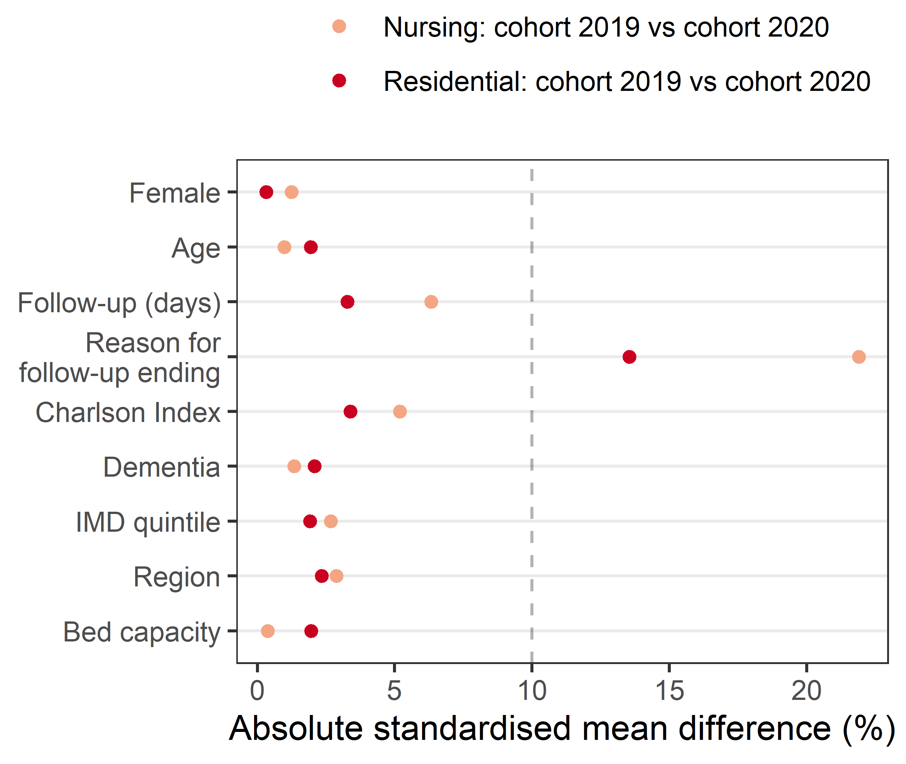

Appendix Figure S3. Assessment of similarity of the characteristics between care home residents admitted to National Health Service hospital trusts in England for suspected or confirmed COVID-19 or for other primary diagnoses, by care home type (1 March to 31 May 2019, and 1 March to 31 May 2020). Includes ordinary elective admissions, elective day cases and emergency admission.
