*Supplementary material*

Molecular docking and biophysical studies for antiproliferative assessment of synthetic pyrazolo-pyrimidinones tethered with hydrazide-hydrazones

**Table of Contents**

Figure S1. Real time monitoring of NHDF cell viability p. 2

Figure S2. Binding mode of ester **3** in the erlotinib binding site of EGFR (PDB:1M17) p. 2

Figure S3. CD spectra of a) KRAS 22RT, b) BCL2-G4, c) Tel 23 and d) Hairpin duplex. p. 3

Figure S4. 1H NMR spectrum of compound **2** (DMSO-*d6*, 400MHz) p. 4

Figure S5. 13C NMR spectrum of compound **2** (DMSO-*d6*, 100MHz) p. 4

Figure S6. 1H NMR spectrum of compound **3** (DMSO-*d6*, 400MHz) p. 5

Figure S7. 13C NMR spectrum of compound **3** (DMSO-*d6*, 100MHz) p. 5

Figure S8. 1H NMR spectrum of compound **4** (DMSO-*d6*, 400MHz) p. 6

Figure S9. 13C NMR spectrum of compound **4** (DMSO-*d6*, 100MHz) p. 6

Figure S10. 1H NMR spectrum of compound **5a** (DMSO-*d6*, 400MHz) p. 7

Figure S11. 13C NMR spectrum of compound **5a** (DMSO-*d6*, 100MHz) p. 7

Figure S12. 1H NMR spectrum of compound **5b** (DMSO-*d6*, 400MHz) p. 8

Figure S13. 13C NMR spectrum of compound **5b** (DMSO-*d6*, 100MHz) p. 8

Figure S14. 1H NMR spectrum of compound **5c** (DMSO-*d6*, 400MHz). p. 9

Figure S15. 13C NMR spectrum of compound **5c** (DMSO-*d6*, 100MHz) p. 9

Figure S16. 1H NMR spectrum of compound **5d** (DMSO-*d6*, 400MHz) p. 10

Figure S17. 13C NMR spectrum of compound **5d** (DMSO-*d6*, 100MHz) p. 10

Figure S18. 1H NMR spectrum of compound **5e** (DMSO-*d6*, 400MHz) p. 11

Figure S19. 13C NMR spectrum of compound **5e** (DMSO-*d6*, 100MHz) p. 11

Figure S20. 1H NMR spectrum of compound **5f** (DMSO-*d6*, 400MHz) p. 12

Figure S21. 13C NMR spectrum of compound **5f** (DMSO-*d6*, 100MHz) p. 12

Figure S22. 1H NMR spectrum of compound **5g** (DMSO-*d6*, 400MHz) p. 13

Figure S23. 13C NMR spectrum of compound **5g** (DMSO-*d6*, 100MHz) p. 13

Figure S24. 1H NMR spectrum of compound **5h** (DMSO-*d6*, 400MHz) p. 14

Figure S25. 13C NMR spectrum of compound **5h** (DMSO-*d6*, 100MHz) p. 14

Figure S26. HR-ESI-MS spectrum of compound **2**. p. 15

Figure S27. HR-ESI-MS spectrum of compound **3**. p. 15

Figure S28. HR-ESI-MS spectrum of compound **4**. p. 15

Figure S29. HR-ESI-MS spectrum of compound **5a**. p. 16

Figure S30. HR-ESI-MS spectrum of compound **5b**. p. 16

Figure S31. HR-ESI-MS spectrum of compound **5c**. p. 16

Figure S32. HR-ESI-MS spectrum of compound **5d**. p. 17

Figure S33. HR-ESI-MS spectrum of compound **5e**. p. 17

Figure S34. HR-ESI-MS spectrum of compound **5f** p.17

Figure S35. HR-ESI-MS spectrum of compound **5g** p. 18

Figure S36. HR-ESI-MS spectrum of compound **5h** p. 18



**Figure S1.** Real time monitoring of NHDF cell viability after 48 h exposure to synthetic compounds **5a**, **5e**, **5g**, and **5h**, using the xCELLigence System Real-Time Cell Analyzer. Left panel, representative NCI traces of NHDF cells exposed to increasing concentrations (12.5, 25, 50 µM) of **5h** and 0.5% DMSO vehicle (control) for 48 hours. Right panel, IC50values (± standard error, SE) of cisplatin (CDDP), **5a**, **5e**, **5g**, and **5h** against NHDF cells after 48h drug exposure. The IC50value represents the concentration of each compound that reduces the NCI by 50%. Data are means of three independent experiments.

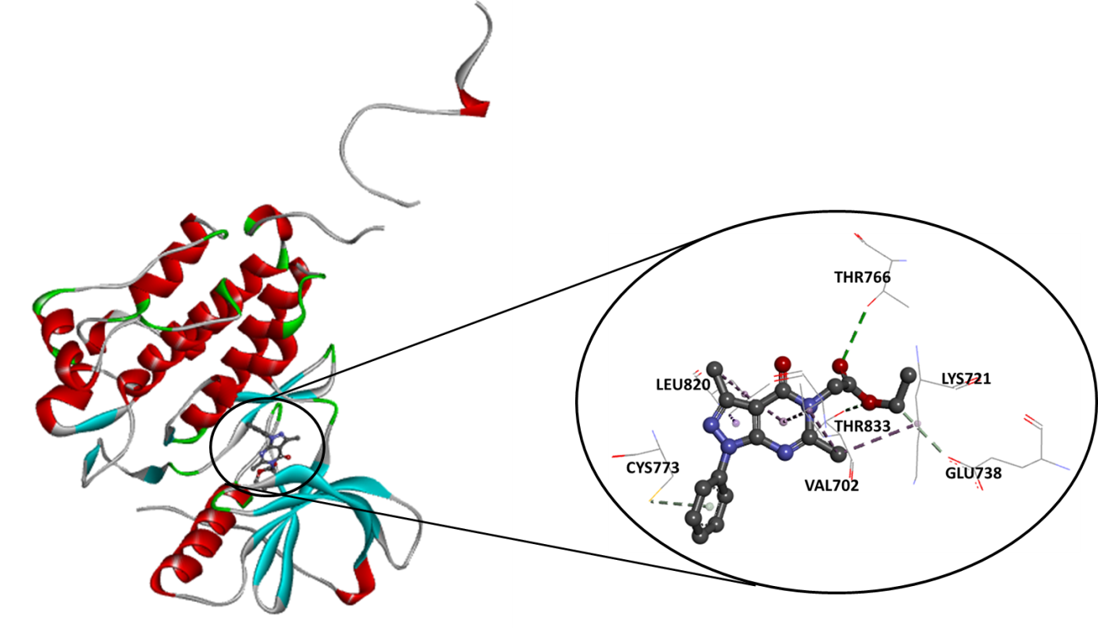

**Figure S2.** Binding mode of ester **3** in the Erlotinib binding site of EGFR (PDB:1M17).

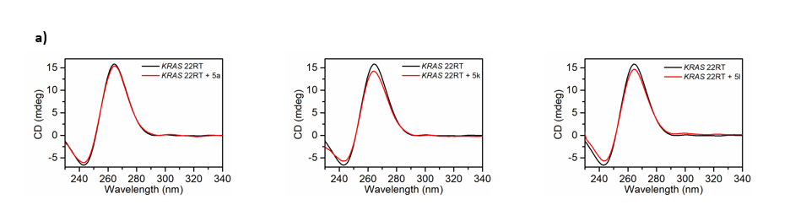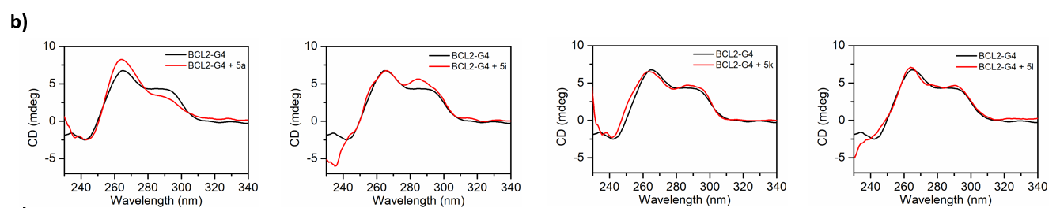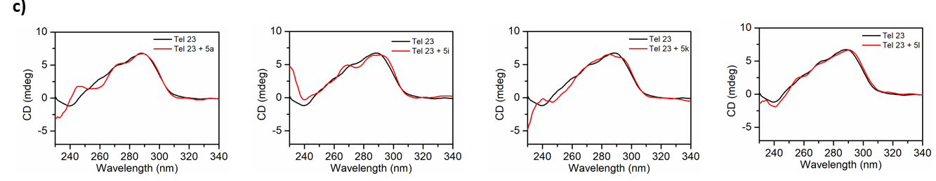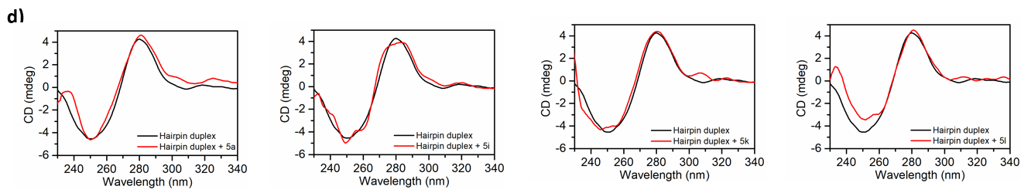

**Figure S3.** CD spectra of **a)** *KRAS* 22RT, **b)** BCL2-G4, **c)** Tel 23 and **d)** Hairpin duplex in the absence (black line) and in the presence (red line) of **5a**, **5e**, **5g** and **5h**.

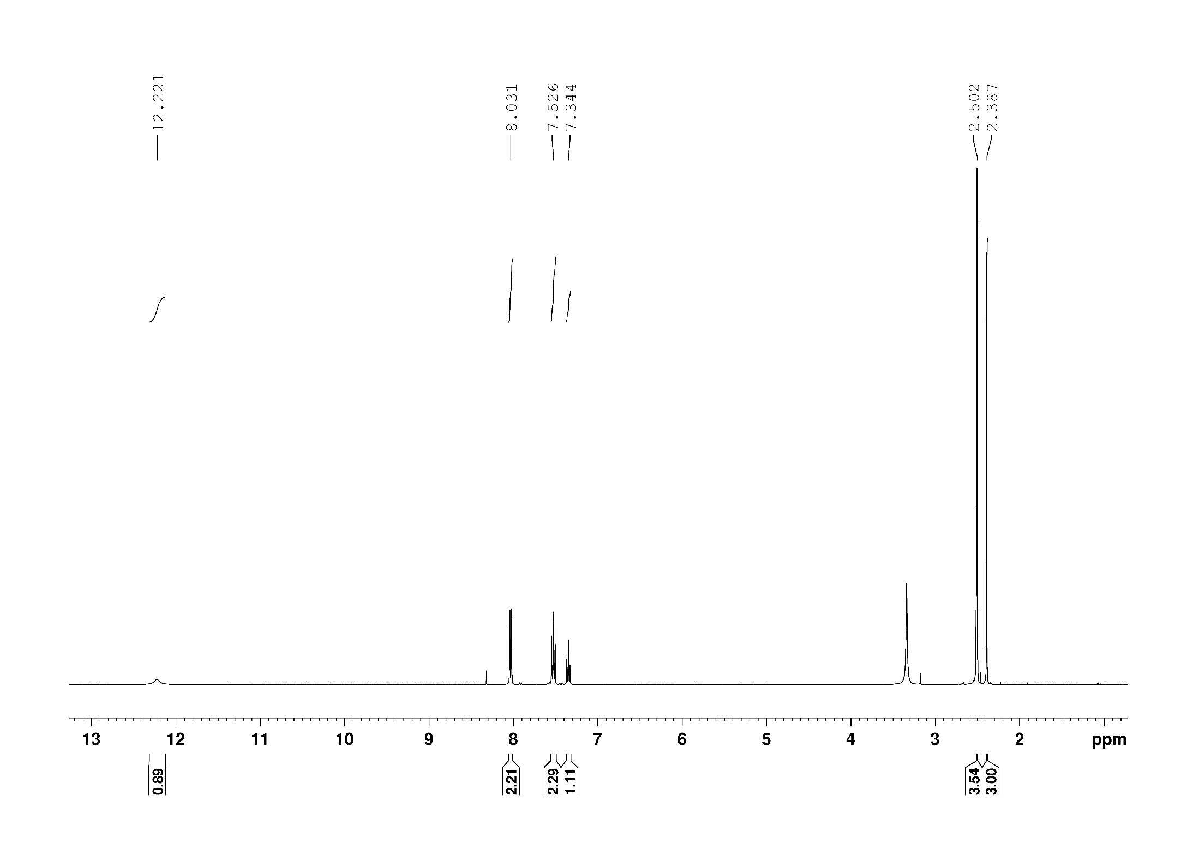

**Figure S4**. 1H NMR spectrum of compound **2** (DMSO-*d6*, 400MHz).

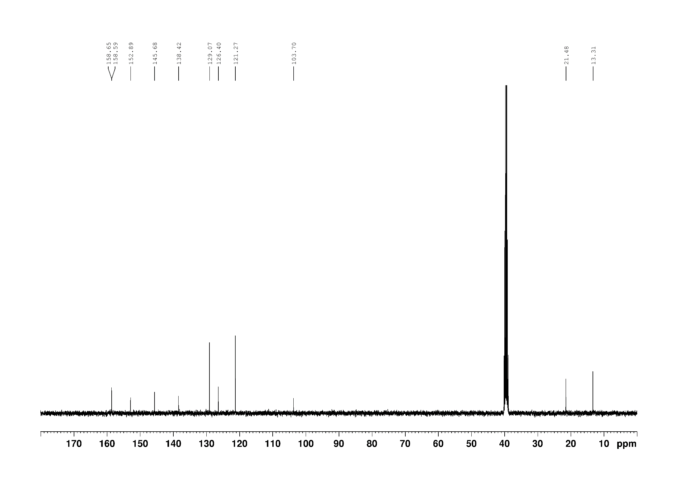

**Figure S5**. 13C NMR spectrum of compound **2** (DMSO-*d6*, 100MHz).

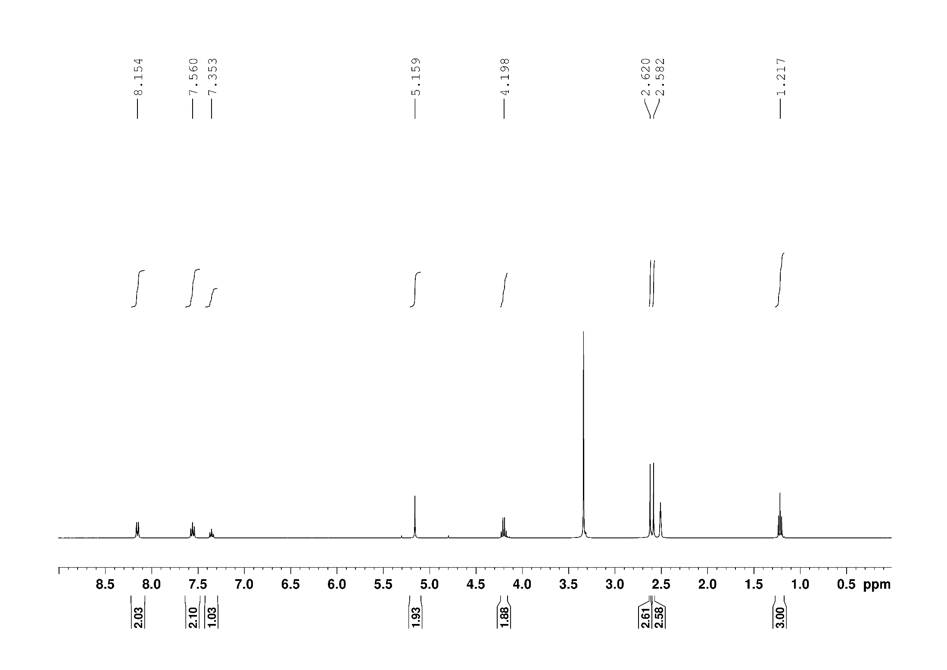

**Figure S6**. 1H NMR spectrum of compound **3** (DMSO-*d6*, 400MHz).

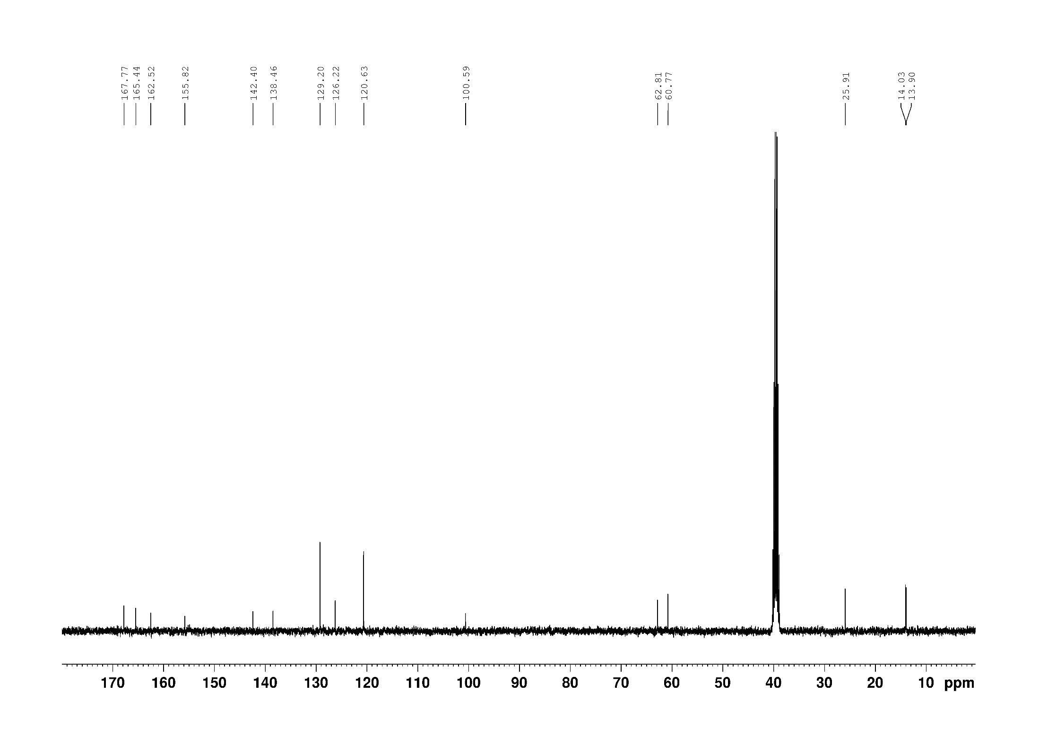

**Figure S7**. 13C NMR spectrum of compound **3** (DMSO-*d6*, 100MHz).

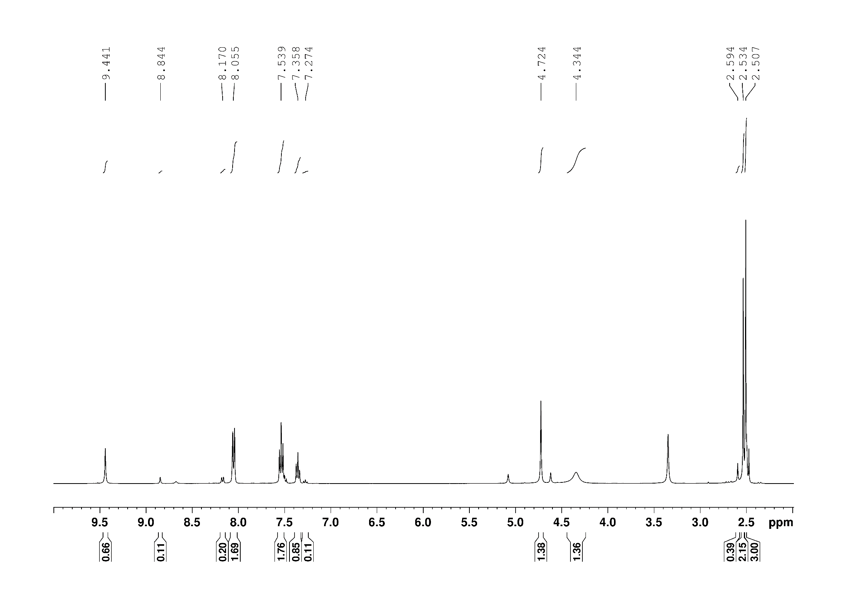

**Figure S8**. 1H NMR spectrum of compound **4** (DMSO-*d6*, 400MHz).

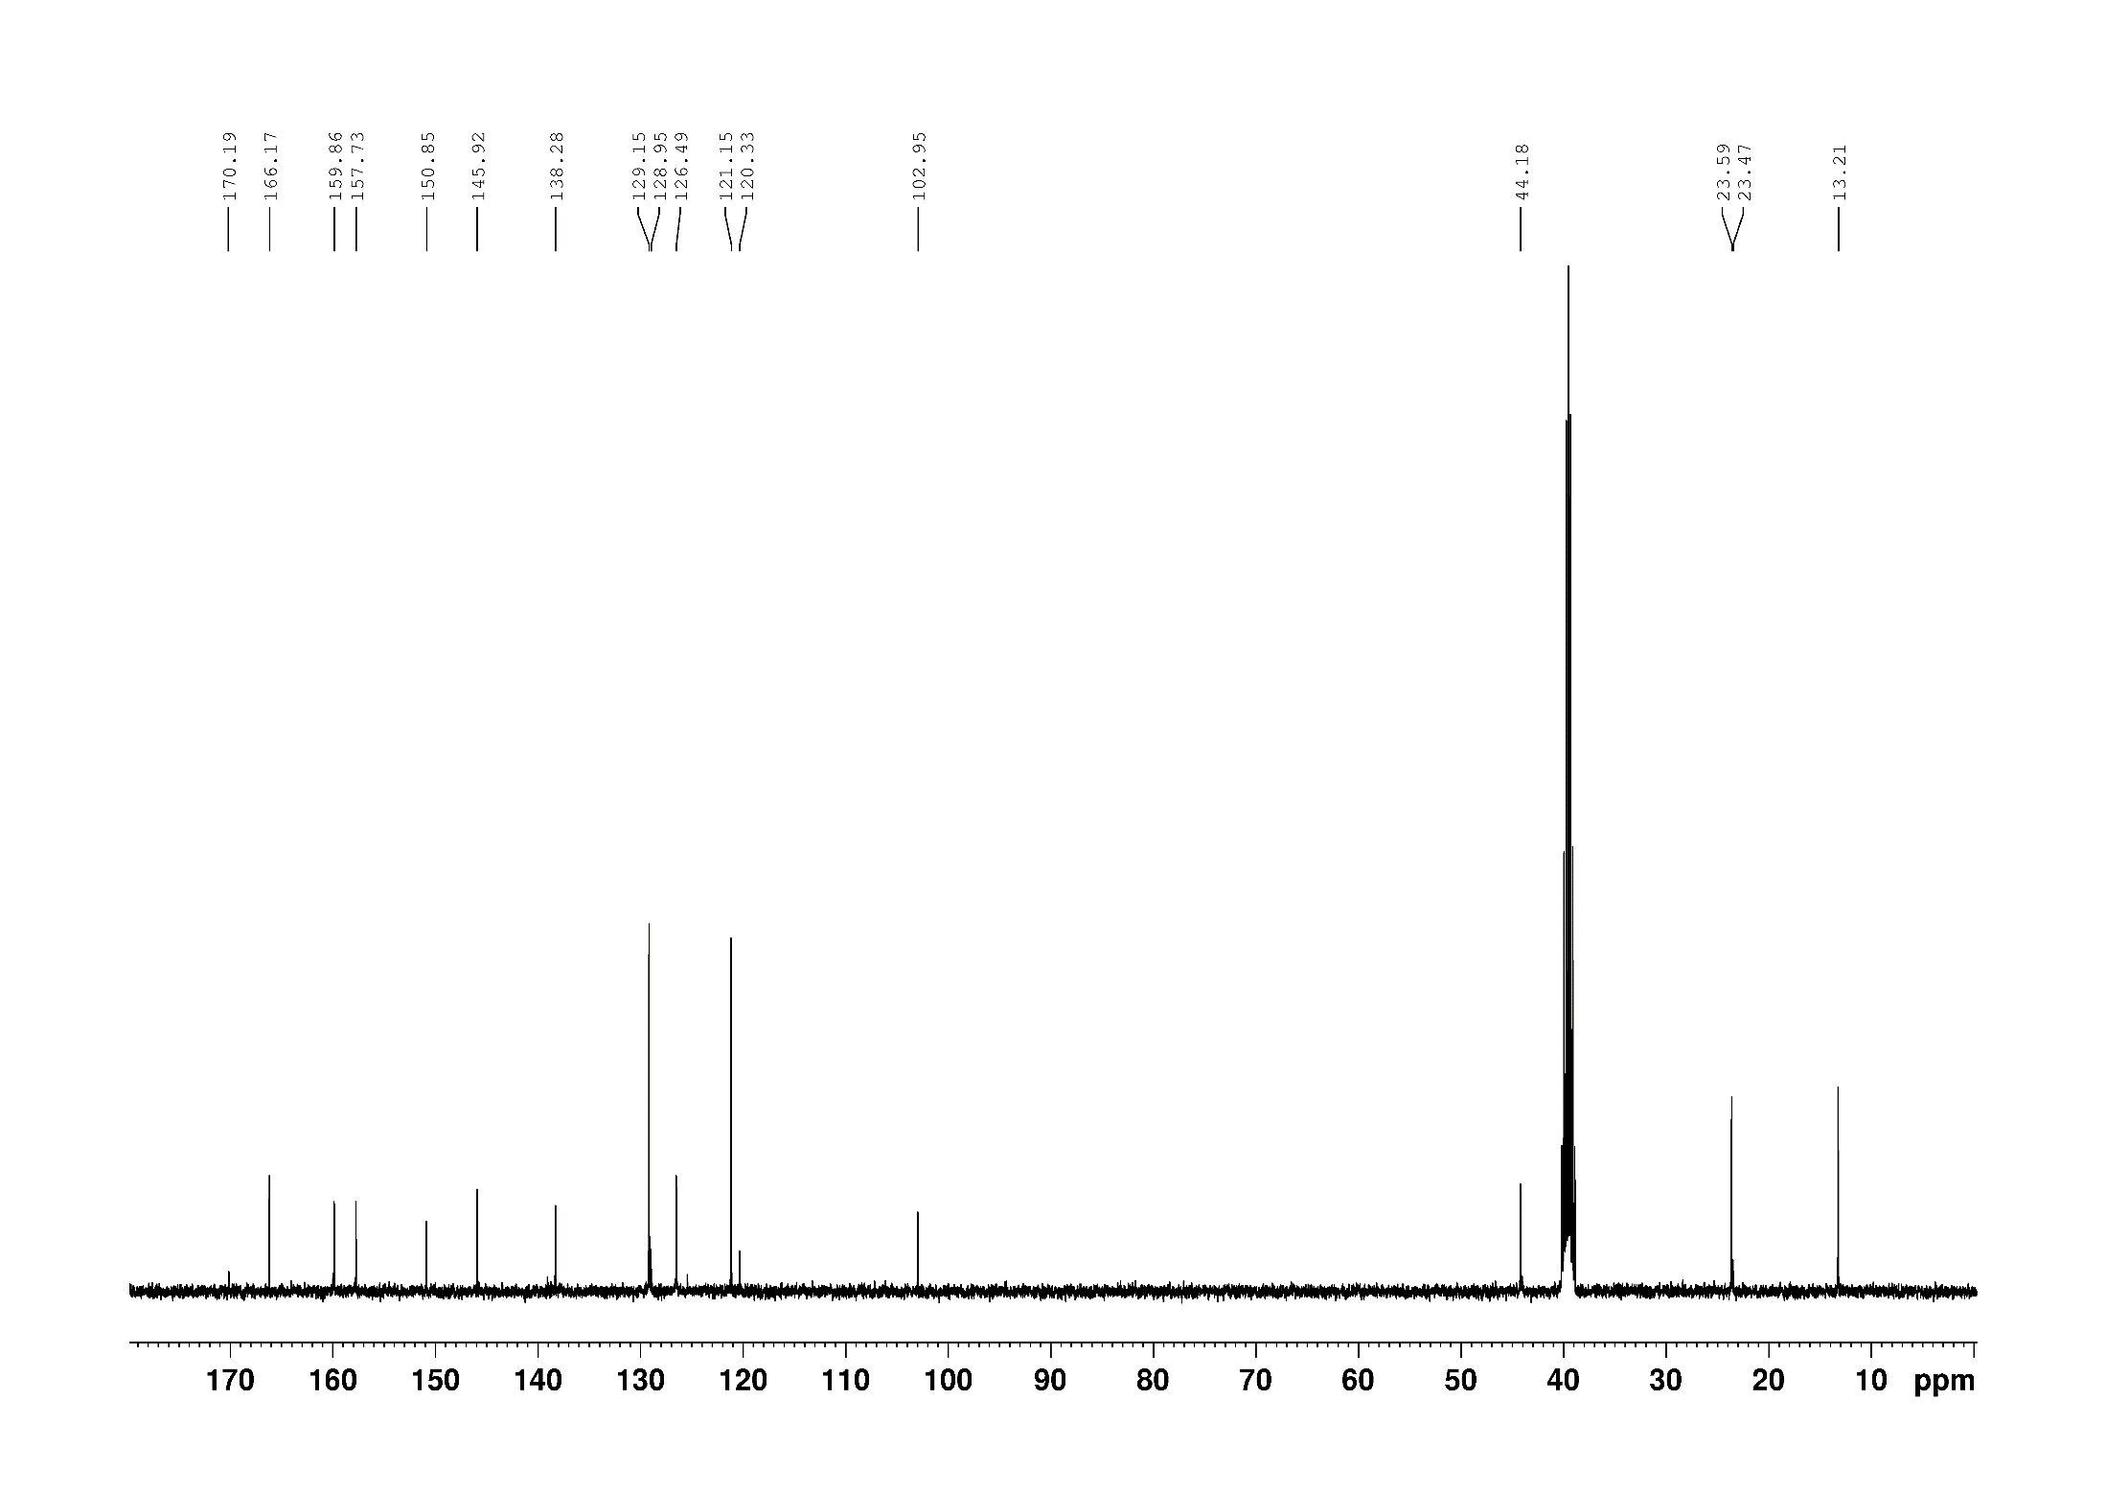

**Figure S9**. 13C NMR spectrum of compound **4** (DMSO-*d6*, 100MHz).

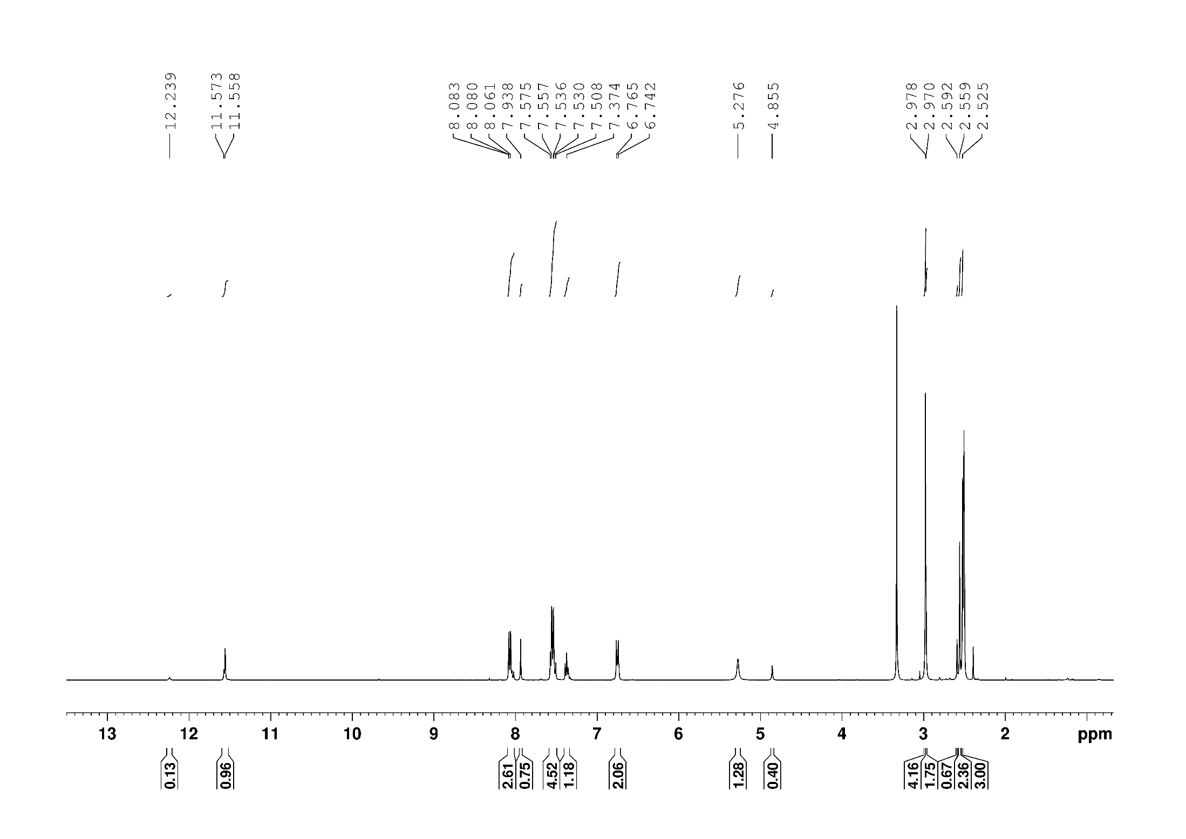

**Figure S10.** 1H NMR spectrum of compound **5a** (DMSO-*d6*, 400MHz).

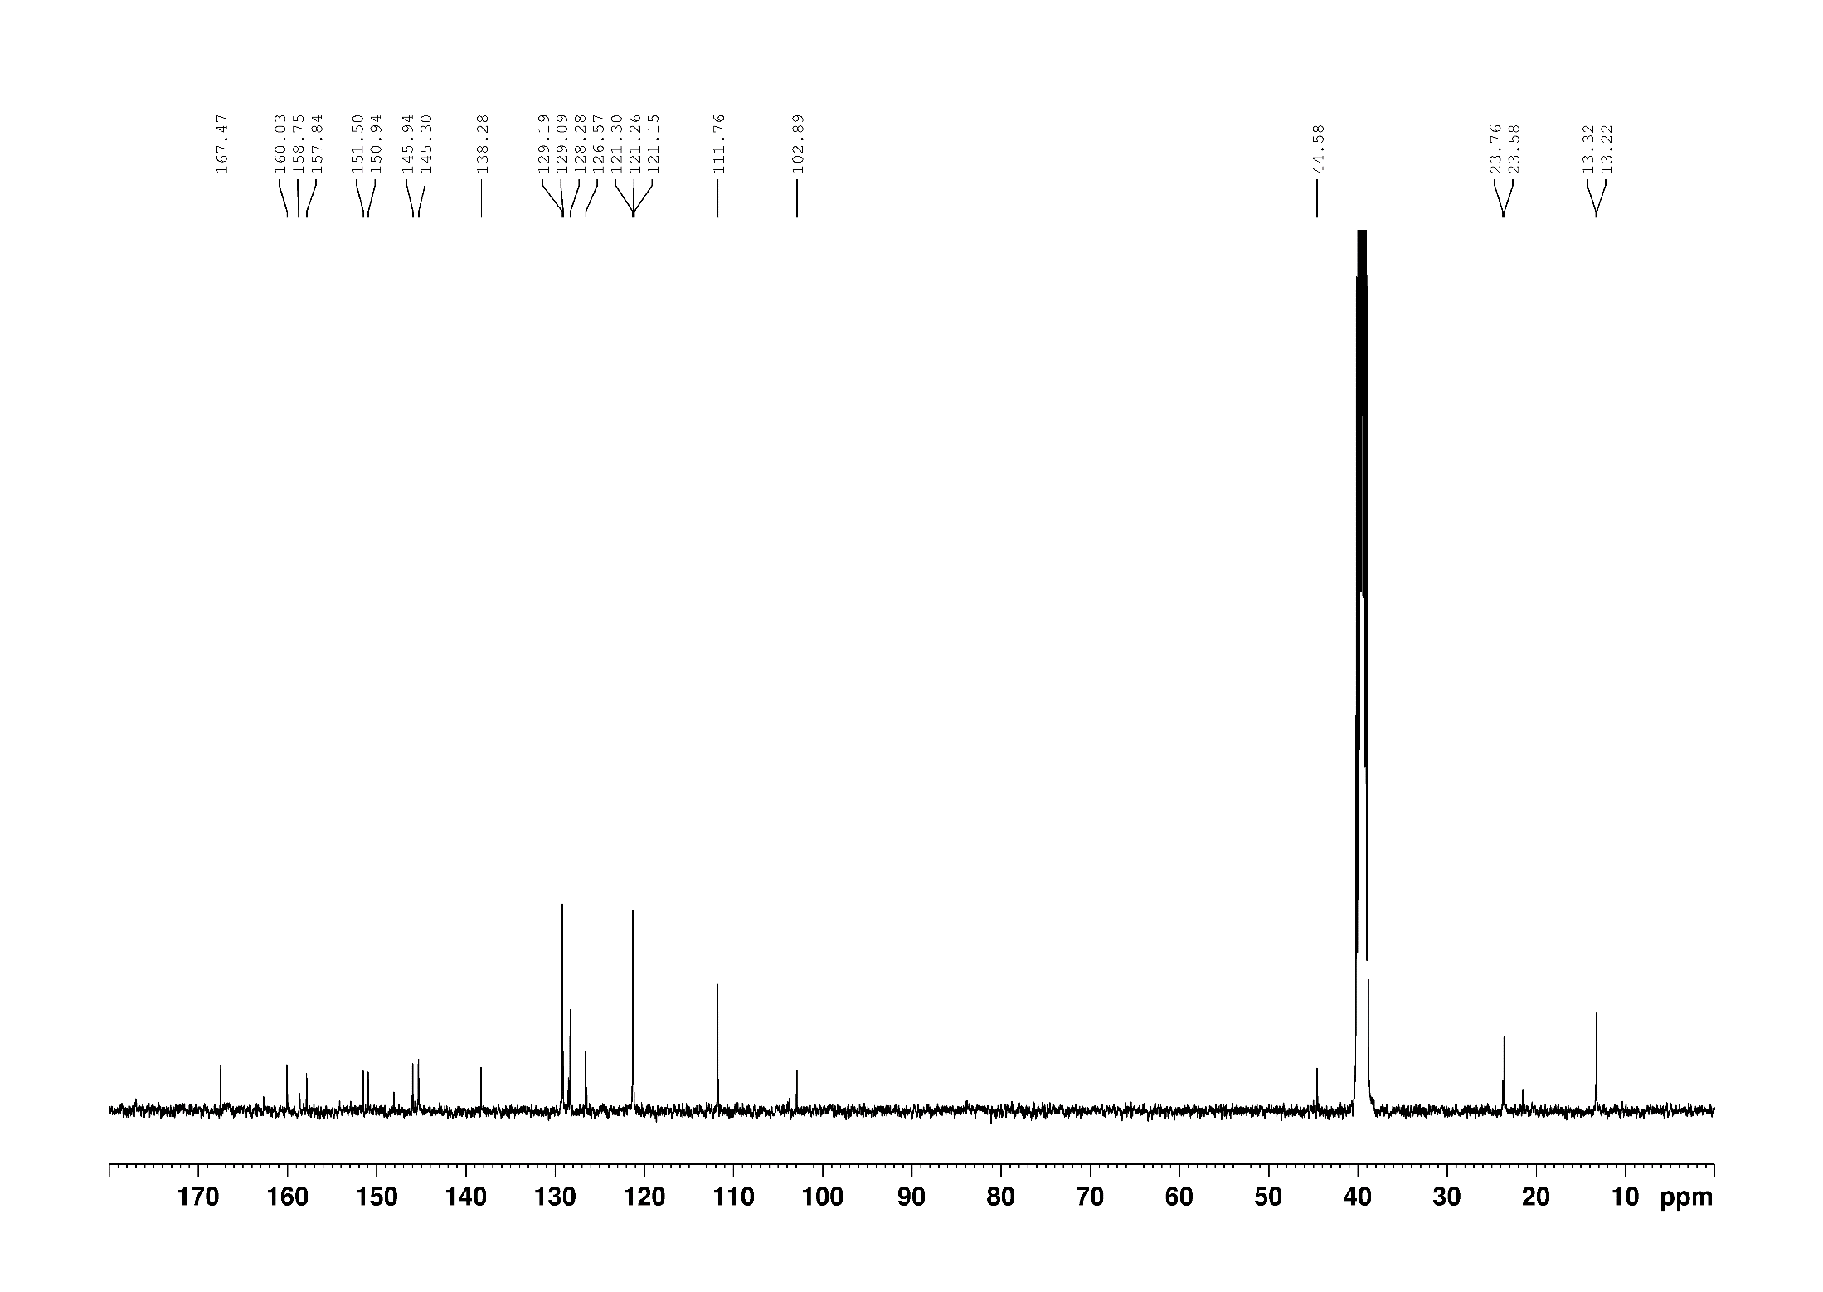

**Figure S11.** 13C NMR spectrum of compound **5a** (DMSO-*d6*, 100MHz).

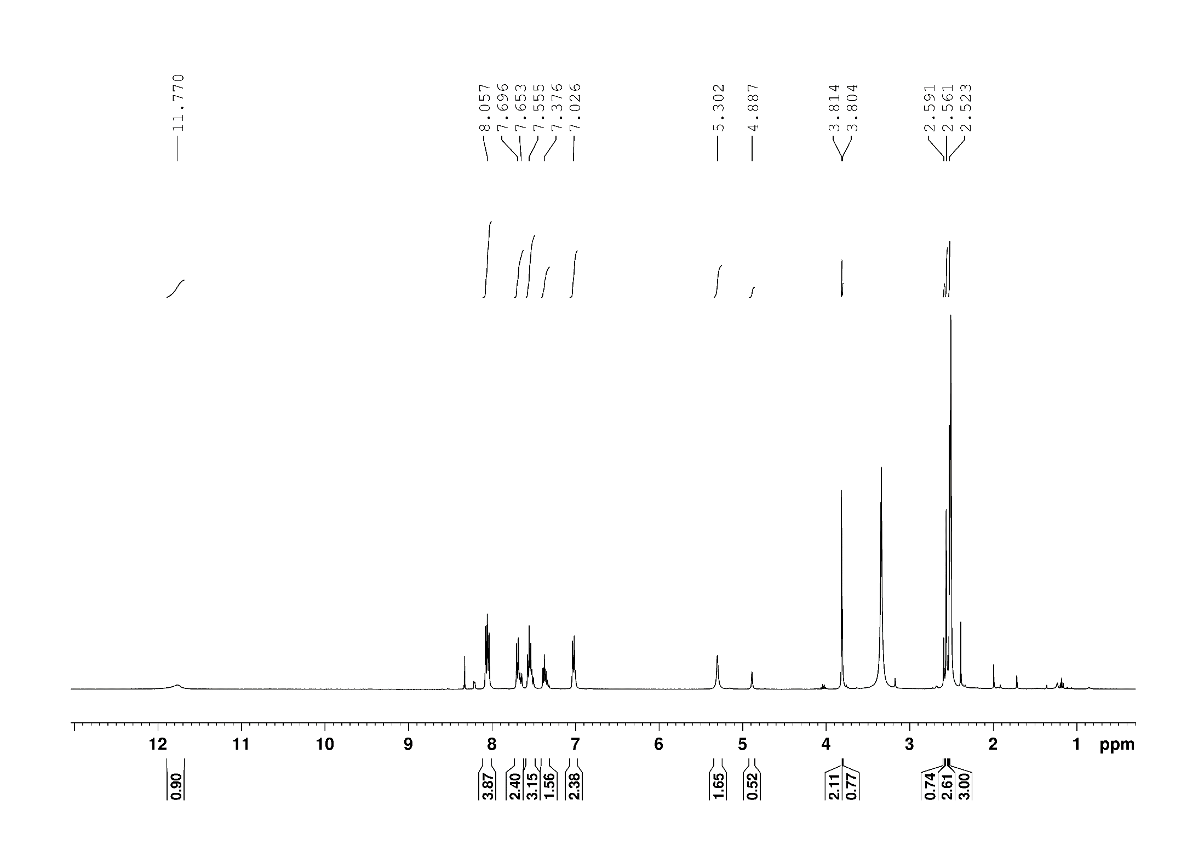

**Figure S12.** 1H NMR spectrum of compound **5b** (DMSO-*d6*, 400MHz).

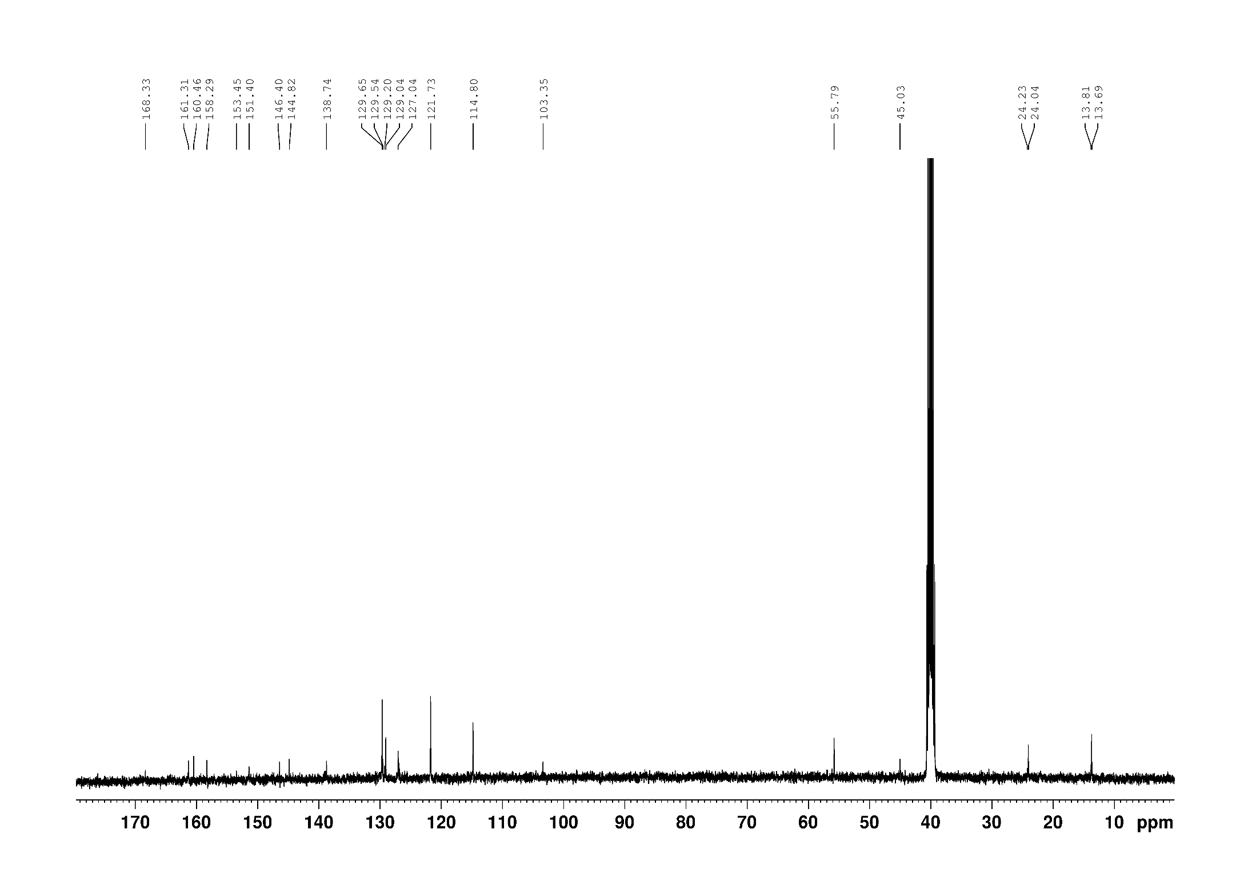

**Figure S13.** 13C NMR spectrum of compound **5b** (DMSO-*d6*, 100MHz).

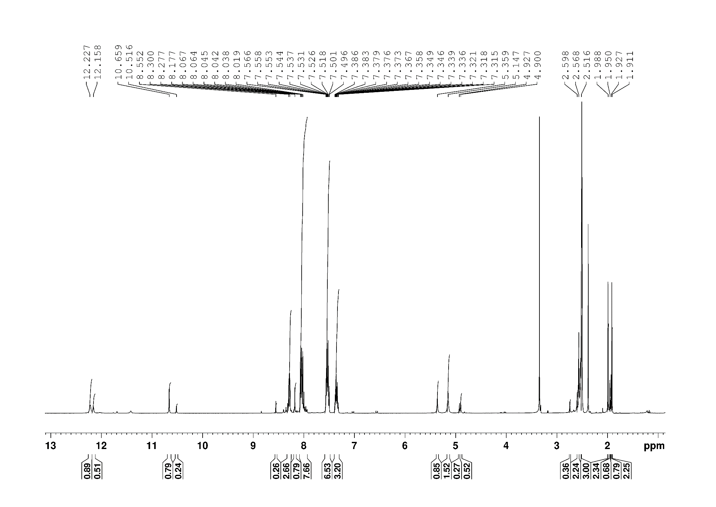

**Figure S14.** 1H NMR spectrum of compound **5c** (DMSO-*d6*, 400MHz).

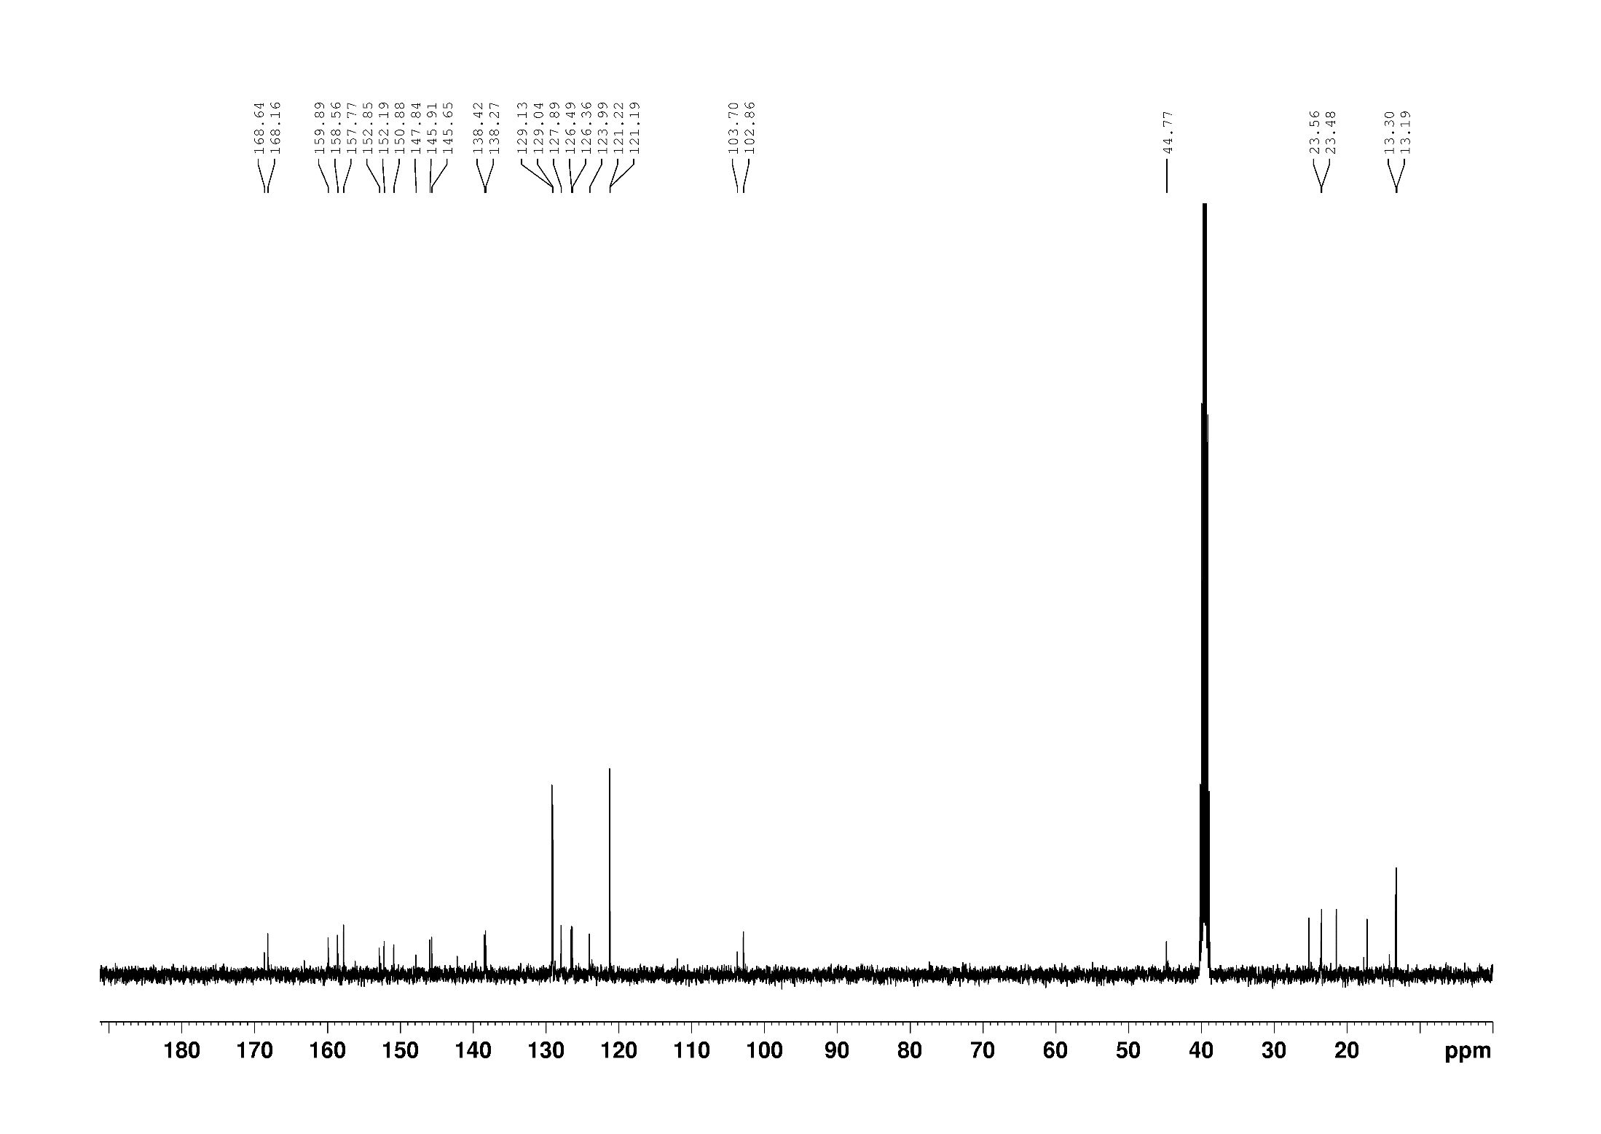

**Figure S15.** 13C NMR spectrum of compound **5c** (DMSO-*d6*, 100MHz).

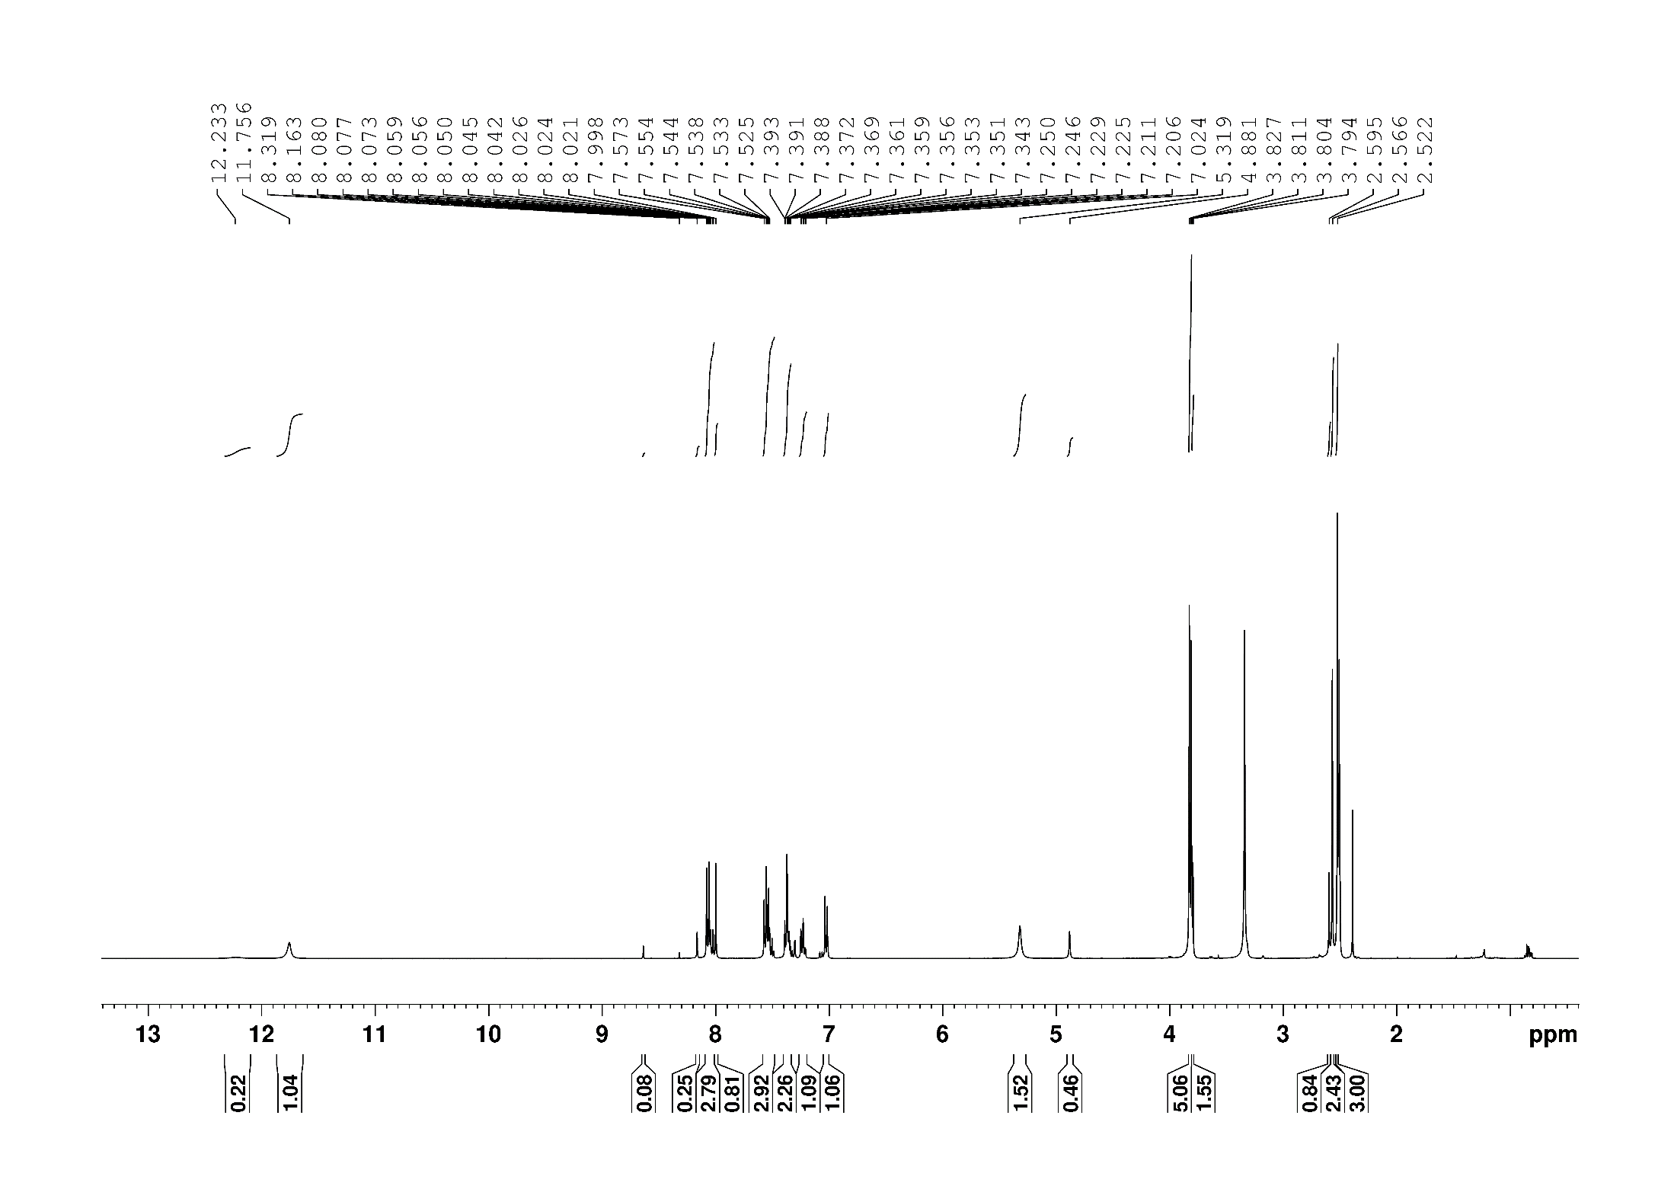

**Figure S16.** 1H NMR spectrum of compound **5d** (DMSO-*d6*, 400MHz).

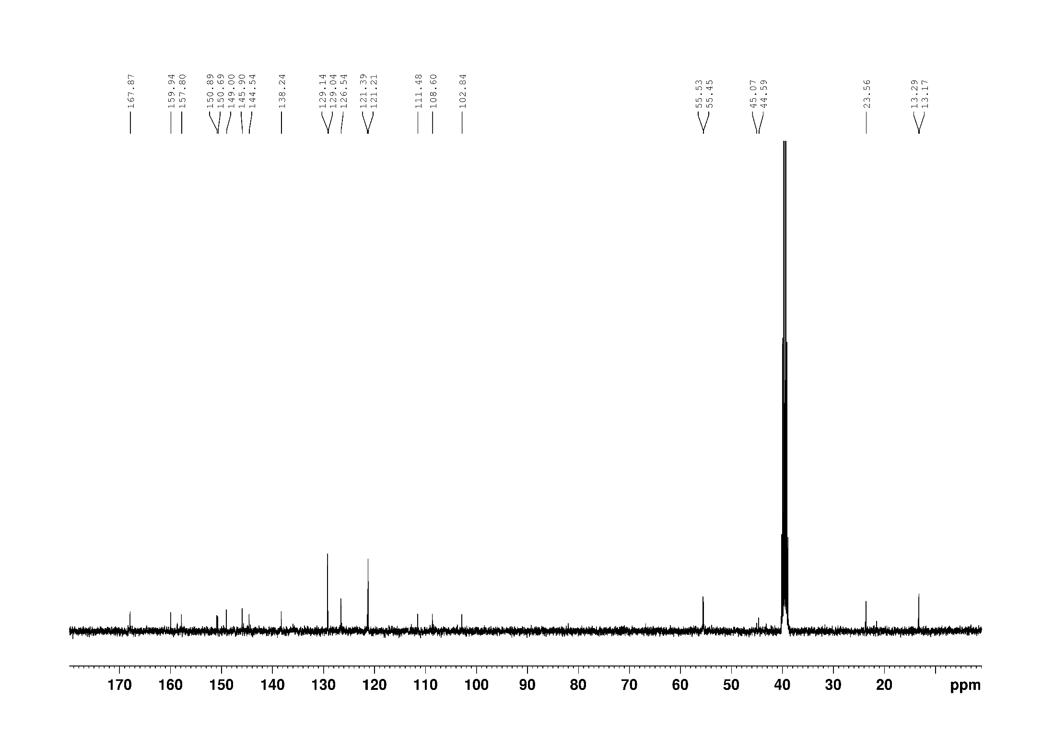

**Figure S17.** 13C NMR spectrum of compound **5d** (DMSO-*d6*, 100MHz).

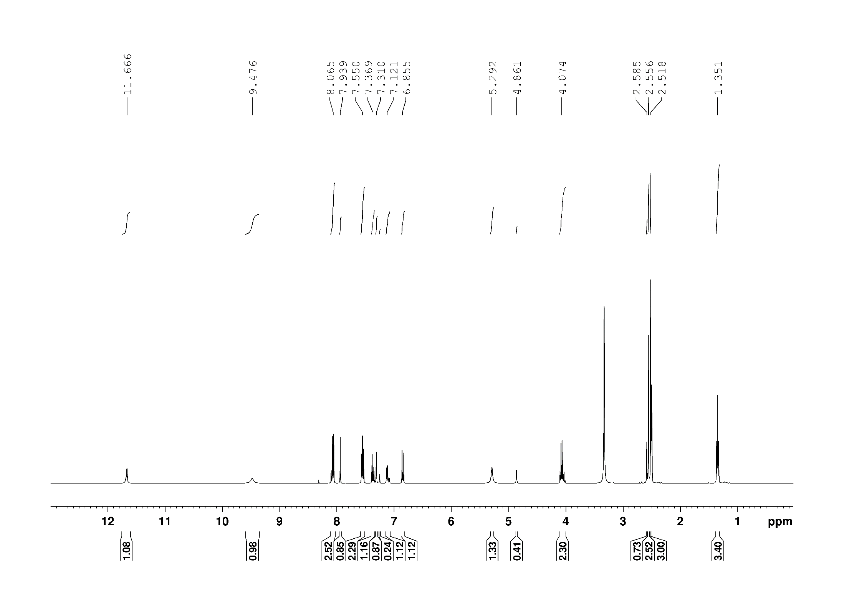

**Figure S18.** 1H NMR spectrum of compound **5e** (DMSO-*d6*, 400MHz).

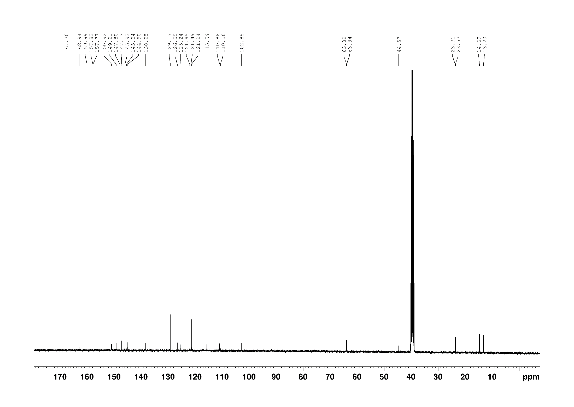

**Figure S19.** 13C NMR spectrum of compound **5e** (DMSO-*d6*, 100MHz).

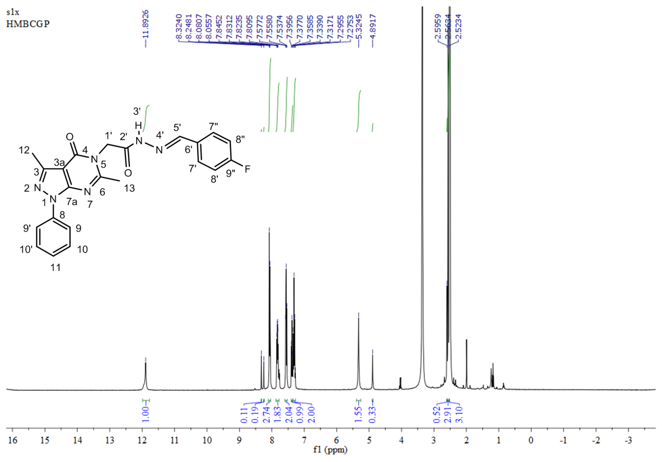

**Figure S20.** 1H NMR spectrum of compound **5f** (DMSO-*d6*, 400MHz).

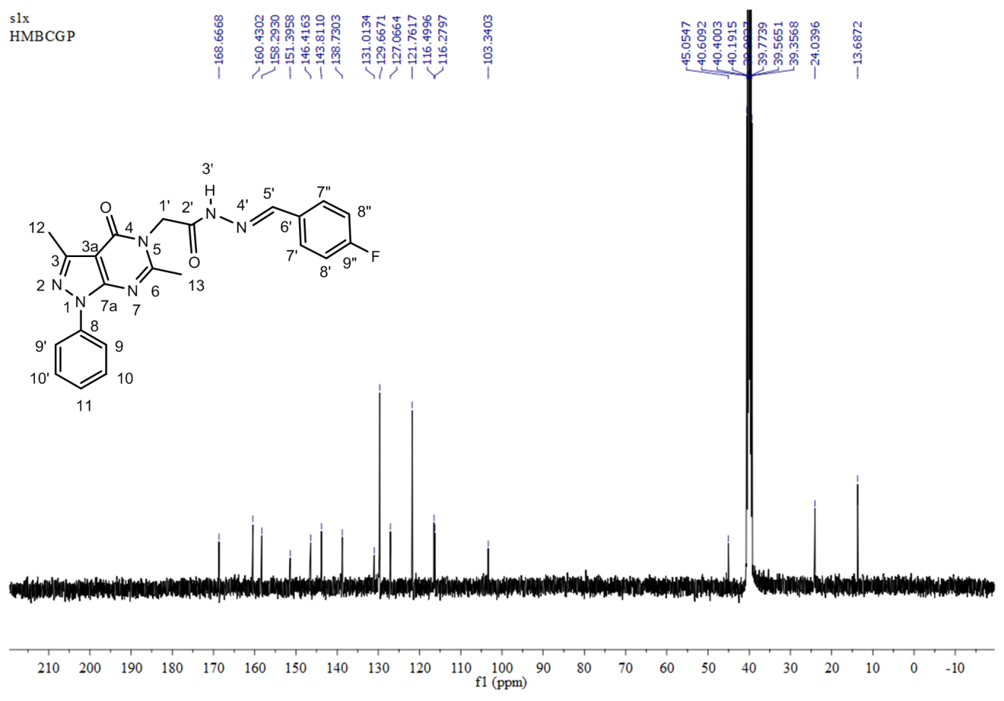

**Figure S21.** 13C NMR spectrum of compound **5f** (DMSO-*d6*, 100MHz).

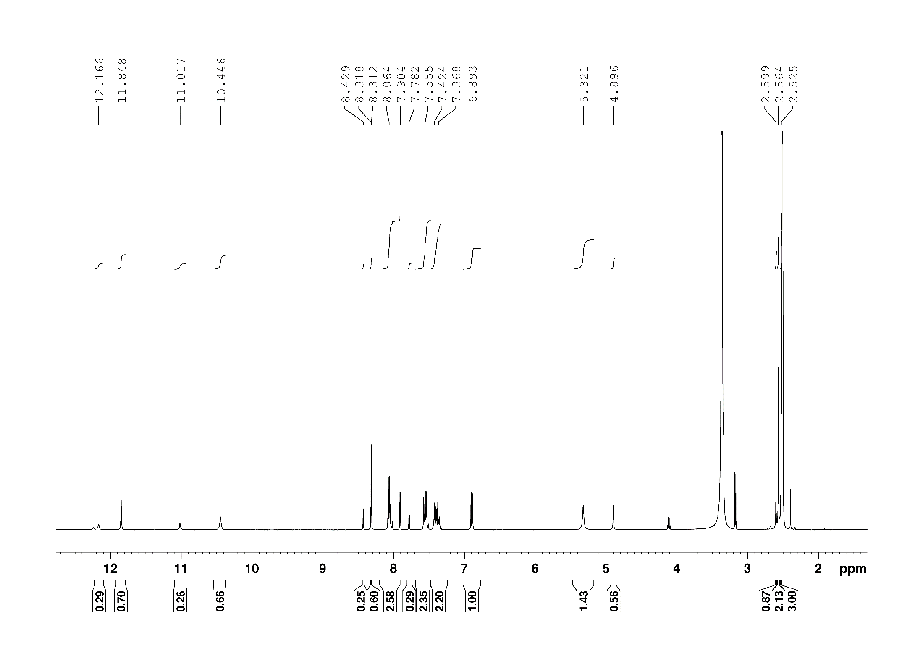

**Figure S22.** 1H NMR spectrum of compound **5g** (DMSO-*d6*, 400MHz)

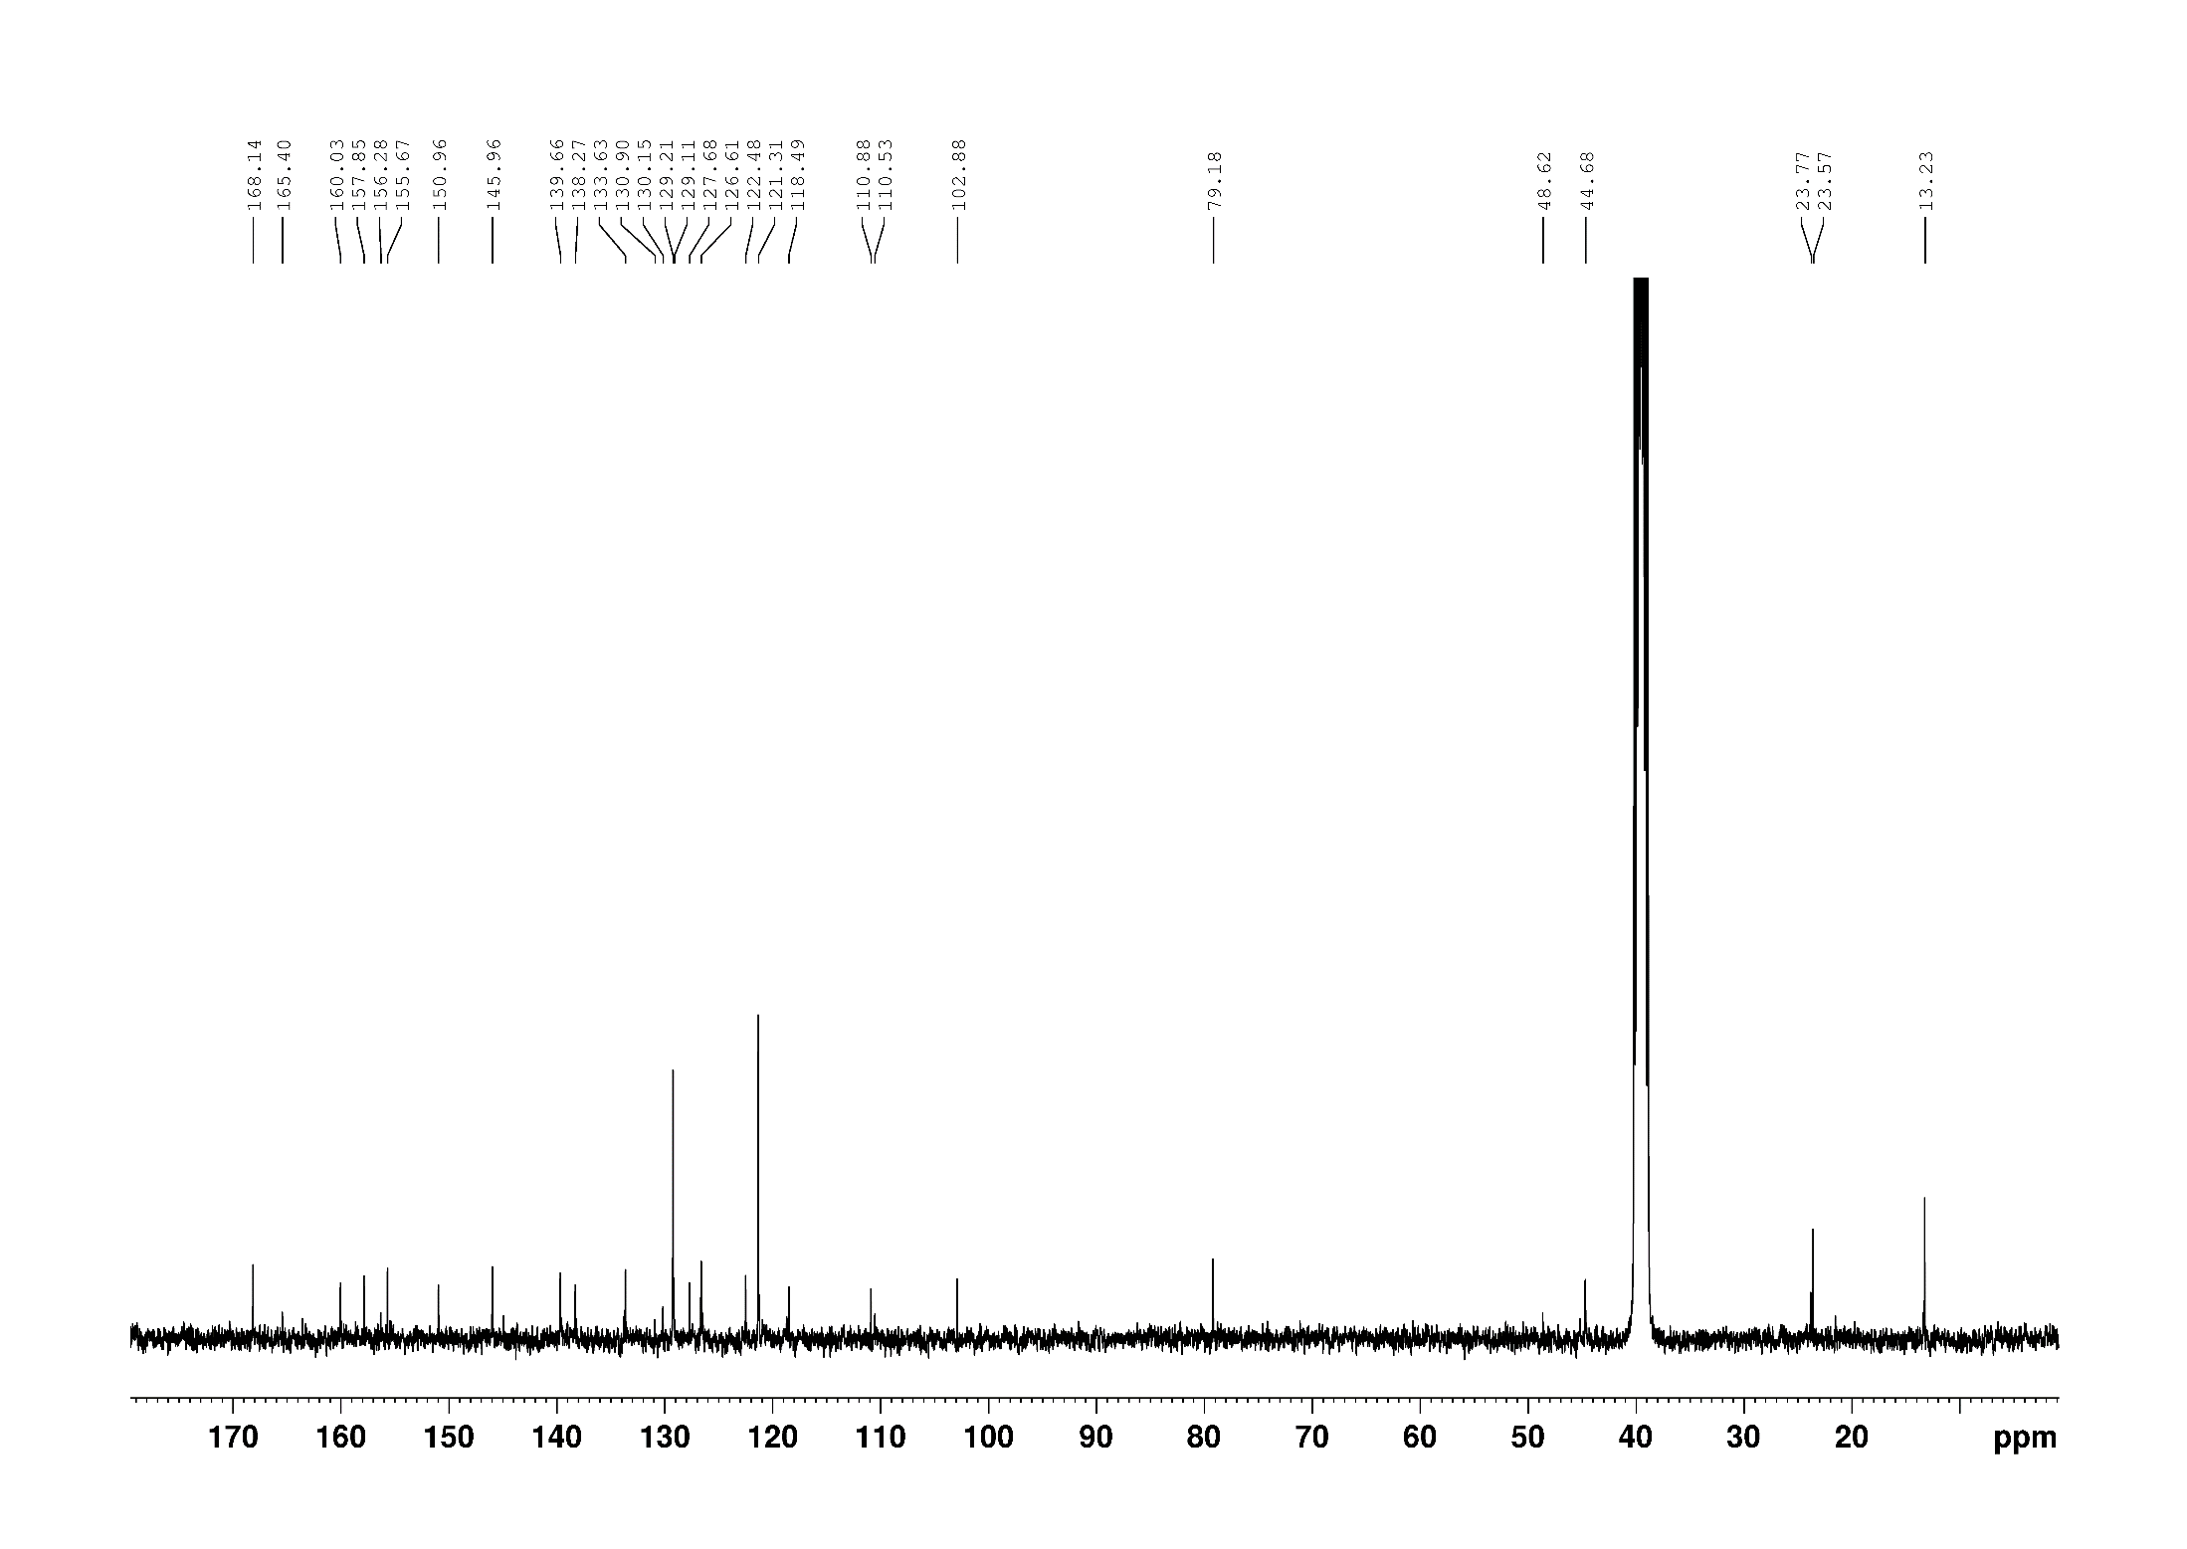

**Figure S23.** 13C NMR spectrum of compound **5g** (DMSO-*d6*, 100MHz)

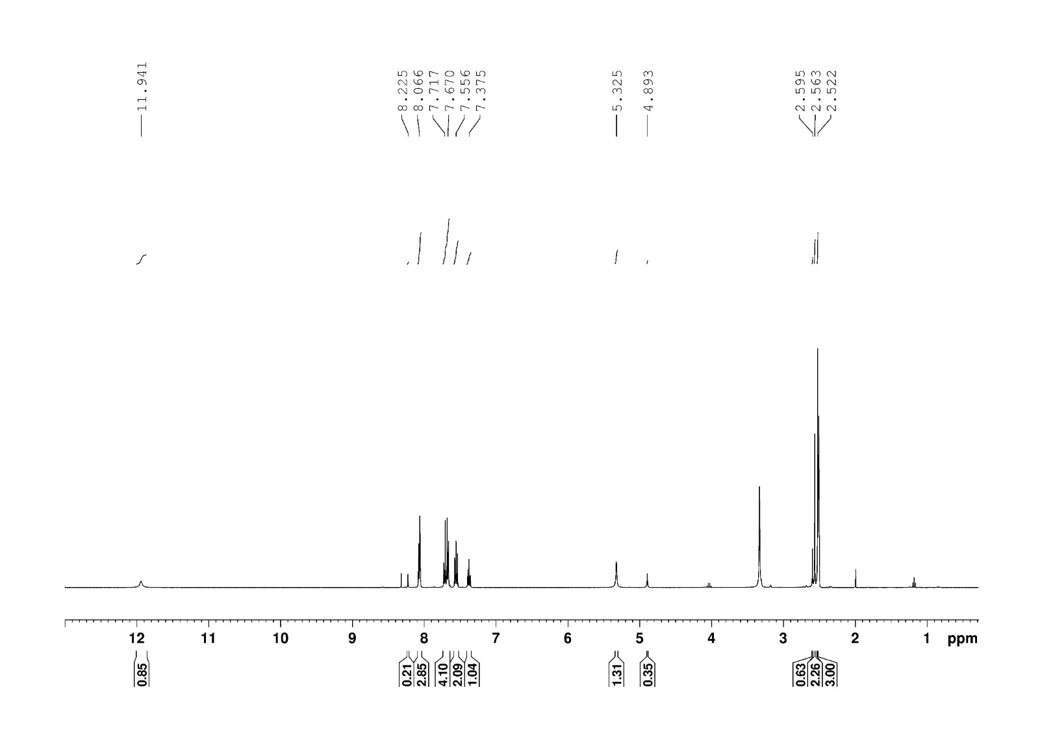

**Figure S24.** 1H NMR spectrum of compound **5h** (DMSO-*d6*, 400MHz)

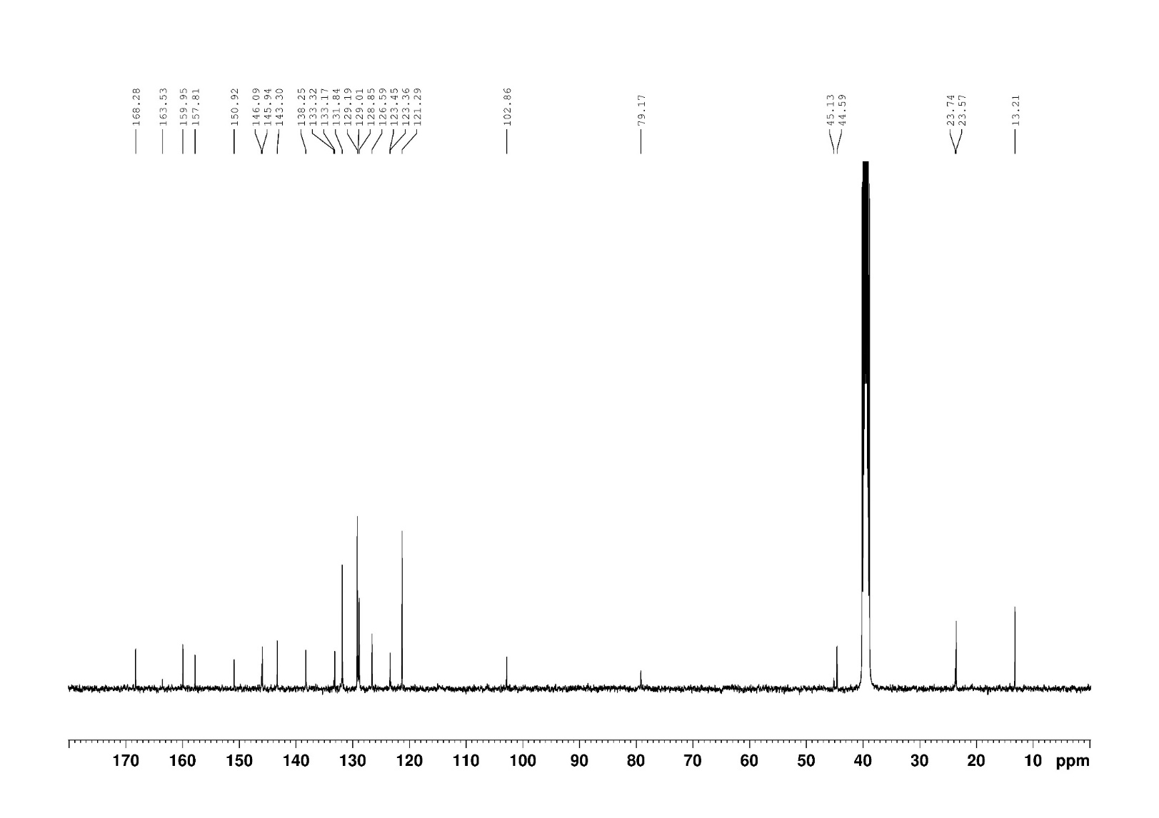

**Figure S25.** 13C NMR spectrum of compound **5h** (DMSO-*d6*, 100MHz)



**Figure S26.** HR-ESI-MS spectrum of compound **2**.



**Figure S27.** HR-ESI-MS spectrum of compound **3**.



**Figure S28.** HR-ESI-MS spectrum of compound **4**.



**Figure S29.** HR-ESI-MS spectrum of compound **5a**.



**Figure S30.** HR-ESI-MS spectrum of compound **5b**.



**Figure S31.** HR-ESI-MS spectrum of compound **5c**.



**Figure S32.** HR-ESI-MS spectrum of compound **5d**.



**Figure S33.** HR-ESI-MS spectrum of compound **5e**.



**Figure S34.** HR-ESI-MS spectrum of compound **5f**.



**Figure S35.** HR-ESI-MS spectrum of compound **5g**.



**Figure S36.** HR-ESI-MS spectrum of compound **5h**.