Appendix A

Abbreviations
AFM – Atomic Force Microscopy
ATR – Attenuated Total Reflectance
BET – Brunauer, Emmett and Teller Analysis
CD – Circular Dichroism
CV – Cyclic Voltammetry
DLS – Dynamic Light Scattering
DRS – Differential Reflectance Spectroscopy
DSC – Differential Scanning Calorimetry
EDS/EDX/EDAX – Energy-Dispersive X-Ray Spectroscopy
EELS – Electron Energy Loss Spectroscopy
ESI-MS – Electrospray Ionisation Mass Spectroscopy
FESEM – Field Emission Scanning Electron Microscopy
FTIR – Fourier-Transform Infrared Spectroscopy
GC-MS – Gas Chromatography-Mass Spectrometry
HRSEM – High Resolution Scanning Electron Microscopy
HRTEM – High Resolution Transmission Electron Microscopy
ICP-OES – Inductively Coupled Plasma-Optical Emission Spectrometry
NAA – Neutron Activation Analysis
NP – Nanoparticle
NTA – Nanoparticle Tracking Analysis
PL – Photoluminescence
SAED – Selected Area Electron Diffraction
SEM – Scanning Electron Microscopy
TEM – Transmission Electron Microscopy
TGA – Thermogravimetric Analysis
UV-vis – Ultra Violet-visible spectroscopy
VSM – Vibrating-Sample Magnetometer
XPS – X-Ray Photoelectron Spectroscopy
XRD – X-Ray Powder Diffraction

Table S1: The Subclasses of Terpenoids
Class | Example Name | Structure | No. of Isoprene Units | General Formula
Hemiterpenoids | Isoprene | 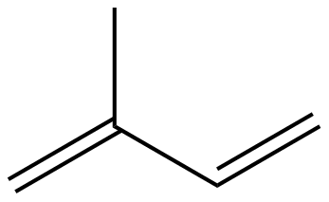 | 1 | C₅H₈
Monoterpenoids | Myrcene | 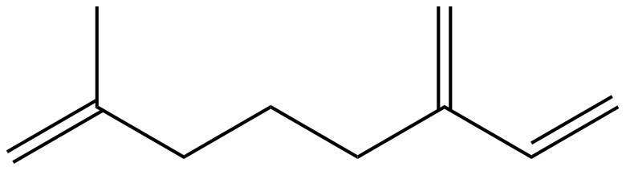 | 2 | C₁₀H₁₆
Sesquiterpenoids | α-Himachalene | 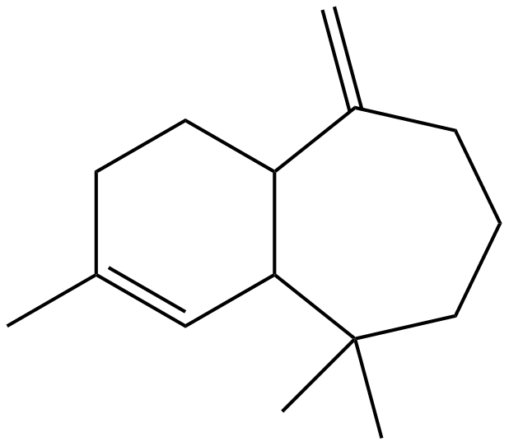 | 3 | C₁₅H₂₄
Diterpenoids | Tanshinone | 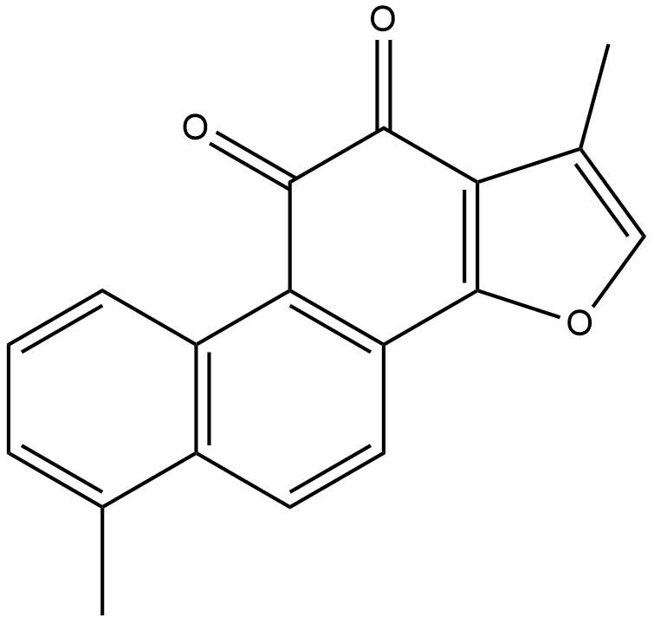 | 4 | C₂₀H₃₂
Sesterterpenoids | Ophiobolin A | 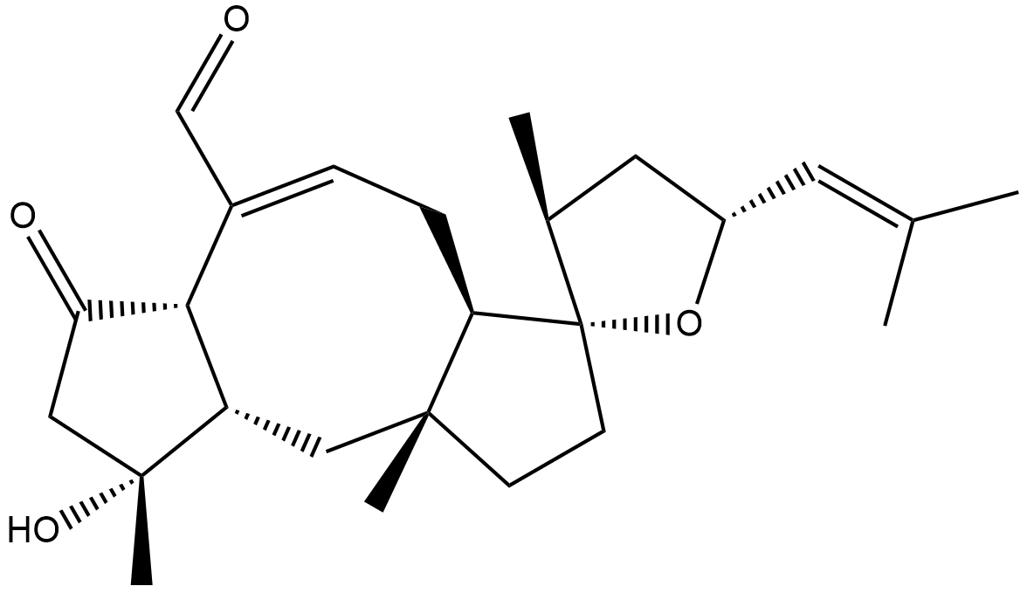 | 5 | C₂₅H₄₀
Triterpenoids | Squalene | 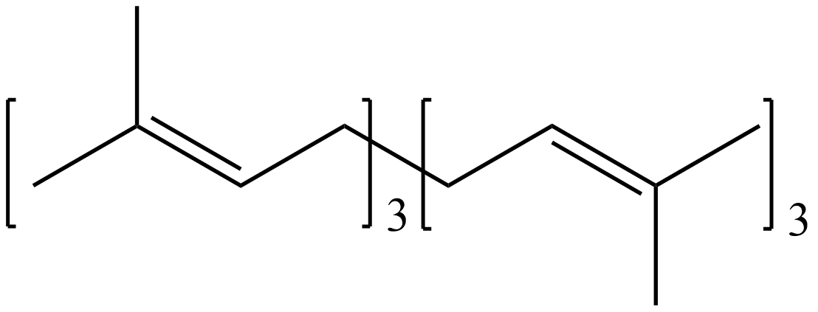 | 6 | C₃₀H₄₈
Tetraterpenoids | Cryptoxanthin | 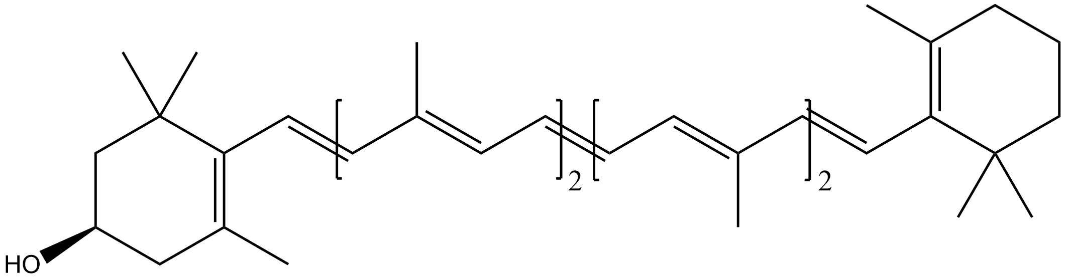 | 8 | C₄₀H₆₄
Polyterpenoids | Dolichol | 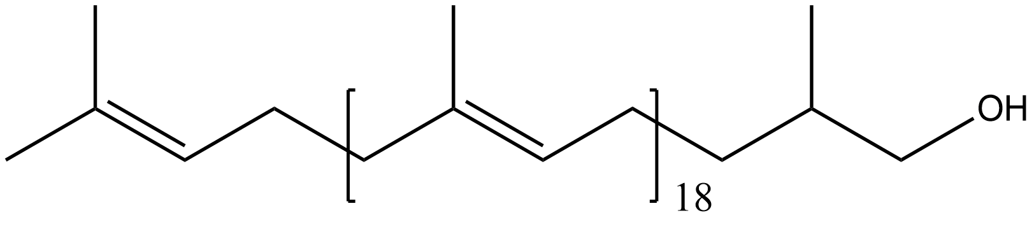 | >8 | (C₅H₈)_{n}

Non-Flavonoids
Class | Structure | General Formula
Hydroxybenzoic Acids | 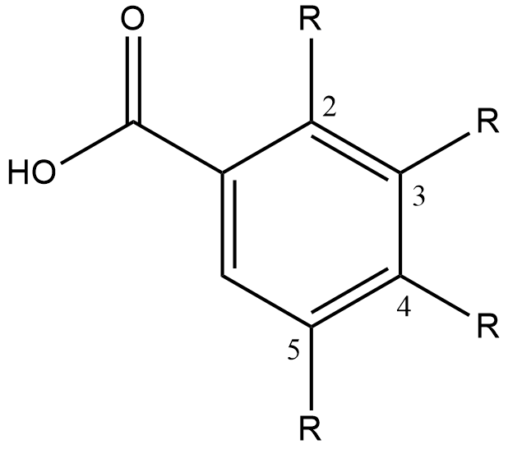 | C₇H₆O₃
Hydroxycinnamic Acids | 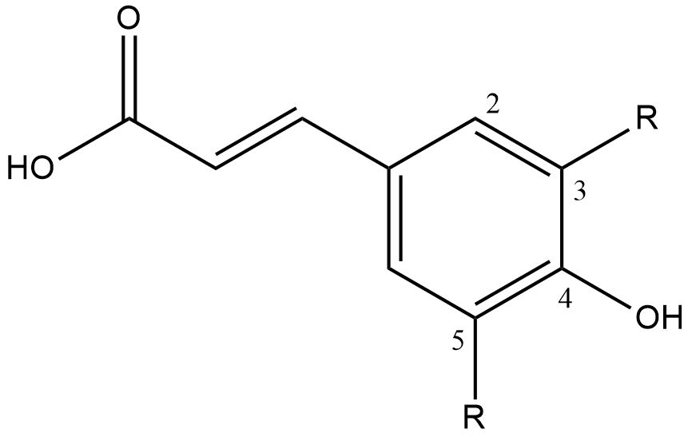 | C₉H₈O₃
Stilbenes | 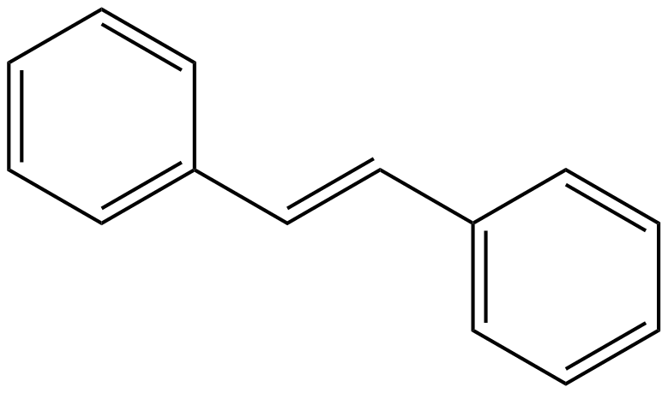 | C₁₄H₁₂

Table S2: The Subclasses of Phenolics
Flavonoids
Class | Structure | General Formula
Flavones | 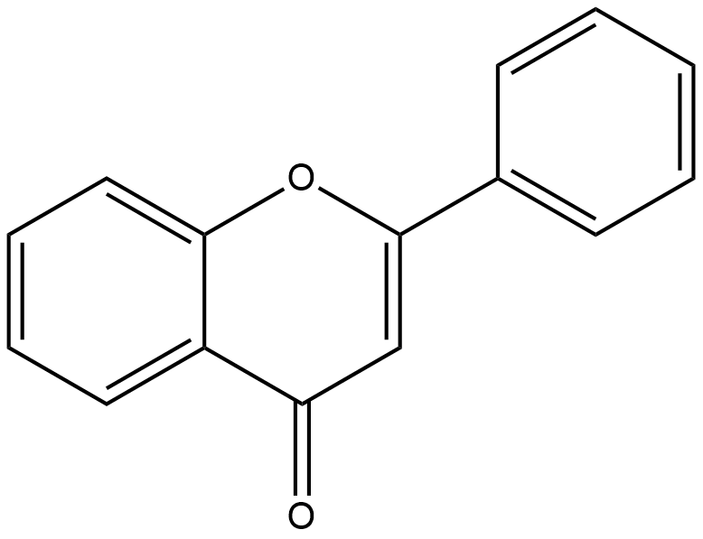 | C₁₅H₁₀O₂
Flavonols | 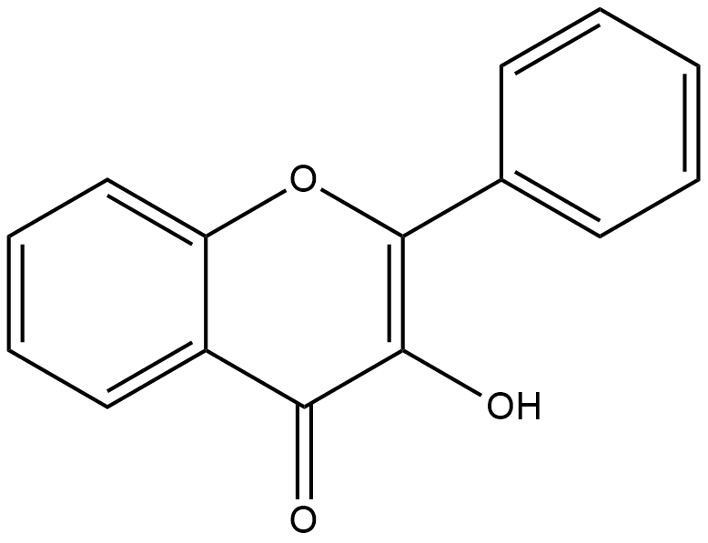 | C₁₅H₁₀O₃
Flavan-3-ols | 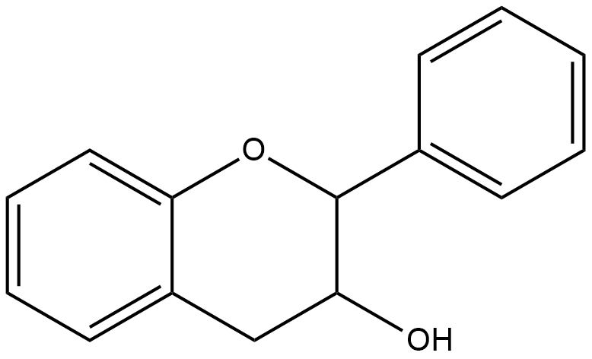 | C₁₅H₁₄O₂
Flavanones | 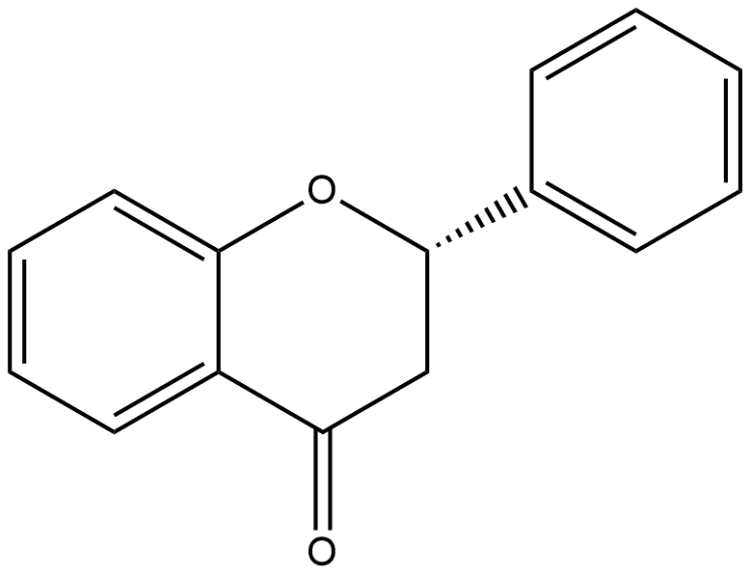 | C₁₅H₁₂O₂
Isoflavones | 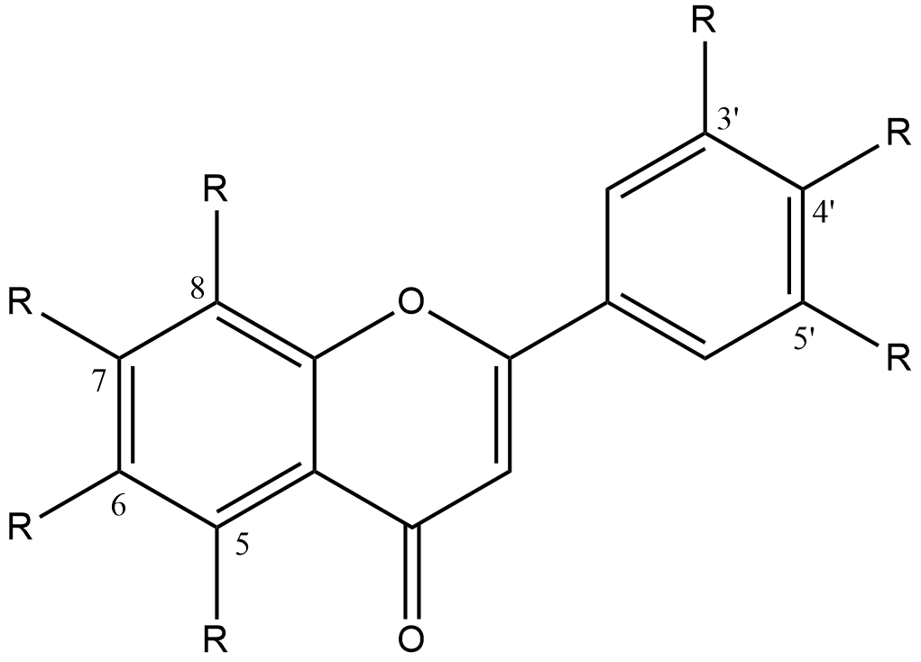 | C₁₅H₁₀O₂
Anthocyanins | 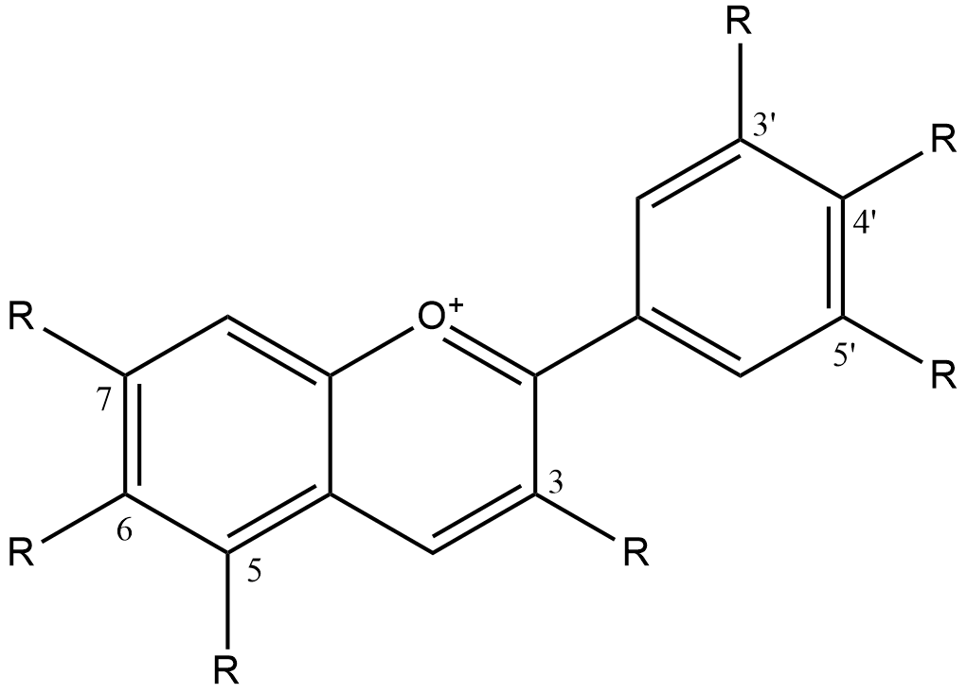 | C₁₅H₁₁O⁺
Chalcones | 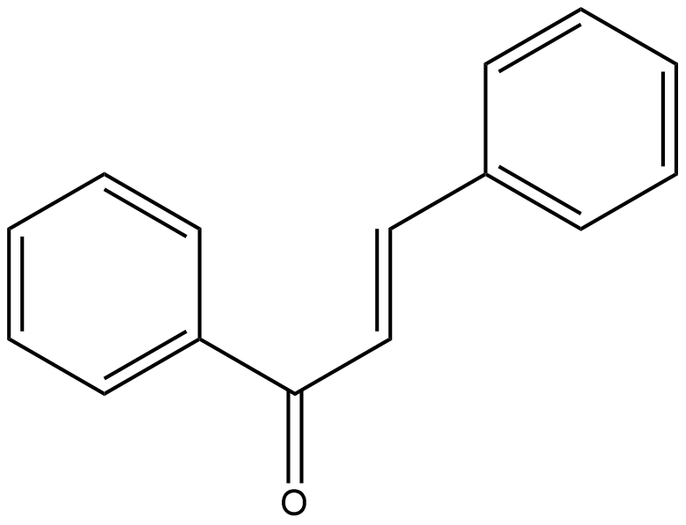 | C₁₅H₁₂O

Table S3: The Subclasses of Alkaloids
Precursor | Structure | Alkaloid Class
Tryptophan | 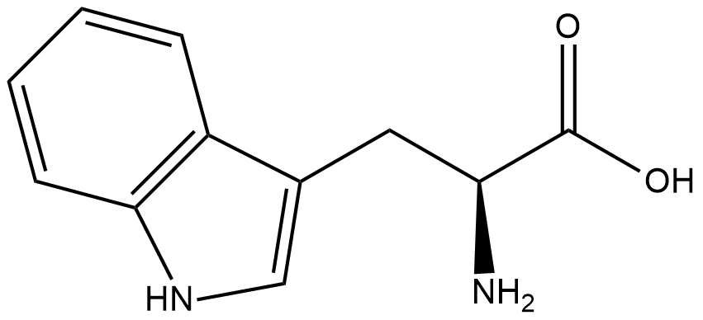 | Indole, Terpenoid indole, Quinoline, Pyrroloindole, and Ergot
Phenylalanine | 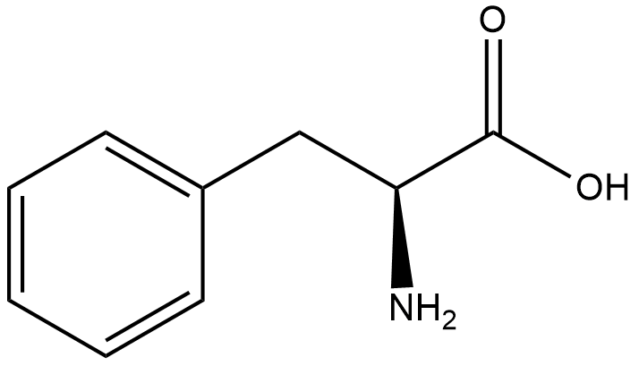
Ornithine | 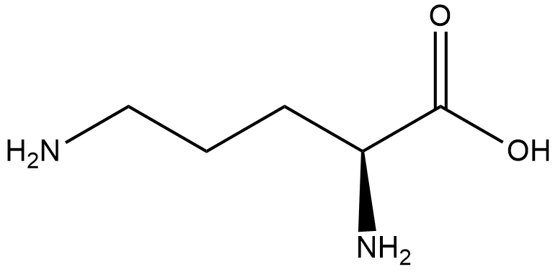 | Pyrrolidine, Tropane, and Pyrrolizidine
Tyrosine | 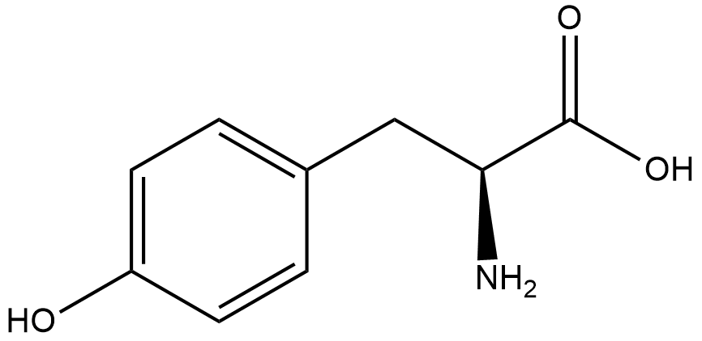 | Phenylethylamino- and Isoquinoline
Anthranilic Acid | 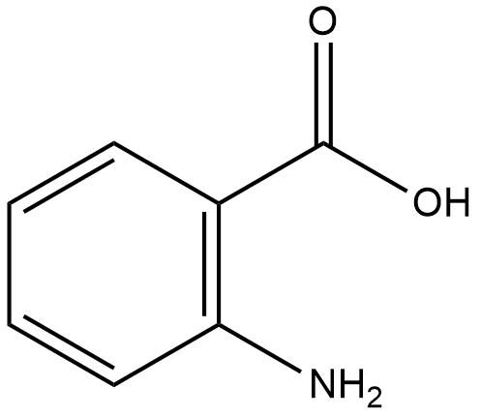 | Quinazoline, Quinoline, and Acridine
Histidine | 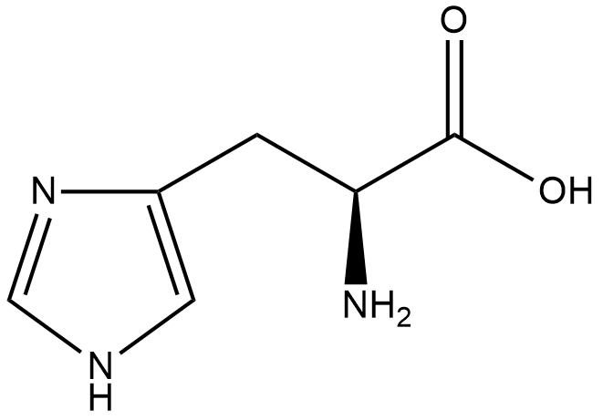 | Imidazole
Nicotinic Acid | 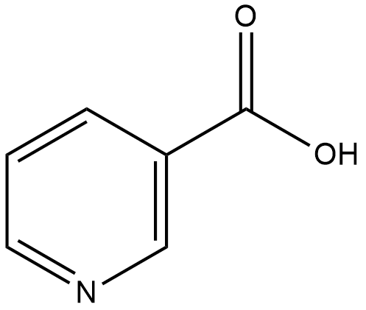 | Pyridine
Lysine | 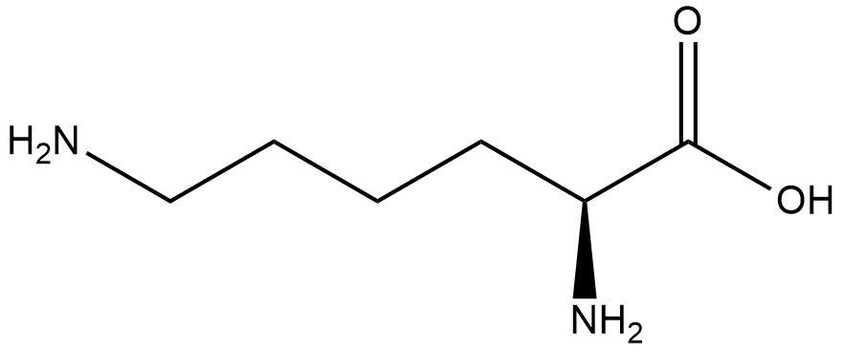 | Piperidine, Quinolizidine, Indolizidine
Leucine | 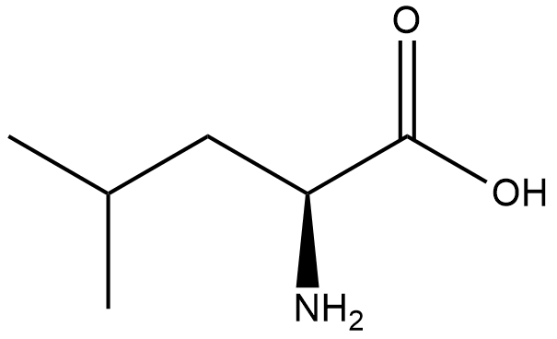 | Pyrrole
Purine | 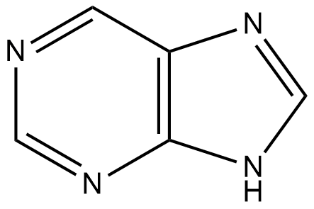
Geranylgeranyl-diphosphate | 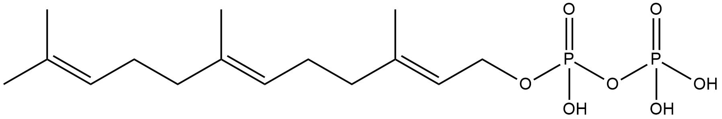 | Terpenoidic
Cholesterol | 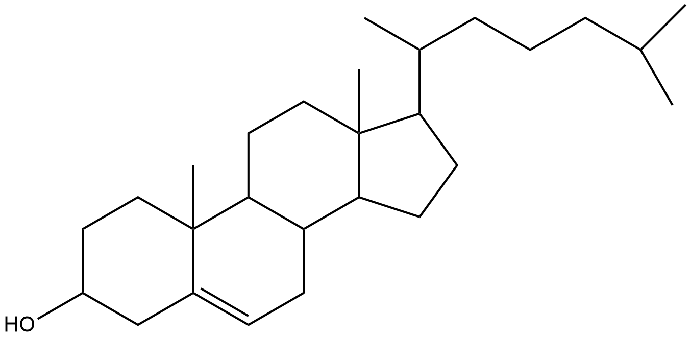 | Steroidal

Class | Structure | General Formula
Ursanes | 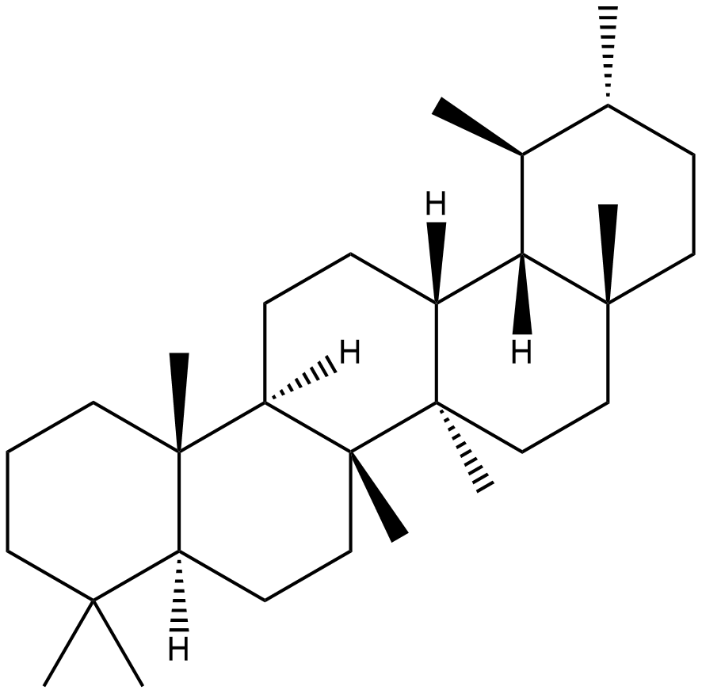 | C₃₀H₅₂
Cycloartanes | 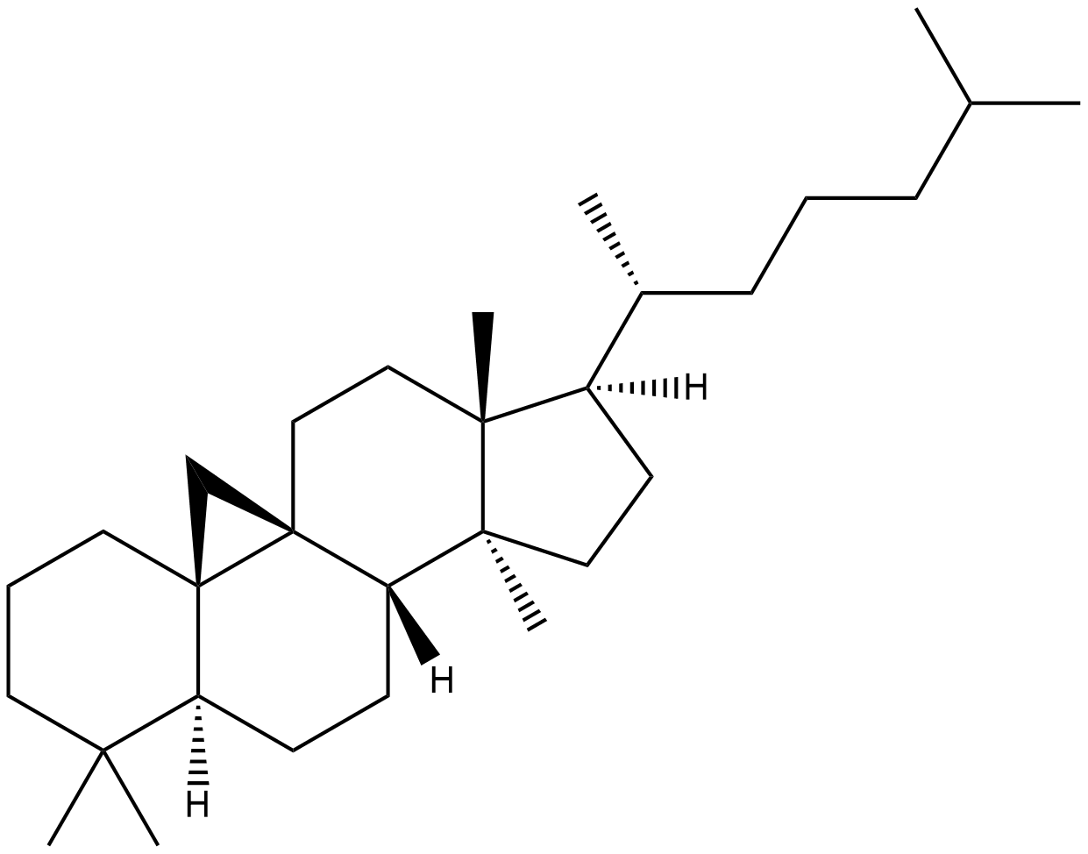 | C₃₀H₅₂
Lanostanes | 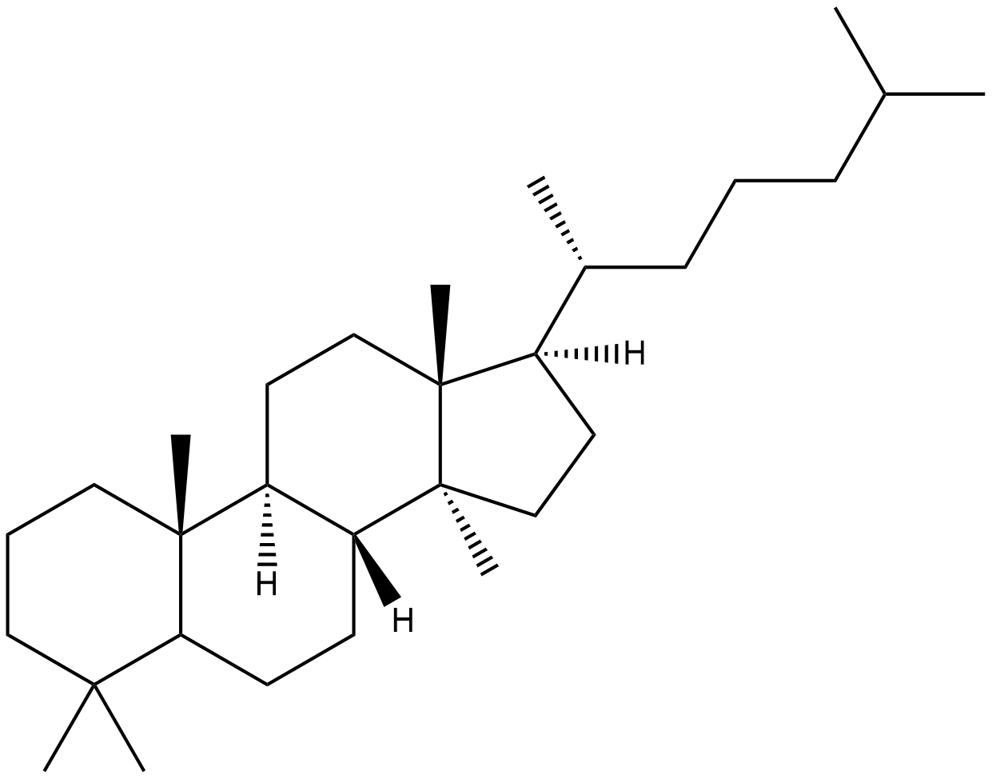 | C₃₀H₅₄
Cucurbitanes | 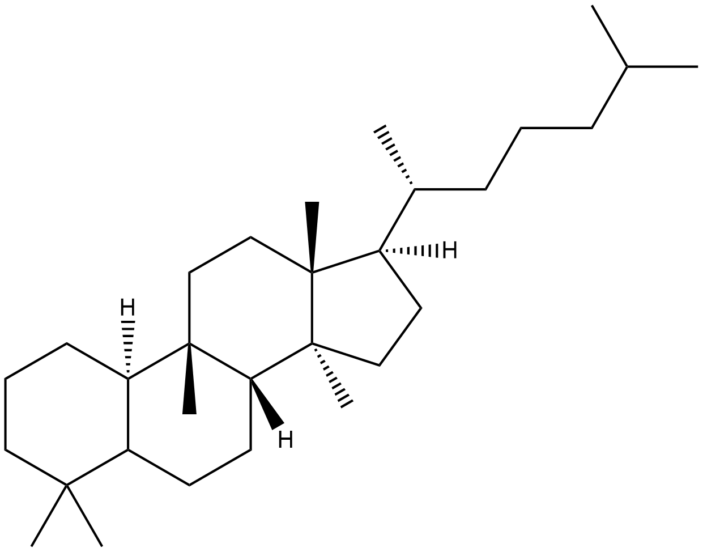 | C₃₀H₅₄
Steroids | 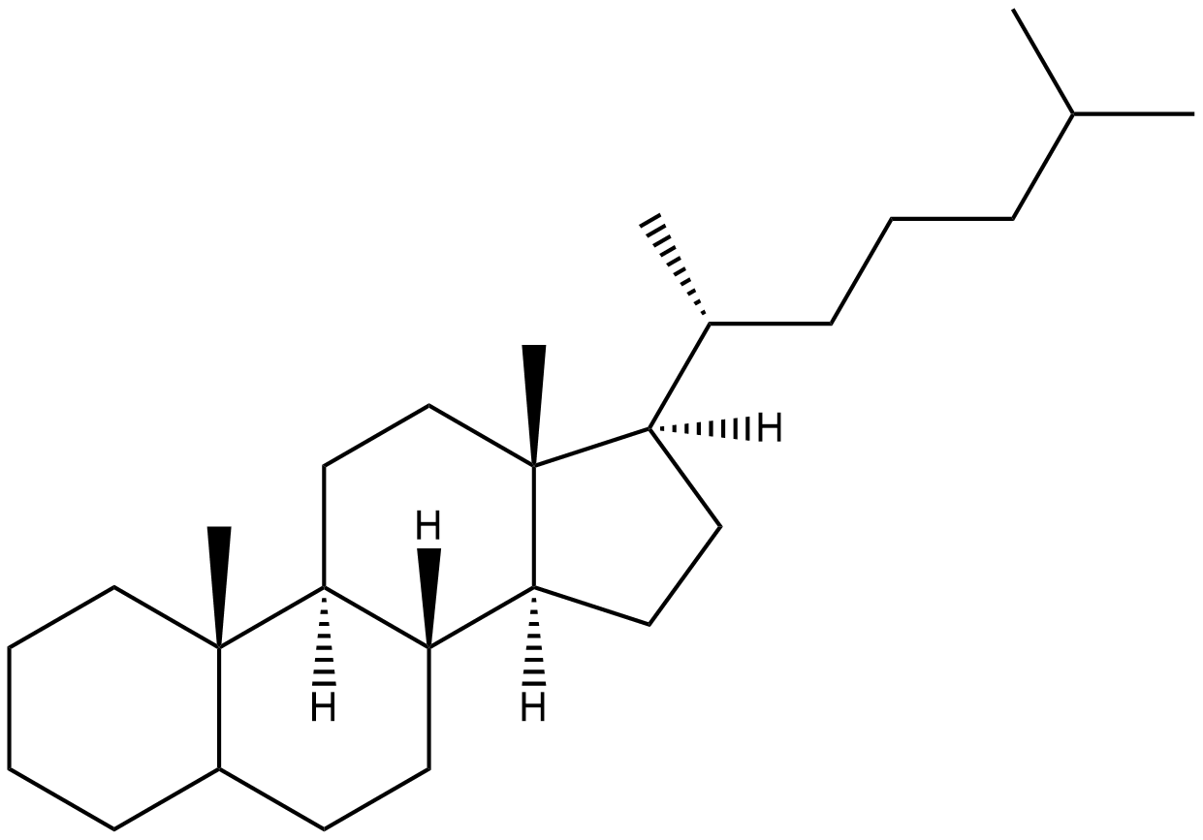 | C₂₇H₄₈

Table S4: The Subclasses of Saponins
Class | Structure | General Formula
Dammaranes | 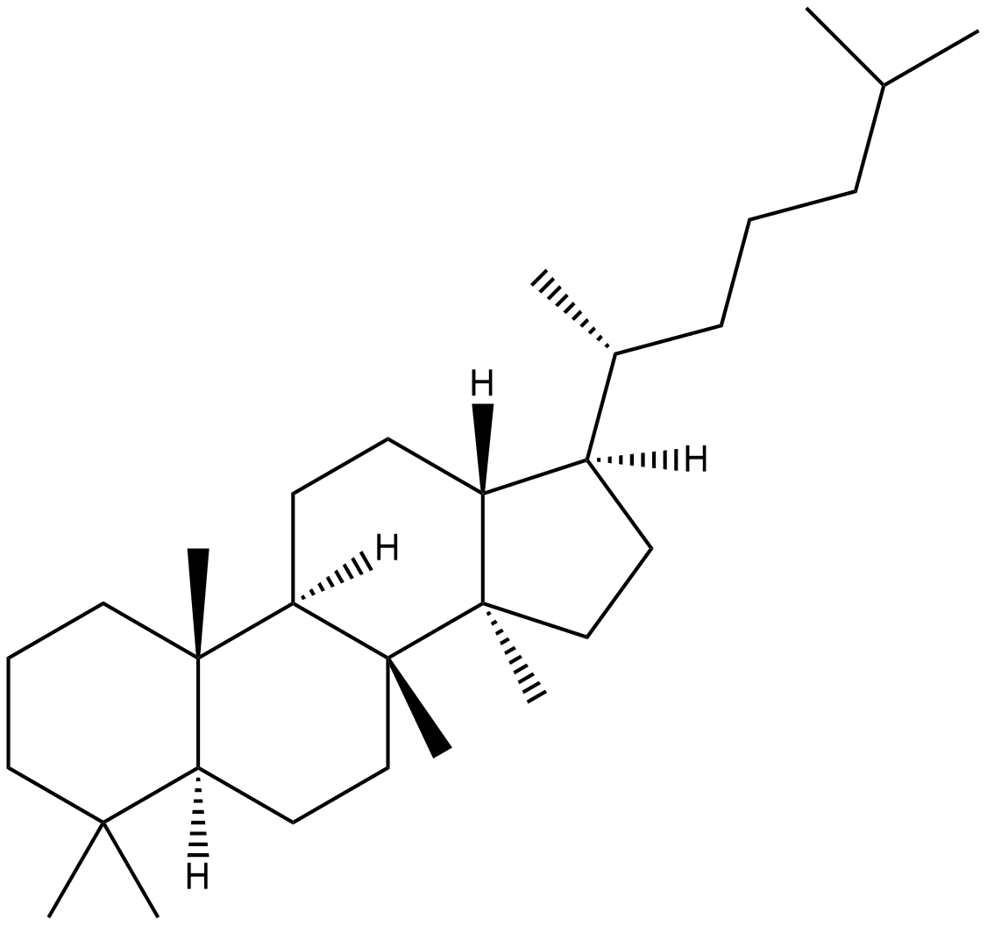 | C₃₀H₅₄
Tirucallanes | 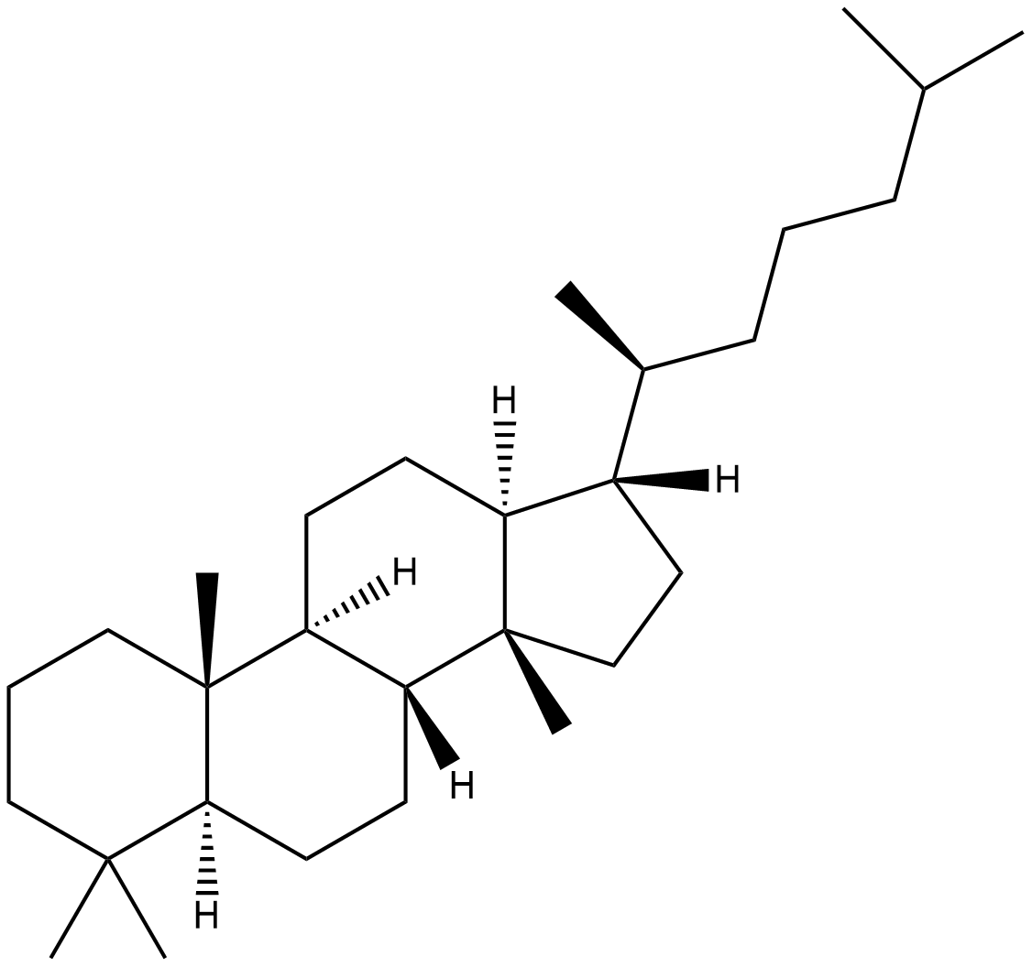 | C₃₀H₅₄
Lupanes | 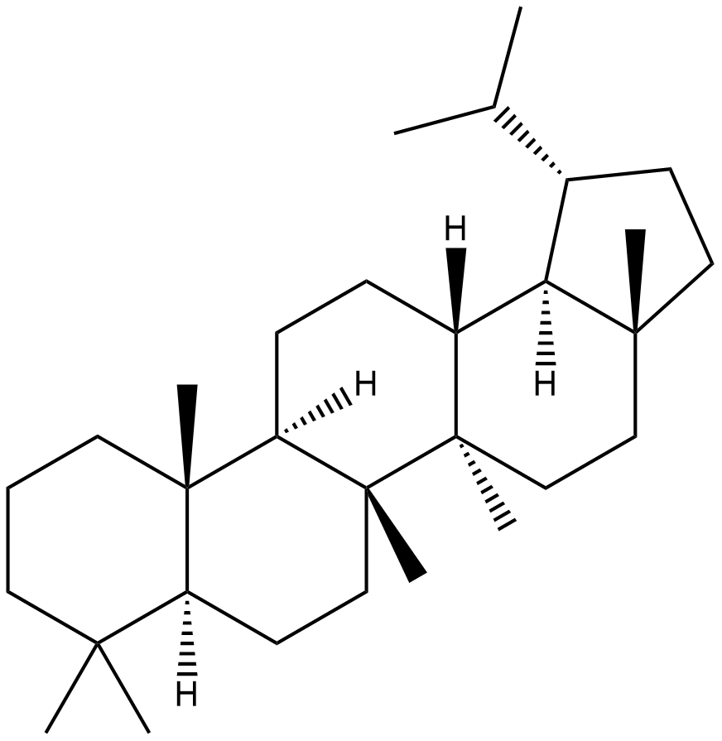 | C₃₀H₅₂
Hopanes | 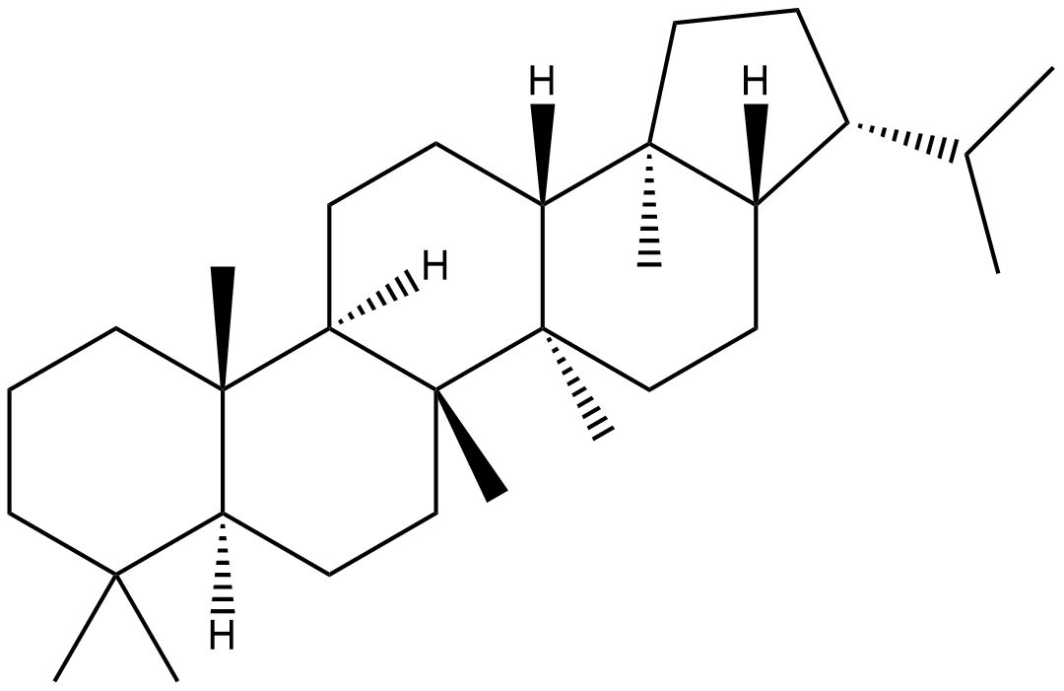 | C₃₀H₅₂
Oleananes | 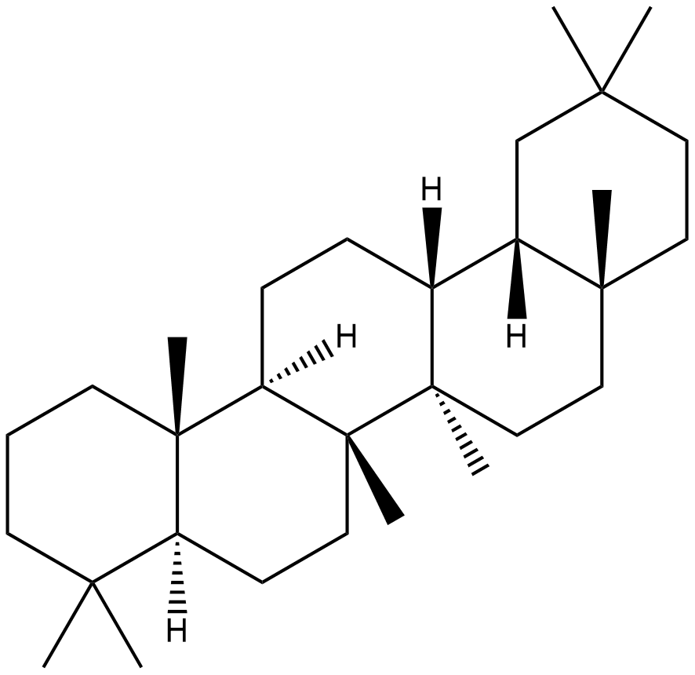 | C₃₀H₅₂
Taraxastanes | 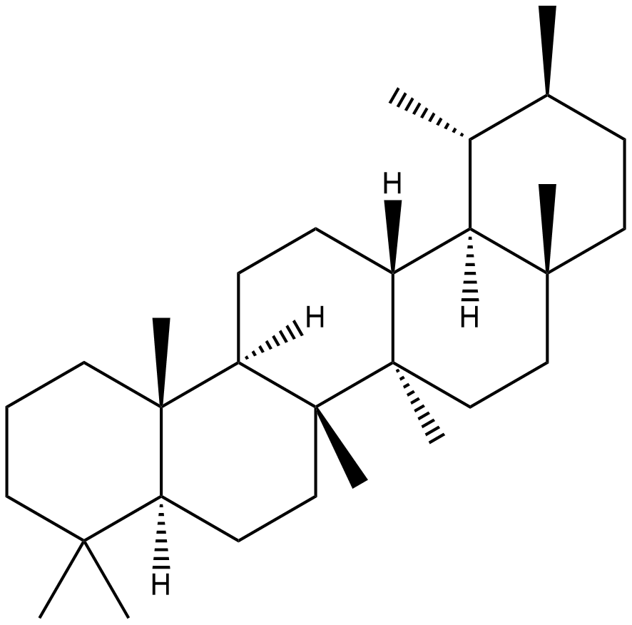 | C₃₀H₅₂

Table S5: The Subclasses of Carbohydrates
Class | Name | Structure | Formula
Monosaccharides | Glucose | 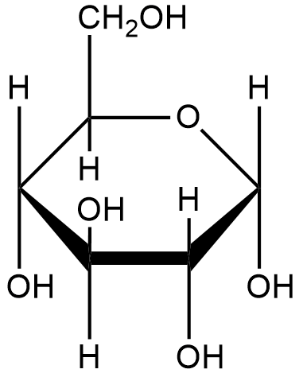 | C₆H₁₂O₆
Oligosaccharides | Raffinose | 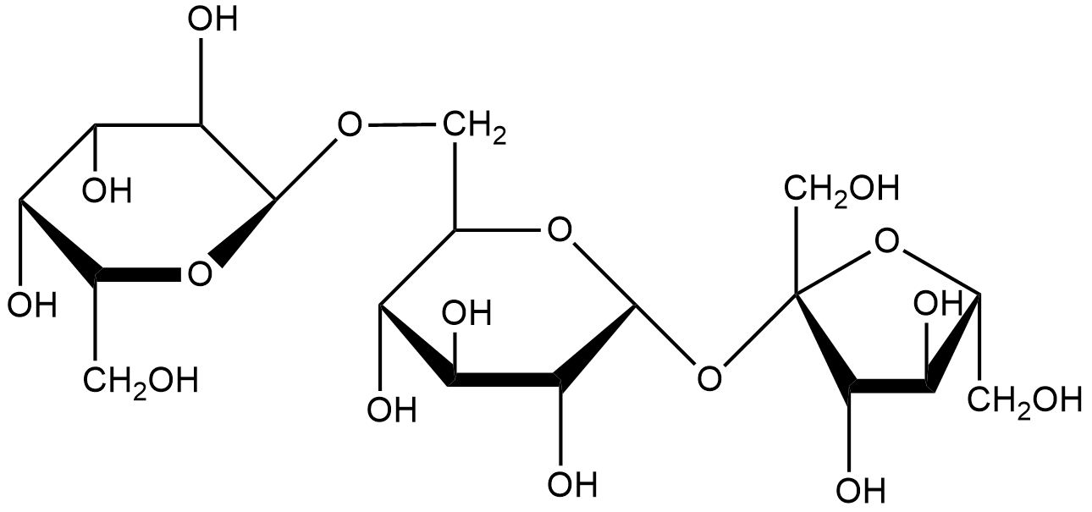 | C₁₈H₃₂O₁₆
Polysaccharides | Amylose Starch | 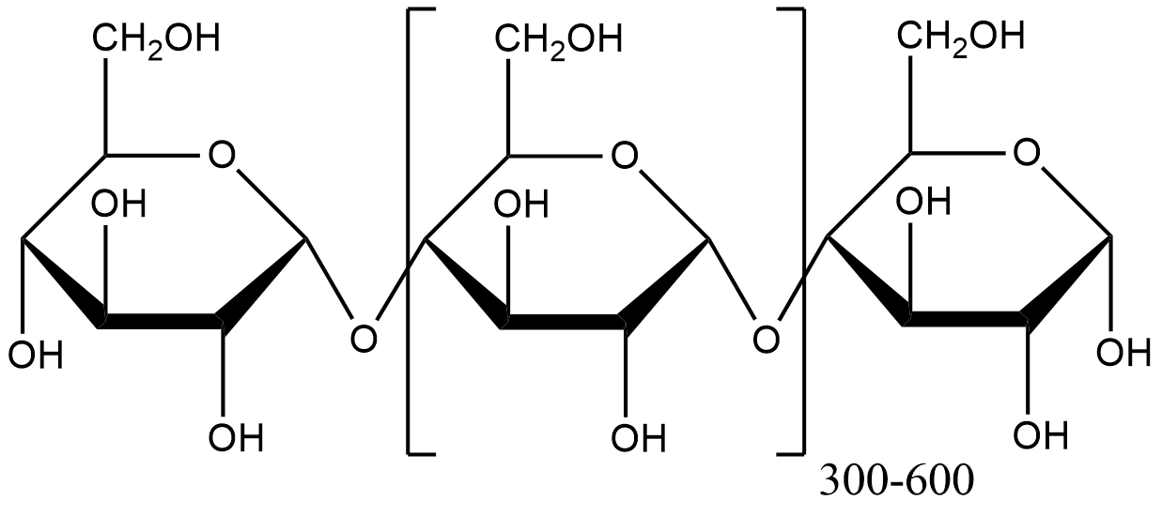 | (C₆H₁₀O₅)₃₀₀₋₆₀₀

Table S6: The Plant-mediated synthesis of Titanium Dioxide Nanoparticles
Plant Species | Nanoparticle | Particle Size (nm) | Morphology | Characterisation | Application | Reference
Acacia senegal | TiO₂ | 9 | Spherical | XRD, FTIR, Raman, SEM-EDX, TEM, HR-TEM and UV | Organic dye removal | (Saranya et al., 2018a)
Acanthopyllum laxiusculum | TiO₂ | 20-25 | Spherical | XRD, FTIR, EDAX and TEM |  | (Madadi & Lotfabad, 2016)
Ageratina altissima | TiO₂ | 60-100 | Spherical | XRD, FTIR and FSEM | Photocatalytic activity | (Ganesan et al., 2016)
Allium cepa | TiO₂ | 89-96 |  | AFM, SEM, TEM, XRD, UV and FTIR | Antimicrobial activity | (Abdul jalill, 2018)
Aloe vera | TiO₂ | 30 | Irregular | SEM, TEM, XRD, UV and FTIR |  | (Khadar et al., 2016)
Alpinia calcarata | TiO₂ | 60-130 | Spherical | UV, FTIR and SEM | Anti-inflammatory & Antibacterial activity | (Pratheema, 2018)
Amylum | TiO₂ | 9 | Spherical | XRD, SEM, BET and NAA | Photocatalytic activity | (Muniandy et al., 2017)
Anisomeles malabarica | TiO₂ | 18 |  | XRD |  | (P. Saravanan et al., 2016)
Annona squamosa | TiO₂ | 23 | Spherical | XRD, TEM, SEM and EDS |  | (S. Roopan et al., 2012)
Arnicae anthodium | TiO₂ | 30 |  | UV, TXRF, FTIR, XRD and SEM-EDS |  | (R Dobrucka, 2017)
Azadirachta indica | TiO₂ | 15-50 | Spherical | SEM, TEM, FTIR and XRD | Antibacterial activity | (Thakur et al., 2019)
Calotropis gigantea | TiO₂ | 10 | Spherical | SEM, EDX and XRD | Acaricidal activity | (Marimuthu et al., 2013)
Capsicum annum | TiO₂ | 90-104 |  | AFM, SEM, TEM, XRD, UV and FTIR | Antimicrobial activity | (Abdul jalill, 2018)
Cassia fistula | TiO₂ |  | Spherical | UV, FTIR, XRD, SEM, EDAX and TGA | Antibacterial activity | (Swathi et al., 2014)
Catharanthus roseus | TiO₂ | 65 | Irregular | XRD, FTIR, SEM and AFM | Antiparasitic activity | (Velayutham et al., 2012)
Cicer arietinum | TiO₂ | 14 | Spherical | TEM, XRD, UV and TGA | Lithium ion batteries | (Kashale et al., 2016)
Cinnamomum tamala | TiO₂ | 23 | Irregular | XRD, FTIR, DLS, TEM, SAED and EDX | Cytotoxicity against D145 cells | (He et al., 2017)
Citrus limon | TiO₂ |  |  | FTIR, SEM and EDAX | Antibacterial activity | (Farook et al., 2017)

Plant Species | Nanoparticle | Particle Size (nm) | Morphology | Characterisation | Application | Reference
Citrus sinensis | TiO₂ | 19 | Tetragonal | TEM, XRD, TGA and PSA |  | (Rao et al., 2015)
Cochlospermum gossypium | TiO₂ | 8-13 | Spherical | XRD, FTIR, SEM-EDX, TEM, HR-TEM, UV and BET | Photocatalytic degradation of organic dye | (Saranya et al., 2011)
Curcuma longa | TiO₂ | 23-44 | Spherical | AFM, UV, XRD and SEM | Antifungal & Anti-pathogenic activity | (Abdul Jalill et al., 2016)
Cymbopogon citratus | Fe-TiO₂ | 7-26 | Irregular | SEM-EDS, XRD, UV and TEM | Photocatalytic activity in wastewater | (Solano et al., 2019)
Cynodon dactylon | TiO₂ | 13-34 | Irregular | XRD, FTIR, Raman and SEM | Antibacterial & Anticancer activity | (Hariharan et al., 2017)
Echinacea purpurea | TiO₂ | 120 | Spherical | UV, SEM, TXRF and FTIR |  | (Renata Dobrucka, 2017)
Eclipta prostrata | TiO₂ | 50 | Spherical | FTIR, XRD, AFM and FESEM |  | (Rajakumar et al., 2012)
Euphorbia prostrata | TiO₂ | 84 | Spherical | SAED, TEM and XRD | Cell death in Leishmania donovani | (Zahir et al., 2015)
Euphorbia thymifolia | Pd-TiO₂ | 19-29 |  | FESEM, EDS, TEM and XRD | Dye degradation | (Maham, Nasrollahzadeh, et al., 2017)
Glycosmis cochinchinensis | TiO₂ | 40 | Spherical | UV, FTIR, SEM-EDS and TEM | Photocatalytic & Antimicrobial activity | (Rosi & Kalyanasundaram, 2018)
Hibiscus rosa-sinensis | TiO₂ |  | Polydispersed | XRD, SEM and FTIR | Antibacterial activity | (Sahaya et al., 2014)
Jatropha curcas | TiO₂ | 13 | Spherical | UV, FESEM, EDS, FTIR, XRD, DLS, BET and BJH | Photocatalytic degradation of tannery wastewater | (Goutam et al., 2018)
Lagenaria siceraria | TiO₂ | 7 | Spherical | FTIR, SEM, EDAX, TEM and XRD | Antimicrobial activity & Free radical scavenging activity | (Kalyanasundaram & Prakash, 2015)
Momordica charantia | TiO₂ | 70 | Irregular/Spherical | UV, XRD, FTIR, HRTEM, EDX, DLS and Zeta-potential | Antimalarial activity | (Gandhi et al., 2018)

Plant Species | Nanoparticle | Particle Size (nm) | Morphology | Characterisation | Application | Reference
Morinda citrifolia | TiO₂ | 15-19 | Spherical | EDAX, FTIR, SEM and XRD | Antimicrobial activity | (Sundrarajan et al., 2017)
Moringa Oleifera | TiO₂ | 100 | Spherical | UV and SEM | Wound-healing activity | (Sivaranjani & Philominathan, 2016)
Nerium Oleander | TiO₂ | 7 | Spherical | FTIR, FESEM, EDX, XRD and UV | Photocatalytic activity | (Deshmukh et al., 2018)
Nyctanthes arbor-tristis | TiO₂ | 100-150 | Spherical | XRD, PSA and SEM |  | (Sundrarajan & Gowri, 2011)
Ocimum basilicum | TiO₂ | 32 | Irregular/Spherical | XRD, PSA, SEM and FTIR |  | (Alapati & Kantheti, 2018)
Peltophorum pterocarpum | TiO₂ | 20-80 |  | XRD, HR-TEM and XANES |  | (S. Saravanan et al., 2016)
Phyllanthus niruri | TiO₂ | 32 | Spherical | XRD, FTIR, TEM and UV | Photocatalytic activity | (Shanavas et al., 2019)
Piper betle | TiO₂ | 7 | Spherical | FTIR, UV, XRD and SEM | Antibacterial activity | (Hunagund et al., 2016)
Pithecellobium dulce | TiO₂ | 6 | Spherical | FTIR, SEM, EDAX, TEM and XRD | Antimicrobial activity & Free radical scavenging activity | (Kalyanasundaram & Prakash, 2015)
Psidium guajava | TiO₂ | 33 | Spherical | XRD, FTIR, FESEM and EDX | Antibacterial & Antioxidant activity | (Santhoshkumar et al., 2014)
Punica granatum | TiO₂ | 75-90 |  | SEM and FTIR | Pharmaceuticals | (Dubey & Singh, 2019)
Senna auriculata | TiO₂ | 38 | Spherical | UV, FTIR, FSEM and XRD |  | (Valli & Geetha, 2015)
Sesbania grandiflora | TiO₂ | 43-56 | Triangular, Cubic and Spherical | FTIR, SEM-EDX, UV and XRD | Toxicity in zebrafish embryos | (Srinivasan et al., 2019)
Solanum trilobatum | TiO₂ |  |  |  | Toxic activity | (Vadlapudi & Behara, 2012)
Taraxacum officinale | TiO₂ |  | Rod | XRD, SEM and TEM | Photocatalytic activity | (Bao et al., 2012)
Trigonella foenum-graecum | TiO₂ | 20-90 | Spherical | FTIR, UV, XRD, HR-TEM and HR-SEM | Antimicrobial activity | (Subhapriya & Gomathipriya, 2018)
Vigna radiata | TiO₂ |  | Oval | FTIR and SEM | Anti-bacterial activity | (Chatterjee et al., 2016)
Vigna unguiculata | TiO₂ |  | Oval | FTIR and SEM | Antimicrobial & Cytotoxic Effects | (Chatterjee et al., 2017)

Table S7: The Plant-Mediated Synthesis of Iron & Iron Oxide Nanoparticles
Plant Species | Nanoparticle | Particle Size (nm) | Morphology | Characterisation | Application | Reference
Abelmoschus esculentus | Fe | 24-34 | Spherical | XRD, UV, FTIR, FESEM and TEM | Antibacterial activity | (Pande et al., 2015)
Acacia nilotica | Fe | 229 | Irregular | FTIR, UV, DLS, TEM, SEM, EDS and XRD | Catalytic, adsorption and antibacterial activity | (Da’na et al., 2018)
Ailanthus excelsa | α-Fe₂O₃ | 40 | Spherical | FTIR, XRD, SEM and UV | Mortality efficacy on green peach Aphid | (Asoufi et al., 2018)
Albizia lebbeck | Fe |  |  | XRD and FTIR | Dye degradation | (Bharadwaj et al., 2016)
Amaranthus dubius | Fe | 43-200 | Spherical | UV, FTIR, SEM, XRD, PSD and Zeta potential | Photocatalytic activity | (Harshiny et al., 2015)
Apium graveolens | Fe₂O₃ | 20-99 | Irregular, Cubic and Hexagonal | XRD, FESEM and UV | Antibacterial activity | (Aziz & Urabe, 2019)
Artemisia vulgaris | Fe₃O₄ | 30 | Spherical | TEM, PSA, XRD, FTIR, VSM and TGA | Dye degradation | (Beheshtkhoo et al., 2018)
Artocarpus altilis | Fe₂O₃ | 36-44 | Spherical | UV, FTIR and SEM | Antibacterial, biofilm inhibition and dye degradation activities | (Kanchana & Zantye, 2018)
Avicennia marina | FeO | 30-100 | Cubic | UV, FTIR, SEM, AFM and XRD | Dye degradation | (Karpagavinayagam & Vedhi, 2019)
Azadirachta indica | Fe | 98-500 | Spherical | SEM, EDS, UV and FTIR | Antibacterial activity | (Devatha et al., 2018)
Camellia sinensis | Fe₂O₃ | 23-43 | Irregular, Cubic and Hexagonal | XRD, FESEM and UV | Antibacterial activity | (Aziz & Urabe, 2019)
Caricaya papaya | Fe₃O₄ | 33 | Capsule-like | FTIR, UV, XRD, SEM and EDS |  | (Latha & Gowri, 2014)
Carum carvi | Fe₂O₃ | 300 | Spherical | UV, XRD, and SEM | Anti-cancer drug adsorption | (Izadi et al., 2018)
Centella asiatica | Fe₂O₃ | 10-50 | Spherical | FTIR, XRD, EDX, VSM, SEM and TEM | Acute oral toxicity studies | (Pravallika et al., 2019)
Ceratonia siliqua | Fe₂O₃ | 7 | Spherical | TEM, SEM, EDX, XRD, BET, FESEM and Raman | AMX degradation | (Demirezen, Yıldız & Yılmaz, 2019)
Citrus maxima | Fe | 10-100 | Irregular | TEM, EDS, XPS, FTIR, DLS and Zeta potential |  | (Wei et al., 2016)

Plant Species | Nanoparticle | Particle Size (nm) | Morphology | Characterisation | Application | Reference
Citrus reticulum | α-Fe₂O₃ | 20-63 | Spherical | UV, TGA, XRD, FTIR, SEM and TEM | Dye degradation | (H. R. Ali et al., 2017)
Coffea arabica | Fe | 50-100 | Spherical | UV, XRD and SEM |  | (Pattanayak & Nayak, 2012)
Couroupita guianensis | Fe₃O₄ | 17 | Spherical and Polydispersed | UV, FTIR, XPS, DLS, XRD, AFM, HRTEM, VSM and Zeta potential | Cytotoxicity and antibacterial activity | (Sathishkumar et al., 2018)
Curcuma longa | Fe₃O₄ | 338,2-488,1 | Cubic | UV, SEM-EDX, XRD and FTIR | Wastewater treatment | (Herlekar et al., 2015)
Cydonia oblonga Miller | 99mTc-labeled-Fe₃O₄ | 50 | Spherical | FESEM, DLS, XRD, VSM and FTIR | Evaluation of their cytotoxicity and biodistribution in rats | (Rahmani et al., 2019)
Daphne mezereum | Fe₂O₃ | 9,2 | Spherical | TEM, PSA, FTIR, XRD, VSM | Dye degradation | (Beheshtkhoo et al., 2018)
Datura inoxia | Fe₃O₄ | 7-14 | Spherical | UV, FTIR, XRD and TEM |  | (Das et al., 2014)
Dodonaea viscose | Fe | 27 | Spherical | UV, XRD, AFM and HRTEM | Antibacterial activity | (S. C.G. Kiruba Daniel et al., 2013)
Emblica officinalis | Fe | 22,6 | Spherical | FTIR, XRD, UV, SEM and TEM | Remediation of lead-contaminated water | (Kumar et al., 2015)
Eriobotrya japonica | Fe₃O₄ | 100 | Irregular | DLS, XRD, FTIR and SEM/EDX | Heterogeneous Fenton-like catalyst for the degradation of Basic Red 46 | (Önal et al., 2017)
Eucalyptus | Fe | 20-80 | Spherical | SEM, EDS, XRD and FTIR | Treatment of eutrophic wastewater | (T. Wang et al., 2014)
Ficus carica | Fe₂O₃ | 9 | Spherical | EDX, TEM, UV, FTIR and DLS |  | (Demirezen, Yıldız, Yılmaz, et al., 2019)
Gardenia jasminoides | Fe | 32 | Hexagonal | TGA, FTIR, TEM, SEM, AFM and XRD | Antibacterial activity | (Naseem & Farrukh, 2015)
Gardenia resinifera | α-Fe₂O₃ | 5 | Spherical | XRD, EDS and TEM | Hyperthermia | (Karade et al., 2019)
Glycine max | Fe₃O₄ | 8 | Spherical | XPS, FTIR, SEM, TEM, SAED and XRD |  | (Cai et al., 2010)
Glycosmis mauritiana | Fe₂O₃ | 58-79 | Spherical | UV, DLS, XRD, FTIR, SEM and TEM | Antibacterial activity | (Amutha & Sridhar, 2015)
Hordeum vulgare | Fe₃O₄ | 30 |  | TEM, SAED, EELS, XPS and DLS |  | (Makarov et al., 2014)

Plant Species | Nanoparticle | Particle Size (nm) | Morphology | Characterisation | Application | Reference
Hydrangea paniculata | Fe₂O₃ | 56 | Spherical | XRD, FTIR, SEM and TEM | Enhancement of Flax plant | (Karunakaran et al., 2017)
Kappaphycus alvarezii | Fe₂O₃ | 10-30 | Spherical | XRD, EDX and FTIR | Photocatalytic and Antibacterial activity | (Arularasu et al., 2018)
Lagenaria siceraria | Fe₃O₄ | 30-100 | Cubic | UV, SEM, EDX, Zeta sizer and FTIR | Antimicrobial activity | (Kanagasubbulakshmi & Kadirvelu, 2017)
Lawsonia inermis | Fe₂O₃ | 150-200 | Spherical | UV, FTIR, SEM and EDX | Antibacterial activity | (Chauhan & Upadhyay, 2019)
Luma apiculata | Fe_{x}O_{y} | 7,5-13,5 | Irregular | UV, FTIR, DLS, Zeta potential, SEM-EDX and Raman | Photocatalytic activity | (Salgado et al., 2019)
Magnolia champaca | Fe | 96-110 | Spherical | UV, SEM, EDX and FTIR | Wastewater treatment | (Devatha et al., 2016)
Mangifera indica | Fe | 100-150 | Spherical | UV, SEM, EDX and FTIR | Wastewater treatment | (Devatha et al., 2016)
Mansoa alliacea | β-Fe₂O₃ | 18,22 | Hexagonal | XRD, FTIR, UV and TGA |  | (Prasad, 2016)
Melaleuca nesophila | Fe | 40-60 | Spherical | SEM, EDS, XRD and FTIR | Dye degradation | (Z. Wang et al., 2014)
Mimosa pudica | Fe₂O₃ | 67 | Spherical | UV, FTIR, XRD, SEM, PDA and VSM |  | (Niraimathee et al., 2016)
Moringa oleifera | Fe | 3,4-7,4 | Spherical | UV, XRD, FTIR, TEM | Removal of Nitrate from water and antibacterial activity | (Katata-Seru et al., 2018)
Murraya koenigii | Fe |  |  | UV, SEM, EDX and FTIR | Antibacterial activity | (Subha et al., 2017)
Musa acuminata | Fe₃O₄ | 72 | Spherical | XRD, FTIR, TEM, UV and PSA |  | (Kale, Barwar, Kane & Bhatt, 2018)
Musa ornata | Fe | 43,69 |  | UV, FTIR, XRD, AFM and PSA | Antibacterial activity | (Saranya et al., 2017)
Myrtus communis | Fe | 40-60 | Spherical | UV, FTIR, XRD, SEM and TEM | Reducing excessive iron in mice | (Eslami et al., 2018)
Nephelium lappaceum | Fe₃O₄ | 200 | Spinel | XRD, Raman, FTIR and TEM |  | (Yuvakkumar & Hong, 2014)
Nephrolepis auriculata | Fe | 40-70 | Spherical | TEM, XRD, EDS, XPS and FTIR | Cr(IV) removal | (Yi et al., 2019)
Ocimum sanctum | Fe₂O₃ | 20 | Irregular | FTIR, XRD, SEM and TEM | Microscopic studies | (Balamurugan et al., 2014)
Oolong tea | Fe | 40-50 | Spherical | SEM, UV, BET, EDS and XRD | Degradation of malachite green dye | (Huang et al., 2014)

Plant Species | Nanoparticle | Particle Size (nm) | Morphology | Characterisation | Application | Reference
Passiflora foetida | Fe₂O₃ | 10-16 | Spherical | UV, XRD, SEM and FTIR | Antibacterial activity | (Suganya, D., Rajan, M. R. and Ramesh., 2016)
Passifora tripartite | Fe₃O₄ | 22,3 | Spherical | TEM, DLS, FTIR, UV and XRD | 2-arylbenzimidazole fabrication | (Kumar et al., 2014)
Phragmites australis | Fe_{x}O_{y} | 24,4-68,1 | Irregular | UV, FTIR, DLS, Zeta potential, SEM-EDX and Raman | Photocatalytic activity | (Salgado et al., 2019)
Phyllanthus Niruri | Fe₃O₄ | 10 | Cubic | IR, UV, TEM, SEM and XRD | Antimicrobial activity | (Viju Kumar & Prem, 2018)
Piliostigma thonningii | Fe | 20000 | Irregular clusters | XRD and SEM | Antibacterial activity | (Igwe & Nwamezie, 2018)
Platanus orientalis | Fe₂O₃ | 78-80 | Spherical | XRD, SEM, TEM, UV, FTIR, EDX and DLS | Antifungal activity | (Devi et al., 2019)
Prunus serotina | Fe | 12 | Spherical | DLS, TEM, XRD and FTIR |  | (Murgueitio et al., 2016)
Psidium guajava | Fe₃O₄ | 13-23 |  | UV, FTIR, SEM and TEM | Doxorubicin drug loading | (Moustafa & Din, 2017)
Punica granatum | Fe | 10 |  | UV | Dye degradation | (Ozkan et al., 2018)
Ricinus communis | Fe | 10-35 | Irregular | UV, FTIR, XRD, XPS, SEM, EDX and TEM | Catalytic effects in transesterification of castor oil | (Rengasamy et al., 2016)
Rosemarinus officinalis | Fe | 50 | Spherical | DLS, FESEM, XRD, TEM, Raman and FTIR | Cytotoxic activity | (Farshchi et al., 2018)
Rumex acetosa | Fe₃O₄ | 10-40 |  | TEM, SAED, EELS, XPS and DLS |  | (Makarov et al., 2014)
Sageretia thea | Fe₂O₃ | 30 | Tetragonal | XRD, FTIR, Raman, EDS, HR-SEM, HR-TEM and SAED | Pharmacognostic properties | (Khalil, Ovais, Ullah, Ali, Khan Shinwari, et al., 2017)
Salvia officinalis | Fe | 5-25 | Spherical | SEM, XPS, FTIR and XRD | Dye degradation | (Wang et al., 2015)
Simarauba glauca | Fe₂O₃ | 43-48 | Spherical | UV, FTIR and SEM | Antibacterial, biofilm inhibition and dye degradation activities | (Kanchana & Zantye, 2018)
Sorghum bran | Fe | 50 | Irregular | FESEM, HR-TEM, UV, XRD, EDS and Zeta potential | Dye degradation | (Njagi et al., 2011)

Plant Species | Nanoparticle | Particle Size (nm) | Morphology | Characterisation | Application | Reference
Spinacia oleracea | Fe |  |  | UV | Wastewater treatment | (Turakhia et al., 2018)
Stevia rebaudiana | Fe₂O₃ | 25 | Spherical | XRD, FESEM, HRTEM, TGA, XPS, VSM and Zeta potential | Antioxidant activity | (Khatami et al., 2019)
Syzygium aromaticum | FeO | 23-29 |  | UV, FTIR, DLS, Zeta potential, XRD and PSA | Cytotoxic activity | (Thenmozhi et al., 2019)
Terminalia chebula | Fe | 80 | Irregular | UV, XRD, FTIR, EDS and TEM |  | (Mohan Kumar et al., 2013)
Trachyspermum ammi | Fe | 50-90 |  | UV and DLS |  | (Rani et al., 2016)
Vaccinium floribundum | Fe | 5-10 | Spherical | TEM, XRD and FTIR | Removal of petroleum oil from contaminated water and soil | (Murgueitio et al., 2018)
Vitex negundo | Fe₂O₃ | 20-22 | Spherical and Hexagonal | UV, XRD, SEM and HR-TEM |  | (Karnan et al., 2018)

Table S8: The Plant-Mediated Synthesis of Cobalt and Cobalt Oxide Nanoparticles
Plant Species | Nanoparticle | Particle Size (nm) | Morphology | Characterisation | Application | Reference
Apium graveolens | Co₃O₄ | 21-72 | Irregular | FESEM, XRD and UV | Antibacterial activity | (Urabe & Aziz, 2019)
Aspalathus linearis | Co₃O₄ | 2-7 | Spherical | HRTEM, EDS, XRD, ATR-FTIR, Raman, XPS |  | (Diallo et al., 2015)
Azadirachta indica | Co₃O₄ | 1-7 | Quasi-spherical | XRD, HRTEM, EDX, DRS, PL, Raman and VSM | Photocatalytic and antimicrobial activity | (Sivachidambaram et al., 2017)
Calotropis gigantea | Co₃O₄ | 50-60 | Spherical | XRD, UV, SEM, TEM and EDX | Photocatalytic and electrocatalytic activity | (J. K. Sharma et al., 2015)
Calotropis procera | Co₃O₄ | 10 | Spherical | XRD, DSC, TEM, EDX, FTIR and UV | Ecotoxic activity | (Dubey et al., 2018)
Camellia sinensis | Co₃O₄ | 21-72 | Irregular | FESEM, XRD and UV | Antibacterial activity | (Urabe & Aziz, 2019)
Chromolaena odorata | Co | 20-49 | Irregular, Cubic and Hexagonal | UV, FTIR, SEM and XRD | Antibacterial activity | (Igwe, 2018)
Conocarpus erectus | Co | 20-60 | Spherical | SEM and XRD |  | (Ahmed, 2016)
Euphorbia heterophylla | Co₃O₄ | 69,75 | Spherical | FTIR, UV, PSA, XRD and DRS | Photocatalytic activity | (Dewi et al., 2019)
Geranium wallichiamum | CoO | 21 | Agglomerated | SEM, XRD, DLS, FTIR, EDX and Raman | Antibacterial, antioxidant, cytotoxic and enzyme inhibition properties | (Iqbal, Abbasi, Batool, et al., 2019)
Gingko biloba | Co₃O₄ | 30-100 | Irregular | XRD, TEM and SEM | Enhanced electrocatalysis | (Han et al., 2015)
Helianthus annus | Co₃O₄ | 200-500 | Plate-shaped | XRD, TGA, SEM and PSA | Photocatalytic activity | (Nomura et al., 2019)
Hibiscus rosa-sinensis | Co₃O₄ | 40,05-61,32 | Cubical spinel | XRD, FESEM, EDX, PL, FTIR and UV | Antibacterial and antifungal activity | (Anuradha & Raji, 2019)
Mangifera indica | Co | 25-40 | Irregular, Cubic and Pentagonal | UV, XRD, FTIR and SEM | Detection of Manganese (II) Ions in industrial wastewater | (Okwunodulu et al., 2019)
Manihot esculenta crantz | Co₃O₄ |  | Octahedral | XRD, SEM, EDAX, TEM, TGA, FTIR and VSM |  | (Ikhuoria et al., 2018)

Plant Species | Nanoparticle | Particle Size (nm) | Morphology | Characterisation | Application | Reference
Moringa oleifera | Co₃O₄ | 20-50 | Spinel cubic | XRD, EDS, EDX, SAED, HRTEM | Electrochemical electrode for supercapacitors | (Matinise et al., 2018)
Nerium indicum | Co | 20-60 | Spherical | SEM and XRD |  | (Ahmed, 2016)
Ocimum sanctum | Co |  | Spherical | UV, FTIR, SEM, EDAX and XRD | Antimicrobial activities | (Kuchekar et al., 2018)
Piper longum | Co |  |  | CV | Sensing organic compounds | (Ranaei Siadat, 2015)
Punica granatum | Co₃O₄ | 40-80 | Spherical | XRD, SEM, EDX, AFM, FTIR and UV | Photocatalytic activity | (Bibi, Nazar, et al., 2017)
Raphanus sativus | Co | 80 | Spherical | UV, FTIR and SEM | Antibacterial and cytotoxic activity | (Koyyati et al., 2016)
Sageretia thea | Co₃O₄ | 20,03 | Cubic | XRD, FTIR, Raman, HRTEM, HRSEM, SAED and EDS | Antibacterial, cytotoxic and antileishmanial activity | (Khalil, Ovais, Ullah, Ali, Shinwari, et al., 2017)
Sechinum edule | Co₃O₄ | 5,8-38,1 | Irregular | XRD, FTIR, AFM, SEM, TEM and VSM | Electrochemical H2O2 sensing | (Das & Golder, 2017)
Taraxacum officinale | Co₂O₃ | 50-100 | Spherical | UV, FTIR, DLS, SEM and TEM | Dye degradation | (Rasheed et al., 2019)
Vitis vinifera | Co₃O₄ | 10-20 | Spherical rods | XRD, FTIR, Raman, TEM, SAED, EDX, DRS, PL and VSM | Catalytic, photocatalytic and antibacterial activity | (Kombaiah et al., 2018)

Table S9: The Plant-Mediated Synthesis of Nickel and Nickel Oxide Nanoparticles
Plant Species | Nanoparticle | Particle Size (nm) | Morphology | Characterisation | Application | Reference
Aegle marmelos | NiO | 8-10 | Spherical | HRSEM, HRTEM, XRD and FTIR | Cytotoxic, antibacterial and photocatalytic activity | (Ezhilarasi et al., 2018)
Agathosma betulina | NiO | 15-55 | Cubic | TEM, EDS, XRD, FTIR, Raman and PL | Photodiode activity | (Thema et al., 2016)
Ageratum conyzoides | NiO | 8-15 | Cubic | UV, FTIR, XRD and TEM | Catalytic activity | (Wardani et al., 2019)
Aloe vera | NiO | 50-70 | Rod-like | SEM, XRD and FTIR | Catalytic activity | (Juibari & Eslami, 2019)
Azadirachta indica | Ni & NiO | 17-70 | Spherical | TEM, SEM, XRD and AMS | Cytotoxic activity | (Mariam et al., 2014)
Callistemon viminalis | NiO | 20-35 |  | UV, Raman, SEM, XPS and XRD | Pseudo-capacitors | (Sone et al., 2016)
Calotropis gigantea | Ni & NiO | 20-60 |  | UV, FTIR and XRD | Catalytic and antimicrobial activity | (Din et al., 2018)
Camellia sinensis | Ni | 43,87-48,76 | Spherical | SEM, EDX and XRD | Photocatalytic activity | (Bibi, Kamal, et al., 2017)
Coriandrum sativum | Ni | 30,71 |  | UV, FTIR and XRD |  | (Vasudeo & Pramod, 2016)
Desmodium gangeticum | Ni |  | Spherical | UV, XRD, FTIR, VSM and Zeta potential | Biological activities | (Sudhasree et al., 2015)
Dioscorea orangeana | Ni | 2-3 | Spherical | UV, XRD, SEM and EDAX | Antimicrobial activity | (Helen & Rani, 2015)
Geranium wallichianum | NiO | 21 | Spherical | XRD, SEM, TEM, FTIR, EDS, Raman, DLS and UV | Biological activities | (Abbasi et al., 2019)
Hibiscus rosa-sinensis | Ni | 10-200 | Spherical | SEM, TEM and XRD |  | (Kar & Ray, 2014)
Medicago sativa | Ni | 1-6 | Spherical | TEM, XRD, FTIR and XPS |  | (Chen et al., 2014)
Monsonia burkenea | NiO | 20 | Spherical | FTIR, EDX, HRTEM and XRD | Photocatalytic, antibacterial and cytotoxic activity | (Kganyago et al., 2018)

Plant Species | Nanoparticle | Particle Size (nm) | Morphology | Characterisation | Application | Reference
Moringa oleifera | NiO |  | Spherical | XRD, FTIR, HRTEM, EDX and PL | Cytotoxic activity | (Ezhilarasi et al., 2016)
Nephelium lappaceum | NiO | 50 | Irregular | TEM, SEM, PSA and XRD | Antibacterial activity | (Yuvakkumar et al., 2014)
Ocimum sanctum | Ni | 15-36 | Spherical to polyhedral | FTIR, UV, XRD, SEM and TEM | Dye and pollutant adsorption | (Pandian et al., 2015)
Physalis angulata | NiO | 64,13 | Spherical | FTIR, Raman, XRD, UV, PSA, SEM-EDS and TEM-SAED |  | (Sulaiman & Yulizar, 2018)
Piper betle | Ni | 31 | Spherical | UV, FTIR, TEM, EDX, PSA, RSM and XRD |  | (Kale, Barwar, Kane & Contractor, 2018)
Psidium guajava | Ni & NiO | 17-70 | Spherical | TEM, SEM, XRD and AMS | Cytotoxic activity | (Mariam et al., 2014)
Rhamnus virgata | NiO | 24 | Spherical | UV, XRD, FTIR, SEM, EDS, TEM, Raman and DLS | Biological activities | (Iqbal, Abbasi, Mahmood, et al., 2019)
Rheum turkestanicum | NiO | 12-15 | Cubic | FESEM, EDX, FTIR and XRD | Photocatalytic and cytotoxic activity | (Saheb et al., 2019)
Tamarix serotine | NiO | 10-14 | Spherical | XRD, FTIR, UV, TEM, VSM and BET | Catalytic activity | (Nasseri et al., 2016)
Taxus brevifolia | Ni | 22 | Hexagonal | UV, SEM, FESEM, XRD, FTIR and TEM | Antibacterial and anticancer activity | (Sarli et al., 2018)

Table S10: The Plant-Mediated Synthesis of Copper and Copper Oxide Nanoparticles
Plant Species | Nanoparticle | Particle Size (nm) | Morphology | Characterisation | Application | Reference
Abutilon indicum | CuO | 16,78 | Hexagonal | XRD, EDX, SEM and UV | Antimicrobial, antioxidant and photocatalytic activities | (Ijaz et al., 2017)
Acanthospermum hispidum | CuO | 5-25 | Spherical | FESEM, EDX, TEM, XRD, FTIR and PL | Biological activities | (Pansambal, Deshmukh, et al., 2017)
Aglaia elaeagnoidea | CuO | 20-45 | Spherical | FESEM, XRD, EDX, TEM and TGA-DSC | Catalytic and recyclability properties | (Manjari et al., 2017)
Albizia lebbeck | CuO | 100 | Spherical | UV, SEM, TEM, EDS and XRD |  | (Jayakumarai et al., 2015)
Alchornea laxiflora | Cu | 3,29 | Spherical | UV, HRTEM, EDX and FTIR | Oxidative desulphurisation of model oil | (Olajire et al., 2018)
Allium cepa | Cu | 21-23 | Spherical | UV, AFM, SEM and EDX | Enhancement of plant growth | (Mansi P. et al., 2017)
Aloe barbadensis | Cu | 80-120 | Spherical & Cubic | UV, FTIR, XRD and SEM | Photocatalytic activity | (Batool, 2018a)
Aloe vera | Cu | 251,1 |  | TEM, UV, Zeta potential | Bioleaching | (Pawlowska & Sadowski, 2017)
Anthemis nobilis | CuO | 18,02-61,29 | Rectangular | SEM, EDS, XRD, FTIR and UV | Catalytic activity | (Nasrollahzadeh, Mohammad Sajadi, et al., 2015)
Arbutus unedo | CuO | 33 | Spherical | XRD, FTIR, UV, EDS and TEM | Cytotoxic activity | (Yu et al., 2018)
Asparagus adscendens | Cu | 10-15 | Spherical | UV, FTIR and HRTEM | Antimicrobial activity | (Thakur et al., 2018)
Azadirachta indica | Cu | 48-73 | Cubic | SEM, UV, FTIR, TEM, EDS and XRD |  | (Nagar & Devra, 2018)
Bauhinia tomentosa | CuO | 22-40 | Spherical | XRD, UV, TEM, EDX and FTIR | Antibacterial activity | (Sharmila et al., 2018)
Calotropis procera | Cu | 15 | Spherical | TEM, XRD, EDAX and FTIR | Cytotoxic activity | (Harne et al., 2012)
Calotropis gigantea | CuO | 20 | Spherical | FESEM, EDX, TEM, XRD and FTIR | Dye-sensitised solar cells application | (Jitendra Kumar Sharma et al., 2015)

Plant Species | Nanoparticle | Particle Size (nm) | Morphology | Characterisation | Application | Reference
Camellia sinensis | Cu | 50-100 |  | TEM, UV and XRD |  | (Mohindru & Garg, 2017)
Capparis spinosa | Cu | 17-41 | Spherical | UV, FTIR, SEM and EDX | Antibacterial activity | (Ebrahimi et al., 2017)
Capparis zeylanica | Cu | 50-100 | Cubic | UV, FTIR, XRD, SEM, EDX and TEM | Antimicrobial activity | (Saranyaadevi et al., 2014)
Carica papaya | Cu | 20 | Spherical | UV, FTIR, XRD, SEM and TEM |  | (Suresh et al., 2014)
Cassia auriculata | Cu | 38,1-43,5 | Spherical | FESEM, XRD, UV and FTIR |  | (Mohan et al., 2017)
Citrus limon | Cu | 60-100 | Spherical | UV, FTIR, XRD, SEM and TEM | Antimicrobial activity | (Jayandran et al., 2015)
Citrus medica Linn | Cu | 10-60 |  | UV, DLS and XRD | Antimicrobial activity | (Shende et al., 2015)
Citrus sinensis | Cu | 2 | Spherical | UV | Antifungal activity | (Kale et al., 2017)
Coffea | CuO | 100 | Spherical | SEM, XRD, UV and FTIR | Antibacterial activity | (Sutradhar et al., 2014)
Cordia sebestena | CuO | 20-35 | Spherical | UV, FTIR, FESEM-EDX, TEM, SAED, DLS and Zeta potential | Photocatalytic and antibacterial activity | (Prakash et al., 2018)
Curcuma longa | Cu | 5-20 | Spherical | TEM, FESEM, XRD, FTIR, UV and EDS | Antimicrobial activity | (Jayarambabu et al., 2020)
Cymbopogon | Cu/CuO | 5,67-9,10 | Spherical | UV, TEM, XRD and EDX | Photocatalytic activity | (Tu, 2019)
Cynomorium coccineum | Cu | 14,2 | Spherical | SEM, EDX, XRD, TGA and FTIR | Photocatalytic activity | (Sebeia et al., 2020)
Drypetes sepiaria | CuO | 18,77 | Spherical | UV, XRD, FTIR and TEM | Photocatalytic activity | (Narasaiah, Mandal, et al., 2017)
Duranta erecta | Cu | 70 | Spherical | UV, FTIR, FESEM, EDX, TGA and XRD | Photocatalytic activity | (Ismail et al., 2019)
Eucalyptus camaldulensis | CuO | 40 | Rod | SEM and UV | Antimicrobial activity | (Shanan et al., 2018)
Eclipta prostrata | Cu | 23-57 | Cubic | SEM, TEM, EDX, XRD, FTIR, SAED and UV | Antioxidant and cytotoxic activities | (Chung et al., 2017)

Plant Species | Nanoparticle | Particle Size (nm) | Morphology | Characterisation | Application | Reference
Euphorbia chamaesyce | CuO | 36-40 | Irregular | FESEM, EDX, FTIR, TEM and UV | Catalytic activity | (Maham, Sajadi, et al., 2017)
Euphorbia esula | Cu | 20-110 | Spherical | UV, XRD and TEM | Catalytic activity | (Nasrollahzadeh et al., 2014)
Ferulago angulata | CuO | 32-36 | Spherical | XRD, FTIR and FESEM | Photocatalytic activity | (Shayegan Mehr et al., 2018)
Ficus religiosa | CuO | 577 | Spherical | FESEM, FTIR, DLS and XRD | Cytotoxic activity | (Sankar et al., 2014)
Ginkgo biloba | Cu | 15-20 | Spherical | TEM, EDS, FTIR and UV | Catalytic activity | (Nasrollahzadeh & Mohammad Sajadi, 2015)
Gloriosa superba | CuO | 5-10 | Spherical | UV, XRD, SEM and TEM | Antibacterial activity | (Naika et al., 2015)
Gum karaya | CuO | 4,8-7,8 | Irregular | SEM, XRD, FTIR, TEM and XPS | Antibacterial activity | (Padil & Černík, 2013)
Hibiscus rosa-sinensis | CuO | 45-80 | Spherical | UV, FTIR, XRD, SEM and EDX | Antibacterial activity | (Rajendran et al., 2018)
Ixiro coccinea | CuO | 80-110 | Irregular | UV, SEM, TEM and FTIR |  | (Vishveshvar et al., 2018)
Lawsonia inermis | Cu | 43 | Spherical | UV, XRD, FTIR, HRTEM, HRSEM and EDX | Nano bio-composites | (Cheirmadurai et al., 2014)
Macrocystis pyrifera | Cu | 102,4 | Spherical | SEM, TEM, EDS and Zeta potential |  | (Araya-Castro et al., 2017)
Malus domestica | CuO | 34 | Cubic | SEM, FTIR, XRD and UV | Antifungal activity | (Choudhary et al., 2018)
Malva sylvestris | CuO | 5-30 | Spherical | FTIR, SEM, XRD and UV | Antibacterial activity | (Awwad et al., 2015)
Mimusops elengi | Cu |  | Rod & Spherical | UV, FTIR, SEM and XRD | Biological activities | (Iyer & Lilian R, 2019)
Moringa oliefera | Cu |  |  | UV and XRD | Enhancement of plant growth | (Sabir et al., 2018)
Murraya koenigii | Cu |  | Spherical | UV, FTIR and SEM |  | (Ashtaputrey et al., 2017)
Musa paradisica | CuO | 60 | Spherical | XRD, EDX, FESEM and FTIR | Photocatalytic activity | (Aminuzzaman et al., 2017)
Nerium odorum | Cu | 139,2 |  | UV, PSA, FTIR and TEM | Antimicrobial activity | (Srivastava & Dwivedi, 2018)
Nerium oleander | Cu |  |  | UV and FTIR | Antibacterial activity | (Gopinath et al., 2014)
Ocimum basilicum | CuO | 70 | Spherical | UV, FTIR and SEM | Antibacterial activity | (Altikatoglu et al., 2017)
Ocimum sanctum | Cu | 77 |  | XRD and FTIR |  | (Kulkarni & Kulkarni, 2013)

Plant Species | Nanoparticle | Particle Size (nm) | Morphology | Characterisation | Application | Reference
Ocimum tenuiflorum | CuO |  | Irregular | FTIR, SEM, XRD and EDX |  | (Sumitha et al., 2016)
Olea europaea | CuO | 20-50 | Spherical | XRD, FTIR, SEM and TEM | Toxic activity | (Sulaiman et al., 2017)
Passiflora foetida | Cu | 24,54 | Spherical | UV, FTIR, SEM, XRD, EDX and DLS | Antimicrobial activity | (Fatma et al., 2017)
Pelargonium graveolens | Cu | 164,7 |  | TEM, UV, Zeta potential | Bioleaching | (Pawlowska & Sadowski, 2017)
Phaseolus vulgaris | CuO | 27 | Spherical | XRD, FTIR, XPS, Raman, DLS, TEM, SAED, SEM and EDX | Cytotoxic activity | (Nagajyothi et al., 2017)
Pheonix dactylifera | CuO | 22-28 | Spherical | UV, FTIR, XRD, SEM and EDAX |  | (Berra et al., 2018)
Phyllanthus embilica | Cu | 15-30 | Flakes | UV, FTIR, XRD, SEM and EDAX | Antimicrobial activity | (Caroling et al., 2015)
Plantago asiatica | Cu | 7-35 | Spherical | FTIR, UV, TEM and XRD | Cyanation of aldehydes | (Nasrollahzadeh et al., 2017)
Polygonum minus | Cu | 20-30 | Spherical | UV, XRD, FTIR, DLS, FESEM-EDX, Zeta potential and TGA | Photocatalytic and antibacterial activity | (Ullah et al., 2019)
Psidium guajava | CuO | 2-6 | Spherical | UV, FTIR, FESEM, TEM, EDX and XRD | Photocatalytic activity | (Singh et al., 2019)
Pterospermum acerifolium | CuO | 100-250 | Oval | UV, FESEM, EDX, FTIR, XPS, Zeta potential and DLS | Toxicity towards Daphnia magna | (Saif et al., 2016)
Punica granatum | CuO | 40 | Spherical | FTIR, SEM, UV and XRD | Effect on green peach Aphid | (Ghidan et al., 2016)
Rheum palmatum | CuO | 10-20 | Spherical | FTIR, UV, XRD, SEM and EDX | Catalytic activity | (Bordbar et al., 2017)
Rosa canina | CuO | 15-25 | Spherical | XRD, FTIR, FESEM, EDS, TEM and UV | Catalytic activity | (Hemmati et al., 2018)
Saraca indica | CuO | 40-70 | Spherical | UV, FTIR, XRD, EDX, XPS, SEM, TEM and HRTEM |  | (Prasad et al., 2017)

Plant Species | Nanoparticle | Particle Size (nm) | Morphology | Characterisation | Application | Reference
Solanum tuberosum | Cu | 5-40 | Spherical | UV, XRD, FTIR, SEM and TEM |  | (Suresh et al., 2014)
Stachys lavandulifolia | Cu/Cu₂O | 80 | Spherical | UV, TEM, XRD and FTIR |  | (Khatami et al., 2017)
Syzygium alternifolium | CuO | 2-69 | Spherical | FTIR, UV, XRD, AFM, SEM, TEM and DLS | Antiviral activity | (Yugandhar et al., 2018)
Syzygium aromaticum | Cu | 20 | Spherical | FESEM, HRTEM, EDS, Zeta potential, UV, XRD and FTIR | Antimicrobial activity | (K. M. Rajesh et al., 2018)
Tabernaemontana divaricate | CuO | 48 | Spherical | UV, XRD, FTIR, SEM, EDX and TEM | Antibacterial activity | (Sivaraj et al., 2014)
Terminalia arjuna | Cu | 20-30 | Spherical | XRD, FTIR, TGA, FESEM and EDX | Biological activity | (Yallappa et al., 2013)
Terminalia catappa | Cu/CuO/Cu₂O | 21-30 | Spherical | TEM, SEM, FTIR, XRD and TGA | Antibacterial activity | (Muthulakshmi et al., 2017)
Thymbra spicata | CuO | 10-20 | Spherical | FTIR, XRD, FESEM, TEM, EDS, WDX and UV | Catalytic activity | (Veisi et al., 2017)
Thymus vulgaris | CuO |  |  | TEM, EDS, FTIR, XRD, TGA and DTA | Catalytic activity | (Nasrollahzadeh et al., 2016)
Tinospora cardifolia | Cu | 63,3 | Spherical | UV, XRD, PSA, Zeta potential, FESEM, EDX, AFM, Raman and TEM | Antimicrobial activity | (P. Sharma et al., 2019)
Vitis vinifera | CuO | 25-50 | Spherical | UV, FTIR, XRD, EDX and SEM |  | (Demirci Gultekin et al., 2017)
Ziziphus mauritiana | CuO | 20-45 | Spherical | XRD, SEM, EDX and TEM |  | (Pansambal, Gavande, et al., 2017)
Ziziphus spina-christi | Cu | 5-20 | Spherical | UV, FTIR, FESEM, TEM and XRD | Photocatalytic and antibacterial activity | (Khani et al., 2018)

Table S11: The Plant-Mediated Synthesis of Zinc and Zinc Oxide Nanoparticles
Plant Species | Nanoparticle | Particle Size (nm) | Morphology | Characterisation | Application | Reference
Acalypha indica | ZnO | 20 | Spherical | XRD, PSA, SEM, TEM and SAA | Textile coating, hydrophobicity, UV resistance and antibacterial activity | (Karthik et al., 2017)
Adhatoda vasica | ZnO | 85-95 | Spherical & Irregular | XRD, FTIR and SEM | Catalytic activity | (Anvekar et al., 2017)
Agathosma betulina | ZnO | 15,8 | Quasi-spherical | TEM, EDX, XRD, FTIR and Raman |  | (Thema et al., 2015)
Albizia lebbeck | ZnO | 66,25-112,87 | Spherical & Irregular | UV, XRD, FTIR, Zeta potential, SEM and EDX | Antimicrobial, antioxidant and cytotoxic activities | (Umar et al., 2019)
Allium sativum | ZnO | 88,67-101,59 | Spherical | AFM, XRD, FTIR and UV |  | (Slman et al., 2018)
Aloe barbadensis | ZnO | 25-40 | Spherical | UV, FTIR, PL, SEM, TEM and XRD |  | (Sangeetha et al., 2011)
Aloe vera | ZnO | 22,18 | Hexagonal | XRD, SEM, UV, PL, BET and TGA | Photocatalytic and antibacterial activity | (Varghese & George, 2015)
Ananas comosus | ZnO | 30-57 | Hexagonal | FESEM, EDX, UV and XRD | Antibacterial activity | (Ahmad et al., 2019)
Andrographis paniculata | Zn |  |  | XRD, EDX, SEM, FTIR and UV | Antimicrobial activity | (Devasenan et al., 2016)
Anisochilus carnosus | ZnO | 20-40 | Spherical | PL, FTIR, XRD, TEM and FESEM | Photocatalytic and antibacterial activity | (Anbuvannan et al., 2015)
Annona muricata | ZnO | 17 | Semi-spherical | UV, SEM-EDS, XRD and FTIR |  | (Sierra et al., 2018)
Aspalathus linearis | ZnO | 24,6-28,5 | Quasi-spherical | SEM, EDS, TEM, XRD, DSC, TGA and FTIR |  | (Nethavhanani et al., 2018)
Astragalus gummifer | ZnO | 50 | Hexagonal | UV, XRD, TGA, FESEM and TEM | Neurotoxicity effect | (Darroudi et al., 2013)
Astragalus membranaceus | ZnO | 35-38 | Spherical | XRD, FTIR and TEM |  | (R. Yang et al., 2017)
Atalantia monophylla | ZnO | 30 | Spherical | UV, XRD, FTIR, SEM, EDX and TEM | Antimicrobial activity | (Vijayakumar et al., 2018)
Azadirachta indica | ZnO | 24,7 | Floral | FTIR, XRD and SEM | Antimicrobial activity | (Noorjahan et al., 2015)
Calotropis gigantea | ZnO | 1,5-8,5 | Spherical | UV, DLS, XRD, FTIR, SEM, EDX and AFM | Enhancement of tree growth | (Chaudhuri & Malodia, 2017)
Calotropis procera | ZnO | 15-25 | Spherical | XRD, DRS, TEM and FTIR | Photocatalytic activity | (Gawade et al., 2017)

Plant Species | Nanoparticle | Particle Size (nm) | Morphology | Characterisation | Application | Reference
Camellia sinensis | ZnO | 80-120 | Hexagonal | UV, FTIR, SEM and XRD | Photocatalytic activity | (Batool, 2018b)
Carica papaya | ZnO | 50 | Spherical | FESEM, TEM, PXRD, FTIR and UV | Photocatalytic and photovoltaic activities | (Rathnasamy et al., 2017)
Cassia auriculata | ZnO |  | Spherical | SEM, UV, PL and FTIR |  | (Ramesh et al., 2014)
Cassia densistipulata | ZnO |  | Spherical | SEM, UV and FTIR |  | (Kooluru & Sharada, 2014)
Cassia fistula | ZnO | 5-15 | Irregular sponge-like | UV, XRD and TEM | Photocatalytic, antioxidant and antibacterial activities | (Suresh et al., 2015)
Catharanthus roseus | ZnO | 23-57 | Spherical | XRD, SEM, EDX and Raman | Antibacterial activity | (Savithramma & Bhumi, 2014)
Celosia argentea | ZnO | 25 | Spherical | UV, SEM, DLS, TGA, XRD and FTIR | Antimicrobial and antioxidant activities | (Vaishnav et al., 2017)
Cestrum nocturnum | Zn | 10-30 | Spherical | TEM and FTIR | Antibacterial activity | (N. Paul, Syed, et al., 2016)
Citrus aurantifolia | ZnO | 50-200 | Spherical | FESEM, PL and XRD |  | (Ain Samat & Md Nor, 2013)
Citrus limon | ZnO | 21,5 | Spherical | FESEM, UV, FTIR and PL | Photocatalytic activity | (Davar et al., 2015)
Citrus sinensis | ZnO | 12,7-24,3 | Irregular sponge-like | FTIR, XRD, HRTEM, EDX and UV | Photocatalytic activity | (Luque et al., 2018)
Cocus nucifera | ZnO | 20-80 | Spherical | UV, XRD, FTIR, TEM and Zeta potential | Combating microfouling | (Krupa & Vimala, 2016)
Coptidis rhizoma | ZnO | 2,9-25,2 | Spherical & Rod | UV, FTIR, SEM-EDX, TGA, SAED, TEM and XRD | Antibacterial, antioxidant and cytotoxic activities | (Nagajyothi et al., 2014)
Coriandrum sativum | ZnO | 66 | Floral | XRD, SEM, FTIR and EDX |  | (Gnanasangeetha & Saralathambavani, 2013)
Corymbia citriodora | ZnO | 64 | Hexagonal | SEM, EDX, XRD, UV, Raman and TGA | Photocatalytic activity | (Zheng et al., 2015)
Costus pictus | ZnO | 20-80 | Hexagonal | FTIR, XRD, SEM, EDX and TEM | Antimicrobial and anticancer activities | (Suresh et al., 2018)
Couroupita guianensis | ZnO |  | Hexagonal | UV, FTIR, XRD, FESEM and Zeta potential | Antimicrobial activity | (Sathishkumar et al., 2017)
Curcuma longa | ZnO | 46 | Rod | UV, FTIR, SEM and TEM | Antibacterial activity | (Jayandran et al., 2015)
Curcuma neilgherrensis | ZnO |  |  | UV, FTIR, SEM and XRD | Antibacterial activity | (Parthasarathy G et al., 2017)

Plant Species | Nanoparticle | Particle Size (nm) | Morphology | Characterisation | Application | Reference
Cymbopogon citratus | ZnO | 85-95 | Spherical & Irregular | XRD, FTIR and SEM | Catalytic activity | (Anvekar et al., 2017)
Duranta erecta | ZnO |  |  | UV |  | (Ravindran et al., 2016)
Eucalyptus globulus | ZnO | 11,6 | Spherical | XRD, FESEM, HRTEM and EDX | Photocatalytic and antioxidant activity | (Reddy & Mandal, 2017)
Garcinia mangostana | ZnO | 21 | Spherical | XRD, FTIR, TEM, FESEM, EDX and UV | Photocatalytic activity | (Aminuzzaman et al., 2018)
Gossypium herbaceum | ZnO | 18,97 | Hexagonal | XRD, EDX, SEM, FTIR and UV |  | (Sadatzadeh et al., 2018)
Hemidesmus indicus | ZnO |  |  | UV |  | (Manokari & Shekhawat, 2015)
Hibiscus rosa-sinensis | ZnO | 30-35 | Sponge-like | SEM and XRD |  | (Devi & Gayathri, 2014)
Hibiscus subdariffa | ZnO | 16-60 | Spherical | UV, FTIR, XRD, FESEM, EDX and HRTEM | Antibacterial and anti-diabetic activity | (Bala et al., 2015)
Hybanthus enneaspermus | ZnO |  |  | UV |  | (Shekhawat et al., 2014)
Ixora coccinea | ZnO | 145,1 | Spherical | UV, XRD, FTIR, DLS, Zeta potential, SEM and EDX |  | (Yedurkar et al., 2016)
Lantana aculeate | ZnO | 12 | Spherical | UV, FTIR, XRD, FESEM and HRTEM | Antifungal activity | (Narendhran & Sivaraj, 2016)
Laurus nobilis | ZnO | 21,49-25,26 | Spherical | UV, FTIR, XRD, EDX and SEM |  | (Fakhari et al., 2019)
Limonia acidissima | ZnO | 12-53 | Spherical | UV, FTIR, AFM, XRD and HRTEM | Antibacterial activity | (Patil & Taranath, 2016)
Lycopersicon esculentum | ZnO | 51,6 | Cubic | UV, FTIR, XRD, TEM and SEM | Antibacterial activity | (Ogunyemi et al., 2019)
Mangifera indica | ZnO | 23 | Semi-spherical | UV, SEM-EDS, XRD and FTIR |  | (Sierra et al., 2018)
Matricaria chamomilla | ZnO | 51,2 | Cubic | UV, FTIR, XRD, TEM and SEM | Antibacterial activity | (Ogunyemi et al., 2019)
Medicago sativa | ZnO | 10 | Spherical | XRD, EDX, SEM, TEM and FTIR | Antimicrobial activity | (Król et al., 2019)
Melia azedarach | ZnO |  |  | UV |  | (Manokari et al., 2016)
Moringa oleifera | ZnO | 52 | Hexagonal | UV, FTIR, SEM and XRD | Photocatalytic and antibacterial activity | (Pal et al., 2018)
Nephelium lappaceum | ZnO | 25-40 | Spherical | XRD, UV, DRS, FESEM and HRTEM | Photocatalytic activity | (Karnan & Selvakumar, 2016)
Nyctanthes arbor-tristis | ZnO | 12-32 |  | UV, FTIR, XRD, DLS and TEM | Antifungal activity | (Jamdagni et al., 2018)

Plant Species | Nanoparticle | Particle Size (nm) | Morphology | Characterisation | Application | Reference
Ocimum basilicum | ZnO | 28,13 | Floral | FTIR, XRD and SEM | Antimicrobial activity | (Noorjahan et al., 2015)
Olea europaea | ZnO | 41 | Cubic | UV, FTIR, XRD, TEM and SEM | Antibacterial activity | (Ogunyemi et al., 2019)
Parthenium hysterophorus | ZnO | 16-45 | Quasi-spherical, radial & cylindrical | FTIR, UV, SEM, EDX and TEM | Antibacterial activity | (Datta et al., 2017)
Passiflora caerulea | ZnO | 70 | Spherical | UV, XRD, FTIR, SEM, EDX and AFM | Antibacterial activity | (Santhoshkumar et al., 2017)
Petroselinum crispum | ZnO | 40 | Spherical | XRD, SEM, DLS and DRS | Antibacterial activity | (Hajiashrafi & Motakef-Kazemi, 2018)
Phyllanthus Emblica | ZnO | 30 | Quasi-spherical | FTIR, XRD, EDAX, PL and TEM |  | (Loganathan et al., 2018)
Phyllanthus niruri | ZnO | 69,71-94,36 | Spherical | FTIR, SEM and TEM | Antibacterial activity | (Noorjahan, 2019)
Physalis alkekengi | ZnO | 72,5 | Triangular | XRD, TEM and EDS |  | (Qu, Yuan, et al., 2011)
Plectranthus amboinicus | ZnO | 20-50 | Spherical & Hexagonal | UV, FTIR, TEM and XRD | Antibacterial, antibiofilm and larvicidal activity | (Vijayakumar et al., 2015)
Polygala tenuifolia | ZnO | 33,03-73,48 | Spherical | UV, FTIR, TGA, TEM, SEM and EDX | Antioxidant and anti-inflammatory activities | (Nagajyothi et al., 2015)
Poncirus trifoliate | ZnO | 8,48-32,51 | Spherical | UV, FTIR, TGA, GC-MS, XRD, SEM-EDX and TEM | Catalytic activity | (Nagajyothi et al., 2013)
Pongamia pinnata | ZnO | 100 | Hexagonal | XRD, UV, DLS, SEM, TEM and FTIR | Antibacterial activity | (Sundrarajan et al., 2015)
Punica granatum | ZnO | 32,98-81,84 | Hexagonal | UV, XRD, TEM, FESEM and FTIR | Cytotoxicity and antibacterial activities | (Mohamad Sukri et al., 2019)
Rosa canina | ZnO | 50 | Spherical | XRD, SEM, EDX, FTIR and DLS | Antibacterial activity | (Jafarirad et al., 2016)
Rosmarinus officinalis | ZnO | 14-27 | Hexagonal | XRD, FTIR, TEM and EPR | Antibacterial activity | (Stan et al., 2016)
Rubia cordifolia | ZnO | 14,18 | Spherical | XRD, SEM and TEM | Antibacterial activity | (Mushtaq et al., 2017)
Scadoxus multiflorus | ZnO | 31 | Spherical & Irregular | FTIR, XRD, Zeta potential and TEM | Antifungal, ovicidal and larvicidal activities | (Al-Dhabi & Arasu, 2018)
Sedum alfredii hance | ZnO | 53,7 | Pseudo-spherical | XRD, TEM and EDS |  | (Qu, Luo, et al., 2011)

Plant Species | Nanoparticle | Particle Size (nm) | Morphology | Characterisation | Application | Reference
Sesamum indicum | ZnO |  |  | UV |  | (Manokari et al., 2019)
Solanum nigrum | ZnO | 20-30 | Quasi-spherical | UV, DRS, PL, XRD, FTIR, FESEM, TEM, TG-DTA, XPS | Antibacterial activity | (Ramesh et al., 2015)
Solanum torvum | ZnO | 38 | Spherical | UV, XRD, FTIR, DLS, TEM, SEM and Zeta potential | Toxicity studies | (Ezealisiji et al., 2019)
Spilanthes acmella | Zn |  | Wire-like | TEM |  | (N. Paul, Khole, et al., 2016)
Spinacia oleracea | ZnO | 30 |  | UV, FTIR, XRD and SEM | Antimicrobial activity | (Sachudanandam et al., n.d.)
Tamarindus indica | ZnO | 16-31 | Spherical | UV, PL, XRD, FTIR, FESEM and EDX | Antibacterial and antifungal activities | (Elumalai et al., 2015)
Trifolium pratense | ZnO | 60-70 |  | UV, XRD, FTIR, SEM and EDX | Antibacterial activity | (Dobrucka & Długaszewska, 2016)
Vitex negundo | ZnO | 10-130 | Hexagonal | UV-DSR, XRD and DLS | Interaction with human serum albium | (Ambika & Sundrarajan, 2015)
Zingiber officinale | ZnO | 30-50 | Spherical | FESEM, EDX and FTIR |  | (Anand Raj & Jayalakshmy, 2015)

Table S12: The Plant-Mediated Synthesis of Palladium and Palladium Oxide Nanoparticles
Plant Species | Nanoparticle | Particle Size (nm) | Morphology | Characterisation | Application | Reference
Acacia senegal | Pd | 9,1 | Spherical | UV, FTIR, XRD, TEM, XPS, DLS and TGA |  | (Keerthi Devi et al., 2010)
Anacardium occidentale | Pd | 2,5-4,5 | Spherical | XRD, TEM, UV and FTIR |  | (Sheny et al., 2012)
Ananas comosus | Pd | 1,71-16,14 | Spherical | UV, XRD, FTIR, HRTEM and EDX | Photocatalytic activity | (Olajire & Mohammed, 2019)
Annona squamosa | Pd | 100 | Spherical | UV, XRD and TEM | Acaricidal, insecticidal and larvicidal activities | (S. M. Roopan et al., 2012)
Anogeissus latifolia | Pd | 4,8 | Spherical | UV, DLS, TEM and XRD | Antioxidant and catalytic activity | (Kora & Rastogi, 2018)
Artemisia abrotanum | Pd | 20 | Spherical | UV, XRD, FTIR, FESEM, TEM and EDS | Catalytic activity | (Ahmadi et al., 2018)
Aspalathus linearis | Pd & PdO | 3,8-22 | Spherical | UV, HRTEM, DSC, XRD, EDS, XPS and Raman |  | (Ismail et al., 2017)
Asparagus racemosus | Pd | 1-6 | Spherical | UV, TEM and CV |  | (Raut et al., 2013)
Camellia sinensis | Pd | 6-18 | Spherical | UV, XRD, TEM and SEM | Antioxidant, antibacterial and antiproliferative activities | (Azizi et al., 2017)
Catharanthus roseus | Pd | 38 | Spherical | UV, XRD, FTIR and TEM | Photocatalytic activity | (Kalaiselvi et al., 2015)
Chlorella vulgaris | Pd | 15 | Spherical | TEM, SEM, FTIR and UV |  | (Arsiya et al., 2017)
Chrysophyllum cainito | Pd |  | Flower-like | HRTEM and XRD | Catalytic activity | (Majumdar et al., 2017)
Cinnamom zeylanicum | Pd | 15-20 | Spherical | TEM, EDX, XRD and FTIR |  | (M. Sathishkumar et al., 2009)
Cinnamomum camphora | Pd | 3,2-6 | Quasi-spherical | UV, XRD, HRTEM, EDX, SAED and XPS |  | (Yang et al., 2010)
Coffea | Pd | 20-60 | Spherical | TEM, UV and XRD |  | (Nadagouda & Varma, 2008)
Curcuma longa | Pd | 10-15 | Spherical | TEM, XRD, FTIR and EDX |  | (M Sathishkumar et al., 2009)
Delonix regia | Pd | 10 |  | UV, DLS, XRD, TEM, EDS and FTIR | Catalytic activity | (Dauthal & Mukhopadhyay, 2013)
Diospyros kaki | Pd | 50-120 | Spherical | UV, SEM and FTIR | Antibacterial activity | (Attar & Altikatoglu Yapaoz, 2018)
Euphorbia granulate | Pd | 25-35 |  | FTIR, UV and TEM | Catalytic activity | (Nasrollahzadeh & Mohammad Sajadi, 2016)
Filicium decipiens | Pd | 2-22 | Spherical | UV, TEM, XRD and FTIR | Antibacterial activity | (Sharmila et al., 2017)

Plant Species | Nanoparticle | Particle Size (nm) | Morphology | Characterisation | Application | Reference
Gardenia jasminoides | Pd | 3-5 | Spherical, rod and polyhedral | UV, XRD, FTIR and TEM | Catalytic activity | (Jia et al., 2009)
Gloriosa superba | Pd | 0,8-3 | Spherical | UV, HRTEM, EDS and DLS | Cytotoxic activity | (Rokade et al., 2018)
Glycin max | Pd | 12 |  | FTIR, XRD, HRTEM and SEM |  | (Suryawanshi et al., 2018)
Hibiscus sabdariffa | Pd | 10 | Spherical | UV, TEM, XRD, FTIR, SEM and EDX | Catalytic activity | (Hekmati et al., 2017)
Hippophae rhamnoides | Pd | 5 | Spherical | XRD, SEM, TEM and UV | Catalytic activity | (Nasrollahzadeh, Sajadi, et al., 2015)
Lithodora hispidula | Pd | 15,03-21,6 | Rod | UV, PMS, XRD, SEM and EDX | Electrocatalytic activity | (Turunc et al., 2017)
Moringa oleifera | Pd | 2-18 | Spherical | UV, TEM, Zeta potential, TGA, SEM and FTIR | Catalytic and biological activities | (Anand & Ranjan, 2016)
Musa paradisica | Pd | 50 |  | UV, SEM-EDS, XRD, DLS and FTIR |  | (Bankar et al., 2010)
Ocimum sanctum | Pd | 10-80 |  | PXRD, SEM, TEM, EDX, XPS, H2-TPR and SAA | Catalytic activity | (Saikia et al., 2016)
Origanum vulgare | Pd | 2,2 | Spherical | UV, FTIR, XRD, TEM, EDX and TGA | Catalytic activity | (Rafi Shaik et al., 2017)
Pimpinella tirupatiensis | Pd | 12,25 | Spherical | UV, FTIR, XRD and TEM | Photocatalytic activity | (Narasaiah, Kumar Mandal, et al., 2017)
Pinus resinosa | Pd | 3,25 | Spherical | FTIR, UV, ICPAE, XPS, TEM and XRD | Catalytic activity | (G. Liu et al., 2017)
Piper nigrum | Pd | 2-7 | Spherical | XRD, FESEM, EDS, TEM, ATR-IR, UV, BET, TGA and ICP-OES | Aryl halide cyanation and hiyama cross-coupling reaction | (Kandathil et al., 2018)
Prunus yedoensis | Pd | 50-150 | Spherical | UV, XRD and FTIR | Antibacterial activity | (Manikandan et al., 2016)
Pulicaria glutinosa | Pd | 20-25 |  | UV, XRD, TEM, EDX and FTIR | Catalytic activity | (Khan et al., 2014)
Sapium sebiferum | Pd | 2-5 | Spherical | UV, FTIR, XRD, SEM, HRTEM, TGA and DLS | Photocatalytic and antibacterial activities | (Tahir et al., 2016)
Solanum trilobatum | Pd | 60-70 | Spherical | UV, FTIR and SEM |  | (Kanchana et al., 2010)
Trigonella foenum-graecum | Pd | 20-50 | Spherical | UV, SEM, SAED, FTIR and XRD | Catalytic activity | (Mallikarjuna et al., 2017)

Table S13: The Plant-Mediated Synthesis of Silver and Silver Oxide Nanoparticles
Plant Species | Nanoparticle | Particle Size (nm) | Morphology | Characterisation | Application | Reference
Achillea bieberstennii | Ag | 10-40 | Spherical & Pentagonal | UV, FTIR, TEM and DLS | Cytotoxic activity | (Baharara et al., 2015)
Achyranthes aspera | Ag | 30-80 | Spherical | UV, SEM and XRD |  | (Prasad Peddi & Abdallah Sadeh, 2018)
Albizia lebbeck | Ag | 12 | Spherical | FTIR, UV and SEM |  | (Félix-Domínguez et al., 2019)
Allium cepa | Ag | 34 | Spherical | UV, DLS and TEM | Antibacterial activity | (Saxena et al., 2010)
Allium sativum | Ag | 23-61 | Spherical | SEM, EDX, XRD and UV | Antimicrobial activity | (Bouqellah et al., 2019)
Aloe vera | Ag | 70 | Triangular & Spherical | SEM, DLS, FTIR and UV | Antifungal activity | (Medda et al., 2015)
Alstonia scholaris | Ag | 15-38 | Spherical | UV, XRD, TEM, FESEM, PL and FTIR |  | (Shimpi et al., 2015)
Althaea officinalis radix | Ag | 112 | Spherical | TEM, DLS and AAS |  | (Korbekandi et al., 2016)
Ananas comosus | Ag | 12 | Spherical | UV, EDAX, SAED, HRTEM and XRD |  | (Ahmad & Sharma, 2012)
Artemisia annua | Ag |  |  | UV | Antimicrobial, antioxidant and corrosion inhibition potentials | (Johnson et al., 2014)
Artemisia vulgaris | Ag | 27-53 | Spherical | UV, SEM, EDX, TEM, AFM and FTIR | Antibacterial, antioxidant and cytotoxic activities | (Rasheed et al., 2017)
Asclepias curassavica | Ag | 75-95 | Spherical | FTIR, XRD, PSA and UV |  | (Rajesh et al., 2018)
Azadirachta indica | Ag | 200 | Triangular | UV, DLS, SEM, TEM, EDS and FTIR | Antimicrobial and toxic activities | (Banerjee et al., 2014)
Berberis vulgaris | Ag | 30-70 | Spherical | UV, XRD, TEM and DLS | Antibacterial activity | (Behravan et al., 2019)
Boerhaavia diffusa | Ag | 25 | Spherical | SEM-EDAX, XRD, TEM, UV and FTIR | Antibacterial activity | (Vijay Kumar et al., 2014)
Brassica oleracea | Ag | 30-50 | Spherical | UV, XRD, SEM and EDAX | Antimicrobial activity | (R. Tamileswari et al., 2015)
Bryophyllum pinnatum | Ag | 70-90 | Spherical | UV, XRD, FTIR, SEM and TEM | Antibacterial activity | (Borah, 2012)
Butea monosperma | Ag | 35 | Spherical | FTIR, XRD, SAED, HRTEM and DLS | Cytotoxic and antibacterial activities | (Pattanayak et al., 2017)

Plant Species | Nanoparticle | Particle Size (nm) | Morphology | Characterisation | Application | Reference
Calliandra haematocephala | Ag | 70 | Spherical | SEM, EDS, XRD, UV and FTIR | Antibacterial and hydrogen peroxide sensing capability | (Raja et al., 2017)
Callistemon lanceolatus | Ag₂O | 3-30 | Oval & Hexagonal | UV, FTIR, XRD, SEM-EDX and HRTEM | Antioxidant and cytotoxic activity | (Ravichandran et al., 2016)
Calotropis gigantea | Ag | 12-84 |  | UV, SEM, XRD and FTIR |  | (Sivakumar et al., 2011)
Camellia sinensis | Ag | 65-70 |  | XRD, SEM, UV, DLS and Zeta potential | Antimicrobial and rheological properties | (Nakhjavani et al., 2017)
Carica papaya | Ag |  |  | UV and FTIR | Colorimetric detection of mercury ions | (Firdaus et al., 2017)
Cassia auriculata | Ag | 50-70 | Spherical | UV, TEM, EDS, XRD and FTIR | Antibacterial activity | (Srinivasan et al., 2015)
Cassia toral | Ag |  | Spherical | UV, FTIR, TEM and XRD | Antimicrobial activity | (Shaikh et al., 2019)
Catharanthus roseus | Ag | 35-55 | Spherical | UV, XRD, FTIR, EDX and SEM | Antilarvicidal activity | (Rajagopal et al., 2015)
Centella asiatic | Ag | 18-21 |  | UV, XRD and TEM | Antibacterial activity | (Saikia et al., 2014)
Centella asiatica | Ag₂O | 11-12 | Spherical | UV, FTIR, XRD, SEM and EDAX | Antimicrobial and photocatalytic activity | (Rashmi et al., 2020)
Chenopodium album | Ag | 10-30 | Quasi-spherical | UV, TEM, XRD, EDX and FTIR |  | (Dwivedi & Gopal, 2010)
Chrysanthemum indicum | Ag | 38-72 | Spherical | UV, XRD, TEM and EDX | Antibacterial and cytotoxic activities | (Arokiyaraj et al., 2014)
Chrysanthemum morifolium | Ag | 20-50 | Spherical | UV, XRD, TEM and FTIR | Antibacterial activity | (He et al., 2013)
Cinnamomum camphora | Ag | 55-80 | Triangular & Spherical | UV, XRD, SEM, TEM, AFM and FTIR |  | (Huang et al., 2007)
Cinnamon zeylanicum | Ag | 8-20 | Spherical | UV and TEM |  | (Saliem & Ibrahem, 2018)
Citrus limon | Ag | 8-15 |  | FTIR, UV, TEM, SEM and AFM | Antimicrobial activity | (Vankar & Shukla, 2012)
Citrus sinensis | Ag | 91 | Spherical | FTIR, UV, SEM, EDS and TEM | Antibacterial activity | (Awad et al., 2014)
Clitoria ternatea | Ag | 10-50 | Spherical | UV, XRD, FTIR and SEM | Antibacterial activity | (Krithiga et al., 2015)
Corchorus olitorus | Ag |  |  | UV and XRD | Antibacterial activity | (Eya’Ane Meva et al., 2017)
Crocus sativus | Ag | 12-20 | Spherical | UV, FTIR, XRD and TEM | Antibacterial activity | (Bagherzade et al., 2017)
Cuminum cyminum | Ag | 3-20 | Spherical | UV, SEM, FTIR and XRD | Biological activities | (Karamian & Kamalnejad, 2019)
Cycas revoluta | Ag | 2-6 | Spherical | XRD, TEM, UV and SAED |  | (Jha & Prasad, 2010)
Cynara scolymus | Ag | 200-223 | Spherical | SEM, EDX and FTIR | Cytotoxic activity | (Erdogan et al., 2019)
Dalbergia sissoo | Ag | 5-55 | Spherical | UV, XRD, FTIR and TEM |  | (Singh et al., 2012)

Plant Species | Nanoparticle | Particle Size (nm) | Morphology | Characterisation | Application | Reference
Datura metel | Ag | 25-40 |  | UV, FTIR and XRD |  | (Banupriya & Muthu, 2016)
Datura stramonium | Ag | 15-20 | Spherical | UV, XRD, TEM, EDAX and FTIR | Antibacterial activity | (Gomathi et al., 2017)
Delonix elata | Ag | 40-90 | Spherical | UV and SEM | Antioxidant and toxic activities | (Reddy, 2019)
Desmodium triflorum | Ag | 5-20 | Spherical | UV, HRTEM and XRD | Antimicrobial activity | (Ahmad et al., 2011)
Eclipta prostrate | Ag | 2-6 | Spherical | UV, FTIR, XRD and TEM |  | (Jha et al., 2009)
Emblica officinalis | Ag | 10-20 | Spherical | UV, FTIR, TEM and SAED |  | (Ankamwar et al., 2005)
Eriobotrya japonica | Ag | 20 | Spherical | UV, DLS, SEM, EDX, XRD and FTIR | Antibacterial activity | (Rao & Tang, 2017)
Eucalyptus camaldulensis | Ag | 16-68 | Spherical | UV, FTIR, XRD, SEM, EDX and DLS | Antioxidant activity | (Alghoraibia et al., 2019)
Eucalyptus globulus | Ag | 30-36 | Spherical | UV, XRD, HRTEM and FTIR |  | (Balamurugan & Saravanan, 2017)
Eucalyptus leucoxylon | Ag | 50 | Spherical | XRD, SEM, TEM and UV | Antioxidant activity | (Rahimi-Nasrabadi et al., 2014)
Eucalyptus oleosa | Ag | 21 |  | SEM, EDX, DLS and FTIR |  | (Pourmortazavi et al., 2014)
Excoecaria agallocha | Ag | 23-42 | Spherical & Hexagonal | UV, XRD, FESEM and EDX | Antibacterial, antioxidant and cytotoxic activities | (Bhuvaneswari et al., 2017)
Ficus benghalensis | Ag₂O | 42.7-51.4 | Spherical | FTIR, UV, XRD and HRTEM | Antibacterial activity | (Manikandan et al., 2017)
Ficus carica | Ag | 10-30 | Spherical | UV, TEM, DLS and XRD | Antioxidant activity | (Kumar et al., 2016)
Ficus religiosa | Ag | 5-50 | Spherical | AFM, XRD, FTIR, FESEM, EDAX and TGA |  | (Saware & Venkataraman, 2014)
Gmelina arborea | Ag | 8-32 | Spherical | UV, TEM, SAED and EDX | Photocatalytic activity | (Saha et al., 2017)
Helicteres isora | Ag | 8-20 | Spherical | UV, TEM, DLS, XRD and FTIR | Antimicrobial activity | (Mapara et al., 2015)
Hibiscus rosa-sinensis | Ag |  | Spherical | UV and SEM |  | (Reveendran et al., 2016)
Ipomoea batatas | Ag |  | Spherical | FTIR, UV, XRD, FESEM and EDX | Antibacterial activity | (Joshi & Chhabra, 2019)
Jatropha curcas | Ag | 15-50 | Spherical | HRTEM, XRD and UV |  | (Bar et al., 2009)
Juglans regia | Ag | 3-50 | Spherical | UV, DLS, EDX, FTIR, XRD and TEM | Biological activities | (Abbasi et al., 2017)
Justica adhatoda | Ag | 20-40 | Spherical | UV, SEM, EDX and FTIR |  | (Bharathi et al., 2015)
Lantana camara | Ag | 13 | Spherical | UV, FTIR and TEM | Antibacterial activity | (Sivakumar et al., 2012)

Plant Species | Nanoparticle | Particle Size (nm) | Morphology | Characterisation | Application | Reference
Lawsonia inermis | Ag | 50 | Spherical | UV, AFM and FTIR | Solar cell | (S.C.G. Kiruba Daniel et al., 2013)
Lens culinaris | Ag | 5-25 | Spherical | ICP, XRD and TEM | Antibacterial activity | (Shams et al., 2014)
Lycium barbarum | Ag | 3-15 | Spherical | UV, TEM and XRD |  | (Dong et al., 2017)
Macrotyloma uniflorum | Ag | 12 | Spherical | XRD, TEM, UV and FTIR |  | (Vidhu et al., 2011)
Melia azedarach | Ag | 34-48 | Spherical | UV, SEM and EDX | Antibacterial activity | (Mehmood et al., 2017)
Melia dubia | Ag | 5-35 | Spherical | UV, XRD and SEM-EDS | Cytotoxic activity | (Kathiravan et al., 2014)
Memecylon edule | Ag | 50-90 | Cubic | UV, SEM, TEM, EDAX and FTIR |  | (Elavazhagan & Arunachalam, 2011)
Mentha piperita | Ag | 20-50 | Spherical, triangular, hexagonal & irregular | FTIR, UV, AFM, TEM and DLS | Antibacterial activity | (Gabriela et al., 2017)
Mimusops elengi | Ag | 55-83 | Spherical | UV, FTIR and SEM | Antibacterial activity | (Prakash et al., 2013)
Morinda citrifolia | Ag | 100 |  | UV | Antimicrobial activity | (Pai et al., 2015)
Musa balbisiana | Ag | 200 | Spherical | UV, DLS, SEM, TEM, EDS and FTIR | Antimicrobial and toxic activities | (Banerjee et al., 2014)
Musa paradisiaca | Ag | 23,7 | Spherical | UV, TEM, FESEM, EDX, XRD and FTIR | Antimicrobial activity | (Ibrahim, 2015)
Nelumbo nucifera | Ag | 45 | Spherical & Triangular | UV, SEM, TEM, XRD and FTIR | Antilarvicidal activity | (Santhoshkumar et al., 2011)
Nerium oleander | Ag | 10-40 |  | UV, FTIR and SEM |  | (Bharathi, 2017)
Ocimum sanctum | Ag | 14,6 | Spherical | PL, FTIR, XRD and TEM | Antibacterial activity | (Jain & Mehata, 2017)
Ocimum tenuiflorum | Ag | 200 | Cubic | UV, DLS, SEM, TEM, EDS and FTIR | Antimicrobial and toxic activities | (Banerjee et al., 2014)
Olea europaea | Ag | 10-30 | Cubic | UV, SEM, XRD, AAS and FTIR | Antibacterial activity | (M. Awwad et al., 2013)
Vaccinium oxycoccus | Ag | 1,4-8,6 | Spherical | TEM, Zeta potential, UV and FTIR | Antimicrobial activity | (Ashour et al., 2015)
Parthenium hysterophorus | Ag | 5-25 |  | UV, PSA and FTIR | Antibacterial and antioxidant activities | (Kalaiselvi et al., 2013)
Pelargonium hortorum | Ag | 25-150 | Spherical | DLS, Zeta potential, UV, FTIR and STEM |  | (Rivera-Rangel et al., 2018)

Plant Species | Nanoparticle | Particle Size (nm) | Morphology | Characterisation | Application | Reference
Phoenix dactylifera | Ag | 14-30 | Spherical | UV, SEM, HRTEM and DLS | Antibacterial activity | (Ansari & Alzohairy, 2018)
Phyllanthus niruri | Ag | 15 | Cubic, rectangular, triangular and spherical | UV, FTIR and SEM | Antibacterial activity | (Amalorpavamary et al., 2019)
Pinus longifolia | Ag₂O |  | Triangular & Spherical | UV and SEM | Antibacterial activity | (Lawrence, 2015)
Piper betle | Ag |  |  | UV and FTIR | Antibacterial activity | (Praba et al., 2016)
Piper pedicellatum | Ag | 3-30 | Spherical | TEM, XRD, UV and HRTEM | Photocatalytic activity | (Tamuly, Hazarika, Bordoloi, et al., 2013)
Pistacia atlantica | Ag | 50 | Spherical | UV, XRD, TEM, SEM and EDX | Antibacterial activity | (Golabiazar et al., 2019)
Poaceae | Ag | 15 | Spherical | UV, XRD and TEM | Antibacterial, antifungal and cytotoxic activities | (Khatami et al., 2018)
Pongamia pinnata | Ag | 20-50 | Spherical | UV, XRD, TEM and FTIR | Antibacterial activity | (Raut et al., 2010)
Premna serratifolia | Ag | 23 | Cubic | SEM, FTIR and XRD | Cytotoxic activity | (Arockia John Paul et al., 2015)
Prunus armeniaca | Ag | 5-40 | Spherical | UV, FTIR, SEM, EDX, XRD and AA | Antibacterial activity | (Islam, Amin, et al., 2019)
Prunus japonica | Ag | 24 | Spherical, hexagonal & irregular | UV, HRTEM, SEM, EDS, XRD and FTIR | Antibacterial and antioxidant activities | (Saravanakumar et al., 2017)
Prunus persica | Ag | 40-98 | Spherical | FESEM, UV and XRD | Antimicrobial and catalytic activities | (R. Kumar et al., 2017)
Psidium guajava | Ag |  |  | EDX | Antibacterial activity | (Venugopal, 2017)
Quercus brantii | Ag | 6 | Spherical | TEM, DLS and AAS |  | (Korbekandi et al., 2015)
Quercus macrocarpa | Ag | 40 | Spherical | UV, FTIR, XRD, DLS, TEM and SEM | Cytotoxic activity | (Heydari & Rashidipour, 2015)
Rheum palmatum | Ag | 121 | Spherical & Hexagonal | UV, XRD, SEM, EDAX, EDS, HRTEM, Zeta potential and FTIR | Antibacterial activity | (Arokiyaraj et al., 2017)
Rosa rugosa | Ag | 12 | Spherical | UV, TEM, XRD, FTIR, Zeta potential and EDX |  | (S. Dubey et al., 2010)
Rubus glaucus | Ag | 12-50 | Spherical | UV, TEM, DLS, XRD and FTIR | Antioxidant activity | (B. Kumar et al., 2017)
Rumex hymenosepalus | Ag | 2-40 | Cubic & Hexagonal | UV, HRTEM and FTIR |  | (Rodríguez-León et al., 2013)
Salvia spinosa | Ag | 19-125 | Spherical | UV, XRD, FESEM, DLS and FTIR | Antibacterial activity | (Pirtarighat et al., 2019)

Plant Species | Nanoparticle | Particle Size (nm) | Morphology | Characterisation | Application | Reference
Securinega leucopyrus | Ag | 11-20 | Spherical & Oval | UV, FTIR, TEM and SEM | Antibacterial activity | (Rao Kudle et al., 2013)
Sesuvium portulacastrum | Ag | 5-20 | Spherical | XRD, FTIR and TEM | Antimicrobial activity | (Nabikhan et al., 2010)
Sida acuta | Ag | 16 | Spherical | UV, FTIR, XRD and TEM | Antibacterial activity and corrosion inhibition potential | (Idrees et al., 2019)
Solanum lycopersicum | Ag |  | Spherical | UV, TEM and XRD | Insecticidal activity | (Bhattacharyya et al., 2016)
Solanum nigrum | Ag | 4-25 | Spherical | UV, FTIR, SEM and TEM | Antidiabetic activity | (Sengottaiyan et al., 2016)
Solanum tricobatum | Ag | 12,5-41,9 | Spherical | UV, FTIR, SEM, TEM, EDX and XRD | Antibacterial and cytotoxic activities | (Ramar et al., 2015)
Solanum tuberosum | Ag | 10 | Spherical | UV, PL, DLS, CD, FTIR and TEM | Effect on human serum albumin | (M. S. Ali et al., 2017)
Sphagneticola Trilobata | Ag | 22-26 | Spherical | UV, FTIR, XRD and SEM | Antibacterial activity | (Vinay et al., 2018)
Syzygium aromaticum | Ag | 5-40 | Spherical | FTIR, TEM, UV and EDX | Cytotoxic activity | (Venugopal et al., 2017)
Syzygium cumini | Ag | 93 | Cubic | UV, SEM, EDX, XRD and FTIR | Antioxidant activity | (Banerjee & Narendhirakannan, 2011)
Tagetes erecta | Ag | 10-90 | Spherical, hexagonal & irregular | UV, FTIR, XRD, TEM and EDX | Antimicrobial activity | (Padalia et al., 2015)
Taxus baccata | Ag | 15-50 | Cubic | FESEM, UV, FTIR and XRD |  | (Asadi et al., 2018)
Tecoma stans | Ag | 2-40 | Spherical | UV, FTIR, XRD, EDX and TEM | Photocatalytic and antimicrobial activities | (Biswas & Rokhum, 2018)
Tectona grandis | Ag | 10-30 | Spherical | UV, XRD, FTIR, SEM/EDS, FESEM and TEM | Antimicrobial activity | (Rautela et al., 2019)
Tephrosia purpurea | Ag | 20 | Spherical | SAED, XRD, FTIR, SEM, TEM and PL | Antimicrobial activity | (Ajitha et al., 2014)
Terminalia arjuna | Ag | 5,2 | Spherical & Irregular | UV, DLS, TEM and FTIR | Antibacterial activity | (Ikram & Ahmed, 2015)
Thevetia peruviana | Ag | 10-30 | Spherical | UV, FTIR, SEM-EDS, XRD and HRTEM |  | (Nyoman Rupiasih et al., 2013)
Trachyspermum ammi | Ag | 87 | Triangular | UV and HRSEM |  | (Vijayaraghavan et al., 2012)
Tribulus terrestris | Ag | 16-28 | Spherical | TEM, AFM, XRD, FTIR and UV | Antimicrobial activity | (Gopinath et al., 2012)
Tridax procumbens | Ag₂O | 11-12 | Spherical | XRD, SEM, EDAX, FTIR and UV | Antimicrobial and photocatalytic activity | (Rashmi et al., 2020)
Vaccinium oxycoccus | Ag | 1,4-8,6 | Spherical | TEM, Zeta potential, UV and FTIR | Antimicrobial activity | (Ashour et al., 2015)

Plant Species | Nanoparticle | Particle Size (nm) | Morphology | Characterisation | Application | Reference
Vitex negundo | Ag | 56 | Spherical | UV, FTIR, XRD and SEM | Antibacterial activity | (Gunasekaran et al., 2013)
Vitis vinifera | Ag | 19 | Spherical | UV, DLS, EDX and TEM | Antibacterial activity | (Roy et al., 2013)
Zingiber officinale | Ag | 10 | Spherical | FTIR, HRTEM, HRSEM, SAED and EDX | Antibacterial activity | (Vijaya et al., 2017)
Ziziphora tenuior | Ag | 20 | Spherical | FTIR, UV, XRD, TEM, SEM and EDAX |  | (Sadeghi & Gholamhoseinpoor, 2015)

Table S14: The Plant-Mediated Synthesis of Platinum Nanoparticles
Plant Species | Nanoparticle | Particle Size (nm) | Morphology | Characterisation | Application | Reference
Alchornea laxiflora | Pt | 3,68-8,77 | Cubic | UV, FTIR, HRTEM, EDX and XRD | Oxidative desulphurisation of model oil | (Olajire et al., 2017)
Anacardium occidentale | Pt |  | Irregular Rods | UV, FTIR and TEM | Catalytic and thermal activities | (Sheny et al., 2013)
Antigonon leptopus | Pt | 5-190 | Spherical | UV, FTIR, SEM-EDAX, TEM and XRD |  | (Ganaie et al., 2018)
Azadirachta indica | Pt | 5-50 | Spherical | UV, TEM and FTIR |  | (Thirumurugan et al., 2016)
Bacopa monnieri | Pt | 5-20 | Spherical | UV, FTIR, TEM and EDX | Neuro-rescue effect on experimental parkinsonism in zebrafish | (Nellore et al., 2013)
Barleria prionitis | Pt | 1-2 |  | UV, HRTEM, EDS, DLS and FTIR | Cytotoxic activity | (Rokade et al., 2017)
Bidens Tripartitus | Pt | 4 | Irregular Rods | UV, FTIR, SEM-EDS, TEM and AFM |  | (Dobrucka, 2016)
Cacumen platycladi | Pt | 3 | Spherical | ICP, FTIR, TEM and XRD |  | (Zheng et al., 2013)
Camellia sinensis | Pt | 2-4 | Spherical | UV, TEM, FTIR, TGA and EDX | Photocatalytic activity | (Khalil et al., 2014)
Carica papaya | Pt | 4,17-13,23 | Spherical | UV, HRTEM, FTIR and SEM-EDX |  | (Olajire & Adesina, 2017)
Cerbera manghas | Pt | 9,6-11,7 | Spherical | FTIR, TEM and XRD | Antibacterial activity | (Rajathi & Nambaru, 2014)
Citrus aurantium | Pt | 60 | Nanowires | UV and TEM | Catalytic and antimicrobial activities | (Castro et al., 2015)
Cochlospermum gossypium | Pt | 2,4 | Spherical | SEM-EDAX, UV, XRD, FTIR and TEM |  | (Vinod et al., 2011)
Croton caudatus geisel | Pt | 10 | Spherical | UV, FTIR, XRD, SEM-EDX and TEM | Biological activities | (Kumar & Kala, 2018)
Curcuma longa | Pt |  |  | UV, SEM-EDX and FTIR | Catalytic activity | (Sahin & Gubbuk, 2019)
Doipyros kaki | Pt | 2-12 | Spherical | UV, TEM, EDX, XRD, FTIR and ICP |  | (Song et al., 2010)
Eichhornia crassipes | Pt | 3,74 | Spherical | TEM, DLS, Zeta potential and FTIR |  | (Anyik & Oluwafemi, 2017)
Fumariae herba | Pt | 30 | Hexagonal & Pentagonal | UV, FTIR, TEM and SEM-EDS | Catalytic activity | (Dobrucka, 2019)

Plant Species | Nanoparticle | Particle Size (nm) | Morphology | Characterisation | Application | Reference
Gloriosa superba | Pt | 10 | Spherical | UV, HRTEM, EDS and DLS | Cytotoxic activity | (Rokade et al., 2018)
Jatropa glandulifera | Pt | 100 | Dodecahedron, Cubic & Spherical | UV, FTIR, FESEM and TEM | Antibacterial activity | (Jeyapaul et al., 2018)
Jatropa gossypifolia | Pt | 20 | Dodecahedron & Spherical | UV, FTIR, FESEM and TEM | Antibacterial activity | (Jeyapaul et al., 2018)
Lantana camara | Pt | 35 | Spherical | UV, SEM-EDAX, Raman and XRD |  | (Mavukkandy et al., 2016)
Mentha x piperita | Pt | 54,3 | Spherical | UV, XRD, FTIR, TM and EDX | Cytotoxic activity | (C. Yang et al., 2017)
Ocimum sanctum | Pt | 2 | Irregular | UV, FTIR, XRD, SEM and TEM |  | (Prabhu & Gajendran, 2017)
Phoenix dactylifera | Pt | 1,3-2,6 | Spherical | FTIR, XRD, SEM-EDX, TGA, UV and TEM | Cytotoxic activity | (Al-Radadi, 2019)
Prunus x yedoensis | Pt | 10-50 | Oval and Spherical | UV, XRD, FTIR and TEM | Antifungal activity | (Velmurugan et al., 2016)
Punica granatum | Pt | 20-100 | Spherical | UV, TEM, XRD, FESEM and FTIR | Cytotoxic activity | (Şahin et al., 2018)
Quercus glauca | Pt | 5-15 | Spherical | UV, FTIR, TEM and XRD | Electrochemical oxidation of hydrazine in water | (Karthik et al., 2016)
Sapindus mukorossi | Pt | 2-19 | Spherical | TEM, XRD, SEM and EDS |  | (M. N. Kumar et al., 2017)
Taraxacum laevigatum | Pt | 2-7 | Spherical | UV, XRD, TEM, SEM, EDX, DLS and FTIR | Antibacterial activity | (Tahir et al., 2017)
Terminalia chebula | Pt | 4 | Cubic & Spherical | HRTEM, SAED, EDAX and XRD |  | (Kumar et al., 2013)
Xanthium strumarium | Pt | 22 | Cubic & Rectangular | UV, FTIR, XRD, SEM-EDAX and TEM | Biological activities | (Kumar et al., 2019)
Zingiber officinale | Pt |  |  | UV, SEM-EDX and FTIR | Catalytic activity | (Sahin & Gubbuk, 2019)

Table S15: The Plant-Mediated Synthesis of Gold Nanoparticles
Plant Species | Nanoparticle | Particle Size (nm) | Morphology | Characterisation | Application | Reference
Acer pentapomicum | Au | 19-24 | Spherical | UV, SEM, EDX, XRD and FTIR | Antibacterial, antifungal and antioxidant activities | (Khan et al., 2018)
Achillea eriohora | Au | 56 | Spherical | UV, XRD and SEM |  | (Elia et al., 2014)
Aerva lantana | Au | 18 | Spherical | UV, FTIR, XRD and HRTEM | Catalytic activity | (Siby & Beena, 2015)
Allium cepa | Au | 100 | Cubic & Spherical | UV, XRD, SEM and TEM |  | (Parida et al., 2011)
Aloe vera | Au | 441 | Spherical | UV, XRD and PSA |  | (Muralikrishna et al., 2014)
Ampelopsis grossedentata | Au |  | Spherical | UV and TEM |  | (Qing-Quan et al., 2016)
Anacardium occidentale | Au | 10-30 | Spherical | UV, TEM, FTIR and XRD | Cytotoxic and antimicrobial activities | (Sunderam et al., 2019)
Annona muricata | Au | 25,5 | Spherical | UV, TEM and FTIR | Antimicrobial activity | (Folorunso et al., 2019)
Anthriscus sylvestris | Au | 18 | Spherical | UV, XRD and SEM |  | (Elia et al., 2014)
Artocarpus heterophyllus | Au | 20-25 | Spherical | UV, SEM and FTIR | Antimicrobial activity | (Basavegowda et al., 2015)
Aspalathus hispida | Au | 34 | Hexagonal, Pentagonal & Spherical | DLS, HRTEM, EDX and UV |  | (Elbagory et al., 2016)
Aspalathus linearis | Au | 61 | Hexagonal | DLS, HRTEM, EDX and UV |  | (Elbagory et al., 2016)
Asparagus rubicundus | Au | 28 | Triangular & Spherical | DLS, HRTEM, EDX and UV |  | (Elbagory et al., 2016)
Azadirachta indica | Au | 25-30 | Spherical | AFM, TEM, UV and FTIR | Antimicrobial activity | (Rao et al., 2017)
Berberis vulgaris | Au | 5-15 | Spherical | UV, TEM and XRD |  | (Abootorabi et al., 2016)
Cacumen platycladi | Au | 15 | Spherical | UV, XRD, TEM and TGA |  | (Zhan et al., 2011)
Camellia japonica | Au | 20 | Spherical | UV, FTIR, XRD and SEM | Antimicrobial activity | (T. S. K. Sharma et al., 2019)
Camellia sinensis | Au | 10 |  | UV and TEM |  | (Banoee et al., 2010)
Cassia auriculata | Au | 15-25 | Triangular & Spherical | UV, TEM, XRD, SEM-EDAX and FTIR |  | (Ganesh Kumar et al., 2011)
Chenopodium album | Au | 10-30 | Quasi-spherical | TEM, XRD, UV, EDX and FTIR |  | (Dwivedi & Gopal, 2010)
Chenopodium formosanum | Au | 8 | Spherical | HRTEM, SAED, EDS, XRD and FTIR | Antibacterial activity | (Chen et al., 2019)
Cicer arietinum | Au | 25 | Triangular | UV, TEM, EDS, XRD, XPS, FTIR and ESI-MS |  | (Ghule et al., 2006)
Cinnamomum camphora | Au | 55-80 | Spherical | UV, XRD, TEM, SEM, AFM and FTIR |  | (Huang et al., 2007)
Cinnamomum verum | Au | 55 |  | UV, FESEM and DLS |  | (Sharma et al., 2017)

Plant Species | Nanoparticle | Particle Size (nm) | Morphology | Characterisation | Application | Reference
Cinnamomum zeylanicum | Au | 25 | Spherical | FTIR, HRTEM, SAED, UV, XRD and PL |  | (Smitha et al., 2009)
Citrus maxima | Au | 8-25 | Spherical | UV, XRD, TEM and FTIR | Catalytic and antibacterial activity | (Yuan et al., 2017)
Citrus sinensis | Au | 20-30 | Spherical | AFM, TEM, UV and FTIR | Antimicrobial activity | (Rao et al., 2017)
Coffea arabica | Au | 14,9 | Spherical | UV, Zeta potential, DLS, FTIR, Raman, XRD and TEM |  | (Keijok et al., 2019)
Coleus amboinicus | Au | 5-55 | Polygonal | UV, XRD, TEM, FTIR and SAED |  | (Narayanan & Sakthivel, 2010)
Corchorus olitorius | Au | 37-50 | Quasi-spherical | UV, TEM, XRD, FTIR and TGA | Cytotoxic activity | (Ismail et al., 2018)
Crocus sativus | Au | 5-10 | Spherical | UV, TEM and XRD |  | (Abootorabi et al., 2016)
Cymbopogon citratus | Au | 20-50 | Triangular, Hexagonal, Rod & Spherical | FTIR, TEM, EDX and XRD | Antimalarial activity | (Murugan et al., 2015)
Cynanchum africanum | Au | 99 | Hexagonal, Pentagonal & Spherical | DLS, HRTEM, EDX and UV |  | (Elbagory et al., 2016)
Dicerothamnus rhinocertis | Au | 63 | Hexagonal | DLS, HRTEM, EDX and UV |  | (Elbagory et al., 2016)
Diospyros kaki | Au | 5-300 | Spherical | ICP, EDS, SEM, TEM, AFM, XPS, PSA and FTIR |  | (Song et al., 2009)
Emblica officianalis | Au | 15-25 | Triangular & Decahedral | UV, FTIR and TEM |  | (Ankamwar et al., 2005)
Eriocephalus africanus | Au | 102 | Hexagonal, Pentagonal & Spherical | DLS, HRTEM, EDX and UV |  | (Elbagory et al., 2016)
Eucalyptus globulus | Au | 13-42 | Spherical | UV, TEM, EDS and FTIR |  | (Dzimitrowicz et al., 2019)
Eucommia ulmoides | Au | 18 | Spherical | UV, HRTEM, EDX, XRD, DLS and Zeta potential | Catalytic activity | (Guo et al., 2015)
Euphorbia hirta | Au | 6-71 | Spherical | TEM, XRD, EDAX, AFM, PSA, FTIR and Raman | Antimicrobial activity | (Annamalai et al., 2013)
Ferula gummosa | Au | 30 | Spherical | UV, XRD and SEM |  | (Elia et al., 2014)
Garcinia combogia | Au | 40-50 |  | UV, XRD, FTIR and SEM | Antibacterial and antibiofilm activity | (Nithya, 2016)
Garcinia mangostana | Au | 33 | Spherical | UV, XRD and TEM |  | (Xin Lee et al., 2016)

Plant Species | Nanoparticle | Particle Size (nm) | Morphology | Characterisation | Application | Reference
Gnidia glauca | Au | 10 | Spherical | HRTEM, DLS, XRD and FTIR | Chemocatalytic activity | (Ghosh et al., 2012)
Gymnocladus assamicus | Au | 5-23 | Hexagonal, Pentagonal & Triangular | UV, XRD and TEM | Antibacterial activity | (Tamuly, Hazarika, Debnath, et al., 2013)
Hermannia alnifolia | Au | 66 | Hexagonal, Pentagonal & Spherical | DLS, HRTEM, EDX and UV |  | (Elbagory et al., 2016)
Hibiscus rosa sinensis | Au | 14 | Triangular, Hexagonal, Dodecahedral & Spherical | UV, TEM, XRD and FTIR |  | (Philip, 2010a)
Hibiscus sabdariffa | Au | 7 | Spherical | UV, XRD, TEM, FESEM, EDX, Zeta potential and FTIR | Electrooxidation of nitrite | (Mohd Taib et al., 2019)
Hypericum hookerianum | Au | 34-61 |  | UV, SEM-EDX and FTIR | Antiparkinson activity | (Subakanmani et al., 2015)
Indigofera brachystachya | Au | 100 | Hexagonal | DLS, HRTEM, EDX and UV |  | (Elbagory et al., 2016)
Lantana camara | Au | 11-32 | Spherical | XRD, FTIR, HRTEM and EDX | Antioxidant and cytotoxic activities | (Ramkumar et al., 2017)
Lawsonia inermis | Au | 5-10 | Spherical | UV, TEM, SEM-EDS, DLS and FTIR | Catalytic activity | (Abd El-Aziz et al., 2018)
Lippia citriodora | Au | 2,6-50 | Pentagonal & Hexagonal | DLS, NTA, SEM, EDS, TEM, ICP-OES and Zeta potential |  | (Elia et al., 2014)
Lobostemon glaber | Au | 136 | Triangular & Hexagonal | DLS, HRTEM, EDX and UV |  | (Elbagory et al., 2016)
Macadamia integrifolia | Au | 50 | Hexagonal, Triangular & Spherical | UV, XRD, SEM and EDS | Antimicrobial activity | (Dang et al., 2019)
Macrotyloma uniflorum | Au | 14-17 | Spherical | UV, TEM, XRD and FTIR |  | (Aromal et al., 2012)
Magnolia kobus | Au | 100-300 | Spherical | SEM and UV |  | (Li et al., 2012)
Mangifera indica | Au | 17 | Spherical | UV, TEM and XRD |  | (Philip, 2010b)
Medicago sativa | Au | 30-60 | Triangular, Decahedral & Icosahedral | SEM, TEM, AFM and SAED |  | (Montes et al., 2011)
Melissa officinalis | Au | 20 | Triangular & Spherical | UV, DLS, FTIR, SEM and TEM |  | (Dzimitrowicz et al., 2019)
Mentha piperita | Au | 34 | Spherical | GC-MS, UV, FESEM, DLS and FTIR |  | (Jafarizad et al., 2015)
Metalasia muricata | Au | 61 | Hexagonal, Pentagonal & Spherical | DLS, HRTEM, EDX and UV |  | (Elbagory et al., 2016)

Plant Species | Nanoparticle | Particle Size (nm) | Morphology | Characterisation | Application | Reference
Mimosa tenuiflora | Au | 20-200 | Hexagonal & Spherical | Zeta potential, FTIR, XPS, TEM, UV and XRD | Assessment of cytotoxicity, cellular uptake and catalysis | (Rodríguez-León et al., 2019)
Mimusops elengi | Au | 9-14 | Spherical | HRTEM, UV, EDX and XRD | Catalytic activity | (Majumdar et al., 2016)
Momordica cochinchinensis | Au | 10-80 | Triangular, Oval & Spherical | UV, FTIR, XRD, TEM and EDX | Anticoagulative and photocatalytic activities | (B. Paul et al., 2016)
Morinda citrifolia | Au | 12-33 | Spherical | UV, XRD, FTIR, FESEM, EDX and TEM |  | (Suman et al., 2014)
Mucuna pruriens | Au | 6-18 | Spherical | UV, FTIR, TEM and XRD |  | (Arulkumar & Sabesan, 2010)
Murraya koenigi | Au | 20-40 | Spherical | UV, FTIR, TEM, TGA and XRD |  | (Alam et al., 2014)
Nauclea latifolia | Au | 7 | Spherical | UV, EDX, DLS and TEM |  | (Dozie-Nwachukwu et al., 2015)
Nepenthes khasiana | Au | 50-80 | Spherical | UV, SEM, XRD, FTIR and TEM | Antimicrobial activity | (Bhau et al., 2015)
Nerium oleander | Au | 20-40 | Spherical | UV, PRS, HRTEM, XRD and DLS | Cytotoxic and catalytic activity | (Barai et al., 2018)
Nidorella foetida | Au | 97 | Hexagonal, Pentagonal & Spherical | DLS, HRTEM, EDX and UV |  | (Elbagory et al., 2016)
Nigella arvensis | Au | 3-37 | Spherical | UV, XRD, FTIR and TEM | Antibacterial, antioxidant, cytotoxic and catalytic activities | (Chahardoli et al., 2018)
Nyctanthes arbortristis | Au | 20 | Spherical | UV, TEM, XRD, FTIR and NMR |  | (Das et al., 2011)
Ocimum sanctum | Au | 1-100 | Spherical | TEM, UV and XRD |  | (Lee et al., 2016)
Ocimum tenuiflorum | Au | 25-30 | Spherical | AFM, TEM, UV and FTIR | Antimicrobial activity | (Rao et al., 2017)
Otholobium bracteolatum | Au | 53 | Hexagonal, Pentagonal & Spherical | DLS, HRTEM, EDX and UV |  | (Elbagory et al., 2016)
Papaver somniferum | Au | 77 | Spherical | UV, SEM and FTIR |  | (Muhammad et al., 2017)
Pelargonium citronellum | Au | 33,8 | Polygonal, Triangular & Spherical | GC-MS, UV, FESEM, DLS and FTIR |  | (Jafarizad et al., 2015)
Pelargonium graveolens | Au | 6-78 |  | DLS, NTA, SEM, EDS, TEM, ICP-OES and Zeta potential |  | (Elia et al., 2014)

Plant Species | Nanoparticle | Particle Size (nm) | Morphology | Characterisation | Application | Reference
Pelargonium zonale | Au | 8-20 | Spherical | UV, TEM, EDS and FTIR |  | (Franco-Romano et al., 2014)
Periploca Aphylla | Au | 25-30 | Spherical | UV, TEM, XRD and FTIR |  | (Kaykhaii et al., 2018)
Phyllanthus amarus | Au | 65-99 | Cubic & Spherical | UV, SEM, XRD, EDX, AFM, PSA and FTIR |  | (Annamalai et al., 2011)
Piper longum | Au | 56 | Spherical | UV, TEM-EDX, DLS and TGA | Antioxidant and catalytic activities | (Nakkala et al., 2016)
Piper nigrum | Au | 55 | Rectangular | UV, FESEM and DLS |  | (Sharma et al., 2017)
Pistacia integerrima | Au | 20-200 |  | UV, FTIR and SEM | Biological activities | (Islam, Jalil, et al., 2019)
Podocarpus falcatus | Au | 102 | Pentagonal | DLS, HRTEM, EDX and UV |  | (Elbagory et al., 2016)
Podocarpus latifolius | Au | 54 | Pentagonal & Hexagonal | DLS, HRTEM, EDX and UV |  | (Elbagory et al., 2016)
Pogestemon benghalensis | Au | 10-50 | Triangular & Spherical | UV, XRD, TEM and FTIR | Photocatalytic activity | (Paul et al., 2015)
Polyscias scutellaria | Au | 5-20 | Cubic | UV, PSA, FTIR, TEM-SAED and XRD | Catalytic activity | (Yulizar et al., 2017)
Psidium guajava | Au | 15 | Spherical | UV, XRD, TEM and FTIR |  | (Taha & Shamsuddin, 2013)
Punica granatum | Au | 34-312 | Irregular | DLS, NTA, SEM, EDS, TEM, ICP-OES and Zeta potential |  | (Elia et al., 2014)
Pyrus pyrifolia | Au | 10-40 | Spherical | UV, TEM, EDS, XRD and FTIR |  | (Ghodake & Lee, 2011)
Rhus coriaria | Au | 21 | Spherical | UV, FTIR, TEM and Zeta potential | Antioxidant activity | (Shabestarian et al., 2017)
Rosa hybrida | Au | 10 | Spherical, Triangular & Hexagonal | UV, FTIR, XRD, EDX, DLS and TEM |  | (Noruzi et al., 2011)
Rosa rugosa | Au | 11 | Spherical | UV, TEM, XRD, FTIR, Zeta potential and EDX |  | (S. Dubey et al., 2010)
Rosmarinus officinalis | Au | 9-61 | Spherical | UV, TEM, EDS and FTIR |  | (Dzimitrowicz et al., 2019)
Salvia africana-lutea | Au | 69 | Hexagonal, Pentagonal & Spherical | DLS, HRTEM, EDX and UV |  | (Elbagory et al., 2016)
Salvia officinalis | Au | 4-72 | Triangular | DLS, NTA, SEM, EDS, TEM, ICP-OES and Zeta potential |  | (Elia et al., 2014)
Saraca indica | Au | 5-23 | Polygonal | SPR, HRTEM, AFM, XRD and FTIR | Catalytic activity | (Dash et al., 2014)
Searsia dissecta | Au | 68 | Triangular & Spherical | DLS, HRTEM, EDX and UV |  | (Elbagory et al., 2016)

Plant Species | Nanoparticle | Particle Size (nm) | Morphology | Characterisation | Application | Reference
Senecio pubigerus | Au | 49 | Hexagonal, Pentagonal & Spherical | DLS, HRTEM, EDX and UV |  | (Elbagory et al., 2016)
Sesbania drummondii | Au | 6-20 | Spherical | ICP, TEM, XANES and EXAFS | Catalytic activity | (Sharma et al., 2007)
Solanum nigrum | Au | 50 | Spherical | UV, DLS, Zeta potential, TEM, XRD and FTIR | Antioxidant and antibacterial activity | (Muthuvel et al., 2014)
Sorbus aucuparia | Au | 18 | Triangular, Hexagonal & Spherical | TEM, UV, XRD, EDX and FTIR |  | (S. P. Dubey et al., 2010)
Stachys lavandulifolia | Au | 22-30 | Triangular & Spherical | UV, FTIR, XRD, EDS, SEM and AFM | Catalytic activity | (Veisi et al., 2018)
Stevia rebaudiana | Au | 5-20 | Spherical | UV, FTIR, XRD, SEM and TEM |  | (Sadeghi et al., 2015)
Syzygium aromaticum | Au | 55 | Cubic | UV, FESEM and DLS |  | (Sharma et al., 2017)
Tabebula argentiea | Au | 56 | Spherical | SEM-EDX | Cytotoxic activity | (Vinay et al., 2017)
Terminalia catappa | Au | 10-35 | Spherical | UV, XRD, FTIR and TEM |  | (Ankamwar, 2010)
Torreya nucifera | Au | 8-42 | Spherical | UV, TEM, XRD and FTIR | Cytotoxic activity | (Kalpana et al., 2013)
Wedelia trilobata | Au | 10-50 | Spherical | UV, XRD, FTIR, TEM-EDX and SAED | Cytotoxic activity | (Dey et al., 2018)
Zea mays | Au | 30 | Spherical | UV, FTIR, SEM, TEM and EDAX |  | (Jon et al., 2019)
Zingiber officinale | Au | 5-15 |  | DLS, UV, FTIR and TEM | Blood compatibility | (Kumar et al., 2011)
Ziziphus zizyphus | Au | 40-50 | Triangular & Hexagonal | TEM, SEM, AFM, XRD, UV, EDX and TGA | Antimicrobial activity | (Aljabali et al., 2018)

