Supporting information
Substantial effect of water on radical melt crosslinking and rheological properties of poly(ε-caprolactone)
Angelica Avella ¹, Rosica Mincheva ², Jean-Marie Raquez ² and Giada Lo Re ^{1,}*
¹ Department of Industrial and Materials Science, Division of Engineering Materials, Chalmers University of Technology, SE-412 96 Gothenburg, Sweden; avella@chalmers.se (A.A.); giadal@chalmers.se (G.L.R.)
² Laboratory of Polymeric and Composite Materials (LPCM), Center of Innovation and Research in Materials and Polymers (CIRMAP), University of Mons (UMONS), B-7000 Mons, Belgium; rosica.mincheva@umons.ac.be (R.M.); jean-marie.raquez@umons.ac.be (J-M.R.)
* Correspondence: giadal@chalmers.se (G.L.R.)
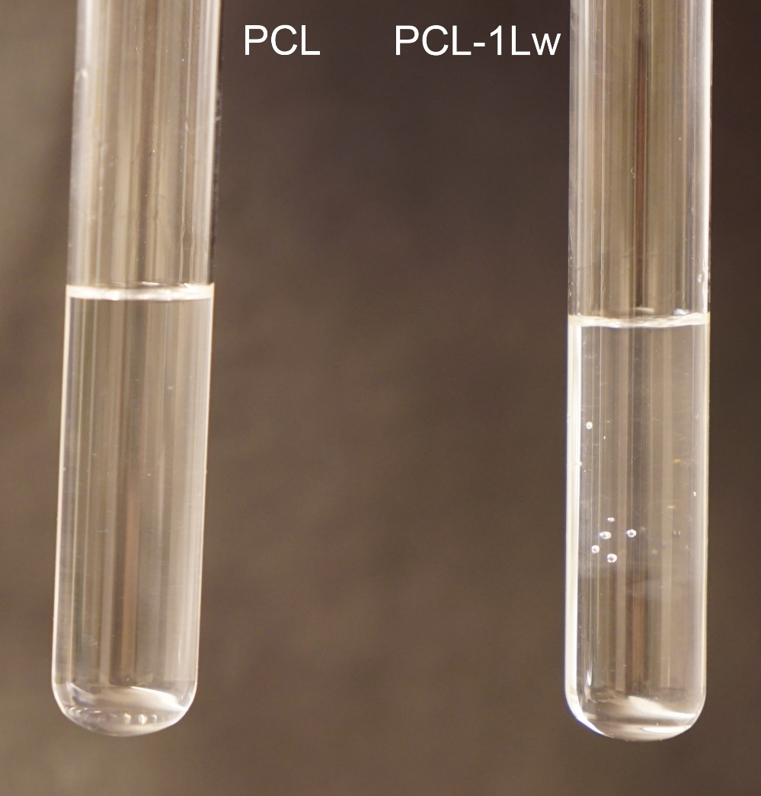
Figure S1. Photo of test tubes containing neat poly(ε-caprolactone) (PCL) and PCL reacted with 1 wt% peroxide in the presence of water (PCL-1Lw), after 24 h in solution with dichloromethane.

Table S1. Thermal properties of neat and reacted PCL detected by Thermogravimetrical analysis (TGA) and Differential Scanning Calorimetry (DSC). TGA: Onset temperatures of degradation (T_{5%} ) evaluated at 5 % weight loss; degradation temperature (T_{d}) evaluated as the peak temperature of DTG; char residue at 550 °C. DSC: Glass (T_{g}) and melting (T_{m}) temperatures detected from the second heating scan; melting enthalpy (ΔH_{M}) and crystallinity (χ_{DSC}) detected from the melting peak in the second heating scan (from 15 to 65 °C); crystallization temperature (T_{c}) detected from the cooling scans.
Material | T_{5%} [°C] | T_{d} [°C] | Char [%] | T_{g} [°C] | T_{m} [°C] | ΔH_{M} [J·g⁻¹] | χ_{DSC} [%] | T_{c} [°C]
PCL | 363 | 400 | 1 | -62 | 57 | 63.73 | 47.0 | 35
PCL-0.1L | 290 | 398 | 1 | -63 | 57 | 62.51 | 46.1 | 30
PCL-0.25L | 304 | 398 | 3 | -65 | 57 | 60.36 | 44.5 | 31
PCL-0.5L | 331 | 398 | 2 | -62 | 57 | 62.9 | 46.4 | 37
PCL-0.5Lw | 325 | 398 | 2 | -61 | 57 | 59.23 | 43.7 | 36
PCL-1L | 345 | 398 | 0 | -62 | 57 | 63.26 | 46.6 | 35-40
PCL-1Lw | 347 | 399 | 2 | -58 | 59 | 61.34 | 45.2 | 41
Figure S2. Curves from thermogravimetrical analysis (TGA) of neat and reacted PCL with different wt% of peroxide during dry (PCL-xL) or water-assisted (PCL-xLw) melt processing.
Figure S3. Derivative thermogravimetric (DTG) curves of neat and reacted PCL.
Figure S4. Thermograms from second heating scan of Differential Scanning Calorimetry (DSC) of neat and reacted PCL.
Figure S5. X-Ray diffractograms of PCL and PCL reacted with 1 wt% peroxide during dry (PCL-1L) or water-assisted (PCL-1Lw) melt processing.
Figure S6. Stress-strain curves from tensile tests at room temperature neat and reacted PCL.

Table S2. Mechanical properties assessed from tensile tests at room temperature. Each value represents the average of 5 measurements with the standard deviation. *Data extracted at the upper limit of the instrument.
Material | Young’s modulus [MPa] | Yield stress [MPa] | Ultimate tensile strength [MPa] | Elongation at break [%]
PCL | 284 ± 5 | 19.2 ± 0.5 | 38.7 ± 0.6 * | 1200 *
PCL-0.1L | 262 ± 3 | 18.7 ± 0.4 | 39 ± 0.5* | 1200*
PCL-0.25L | 262 ± 2 | 18.5 ± 0.1 | 39.1 ± 0.9* | 1200*
PCL-0.5L | 248 ± 6 | 18.4 ± 0.1 | 38.8 ± 2.4 * | 1175 ± 44 *
PCL-0.5Lw | 218 ± 8 | 16 ± 0.4 | 39.8 ± 0.1 * | 1200 *
PCL-1L | 242 ± 13 | 17.3 ± 1 | 33.6 ± 1.3 | 941 ± 57
PCL-1Lw | 225 ± 14 | 17.1 ± 0.5 | 44 ± 1.2 | 1035 ± 48

