Tables Captions

Table 1 The operating conditions optimized for Cr(VI) determination with DP-ASV using a Au_{film}-GCE sensor

Experimental conditions:  (DP-ASV) | Optimized Value
Supporting electrolyte | HCl 0.1 M
pH | 1.0
Deposition time | 120 s
Deposition potential | -0.2 V
Detection potentialª | +0.3 V
Scan rate | 100 mV/s
Potential scan | -0.2 to 0.8 V
Modulation amplitude | 20 mV
Modulation time | 5 ms

Table 2 Analytical performance of different modified electrodes for Cr(VI) determination.
Modified electrode |  |  |  |  | Method | LOD (µg/L⁻¹) |  |  |  | LDR (µg/L⁻¹) |  |  | Reference
Electrochemically activated GCE |  |  |  | DPV |  | 6.25 |  |  |  | 20.8–13000 |  |  | Richtera et al 2016
Gold screen printed macro electrode |  |  |  | LSV |  | 228 |  |  |  | 520-84240 |  |  | Metters et al 2012
AuNP-ITO electrode ^{d} |  |  |  | CV ^{c} |  | 104 | 260–5200 |  |  |  |  | Tsai and Chen 2008
 |  |  |  | Amperometry |  | 5.2 | 26–2600
 |  |  |  |  |  |  |  |  |  |  |  | Tsai and Chen 2008
Ag NPs ª - carbon SPE ^{e} |  |  |  | DPV |  | 44.2 |  | 26–1976 |  |  |  |  | Domínguez-Renedo et al 2008
Au NPs - carbon SPE |  |  |  | DPV |  | 20.8 |  | 20.8–1664
Ag _{plated-}GCE |  |  |  | DP-ASV |  | 5.2 |  | 18.2-2080 |  |  | Stojanović et al 2018
Graphite screen printed electrode |  |  |  | LSV |  | 18.7 |  | 99.8-998.4 |  |  |  |  |  |  |  | Hallam et al 2010
Au _{film-}GCE |  |  |  | DP-ASV |  | 5.5 |  |  | 10–120 |  |  |  |  |  | This work
ªNPs – nanoparticles, ^{b}LSV – Linear sweep voltammetry, ^{c}CV – Cyclic voltammetry, ^{d}AuNP-ITO electrode – Gold
nanoparticle- electrodeposited indium-tin oxide electrode, ^{e} SPE – screen printed electrode

Table. 3 Recovery test with sewage water samples
Sample  (sewage water)  (µgL⁻¹) | Cr(VI)  Added  (µgL⁻¹) | Cr (VI)  Found  (µgL⁻¹) | Spike  Recovery  (%)
Chromium Concentration | 88 | 86.1± 0.8 | 97.8
150 ± 0.6 | 176 | 176.5 ±0.5 | 100.3

Figure Captions
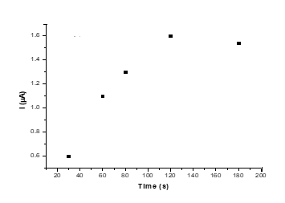

Fig. 1 Effect of the accumulation time (30s; 60s;120s; 180s) at Au_{film}/GCE, in 0.1 M HCl for concentration 50 µg L⁻¹ Cr(VI)

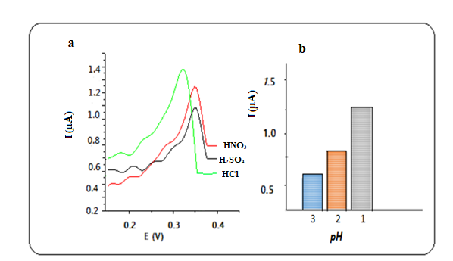

Fig. 2 a) Anodic stripping voltammograms of 50 µg L^{–1} Cr(VI) at various electrolyte. b) Effect of pH on the peak current for the determination of Cr(VI) on Au_{film}-GCE

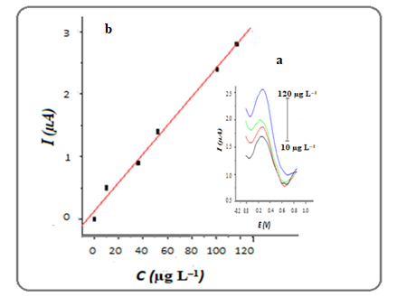
Fig. 3 a) DP-AS voltammograms registered with Au_{film}/GCE electrode in HCl 0.1 M, t_{dep}=120 s, poteciacial from -0.2 to 0.8 V in different concetration of Cr (VI) .b) Calibration curve of various Cr (VI) concentration

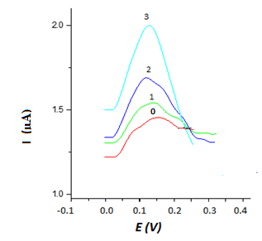

Fig. 4 DP-AS Voltammograms for standard additions of Cr(VI) in a sewage water sample, (0) sample signal before spiking and in concentrations (1)30, (2) 60, (3) 88 µg/L⁻¹ Cr(VI)

