Table S1. Primers used for qRT-PCR
Gene name | Locus | Direction | Primer sequence
ERFII-1 | GK_11A12 | forward | CTCCGTTGCCTACTACTGCC
 |  | reverse | CCTCTGTAATGCCTCTTCTCCT
ARF19 | AT1G19220 | forward | TCCAGTGCTGCAATCAGTTC
 |  | reverse | CCTCCACCATTCATGATTCC
CKX1 | AT2G41510 | forward | ACAGAGGAAACAAGCCTACGAC
 |  | reverse | TGACTTTGCGAGTTGGATGG
ADC1 | AT2G16500 | forward | AGAGGGATCTTATCGGATTT
 |  | reverse | TCTCATCTTTGCCCTTGC
DAR2 | AT2G39830 | forward | AGCATGAGTTCTCTCTGTCAGG
 |  | reverse | CCAAAACGGATGGCATCGATAC
IQM3 | At3G52870 | forward | GGAGGGTGATTGTTGACAATGG
 |  | reverse | AGGTTCACTGCGTTCTCTCTG
ACT2 | At3G18780 | forward | GCCATCCAAGCTGTTCTCTC
 |  | reverse | GCTCGTAGTCAACAGCAACAA

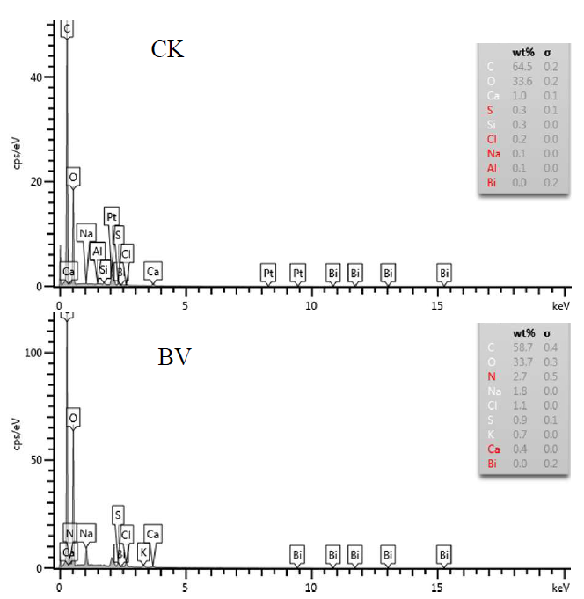
Figure S1. Effect of nanomaterial BV on the extension zone of taproot in Arabidopsis. CK: without nanomaterial BV treatment. BV was treated with BV about 200 µg·mL⁻¹.
N=3

