Supplementary material
Ellipsometry fitting results
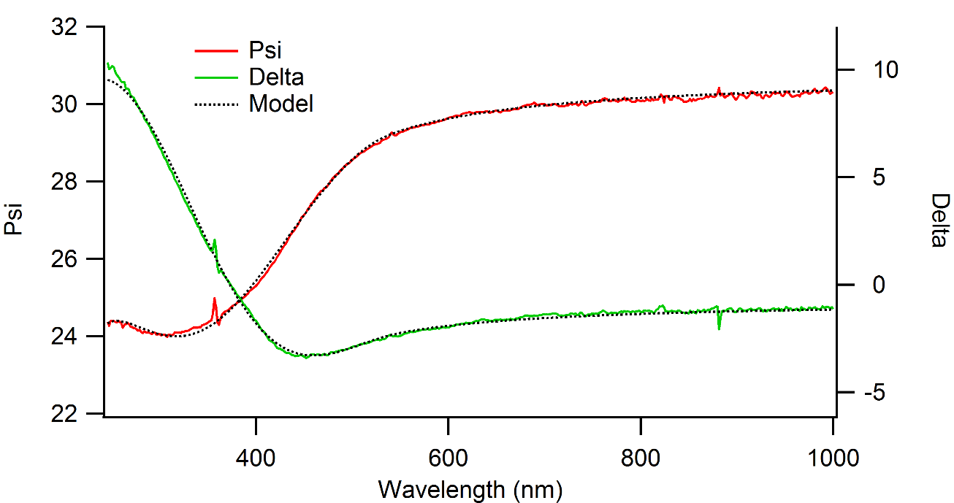
Figure 1: Thickness fitting of sample A

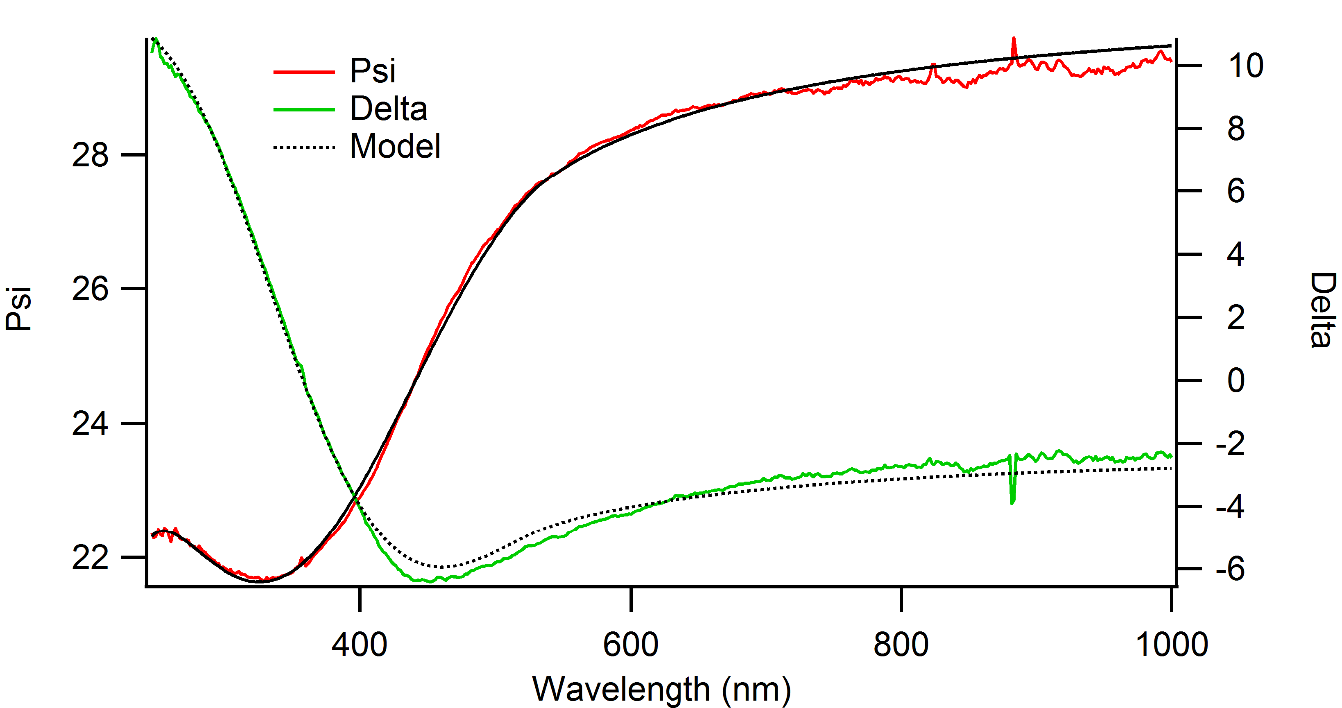
Figure 2: Thickness fitting of sample B

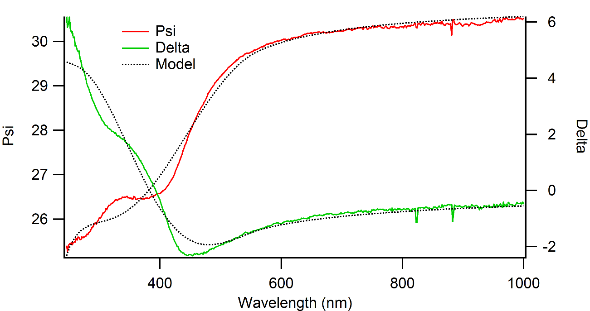
Figure 3: Thickness fitting of sample C
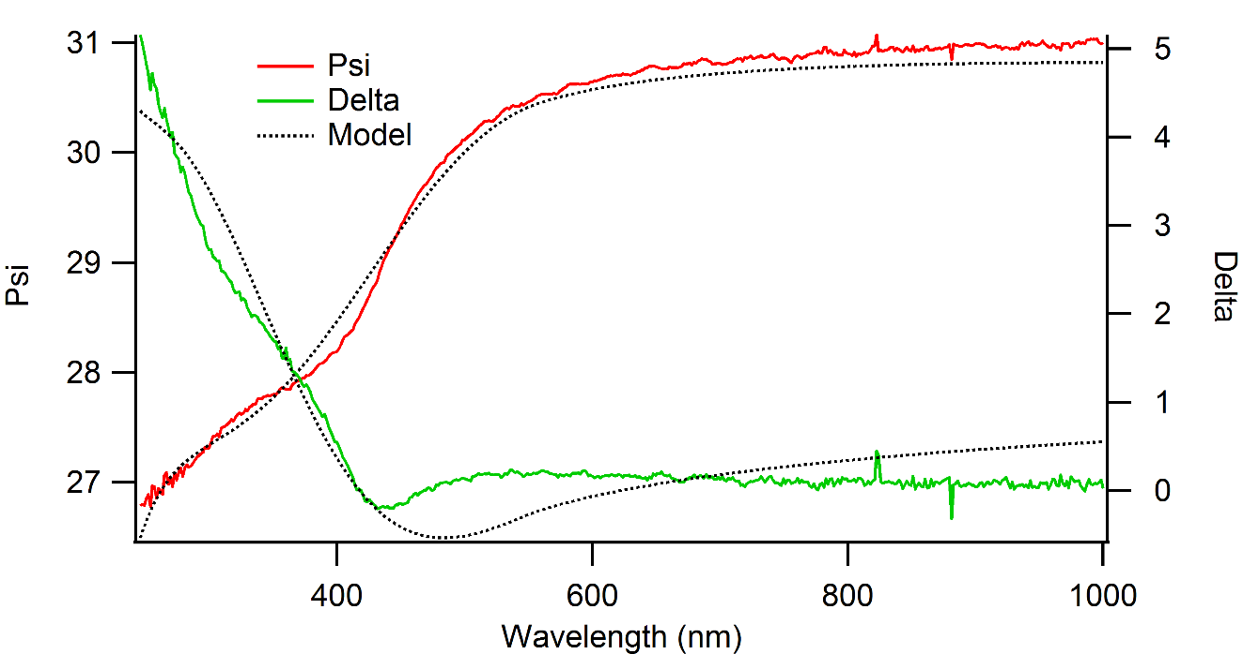
Figure 4: Thickness fitting of sample D

