Associations between DPP9 expression, survival and gene expression signature in human hepatocellular carcinoma: Comprehensive in silico analyses
Jiali Carrie Huang^{1,2}, Abdullah Al Emran^{1,2}, Justine Moreno Endaya^{1,2}, Geoffrey W McCaughan^{1,2,3}, Mark D Gorrell^{1,2*}, Hui Emma Zhang^{1,2*}

¹ Centenary Institute, Camperdown, New South Wales, Australia; j.huang@centenary.org.au (J.C.H.), a.alemran@centenary.org.au (A.A.E.), g.mccaughan@centenary.org.au (G.W.M.)
² The University of Sydney, Faculty of Medicine and Health, Sydney, New South Wales, 2006, Australia; jend8597@uni.sydney.edu.au (J.M.E.)
³ AW Morrow GE & Liver Centre, Royal Prince Alfred Hospital, Camperdown, New South Wales, 2050, Australia;
* Correspondence: e.zhang@centenary.org.au (H.E.Z.), m.gorrell@centenary.org.au (M.D.G.); Tel.: 61-2-95656156

Supplementary Table 1. DPP8 LoF variants in TCGA. Simple somatic mutation (SSM) affected frequency is calculated as the number of cases affected by a specific mutation in a TCGA disease project divided by the number of cases tested for SSM in that disease project in TCGA. *Termination codon (Ter).
Position | Reference | Alternate | Protein consequence | Annotation | Case ID | Disease | # SSM affected cases and frequency
65479016delA |  |  | p.Gln458Lys*29 | Frameshift | TCGA-AZ-6598  TCGA-AD-5900 | Colon Adenocarcinoma | 2/400 (0.50%)
65479011_65479012insG |  |  | p.Gln458Pro*8 | Frameshift | TCGA-HU-A4GT | Stomach Adenocarcinoma | 1/440 (0.23%)
65474260delC |  |  | p.Ile512* | Frameshift | TCGA-12-0778 | Glioblastoma  Multiforme | 1/393 (0.25%)
65467180_65467181insAGGTAAATTATTAGTCAATT |  |  | p.Thr543Lys*13 | Frameshift | TCGA-13-1500 | Ovarian Serous Cystadenocarcinoma | 1/463 (0.23%)
65456248_65456249insAAATTTAAGCCCTCGGTGACAGGATCCCCTGTTGAGGGCTTAAATTTGAAGGCGCCTTT |  |  | p.Glu715Lys*31 | Frameshift | TCGA-4V-A9QI | Thymoma | 1/123 (0.81%)
65454301delAGAGGTATCC |  |  | p.Gly758Pro*2 | Frameshift | TCGA-AP-A1DO | Uterine Corpus Endometrial Carcinoma | 1/530 (0.19%)
65500743 | C | A | p.Glu153* | Stop gained | TCGA-BK-A6W3 | Uterine Corpus Endometrial Carcinoma | 1/530 (0.19%)
65500731 | C | A | p.Glu157* | Stop gained | TCGA-D1-A17Q | Uterine Corpus Endometrial Carcinoma | 1/530 (0.19%)
65500639 | A | T | p.Tyr187* | Stop gained | TCGA-VQ-A91D | Stomach Adenocarcinoma | 1/440 (0.23%)
65490237 | C | A | p.Glu276* | Stop gained | TCGA-AX-A05Z  TCGA-AJ-A5DW  TCGA-AA-3510 | Uterine Corpus Endometrial Carcinoma  Colon Adenocarcinoma | 2/530 (0.38%)  1/400 (0.25%)
65480371 | G | A | p.Gln399* | Stop gained | TCGA-D3-A8GK | Skin Cutaneous Melanoma | 1/469 (0.21%)
65478907 | G | A | p.Arg493* | Stop gained | TCGA-AG-A02N | Rectum Adenocarcinoma | 1/137 (0.73%)
65467149 | G | C | p.Tyr553* | Stop gained | TCGA-Q1-A6DW | Cervical Squamous Cell Carcinoma and Endocervical Adenocarcinoma | 1/289 (0.35%)
65467135_65467136insTTGTCATCCACCTACCTCGG |  |  | p.Val558A*6 | Stop gained | TCGA-24-1431 | Ovarian Serous Cystadenocarcinoma | 1/436 (0.23%)
65467124 | C | A | p.Glu562* | Stop gained | TCGA-29-1768 | Ovarian Serous Cystadenocarcinoma | 1/436 (0.23%)
65456263 | G | A | p.Arg710* | Stop gained | TCGA-AZ-4615 | Colon Adenocarcinoma | 1/400 (0.25%)
65454394 | G | A | p.Gln730* | Stop gained | TCGA-ZP-A9CY | Liver Hepatocellular Carcinoma | 1/364 (0.27%)

Supplementary Table 2. DPP8 LoF variants in COSMIC. Nonsense mutation is a substitution mutation resulting in a termination codon (*). CDS= coding sequence; AA= amino acid, SSM= simple somatic mutation.
CDS mutation | AA mutation | Legacy mutation ID | Type | Disease | #SSM affected cases
c.2262G>A | p.Trp754* | COSM5946730 | Nonsense | Lymphoid neoplasm | 1
c.2017C>T | p.Gln673* | COSM6574976 | Nonsense | ER-PR-positive breast carcinoma | 1
c.1659C>G | p.Tyr553* | COSM4856031 | Nonsense | Cervical squamous cell carcinoma | 1
c.328G>T | p.Glu110* | COSM1678543 | Nonsense | Colon adenocarcinoma | 2
c.2128C>T | p.Arg710* | COSM3690497 | Nonsense | Colon adenocarcinoma | 1
c.826G>T | p.Glu276* | COSM964071 | Nonsense | Endometrioid carcinoma  Colon adenocarcinoma | 3
c.1477C>T | p.Arg493* | COSM167000 | Nonsense | Colon adenocarcinoma | 1
c.2170C>T | p.Gln724* | COSM6648997 | Nonsense | Colon adenocarcinoma | 1
c.457G>T | p.Glu153* | COSM8970383 | Nonsense | Endometrioid carcinoma | 1
c.469G>T | p.Glu157* | COSM964073 | Nonsense | Endometrioid carcinoma | 1
c.2188C>T | p.Gln730* | COSM8423812 | Nonsense | Hepatocellular carcinoma | 1
c.2649C>G | p.Tyr883* | COSM88480 | Nonsense | Ovarian clear cell carcinoma | 1
c.1684G>T | p.Glu562* | COSM1323886 | Nonsense | Ovarian serous carcinoma | 1
c.1816G>T | p.Glu606* | COSM3981612 | Nonsense | Ovarian mixed adeno-squamous carcinoma | 1
c.2218C>T | p.Arg740* | COSM5929565 | Nonsense | Skin basal cell carcinoma | 1
c.1927G>T | p.Gly643* | COSM7894053 | Nonsense | Malignant melanoma | 1
c.1195C>T | p.Gln399* | COSM8050061 | Nonsense | Malignant melanoma | 1
c.1228G>T | p.Glu410* | COSM7945996 | Nonsense | Malignant melanoma | 1
c.2352G>A | p.Trp784* | COSM135677 | Nonsense | Skin squamous cell carcinoma | 1
c.561T>A | p.Tyr187* | COSM8209774 | Nonsense | Stomach adenocarcinoma | 1

Supplementary Table 3. Genome-wide significant loci for severe COVID-19: Intronic DPP9 variants rs12610495 and rs2109069. hg19_coordinates: the hg19 chromosome position. Hg38_coordinates: the hg38 chromosome position. a1: the effect allele (aligned to the + strand). a2: the non-effect allele (aligned to the + strand). afr/amr/eas/eur/sas: the allele frequency for A1 in AFR/AMR/EAS/EUR/SAS population in 1000 Genomes. beta: association between the trait and the SNP expressed per additional copy of the effect allele (odds ratio is given on the log-scale). efo: the experimental factor oncology term for the phenotype or disease. AFR= African; AMR= American; EAS= East Asian; EUR= European; SAS= South Asian.
 |  | Genomic location |  |  |  | Allele frequencies
Gene | rsid | hg19_coordinates | hg38_coordinates | a1 | a2 | afr | amr | eas | eur | sas | beta | Standard error of beta | p value | # individuals | Dataset ID | Trait (phenotype or disease) | p  value  COVID | efo
DPP9 | rs12610495 | chr19:4717672 | chr19:4717660 | A | G | 0.872 | 0.797 | 0.857 | 0.706 | 0.828 | NA | NA | 1.68E-12 | 47644 | GRASP | Fibrotic idiopathic interstitial pneumonias pulmonary fibrosis | 5.20E-06 | NCIT_C35714
DPP9 | rs12610495 | chr19:4717672 | chr19:4717660 | A | G | 0.872 | 0.797 | 0.857 | 0.706 | 0.828 | -0.255 | 0.0362 | 2.00E-12 | - | NHGRI-EBI_GWAS_Catalog | Interstitial lung disease | 5.20E-06 | EFO_0004244
DPP9 | rs2109069 | chr19:4719443 | chr19:4719431 | A | G | 0.196 | 0.219 | 0.14 | 0.321 | 0.186 | NA | NA | 2.42E-11 | 47644 | GRASP | Fibrotic idiopathic interstitial pneumonias pulmonary fibrosis | 2.41E-05 | NCIT_C35714

Supplementary Table 4. The LIHC/HCC (n=360) and UCEC (n=540) patient demographics
Characteristic | LIHC/HCC | UCEC
 | Number and percentage or median and range * | Number and percentage or median and range *
Sex  Male  Female | 244 (67.8%)  116 (32.2%) | /  540 (100%)
Age at diagnosis (years) | 61 (16, 85) | 64 (31, 90)
Tumour site  Liver  Endometrium  Fundus uteri  Corpus uteri  Isthmus uteri | 360 (100%) | 525 (97.2%)  6 (1.11%)  4 (0.74%)  3 (0.56%)
Overall death | 126 (35%) | 91 (16.9%)
Follow up time (days) | 587 (1, 3675) | 885 (0, 6859)
AJCC stage  I  II  III  IV | 169 (46.9%)  83 (23.1%)  83 (23.1%)  4 (1.11%) | 334 (61.9%)  52 (9.6%)  123 (22.8%)  - 5.4%)
*Missing data excluded in percentage calculation

Supplementary Figure 1. DPP9 variants mapping to the DPP9 protein structure. Exonic variants were exported from (A) gnomAD, (B) TCGA and (C) COSMIC databases. The PDB for DPP9 apo structure is 6EOQ. The figures were created using UCSF Chimera (Alpha version 1.15, University of California, USA).

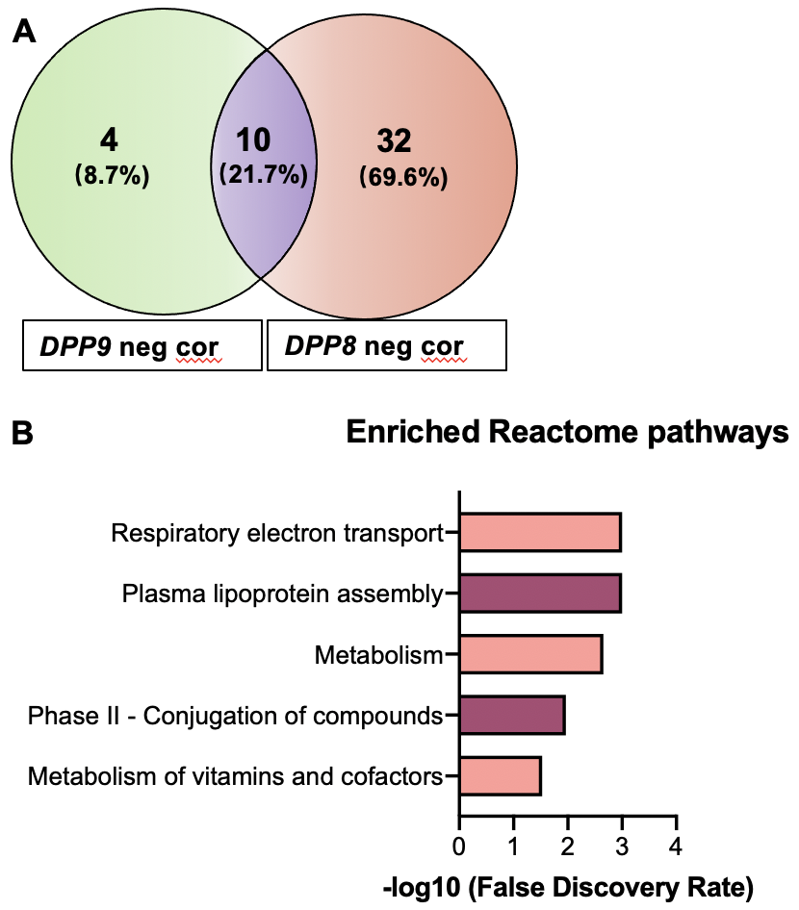
Supplementary Figure 2. Enriched Reactome pathways of genes that were negatively correlated and in-common between DPP9 and DPP8. (A) Venn diagram of the genes negatively correlated with DPP9 and DPP8. “Neg cor” refers to negative correlation. (B) Enriched Reactome pathways associated with negatively correlated genes in-common between DPP9 and DPP8.

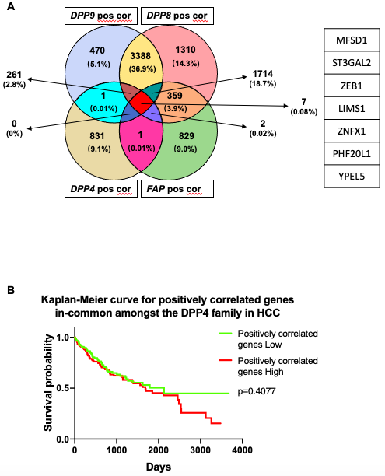
Supplementary Figure 3. Survival analysis on genes that were positively correlated and in-common amongst DPP9, DPP8, DPP4 and FAP in HCC. (A) Venn diagram showing the numbers of genes that were positively correlated in-common with DPP9, DPP8, DPP4 and FAP. The 7 genes in-common genes with all four genes are listed to the right-hand side. The genes in the blue section and pink section are TPRA1 and SH3BP5 respectively. The two genes on the purple section are VAMP3 and TTL. “Pos cor” refers to positive correlation. (B) Kaplan-Meier curve for the 7 genes that were positively correlated in-common amongst DPP9, DPP8, DPP4 and FAP in HCC patients. The high (red) and low (green) mRNA expression levels of genes in liver tumours were stratified based on median expression value. P values were calculated by Log-rank (Mantel-Cox) test.

