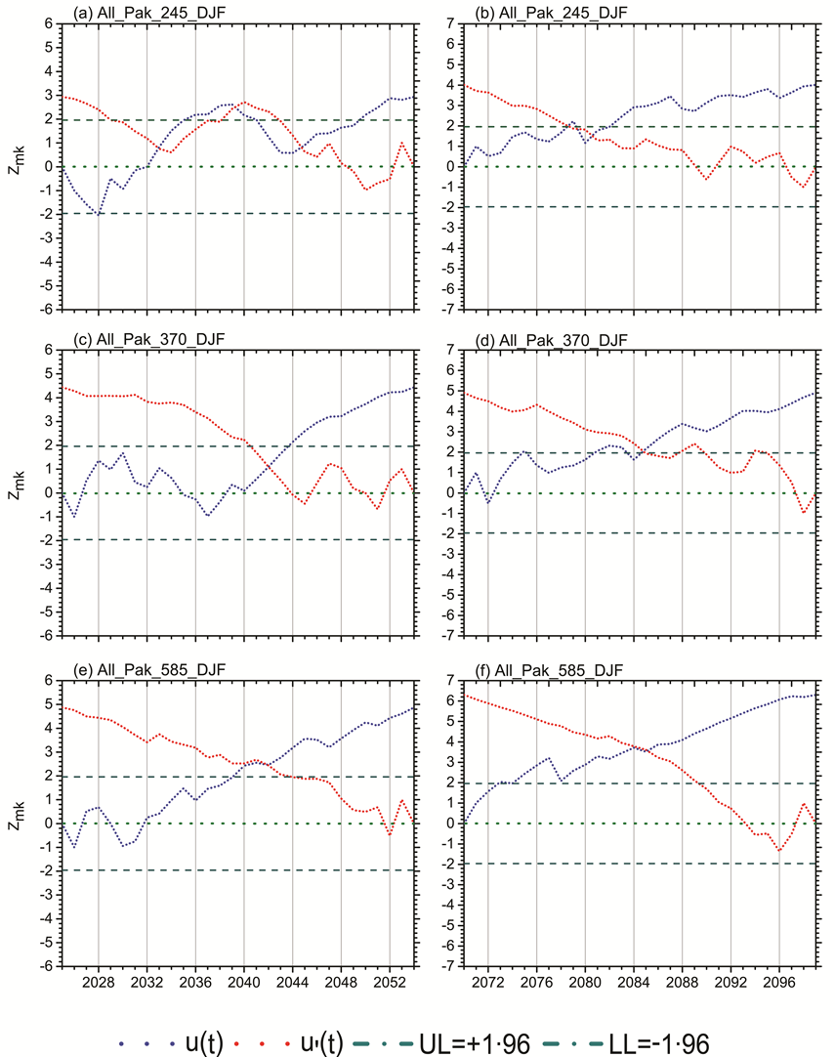
Figure S1. Temporal abrupt changes in DJF season trend for surface mean temperature trends for 2025-2054 and 2070-2099 time periods over Pakistan. Blue color line defines the progressive series while the red one identifies retrograde series for the change (intersection) detection at 95% confidence level (viridian color lines).

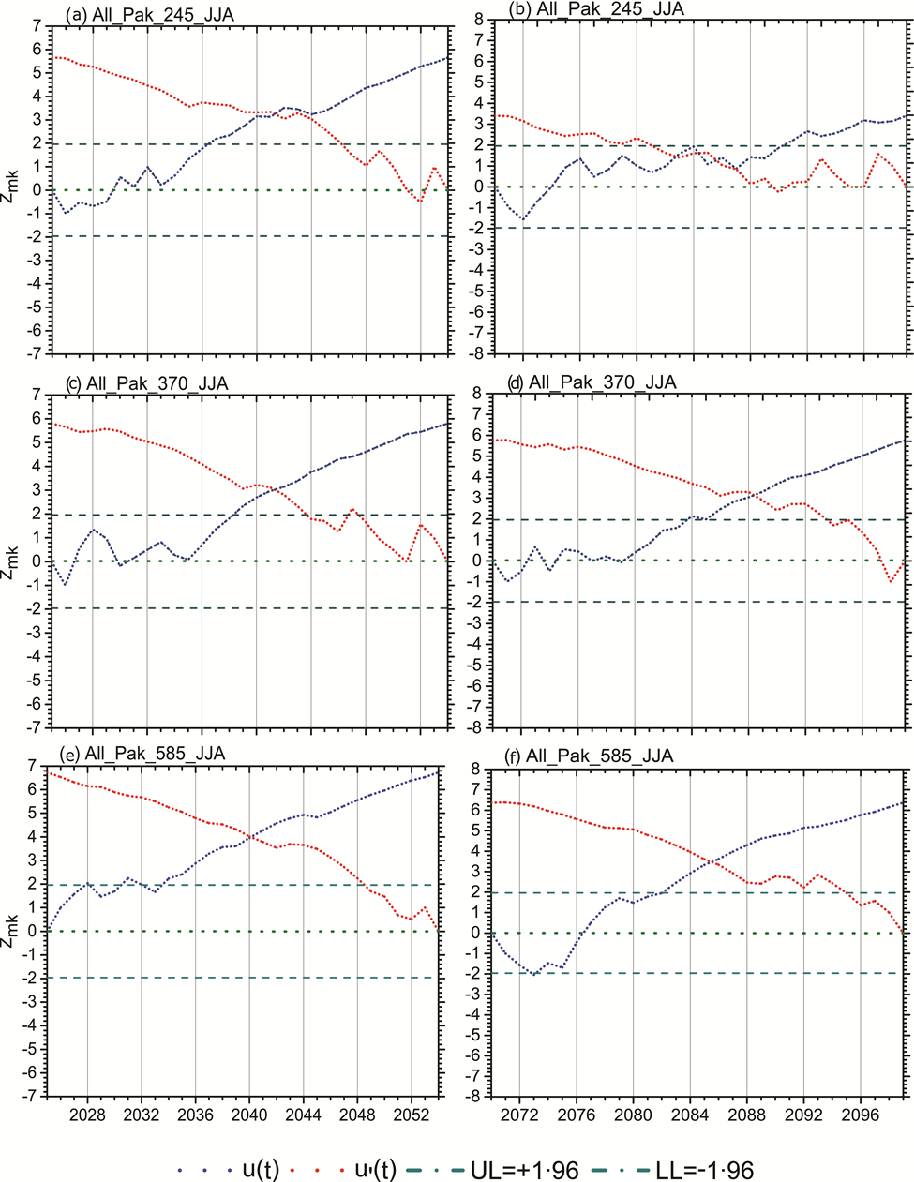
Figure S2. Temporal abrupt changes in the JJA season trend for surface mean temperature trends for 2025-2054 and 2070-2099 time periods over Pakistan. The blue color line defines the progressive series, while the red one identifies retrograde series for the change (intersection) detection at a 95% confidence level (viridian color lines).

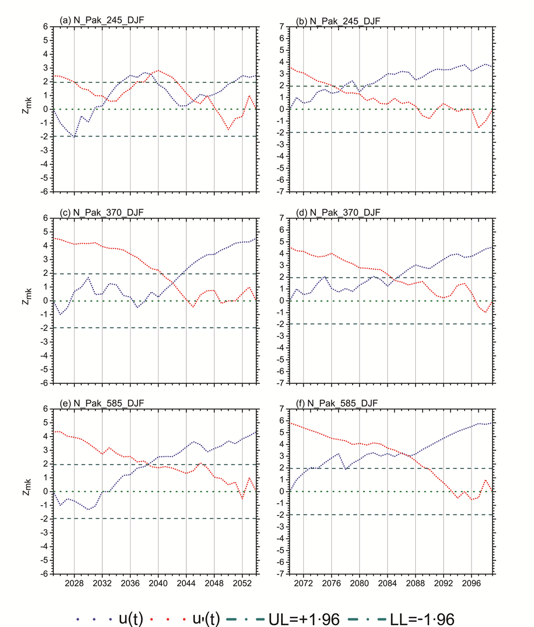
Figure S3. Same as S1, but for Northern Pakistan.
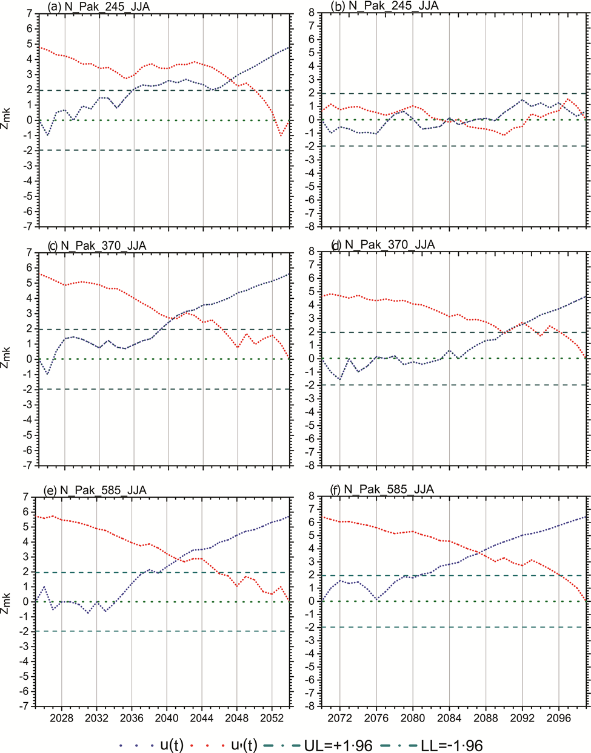
Figure S4. Same as S2, but for Northern Pakistan.

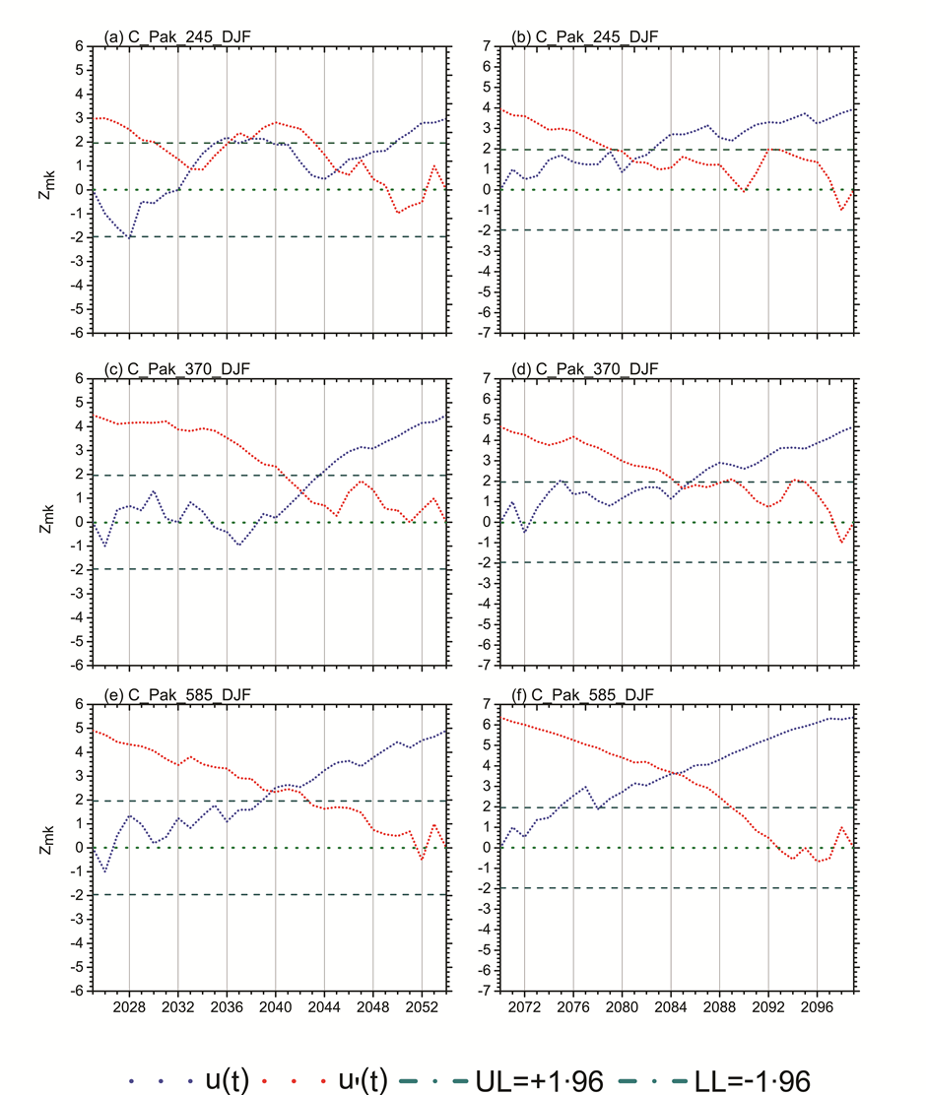
Figure S5. Same as figure S1, but for Central Pakistan

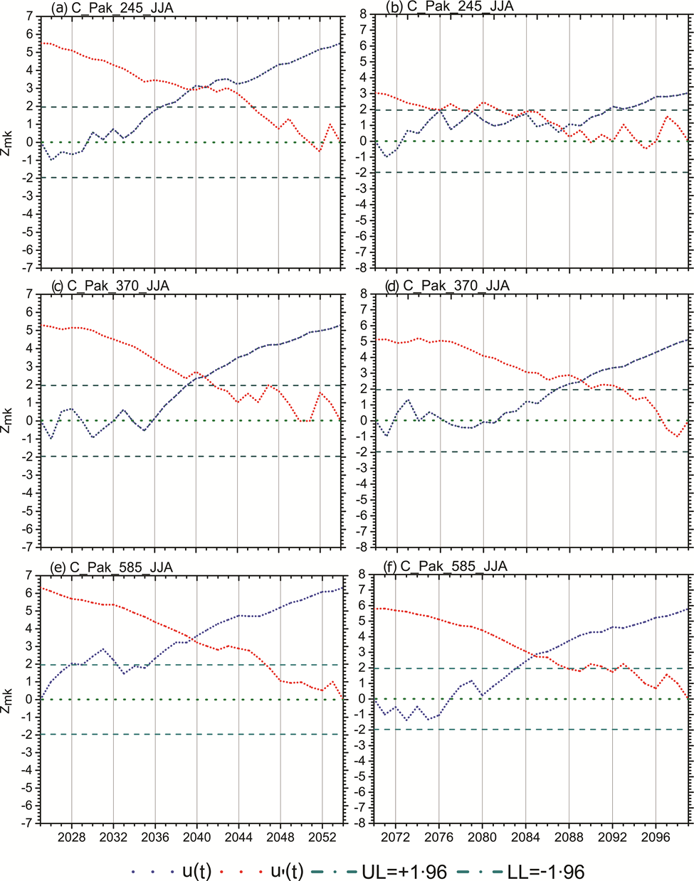
Figure S6. Same as figure S2, but for Central Pakistan

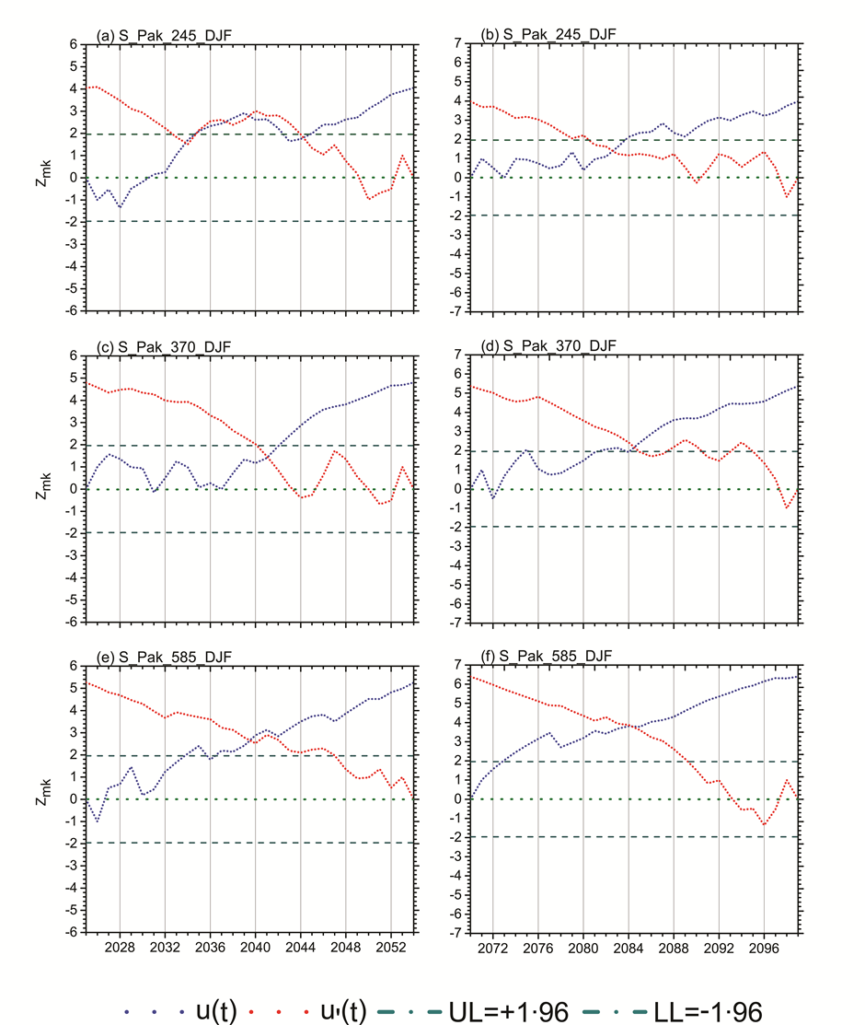
Figure S7. Same as figure S1, but for Southern Pakistan

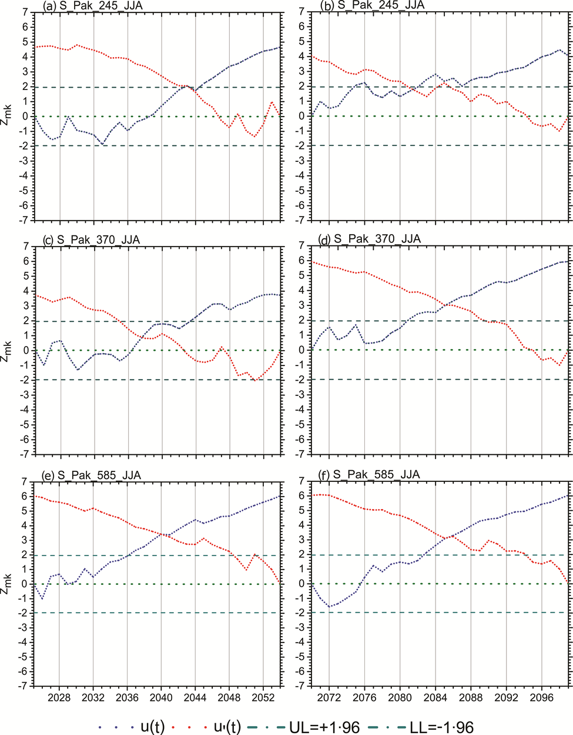
Figure S8. Same as figure S2, but for Southern Pakistan

