SUPPLEMENTARY MATERIALS
VEGF Detection via Simplified FLISA using a 3D Microfluidic Disk Platform
Dong Hee Kang ¹, Na Kyong Kim ¹, Sang-Woo Park ^{2,*}, and Hyun Wook Kang ^{1,*}
¹ Department of Mechanical Engineering, Chonnam National University
77 Youngbong-ro, Buk-gu, Gwangju 61186, Republic of Korea
² Department of Ophthalmology, Chonnam National University Medical School
and Hospital, Baekseo-ro, Dong-gu, Gwangju 61469, Republic of Korea
December 2020
† Co-correspondence to Prof. Hyun Wook Kang and Prof. Sang-Woo Park
Tel) +82-62-530-1662
Fax) +82-62-560-1689
E-mail) (H.W.K) kanghw@chonnam.ac.kr ; (S.W.P) exo70@naver.com
Supplementary Materials
Figure. S1. Angular velocity of disk with respect to time for the mixing cycle during incubation and the bead washing process.
Figure. S2. SEM images of micropillars (designed diameter (D) =500, 250, 200, and 100 μm) on 3D printed surface fabricated in the (a–d) vertical and (e–h) lateral directions.
Figure. S3. (a) Top view of 3D-printed block. (b) Isometric view and (c) sectional view of the 3D-printed block.

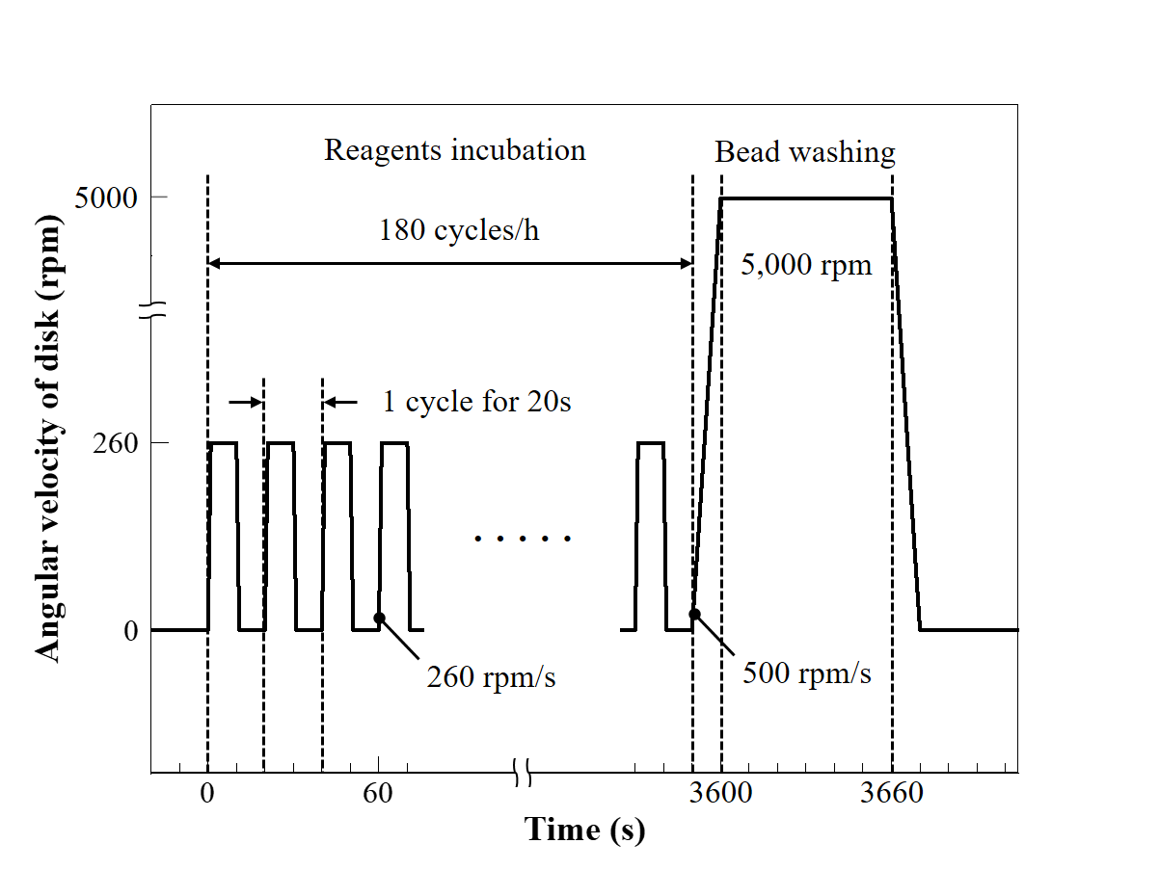
Figure. S1. Angular velocity of disk with respect to time for the mixing cycle during incubation and the bead washing process.

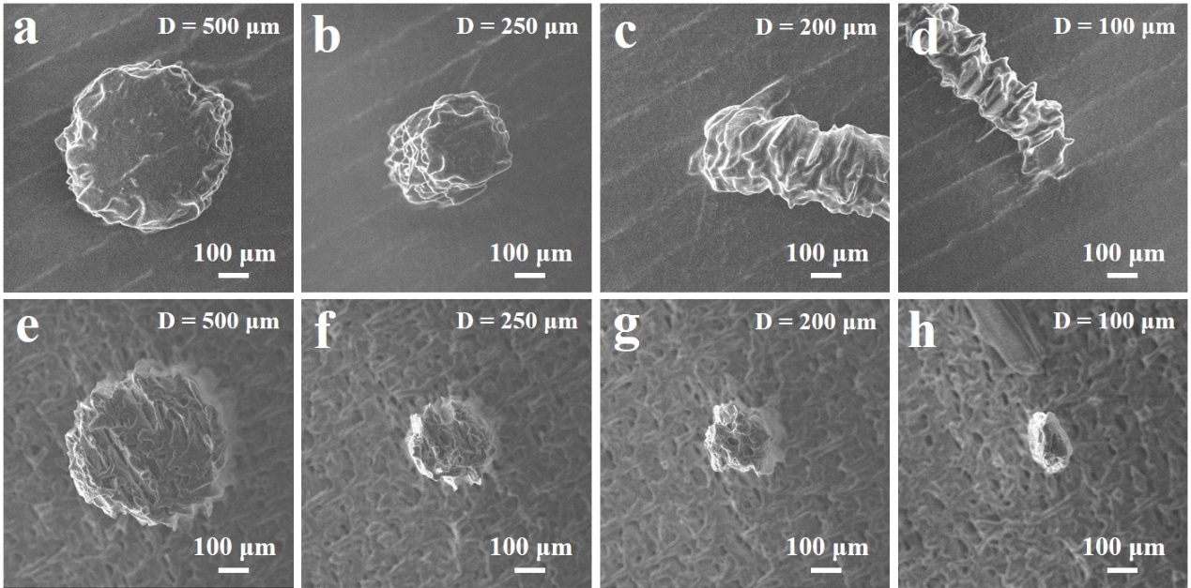
Figure. S2. SEM images of micropillars (designed diameter (D) =500, 250, 200, and 100 μm) on 3D printed surface fabricated in the (a–d) vertical and (e–h) lateral directions.

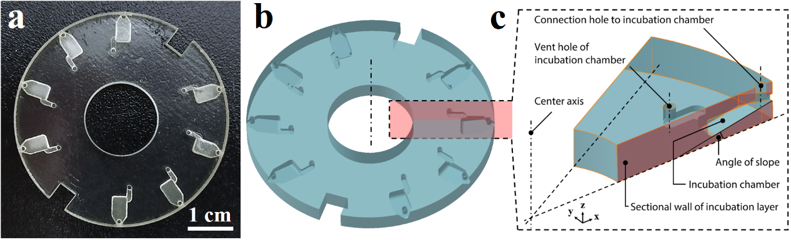
Figure. S3. (a) Top view of 3D-printed block. (b) isometric view and (c) sectional view of the 3D-printed block.

