DATA

No | Data | Sources
1 | Landsat TM5 | http://landsat.usgs.gov
2 | Landsat OLI 8 | http://landsat.usgs.gov
3 | Administration Map | http://tanahairindonesia.go.id
No | Table. 2 Tools  Tools
1 | ENVI
2 | Q-GIS

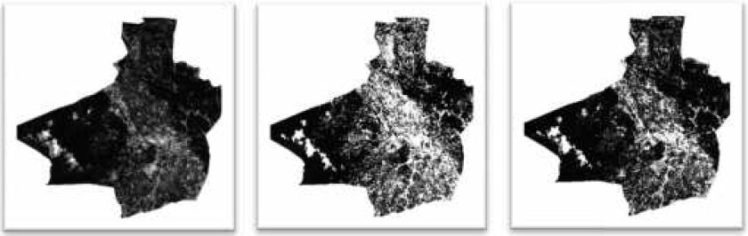
NDVI 2004 | NDBI 2004 | BUIL-UP 2004
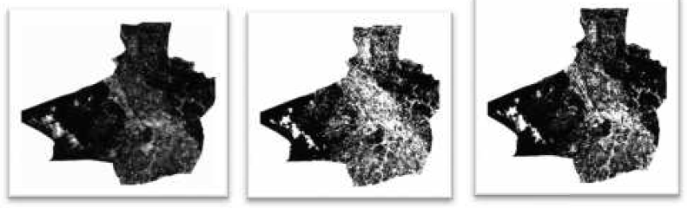
NDVI 2010 | NDBI 2010 | BUIL-UP 2010
NDVI 2018 | NDBI 2018 | BUIL-UP 2020

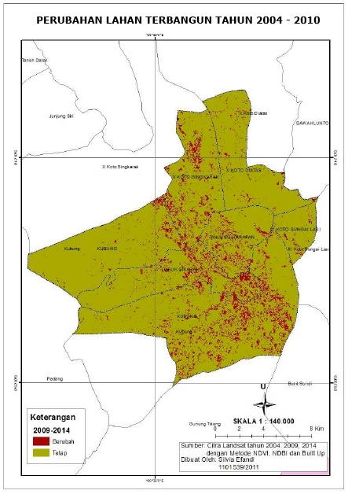 | 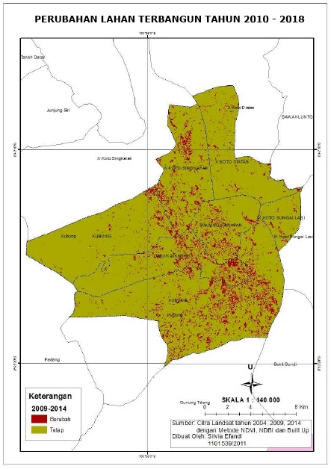

Figure. Result of Comparison Built Environment Changes in 2004 to 2010 and 2020 to 2018

