Article
Evaluation of image-based phenotyping methods for measuring water yam (Dioscorea alata L.) growth and nitrogen nutritional status under greenhouse and field conditions
Emmanuel Frossard ^{*#1}, Frank Liebisch ^{#2,3}, Valerie K Hgaza ^{4,5}, Delwende I Kiba ^{1,6}, Norbert Kirchgessner ², Laurin Müller ^{1,2}, Patrick Müller ^{1,2}, Nestor Pouya ⁷, Cecil Ringger ^{1,2,3}, Achim Walter ²
¹ Group of Plant Nutrition, Institute of Agricultural Sciences, ETH Zurich, Switzerland; emmanuel.frossard@usys.ethz.ch; delwende.kiba@usys.ethz.ch; muellaur@gmail.com; mupatric@student.ethz.ch
² Group of Crop Science, Institute of Agricultural Sciences, ETH Zurich, Switzerland; frank.liebisch@usys.ethz.ch; norbert.kirchgessner@usys.ethz.ch; achim.walter@usys.ethz.ch
³ Agroscope, Zürich, Switzerland; frank.liebisch@agroscope.admin.ch; cecil.ringger@agroscope.admin.ch
⁴ Centre Suisse de Recherches Scientifiques, Abidjan, Côte d’Ivoire; hgaza.kouame@csrs.ci
⁵ Département d’Agrophysiologie des Plantes, Université Peleforo Gon Coulibaly, Korhogo, Côte d’Ivoire;
⁶ Institut de l'Environnement et Recherches Agricoles, Ouagadougou, Burkina Faso;
⁷ Laboratory of Plant Physiology, Université Félix Houphouët Boigny, Abidjan, Côte d’Ivoire; nestaledja@gmail.com
* Correspondence: emmanuel.frossard@usys.ethz.ch; Tel +41 52 354 91 40
# Both first authors (EF, FL) have contributed in the same manner to this paper

Supplementary materials
1. Supplementary material part 1: Greenhouse experiment 1 [23]
This experiment was conducted at the ETH research station for plant sciences in Lindau-Eschikon, Switzerland, from July to October 2015.
1.1. Materials and Methods
1.1.1. Plant materials, experimental design and plant growth conditions
Two genotypes of water yam were selected for the pot experiment. One genotype (SL, cv. Raja ala), a purple-fleshed variety with purplish veins, stems and young leaves, was obtained from Sri Lanka, but sourced locally at SK Trading GmbH, Zurich, Switzerland. The second genotype (CI, cv. Florido), a white fleshed variety with purely green leaves, was obtained from a local market in Youpougon, Abidjan, Côte d’Ivoire. Both genotypes were received in June 2015.
Tubers of both genotypes were cut into setts of 100 g fresh weight on July 7th 2015. The round tubers of SL were halved into head (proximal) and tail (distal) parts and each half was then cut into wedge-shaped pieces. The oblong tubers of IC, were first halved lengthways, and then cut into several head, middle and tail pieces. Cut setts were immersed in a liquid mixture of a broad-spectrum fungicide (active ingredient: 70% mancozeb, 1.75% bentihavalicarb) and insecticide (active ingredient: 25% diazinon) and were air-dried for 20 hours. A total of 24 setts per genotype was planted in the pots and substrate described in the main part of the paper. At planting, setts were assigned to a nitrogen (N) treatment. Head, middle and tail setts, as well as setts originating from different tubers (with potential differences in dormancy) were equally distributed among N treatments. Pots were then placed in a greenhouse chamber in a randomized complete block design, consisting of four blocks (i.e. four replicates à 12 pots/block: two genotypes, three N treatments, two plant sampling dates 6 and 8 weeks after emergence). The environmental conditions were the same as those described in the main text of the paper.
Plant emergence was recorded for each individual plant, when the first sprout became visible. All 48 plants emerged between two and six weeks after planting. Original sett position within the tuber (head, middle, tail) strongly affected the emergence date, with head setts emerging faster (2 to 3 weeks after planting) than middle and tail setts (3 to 6 and 4 to 6 weeks after planting, respectively). Plants were grouped into emergence classes, as suggested by Cornet et al. (2014) to reduce the high plant variability characteristic for yam. Plants emerging within the same week were grouped into the same class. Timing of fertilizer applications and measurements was defined with regard to emergence classes
Three N levels were considered for each genotype, either no N added (0N) or an application of 101 or 342 mg N pot-1 (corresponding to 50 (50N) and 170 kg N ha-1 (170N), respectively). N was added two weeks after emergence (wae) as Ca(NO3)2·4H2O for both treatments. Nitrogen was applied once in the 50N treatment and was split at two and four wae for 170N. Further nutrients were added in a nutrient solution 2 wae as follows: 175 mg P as KH2PO4; 35 mg S as K2SO4; 3.5 mg Zn as ZnSO4·7H2O; and 3.5 mg Fe as Fe-EDTA per pot. The total amount of K applied as KH2PO4 and K2SO4 was 263.6 mg K pot-1.
1.1.2. Measurements
1.1.2.1. Measurements on plant level
Total shoot length (sum of both main and lateral shoots) was measured using a flexible tape. Shoot length of main shoots was measured from the substrate surface to the tip of the apical bud, that of lateral shoots from the axil (on the main shoot) to the tip of the apical bud.
The total number of unfolded leaves per plant was counted. Unfolded leaves were defined as those with a smooth and flat lamina. Counting leaves proved difficult for many plants of CI as they showed symptoms indicating a virus infection. Symptoms included stunted growth and a range of symptoms on the leaves, including: mosaic pattern, deformation (crinkling and blistering) and early senescence. As plants were mainly affected by virus infection within their first few weeks of growth, symptoms were only found on older leaves at harvest. Deformed leaves never met the actual definition of an unfolded leave, but they were nevertheless counted as one since they were clearly unfolded with regard to their development stage.
Total leaf area (LA) was defined as the leaf area of all unfolded leaves. Leaf blades of unfolded leaves were cut and total leaf area was measured by scanning them with a leaf area meter (LICOR 3100, LI-COR, Lincoln, NE, USA). Shoot fresh weight (FW) was determined immediately after cutting the stems at soil surface. Shoot dry weight (DW) was obtained after drying the shoots to constant weight at 60°C for three days. Both fresh and dry weight were determined with a precision scale (PM4600 DeltaRange, Mettler-Toldo GmbH, Greifensee, Switzerland, 0.01g precision).
Image-based phenotyping at plant level was conducted as described in the paper.
1.1.2.2. Measurements on leaf level
Measurements on leaf level were only performed on one vine per plant. For plants with several vines, only the longest was selected for measurements. All measurements were taken on every 8th unfolded leaf of the main shoot– counting nodes from the base of the vine to the apex (i.e. leaves at the 1st, 8th and for some plants 16th node). Most plants had an alternate leaf arrangement on the lower part of the stem, but an opposite leaf arrangement on the upper part. In an opposite pattern, selection of the measured leaf was random.
SPAD data and N leaf content were acquired on these leaves as described in the paper.
Image-based phenotyping at leaf level was conducted as described in the paper.

1.2. Main results
Table S1.1: Pearson’s correlation coefficient of projected leaf area assessed from the nadir (top) view, side view 0°, side view 90°, the sum of two views (nadir and side 0°) and the sum of three views and destructively measured total leaf area, dry weight and fresh weight measured on two genotypes of water yam (raja ala and florido, n=24 genotype⁻¹) grown in the greenhouse under three nitrogen fertilizer treatments (0, 50 and 170 kg N ha⁻¹) and harvested six and eight weeks after emergence. Leaf area was transformed prior to the calculation using the natural logarithm.
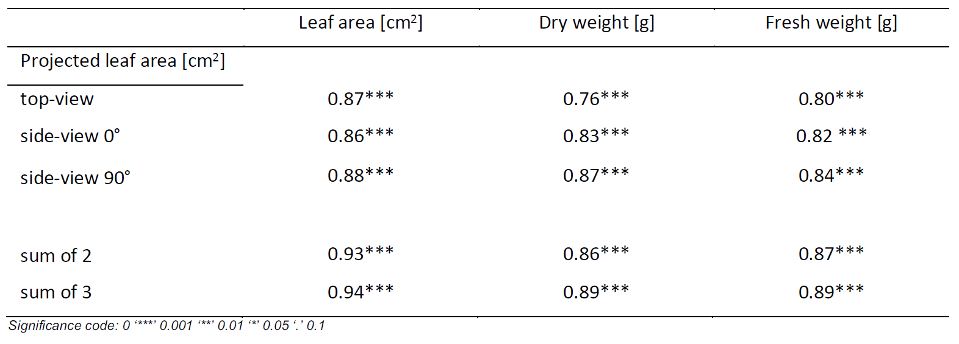

a b c

Figure S1.1: Relation between projected leaf surface calculated from single top (nadir) images, and destructively measured total leaf surface a), shoot dry weight b), and shoot fresh weight c) for two genotypes of water yam (SL, CI, n=24 genotype⁻¹) grown in the greenhouse under three nitrogen fertilizer treatments (0, 50 and 170 kg N ha⁻¹) and harvested six and eight weeks after emergence.

a b

Figure S1.2: Relation between SPAD value and leaf nitrogen (N) content at different leaf positions (leaf no. 1, 8, 16, counted from base to apex) A) and between TGI value (triangular greenness index) and leaf nitrogen (N) content at different leaf positions (leaf no. 1, 8, 16, counted from base to apex) B) in water yam cv raja ala, six and eight weeks after emergence (wae). Plants were grown under three nitrogen treatments (0, 50, 170 kg N ha⁻¹) in a greenhouse. Regression lines were included, when results were significant (p-value <= 0.05).
2. Supplementary material part 2: field experiment in Tieningboué

Figure S2.1: Climate diagram of the season 2018 for Tieningboué. The mean temperature (°C) is shown by the red line, the maximum temperature by the upper black line and the minimum temperature by the lower black line. The precipitation (mm) is shown with bar plots. No weather data was available for 22 days in March and 22 days in April 2018

Table S2.1: Tuber yield (average and standard error) of water yam cv C18 measured in a nearby experiment located on the same soil and submitted to the same treatments (rotation R1 to R4 and fertilization T0 to T3, see details in the paper) as those studied in our field experiment.

Table S2.2: Soil surface coverage (%) measured from pixel numbers obtained from TGI image for each studied plant between July 5 2018 and August 10, 2018 in our field experiment.

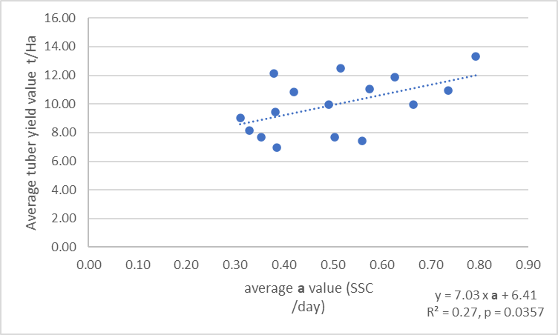

Figure S2.2: Relationship between final tuber yields and the average daily rate of soil surface coverage by yam shoots (a) between July 5 and August 10, 2018 in our field experiment.

Table S2.3: TGI measured at plant level for each studied plant between July 5 2018 and August 10, 2018 in our field experiment.

