Supplementary Information
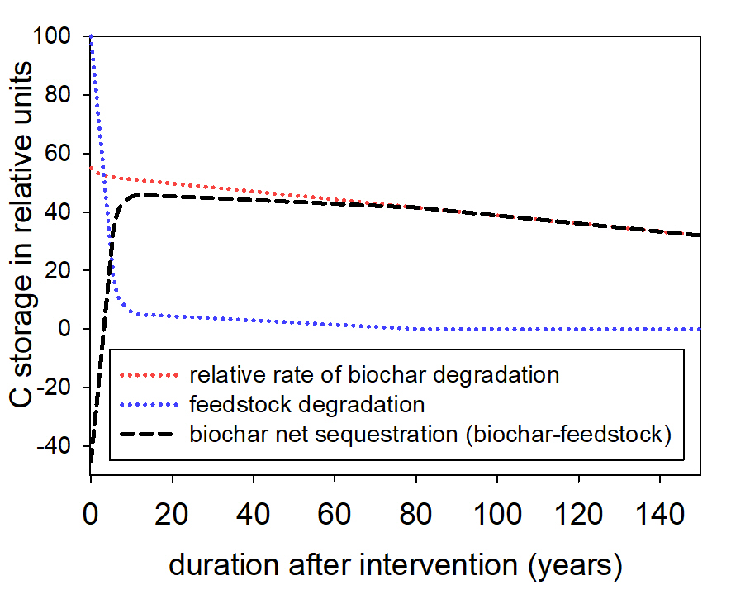
Sup Figure 1: Carbon storage over time in relative units with natural biomass decomposition, conversion of biomass residues into biochar and net carbon sequestration through biochar ^{1–3}.
References
1. Kuzyakov, Y., Bogomolova, I. & Glaser, B. Biochar stability in soil: Decomposition during eight years and transformation as assessed by compound-specific 14C analysis. Soil Biol. Biochem. 70, 229–236 (2014).
2. Budai, A., Rasse, D. P., Lagomarsino, A., Lerch, T. Z. & Paruch, L. Biochar persistence, priming and microbial responses to pyrolysis temperature series. Biol. Fertil. Soils 52, 749–761 (2016).
3. Bolinder, M. A., Angers, D. A., Giroux, M. & Laverdière, M. R. Estimating C inputs retained as soil organic matter from corn (Zea Mays L.). Plant Soil 215, 85–91 (1999).

