Article
Anti-inflammatory, antioxidant and wound healing properties of cyanobacteria from thermal mud of Balaruc-les-Bains, France: a multi-approach study
Justine Demay ^{1,2}, Sébastien Halary ¹, Adeline Knittel-Obrecht ^{3,4}, Pascal Villa ^{3,4}, Charlotte Duval ¹, Sahima Hamlaoui ¹, Théotime Roussel ¹, Claude Yéprémian ¹, Anita Reinhardt ², Cécile Bernard ^{1,}*, and Benjamin Marie ^{1,}*
¹ UMR7245 MCAM MNHN-CNRS, Muséum National d’Histoire Naturelle, CP 39, 12 rue Buffon, F-75231 Paris Cedex 05, France.; justine.demay1@mnhn.fr (J.D.) ; sebastien.halary@mnhn.fr (S.H.) ; charlotte.duval@mnhn.fr (C.D.) ; sahima.hamlaoui@mnhn.fr (Sa.H.) ; theotime.roussel@mnhn.fr (T.H.) ; claude.yepremian@mnhn.fr (C.Y.)
² Thermes de Balaruc-Les-Bains, 1 rue du Mont Saint-Clair BP 45, 34540 Balaruc-Les-Bains, France.; anita.reinhardt@thermesbalaruc.com (A.R.)
³ CNRS, Université de Strasbourg, PCBIS Plate-forme de Chimie Biologique Intégrative de Strasbourg UMS
3286, F-67412 Illkirch, France.; aobrecht@unistra.fr (A.O) ; pvilla@unistra.fr (P.V.)
⁴ Labex MEDALIS, F-67000 Strasbourg, France
* Correspondence: cecile.bernard@mnhn.fr - Tel.: +33 1 40 79 31 83 (C.B.) ; bmarie@mnhn.fr – Tel. : +33 1 40 79 32 12 (B.M.)
Received: date; Accepted: date; Published: date

Supplementary data

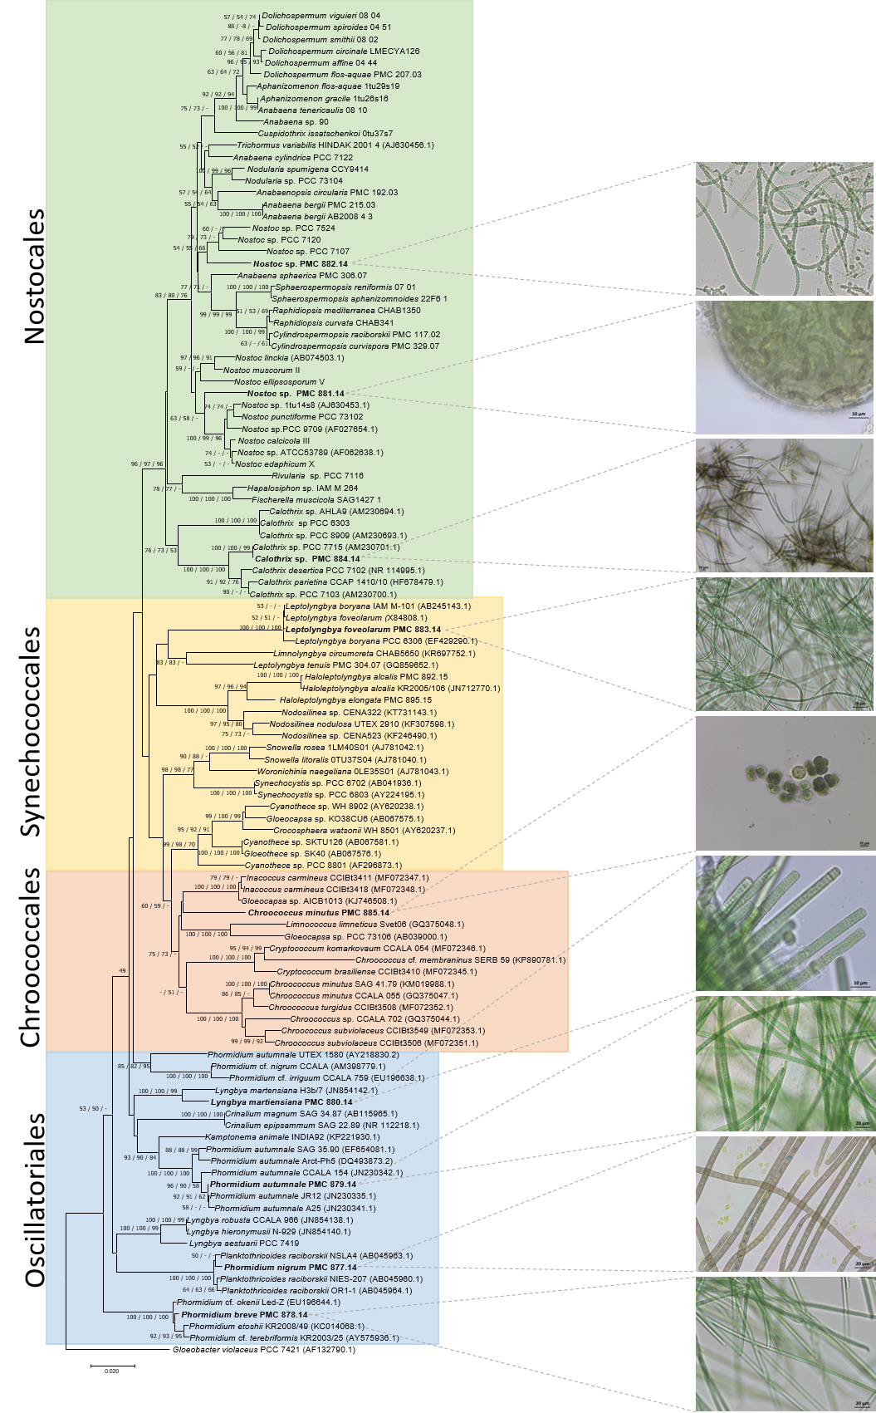
Figure S1. Consensus phylogenetic tree based on 16S rRNA gene sequences of representative cyanobacteria strains belonging to the orders Oscillatoriales, Nostocales, Chroococcales and Synechococcales, Balaruc-les-Bains strains (in bold) and one outgroup (Gloeobacter violaceus). Numbers above branches indicate bootstrap support (>50%) from 1000 replicates. Bootstrap values are given in the following order: neighbor joining/maximum likelihood/maximum parsimony.

Table S1. Biosynthetic gene clusters from Planktothricoides raciborskii PMC 877.14
Table S2. Biosynthetic gene clusters from Laspinema sp. PMC 878.14
Table S3. Biosynthetic gene clusters from Microcoleus vaginatus PMC 879.14
Table S4. Biosynthetic gene clusters from Lyngbya martensiana PMC 880.14

Table S5. Biosynthetic gene clusters from Nostoc sp. PMC 881.14
Table S6. Biosynthetic gene clusters from Aliinostoc sp. PMC 882.14
Table S7. Biosynthetic gene clusters from Leptolyngbya boryana PMC 883.14
Table S8. Biosynthetic gene clusters from Calothrix sp. PMC 884.14
Table S9. Biosynthetic gene clusters from Pseudo-chroococcus couteii PMC 885.14
Table S10. Biosynthetic genes for pigment production
Table S12-S20. BGCs from heterotrophic bacteria associated to Balaruc cyanobacteria in culture
(see .xsls file)
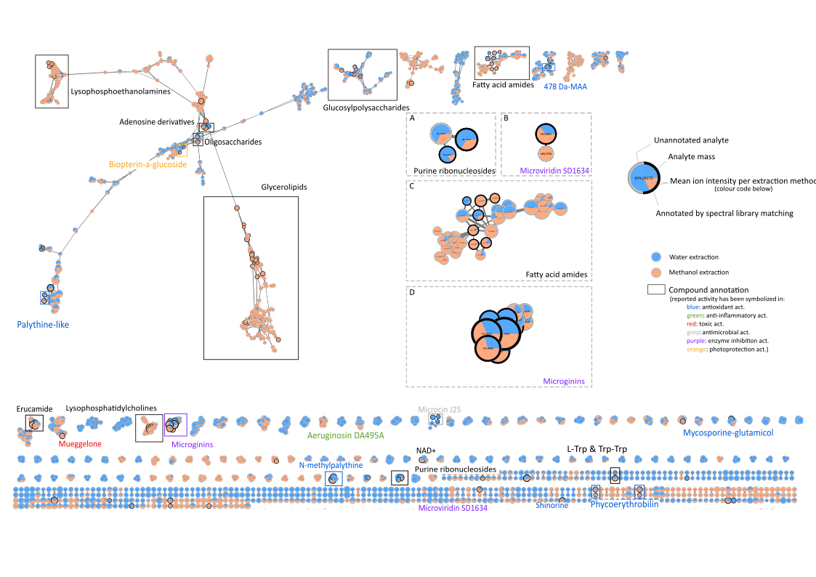
Figure S2. Molecular network of the metabolites produced by the nine cyanobacteria isolated from Balaruc thermal mud. Annotations obtained by untargeted analysis are figured inboxes. Nodes have been coloured according to the fraction of the extraction in which they were detected.
Table S11. Cell viability bioassays were assessed on the three cell types used for other activity tests (RAW 264.7; HaCaT; PMBC cell lines). The reliable toxicity threshold is set at a 40% decrease in cell viability.
 |  |  | P. raciborskii  PMC 887.14 |  | Laspinema sp.  PMC 878.14 |  | M. vaginatus  PMC 879.14 |  | L. martensiana  PMC 880.14 |  | Nostoc sp.  PMC 881.14 |  | Aliinostoc sp.  PMC 882.14 |  | L. boryana  PMC 883.14 |  | Calothrix sp.  PMC 884.14 |  | P. couteii  PMC 885.14
Bioassay |  | µg.mL⁻¹ | MeOH | H₂O | MeOH | H₂O | MeOH | H₂O | MeOH | H₂O | MeOH | H₂O | MeOH | H₂O | MeOH | H₂O | MeOH | H₂O | MeOH | H₂O
Cell Viability | RAW 264.7 | 1 | - |  | - | -30 +/-2 | - |  | - | -33 +/-1 | - | -38 +/-1 | - | -32 +/-2 | - |  | - |  | -
 |  | 5 | - |  | - | -32 +/-2 | - |  | - | -34 +/-5 | -32 +/-1 | -41 +/-0 | - | -36 +/-3 | - |  | - |  | -
 |  | 10 | - |  | - | -30 +/-2 | - |  | - | -28 +/-6 | -35 +/-1 | -37 +/-2 | - |  | - |  | - |  | -
 |  | 50 | - |  | - |  | - |  | -28 +/-2 | - | - |  | -28 +/-3 | - | - |  | - | -32 +/-1 | -
 | HaCaT | 1 | -
 |  | 5 | -
 |  | 10 | -
 |  | 50 | -
 | PBMC | 1 | -
 |  | 5 | -
 |  | 10 | -
 |  | 50 | -

