Supporting Information.

Elements | Nude | APTES | APTES+GA | APTES+GA+PSGL-1
O1s | 74.52% | 68.05% | 51.17% | 29.08%
C1s | 24.42% | 28.78% | 45.8% | 60.85%
N1s | 1.06% | 3.17% | 3.13% | 10.06%
Table S1. Element contents on the modified surface

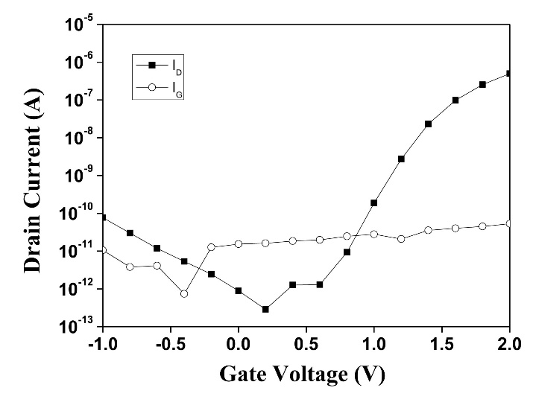
Figure S1. Electrical characteristics of the poly-Si NWFET
I_{D}−V_{G} curve of the poly-Si NWFET device, the drain current (I_{D}) and gate leakage (I_{G}) were showed
respectively.

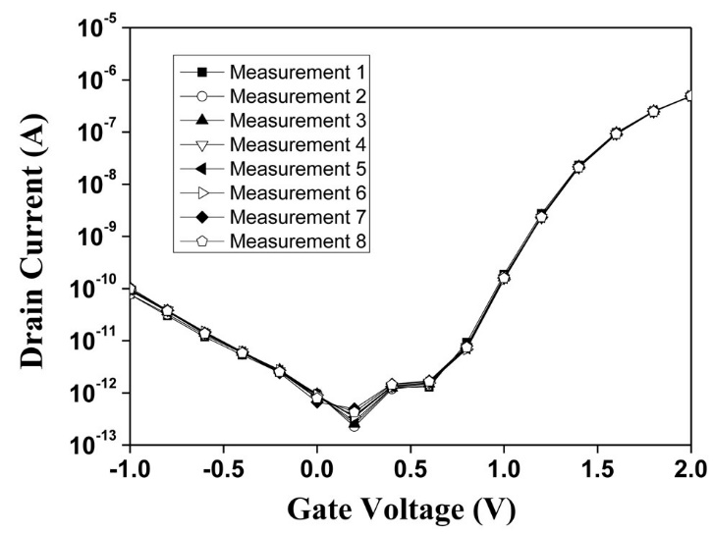
Figure S2. Eight consecutive measurements of I_{D}-V_{G} of the device
Eight consecutive measurements of the I_{D}-V_{G} curve are shown. Each of the I_{D}-V_{G} curves is close, indicating the stability of the device.
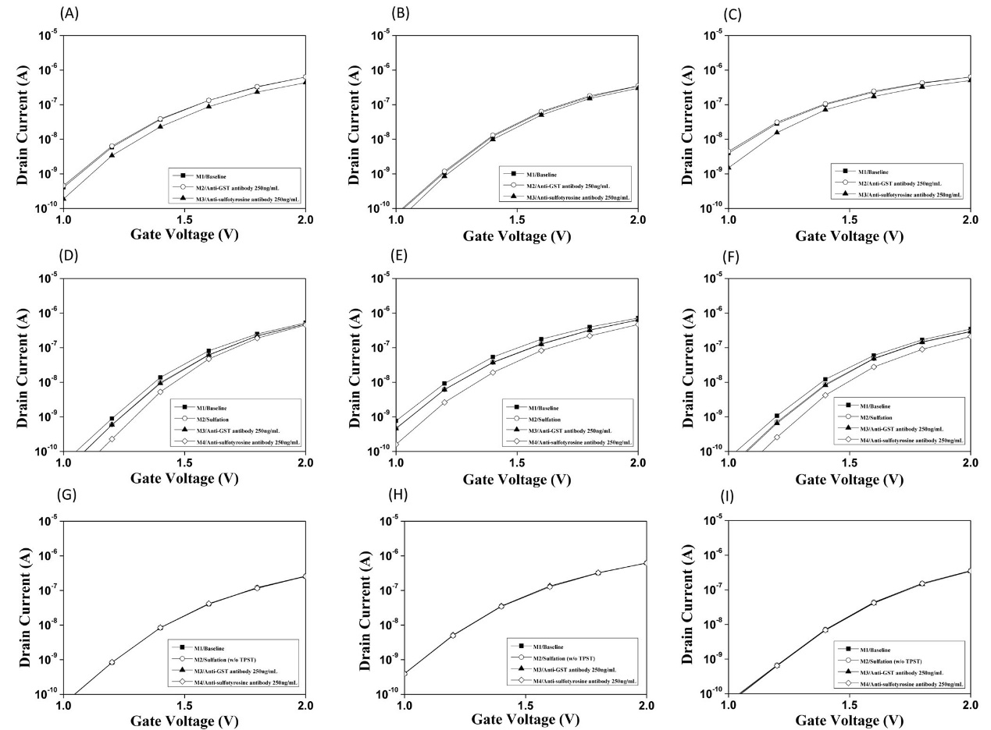
Figure S3. Electrical responses of the functionalized pSNWFET to PSGL-1 sulfation
(A)(B)(C) I_{D}–V_{G} curve obtained from the synthesized sulfated PSGL-1 peptide and interaction with anti-sulfotyrosine, and anti-GST antibodies as the controls. (D)(E)(F) I_{D}–V_{G} curve obtained through PSGL-1 sulfation and interaction with anti-sulfotyrosine, and anti-GST antibodies as the controls. (G)(H)(I) I_{D}–V_{G} curve obtained from non-sulfated PSGL-1 following coupled enzyme treatment without the critical enzyme TPST and the interaction with anti-sulfotyrosine, and anti-GST antibodies as the controls.

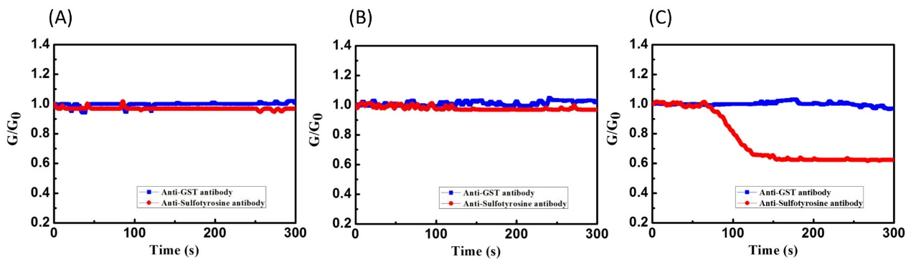
Figure S4. Real-time response of the pSNWFET following different surface modifications
(A) Response of the pSNWFET with an unmodified surface to anti-GST and anti-sulfotyrosine antibodies. (B) Response of the pSNWFET with a non-sulfated PSGL-1 peptide-modified surface to anti-GST and anti-sulfotyrosine antibodies. (C) Response of the pSNWFET with native PSGL-1 peptide-modified surface following PTS catalyzed by PST–TPST coupled enzyme system to anti-GST and anti-sulfotyrosine antibodies. The conductance was measured at fixed gate voltage. G₀ was the conductance obtained from the anti-GST treatment as the baseline, and the changes in the conductance (G/G₀ = Ganti-sulfotyrosine/Ganti-GST) were calculated.

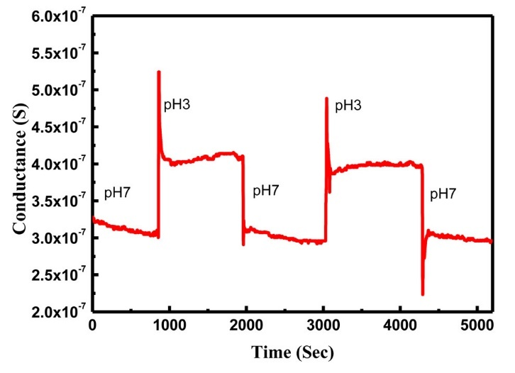
Figure S5. pH profile of the PSGL-1 modified surface
The real-time conductance response of the PSGL-1 modified NWFET device in 2 different pH buffers.

