Supplementary Materials

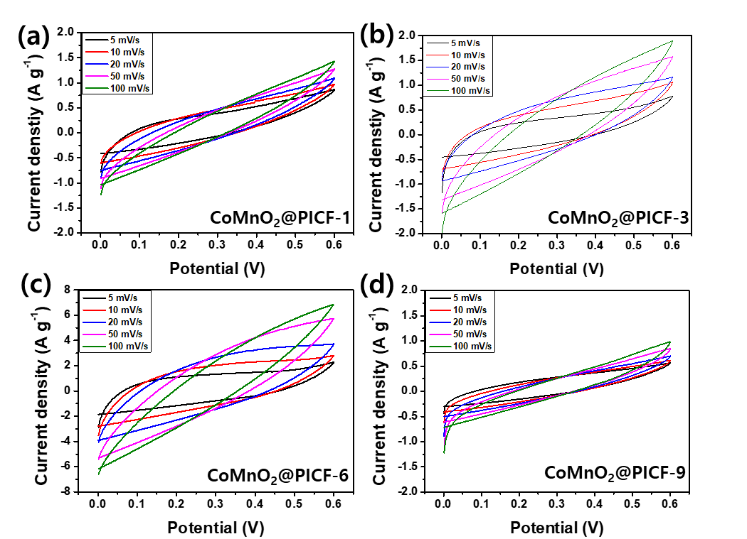

Figure S1. CV curves of pure PICFs, CoMnO₂@PICF-1, CoMnO₂@PICF-3, CoMnO₂@PICF-6 and CoMnO₂@PICF-9 electrode materials at various scan rates,

Table S1. The specific capacitance, energy density and cycle stability of the CoMnO₂/N20@PICF-6//Fe₂O₃/N20@PICF device, compared to previously reported mixed transition metal oxide based electrode materials.
Electorde material | Specific capacitance | Energy density  (Wh kg⁻¹) | Cycle stability | Electrolyte | Ref.
NiCoMn-TH/AEG//CFP-S | 66 F g⁻¹ at 0.5 A g⁻¹ | 23.5 Wh kg⁻¹ at 427 W kg⁻¹ | 87.8% 10,000 cycles at 6 A g⁻¹ | 1 M KOH | 40
NiCoMn-OH//AC | 121.5 F g⁻¹ at 1 A g⁻¹ | 43.2 Wh kg⁻¹ at 790W kg⁻¹ | 100% 10,000 cycles at 5 A g⁻¹ | PVA/KOH | 41
CoMn-HW/RGO10//AC | 107.6 F g⁻¹ at 1 A g⁻¹ | 38.3 Wh kg⁻¹ at 8000 W kg⁻¹ | 89.5% 3000 cycles at 2 A g⁻¹ | 3M KOH | 42
CoMn LDH/PPy//MLG | 38.6 mAh g⁻¹ at 0.5 A g⁻¹ | 29.6 Wh kg⁻¹ at 500 W kg⁻¹ | 99.5% 8000 cycles | 2M KOH | 43
NCM//AC | 114.5 mAh g⁻¹ at 3 A g⁻¹ | 23.7 Wh kg⁻¹ at 2625 W kg⁻¹ | 93.2% 10,000 cylces | 3M KOH | 44
Ni-Mn LDH/rGO//AC | 86.26 F g⁻¹ at 1 A g⁻¹ | 33.8 Wh kg⁻¹ at 850 W kg⁻¹ | 74.1% 10,000 cycles at 10 A g⁻¹ | 2M KOH | 45
Co/Mn-ZIF//AC | 73.54 F g⁻¹ at 0.5 A g⁻¹ | 52.5 Wh kg⁻¹ at 1080 W kg⁻¹ | 51% 1500 cycles at 10 A g⁻¹ | 3M KOH | 46
CoMnO₂/N20@PICF-6// Fe2O₃/N20@PICF | 221 F g⁻¹ at 0.7 A g⁻¹ | 60.16 Wh kg⁻¹ at 490 W kg⁻¹ | 95% 3000 cylces at 1.4 A g⁻¹ | PVA/KOH | This work

