Supplementary materials: Prediction of lung function in adolescence using epigenetic aging: a machine learning approach
Table S1. Summary of the variables IOWBC 10- and 18-year matched samples.
Features | Age 10 | Age 18
FEV₁ | 2.04 ± 0.29 | 4.151±0.786
Female (%) | 43.25 | same
Height (cm) | 139.07 ± 6.19 | 171.71 ± 9.39
Weight (kg) | 35.22 ± 7.56 | 69.01 ± 14.25
BMI (kg/m²) | 18.10 ± 2.98 | 23.32 ± 4.58
Ever asthma | 63 (19.33) | 94 (28.83)
Eczema | 81 (24.85) | 61 (18.71)
Hay fever | 65 (19.94) | 109 (33.46)
AA | 19.10 ± 7.98 | 8.25 ± 8.26
AAres | -0.008 ± 3.99 | -0.06 ± 3.78
IEAA | -0.007 ± 3.90 | -0.07 ± 3.49
Data are presented as n (%) for categorical and mean ± SD for continuous variables.

Table S2. Mutual information regression scores for predicting FEV1 and FVC at 18 years
Features | FEV1 | FVC
Sex | 0.4243 | 0.4015
AA | 0.0443 | 0.0292
AAres | 0.0277 | 0
IEAA | 0.0021 | 0
Eczema | 0 | 0.0314
Hayfever | 0.0364 | 0
Weight | 0.114 | 0.1257
FEV1_10 | 0.2452 | 0.2097
BMI | 0.0434 | 0.0046
Smoking | 0.0253 | 0
Height | 0.4675 | 0.5735
Asthma | 0.0237 | 0

Table S3. Results of five regression models predicting FEV₁ using best features and AAs
Added feature | Regression model | R² | RMSE
AA | Linear | 74.91 ± 8.28 | 0.3782 ± 0.0720
 | Lasso  ( α = 0.0001) | 74.90 ± 8.26 | 0.3784 ± 0.0719
 | Ridge  (α = 0.4) | 74.96 ± 8.16 | 0.3782 ± 0.0716
 | Elastic Net  (α = 0.001) | 74.91 ± 8.17 | 0.3785 ± 0.0714
 | Bayesian Ridge | 74.93 ± 8.23 | 0.3782 ± 0.0718
AA_{res} | Linear | 74.81 ± 7.88 | 0.3793 ± 0.0683
 | Lasso  ( α = 0.0001) | 74.83 ± 7.80 | 0.3793 ± 0.0682
 | Ridge  (α = 0.4) | 74.87 ± 7.79 | 0.3790 ± 0.0683
 | Elastic Net  (α = 0.001) | 74.81 ± 7.87 | 0.3793 ± 0.0680
 | Bayesian Ridge | 74.84 ± 7.84 | 0.3791 ± 0.0683
IEAA | Linear | 74.77 ± 7.81 | 0.3796 ± -0.0673
 | Lasso  ( α = 0.0001) | 74.77 ± 7.81 | 0.3796 ± 0.0673
 | Ridge  (α = 0.4) | 74.83 ± 7.72 | 0.3793 ± 0.0673
 | Elastic Net  (α = 0.001) | 74.79 ± 7.73 | 0.3796 ± 0.0670
 | Bayesian Ridge | 74.8 ± 7.77 | 0.3794 ± 0.0673
The models were developed using best four features (height, sex, weight at age 18 and FEV1 at age 10) with AAs (AA, AA_{res}, and IEAA respectively) as predictors of FEV1. Here, R² = average goodness-of-fit measure for regression models represented as percentage and RMSE = average root mean square error
Table S4. Results of five regression models predicting FEV₁ using best features and AA_{resdiff} and IEAA_{diff}
Added feature | Regression model | R² | RMSE
AA_{resdiff} | Linear | 74.85 ± 7.46 | 0.3792 ± 0.0644
 | Lasso  ( α = 0.0001) | 74.86 ± 7.45 | 0.3792 ± 0.0644)
 | Ridge  (α = 0.4) | 74.90 ± 7.38 | 0.3790 ± 0.0646)
 | Elastic Net  (α = 0.001) | 74.90 ± 7.40 | 0.3789 ± 0.0643)
 | Bayesian Ridge | 74.88 ± 7.43 | 0.3791 ± 0.0645
IEAA_{diff} | Linear | 74.83 ± 7.53 | 0.3793 ± 0.0647
 | Lasso  ( α = 0.0001) | 74.83 ± 7.52 | 0.3792 ± 0.0646
 | Ridge  (α = 0.4) | 74.88 ± 7.44 | 0.3791 ± 0.0648
 | Elastic Net  (α = 0.001) | 74.87 ± 7.46 | 0.3791 ± 0.0646
 | Bayesian Ridge | 74.86 ± 7.49 | 0.3791 ± 0.0647)
The models were developed using best four features (height, sex, weight at age 18 and FEV1 at age 10) with AA_{resdiff} and IEAA_{diff} respectively as predictors of FEV1. Here, AA_{resdiff} = AA_{res} at 18 – AA_{res} at 10, IEAA_{diff} = IEAA at 18 – IEAA at 10, R² = average goodness-of-fit measure for regression models represented as percentage and RMSE = average root mean square error

Table S5. Results of five regression models predicting FVC using best features and AAs
Added feature | Regression model | R² | RMSE
AA | Linear | 74.85 ± 7.69 | 0.4485 ± 0.0729
 | Lasso  ( α = 0.0001) | 74.87 ± 07.66 | 0.4484 ± 0.0727
 | Ridge  (α = 0.4) | 74.87 ± 7.60 | 0.4486 ± 0.0722
 | Elastic Net  (α = 0.0025) | 75.04 ± 7.32 | 0.4475 ± 0.0711
 | Bayesian Ridge | 74.87 ± 07.66 | 0.4485 ± 0.0726
AA_{res} | Linear | 75.10 ± 7.30 | 0.4467 ± 0.0701
 | Lasso  ( α = 0.0001) | 75.12 ± 7.28 | 0.4466 ± 0.0700
 | Ridge  (α = 0.4) | 75.11 ± 7.21 | 0.4469 ± 0.0693
 | Elastic Net  (α = 0.0025) | 75.24 ± .0701 | 0.4460 ± 0.0687
 | Bayesian Ridge | 75.12 ± .0726 | 0.4467 ± 0.0698
IEAA | Linear | 75.01 ± .0741 | 0.4475 ± 0.0706
 | Lasso  ( α = 0.0001) | 75.02 ± .0738 | 0.4473 ± 0.0704
 | Ridge  (α = 0.4) | 75.02 ± .0732 | 0.4476 ± 0.0698
 | Elastic Net  (α = 0.0025) | 75.18 ± .0708 | 0.4464 ± 0.0689
 | Bayesian Ridge | 75.02 ± .0737 | 0.4474 ± 0.0703
The models were developed using best four features (height, sex, weight at age 18 and FVC at age 10) with AAs (AA, AA_{res}, and IEAA respectively) as predictors of FVC. Here, R² = average goodness-of-fit measure for regression models represented as percentage and RMSE = average root mean square error
Table S6. Results of five regression models predicting FVC using best features and AA_{resdiff} and IEAA_{diff}
Added feature | Regression model | R² | RMSE
AA_{resdiff} | Linear | 75.13 ± .0703 | 0.4467 ± 0.0668
 | Lasso  ( α = 0.0001) | 75.14 ± .0703 | 0.4466 ± 0.0669
 | Ridge  (α = 0.4) | 75.13 ± .0696 | 0.4469 ± 0.0662
 | Elastic Net  (α = 0.0025) | 75.23 ± .0689 | 0.4461 ± 0.0669
 | Bayesian Ridge | 75.14 ± .0700 | 0.4467 ± 0.0666
IEAA_{diff} | Linear | 75.26 ± .0685 | 0.4458 ± 0.0659
 | Lasso  ( α = 0.0001) | 75.27 ± .0685 | 0.4457 ± 0.0660
 | Ridge  (α = 0.4) | 75.25 ± .0677 | 0.4460 ± 0.0653
 | Elastic Net  (α = 0.0025) | 75.32 ± .0677 | 0.4455 ± 0.0660
 | Bayesian Ridge | 75.27 ± .0682 | 0.4457 ± 0.0656
The models were developed using best four features (height, sex, weight at age 18 and FVC at age 10) with AA_{resdiff} and IEAA_{diff} respectively as predictors of FVC. Here, AA_{resdiff} = AA_{res} at 18 – AA_{res} at 10, IEAA_{diff} = IEAA at 18 – IEAA at 10, R² = average goodness-of-fit measure for regression models represented as percentage and RMSE = average root mean square error

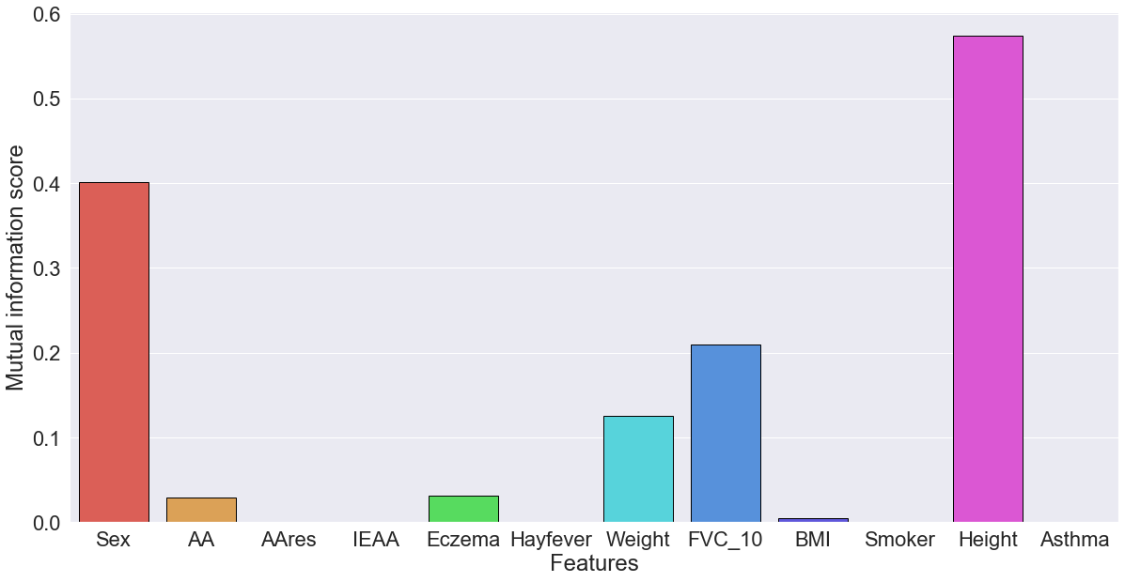
Figure S1. Mutual information score between each feature and the target which is FVC at age 18. Association of height and gender with FVC is higher than any of the other features.

