Supplementary Figures
He et al. Compact bidirectional promoters for dual-gene expression in a Sleeping Beauty transposon

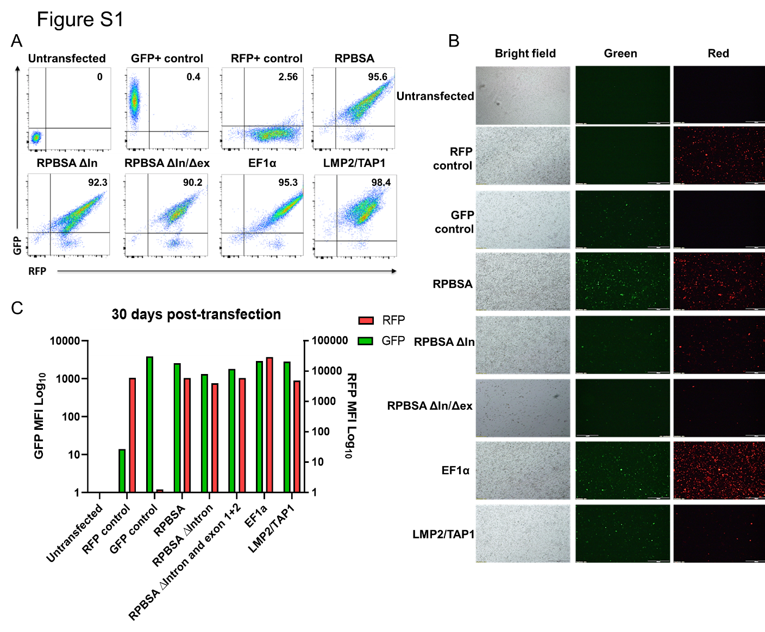
Figure S1. Monitoring maintenance of long-term expression by bidirectional promtoters after 30 days. (A) Flow cytometry carried out to measure the expression GFP and RFP in Jurkat cells. Cells were subjected to FSc and SSc doublet discrimination (B) Fluorescent microscopy of Jurkat cells expressing GFP and RFP. (C) MFI assessment of Jurkat cells for GFP and RFP expression.
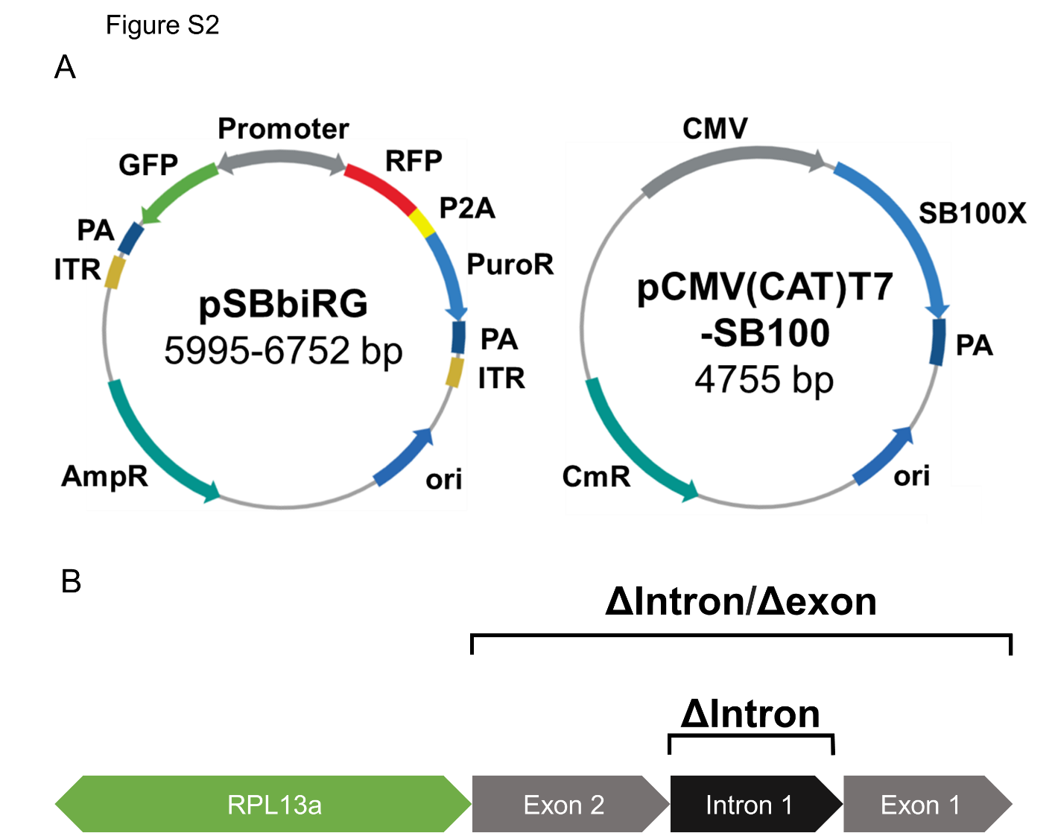
Figure S2. Plasmid construction. A) A plasmid map illustrating the SB plasmid bearing the bidirectional construct or the transposase gene on a separate plasmid, respectively. B) RPBSA as constructed and designed by Kowarz et al. Deletions to RPBSA were made as indicated.

