Supplementary Materials: The following are available online at www.mdpi.com/xxx/s1, Figure S1: ¹H NMR (200 MHz, CDCl₃:CD₃OD) of compound (6), Figure S2: ¹³C NMR (50 MHz, CDCl₃:CD₃OD) of compound (6), Figure S3: ¹H NMR (500 MHz, CDCl₃:CD₃OD) of compound (7), Figure S4: COSY (500 MHz, CDCl₃:CD₃OD) of compound (7), Figure S5: DEPT (125 MHz, CDCl₃:CD₃OD) of compound (7), Figure S6: ¹H NMR (125 MHz, CDCl₃:CD₃OD) of compound (7), Figure S7: HSQC (500 MHz, CDCl₃:CD₃OD) of compound (7), Figure S8: HMBC (500 MHz, CDCl3:CD₃OD) of compound (7), Figure S9: GC-MS chromatograms for standard compound and EtOAc extract. a) 2,3-dihydrobenzofuran profile used as a standard; b) EtOAc extract profile from A. pichinchensis cell culture suspension at 8 days of culture showing the peak of 2,3-dihydrobenzofuran compound, Figure S10: GC-MS chromatograms for standard compound and EtOAc extract. a) 3-epilupeol profile used as a standard; b) EtOAc extract profile from A. pichinchensis cell culture suspension at 16 days of culture showing the peak of 3-epilupeol compound.

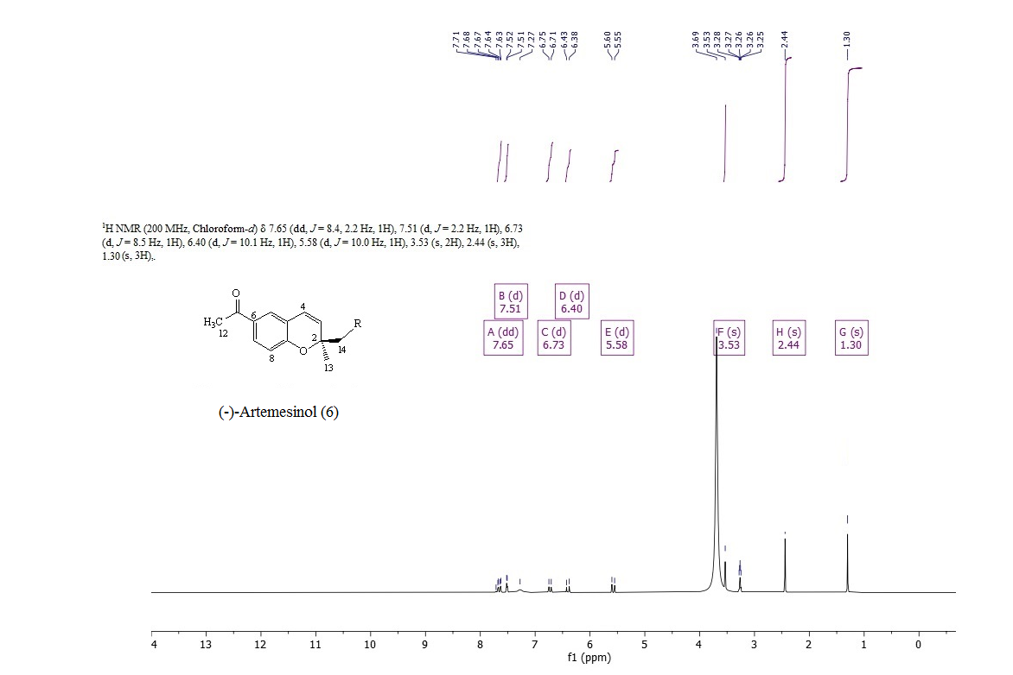
Figure S1: ¹H NMR (200 MHz, CDCl₃:CD₃OD) of compound (6)

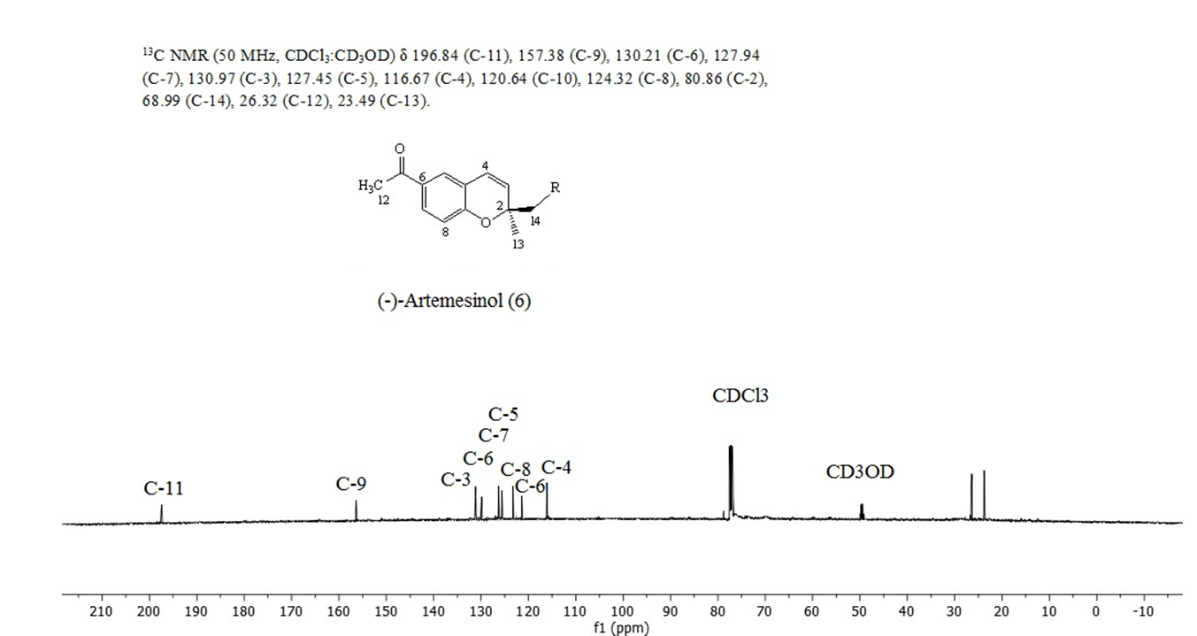
Figure S2: ¹³C NMR (50 MHz, CDCl₃:CD₃OD) of compound (6)

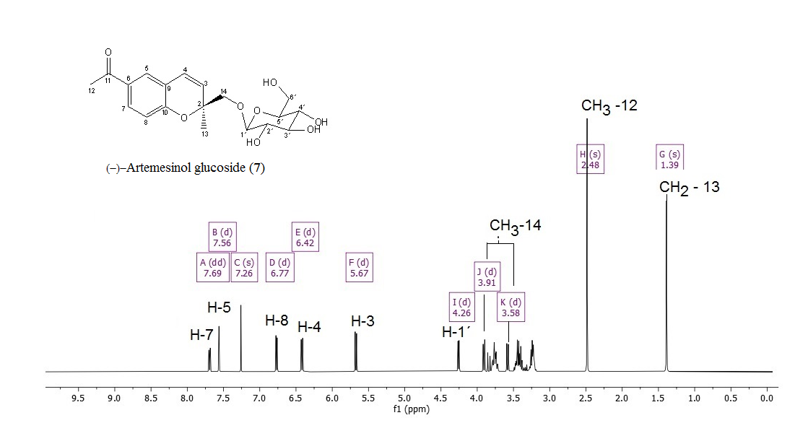
Figure S3: ¹H NMR (500 MHz, CDCl₃:CD₃OD) of compound (7)

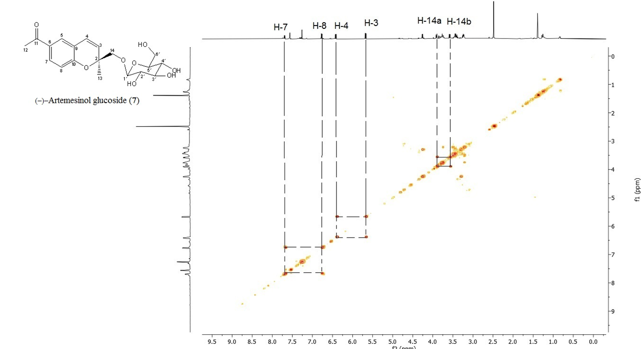
Figure S4: COSY (500 MHz, CDCl₃:CD₃OD) of compound (7)
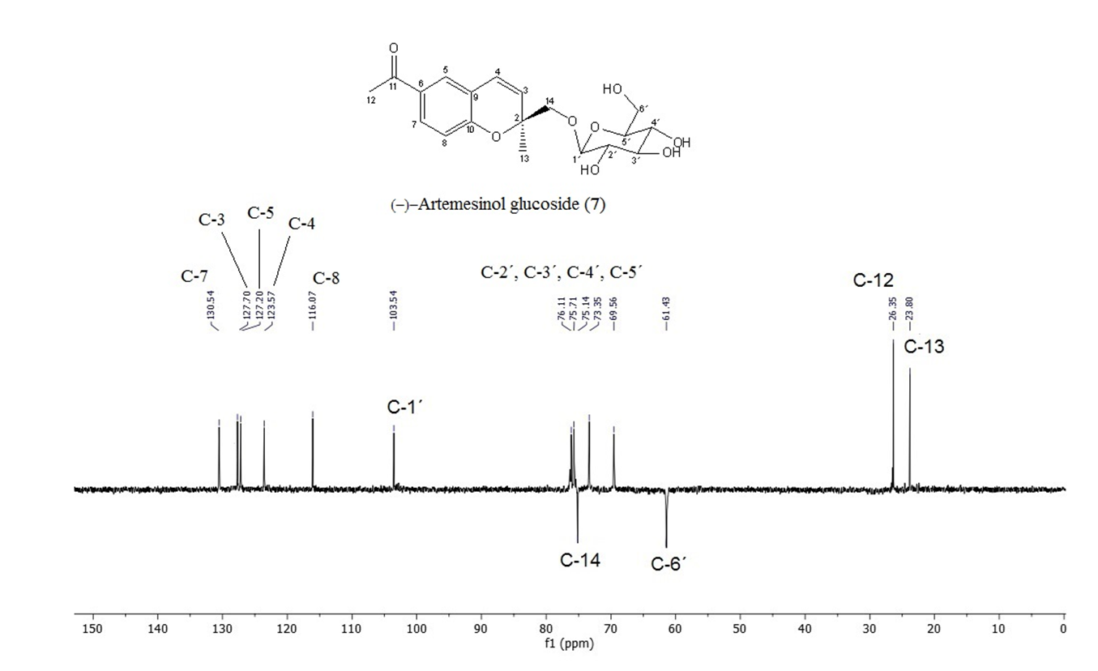
Figure S5: DEPT (125 MHz, CDCl₃:CD₃OD) of compound (7)
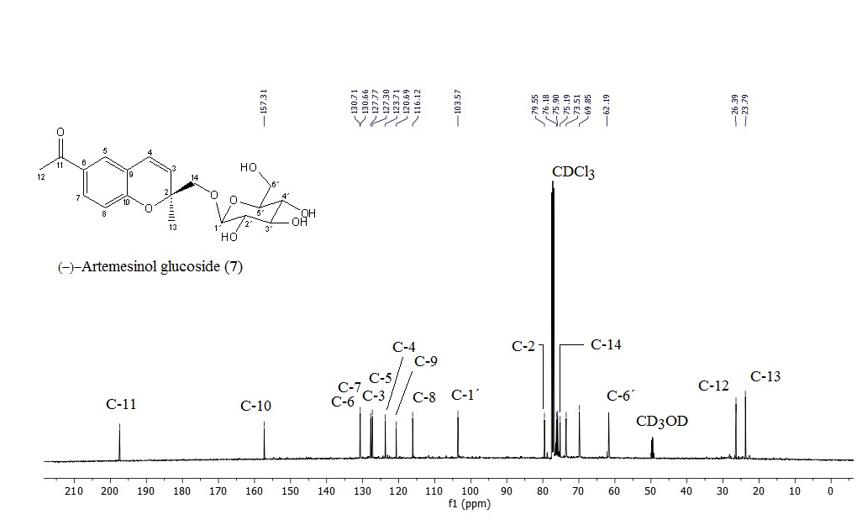
Figure S6: ¹H NMR (125 MHz, CDCl₃:CD₃OD) of compound (7)
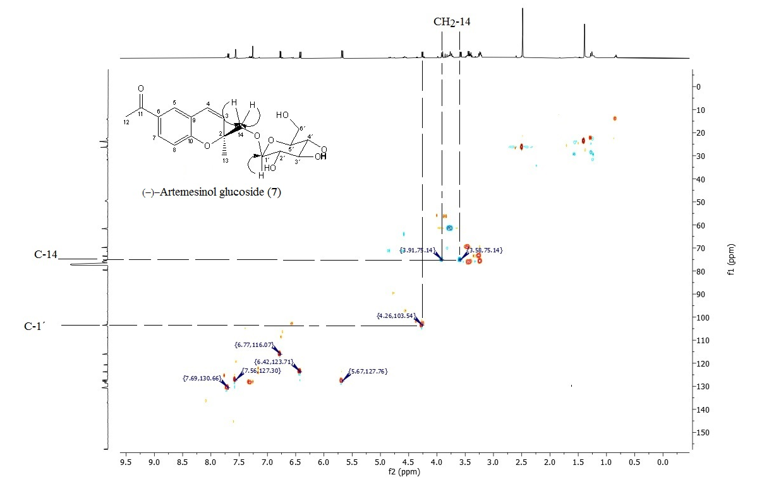
Figure S7: HSQC (500 MHz, CDCl₃:CD₃OD) of compound (7)
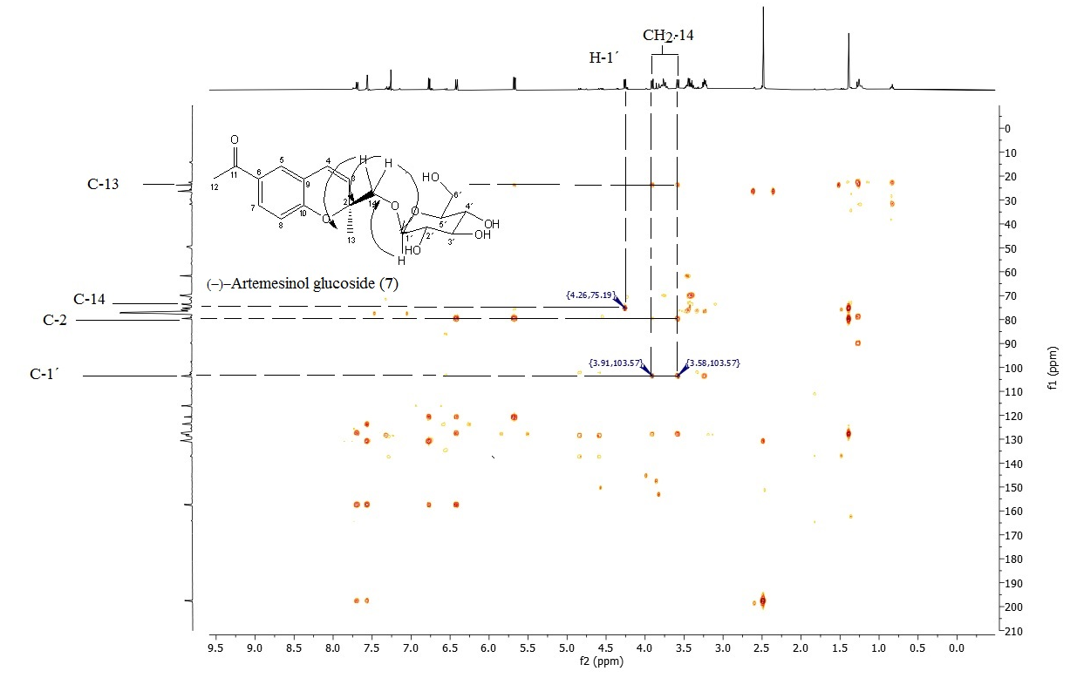
Figure S8: HMBC (500 MHz, CDCl3:CD₃OD) of compound (7)

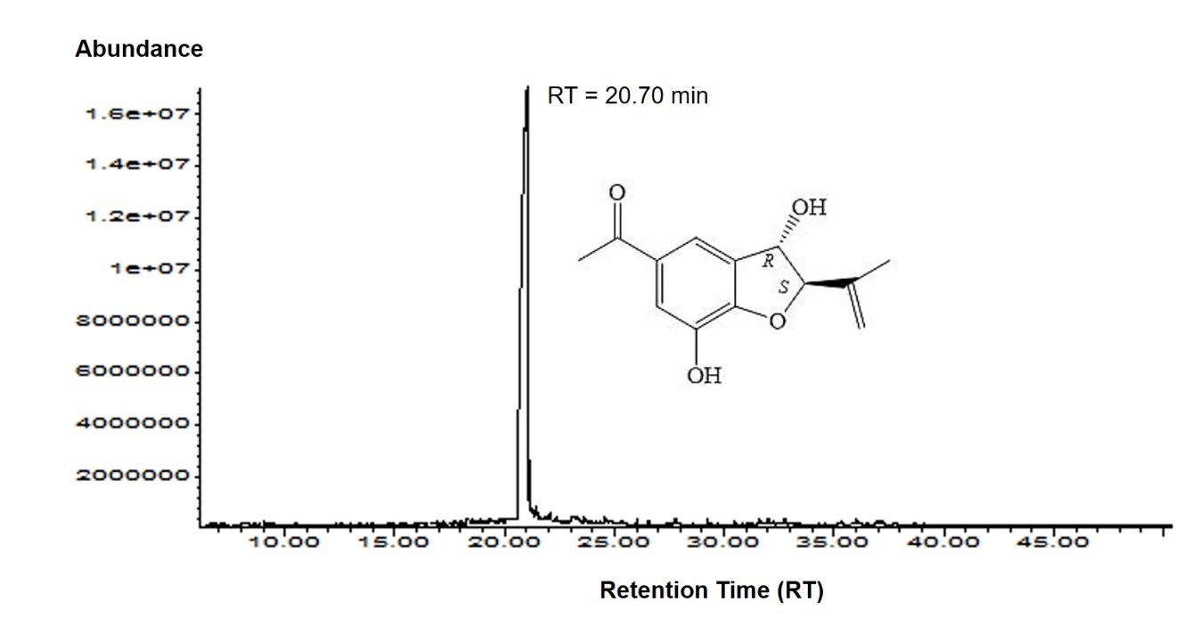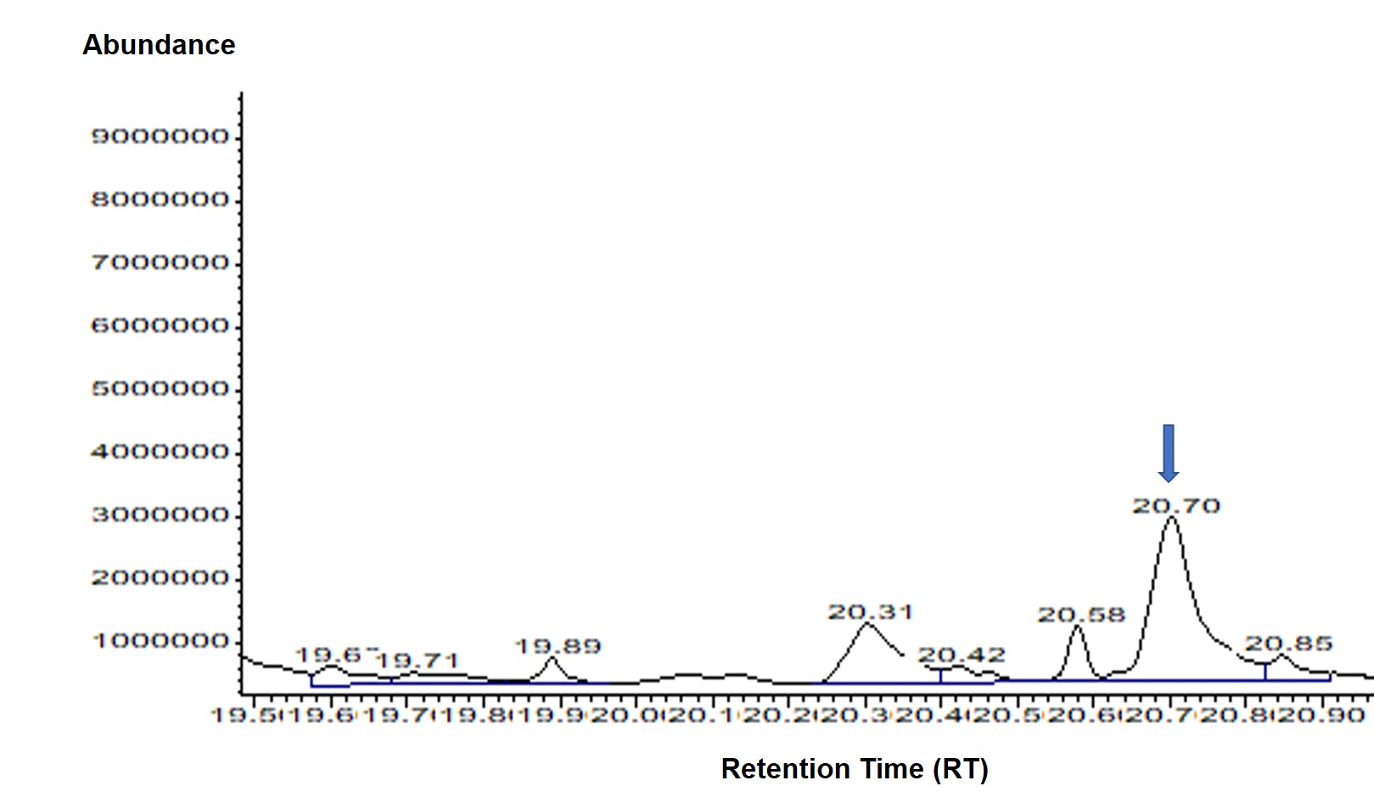
a
b
Figure S9: GC-MS chromatograms for standard compound and EtOAc extract. a) 2,3-dihydrobenzofuran profile used as a standard; b) EtOAc extract profile from A. pichinchensis cell culture suspension at 8 days of culture showing the peak of 2,3-dihydrobenzofuran compound.

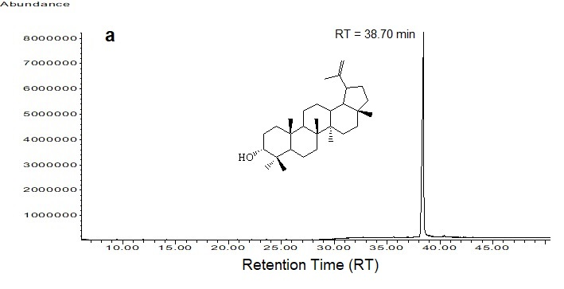
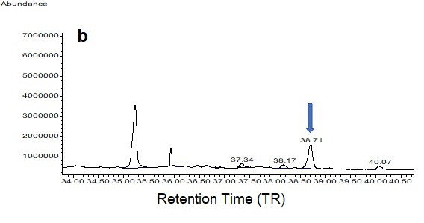Figure S10: GC-MS chromatograms for standard compound and EtOAc extract. a) 3-epilupeol profile used as a standard; b) EtOAc extract profile from A. pichinchensis cell culture suspension at 16 days of culture showing the peak of 3-epilupeol compound.

