Supplementary Materials
Discovery of unusual cyanobacterial tryptophan-containing anabaenopeptins by MS/MS based molecular networking
Subhasish Saha^{1#}, Germana Esposito^{2#}, Petra Urajová¹, Jan Mareš^{1,3}, Daniela Ewe¹, Alessia Caso², Markéta Macho^{1,4}, Kateřina Delawská^{1,4}, Andreja Kust^{1,3}, Pavel Hrouzek¹, Josef Juráň^{4,5}, Valeria Costantino³ and Kumar Saurav¹*
¹Laboratory of Algal Biotechnology-Centre Algatech, Institute of Microbiology of the Czech Academy of Sciences, Třeboň, Czech Republic, saha@alga.cz (S.S.); urajova@alga.cz (P.E.); ewe@alga.cz (D.E.); macho@alga.cz (M.M.); delawska@alga.cz (K.D.); kust@alga.cz (A.K.); sauravverma17@gmail.com (K.S.)
²TheBlue Chemistry lab, Università degli Studi di Napoli, task Force "BigFed2, Napoli, Italy, germana.esposito@unina.it (G.E.); alessia.caso@unina.it (A.C.); valeria.costantino@unina.it (V.C.).
³Biology Centre of the Czech Academy of Sciences, Institute of Hydrobiology,České Budějovice, Czech Republic. andreja.kust@gmail.com (A.K.), jan.mares@centrum.cz (J.M.)
⁴University of South Bohemia, Faculty of Science, Branišovská 1760, České Budějovice, Czech Republic. delawska@alga.cz (K.D.); macho@alga.cz (M.M)
⁵Institute of Botany of the Czech Academy of Sciences, Třeboň, Czech Republic, juran.josef@seznam.cz (J.J.).

#Equal contribution
*Correspondence: valeria.costantino@unina.it (V.C.), sauravverma17@gmail.com (K.S.); Tel.: (+420-737-003-359 (K.S.).
Received: date; Accepted: date; Published: date

Table S1. Biosynthetic gene clusters (BGCs) predicted from the genome of Brasilonema sp. CT11 using antiSMASH. Out of the 36 clusters identified, four clusters possess 100% similarity with other known BGCs whereas only two clusters were detected with more than 75% similarity with BGCs of known compounds.
Table S2. Summary of deduced proteins in the anabaenopeptin biosynthetic pathway in Brasilonema sp. CT11 and their closest homologues.
Table S3. Summary of adenylation domains and their substrates involved in anabaenopeptin biosynthesis in Brasilonema sp. CT11.
Figure S1. Molecular networking analyses of the crude extract of Brasilonema CT11 analyzed via LC-HRMS/MS. Labelled box represents the cluster containing APT molecules.
Figure S2. HR-MS/MS product ion spectra of protonated anabenopeptin 802 2a and 2b from Brasilonema CT11.
Table S4. NMR data of anabenopeptin 802a (2a) (700 MHz, CD₃OD).
Figure S3. ¹H-NMR spectrum of anabenopeptin 802a (2a) (700 MHz, CD₃OD).
Figure S4. COSY spectrum of anabenopeptin 802a (2a) (700 MHz, CD₃OD).
Figure S5. NOESY spectrum of anabenopeptin 802a (2a) (700 MHz, CD₃OD).
Figure S6. HSQC spectrum of anabenopeptin 802a (2a) (700 MHz, CD₃OD).
Figure S7. HMBC spectrum of anabenopeptin 802a (2a) (700 MHz, CD₃OD).
Figure S8. TOCSY spectrum of anabenopeptin 802a (2a) (700 MHz, CD₃OD).
Table S5. NMR data of anabenopeptin 802b (2b) (700 MHz, CD₃OD).
Figure S9. ¹H-NMR spectrum of anabenopeptin 802b (2b) (700 MHz, CD₃OD).
Figure S10. COSY spectrum of anabenopeptin 802b (2b) (700 MHz, CD₃OD).
Figure S11. NOESY spectrum of anabenopeptin 802b (2b) (700 MHz, CD₃OD).
Figure S12. HSQC spectrum of anabenopeptin 802b (2b) (700 MHz, CD₃OD).
Figure S13. HMBC spectrum of anabenopeptin 802b (2b) (700 MHz, CD₃OD).
Figure S14. TOCSY spectrum of anabenopeptin 802b (2b) (700 MHz, CD₃OD).

Table S1. BGCs predicted from this strain using antiSMASH. Out of the 36 clusters identified, four clusters possess 100% similarity with other known BGCs whereas only two clusters were detected with more than 75% similarity with BGCs of known compounds.

Metabolite Class | Brasilonema CT11 | Most similar known cluster (%)
PKS I | 01 | Merocyclophane C/D (22%)
NRPS | 12 | Anabaenopeptin 908/915 (100%)
PKS-NRPS Hybrid | 06 | Nostopeptolide A2 (100%)
Terpene | 03 | Geosmin (100%)
RiPP | 02 | -
Bacteriocin | 04 | -
Indole | 01 | Staurosporine (26%)
Mixed | 04 | -
Others | 03 | -

Table S2. Summary of deduced proteins in the anabaenopeptin biosynthetic pathway in Brasilonema sp. CT11 and their closest homologues.

Anabaenopeptin pathway |  |  | Closest homologue (BLASTp) |  |  |  | Top BLASTp hit with known function
Protein | Size [aa] | Proposed Function | Accession | Organism | Identity [%] | Function | Accession | Organism |  | Identity [%] | Function
AptA | 2201 | NRPS | WP_171976800.1 | Brasilonema (multispecies) | 89 | NRPS (hypothetical) | AVK43380.1 | Nostoc sp. N135.9.1 |  | 81 | NRPS - AptA (anabaenopeptin pathway)
AptB | 1069 | NRPS | WP_073634533.1 | Scytonema sp. HK-05 | 87 | NRPS (hypothetical) | ASR75186.1 | Nostoc sp. KVJ2 |  | 83 | NRPS - AptB (anabaenopeptin pathway)
AptC | 2588 | NRPS | WP_073634532.1 | Scytonema sp. HK-05 | 84 | NRPS (hypothetical) | AVK43394.1 | Nostoc sp. XHIID C2 |  | 82 | NRPS - AptC (anabaenopeptin pathway)
ORF1 | 206 | unknown | WP_073634531.1 | Scytonema sp. HK-05 | 88 | Uma2 family endonuclease (hypothetical) | no hit
AptD | 1397 | NRPS | WP_171976805.1 | Brasilonema (multispecies) | 91 | NRPS (hypothetical) | AVK43292.1 | Nodularia spumigena AV2 |  | 83 | NRPS - AptD (anabaenopeptin pathway)
AptE | 736 | ABC transporter | WP_171976806.1 | Brasilonema (multispecies) | 82 | ATP-binding cassette domain-containing protein (hypothetical) | AVV48476.1 | Anabaena sp. SYKE748A | 71 |  | ABC transporter - AptE (anabaenopeptin pathway)

Table S3. Summary of adenylation domains and their substrates involved in anabaenopeptin biosynthesis in Brasilonema sp. CT11.

Protein | Domain (aa range) | Closest annotated BLAST hit (aa range) | Identity [%] | Predicted substrate (antiSMASH) | Incorporated aa residue in anabaenopeptin
AptA | A0 (46-449) | AptA1, Nostoc sp. 268, AVK43337.1 (47-446) | 83 | Val/Ile | L-Val/L-Leu
 | A1 (1130-1537) | AptA2, Nostoc sp. N135.9.1, AVK43380.1 (1121-1523) | 82 | Lys | D-Lys
AptB | A2 (450-848) | AptB, Nostoc sp. XHIID C2, AVK43393.1 (470-867) | 84 | Leu/Ile | L-Leu/L-Ile/L-Val
AptC | A3 (511-905) | AptD, Nostoc sp. KVJ2, ASR75188.1 (544-937) | 80 | Leu | L-Trp
 | A4 (1563-1972) | AptC, Nostoc sp. XHIID C2, AVK43394.1 (1569-1967) | 82 | Ala | L-NMeAla
AptD | A5 (545-939) | AptD, Nodularia spumigena 309, AVK43275.1 (546-937) | 82 | Phe | L-Phe

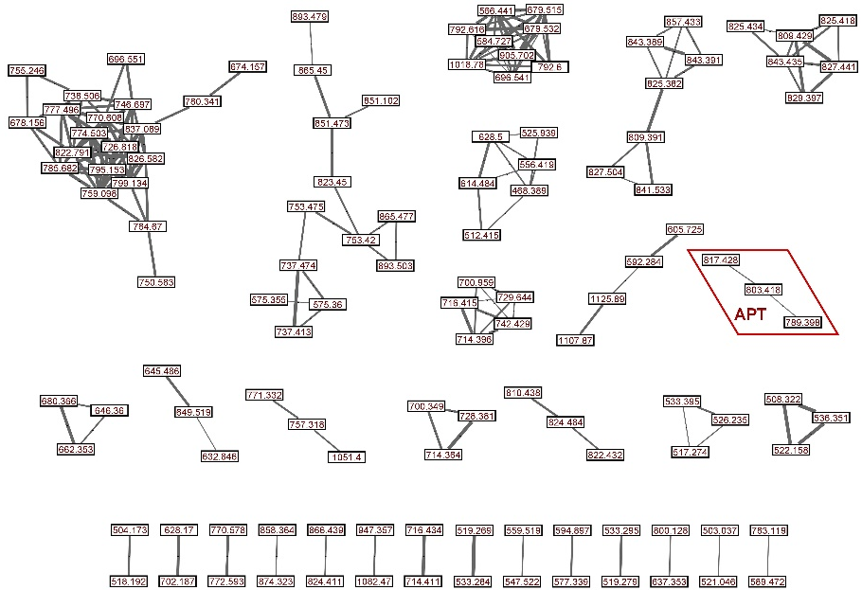

Figure S1. Molecular networking analyses of the crude extract of Brasilonema CT11 analyzed via LC-HRMS/MS. Labelled box represents the cluster containing APT molecules.

Figure S2. HR-MS/MS product ion spectra of protonated anabenopeptin 802 2a and 2b from Brasilonema CT11.

Table S4. NMR data of anabenopeptin 802a (2a) (700 MHz, CD₃OD)

 | Position | d_{C}, type |  | d_{H}, mult (J in Hz) | HMBCª | NOESY
Val | NH |  |  | 8.40, br s
 | 1 | 175.9, C |  | -
 | 2 | 59.7, CH |  | 4.18, br s
 | 3 | 31.6, CH |  | 2.25, m |  | 4, 5
 | 4 | 17.3, CH₃ |  | 0.91, d (6.9) | 2, 3, 5 | 2, 3
 | 5 | 19.8, CH₃ |  | 0.98, d (6.9) | 2, 3, 4 | 2, 3
C=O | 6 | 159.6, C |  | -
Lys | NH |  |  | 8.40, br s
 | 1 | 175.9, C |  | -
 | 2 | 56.0, CH |  | 4.15, t (4.6) | 1, 3, 4, 6, 7 | 3a
 | 3 | 32.3, CH₂ | a | 1.75, m | 1, 2
 |  |  | b | 1.93, m | 1
 | 4 | 21.5, CH₂ | a | 1.26, m
 |  |  | b | 1.45, m
 | 5 | 35.6, CH₂ |  | 1.51, m
 | 6 | 39.8, CH₂ | a | 2.92, br d (12.6) |  | 6b
 |  |  | b | 3.75, m |  | 6a
 | NH |  |  | 7.82, d (8.0)
Phe | NH |  |  | 9.21, d (8.8)
 | 1 | 174.0, C |  | -
 | 2 | 56.6, CH |  | 4.5, ddd (12.5, 8.7, 2.9) | 1, 3, 4 | 3a
 | 3 | 38.6, CH₂ | a | 2.86, t (13.2) | 2, 4, 5/9
 |  |  | b | 3.38, dd (13.7, 3.1) | 4, 5/9 | 3a
 | 4 | 139.4, C |  | -
 | 5/9 | 129.9, CH |  | 7.11, d (7.6) | 3, 6, 7 | 2, 3a
 | 6/8 | 129.5, CH |  | 7.21, t (7.6) | 4, 5/9
 | 7 | 127.3, CH |  | 7.14, t (7.6) | 5/9
NMeAla | 1 | 173.3, C |  | -
 | 2 | 56.6, CH |  | 4.60, q (6.7) | 1, 3, 4 | 3
 | 3 | 12.5, CH₃ |  | -0.26, d (6.7) | 1, 2 | 2
 | 4 | 27.9, CH₃ |  | 1.57, s | 2, C1-Trp
Trp | NH |  |  | 8.97, d (3.2)
 | 1 | 174.0, C |  | -
 | 2 | 51.7, CH |  | 5.05, dt (11.2, 5.0, 3.7) | 1, 3, 4
 | 3 | 28.8, CH₂ |  | 3.27, m | 1, 2, 4, 5
 | 4 | 109.8, C |  | -
 | 5 | 124.5, CH |  | 7.05, s | 3, 4, 6, 11 | 10
 | 6 | 128.7, C |  | -
 | 7 | 112.3, CH |  | 7.31, d (8.1) | 6, 8
 | 8 | 119.9, CH |  | 7.02, t (7.4) | 6, 7 | 10
 | 9 | 122.3, CH |  | 7.09, br d (7.6) | 10, 11
 | 10 | 119.0, CH |  | 7.57, d (7.9) | 4, 6, 9, 11 | 5, 8, 9
 | 11 | 137.8, C |  | -
 | NH |  |  | 7.90, s
Ile | NH |  |  | 7.78, br s
 | 1 | 173.9, C |  | -
 | 2 | 59.3, CH |  | 4.04, dd (9.6, 4.9) | 1, 3 | 3
 | 3 | 36.9, CH |  | 1.96, m
 | 4 | 15.3, CH₃ |  | 1.17, d (6.8) | 2, 3
 | 5 | 19.8, CH₂ |  | 1.38, m | 6
 | 6 | 14.0, CH₃ |  | 0.93, t (7.4) | 5 | 2
ª Selected HMBC correlations from proton stated to the indicated carbon.
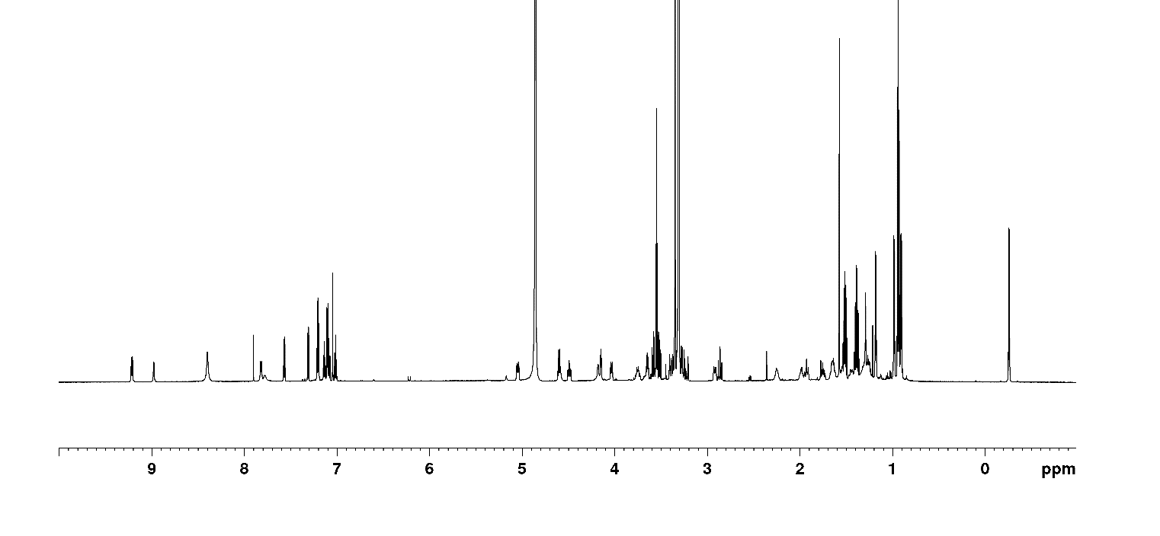

Figure S3. ¹H-NMR spectrum of anabenopeptin 802 (2a) (700 MHz, CD₃OD)

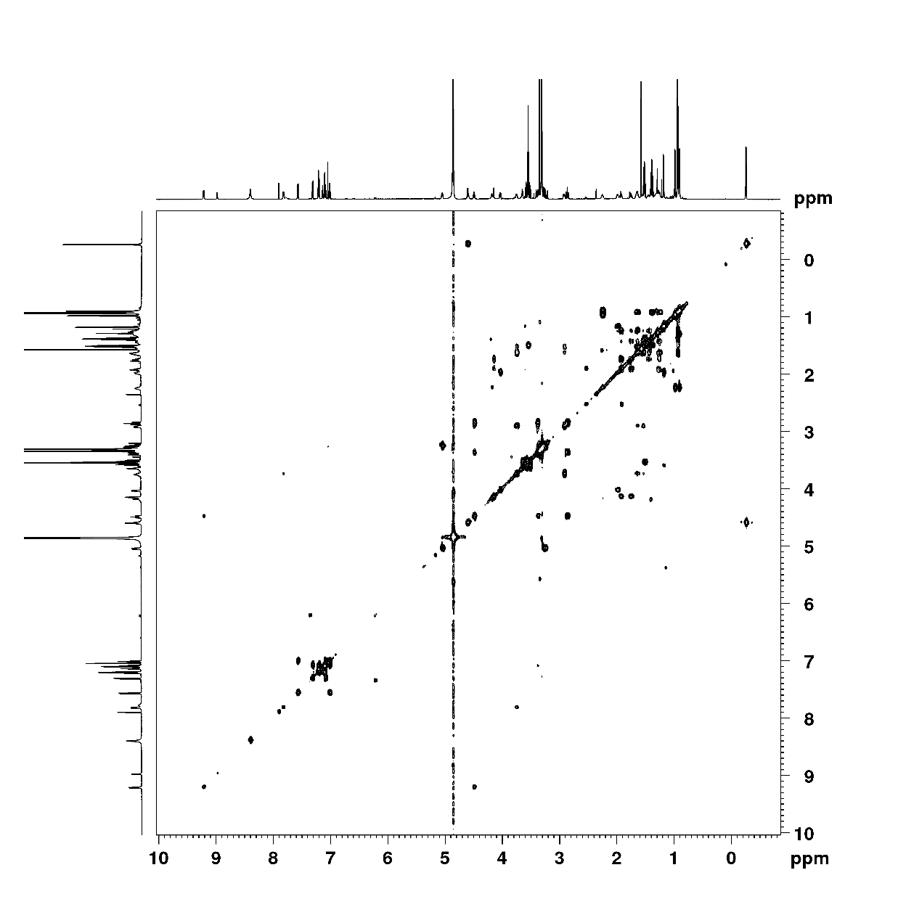
Figure S4. COSY spectrum of anabenopeptin 802 (2a) (700 MHz, CD₃OD)

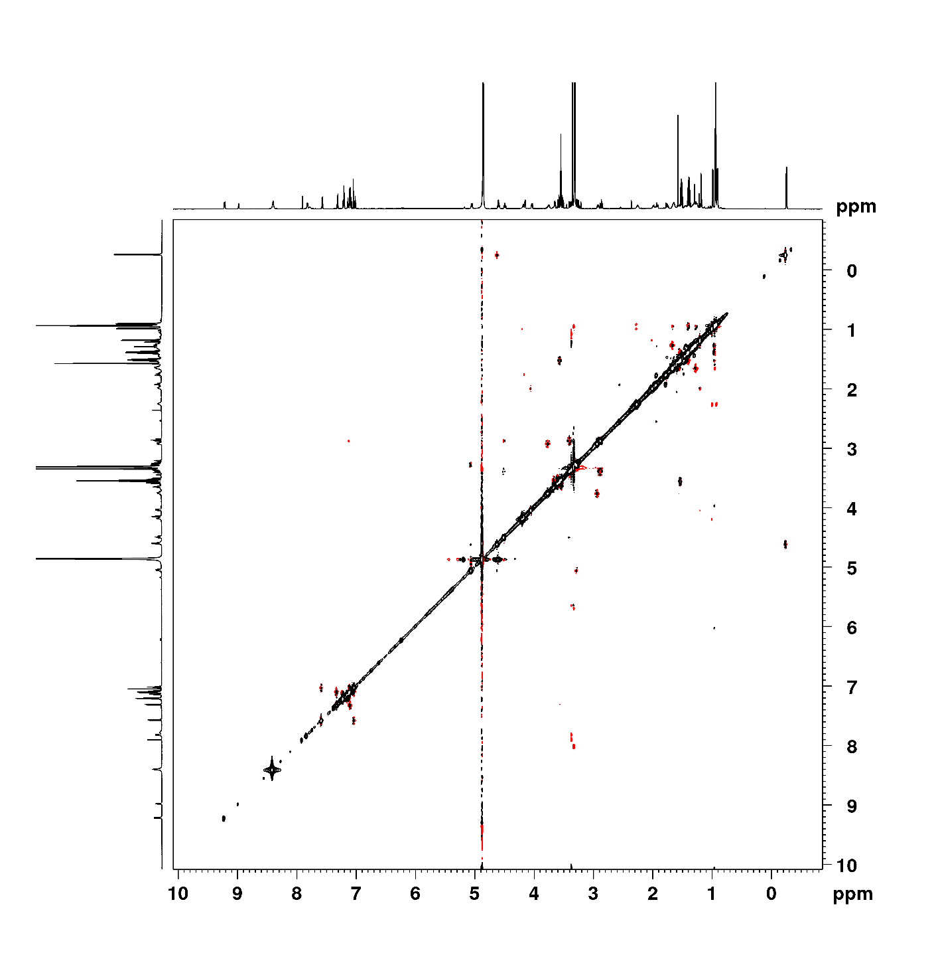
Figure S5. NOESY spectrum of anabenopeptin 802 (2a) (700 MHz, CD₃OD)

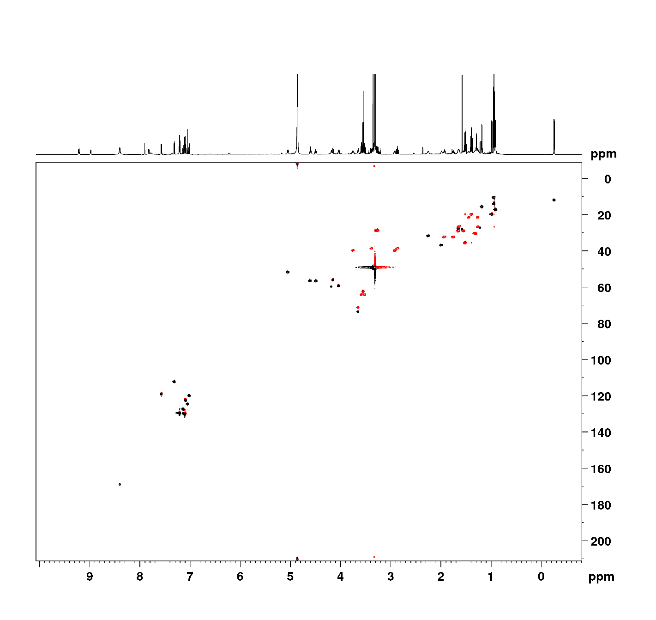

Figure S6. HSQC spectrum of anabenopeptin 802 (2a) (700 MHz, CD₃OD)

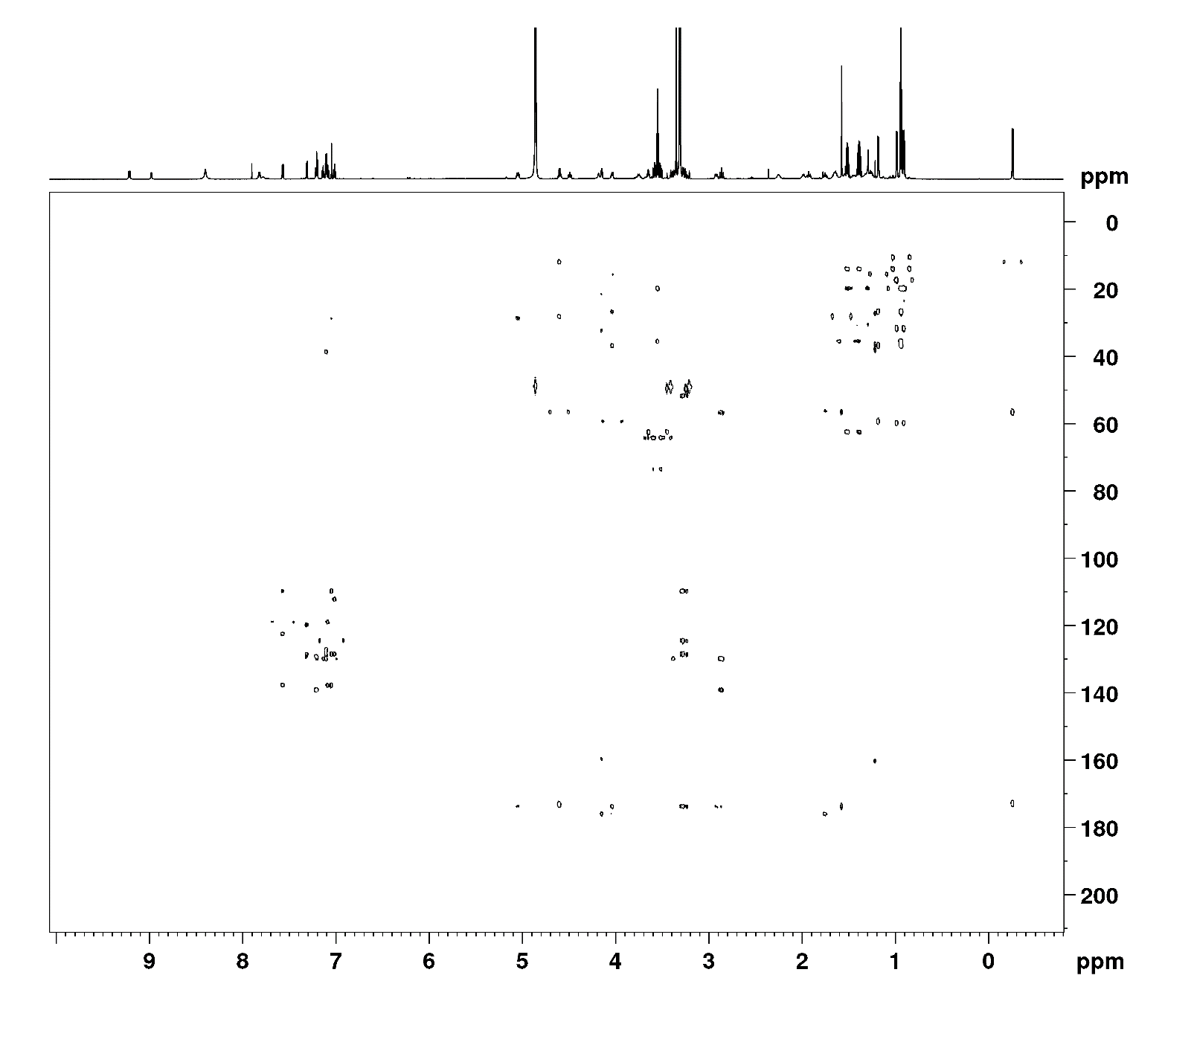
Figure S7. HMBC spectrum of anabenopeptin 802 (2a) (700 MHz, CD₃OD)

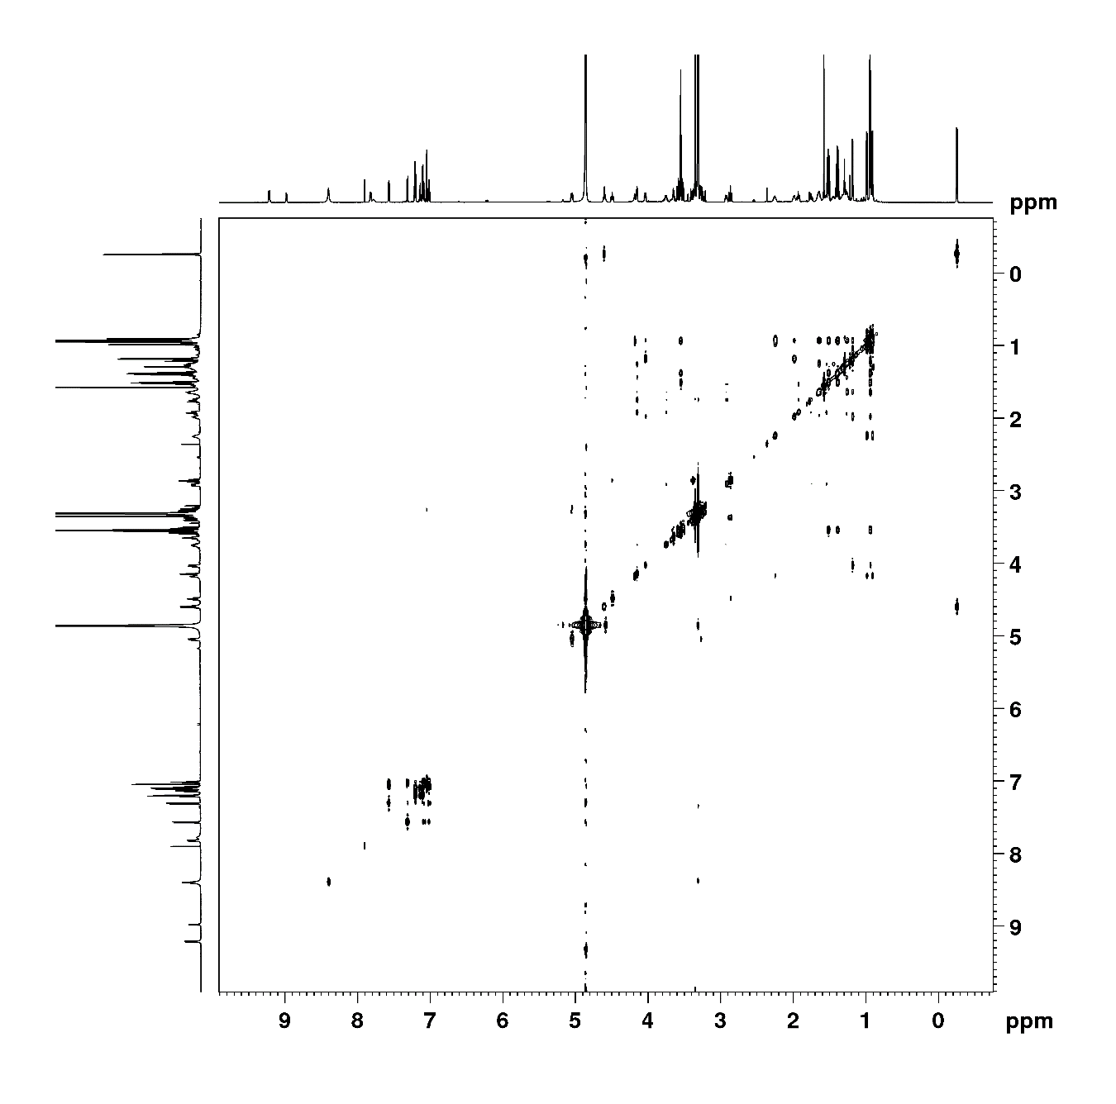

Figure S8. TOCSY spectrum of anabenopeptin 802 (2a) (700 MHz, CD₃OD)

Table S4. NMR data of anabenopeptin 802b (2b) (700 MHz, CD₃OD)

 | Position | d_{C}, type |  | d_{H}, mult (J in Hz) | HMBCª | NOESY
Val | NH |  |  | 8.20, br s
 | 1 | 176.7, C |  | -
 | 2 | 59.2, CH |  | 4.20, d (3.8) | 1, 3,7 | 3,5
 | 3 | 31.3, CH |  | 2.25, m
 | 4 | 17.2, CH₃ |  | 0.92, d (6.8) |  | 3
 | 5 | 19.8, CH₃ |  | 1.00, dd (6.6, 1.9) |  | 3
C=O | 6 | 159.6, C
Lys | NH |  |  | 8.20, br s
 | 1 | 176.3, C |  | -
 | 2 | 55.9, CH |  | 4.16, t (4.9) | 1, Val-NH | 3a, 4a
 | 3 | 31.1, CH₂ | a | 1.73, ovl
 |  |  | b | 1.95, tt (13.8, 3.4)
 | 4 | 20.2, CH₂ | a | 1.27, m
 |  |  | b | 1.47, m
 | 5 | 29.0, CH₂ | a | 1.55, m
 |  |  | b | 1.62, m
 | 6 | 39.8, CH₂ | a | 2.90, br d
 |  |  | b | 3.80, m
 | NH |  |  | 7.90, d (8.6) |  | 5b, 6a, 6b
Phe | NH |  |  | 9.20, d (8.7) |  | 2, 3a
 | 1 | 176.3, C |  | -
 | 2 | 56.9, CH |  | 4.47, ddd (12.1, 8.5, 3.1) | 1, 3a, 4 | 3a, 3b
 | 3 | 38.8, CH₂ | a | 2.85, t (13.3)
 |  |  | b | 3.40, dd (13.5,3.1)
 | 4 | 139.1, C |  | -
 | 5/9 | 129.5, CH |  | 7.20, t (7.4)
 | 6/8 | 130.1, CH |  | 7.09, ovl | 4 | 2, 3a, H4-Leu, H5-Leu
 | 7 | 127.6, CH |  | 7.14, t (7.4)
NMeAla | 1 | 173.5, C |  | -
 | 2 | 56.5, CH |  | 4.60, q (6.7) | 3 | 3
 | 3 | 10.7, CH₃ |  | -0.25, d (6.6)
 | 4 | 27.6, CH₃ |  | 1.58, s | 2
Trp | NH |  |  | 9.00, d (3.4)
 | 1 | 173.6, C |  | -
 | 2 | 51.7, CH |  | 5.10, m
 | 3 | 28.3, CH2 |  | 3.30, d (5.1) | 1, 4, 5 | 2
 | 4 | 109.5, C |  | -
 | 5 | 124.7, CH |  | 7.04, s | 4
 | 6 | 128.5, C |  | -
 | 7 | 119.1, CH |  | 7.60, d (8.1) | 9, 11 | 2, 3, H2-Leu
 | 8 | 120.1, CH |  | 7.00, t (7.4) | 6, 10
 | 9 | 122.5, CH |  | 7.09, ovl
 | 10 | 112.5, CH |  | 7.30, d (8.1)
 | 11 | 137.8, C |  | -
 | NH |  |  | 10.40, s
Leu | NH |  |  | 7.70, br s
 | 1 | 174.7, C |  | -
 | 2 | 53.5, CH |  | 4.30, m | 1, 3, 4
 | 3 | 41.1, CH₂ |  | 1.76, ovl
 | 4 | 25.4, CH |  | 1.87, m | 2, 3
 | 5 | 22.3, CH₃ |  | 1.00, dd (6.6, 1.9) |  | 1
 | 6 | 23.0, CH₃ |  | 1.05, d (6.4) |  | 3, 4

ª Selected HMBC correlations from proton stated to the indicated carbon.

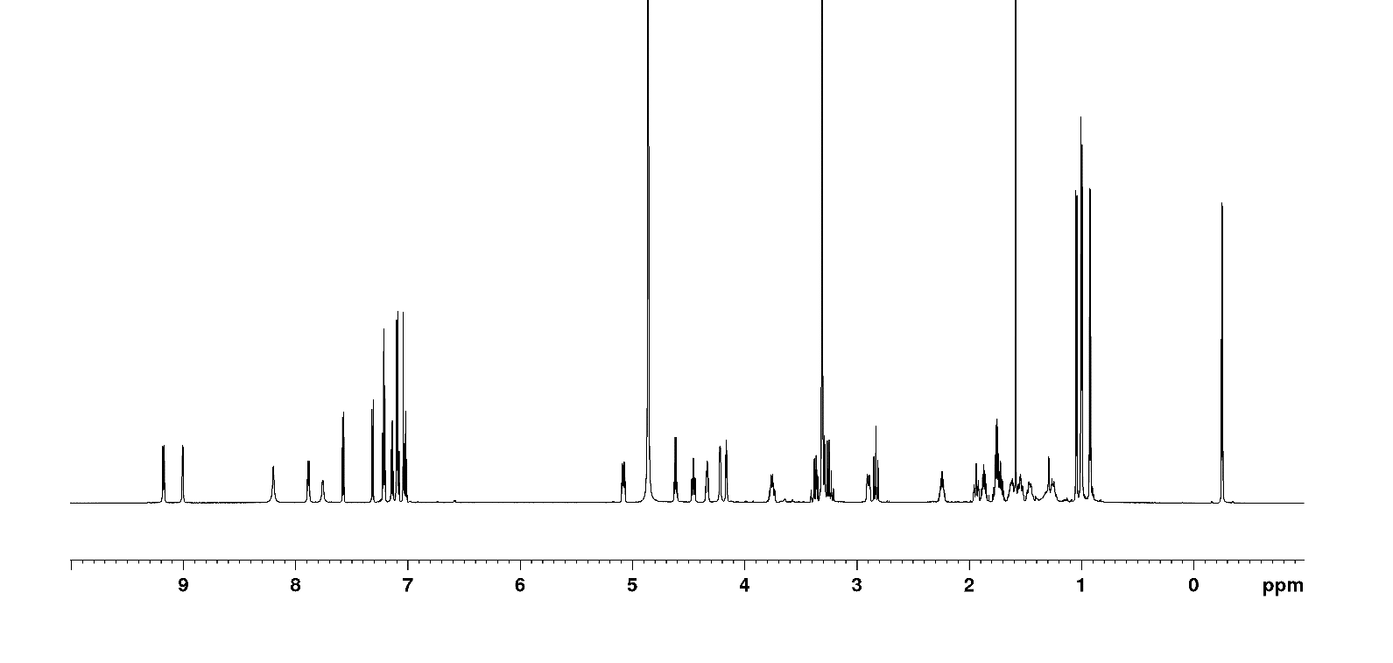
Figure S9. ¹H-NMR spectrum of anabenopeptin 802b (2b) (700 MHz, CD₃OD)

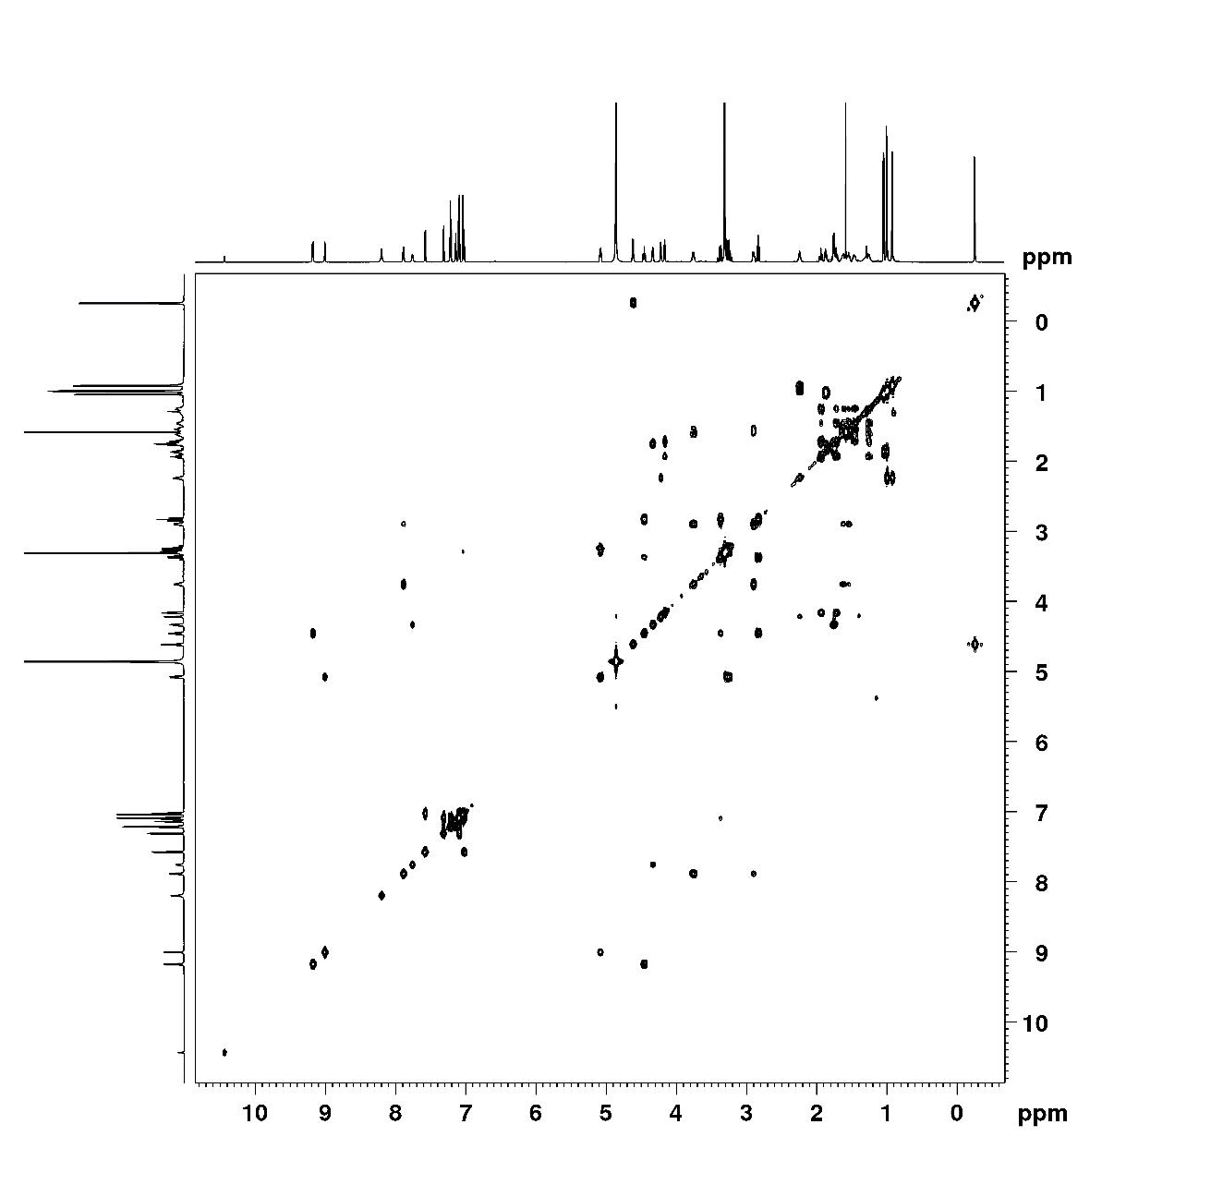
Figure S10. COSY spectrum of anabenopeptin 802b (2b) (700 MHz, CD₃OD)

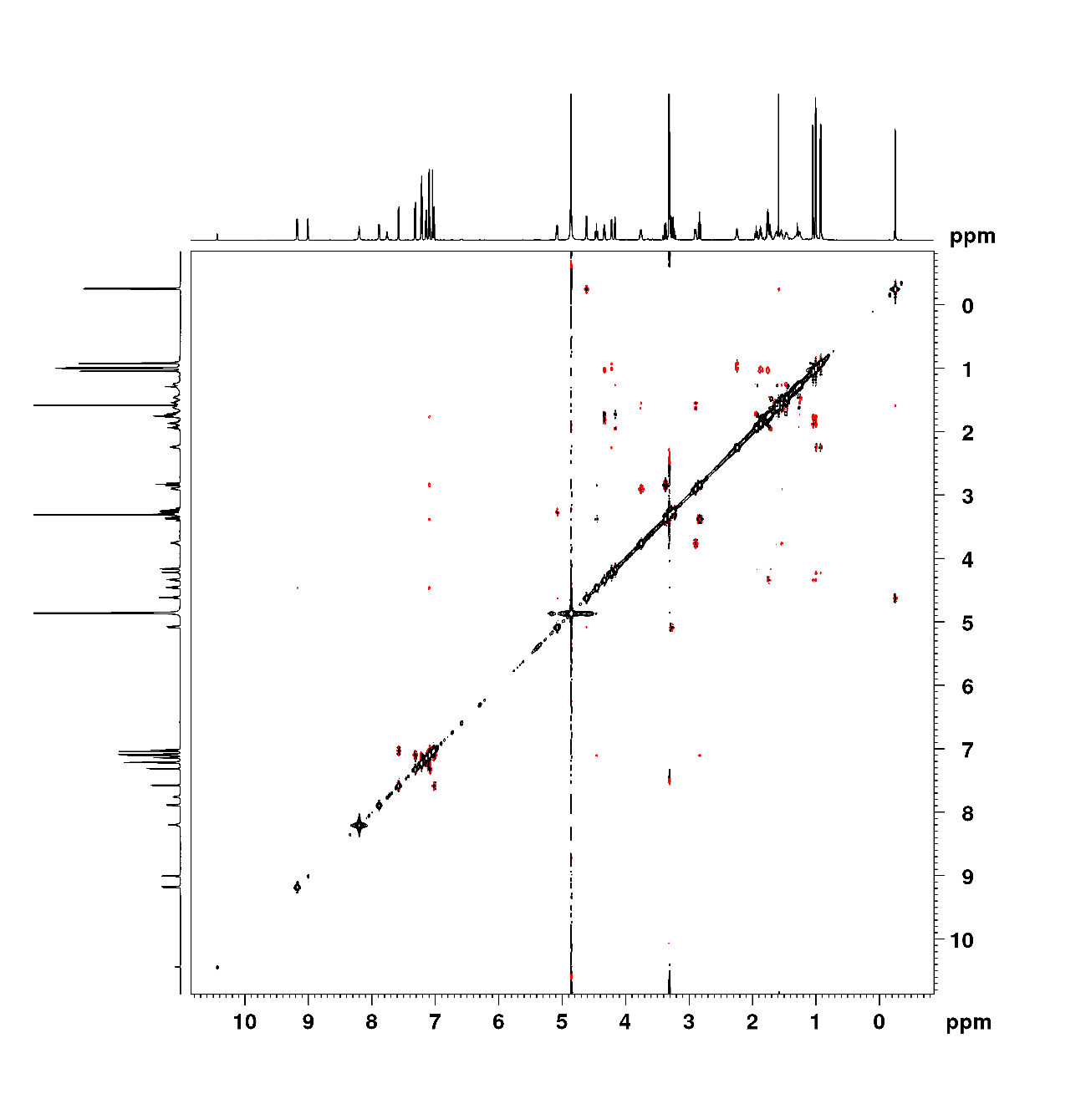
Figure S11. NOESY spectrum of anabenopeptin 802b (2b) (700 MHz, CD₃OD)

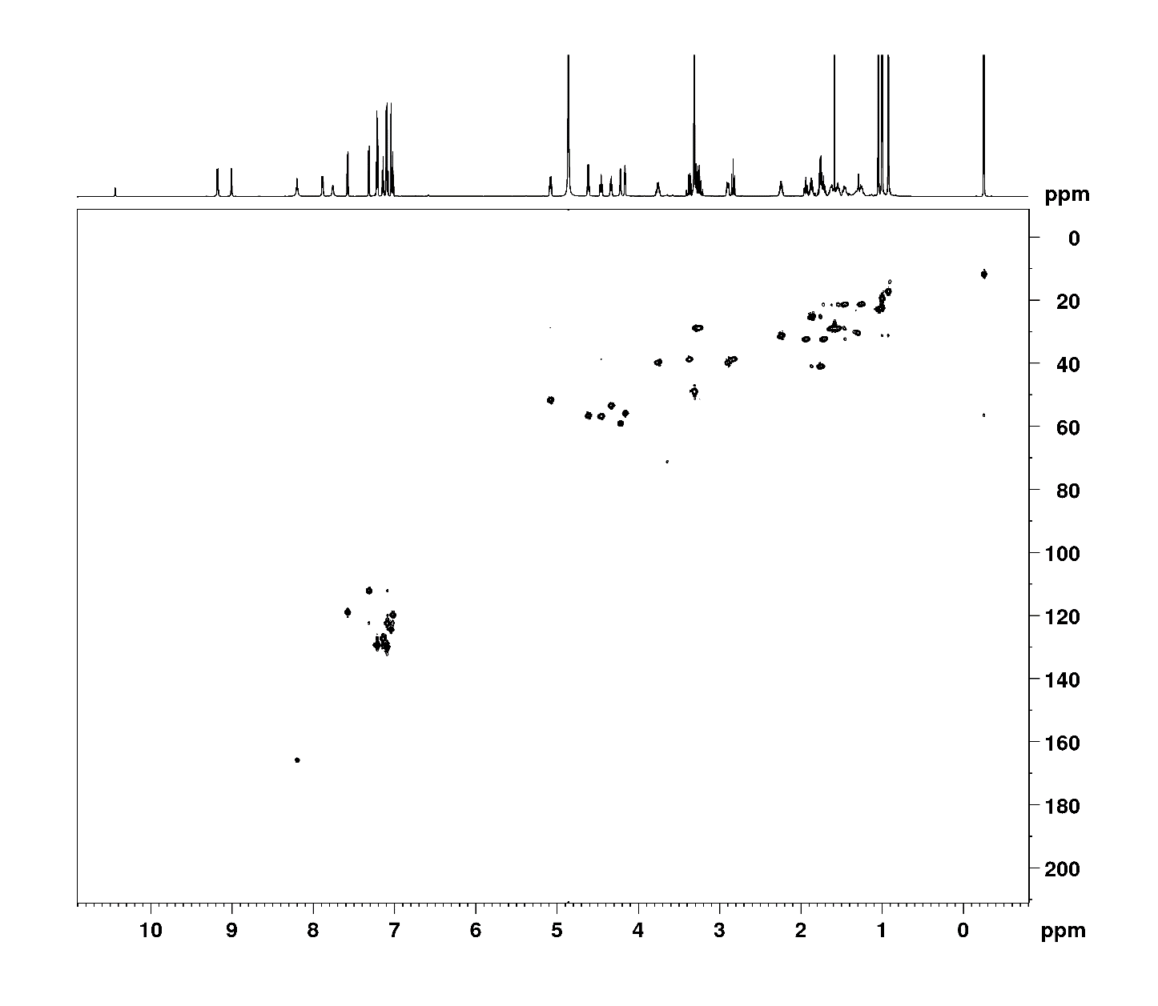
Figure S12. HSQC spectrum of anabenopeptin 802b (2b) (700 MHz, CD₃OD)

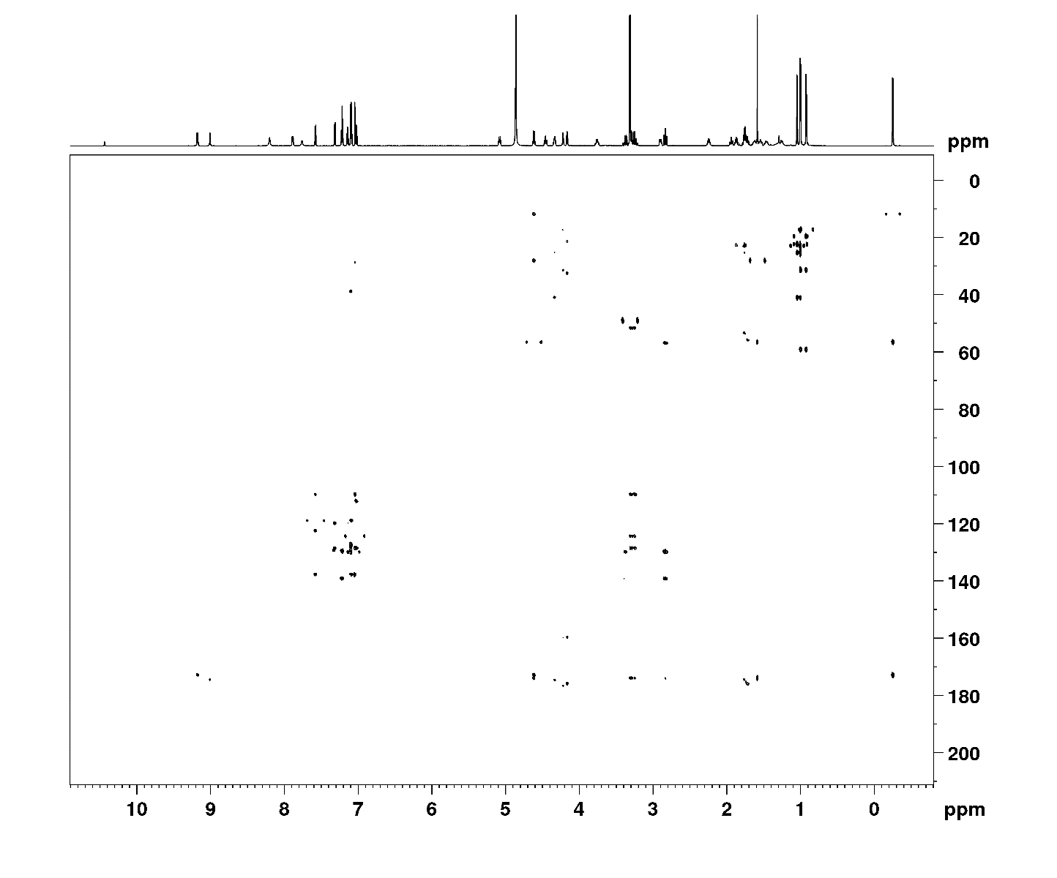
Figure S13. HMBC spectrum of anabenopeptin 802b (2b) (700 MHz, CD₃OD)

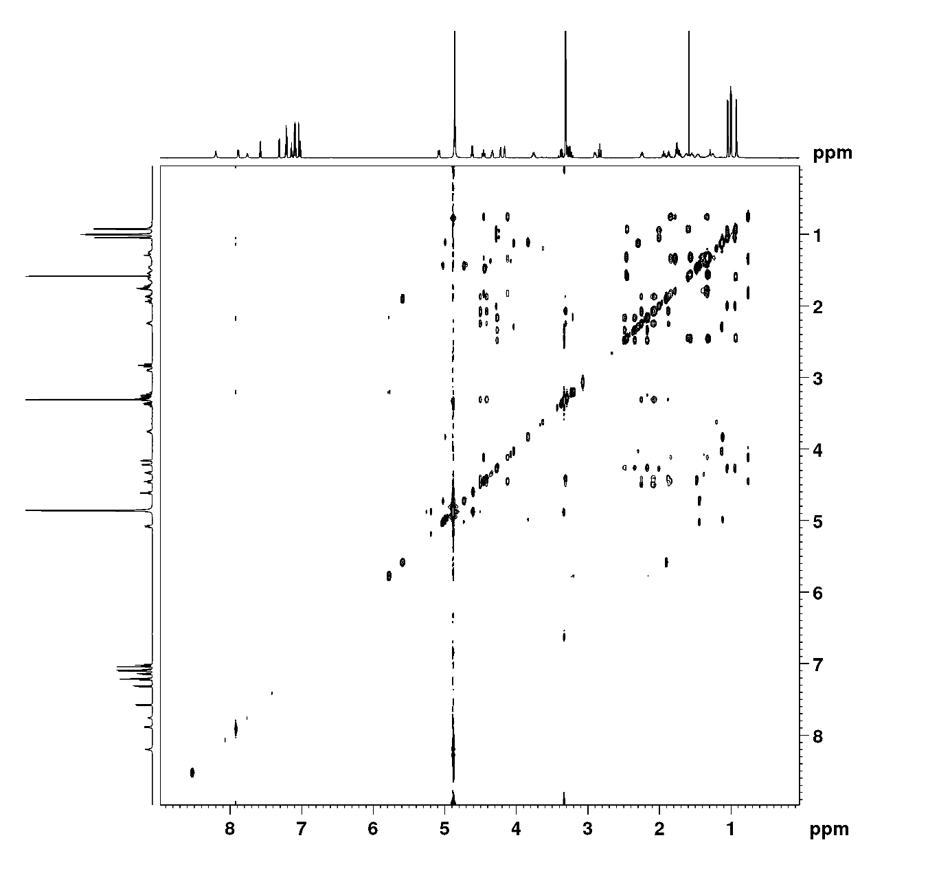
Figure S14. TOCSY spectrum of anabenopeptin 802b (2b) (700 MHz, CD₃OD)

