**Supplementary Materials**

**Flood Frequency Analysis:** In this study Generalized Extreme Value (GEV) probability distribution is fitted to annual maximum flood series (Jenkinson, 1955), widely adopted in hydrological studies in several regions (El-Jabi et al., 2015; Kochanek et al., 2013; Leclerc and Ouarda, 2007; O’Brien and Burn, 2014; Smith et al., 2015). GEV is expressed as thus:

F (x| τ, α, and k) = 

Where: τ, α, and k represent location, scale and shape parameters respectively of the distribution function.

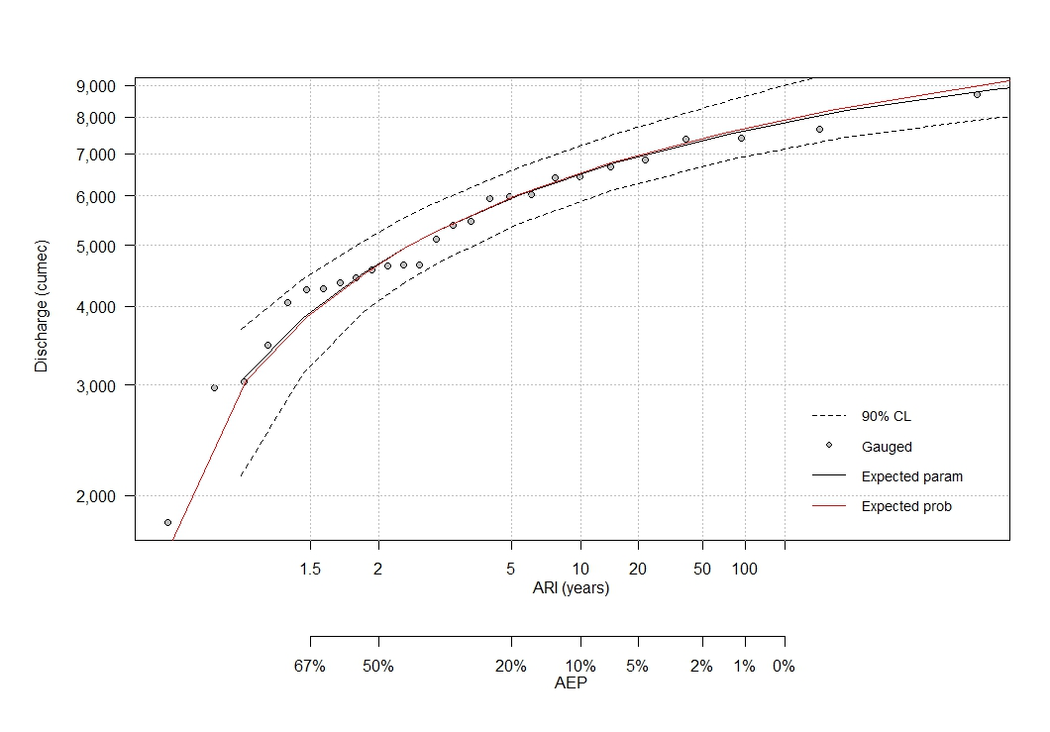

Figure S1: Baro flood frequency plot

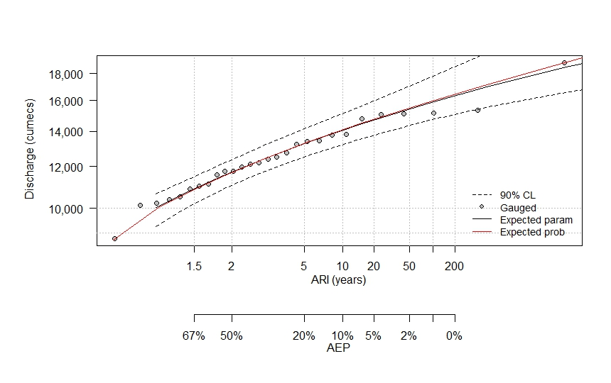

Figure S2: Umaisha flood frequency plot

|  |  |
| --- | --- |
|  |  |
| D:\Decision tree Radar Analysis\OVERFLy-Photos\ALL GeoTAgged Images\19oct12217.JPG | D:\Decision tree Radar Analysis\OVERFLy-Photos\ALL GeoTAgged Images\19oct12220.JPG |

Figure S3: Model, Observation and Overflight line of sight overlaid on high-resolution GeoEye Imagery.

Figure S4: Input hydrographs at the upstream boundaries of Umaisha and Baro