Self-supporting smart air filters based on PZT/PVDF electrospun nanofiber composite membrane
Weidong He^{1,2,3}, Yinghe Guo^{1,2,3}, Fuze Jiang^{2,3}, Yi-Bo Zhao^{2,3}, Jean Schmitt^{2,3}, Yang Yue^{2,3}, Jingxian Liu^{1,*}, Junji Cao⁴, Jing Wang^{2,3,*}
¹Filter Test Center, College of Resources and Civil Engineering, Northeastern University, NO. 3-11, Wenhua Road, Heping District, Shenyang, Liaoning 110819, China
²Institute of Environmental Engineering, ETH Zurich, 8093, Zurich, Switzerland
³Advanced Analytical Technologies, Empa, Ueberlandstrasse 129, 8600, Dübendorf, Switzerland
⁴Institute of Earth Environment, Chinese Academy of Sciences, No. 97, Yanxiang Road, Yanta Zone, Xian, Shanxi 710061, China
*Corresponding authors: jing.wang@ifu.baug.ethz.ch (J. Wang), 82003@126.com (J. Liu).

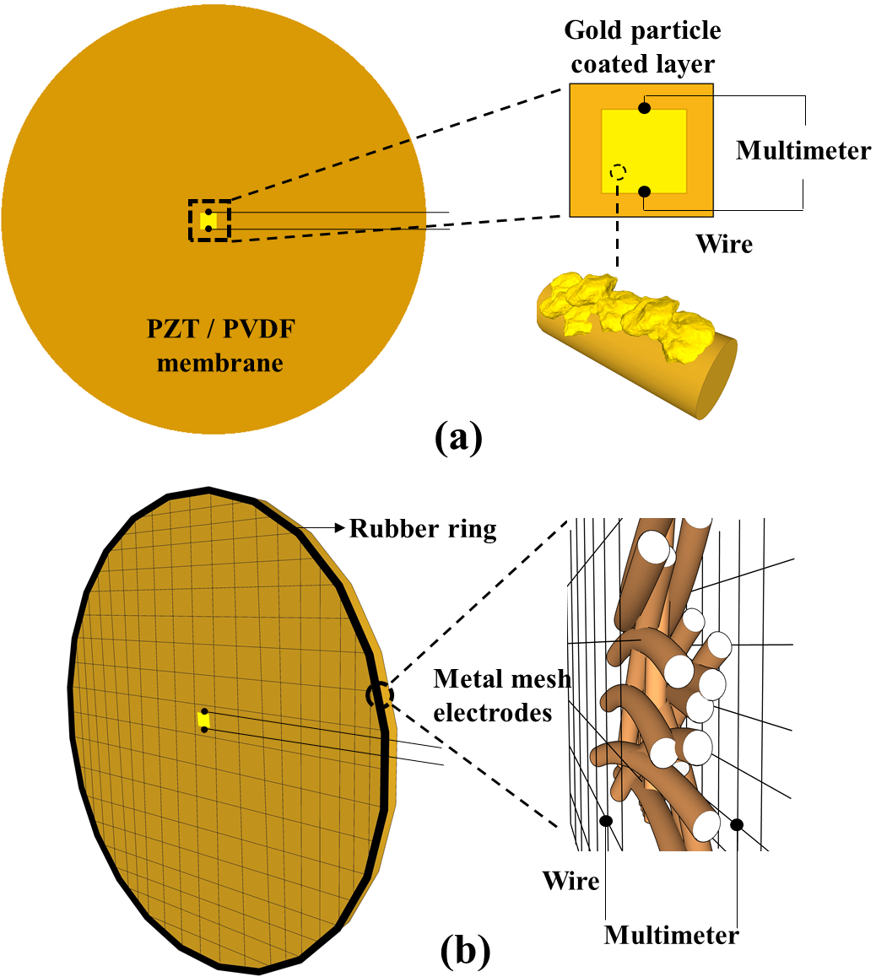
Fig.S1 The schematic diagram of SSSAF. (a) VOCs sensor.(b) Pressure drop sensor.

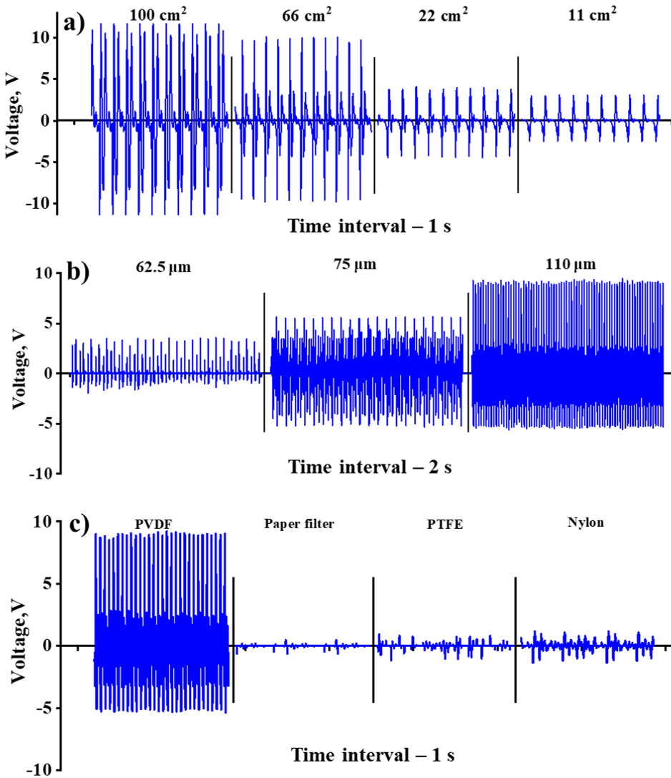
Fig. S2 a) The output voltage signal of SSSAF equipped with PZT/PVDF membranes of different area. b) The output voltage signal of SSSAF equipped with PZT/PVDF membranes of different thickness. c) The output voltage signal of PVDF membrane, paper filter, PTFE membrane and nylon membrane.

Fig. S3 Three voltage signals for energy harvesting measurement, all signals were generated by SSSAF based nanogenerator

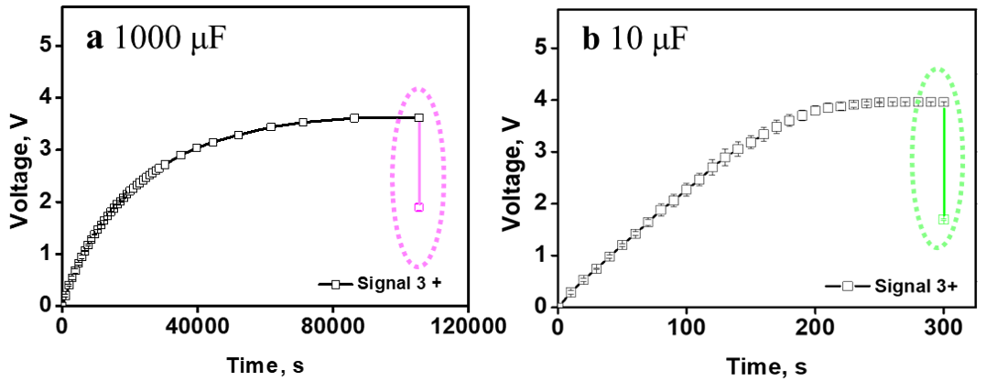
Fig. S4 Charge curves of capacitors with different capacity.

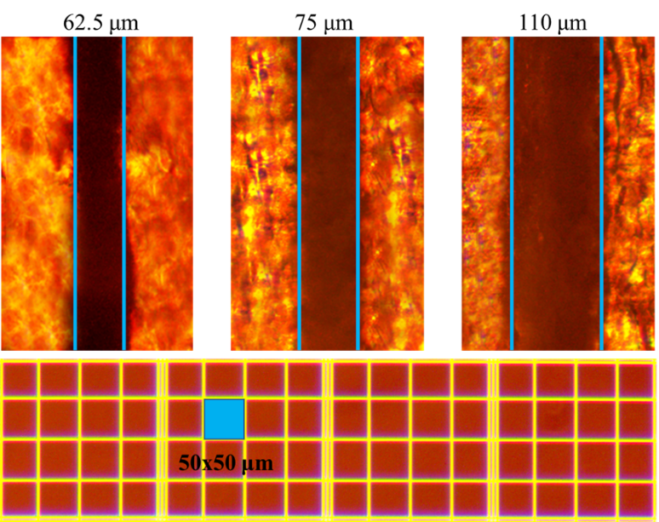
Fig. S5 Thickness of PZT/PVDF membranes which were used to equip SSSAF. The film was immersed in epoxy resin, cured and sliced, and the thickness of the film was measured via an optical microscope.

Fig. S6. Electrical discharge curve of capacitor which used for inhibiting bacteria, a) curve of electrical current, b) curve of voltage.

