Supplementary information

Assessment of surface coating strategies:

Methods:
- Surface coating
Scaffolds were coated with three different layers. For the first layer, scaffolds were immerged into FBS for 24 hours, which labeled as FBS. For the second coating, following the first layer coating scaffolds were immerged into 10 N NaOH for 30 minutes and washed by DI water for 3 times, which labeled as FBS+NaOH. For the third layer, scaffolds with previous 2 layers coating incubated in FBS again for 24 hours, which labeled as FBS+NaOH+FBS (Figure 3).
- Contact angle test
Scaffold was placed on the stage of contact angle system OCA (DataPhysics Instruments, Germany), and then the distance between stage and camera was adjusted to have a clear picture. One drop of DI water was put on the surface of scaffold, the contact angle was analyzed by software SCA 20 (DataPhysics Instruments, Germany). Five specimens of each coating layer were measured.
- Detection of surface chemical deposition
Scaffolds were analyzed by EDS, elements of carbon (C), oxygen (O), sodium (Na), chlorine (Cl), and nitrogen (N) were presented, and the deposition amount of Na was counted.
- Cell adhesion
Coated scaffolds were put into 48 wells plate, each well had one printed scaffold and seeded with pre-osteoblast (MC3T3-E1, ATCC, Manassas, VA) at a cell density of 1×10⁵/well. Then, the cells were cultured in alpha modification of Eagle’s medium (α-MEM, Hyclone, GE Life Sciences) with 10% fetal bovine serum (FBS) and 1% Pen/Strep antibiotic (Life Technologies Corporation) in a humidified incubator at 37 °C and 5% CO₂ for 24 hours. Then cells were fixed by 4% paraformaldehyde for 15 minutes and stained with Hoechst 33342 and actin-stain 488 phalloidin. Cell nucleus and actin filaments were observed by fluorescent microscope under DAPI and FITC filter, respectively.

Osteogenic differentiation
Mineralization-Alizarin red staining and Picrosirius red staining were applied with the procedure described in 2.9 and 2.10 of main body of manuscript.

Results:
Contact Angle
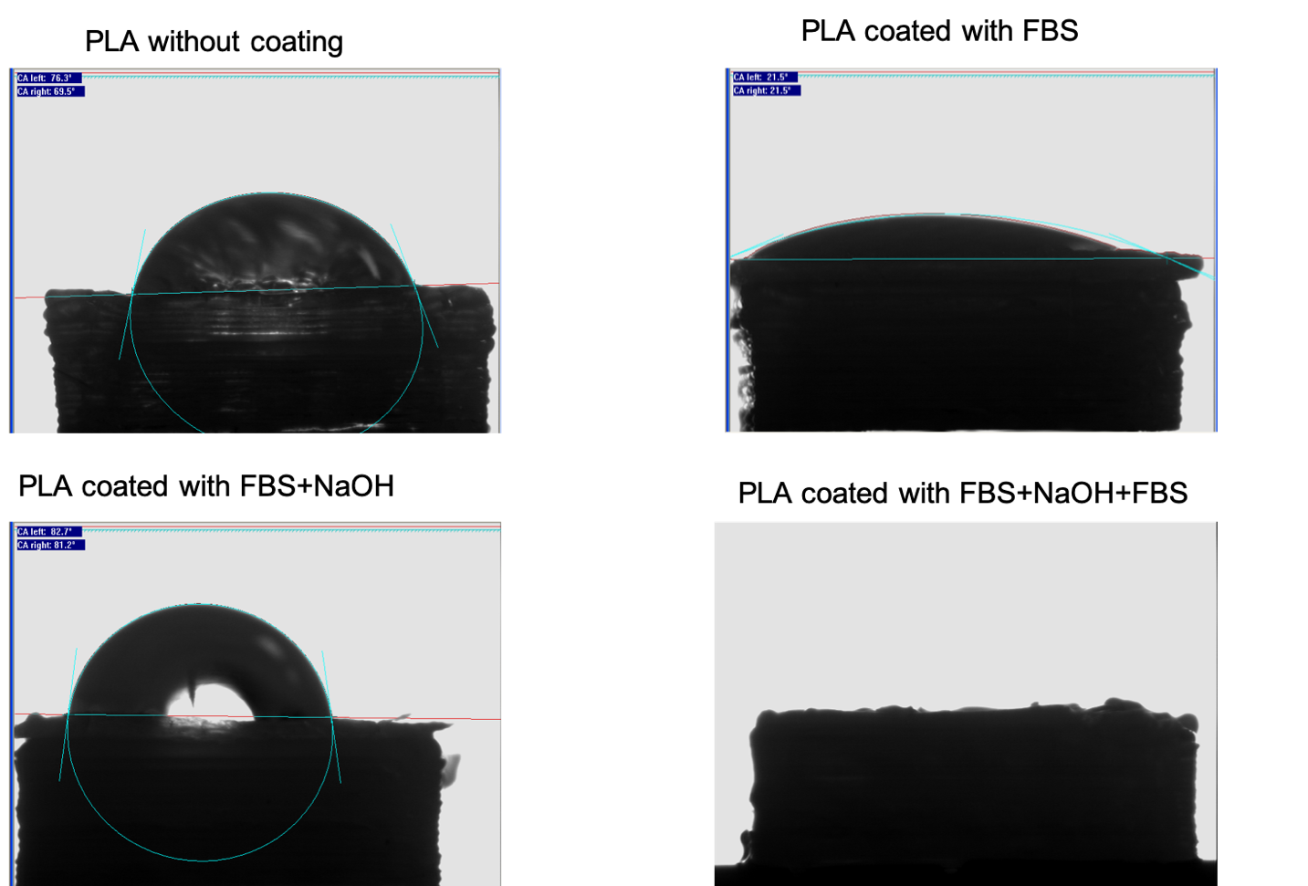
Figure 1: Contact angle at each layer modification. The average contact angle for PLA without coating is 66.4°±9.8° (left) and 61.7°±7.2° (right); for PLA coated with FBS is 24.4°±5.2° (left) and 26.2°±4.1° (right); for PLA coated with FBS+NaOH is 82.5°±9.8° (left) and 82.4°±10.4° (right); and for PLA coated with FBS+NaOH+FBS, no data could be recorded due to the highly hydrophilicity.

Surface Chemical Deposition
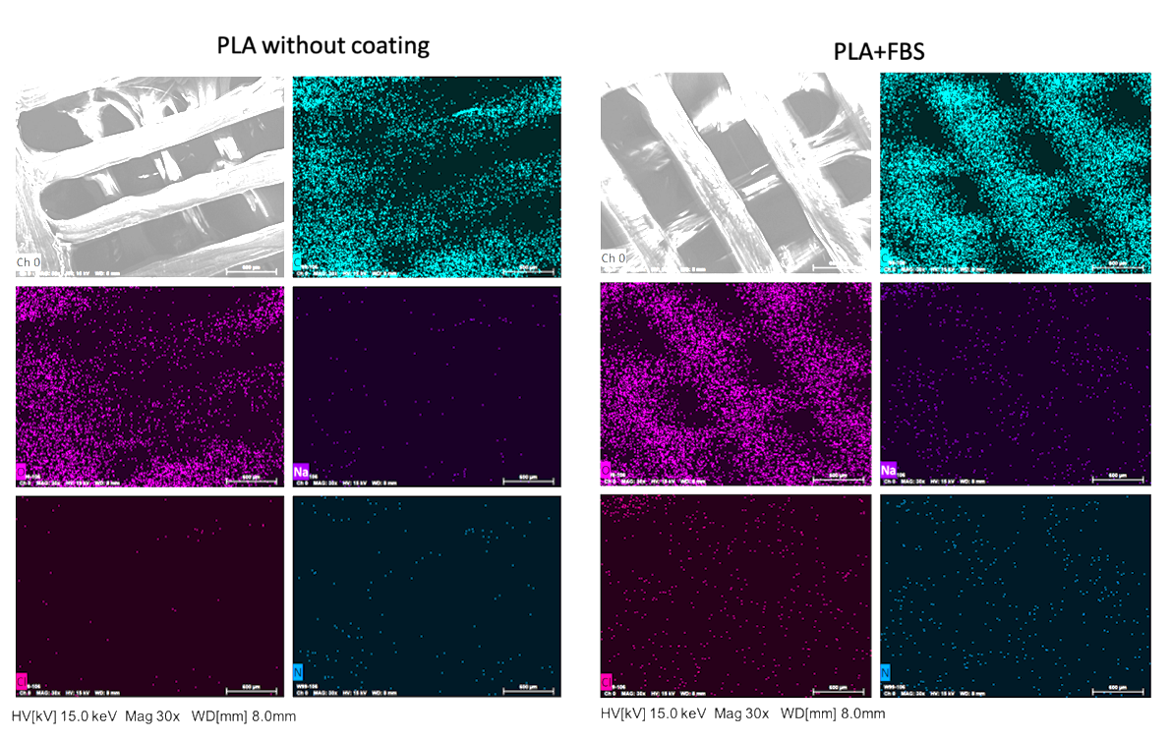
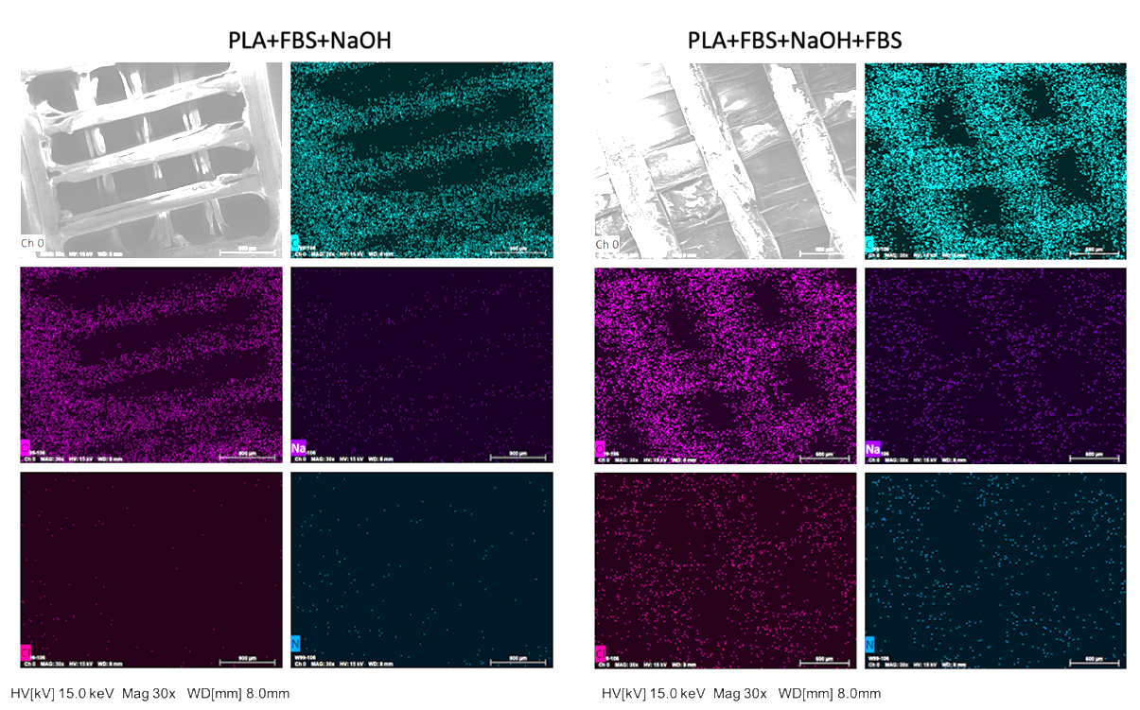
Figure 2: The SEM images and EDS element analysis for 3D printed scaffold. The first picture of each group is the SEM image, others are the distribution of each elements. Carbon and oxygen were detected over the scaffold, because they are the main elements of PLA. There were only few of Na, Cl, and N on the surface without coating (PLA), then more of them were detected with first layer coating (PLA+FBS), but their amounts decreased with the second layer modification (PLA+FBS+NaOH), and with the third layer modification (PLA+FBS+NaOH+FBS) more of them deposited.
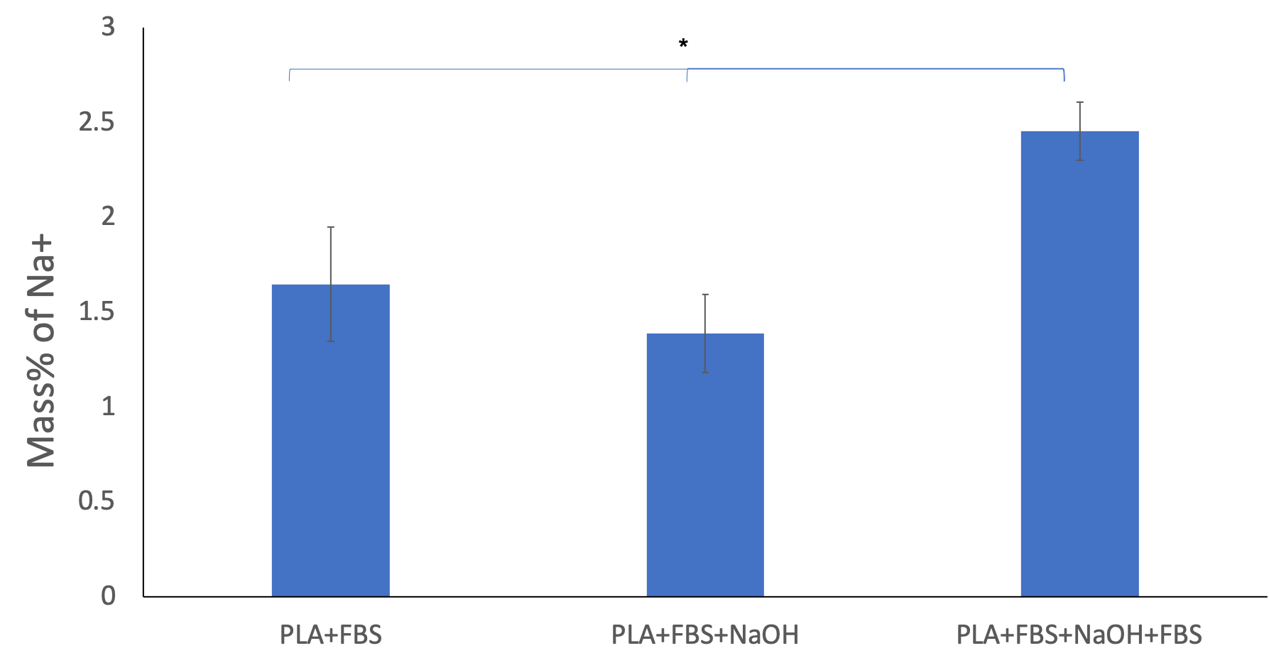
Figure 3: Deposition of Na for each step modification. (error bar with standard deviation, n=3, p<0.05).

Cell Adhesion
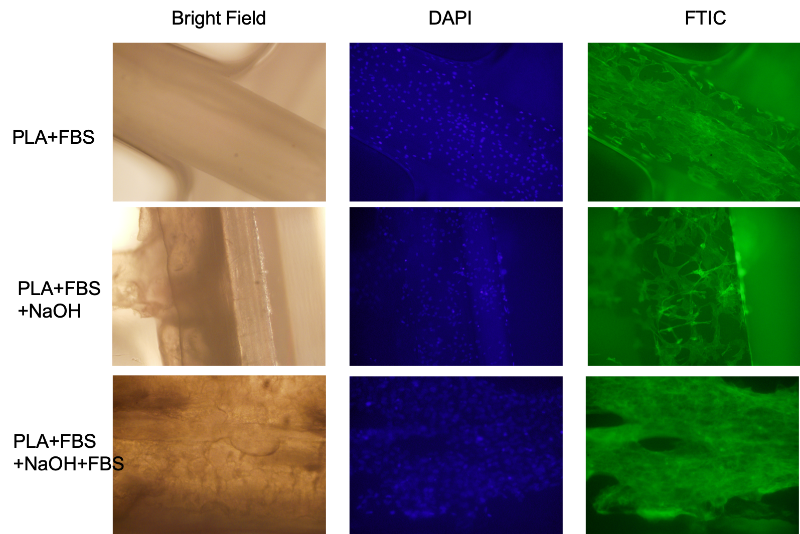
Figure 4: Cell adhesion on surface that with each layer modification. First column is the bright phase. Second column is fluorescent pictures under DAPI filter, which represents cell nucleus. Third column is the fluorescent pictures under FTIC filter, which represents the actin fibers.

Osteogenic Differentiation

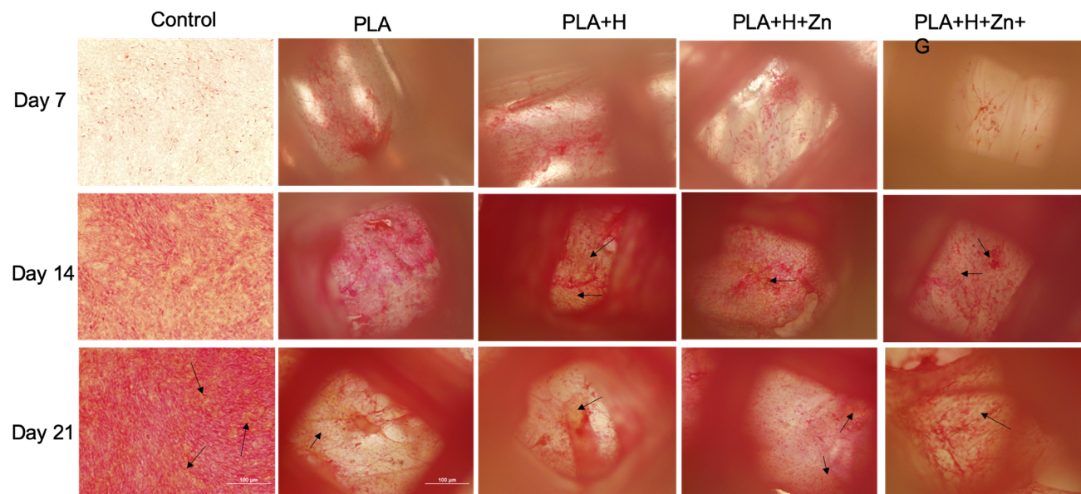
Figure 5: Picro-sirius Red Stain for type I (yellow) and type III (red) collagen that are synthesized at bottom layer of 3D scaffolds with different time incubation. Arrows point to type I collagen.
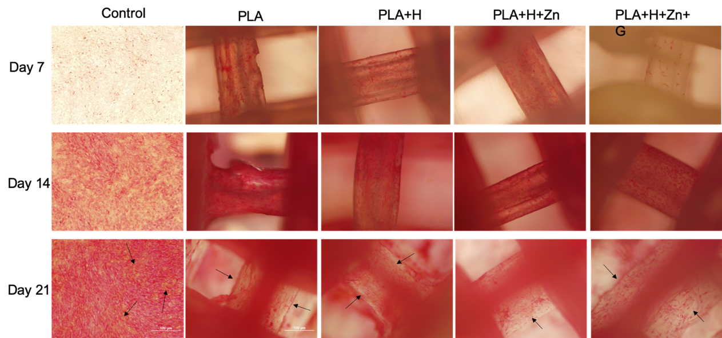
Figure 6: Picro-sirius Red Stain for type I (yellow) and type III (red) collagen that are synthesized at inner space of 3D scaffolds with different time incubation. Arrows point to type I collagen.
Figure 7. ARS stain for calcium deposition with cells cultured in regular 2D environment (control) and 3D scaffolds. The red color represents calcium deposition. (Scale bar=100 μm)

