**Supplementary Information**

Insights of Gravitational Phenomena: a Study Applying Thermodynamic Properties of Gases

C.K. Gamini Piyadasa*

**Section A: -**

Brief note on Newtonian and Einsteinian Gravity Concepts:

The concept of gravity, the ‘Law of Universal Gravity’, was first proposed and mathematically derived as a relationship based on inductive reasoning of empirical observations by Newton in 1687 [1]. This empirical solution for the gravitational force between two masses m1 and m2, which are distance r apart, is given in the following mathematical form (Sup. Equation 1):

 (S1)

where, *G* is the universal gravitational constant.

Secondly, another major interpretation of gravity was given by Einstein in 1907 as General Relativity [2], which is the theory of gravitation where the observed gravitational effect between masses results from their warping of space-time. Therein, gravity is not considered as a force, it is a consequence of the curvature of spacetime caused by the presence of mass energy. See ‘Einstein Field Equations’ (EFE) in theory of general relativity.

The general form of EFE is given as (Sup. Equation 2):

 (S2)

where,  is the Ricci curvature tensor, is the scalar curvature, is the metric tensor, **is the cosmological constant, is Newton's gravitational constant,  is the speed of light in vacuum, and is the stress–energy tensor.

Experiments and observations show that Einstein's description of gravitation accounts for several effects that are unexplained by Newton's laws, such as minute anomalies in the orbits of Mercury and other planets [3]. General relativity also predicts novel effects of gravity, such as gravitational waves [4], gravitational lensing [5] and an effect of gravity on time known as gravitational time dilation [6]. While some of the astronomical anomalies have been explained by the Einstein’s theory of general relativity, almost all the practical applications (for example all engineering applications) to date are still based precisely on the Newtonian model of gravitation.

The cosmological constant , the energy density of space, that arises in the Albert Einstein's field equations could be closely associated with the concepts of dark energy and quintessence (hypothetical form of dark energy, postulated in explaining the accelerating expansion of the universe) [7,8]. However, some doubts have been raised lately on the accuracy of the cosmological constant [9-11].

It has also been shown that by considering local energy–momentum conservation, the EFE converges to the Newton’s law of gravitation where the gravitational field is considered weak and velocities are much less than the speed of light [12]. It is worth noting that the empirically derived gravitational constant in EFE is borrowed from the Newton’s universal gravitation relation; not a constant derived independently by Einstein. It could, hence, be observed that the EFE is, to some extent, related to the Newton’s law of gravity. This aspect, however, is out of the scope of this paper, thus to be discussed separately.

It also has to be noted that, under existing (Newtonian and Einsteinian) models, the gravitational force has been reckoned as a “weak force”. According to Table S1, the gravitational force is 10 –36 weak compared to the electromagnetic force; accordingly, a negligible force.

Table S1: Fundamental Interactions (also known as Fundamental Forces in Classical Theory) [13]

|  |  |  |  |
| --- | --- | --- | --- |
| **Interaction or Force** | **Relative**  **Strength** | **Range (m)** | **Existing Models** |
| Weak (Subatomic) | 1025 | 10 –18 | Electroweak Theory |
| Strong (Subatomic) | 1038 | 10 –15 | Quantum Chromodynamics |
| Electromagnetic | 1036 | ꝏ | Quantum Electrodynamics |
| Gravitational | 1 | ꝏ | General Relativity |

Early Notions of Gravitational Repulsion Force:

The above discussion compares Newtonian and Einsteinian gravity concepts, highlighting foundations of our present understanding. Newton’s model describes gravitation as an attractive force, and the repulsive nature of gravity has never been entertained. It has, however, been shown that a repulsive gravitational force could manifest itself within the theory of general relativity [14-19].

Albert Einstein, subsequently, attempted to form a generalized theory of gravitation that would unify the gravitational and electromagnetic forces (and perhaps others), guided by a belief in a single origin for the entire set of physical laws. Models of electromagnetism and gravity were pursued by Einstein in his attempts at a unified field theory (UFT) [20]. There was even an attempt at harnessing electromagnetic interactions with gravitational interactions to induce torsion, which in turn could null out gravity. Thus, a sort of counteraction to gravity or an “antigravity” field would be the result [21]. UFT could be a point in the history of science that the idea of antigravity surfaced.

In Newtonian and Einsteinian mechanics, what has been observed as a gravitational effect between two bodies is nothing but the **resultant effect of both gravitational repulsion and attraction forces** acting simultaneously [22]. If gravitation attraction is the only force, the universe must see a contraction instead of expansion with an acceleration [23,24], and would eventually collapse. To explain the accelerating expansion of the Universe there have developed numerous modified Einsteinian models, modified Poissonian models [25] and cosmological models [26] assuming hypothetical ‘dark energy’ [27], and a repulsive force of the cosmological scale [19] relating to ideas of dark matter and dark energy [28-30]. Although cosmologists have brought in such ideas as possible reasons for expansion of the universe, they are still speculative and incomplete in explaining the observations in processes occurring/happening in the universe.

The present research inundated in this paper makes an independent approach using an alternative mathematical model of the gravitational repulsion force and the gravitational attraction force. No usual hypothetical assumptions are made here. The model is validated using experimentally determined and established data in practical thermodynamic applications in the mechanical engineering arena.

**Section B: -**

Behavior of Real gas – the Van Der Waals Equation

Van der Waals modified [31] the ideal gas equation to describe the behavior of real gases by explicitly including the effects of molecular size and intermolecular attractive forces. The modified ideal gas equation (Eqn. 3), the so-called van der Waals equation:

 (S3)

where *a* and *b* are empirical constants that are dependent on the type of gas. *an2/V2* is added to account for intermolecular attractive forces and *nb* corrects the volume term in the ideal gas equation by subtracting volume taken by the molecules in the space.

The anomalies addressed in the real gas behavior by the Van der Waals equation are only the attraction force between molecules and the volume taken by the gas molecules. The attraction force discussed by Van der Waals is considered as a weak electrostatic force, and not a gravitational force.

The concept of gravitational repulsion or antigravity or matter moving against the gravitational field, is not a novel concept but one which has been under speculation over the years [28,29,32,33]. The repulsion between atoms at short distance (within the eigenvolume) has been modeled in Lennard-Jones potential [34,35]. This repulsion force, however, acts at very short range (~3-6 A°) usually between diatomic molecules. Van der Waals forces, nevertheless, are attractive interactions between atoms resulting from induced dipoles, and repulsive interactions resulting from overlap of the electron clouds of two atoms (electrostatic repulsion) when they get too close to each other [36]. The total energy of Van der Waals interactions could be approximated by the Lennard-Jones expression. They, however, gravitational repulsion and gravitational attraction forces among gaseous atoms/molecules have not considered.

Recently published experiments by the author [22,37-39] show that there exists not only gravitational attraction forces acting on matter but also gravitational repulsion forces between them. The following section briefly recalls a groundbreaking laboratory experiment [39] as it makes a **landmark revelation of the effect of gravitational repulsion**.

**Section C:**

**Groundbreaking Experiment on Gravitational Repulsion:**

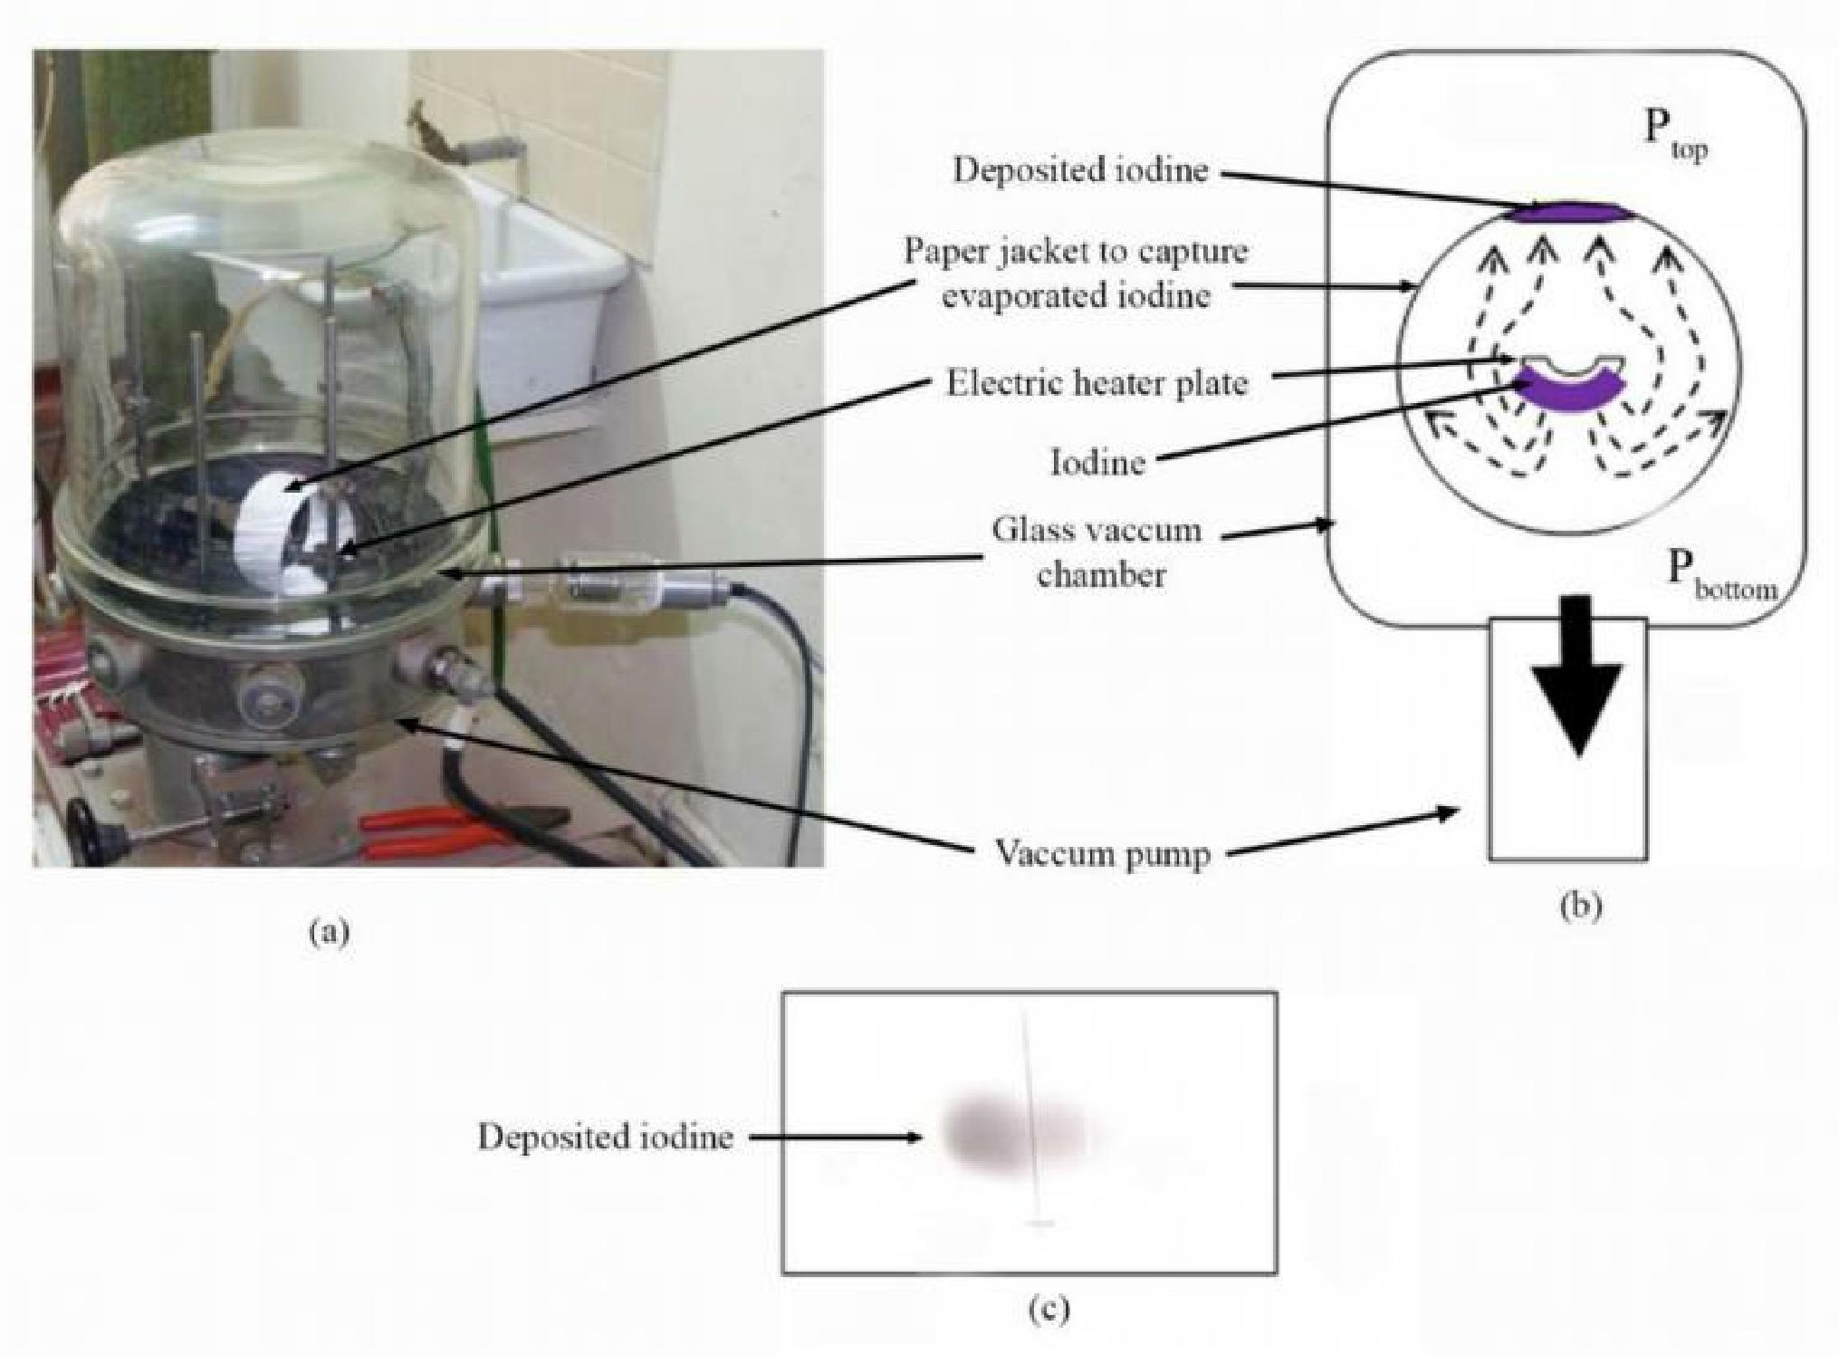

Figure S1. *(Source: Reproduced with permission, [**39**] 2011, SENRA Academic Publishers) – Experimental set-up to observe movement of heat-evaporated iodine vapor in vacuum.*

*(a) Vacuum deposition chamber*

*(b) A layer of iodine was gradually heat evaporated (ejected in the downward direction) inside the vacuum chamber. The electrical heater plate itself covers the iodine particles from moving directly in the upward direction. The iodine source was surrounded with a paper jacket in order to capture the deposition geometry of iodine. The paper was placed 50 mm radially away from the iodine source. Pressure in the chamber was ~ 1x10 –5 mbar, average mean free path is greater than 6.6 m and air density was approximately 12.6 ng m –3. Pressure at the top () of the chamber was higher than the bottom (); >*

*(c) Photograph of deposited iodine on inner top part of the paper.*

**Section D: -**

**D.1 Solving for** **Parameters *x*, *GR*, *GA*, *FR* and *FA*:**

Substituting values from Equations 5 and 6 to Equation 4:

 (S4)

Application of the relationship in Equation S4 to the two gas molecules in the box (Figure 3), in the 3 situations given below, is used to derive:

1. The value of *x*
2. The value of *y*
3. The orders of magnitude of the relevant coefficients:
   1. *GR* – Gravitational Repulsion Coefficient
   2. *GA* – Gravitational Attraction Coefficient
4. The orders of magnitude of the forces:
   1. *FR* – Gravitational Repulsion Force
   2. *FA* – Gravitational Attraction Force

D.2 Building Relationships to Derive *x*, *y*, *GR*, *GA*, *FR* and *FA*:

Three situations defined as illustrated in Figure S2, where two gas molecules are in equilibrium in a box, are considered to derive *x*, *y*, *GR*, *GA*, *FR*, and *FA*.

**Situation i:**  Figure S2 (i). Two gas molecules, each having mass *m*, and thermal energy content *Q1* (corresponding temperature is *T1*), are at a distance *r1* apart, in a box. Molecules are pressing the opposite walls of the box by the force (using Equation 4):

 (S5)

In this situation, pressure *P1* of the gas results from the force *FW1* (on the wall) of the system. Hence, *P1 ∝ FW1*

**Situation ii:** Figure S2 (ii). Thermal energy content of each molecule is *Q2 (Q2 > Q1)*. Corresponding temperature is *T2**(T2 > T1)*. The distance between molecules is *r1* (i.e., box dimensions are same as Situation i). Resultant force on the wall increases to *FW2* *(FW2 > FW1)*. Hence, using Equation 4:

 (S6)

In this situation, pressure *P2* of the gas (on the wall) results from the force *FW2* of the system. Hence, *P2∝ FW2*

**Situation iii:** Figure S2 (iii). Thermal energy content of each molecule is *Q2* (corresponding temperature is *T2*). The distance between the two molecules is *r3*, in order that, the resulting force applying on the wall is equal to *FW1*. Hence, using Equation 4:

 (S7)

In this situation, pressure *P1* of the gas (on the wall) results from the force *FW1* of the system. Hence, *P1 ∝ FW1*

**Figure S2**. *Two air molecules at Situations i, ii and iii.*

r3

m

**Q2**

FR3

FA3

m

**Q2 (T)**

FR3

FA3

Gas Molecules @ T1

r1

m

**Q1**

FR1

FA1

FW1

m

**Q1 (T)**

FR1

FA1

(i)

FW1

FW2

FW2

FW1

FW1

(iii)

Gas Molecules @ T2

Box

r1

m

**Q2**

FR2

FA1

m

**Q2 (T)**

FR2

FA1

(ii)

Gas Molecules @ T2

FW1

FW2

FW1

FW1

FW2

FW1

* + 1. *Thermal energy of each molecule is Q1 (corresponding temperature is T1) and the distance between them is r1. The molecules apply the force FW1 on the wall.*
    2. *Thermal energy of each molecule is Q2, Q2 > Q1 (corresponding temperature is T2, T2 > T1). Both molecules are at the temperature T2, and the distance r1 between them is kept unchanged, hence, applying the force FW2, FW2> FW1 on the wall.*
    3. *Thermal energy of each molecule is Q2 (corresponding temperature is T2). The distance between the two molecules is r3, in order that, the resulting force applying on the wall is equal to FW1.*

Force diagram (Figure S3) shows the graphical representation of the magnitudes (not drawn to scale) of the forces on the two gas molecules when the temperature and the distance between them are as described in Situations i, ii and iii (also see Sup. Figure 2).

**Figure S3**. *Force Diagram*

FR1

FR2

FA1

m [Situation i]

m [Situation ii]

FR3

FA3

m [Situation iii]

d2

d2

d1

d1

d3

d3

Intermolecular

Distance (r)

FW1

FW2

FW1

H1 [Situation i]

H2 [Situation ii]

H2 [Situation iii]

Repulsive Force (FR)

Attractive Force (FA)

r1

r3

Repulsive Force (FR)

Attractive Force (FA)

Changes Between Situations i, ii and iii

1. *The two molecules at temperature T1 and distance r1 apart. Force on the wall is FW1. Sum of forces FA1 and FW1 is equal to FR1 (indicated as the distance d1).*
2. *The two molecules at temperature T2 and distance r1 apart. Force on the wall is FW2. Sum of forces FA1 and FW2 is equal to FR2 (indicated as the distance d2).*
3. *The two molecules at temperature T2 and distance r3 apart. Force on the wall is FW1. Sum of forces FA3 and FW1 is equal to FR3 (indicated as the distance d3).*

**Situation i:** Forces act on the two air molecules, each with mass m and thermal energy *Q1* separated by a distance *r1*. Substituting Situation i values in Equation S4:

 (S8)

The magnitude of forces in each direction at equilibrium, are depicted in Figure S3 by the distance *d1*.

**Situation ii:** At distance *r1* between the two molecules, the temperature is *T2*. The force on the wall is *FW2*. Substituting the Situation ii values in Equation S4:

 (S9)

The magnitude of forces in each direction at equilibrium, are depicted in Figure S3 by the distance *d2*.

**Situation iii:** The distance between the two molecules is *r3*, *r3* > *r1* in order that the force on the wall is *FW1*. The corresponding temperature is *T2* as the thermal energy of the molecule is *Q2* (Equation 3). Substituting Situation iii values in Equation S4:

 (S10)

The magnitude of forces in each direction at equilibrium, are depicted in Figure S3 by distance the *d3.*

D.3 Translating Intermolecular Force to Pressure:

According to the definition, pressure is the force (or sum of the forces) on a unit area. Considering Figure 3:

 (S11)

where, *Nf* is the number of molecules on a unit area.

*Nf* is calculated from very general considerations. The number of molecules present at any given unit surface area within a gas volume (that contains evenly distributed *n* number of gas molecules per unit volume) at varying pressures and temperatures is considered with nearest image convention under periodic boundary conditions [35]. So, *Nf* is calculated by;

 (S12)

**Section E :-**

Molecular distance and pressure were calculated as given below.

E.1 Determining Values of *P* and *r* as *T* Varies:

**Pressure *P*:** Guillaume Amontons was the first to empirically establish the relationship between the pressure and the temperature of a gas (~1700 CE), and Joseph Louis Gay-Lussac determined the relationship more precisely (~1800 CE). Because of this, the *P*–*T* relationship of gases is known as either **Amontons’ Law** or **Gay-Lussac’s Law**. It states that: *the pressure of a given amount of gas is directly proportional to its temperature on the absolute scale when the volume is held constant* [40]*.* This empirically established relationship is used to obtain the pressure of a given mass of gas held within a unit volume, as temperature is varied; with reference to the temperature 305.54 K and pressure 101.325 kPa (see supplementary information file SF1).

From the list of values in data [41], the temperature 305.54 K was chosen, because that is the value closest to the naturally existing livable temperatures. At that temperature, it was assumed that a unit volume of the gas exists at the pressure of 1 atm (standard atmosphere), i.e., 101.325 kPa. Amontons’ Law/Gay-Lussac’s Law was used to obtain the pressure of the given mass of gas held within a unit volume, at other temperatures listed in data tables.

**Mean intermolecular distance *r*:** Distances *r1* and *r3* between adjacent nitrogen gas molecules in a unit volume having total number of molecules *n*, at varying pressures relative to temperatures were calculated using the Avogadro number, provided that that the molecules are evenly distributed in the space. So, the *r* is given by  [42].

E.2 Observations of Characteristic Behaviors of *x*, *GR*, *GA*, *FR* and *FA*:

Characteristic behavior of *x*, *GR*, *GA*, *FR* and *FA* for temperatures ranging from 194.43 K to 2888.9 K (data availability) relative to *y* ranging from 0.1 to 1 **(**suitable range of *y* was determined as 0.1 to 1 by repeated calculations) was determined based on Equations S11,S12,8,9 and 10. Calculations were conducted applying established experimental data [41], using Wolfram Mathematica 11.2, and the complete set of results is presented in supplementary information files SF2 and SF3. For readers’ convenience, 3D graphs on behavior of *x*, *GR*, *GA*, *FR* and *FA* with respect to *T* and *y* are presented in Figure S4 Graphs (a), (b), (c), (d) and (e).

**Figure S4.** *3D Graphs (a), (b), (c), (d) and (e) respectively show behaviors of x, GR, GA, FR and FA relative to temperature T (ranging from 194.43 K to 2888.9 K) and y (ranging from 0.1 to 1). For the calculation, reference temperature T1 was taken as 146.65 K. While results for both cv and cp values are available in* *supplementary information file Section G Data File SF1-SF3, graphs shown herein pertain to cp. All values are in SI Units.*

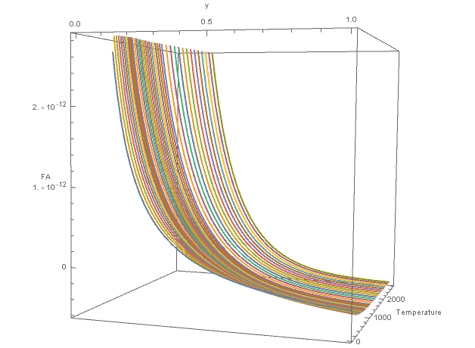

(e)

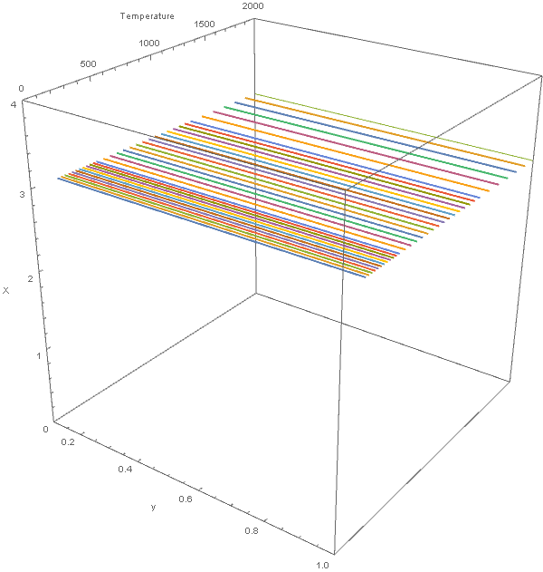

(a)

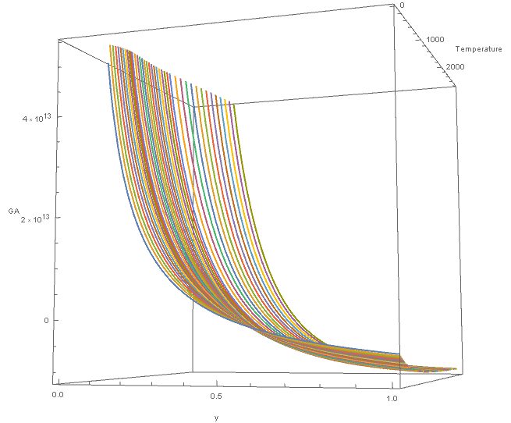

(c)

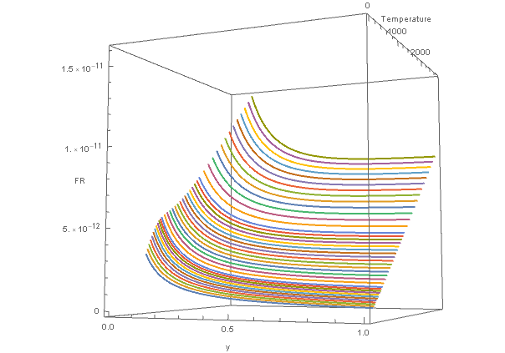

(d)

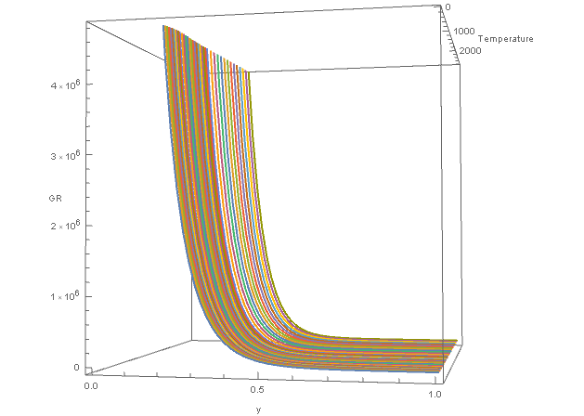

(b)

*(a) Variation of x relative to T and y. Value of x remains constant at 3 regardless of T and y.*

*(b) Variation of GR relative to T and y. GR remains positive over the entire range of T and y. For any given value T:*

*i. When y < 0.5, as y decreases, the rate of change of GR is very high.*

*ii. When y > 0.5, as y increases, GR is much stable, compared when y values are low.*

*For any given value of y, variation of GR vs. T is comparatively low.*

*(c) Variation of GA relative to T and y. For any given value T:*

*i. When y < 0.5, GA is positive, and the rate of change of GA vs. y is high.*

*ii. When y > 0.5, GA is negative, and the rate of change of GA vs. y is comparatively low.*

*For any given value y: variation of GA vs. T appears significant; comparatively more than GR.*

*(d) Variation of FR relative to T and y. FR is linearly proportionate to T at any given value of y. Gradient of the linear relationship FR vs. T is greater when y < 0.5 compared to when y > 0.5. Further, in the linear relationship FR vs. T:*

*i. When y < 0.5, intercept > 0*

*ii. When y ≈ 0.5, intercept ≈ 0*

*iii. When y > 0.5, intercept < 0*

*(e) Variation of FA relative to T and y.*

*i. When y < 0.5, FA is positive, and the rate of change of FA vs. y is high.*

*ii. When y > 0.5, FA is negative, and the rate of change of FA vs. y is comparatively low.*

*iii. Hence, when y ≈ 0.5, FA changes polarity.*

Section F :-

The significance of numerical values obtained for *x*, *y*, *GR*, *GA*, *FR* and *FA*

F.1 The Significance *x = 3.0*, Inverse Proportionality to the Cube of the Distance:

Results presented in Figure S4(a) and supplementary information file: Section G Data File SF1-SF3, show that, at the length scale of intermolecular distances for gas molecules, ***x* = 3.0** with a very low variance of 8.4233 x 10 –9 for both *cv*and *cp*. Calculations show that the *x* is constant, independent of the atomic mass *m* (analysis was repeated for hydrogen, oxygen, water vapor, carbon monoxide and carbon dioxide yielding the same result; information available on request), the Specific Heat Capacity *c* and *y*, over a wide range of temperature data. It is, hence, concluded that ***x* = 3.0**; a significant finding of this research. This delivers *r3* in the denominators of expressions for both the gravitational repulsion force and the gravitational attraction force. In other words, both gravitational repulsion force and gravitational attraction force, at the length scale of intermolecular distances for gas molecules, are **inversely proportional to the cube** of the distance between them. The very low variance of the result ***x* = 3.0** shows that the inverse cube relationship is dominant.

Until now, under the Newtonian model, it has considered that the classically known gravitational force between two entities is inversely proportional to the square of the distance between them [1] (Equation (1)). Such a classically known gravitational force is the **resultant** of the two distinct forces, viz., gravitational repulsion and attraction forces as revealed in this research program. The inverse square concept is also seen in the Coulomb’s Law [43] for the electromagnetic force between two charged particles. **The inverse proportionality** to the cube-of-the-distance (r3) as determined here, is a significant deviation from the classical acceptance.

Value ***x* = 3.0** gives that gravitational repulsion and attraction field/flux flow is closer to the **volumetric or solid spherical distribution** (*4/3 πr3*) rather than the area or surface distribution (*4πr2*) considered in the classical model. With the interpretation of the antigravity effect, we have come up with a **volumetric or solid spherical (*r3*) model which is more relevant to gases in 3-dimensional space.**  Such volumetric or solid spherical model maybe more relevant to other contexts in the universe in general. Furthermore, this alternative model is a more appropriate application on a force field that fills up free space. This is a significant departure from the Inverse-Square Law. Inverse proportionality to the cube of the distance, revealed in this experiment, is **one most important revelation/result in fundamental sciences**.

F.2 The Significance of *y = 0.5*:

As stated, when presenting Equation 7, the parameter *y* as the exponent of *T* was introduced because the effect of absolute temperature on the thermal energy of an entity is not known in the context of gravitational repulsion. The above analysis (Figure S4) elaborated that ***y* = 0.5** is a very noteworthy value when considering behaviors of *GR*, *GA*, *FR* and *FA*.

It is very significant that, for both *cv*and *cp*, when *y* ≈ 0.5:

* Extrapolation of graph *FR* vs. *T* crosses (0,0) (Figure S7).
* Negative *FA* tends to become positive as *T* approaches 0 K (Figure S8).

Hence, *FW* [= *FR* - *FA*] may become negative and the gas may condense, when *y* ≈ 0.5 and *T* → 0; see Equation S4. The analysis was repeated for hydrogen, oxygen, water vapor, carbon monoxide and carbon dioxide, yielding the same result irrespective of atomic mass *m*; information available on request. This happens only when *y* ≈ 0.5, although *P ∝ T* concept of the **Amontons’ Law/Gay-Lussac’s Law** was applied across all calculations irrespective of the value of *y*. Therefore, *y* = 0.5 is observed as the value that satisfies existing empirical observations of the **Amontons’ Law/Gay-Lussac’s Law**, hence, *chosen to conduct subsequent analysis in this paper*.

F.3 Units of *GR*, *GA*, *FR* and *FA*:

When *y* = 0.5, units of *GR* and *GA* would be as follows:

*GR*: s2 K kg-1

*GA*: m4 kg-1 s-2

Newtonian Universal Gravitation Constant *G* has m3 kg‑1 s‑2 as units; note m3 in the numerator. Units of *GA* have m4 in the numerator. This difference of one in the power of the unit of length is because the Newtonian model is based on the Inverse Square Law, whereas the model presented above is based on the Inverse Cube Law. The units of the finally calculated forces *FR* and *FA* are found to be kg m s-2, i.e., Newton, as expected, thus vindicating the model.

F.4 Orders of the Magnitude of *GR* and *GA*:

Figure S5 presents variations of *GR* and *GA* against *T* for gaseous nitrogen; thus, depicts their orders of magnitude. The values were calculated applying the empirical data and the value *y* = 0.5 to Equations 9-10 (*Section G Data File SF1*).

Gravitational attraction was initially, expected to be independent of *T*. Results presented in Figure S5 (b), nevertheless, show that *GA* is dependent of *T*, and this would be discussed later together with *FA*.

Results pertaining to both *cp* and *cv* are presented for comparison in Figure S5. The variance of *GR* and *GA* are smaller for *cp* compared to *cv*. It could be noted that, the model developed herein is where starting (Situation i) and ending (Situation iii) pressures are equal (over all under constant pressure). Hence, data pertaining to *cp* is more appropriate to the analysis. Substituting *cp* values to Equations 9–10, therefore, shows lesser variations of both *GR* and *GA*.

**Figure S5.** *GR* and *GA* vs. *T2* results (relative to *T1* 146.65 K), from calculations using *cv* and *cp*:

(a)

(b)

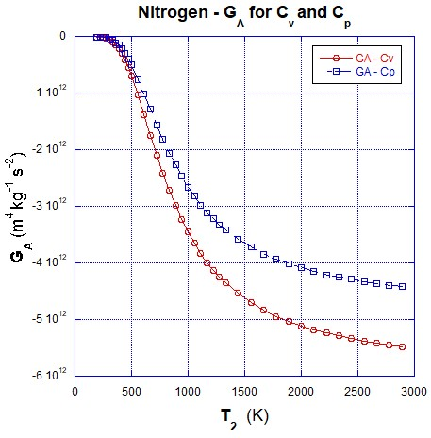

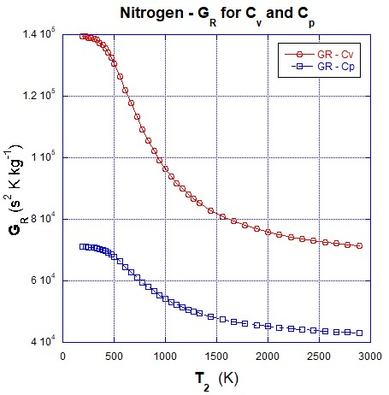

(a) Results of *GR* from calculations using *cv*and *cp*

(b) Results of *GA* from calculations using *cv*and *cp*

The variance of *GR* and *GA* are smaller for *cp* compared to cv.

The orders of the magnitude of *GR* and *GA* yielded by the gravitational repulsion and attraction model, as presented above, are very large compared to the Newtonian Universal Gravitation Constant *G*, which is6.674 x 10‑11 m3 kg‑1 s‑2. Considering equilibria in the infinite universe with infinite distances, such large values of *GR* and *GA* are not impractical. The very small value Newtonian constant has been deduced to represent a very small gravity force observed by the scientists at that time [44]. The present program of research has shown that the so called ‘weak’ gravitational force is actually the resultant (algebraic sum) of two extremely large forces, i.e., gravitational repulsion and gravitational attraction, which distinctly act on matter. This would be discussed in more details in the subsequent section that deals with the orders of the magnitude of the forces.

The analysis was repeated for hydrogen, oxygen, water vapor, carbon monoxide and carbon dioxide as well, yielding the similar result; information available on request. Magnitudes of *GR* and *GA* for the above gases were also in a similar order.

F.5 Orders of the Magnitude of *FR* and *FA*:

Values of *FR* and *FA* for nitrogen gas are calculated applying the empirical data and the value *y* = 0.5 to Equations 11–12 (*Section G Data File SF1*). The analysis was repeated for hydrogen, oxygen, water vapor, carbon monoxide and carbon dioxide as well, yielding similar results; information available on request.

To give an example for the convenience of readers, the values of *FR* and *FA* between two nitrogen gas molecules, at the temperature *T2* 333.32 K (≈ 60 °C) and pertaining to *cp* are, respectively, 1.324 × 10-12 Nand -3.587 × 10-15 N. (Note: *FR* *>>>* *FA*). The resultant of *FR* and *FA* between two nitrogen gas molecules *= FW = FR* *-* *FA* *=* 1.328 × 10-12 N. [Note: As defined in the mathematical model presented herein, *FW* acts in the direction of repulsion]. *FW* exerted by nitrogen gas molecules, was translated to Pressure *P*, in the unit Pa by applying Equations S11 and S12. The result is: 110.537 N on an area of 1 m2 (110.537 kPa = 1.091 standard atmosphere), which is equal to the value obtained by applying **Amontons’ Law**/**Gay-Lussac’s Law**. See Supplementary File1 for the full set of results.

Further in the SF1, when *FW* values obtained based on *cp* and *cv* (corresponding to any given temperature) are compared, the difference is in the order of a millionth of the *FW* values. It shows that difference in *FW* caused by the difference of applying either *cp* or *cv* is very small.

It is useful to compare *FR* and *FA* with the gravitational force between gas molecules calculated according to the classical theory as defined in Equation 1. When two nitrogen molecules are 4.557 x 10-9 m apart [which does occur at around 333 K (≈ 60 °C) and 1 atm], the classical theory calculated gravitational force between the two molecules is equal to 1.202 x 10-44 N. [Note: As defined in the classical theory, this gravitational force acts in the direction of attraction]. It is, nevertheless, interesting to note that: *FR* and *FA* in nitrogen [at around 333 K (≈ 60 °C) and 1 atm] are respectively 1.101 x 1032 and 2.984 x 1029 times greater than the gravitational force between gas molecules calculated according to the classical theory as defined in Equation S1.

Above pressure calculations were conducted using only the mere two molecular system introduced in this paper. It could thus be justified that any two neighboring molecules of gas produces the same force at any given point throughout a gas; provided that the temperature and the molecular distance (volume) are the same. In reality, any small quantity of gas molecules exhibits the same pressure regardless of the number of molecules enclosed. Significance of this analysis is in the absence of idealistic assumptions such as: *large number of molecules making perfectly elastic collisions* in deriving the ideal gas equation.

Gravitational attraction was, as pointed out before, generally expected to be independent of *T*. Results, nevertheless, show that *GR*, *GA*, *FR* and *FA* are dependent of *T*. The four fundamental interactions are not so far identified as to be temperature dependent. Nevertheless, phenomena are observed in nature/universe (e.g.: pressure, expansion, and so on) that are dependent on temperature/thermal energy content. With this research revealing that both *FR* and *FA* are temperature dependent, it appears that the **critical gap between energy and fundamental forces has been filled**.

F.6 Negative Gravitational Attraction Forces Among Gas Molecules:

Applying empirical data to Equation 12 shows that, *FA* (the attraction force among gas molecules) is negative at elevated temperatures (Figure S4(e)) and Figure S3), implying that it acts as a repulsive force together with *FR*. This negative *FA* tends to become positive at lower temperatures where gases are expected to condense. For example, the value calculated for *FA* between gaseous nitrogen molecules is -7.118 10-16 N at 194.43 K and 64.478 kPa, and -2.299 10-13 N at 2,888.9 K and 958.029 kPa (Section G File SF1).

Negative values of *FA* at elevated temperatures, together with *FR*, reveal that the gas exhibits repulsive forces only among molecules. This gives rise to the property that real gases expand infinitely as the available space increases. Similar circumstances were also observed in other gases studied (hydrogen, oxygen, water vapor, carbon monoxide and carbon dioxide). Further for all these gases, too tendencies of negative *FA* becoming positive at lower temperatures could be observed from the results; suggesting that the gases tend to condense as they cool. All the information on the other gases studied are available on request.

The exact **fundamental** mechanism of condensation has so far not been explained by existing theories. It is presently believed that condensation is initiated by the formation of atomic/molecular clusters [45]. How such formation of clusters initiate has not been explained **fundamentally**. Both the kinetic theory and the ideal gas law predict that gases compressed to very high pressures and cooled to very low temperatures should still behave like gases. Concepts of thermodynamics, thus far, indicate only that decrease in temperature reduces kinetic energies of particles [31], but not how atoms/molecules form clusters or how/why aggregation occurs are unexplained. Molecular vibrational distances are far smaller than intermolecular distances in gases. Reduction of molecular kinetic energy, hence, does not explain how intermolecular distances get smaller enough with the reduction of the temperature.

In real gases (obeying Van der Waals equation), it is conceptualized that [34] condensation occurs when the molecules of a gases are cooled to the point where they no longer possess sufficient kinetic energy to overcome intermolecular attractive forces [46]. Even in this explanation, it is not explained how kinetic energy and intermolecular force relate to each other each other fundamentally.

Values of *FR* and *FA* calculated in the above analysis show that as temperature decreases, repulsion forces decrease and attraction forces increase (from negative at elevated temperatures to close to positive at lower temperatures) between gaseous molecules, thus causing aggregation of atoms/molecules together, i.e., causing condensation of the gas.

In other states of matter, different mechanisms pertaining to *FA* could be observed. For example, as highlighted in the Author’s previous publication [37]: collections of water droplets suspended in midair are observed to flocculate as clouds. In such circumstances, gravitational attraction and repulsion forces among water droplets are equal thus in equilibrium (see ‘5.0 Discussion’).

**Figure S6.** The Gist of the Model and the Outcomes

Iodine Experiment [2,3]

Water Condensate Droplets in Ice Cylinder Experiment [2]

Selected Natural Phenomena [1,2]

Demonstrated that Gravitational **Repulsion and Attraction exist** as two **distinct forces**, and what we experience is their **resultant**.

Section 3.0 Mathematical **Model was developed** for the Gravitational Repulsion and Attraction Forces between **two** gas molecules:

** (4)

 (5)

 (6)

 (7)

Established experimental data [24] on:

Nitrogen

Hydrogen

Oxygen

Water vapor

Carbon monoxide

Carbon dioxide

was **applied on the model**

**Model performed** yielding results given in Section 4.0 and Figure S4

**Confirmed existence** of both Gravitational Repulsion and Attraction forces

***x = 3.0***

**Inverse-Cube** relationship revealed

(Sup Section E)

When ***y = 0.5***

*FR* **linearly proportional** to *T*

(See Section 4.4)

*FR* and *FA* **larger in the order of 1032 and 1029 times** respectively to the traditionally known gravitational force

(Sup Section E)

*FR* and *FA* both are temperature dependent, thus **filling critical gap between energy and fundamental forces**

(Sup Section E)

Yielding better explanations of observable temperature dependent phenomena

Understanding these two colossal forces enables us make hitherto unknown outcomes and developments

*FA* **increases** from negative at elevated temperatures to close to positive at lower temperatures

(Sup Section E)

Explaining expansion at elevated temperatures and condensation at lower temperatures

Water Droplet Experiment [2]

Section G: -

**File SF1.** File Type: MS Excel. Note: Original empirical data for nitrogen given in the British Imperial System of Units have been converted to SI Units for the calculations.

**File SF2.** File Type:PDF**.** Program text written inWolfram Mathematica 11.2 to calculate parameters *x, GR, GA, FR* and *FA* with respect to *T* and *y*.

**File SF3**. File type: Wolfram Mathematica 11.2 note book file

**Note:** Double click on the documents .xlsx, .PDF and .nb to open

**Figure S6 -** Graphical representation of tf (in Table S2) through a metal tube of water droplets of masses 4 and 9 mg against temperature.

**Figure S7 -** *FR* vs. *T* - Extrapolation of graph *FR* vs. *T* crosses (0,0) when y ≈ 0.5

**Figure S8 -** *FA* vs. *T* - Negative *FA* tends to become positive as *T* approaches 0 K when y ≈ 0.5

**File SF1.** File Type: MS Excel. Note: Original empirical data for nitrogen given in British Imperial Units have been converted to SI Units for the calculations.



**File SF2.** File Type: PDF. Program text written in Wolfram Mathematica 11.2 to calculate parameters *x*, *GR*, *GA*, *FR* and *FA* with respect to *T* and *y*.



**File SF3**. File type: Wolfram Mathematica 11.2 note book file



**Figure S6.** Time of fall (*tf*) of water droplets of 4 and 9 mg in air at temperatures 10, 30 and 60⁰C

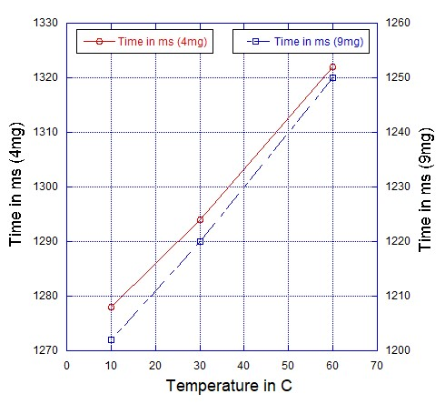

Investigating the time of fall (*tf*) of water droplets under varying droplet temperatures:

A water-droplet of mass 4 mg and temperature 10⁰C was dropped through a metal tube of height 5.913 m, and the time of fall (*tf*) was measured. Drop was repeated 25 times, and the readings were averaged. The experiment was repeated for droplets at temperatures 30 and 60⁰C.

The entire experiment was repeated with water droplets of mass 9 mg.

Results are given in Table S2, and graphically presented in Fig. S6.



For further details please refer {Gamini Piyadasa, 2019 #153}.

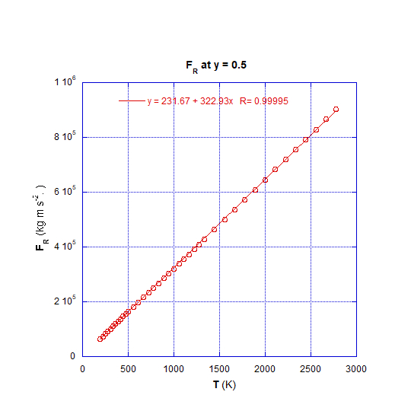



**Figure S7.** *FR* vs. *T; w*hen extrapolated crosses (0,0) when *y* ≈ 0.5

*FR* is linearly proportionate to *T* at any given value of *y* (Fig. S4(d)); thus, vindicating the mathematical model Eq. 5.

A significant finding is that, in the linear relationship *FR* vs. *T* extrapolated graph intercept ≈ 0 when *y*≈ 0.5, while intercept > 0 when *y*< 0.5, and intercept < 0 when *y*> 0.5.

Significantly, this result confirms the findings presented in a previous paper [47] of the series of publications emanating from this research program.

**Figure S8.** *FA* vs. *T*; *FA* tends to become positive as *T* approaches 0 K when *y* ≈ 0.5

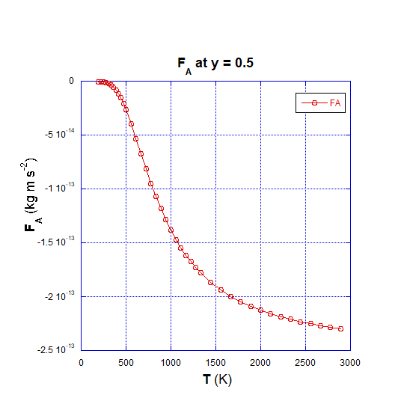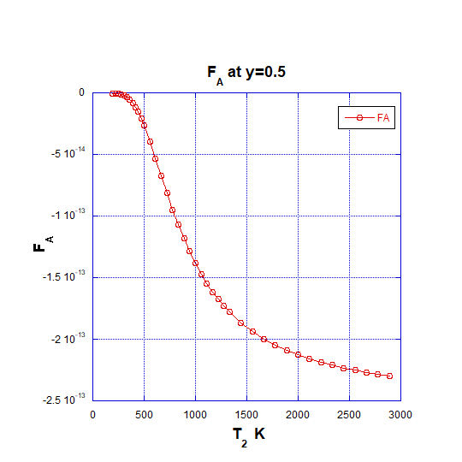

Applying empirical data to Eq. 12 has unearthed that *FA*, (the attraction force among gas molecules) is negative at elevated temperatures, implying that it acts as a repulsive force together with *FR*. This negative *FA* tends to becomes positive at lower temperatures where gases are expected to condense.

**References**

1. I. Newton, A. Motte, and J. Machin, *The Mathematical Principles of Natural Philosophy* (Benjamin Motte, London, 1729), v. 1.

2. A. Einstein and R. W. Lawson, *Relativity: The Special and the General Theory* (Ancient Wisdom Publications, Canada, 2010).

3. R. S. Park, W. M. Folkner, A. S. Konopliv, J. G. Williams, D. E. Smith, and M. T. Zuber, *The Astronomical Journal* **153**, 121 (2017).

4. M. Maggiore, *Gravitational Waves: Volume 1: Theory and Experiments* (Oxford University Press, UK, 2008).

5. P. Schneider, J. Ehlers, and E. E. Falco, *Gravitational Lenses* (Springer, Germany, 1999).

6. W. Cowen-Breen, *Effects of Gravitational Time Dilation in the Apparent Accelerated Expansion of the Universe* (CreateSpace Independent Publishing Platform, California, 2018).

7. P. J. E. Peebles and B. Ratra, *Reviews of Modern Physics* **75**, 559 (2003).

8. R. R. Caldwell, *Physics Letters B* **545**, 23 (2002).

9. S. Weinberg, *Reviews of Modern Physics* **61**, 1 (1989).

10. R. J. Adler, B. Casey, and O. C. Jacob, *American Journal of Physics* **63**, 620 (1995).

11. S. Hossenfelder, *Experimental Search for Quantum Gravity* (Springer International Publishing, Germany, 2017), p.^pp. 109 - 120.

12. S. Carroll, S. M. Carroll, and Addison-Wesley, *Spacetime and Geometry: An Introduction to General Relativity* (Addison Wesley, Boston, 2004).

13. P. Davies, C. SANDY, P. C. W. Davies, and C. BARBISAN, *Forces of Nature* (Cambridge University Press, UK, 1986).

14. N. Gorkavyi and A. Vasilkov, *Monthly Notices of the Royal Astronomical Society* **461**, 2929 (2016).

15. G. C. MCVITTIE, *General Relativity and Cosmology, Vol. IV.* (Chapman and Hall London, 1956), 07/28 edn., Vol. 4, The Journal of the Royal Aeronautical Society, 551.

16. V. Sahni and A. Krasiński, *General Relativity and Gravitation* **40**, 1557 (2008).

17. C. H. McGruder, *Physical Review D* **25**, 3191 (1982).

18. Z. Göttingen, *Nachrichten von der Gesellschaft der Wissenschaften, Mathematisch-Physikalische Klasse* (Weidmannsche Buchhandlung, Berlin, 1917).

19. V. L. Fitch, C. C. A. P. University, D. R. Marlow, P. University, M. A. E. Dementi, and M. A. E. Dementi, *Critical Problems in Physics: Proceedings of a Conference Celebrating the 250th Anniversary of Princeton University, Princeton, New Jersey, October 31, November 1, November 2, 1996* (Princeton University Press, New Jersey, 1997).

20. M. Janssen and C. Lehner, *The Cambridge Companion to Einstein* (Cambridge University Press, UK, 2014), v. 1.

21. M. D. Jones, *Psience: Easyread Comfort Edition* (CREATESPACE PUB, Google Book, 2009), p.^pp. 432.

22. C. K. G. Piyadasa, *Physics Essays* **32**, 10 (2019).

23. S. Perlmutter *et al.*, *The Astrophysical Journal* **517**, 565 (1999).

24. A. G. Riess *et al.*, *The Astronomical Journal* **116**, 1009 (1998).

25. C. Chicone and B. Mashhoon, *Journal of Mathematical Physics* **53**, 042501 (2012).

26. J. S. Wang and F. Y. Wang, *A&A* **564**, A137 (2014).

27. K. Bamba, S. i. Nojiri, S. D. Odintsov, and D. Sáez-Gómez, *Physical Review D* **90**, 124061 (2014).

28. M. Villata, *Europhysics Letters* **94**, 20001 (2011).

29. M. Wanas, *Advances of High Energy Physics* **2012**, 10, 752613 (2012).

30. P. J. Steinhardt, *Philosophical Transactions: Mathematical, Physical and Engineering Sciences* **361**, 2497 (2003).

31. E. F. Obert, *Concepts of Thermodynamics* (McGraw-Hill, New York, 1960).

32. G. R. Fowles, *Introduction to Modern Optics* (Dover Publications, New York, 1975).

33. V. K. Oikonomou and N. Karagiannakis, *Journal of Gravity* **2014**, 625836 (2014).

34. A. I. Burshtein, *Introduction to Thermodynamics and Kinetic Theory of Matter* (Wiley, New Jersey, 2005).

35. T. Vlugt, J. V. Eerden, M. Dijkstra, B. Smit, and D. Frenkel, *Introduction to Molecular Simulation and Statistical Thermodynamics* (Delft University of Technology, Netherlands, 2009).

36. A. K. Singh, *Structure, Synthesis, and Application of Nanoparticles* (Academic Press, Boston, 2016), Engineered Nanoparticles.

37. C. K. G. Piyadasa, *Advances of High Energy Physics, Special issue : Dark Matter and Dark Energy in General Relativity and Modified Theories of Gravity* **2020**, 1 (2020).

38. C. K. G. Piyadasa, *Canadian Journal of Pure and Applied Sciences* **6**, 1991 (2012).

39. C. K. G. Piyadasa, *Canadian Journal of Pure and Applied Sciences* **5**, 1715 (2011).

40. J. L. Gay-Lussac, *Annal. Chim.* **43** 137 (1802).

41. J. H. Keenan and J. Kaye, *Gas Tables: Thermodynamic Properties of Air, Products of Combustion and Component Gases, Compressible Flow Function Including Those of Ascher H. Shapiro and Gilbert M. Edelman* (J. Wiley, 1948).

42. S. Chandrasekhar, *Reviews of Modern Physics* **15**, 1 (1943).

43. C. A. de Coulomb, *Théorie des machines simples* (Librairie scientifique et technique Albert Blanchard, 2002).

44. C. V. Boys, *Proceedings* (Royal Institution of Great Britain, London, 1896), Vol. 14, p.^pp. 355.

45. V. N. Popok, in *Polymer-Based Multifunctional Nanocomposites and Their Applications*, edited by K. Song, C. Liu, and J. Z. Guo (Elsevier, Amsterdam, 2019), pp. 35.

46. Real Gases- The Effects of Size and Intermolecular Forces, https://chem.libretexts.org/Bookshelves/General_Chemistry/Map%3A_A_Molecular_Approach_(Tro)/05%3A_Gases/5.10%3A_Real_Gases-_The_Effects_of_Size_and_Intermolecular_Forces.

47. C. K. Gamini Piyadasa, *Physics Essays* **32**, 141 (2019).