Supplementary Material

Zn(II) complex for highly sensitive and selective detection of acetone at room temperature

Abdullah Alarifi¹, Mohammad Usman², Mohd. Muddassir¹*
¹Catalytic Chemistry Research Chair, Department of Chemistry, College of Science, KSU, Riyadh 11451, KSA.
²Department of Chemistry, IIT Kanpur
Corresponding author email: mmohammadarshad@ksu.edu.sa

Crystal structure determination
Single crystals of Zn complex were coated with a trace of Fomblin oil and quickly transferred to the goniometer head of a Bruker Quest diffractometer with a fixed chi angle, a sealed tube fine focus X-ray tube, single crystal curved graphite incident beam monochromator, a Photon100 CMOS area detector and an Oxford Cryosystems low-temperature device. Examination and data collection were performed with Mo Kα radiation (λ = 0.71073 Å) at 150 K.
Data were collected, reflections were indexed and processed, and the files scaled and corrected for absorption using APEX3 [1] [1]. The space groups were assigned, and the structures were solved by direct methods using XPREP within the SHELXTL suite of programs [2,3] and refined by full-matrix least squares against F² with all reflections using Shelxl2018 [4,5] using the graphical interface Shelxle [6]. H atoms attached to carbon and nitrogen atoms as well as hydroxyl hydrogens were positioned geometrically and constrained to ride on their parent atoms. C-H bond distances were constrained to 0.95 Å for aromatic and alkene C-H moieties. N-H bond distances were constrained to 0.88 Å for planar (sp² hybridized) N-H groups. Figures were drawn using ORTEP-3.3 [7] and MERCURY-4.1.0 [8].
Computational methodology
The full geometry optimizations have been carried out at DFT level of theory using the B3LYP functional [9–11] with the help of the Gaussian-09 program package [12]. The calculations were performed using 6-31G* basis sets [13,14] for C, H, N, O, Cl atoms and def2-TZVP basis set for Zn atom. All the DFT calculations were performed with counter ions by employing the polarizable continuum model, CPCM (DMSO as solvent) [15–17]. No symmetry restrictions have been applied during geometry optimization. The Hessian matrix was calculated analytically for the optimized structures in order to prove the location of correct minima (no imaginary frequencies). The Cartesian atomic coordinates of the calculated optimized structures in DMSO are given in the ESI-material.
Table Ligands
Table S1. Crystallographic data of [Zn(bipy)₂(H₂O)](ClO₄)₂
Table S2. . Selected bond lengths [Å] and bond angles [°] of [Zn(bipy)₂(H₂O)](ClO₄)₂

Table S1.
_______________________________________________
CCDC No. CCDC 766185
Color White
Molecular formula C₂₀H₁₈N₄OZn•2(ClO₄)
Molecular weight 594.65
Crystal system P21/c
Space group Monoclinic
a (Å) 8.988 (3)
b (Å) 12.812 (4)
c (Å) 19.921 (5)
U (Å³) 2214.8 (12)
β = (°) 105.095 (12)
DX (Mg m−3) 1.783
Z 4
F (000) 1208
Crystal size/mm 0.30 × 0.25 × 0.20
μ(mm⁻¹) 1.41
θ (°) 2.4–27.5
Index ranges -10 < h < 10; -15 < k < 14;
-15 < l < 23
No. of reflections collected 1115
No. of independent reflections (Rint) 3907 (0.055)
No. of observed [I > 2σ(I)] reflections 3218
No. of data/restraints/ parameters 3907/0/325
R[F2 > 2σ(F2)] 0.050
wR(F2) 0.129
Δρmax and Δρmin (e Å⁻³) 0.77 and -0.81
_______________________________________________
Table S2.
______________________________________________
Zn—O1 2.028 (3) Zn—N2 2.061 (3)
Zn—N4 2.070 (3) Zn—N1 2.091 (3)
Zn—N3 2.104 (3)
O1—Zn—N2 118.99 (11) O1—Zn—N4 121.81 (12)
N2—Zn—N4 119.18 (12) O1—Zn—N1 89.67 (11)
N2—Zn—N1 79.03 (13) N4—Zn—N1 102.44 (13)
O1—Zn—N3 90.58 (10) N2—Zn—N3 99.86 (12)
N4—Zn—N3 78.39 (12) N1—Zn—N3 178.83 (13)
Zn—O1—H1A 121.2 Zn—O1—H1B 107.0
C12—N1—Zn 115.0 (3) C3—N2—C8 119.0 (3)
C3—N2—Zn 126.1 (2) C8—N2—Zn 114.9 (2)
C7—N3—C19 118.4 (3) C7—N3—Zn 114.7 (2)
C19—N3—Zn 126.3 (3) C9—N4—C6 118.8 (3)
C9—N4—Zn 125.7 (3) C6—N4—Zn 115.4 (2)
______________________________________________

Fig. Legends.
Scheme S1. Synthetic Scheme of Complex 1
Fig S1. Thermal ellipsoidal presentation of the molecular structure of [Zn(bipy)₂(H₂O)](ClO₄)₂ with 30% probability factor.
Fig. S2. The ¹H NMR spectrum of Complex 1.
Fig. S3. The ¹³C NMR spectrum of Complex 1.
Fig. S4. Thermogravimetric analysis of [Zn(bipy)₂(H₂O)](ClO₄)₂
Fig. S5. IR spectrum of [Zn(bipy)₂(H₂O)](ClO₄)₂
Fig. S6. UV-Vis Spectrum of Complex 1.
Fig. S7. Change in the fluorescence intensity of [Zn(bipy)₂(H₂O)](ClO₄)₂ (dissolved in DMSO) upon titration with acetone.

Fig. S8. B3LYP/DFT optimized structures of the aggregate of Zn(II)-complex with the various used molecules for sensing. The d···d’ distance in angstrom represents the nearest distance between the carbon atoms of bipyridyl moiety of Zn(II)-complex and different solvents.

Scheme S1

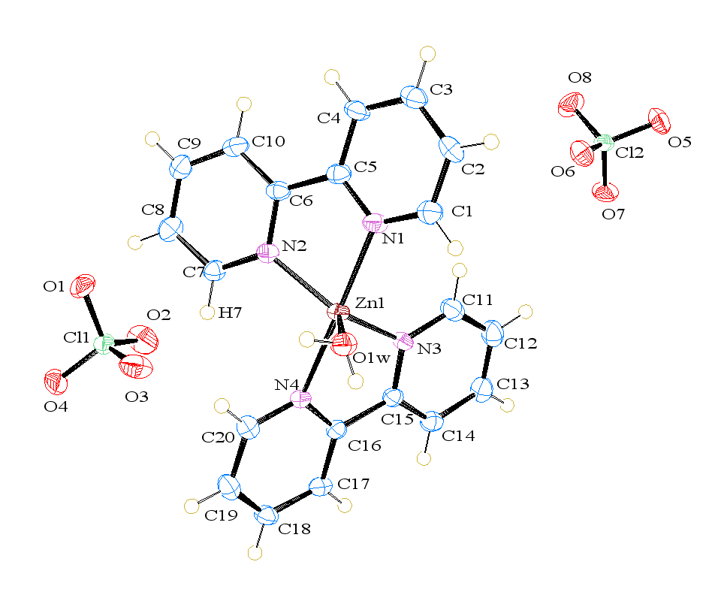
Fig. S1.

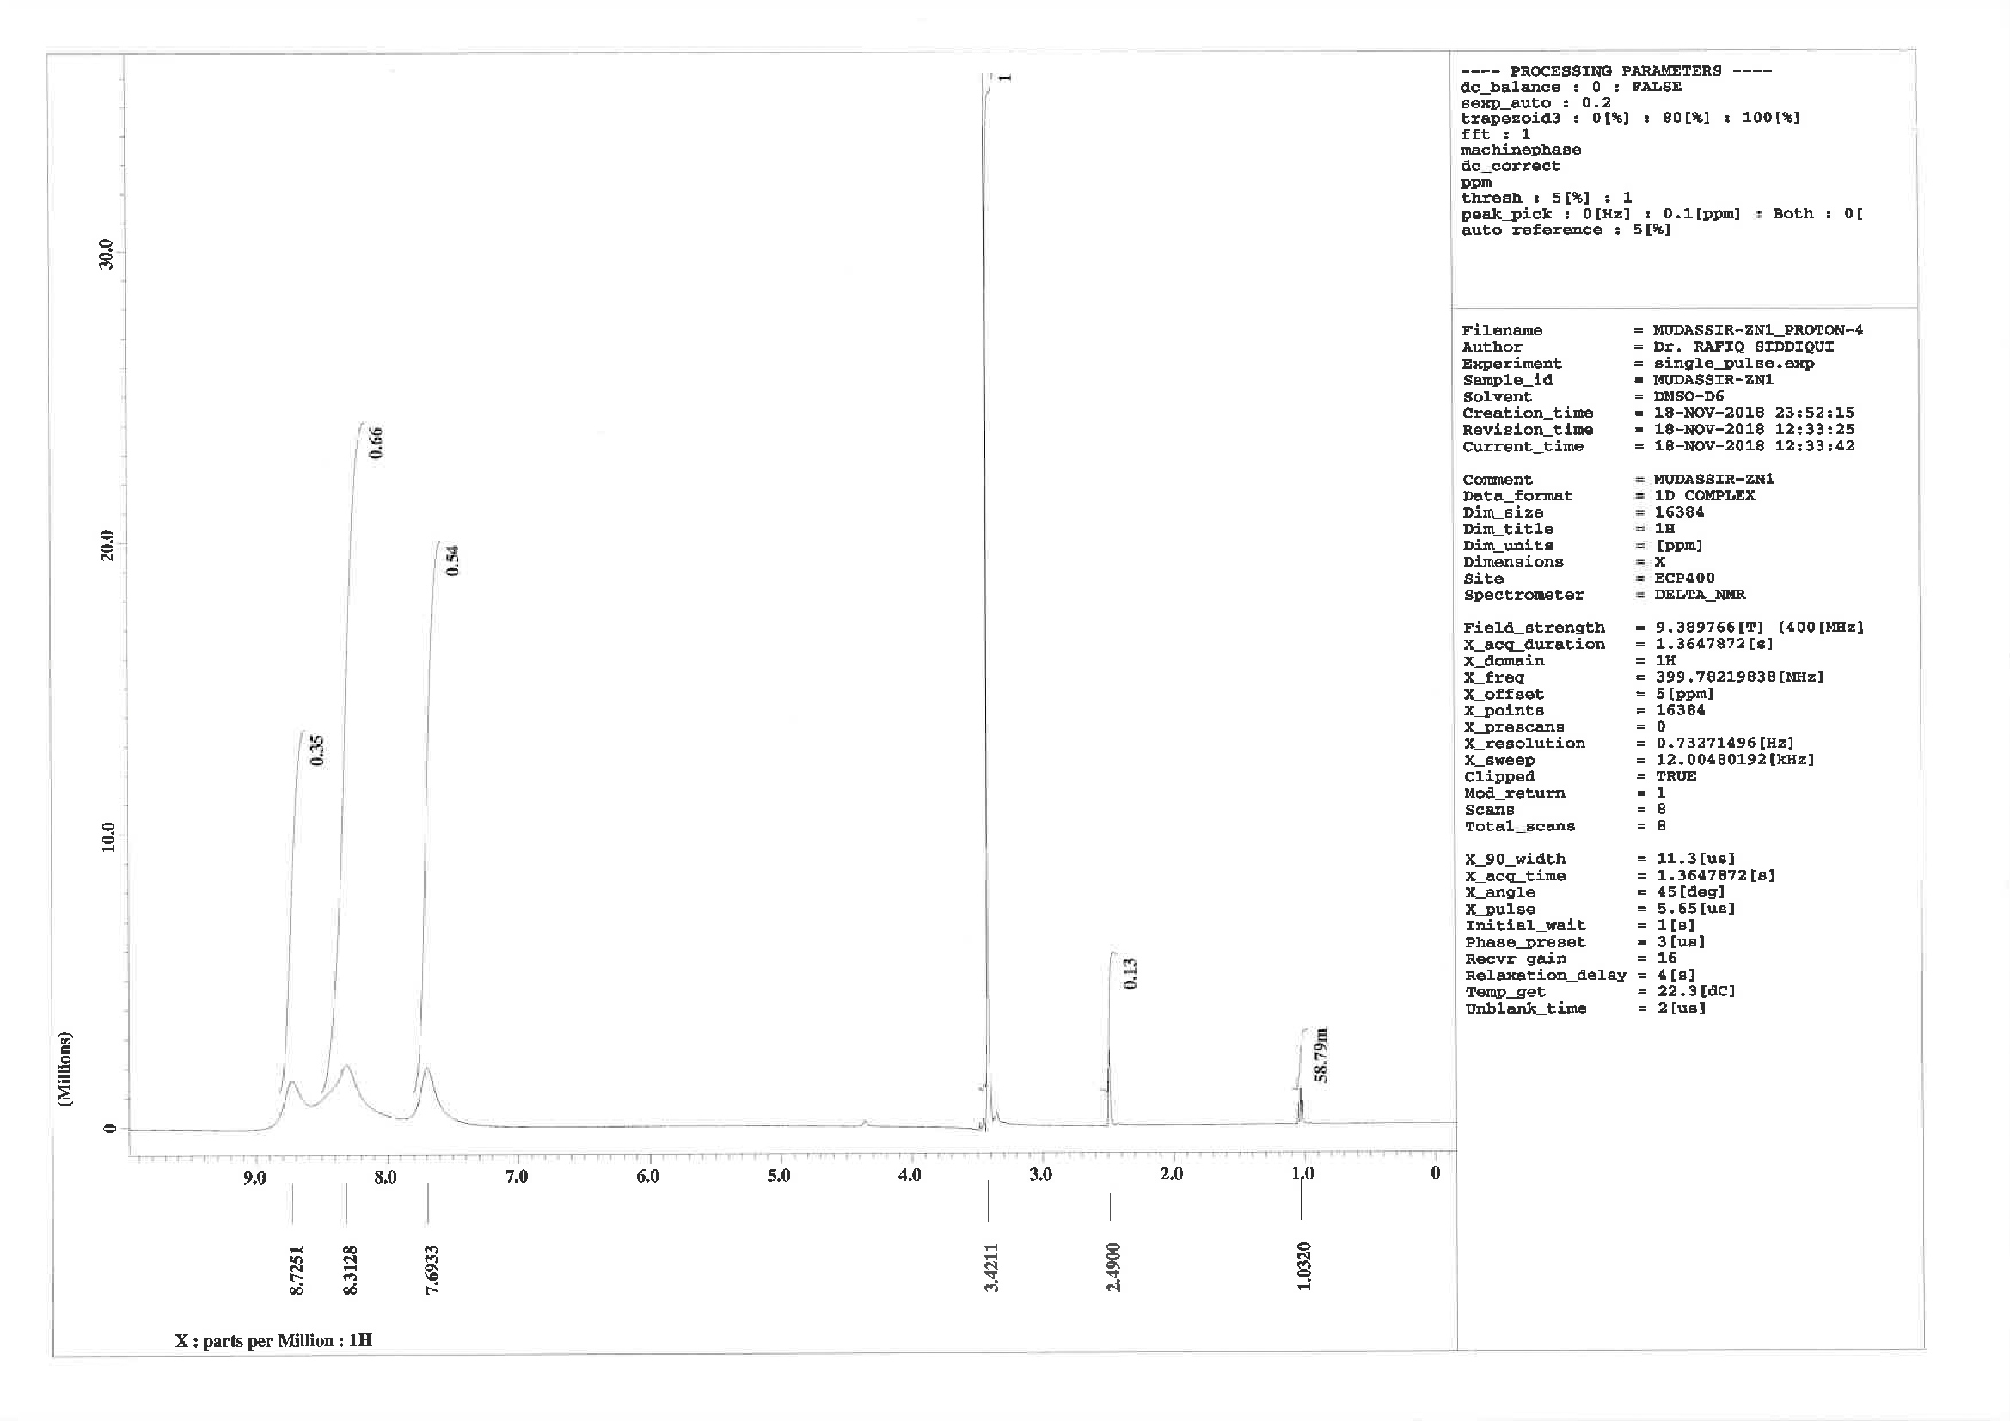
Fig. S2.

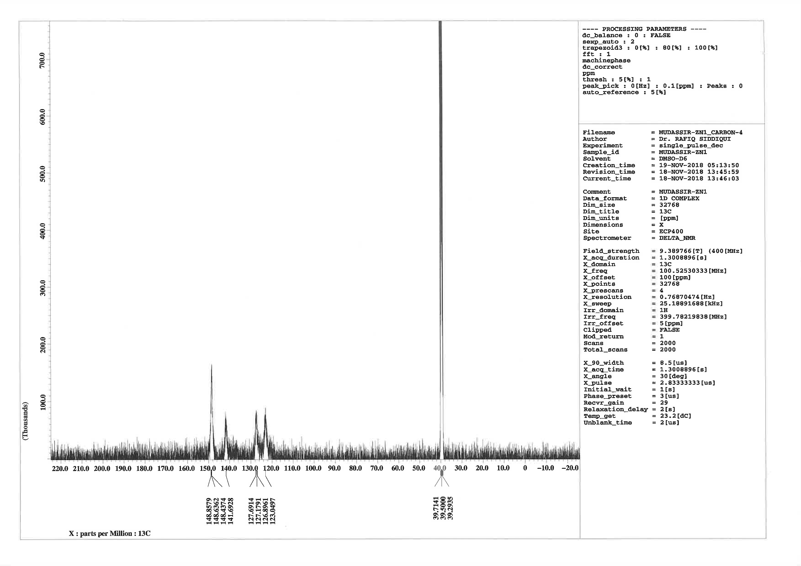
Fig. S3.
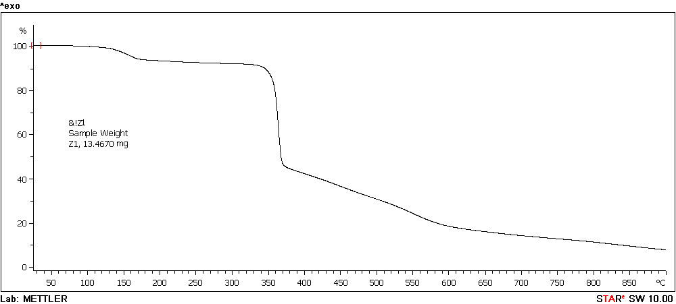
Fig. S4.

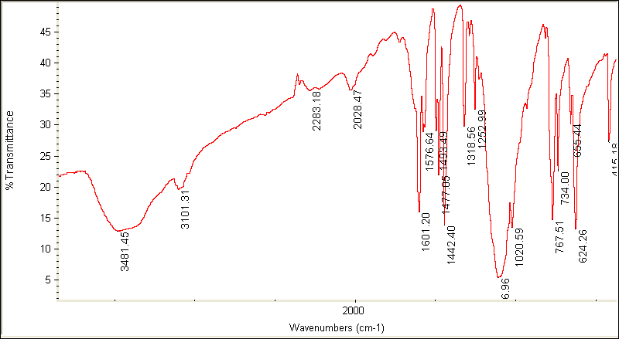
Fig. S5.

Fig. S6.

Fig. S7.

Fig. S8.

References
[1] Bruker (2016). Apex3 v2016.9-0, Saint V8.34A, SAINT V8.37A, Bruker AXS Inc.: Madison (WI), USA, 2013/2014, (2016).
[2] SHELXTL suite of programs, Version 6.14, 2000-2003, Bruker Advanced X-ray Solutions, Bruker AXS Inc., Madison, Wisconsin: USA, (n.d.).
[3] G.M. Sheldrick, A short history of SHELX., Acta Crystallogr. A. 64 (2008) 112–22. doi:10.1107/S0108767307043930.
[4] Sheldrick George M. University of Göttingen, Germany., (2018).
[5] G.M. Sheldrick, Crystal structure refinement with SHELXL., Acta Crystallogr. Sect. C, Struct. Chem. 71 (2015) 3–8. doi:10.1107/S2053229614024218.
[6] C.B. Hübschle, G.M. Sheldrick, B. Dittrich, ShelXle: A Qt graphical user interface for SHELXL, J. Appl. Crystallogr. 44 (2011) 1281–1284. doi:10.1107/S0021889811043202.
[7] L.J. Farrugia, ORTEP-3 for windows - A version of ORTEP-III with a graphical user interface (GUI), J. Appl. Crystallogr. 30 (1997) 565. doi:10.1107/S0021889897003117.
[8] C.F. Macrae, P.R. Edgington, P. McCabe, E. Pidcock, G.P. Shields, R. Taylor, M. Towler, J. van de Streek, Mercury : visualization and analysis of crystal structures , J. Appl. Crystallogr. 39 (2006) 453–457. doi:10.1107/s002188980600731x.
[9] A.D. Becke, Density‐functional thermochemistry. III. The role of exact exchange, J. Chem. Phys. 98 (1993) 5648–5652. doi:10.1063/1.464913.
[10] C. Lee, W. Yang, R.G. Parr, Development of the Colle-Salvetti correlation-energy formula into a functional of the electron density, Phys. Rev. B. 37 (1988) 785–789. doi:10.1103/PhysRevB.37.785.
[11] P.J. Stephens, F.J. Devlin, C.F. Chabalowski, M.J. Frisch, Ab Initio Calculation of Vibrational Absorption and Circular Dichroism Spectra Using Density Functional Force Fields, J. Phys. Chem. 98 (1994) 11623–11627. doi:10.1021/j100096a001.
[12] M.J.. Frisch, G.W.. Trucks, H.B.. Schlegel, G.E.. Scuseria, M.A.. Robb, J.R.. Cheeseman, G.. Scalmani, V.. Barone, B.. Mennucci, G.A.. Petersson, H.. Nakatsuji, M.. Caricato, X.. Li, H.P.. Hratchian, A.F.. Izmaylov, J.. Bloino, G.. Zheng, J.L.. Sonnenberg, M.. Hada, M.. Ehara, K.. Toyota, R.. Fukuda, J.. Hasegawa, M.. Ishida, T.. Nakajima, Y.. Honda, O.. Kitao, H.. Nakai, T.. Vreven, J.. Montgomery, J. A., J.E.. Peralta, F.. Ogliaro, M.. Bearpark, J.J.. Heyd, E.. Brothers, K.N.. Kudin, V.N.. Staroverov, R.. Kobayashi, J.. Normand, K.. Raghavachari, A.. Rendell, J.C.. Burant, S.S.. Iyengar, J.. Tomasi, M.. Cossi, N.. Rega, J.M.. Millam, M.. Klene, J.E.. Knox, J.B.. Cross, V.. Bakken, C.. Adamo, J.. Jaramillo, R.. Gomperts, R.E.. Stratmann, O.. Yazyev, A.J.. Austin, R.. Cammi, C.. Pomelli, J.W.. Ochterski, R.L.. Martin, K.. Morokuma, V.G.. Zakrzewski, G.A.. Voth, P.. Salvador, J.J.. Dannenberg, S.. Dapprich, A.D.. Daniels, Ö.. Farkas, J.B.. Foresman, J.V.. Ortiz, J.. Cioslowski, D.J. Fox, Gaussian 09 Citation | Gaussian.com, Gaussian, Inc., Wallingford CT,. (2009). http://gaussian.com/g09citation/ (accessed November 11, 2019).
[13] P.J. Hay, W.R. Wadt, Ab initio effective core potentials for molecular calculations. Potentials for the transition metal atoms Sc to Hg, J. Chem. Phys. 82 (1985) 270–283. doi:10.1063/1.448799.
[14] W.R. Wadt, P.J. Hay, Ab initio effective core potentials for molecular calculations. Potentials for main group elements Na to Bi, J. Chem. Phys. 82 (1985) 284–298. doi:10.1063/1.448800.
[15] V. Barone, M. Cossi, Quantum Calculation of Molecular Energies and Energy Gradients in Solution by a Conductor Solvent Model, J. Phys. Chem. A. 102 (1998) 1995–2001. doi:10.1021/jp9716997.
[16] M. Cossi, V. Barone, Time-dependent density functional theory for molecules in liquid solutions, J. Chem. Phys. 115 (2001) 4708–4717. doi:10.1063/1.1394921.
[17] M. Cossi, N. Rega, G. Scalmani, V. Barone, Energies, structures, and electronic properties of molecules in solution with the C-PCM solvation model, J. Comput. Chem. 24 (2003) 669–681. doi:10.1002/jcc.10189.

